The 3-Month Efficacy of Visual Art Training on Observational and Diagnostic Skills Among Nursing Students- A Randomized Controlled Trial
Running Title：The Efficacy of Visual Art Training
List of All Authors:
- Jia GUO Associate Professor, PhD, RN
Xiangya School of Nursing, Central South University, Changsha, Hunan Province, China. E-mail: guojia621@163.com
- Qinyi ZHONG MSc, RN
Xiangya School of Nursing, Central South University, Changsha, Hunan Province, China. E-mail: zhongqinyi71@126.com
- Ying TANG Assistant Professor, MA
School of Architecture and Art, Central South University, Changsha, Hunan Province, China. E-mail: 747834866@qq.com
- Jiaxin LUO MSc, RN
Xiangya School of Nursing, Central South University, Changsha, Hunan Province, China. E-mail: 1311032001@qq.com
- Hongjuan WANG MSc, RN
Xiangya School of Nursing, Central South University, Changsha, Hunan Province, China. E-mail: 2573054251@qq.com
- Xiaofen QIN MSc, RN
Hainan General Hospital, Haikou, Hainan Province, China. E-mail: qinxiaofen@csu.edu.cn
- Xiuhua WANG Professor, PhD, RN
Xiangya School of Nursing, Central South University, Changsha, Hunan Province, China. E-mail: 653012790@qq.com
- James Allen WILEY Professor, MSc, PhD
Department of Family and Community Medicine, University of California, San Francisco, the United States. E-mail: jwiley124@gmail.com

Correspondence to Jia Guo:
E-mail: guojia621@163.com
Tel: +86 0731-82650290
Address: NO.172 Tongzipo Road Yuelu District, Changsha 410013, China
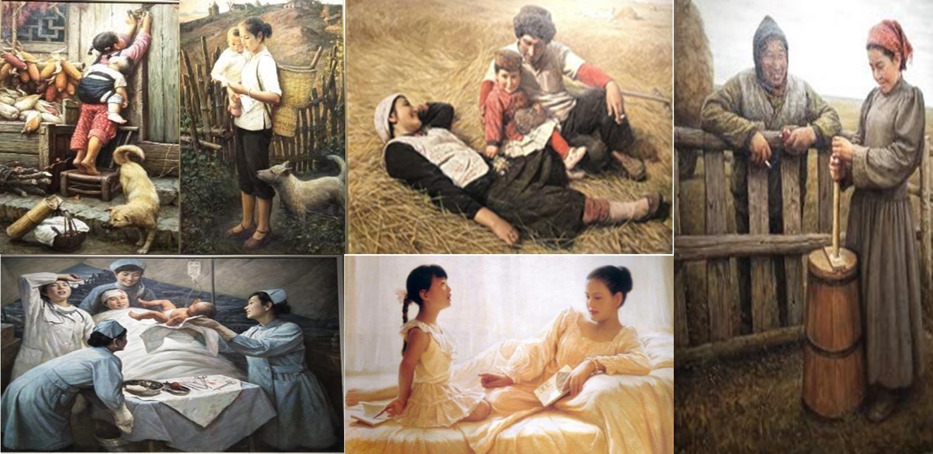
Appendix A: The Chinese art paintings used for museum visit in the study.

Note. Li Zijian’s painting reprinted with permission from the Li Zijian Art Museum.

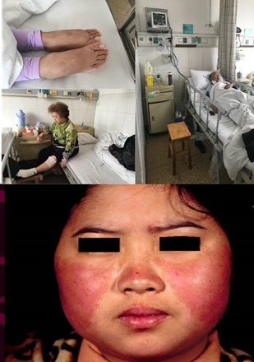
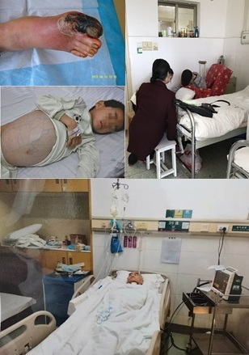
Appendix B: The clinical images used in the study.

Note. The images obtained the permissions from patients. Pretest on the left and Posttest on the right.

