Wet and Dry Deposition Flux Measurements of Atmospheric Microplastic Particles in Central Germany

Sarmite Kernchen^{1,4*}, Holger Schmalz^{2.3}, Martin G. J. Löder⁴, Christoph Georgi⁵, Andrej Einhorn¹, Andreas Greiner^{2.3}, Anke C. Nölscher¹, Christian Laforsch⁴ and Andreas Held⁵

¹Chair of Atmospheric Chemistry, University of Bayreuth, Bayreuth, 95440, Germany
²Chair of Macromolecular Chemistry II, University of Bayreuth, Bayreuth, 95440, Germany
³Bavarian Polymer Institute, Keylab Synthesis and Molecular Characterization, University of Bayreuth, Bayreuth 95440, Germany
⁴Chair of Animal Ecology I, University of Bayreuth, Bayreuth, 95440, Germany
⁵Chair of Environmental Chemistry and Air Research, Technische Universität Berlin, Berlin, 10623, Germany
* Present address

Keywords: plastic pollution, dry and wet deposition of microplastics, µFTIR, Raman spectroscopy

Corresponding author: Sarmite Kernchen

Supplementary Information

CONTENT

Mathematical equations: Dry deposition velocity calculations
Table S1: Wet and dry atmospheric deposition collection and meteorological data
Table S2: Correlation between meteorological variables and microplastic dry, wet, and total DFs, and concentrations in precipitation
Figure S1: Daily precipitation at the sampling site in Kassel over monthly wet and dry deposition collection period. The data were were retrieved from the wastewater treatment plant KASSELWASSER.
Figure S2: Wet and dry atmospheric deposition collector.
Figure S3: Wet and dry mass atmospheric deposition of MPs at the study site over the sampling period.
Figure S4a-l: Local wind field plots over the sampling period. Meteorological data were retrieved from the weather station Kassel-Mitte (HLNUG).
Figure S5a,b: (a) Optical stitching image of the filter and the selected area used for analysis via ParticleScout (3 × 3 mm²); (b) distribution of particles on a subsample identified by ParticleScout. In total, 1362 particles were found by the WITec ParticleScout software, 3 particles were assigned to plastics, 13 to cellulose, and 7 to bacteria (Escherichia coli and Corynebacterium glutamicum).
Figure S6a,h: (a,c) Optical images of cellulose particle fragments and (e,g) bacterial colonies. and (b, d, f, h) corresponding Raman spectra (black) in comparison with the reference spectra from the database (blue).
Figure S7a,b: (a) Optical image of filter fragment enclosing a polypropylene particle and (b) FTIR spectrum of the particle (red) in comparison with the reference spectra (black).
Figure S8a-c: Optical stitching image of a filter fragment. The red square shows the position of the large area Raman scan (500 x 500 µm, step size of 2 µm pixel⁻¹), where a polydimethylsiloxane (PDMS) MP was found; (b) overlay of optical image with the component distribution obtained by True Component Analysis (Witec Project 5.3) of the large area Raman scan. Colour code corresponds to components, whose spectra are displayed in (c).
Figure S9a-l: (a) Optical stitching image of the filter indicating the position (red square) for the large area Raman scan (100 x 100 µm) conducted with a smaller step size of 0.5 µm pixel⁻¹; (b) overlay of optical image with component distribution retrieved from the large area Raman scan employing the True Component Analysis included in the Witec Project 5.3 software; spatial distributions of (c) amylose, (e) soot, (g) quartz, and (i) calcite particles and (d, f, h, j,) respective Raman spectra of the particles (black) extracted from True Component Analysis in comparison with the reference spectra from the database (blue).

References

Mathematical equations: Dry deposition velocity calculations

Supermicron particles (> 1 µm) are expected to settle by sedimentation and due to turbulent motion. Therefore, the deposition velocity (DV) can be approximated by Eq. (1) [1]:

$DV=υ_{s}+υ_{t}$ (1)

where υ_{s} – particle sedimentation velocity (m s⁻¹); υ_{t} –turbulent dry deposition velocity (m s⁻¹). Depending on the particle equivalent spherical diameter (d_{ESD}) υ_{t} is approximated as 0.01 m s⁻¹ for particles with d_{ESD} = 2.5-10 µm, 0.05 m s⁻¹ for particles with d_{ESD} = 10-50 µm, and 0.2 m s⁻¹ for particles with d_{ESD} larger than 50 µm [2].

The volume equivalent diameter d_{ESD} is the diameter for the sphere with the same volume as the particle under consideration, that is

$d_{EDS}=\sqrt[3]{\frac{6V_{p}}{π}}$ (2)

where V_{p} – particle volume; for calculation of V_{p} it was assumed that the particle is an elliptical cylinder with the major dimension a, minor dimension b, and height h (a, b determined by µFTIR).
a
b
h
b
a
Plastic particle

$V_{p}=\frac{1}{4}πabh$ (3)

$h=0.67b$ (4)

The sedimentation velocity υ_{s} was calculated by Newton’s law of resistance (5), taking into consideration buoyancy effects and particle size and shape:

$υ_{s}=\sqrt{\frac{4}{3}\frac{d_{ESD}}{C_{D}}g\frac{ρ_{p}-ρ}{ρ}}$ (5)

where C_{D} – dimensionless drag coefficient; g – gravitational acceleration (9.81 m s⁻¹); ρ – air density (1.225 kg m⁻³ or 1.225 ⨯ 10⁹ µg m⁻³ at 1 atm and 15 °C); and ρ_{p} – particle density (µg m⁻³).

The dimensionless drag coefficient was calculated following [3, 4] for non-spherical volcanic ash particles:

$C_{D}=\frac{4}{3}\frac{0.559C_{D. sphere}{(Re^{4.18}ψ^{{-Re}^{-0.2}})}^{0.5134}}{{Re}^{2}}$ (6)

$C_{D. sphere}=\frac{24}{Re}(1+0.15{Re}^{0.687})+\frac{0.42}{1+\frac{42500}{{Re}^{1.16}}}$ (7)

$ψ=\frac{π^{\frac{1}{3}}{6V_{p}}^{\frac{2}{3}}}{A_{p}}$ (8)

$Re=\frac{ρυd}{μ}$ (9)

$υ=\frac{2\left(ρ_{p}-ρ\right)g({\frac{d}{2})}^{2}}{9μ}$ (10)

where Re – Reynolds number; ψ – sphericity; V_{p} – particle volume (m³); A_{p} – particle surface area (m²); μ is the dynamic viscosity of the air (1.81 kg m⁻¹ s⁻¹ or 1.81 ⨯ 10⁹ µg m⁻¹ s⁻¹ at 15 °C); and υ – Stokes particle settling velocity (m s⁻¹).

Table S1: Wet and dry atmospheric deposition collection and meteorological data*
Parameter | May | June | July | August | September | October | November | December | January | February | March | April | Mean | SD
Parameter | 29.04.19-27.05.19 | 27.05.19-24.06.19 | 24.06.19-29.07.19 | 29.07.19-27.08.19 | 27.08.19-30.09.19 | 30.09.19-30.10.19 | 30.10.19-26.11.19 | 26.11.19-02.01.20 | 02.01.20-30.01.20 | 30.01.20-15.03.20 | 15.03.20-30.04.20 | 30.04.20-28.05.20 | Mean | SD
MP Dry DFs [N m⁻² day⁻¹] | 0 | 0 | 0 | 17 | 21 | 8 | 0 | 7 | 0 | 5 | 0 | 0 | 5 | 7
MP Wet DFs [N m⁻² day⁻¹] | 6 | 13 | 5 | 19 | 16 | 6 | 7 | 5 | - | - | - | - | 10 | 5
MP Total DFs [N m⁻² day⁻¹] | 6 | 13 | 5 | 37 | 39 | 15 | 7 | 13 | - | - | - | - | 17 | 14
MP conc. in precipitation [MPs L⁻¹] | 2 | 9 | 5 | 12 | 18 | 3 | 6 | 3 | - | - | - | - | 7 | 5
Average dry period [days] | 1.3 | 1.5 | 1.5 | 0.7 | 0.8 | 0.8 | 0.7 | 0.7 | 0.8 | 0.4 | 4.1 | 0.9 | 1.2 | 1
Maximal dry period [days] | 5.8 | 5.4 | 7.5 | 4 | 4.4 | 6.7 | 6.3 | 7.5 | 4.7 | 4.4 | 15.2 | 6 | 6.5 | 3
Average wet period [h] | 3.8 | 2.3 | 2.1 | 1.6 | 1.9 | 3 | 2.2 | 2.7 | 2.3 | 2.3 | 1.9 | 1.8 | 2.3 | 0.6
Maximal wet period [h] | 16 | 6 | 5 | 7 | 8 | 11 | 14 | 16 | 20 | 16 | 4 | 4 | 11 | 6
Precipitation [mm] | 93 | 40 | 39 | 48 | 32 | 57 | 33 | 66 | 35 | 127 | 7 | 30 | 51 | 32
Light rain (0.2-0.5 mm h⁻¹) [h] | 9 | 8 | 12 | 25 | 32 | 22 | 24 | 35 | 24 | 78 | 8 | 19 | 25 | 19
Moderate rain (0.5-4.0 mm h⁻¹) [h] | 8 | 10 | 9 | 12 | 7 | 8 | 9 | 12 | 6 | 21 | 3 | 9 | 10 | 4
Heavy rain (4.0-24 mm h⁻¹) [h] | 1 | 0 | 0 | 0 | 0 | 0 | 0 | 0 | 0 | 0 | 0 | 0 | 0.1 | 0.3
Average rain intensity [mm h⁻¹] | 0.88 | 0.82 | 0.7 | 0.49 | 0.28 | 0.48 | 0.36 | 0.36 | 0.3 | 0.42 | 0.28 | 0.44 | 0.5 | 0.2
Wind speed [m s⁻¹] | 1.8 | 1.7 | 1.5 | 1.6 | 1.6 | 2.1 | 1.8 | 2.1 | 2.5 | 2.9 | 1.9 | 1.7 | 1.9 | 0.4
Average wind direction [°] | 358 | 177 | 354 | 202 | 215 | 196 | 187 | 204 | 211 | 220 | 44 | 3 | - | -
Dominant wind direction | NE | SSW | NE | SSW | SSW | SSW | SSW | SSW | SSW | SSW | NE | NE | - | -
TAPD** [km⁻²] | 294 | 331 | 308 | 325 | 351 | 286 | 297 | 295 | 318 | 250 | 313 | 332 | 308 | 26.5
Temperature [°C] | 12 | 19 | 21 | 20 | 16 | 12 | 5 | 5 | 4 | 6 | 10 | 13 | 12 | 6
Global radiation [W m⁻²] | 179 | 231 | 223 | 189 | 133 | 58 | 27 | 16 | 17 | 53 | 190 | 192 | 126 | 85
Air pressure [hPa] | 1016 | 1016 | 1018 | 1017 | 1019 | 1014 | 1007 | 1013 | 1024 | 1011 | 1020 | 1017 | 1016 | 4
Relative humidity [%] | 73 | 68 | 67 | 68 | 74 | 85 | 91 | 88 | 90 | 80 | 61 | 69 | 76 | 10
PM10 [µg m⁻³] | 14 | 14 | 16 | 15 | 14 | 14 | 17 | 17 | 17 | 11 | 19 | 13 | 15 | 2
SO₂ [µg m⁻³] | 0.8 | 0.8 | 0.9 | 0.8 | 0.8 | 0.8 | 0.9 | 0.9 | 0.8 | 0.8 | 1 | 0.8 | 0.8 | 0.1
NO [µg m⁻³] | 2.3 | 1.9 | 2.1 | 2.4 | 3.8 | 5.6 | 9.6 | 9.4 | 7.9 | 2.4 | 2 | 1.8 | 4.3 | 3.1
NO₂ [µg m⁻³] | 15 | 15 | 14 | 16 | 19 | 20 | 26 | 26 | 24 | 15 | 15 | 13 | 18 | 5
O₃ [µg m⁻³] | 65 | 69 | 69 | 60 | 48 | 33 | 21 | 30 | 31 | 54 | 68 | 66 | 51 | 18
* Meteorological data were retrieved from wastewater treatment plant KasselWasser and weather station Kassel-Mitte (HLNUG); ** Trajectory-averaged population density
Table S2: Correlation between meteorological variables and microplastic dry, wet, and total DFs, and concentrations in precipitation*
Parameter | MP dry DF  [MPs m⁻² day⁻¹] | MP wet DF  [MPs m⁻² day⁻¹] | MP total DF  [MPs m⁻² day⁻¹] | MP conc. in precipitation [MPs L⁻¹]
Average dry period [days] | -0.56 | -0.21 | -0.42 | -0.12
Maximal dry period [days] | -0.40 | -0.96 | -0.61 | -0.68
Average wet period [h] | -0.09 | -0.58 | -0.40 | -0.87
Maximal wet period [h] | 0.16 | -0.28 | -0.05 | -0.58
Precipitation [mm] | 0.29 | -0.41 | -0.20 | -0.78
Light rain (drizzle. 0.2-0.5 mm h⁻¹) [h] | 0.68 | 0.08 | 0.54 | 0.26
Moderate rain (0.5-4.0 mm h⁻¹) [h] | 0.24 | -0.02 | -0.07 | 0.06
Heavy rain (4.0-24 mm h⁻¹) [h] | -0.24 | -0.17 | -0.41 | -0.58
Average rain intensity [mm h⁻¹] | -0.20 | -0.14 | -0.55 | -0.39
Wind speed [m s⁻¹] | -0.04 | -0.19 | 0.02 | -0.55
Average wind direction [°] | 0.19 | -0.36 | -0.29 | -0.32
Trajectory-averaged population density [km⁻²] | 0.00 | 0.64 | 0.38 | 0.91
Temperature [°C] | 0.17 | 0.09 | 0.03 | 0.34
Global radiation [W m⁻²] | -0.31 | 0.04 | -0.16 | 0.14
Air pressure [hPa] | -0.12 | 0.23 | 0.25 | 0.50
Relative humidity [%] | 0.17 | 0.07 | 0.17 | -0.09
PM10 [µg m⁻³] | -0.23 | -0.12 | -0.35 | 0.06
SO₂ [µg m⁻³] | -0.30 | -0.48 | -0.57 | -0.16
NO [µg m⁻³] | 0.39 | 0.13 | 0.24 | 0.04
NO₂ [µg m⁻³] | 0.38 | 0.32 | 0.38 | 0.18
O₃ [µg m⁻³] | -0.37 | -0.20 | -0.28 | -0.07
*Spearman rank correlation coefficients between meteorological variables and MP DFs and concentrations in precipitation: p < 0.05 (in red), p > 0.05 (in black)

Figure S1: Daily precipitation at the sampling site in Kassel over monthly wet and dry deposition collection periods (indicated by vertical dotted lines). The data were retrieved from the wastewater treatment plant KasselWasser.
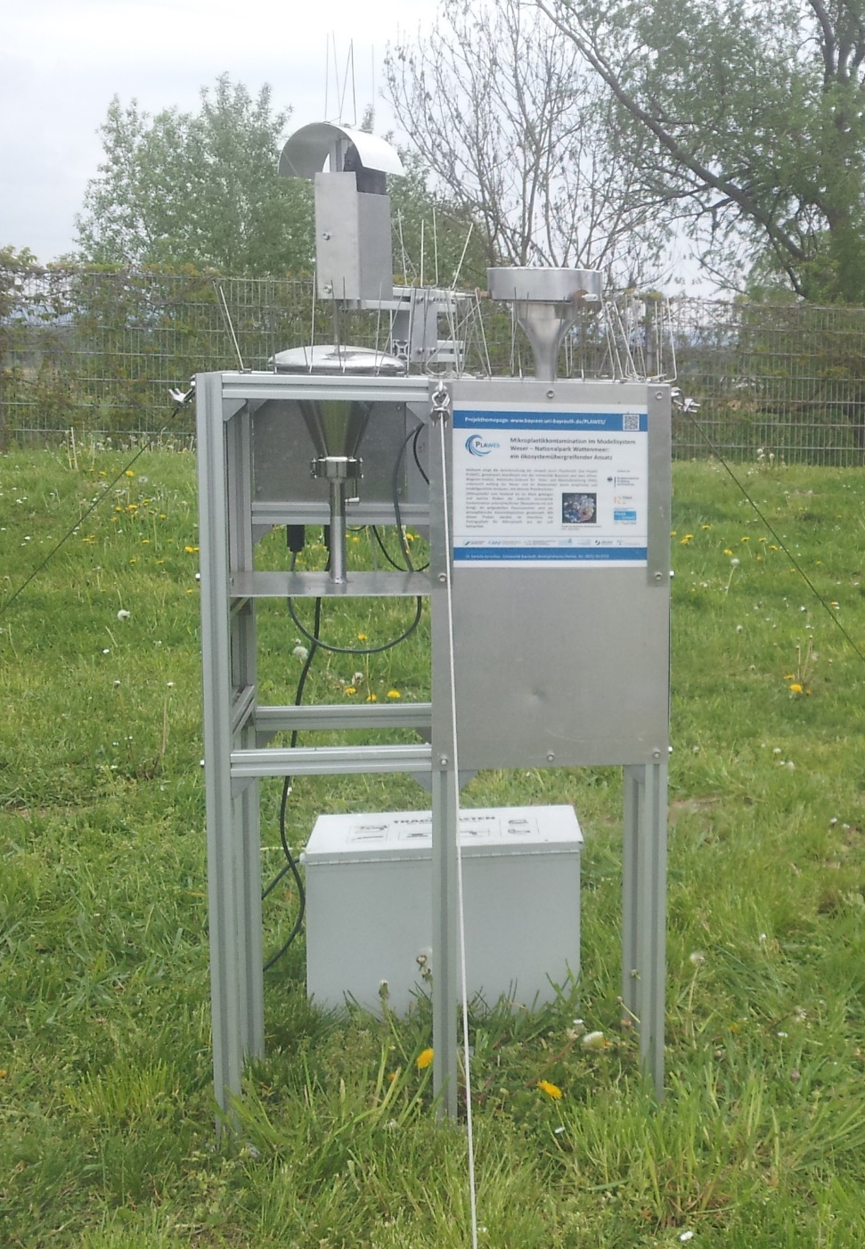

Figure S2: Wet and dry atmospheric deposition collector.

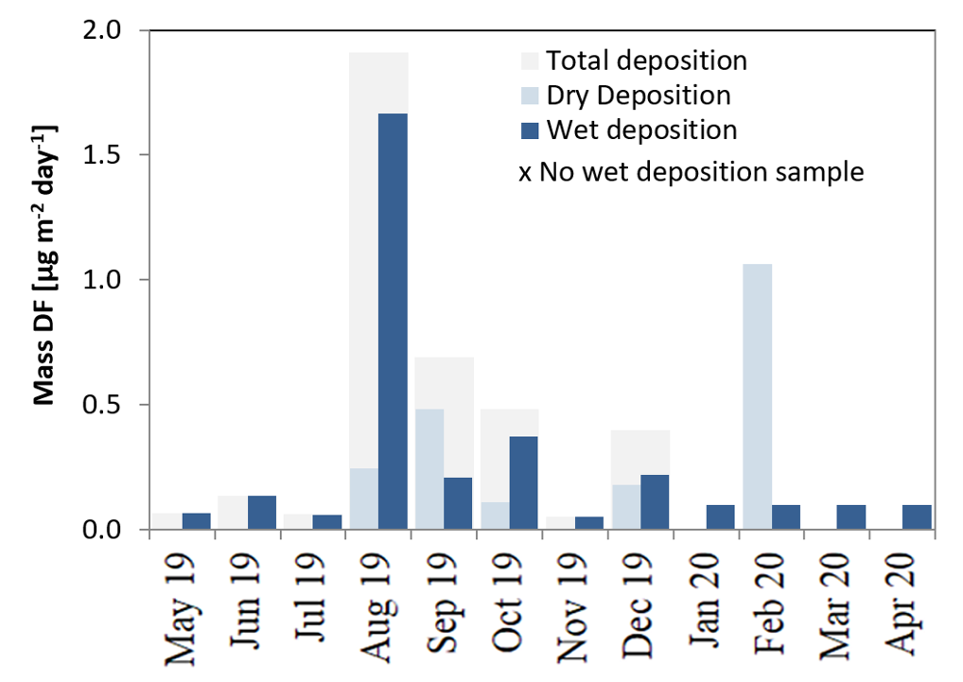
Figure S3: Wet and dry mass atmospheric deposition of MPs at the study site over the sampling period.

Figure S4a-l: Local wind field plots over the sampling period. Meteorological data were retrieved from the weather station Kassel-Mitte (HLNUG).

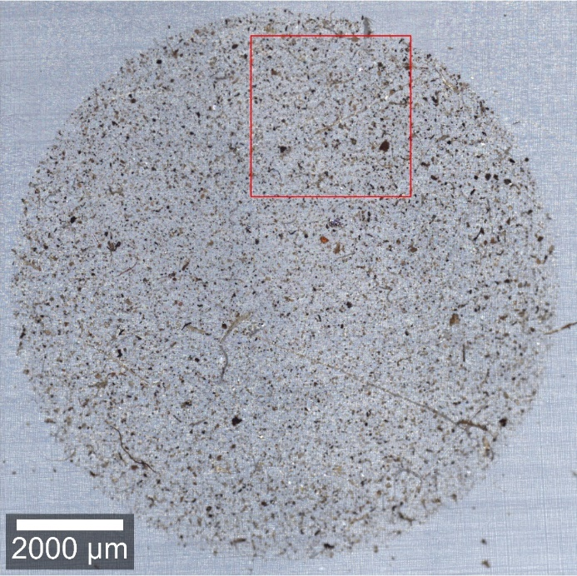
(b)
(a)

Figure S5a,b: (a) Optical stitching image of the filter and the selected area used for analysis via ParticleScout (3 × 3 mm²); (b) distribution of particles on a subsample identified by ParticleScout. In total, 1362 particles were found by the WITec ParticleScout software, 3 particles were assigned to plastics, 13 to cellulose, and 7 to bacteria (Escherichia coli and Corynebacterium glutamicum).

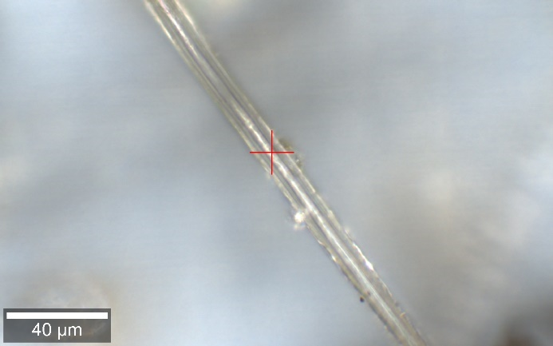  (a) | (b) Cellulose
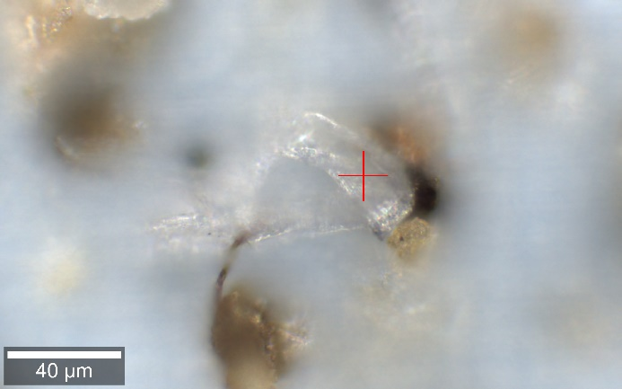  (e)  (c) | (d) Cellulose
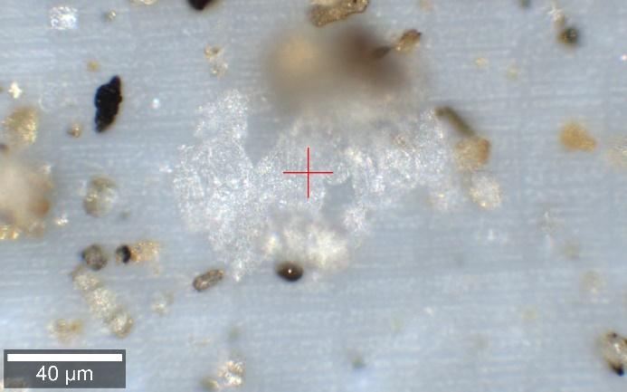 | (f) Bacteria (Escherichia coli)
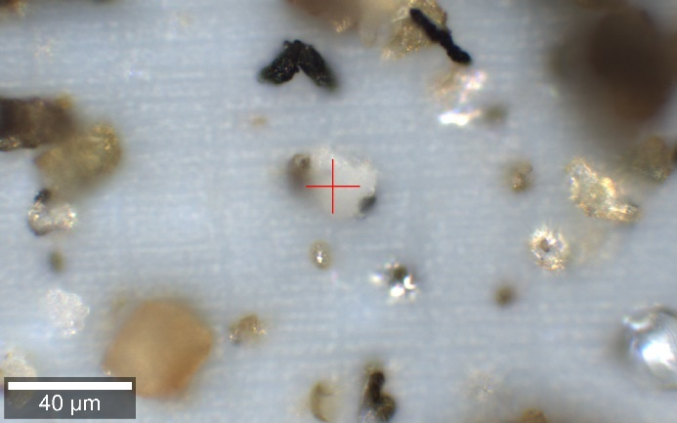  (g) | (h) Bacteria (Micrococcus luteus)
Figure S6a,h: (a,c) Optical images of cellulose particle fragments and (e,g) bacterial colonies, and (b, d, f, h) corresponding Raman spectra (black) in comparison with the reference spectra from the database (blue).
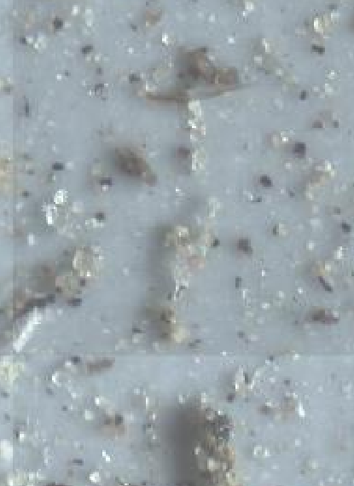
(a)
PP particle
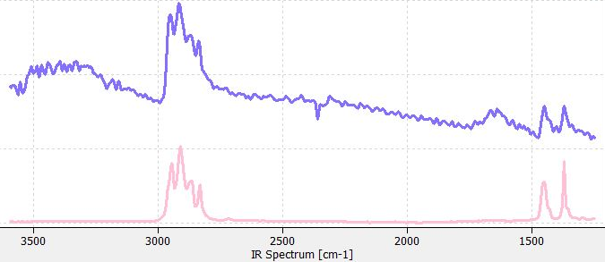
(b)

Figure S7a,b: (a) Optical image of filter fragment enclosing a polypropylene particle and (b) FTIR spectrum of the particle (purple) in comparison with the reference spectra (pink).

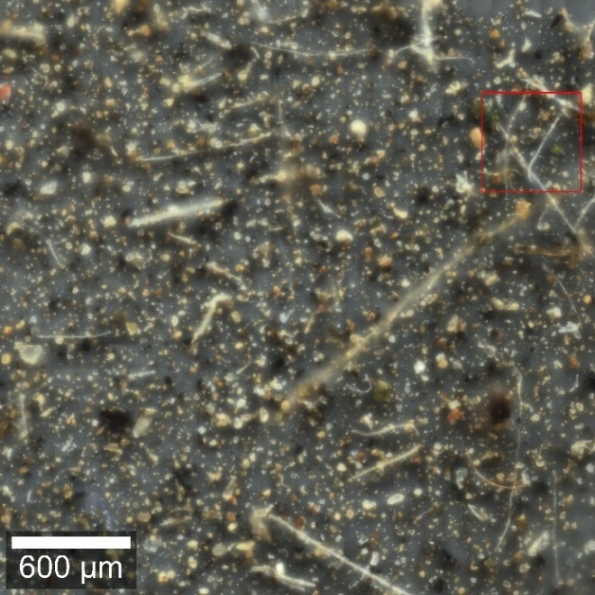  (a) | 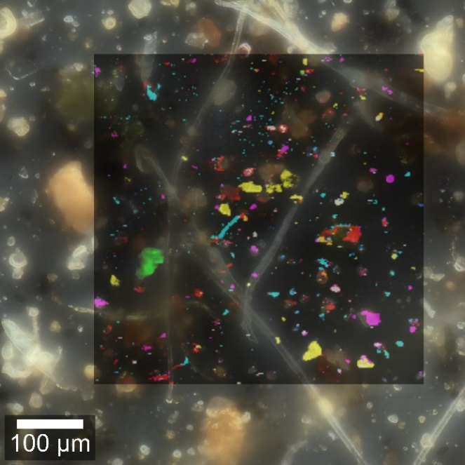  (b)

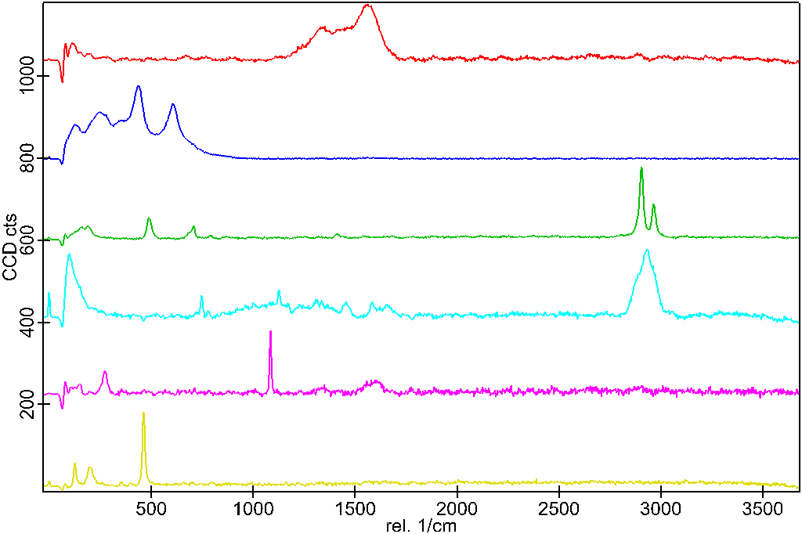
Figure S8a-c: (a) Optical stitching image of a filter fragment (corresponding to position 2 in Fig. 5a). The red square shows the position of the large area Raman scan (500 x 500 µm², step size of 2 µm pixel⁻¹), where a polydimethylsiloxane (PDMS) MP was found; (b) overlay of optical image with the component distribution obtained by True Component Analysis (Witec Project 5.3) of the large area Raman scan. Colour code corresponds to components, whose spectra are displayed in (c).
Carbon black
TiO₂
Dolomite
Quartz
PDMS
Bacteria
(c)
Raman shift, cm⁻¹
CCD counts, arb. units

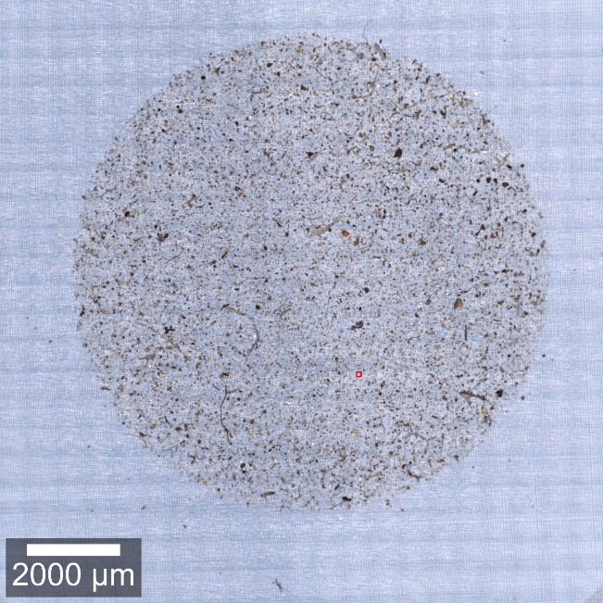  (a) |  | 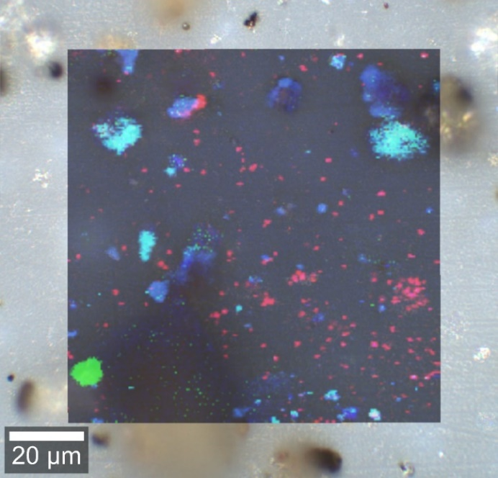  (b)
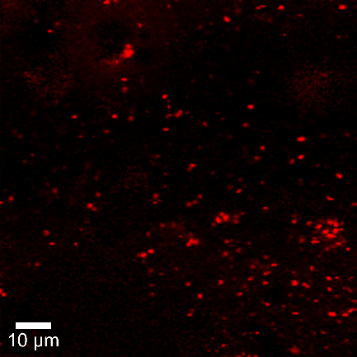  (c) | (d) Amylose
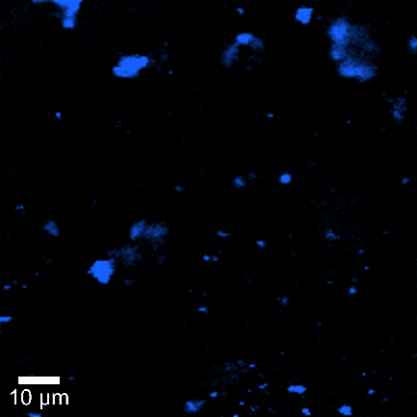  (e) | (f) Soot

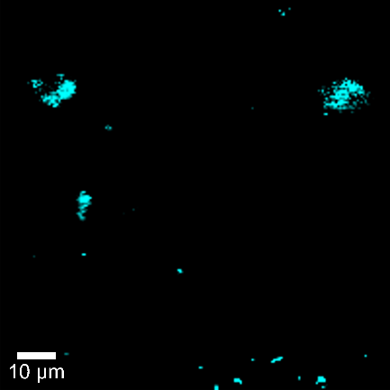  (g) | (h) Quartz
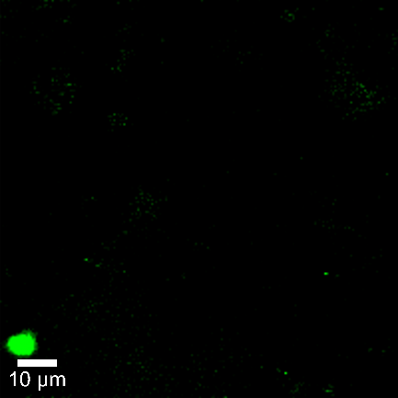  (i) | (j) Calcite
Figure S9a-j: (a) Optical stitching image of the filter indicating the position (red square) for the large area Raman scan (100 x 100 µm²) conducted with a smaller step size of 0.5 µm pixel⁻¹ (corresponding to position 3b in Fig. 5A); (b) overlay of optical image with component distribution retrieved from the large area Raman scan employing the True Component Analysis included in the Witec Project 5.3 software; spatial distributions of (c) amylose, (e) soot, (g) quartz, and (i) calcite particles and (d, f, h, j,) respective Raman spectra of the particles (black) extracted from True Component Analysis in comparison with the reference spectra from the database (blue).

References
1. Aluko O, Noll KE. Deposition and suspension of large, airborne particles. Aerosol science and technology. 2006;40:503–513.
2. Luft TA. Erste Allgemeine Verwaltungsvorschrift zum Bundes-Immissionsschutzgesetz (Technische Anleitung zur Reinhaltung der Luft–TA Luft). Vom. 2002;24:25–29.
3. Dioguardi F, Mele D, Dellino P, Dürig T. The terminal velocity of volcanic particles with shape obtained from 3D X-ray microtomography. Journal of Volcanology and Geothermal Research. 2017;329:41–53.
4. Saxby J, Beckett F, Cashman K, Rust A, Tennant E. The impact of particle shape on fall velocity: Implications for volcanic ash dispersion modelling. Journal of Volcanology and Geothermal Research. 2018;362:32–48.

