Supplementary Figures

a. b.
Fig. S1. (a) Types of repetitive elements identified in winged bean genome and (b) their distributions across the genome, by super-scaffold
a.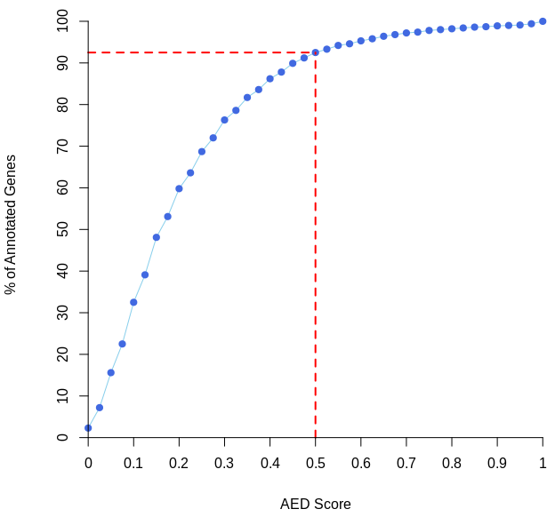 b.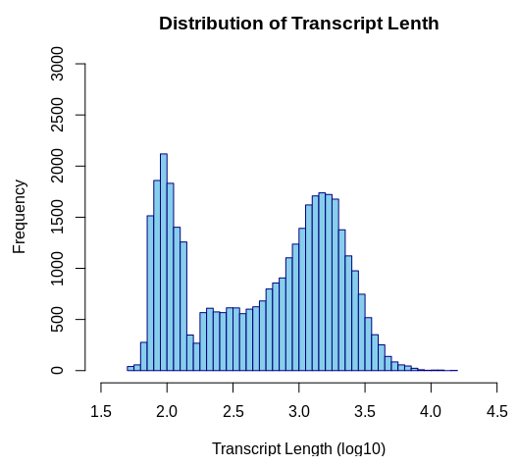
Fig. S2. (a) Annotation Edit Distance (AED) score as a measure of annotation quality in terms of specificity and sensitivity. High quality annotations are those of 0.3 and below¹⁵. (b) An overview of transcript lengths and frequencies of the annotated gene models.

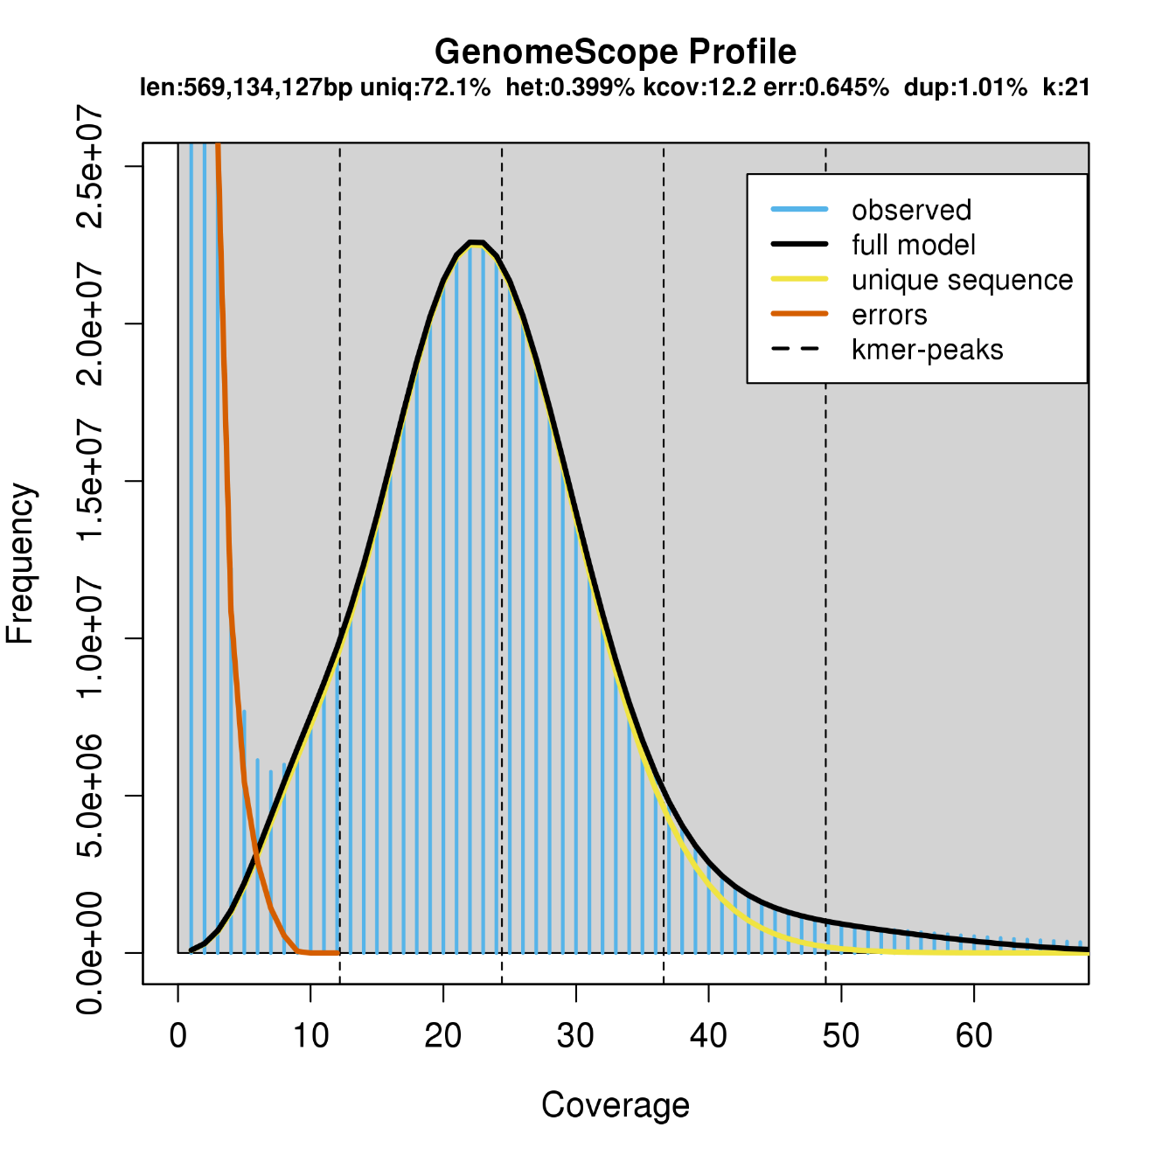
Fig. S3. K-mer analysis suggesting a genome size of 569Mbp

a.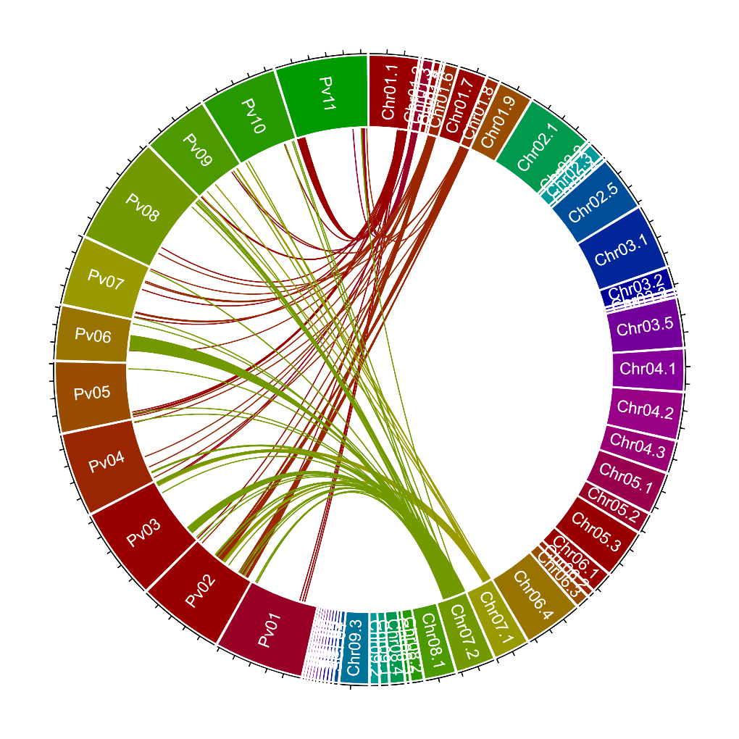b.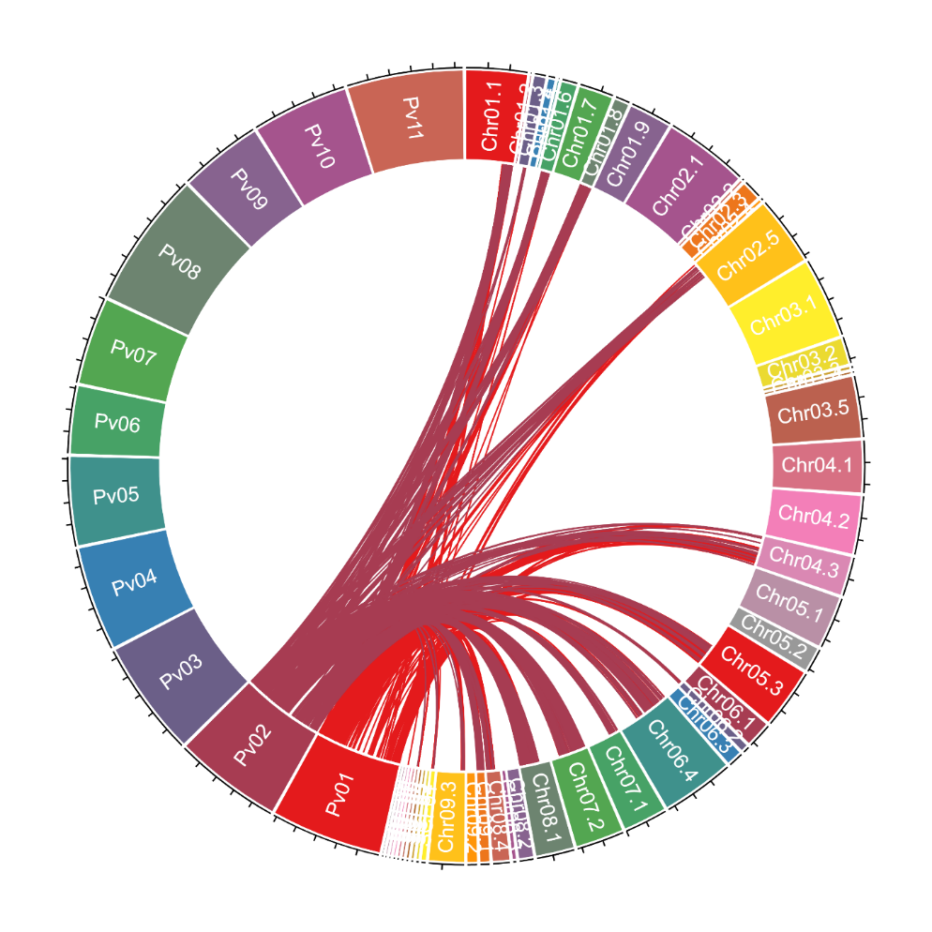
Fig. S4 (a) The syntenic relationship among the orthologues at Pt 01 (Chr01.1 to Chr01.7) and Pt07 (Chr07.1 to Chr07.2) to the corresponding chromosome positions in Phaseolous vulgaris genome. (b) The syntenic relationship among the orthologues at Pv01 and Pv02 to the corresponding chromosome location in winged bean genome.

b.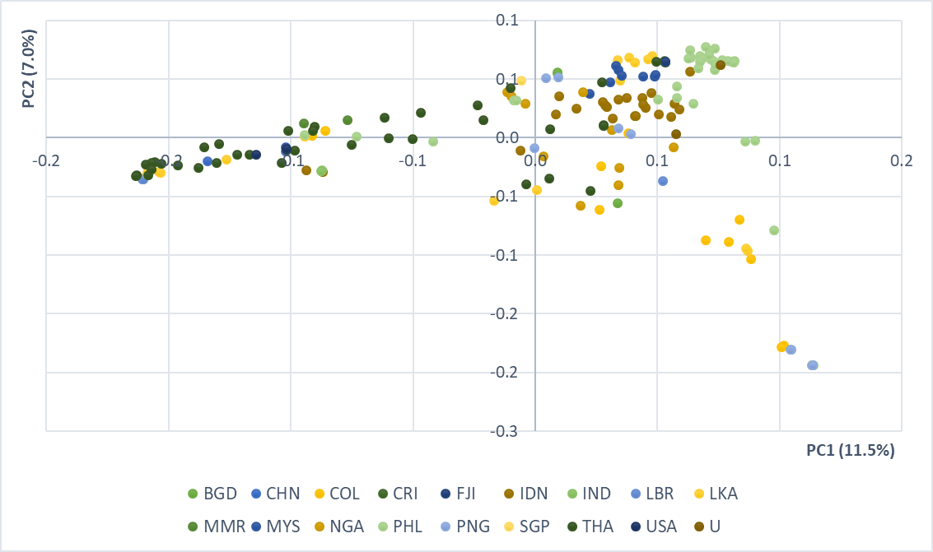
Fig. S5 (a) The marginal likelihood when K ranged from one to eight. (b) PCoA analysis of PC1 and PC2 coloured by their origin of collection demonstrates the clustering does not correspond well with country of origin.

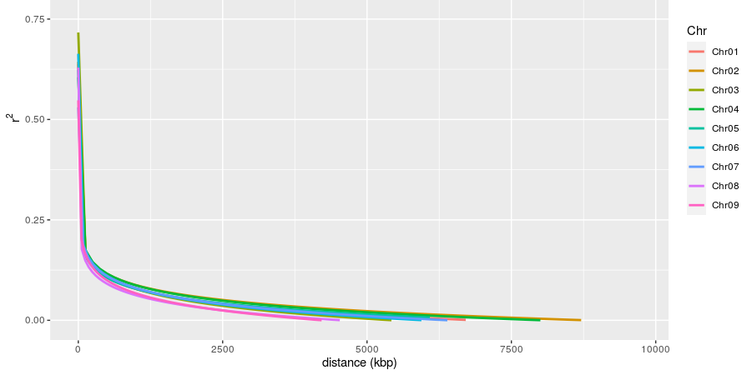
Fig. S6. LD decay plot, according to pseudochromosome.

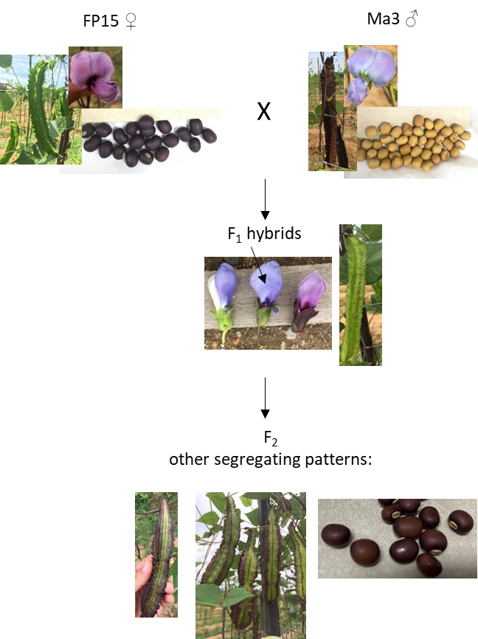

Fig. S7. Pigment inheritance observed in the XB population. While the petal colour of both genotypes is not easily distinguishable (the Ma3 genotype has light violet flowers whilst the FP15 genotype bore fuchsia-coloured flowers), their sepal colour does contrast. A green calyx was observed in the Ma3 genotype whilst dark purple was seen in FP15.

Fig S8. Seed coat colour observed in the F₂ of XB population.

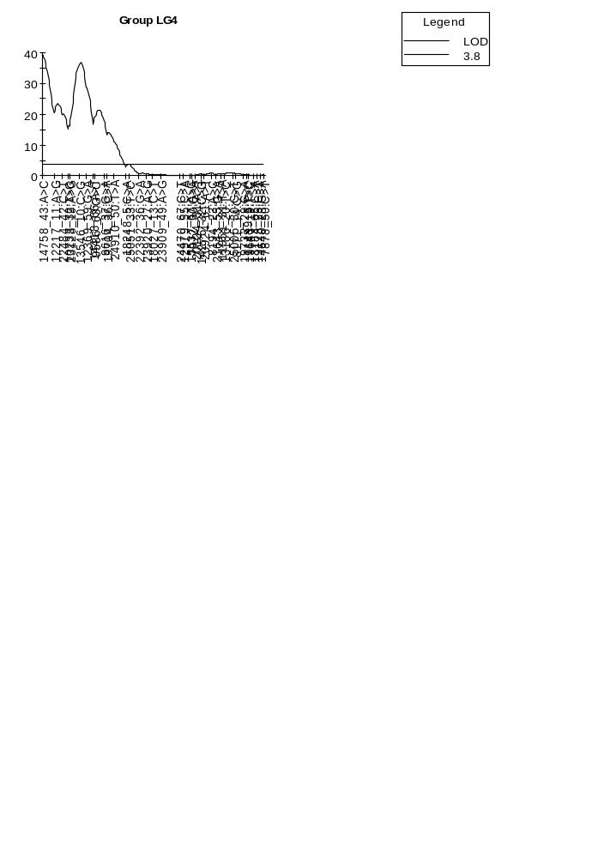
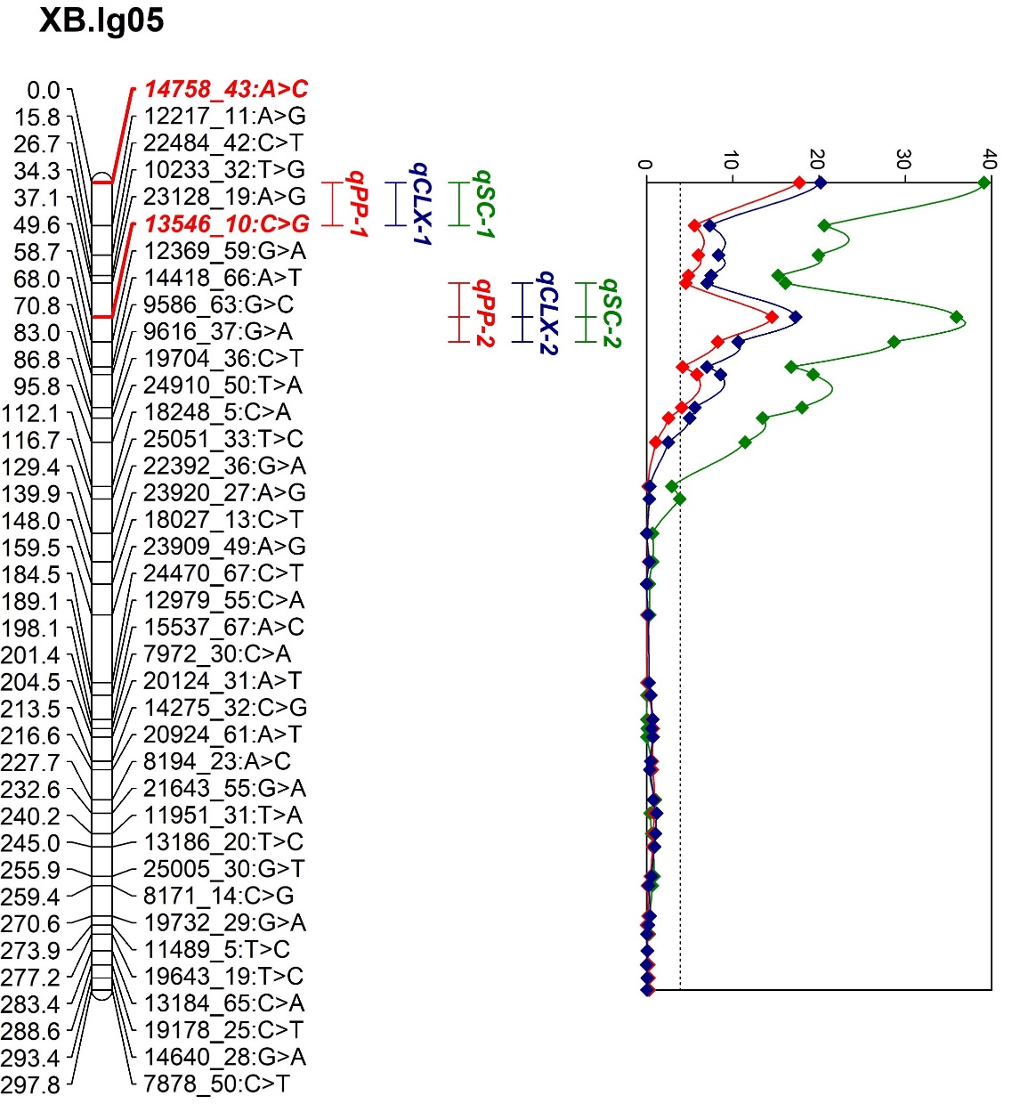
Fig S9. The LOD score of seed coat colour (qSC), pod pattern (qPP) and calyx colour (qCLX) on Pt05/XB.lg05. The major peaks were designated as P1 and P2 alleles.

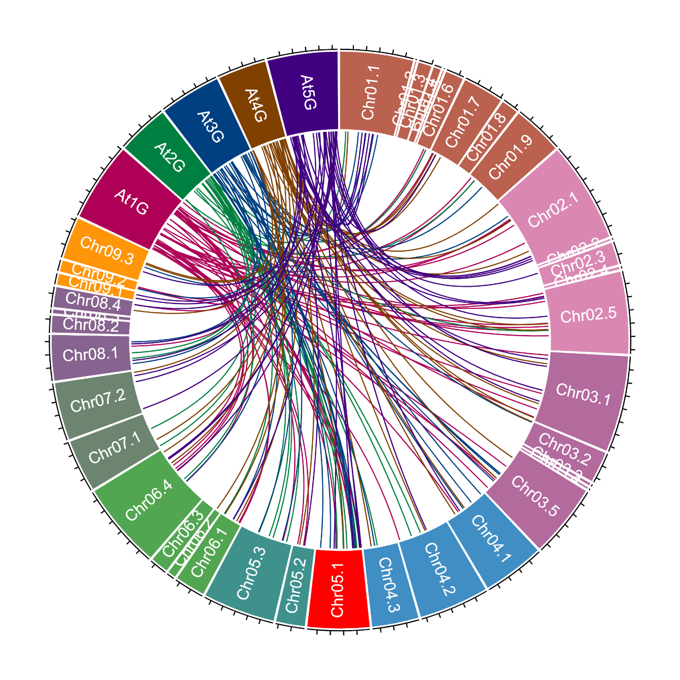Fig S10. Distribution of the identified anthocyanin biosynthetic genes in Arabidopsis and their orthologues in winged bean.

