

Rohit Bathla received M.Tech degree in Computer Science and Engineering from D.C.S.A kurukshetra university having more than 10 year of teaching Experience .Currently he is Ph. D Research scholor in NIT kurukshetra in Computer science
Engineering Department NIT Kurukshetra Haryana, India. His area of interest areKey management, Wireless Sensor Networks Security.

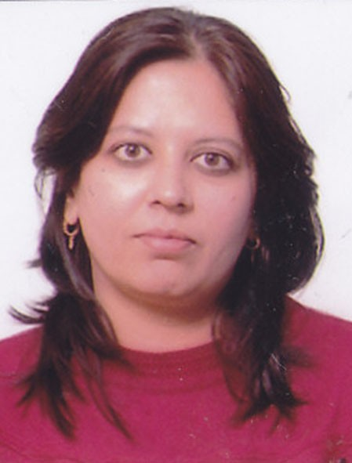
Priyanka Ahlawat received B.Tech, M.Tech in Computer Science and Engineering from M.D.U, Rohtak and Guru Jambheshwar University of Science and Technology, Hisar. Currently, she is Assistant Professor in Computer Engineering Department NIT Kurukshetra Haryana, India. She is working towards her Ph.D. in Wireless Sensor Network Security from the Department of Computer Engineering, National Institute of Technology Kurukshetra, India. Her interest areas are Key management, Wireless Sensor Networks Security.

