Supplemental Figure 1. Geographic distribution of the index of SED quintiles and the means of its components for 2010–2014 in 66 sub-regions of Poland.
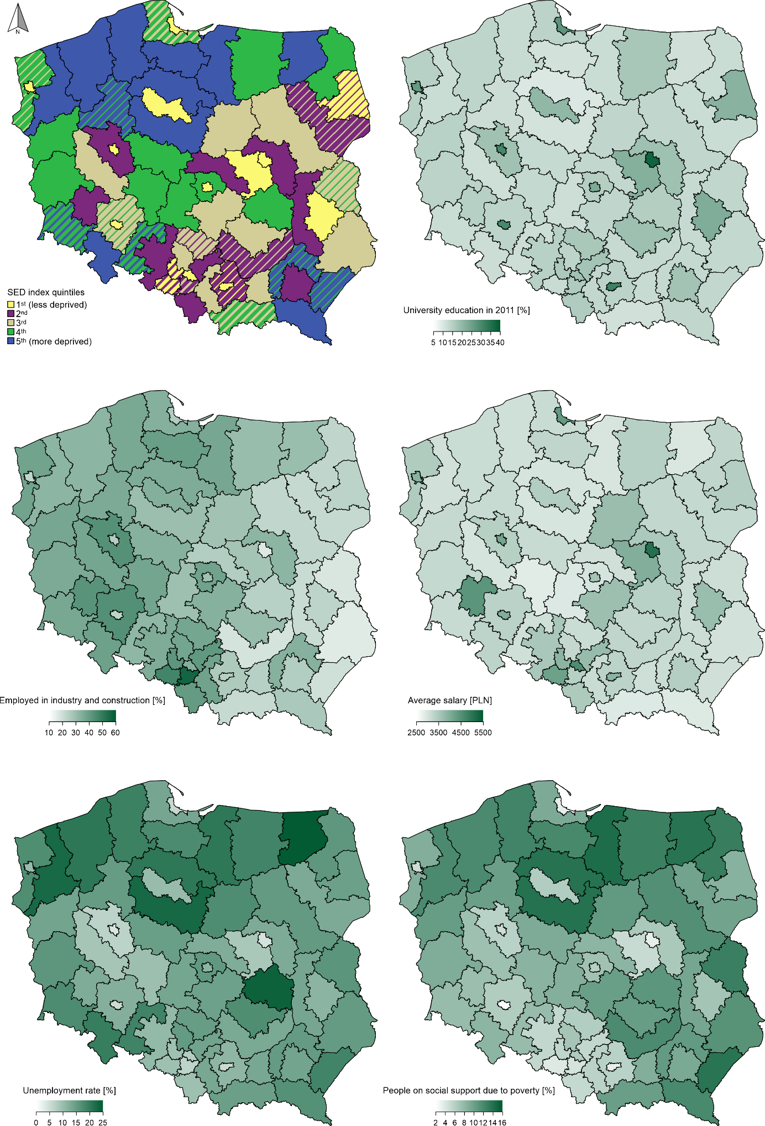

Striped areas on SED quintile subplot indicate regions where quintile group membership was not constant over time. Stripe width corresponds to the number of years in 5-year 2010 to 2014 period.

Map created using IBM SPSS Statistics for Windows ver. 20.0 - https://www.ibm.com/products/spss-statistics
Supplemental Table 1 Age-standardized mortality rates from CSD and proportion of DPP in men in 2010 and 2014 by the index of SED quintile groups.
Index of SED | 1st quintile (less deprived) |  | 2nd quintile |  | 3rd quintile |  | 4th quintile |  | 5th quintile (more deprived)
Calendar year | 2010 | 2014 | 2010 | 2014 | 2010 | 2014 | 2010 | 2014 | 2010 | 2014
Population number | 3,835,997 | 3,809,149 | 3,456,664 | 3,472,483 | 2,700,460 | 2,702,729 | 2,499,530 | 2,521,183 | 3,157,161 | 3,155,967
Circulatory system diseases
SMR (95% CI) | 823  (811-835) | 732  (721-742) | 1,004  (988-1,019) | 869  (855-882) | 985  (968-1,002) | 866  (851-881) | 974  (956-993) | 843  (827-859) | 1,010  (993-1,027) | 859  (844-873)
Observed number of deaths | 19,949 | 19,663 | 18,642 | 18,045 | 14,504 | 13,903 | 12,307 | 11,843 | 16,045 | 15,349
Expected number of deaths* |  | 22,175 |  | 20,871 |  | 15,966 |  | 13,685 |  | 17,903
Number (percentage) of DPP** |  | 2,  512  (11.3%) |  | 2,  826  (13.5%) |  | 2,  063  (12.9%) |  | 1,842  (13.5%) |  | 2,  554  (14.3%)
Linear trend for DPP | p<0.001
Ischemic heart disease
SMR (95% CI) | 250  (244-257) | 228  (222-234) | 296  (287-304) | 196  (190-203) | 313  (303-323) | 214  (207-221) | 269  (260-279) | 191  (184-199) | 240  (232-248) | 188  (181-194)
Observed number of deaths | 6,290 | 6,223 | 5,921 | 4,457 | 4,809 | 3,768 | 3,625 | 2,942 | 4,228 | 3,653
Expected number of deaths* |  | 6,927 |  | 6,552 |  | 5,268 |  | 4,034 |  | 4,675
Number (percentage) of DPP** |  | 704  (10.2%) |  | 2,095  (32.0%) |  | 1,  500  (28.5%) |  | 1,  092  (27.1%) |  | 1,  022  (21.9%)
Linear trend for DPP | p<0.001
Cerebrovascular diseases
SMR (95% CI) | 144  (139-149) | 119  (115-123) | 197  (190-204) | 146  (140-151) | 196  (188-204) | 154  (147-160) | 191  (183-199) | 146  (139-153) | 163  (156-170) | 133  (128-139)
Observed number of deaths | 3,538 | 3,236 | 3,749 | 3,153 | 2,932 | 2,507 | 2,421 | 2,060 | 2,688 | 2,404
Expected number of deaths* |  | 3,915 |  | 4,180 |  | 3,219 |  | 2,672 |  | 2,995
Number (percentage) of DPP** |  | 679  (17.3%) |  | 1,027  (24.6%) |  | 712  (22.1%) |  | 612  (22.9%) |  | 591  (19.7%)
Linear trend for DPP | p=0.103
Abbreviations: CSD—circulatory system diseases; DPP—deaths prevented or postponed; SED—socioeconomic deprivation; SMR—standardized mortality rate per 100,000 population; CI—confidence interval;
*Assuming that death rates by age groups from 2010 persist in 2014
** relative to expected deaths

Supplemental Table 2 Age-standardized mortality rates from CSD and proportion of DPP in women in 2010 and 2014 by the index of SED quintile groups.
Index of SED | 1st quintile (less deprived) |  | 2nd quintile |  | 3rd quintile |  | 4th quintile |  | 5th quintile (more deprived)
Calendar year | 2010 | 2014 | 2010 | 2014 | 2010 | 2014 | 2010 | 2014 | 2010 | 2014
Population number | 4,431,931 | 4,414,662 | 3,714,608 | 3,734,434 | 2,864,117 | 2,868,189 | 3,140,666 | 3,157,168 | 3,948,212 | 3,913,106
Circulatory system diseases
SMR (95% CI) | 553  (546-560) | 497  (491-503) | 673  (665-682) | 596  (588-604) | 660  (651-670) | 581  (572-589) | 541  (532-550) | 456  (448-463) | 556  (548-564  ) | 466  (459-473)
Observed number of deaths | 22,866 | 23,343 | 21,222 | 21,026 | 16,524 | 16,315 | 13,822 | 13,126 | 18,061 | 17,099
Expected number of deaths* |  | 25,984 |  | 23,802 |  | 18,527 |  | 15,575 |  | 20,385
Number (percentage) of DPP** |  | 2,  641  (10.2%) |  | 2,  776  (11.7%) |  | 2,  212  (11.9%) |  | 2,449  (15.7%) |  | 3,286  (16.1%)
Linear trend for DPP | p<0.001
Ischemic heart disease
SMR (95% CI) | 135  (131-138) | 123  (120-126) | 155  (151-159) | 99  (96-103) | 166  (161-171) | 108  (104-112) | 142  (137-147) | 95  (91-99) | 120  (116-124) | 93  (90-97)
Observed number of deaths | 5,557 | 5,780 | 4,919 | 3,509 | 4,153 | 3,019 | 3,048 | 2,305 | 3,282 | 2,881
Expected number of deaths* |  | 6,287 |  | 5,471 |  | 4,651 |  | 3,426 |  | 3,674
Number (percentage) of DPP ** |  | 507  (8.1%) |  | 1,  962  (35.9%) |  | 1,  632  (35.1%) |  | 1,  121  (32.7%) |  | 793  (21.6%)
Linear trend for DPP | p<0.001
Cerebrovascular diseases
SMR (95% CI) | 120  (116-123) | 96  (94-99) | 150  (146-155) | 112  (108-115) | 155  (150-160) | 123  (119-127) | 142  (137-148) | 110  (106-114) | 124  (120-128) | 101  (97-104)
Observed number of deaths | 4,985 | 4,505 | 4,790 | 3,934 | 3,910 | 3,446 | 3,102 | 2,656 | 3,444 | 3,102
Expected number of deaths* |  | 5,584 |  | 5,309 |  | 4,321 |  | 3,446 |  | 3,827
Number (percentage) of DPP** |  | 1,  079  (19.3%) |  | 1,  375  (25.9%) |  | 875  (20.2%) |  | 790  (22.9%) |  | 725  (18.9%)
Linear trend for DPP | p=0.122
Abbreviations: CSD—circulatory system diseases; DPP—deaths prevented or postponed; SED—socioeconomic deprivation; SMR—standardized mortality rate per 100,000 population; CI—confidence interval;
*Assuming that death rates by age groups from 2010 persist in 2014
** relative to expected deaths

