Supplementary figure 1 Efficacy of UST on both CD and perianal fistula and the underlying relationship between clinical remission and fistula healing. (Panel A: Clinical remission and response rate based on CDAI; Panel B: Clinical fistula remission and response rates; Panel C: Percentages of clinical fistula remission/response on patients with or without clinical remission.)
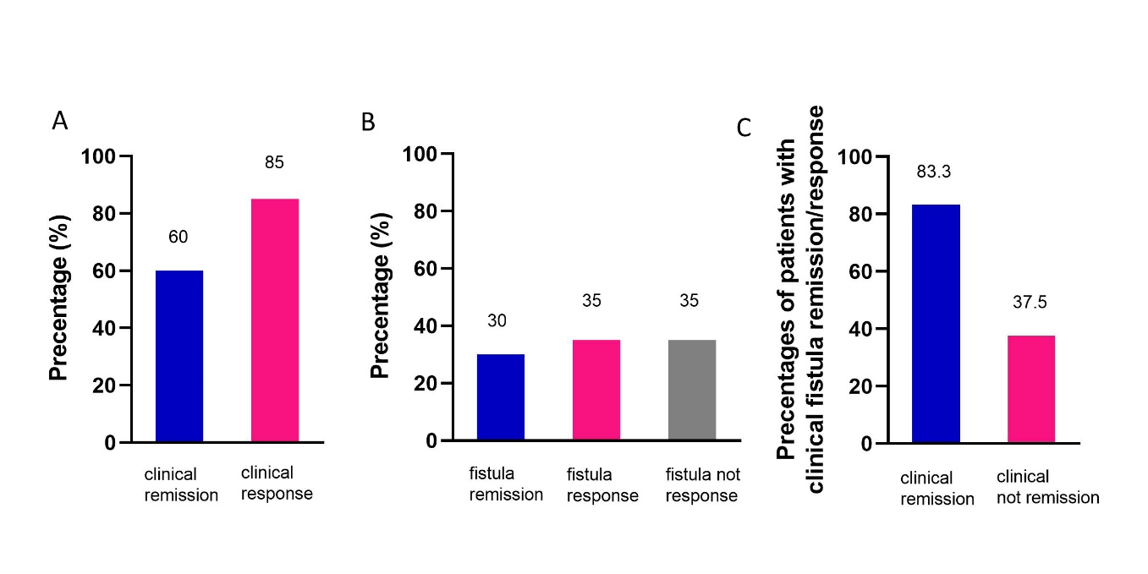

Supplementary figure 2 A case showing radiological fistula remission. (Panel A: Arrows show supra-musculi levator ani fistulas closure with scarring. Panel B: Arrows show sub-musculi levator ani fistulas closure with scarring. Panel C: Arrows showed vanishment of lesions in the superior space of levator ani muscle, and triangle shows improvement of proctitis.)
