The impact of COVID-19 pandemic on HIV care continuum in Jiangsu, China
Lingen Shi, Weiming Tang, Haiyang Hu, Tao Qiu, Gifty Marley, Xiaoyan Liu, Yuheng Chen, Yunting Chen, Gengfeng Fu

Supplement fig1 HIV/COVID-19 daily report in Jiangsu from January to March in 2020

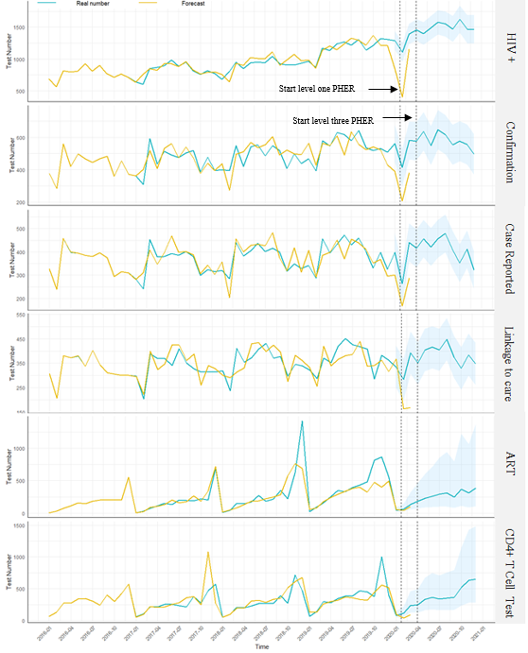

Supplement fig 2. The estimation curve of HIV/AIDS from screen positive to ART during 2019 to 2020

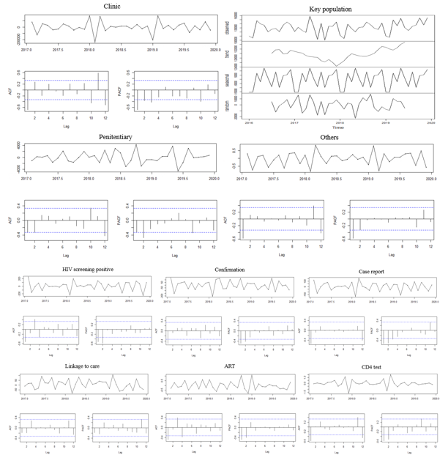

Supplement fig 3. Seasonal variation, autocorrelation function and partial autocorrelation function for the forecasting data

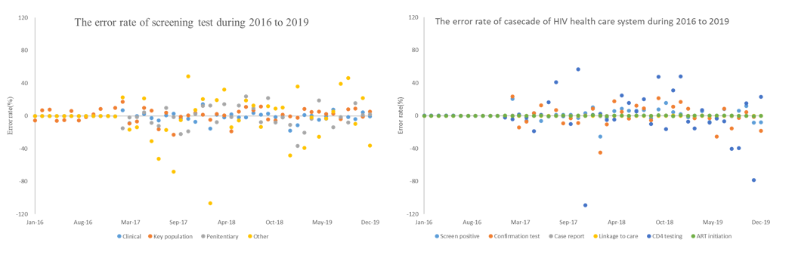
Supplement fig 4. The error rate in the casecade flow in HIV health care system during 2019 to 2020

Supplement table 1 Models parameters of the forecasting
Variables | Parameters | ME | RMSE | MAE | MPE | MAPE | MASE | ACF1 | AIC | Ljung-Box
 |  |  |  |  |  |  |  |  |  | Chi-square | P value
Clinic | ARIMA(0,1,1)(1,1,0)[12] | -5160.98 | 35082.33 | 21666.02 | -0.92 | 3.14 | 0.43 | -0.20 | 858.27 | 2.09 | 0.15
Penitentiary | ARIMA(0,1,1) (1,1,0)[12] | 14.75 | 1025.12 | 699.72 | -0.92 | 7.67 | 0.22 | 0.15 | 611.41 | 1.14 | 0.29
Others | ARIMA(0,1,1) (1,1,0)[12] | -514.12 | 11740.49 | 7886.26 | -2.69 | 17.37 | 0.52 | -0.09 | 774.30 | 0.45 | 0.50
Screen positive | ARIMA(0,1,2) (0,1,0)[12] | 13.47 | 64.82 | 43.40 | 1.17 | 4.43 | 0.49 | 0.04 | 409.82 | 0.07 | 0.79
Confirmation | ARIMA(0,1,1) (1,1,0)[12] | 2.37 | 50.45 | 34.37 | -0.13 | 7.25 | 0.46 | -0.07 | 394.19 | 0.25 | 0.61
Case report | ARIMA(0,1,1) (1,1,0)[12] | 3.14 | 34.87 | 22.62 | 0.18 | 6.23 | 0.38 | -0.20 | 373.07 | 2.05 | 0.15
Linkage to care | ARIMA(0,1,1) (1,1,0)[12] | -0.28 | 36.96 | 27.16 | -0.62 | 7.78 | 0.53 | -0.17 | 375.08 | 1.46 | 0.23
Art | ARIMA(1,0,0) (0,1,0)[12] | 12.20 | 98.44 | 56.79 | -2.59 | 28.50 | 0.54 | 0.07 | 447.34 | 0.28 | 0.60
CD4 | ARIMA(0,1,1) (1,1,0)[12] | 12.25 | 114.62 | 57.68 | -0.02 | 15.06 | 0.49 | -0.31 | 458.60 | 4.86 | 0.03
 |  | Alpha | Beta | Gamma | - | - | - | - | AIC | - | -
Key-population | Holt-winter exponential smoothing | 0.01 | 0.01 | 0.0001 | - | - | - | - | 1104.08 | - | -
-: Not available or necessary in this model.

