Supplementary Material

Repurposing Peptidomimetic as Potential Inhibitors of Novel SARS-CoV-2 Main Protease Using Network Theory: A Protein-Ligand Binding Site Similarity Approach
Sagar Bhayye and N. Sukumar*
Center for Informatics, Shiv Nadar University, Dadri, Uttar Pradesh, India
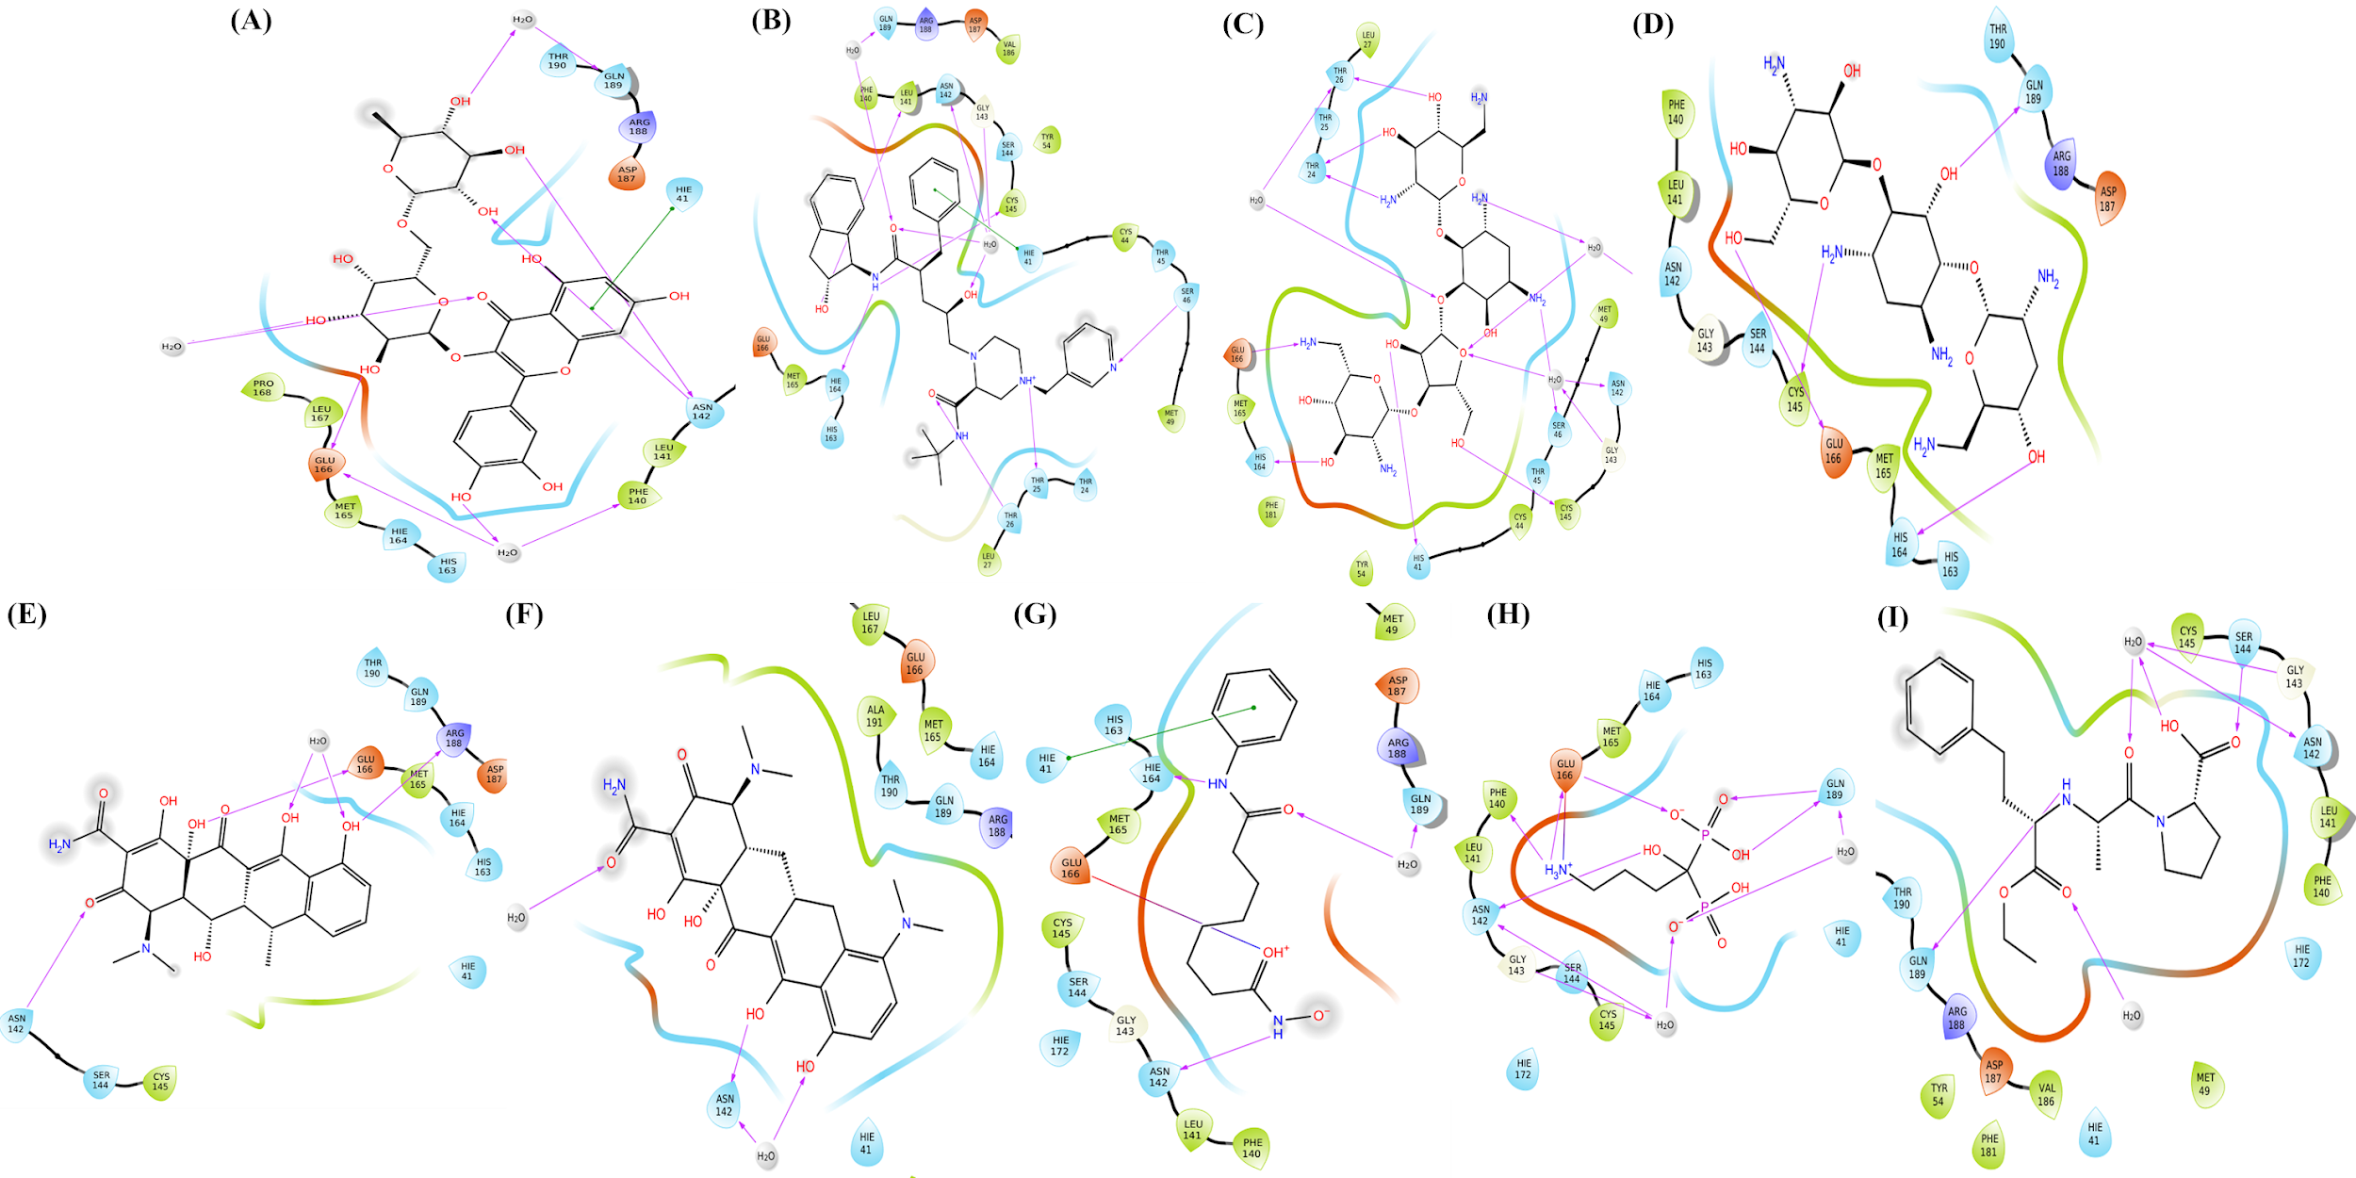
Figure S1. Molecules which are in clinical use, showing good affinity and interaction with SARS COV-2 main protease. (A) Rutin (B) Indinavir (C) Neomycin (D) Tobramycin (E) Doxycycline (F) Minocycline (G) Vorinostat (H) Alendronate and (I) Enalapril.
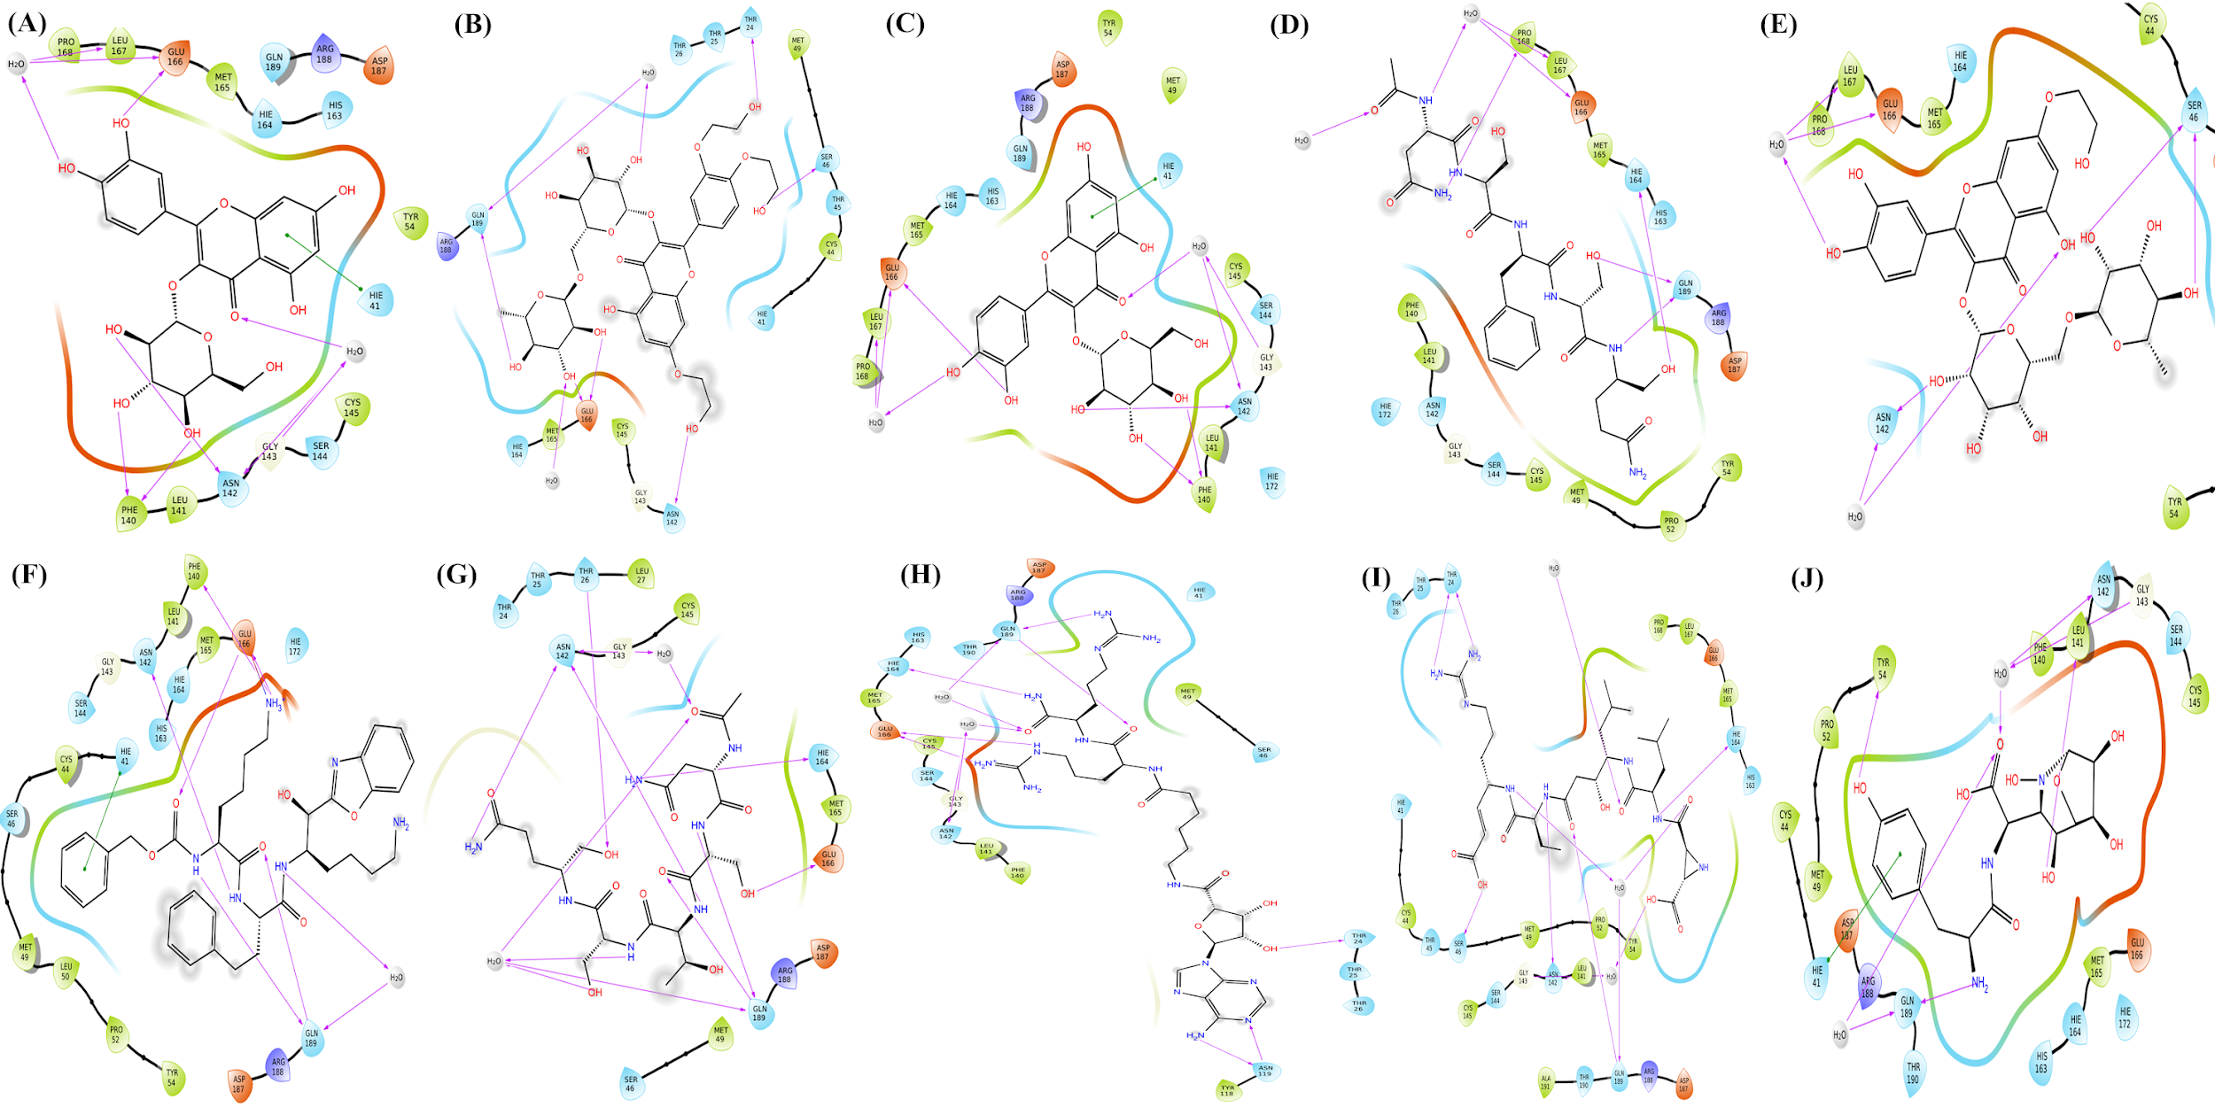Figure S2. Molecules which are in investigational and experimental phase, showing good affinity and interaction with SARS COV-2 main protease. (A) Isoquercitrin (B) Hyperoside (C) PRD_000772 (D) Troxerutin (E) Monoxerutin (F) Q27458218 (G) PRD_000771 (H) ARC-1034 (I) Miraziridine A and (J) SB-219383.
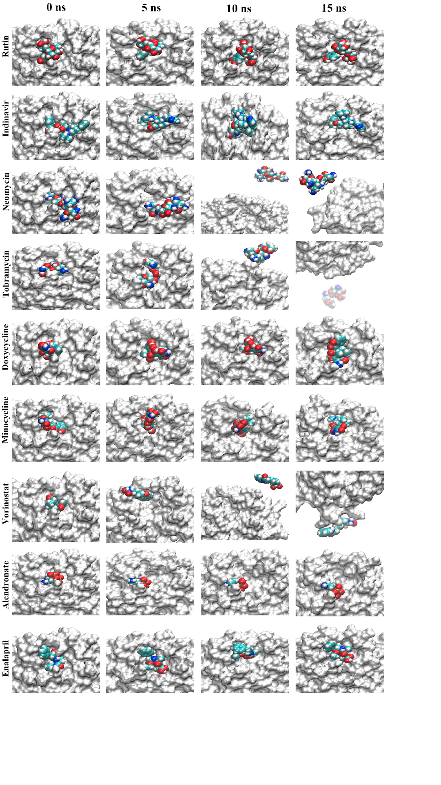
Figure S3. Movement of drugs in clinical use in binding site of SARS COV-2 main protease during 15 ns of MD simulation. Different atoms such as carbon (Cyan), Nitrogen (blue) oxygen (red) and Hydrogen (white) in ligand shown as vdW sphere.
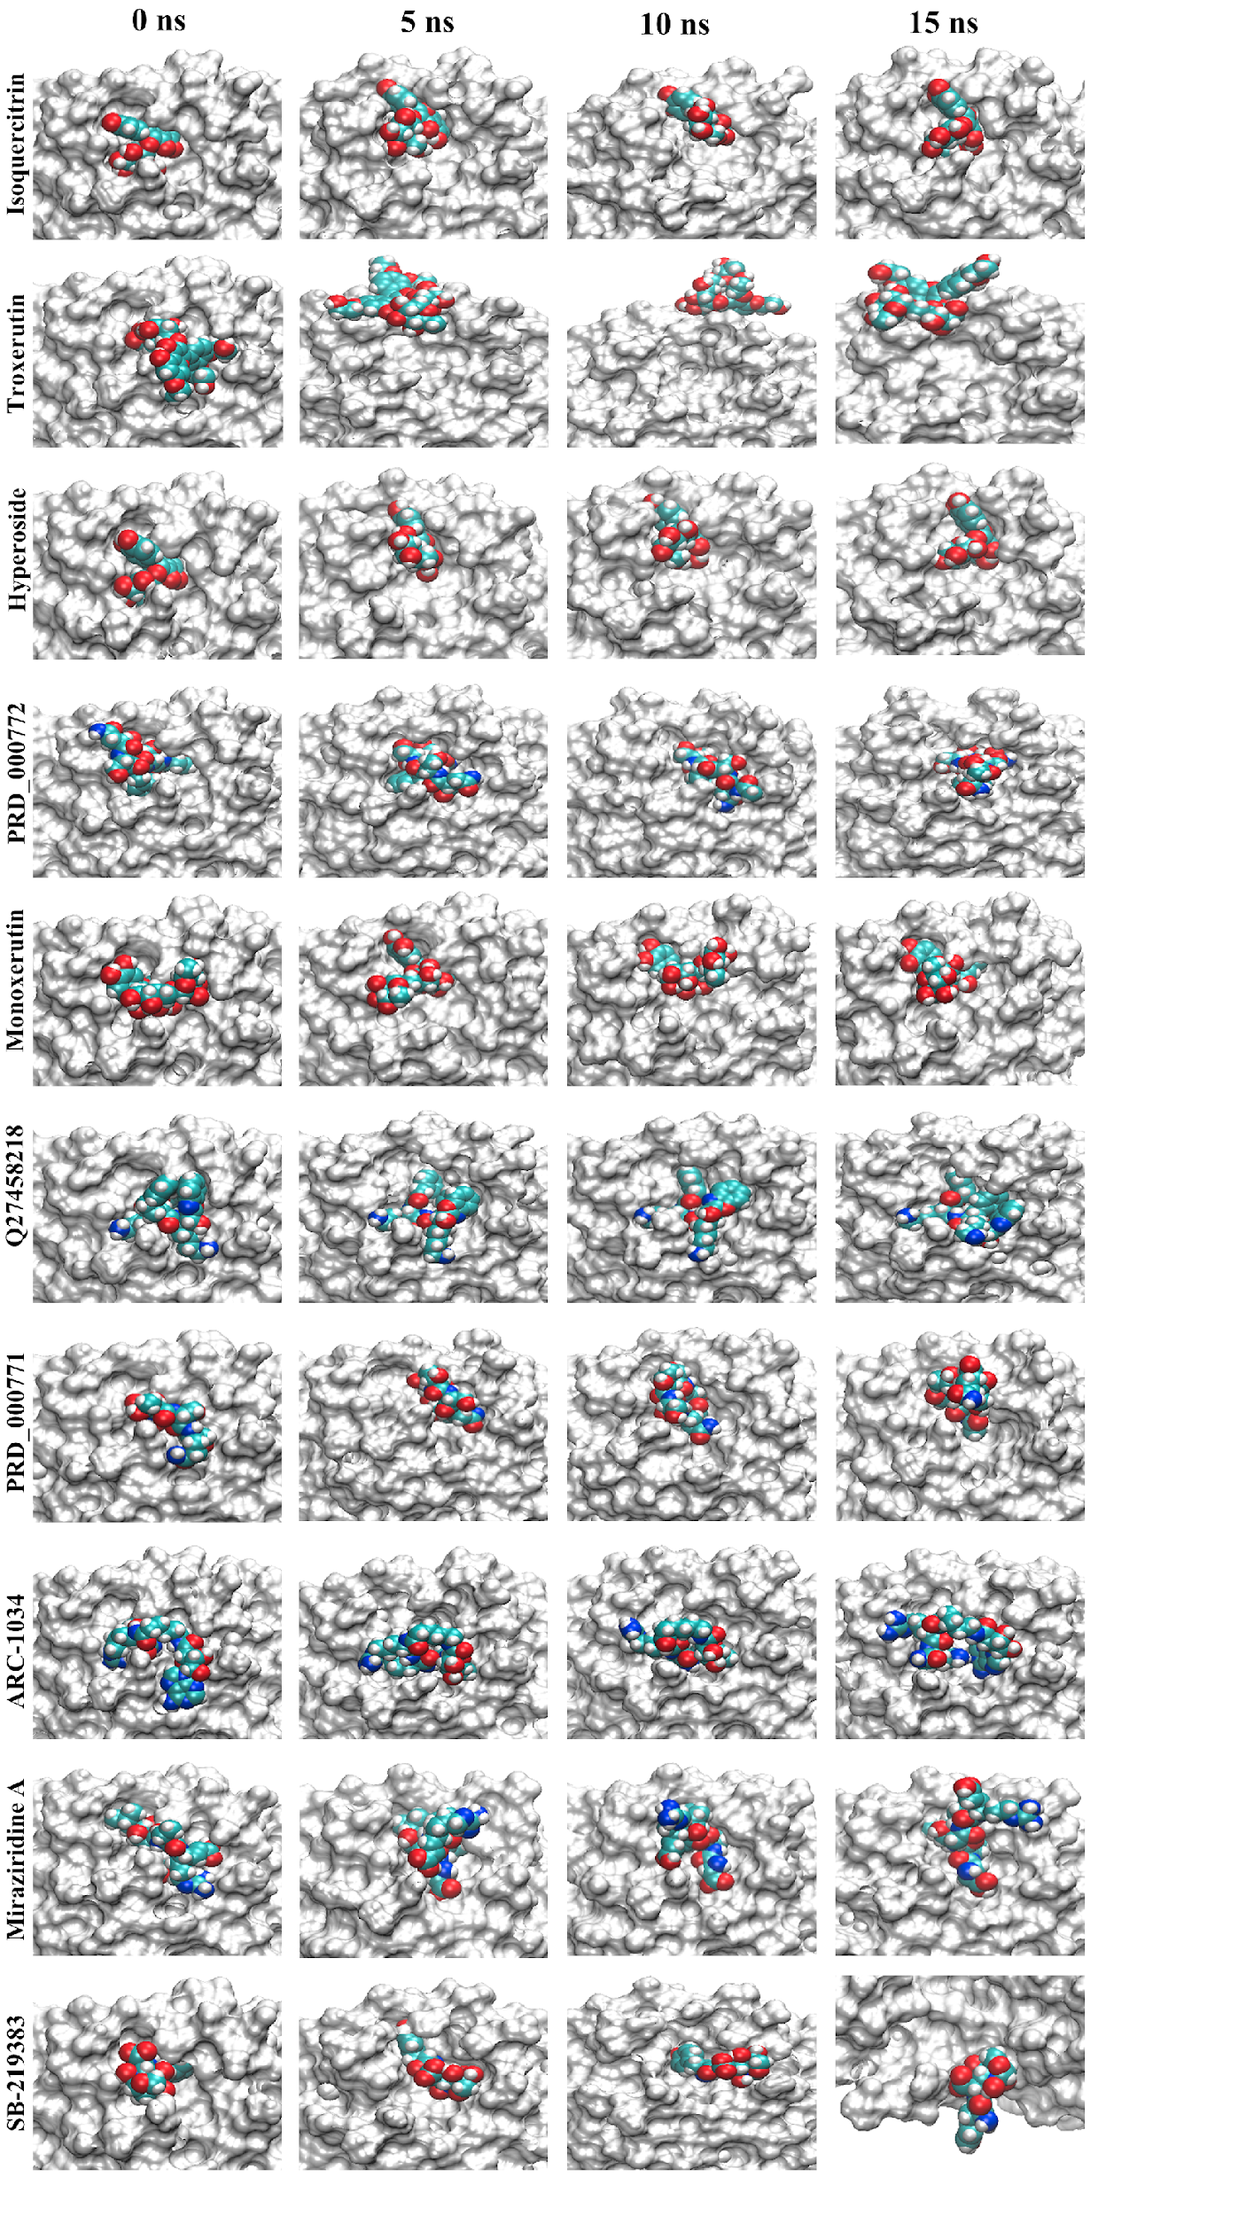
Figure S4. Movement of compounds which are in experimental/ investigational in binding site of SARS COV-2 main protease during 15 ns of MD simulation. Different atoms such as carbon (Cyan), Nitrogen (blue) oxygen (red) and Hydrogen (white) in ligand shown as vdW sphere.

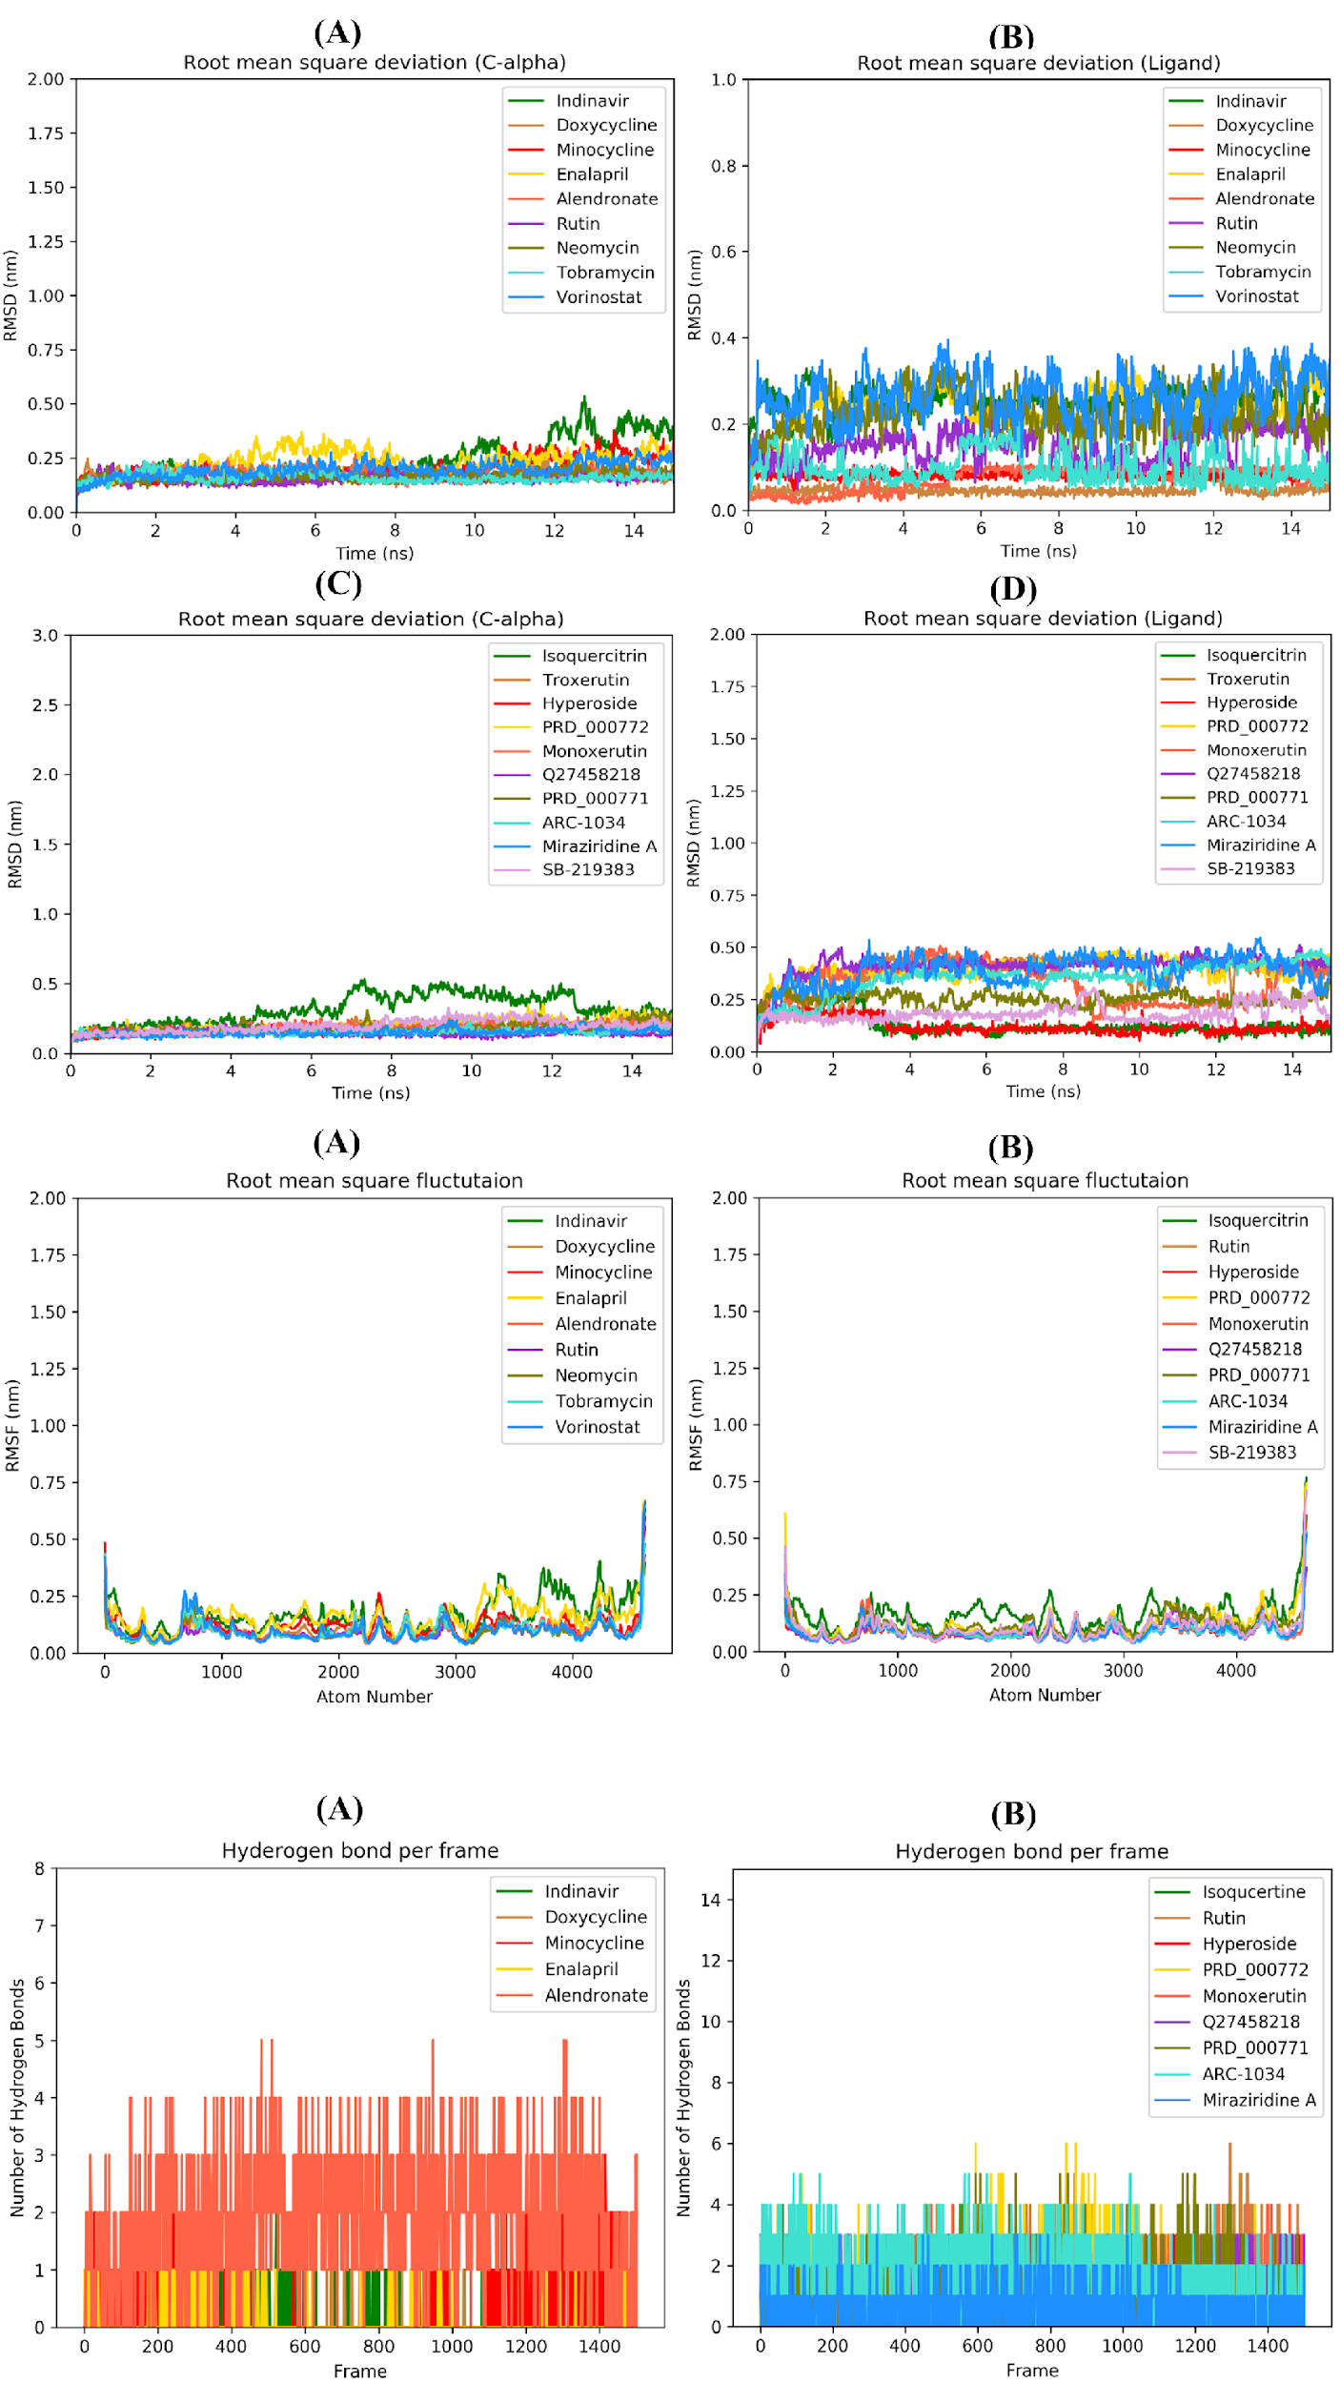
Figure S5. Root mean square deviation of Protein C-alpha atoms (A and C) and Ligands (B and D) during 15 ns MD simulation for drugs in clinical use and compounds in experimental/ investigational phase.
Figure S6. Root mean square fluctuation of protein backbone atoms during 15 ns MD simulation (A) with drugs in clinical use and (B) with compounds in experimental and investigational phase.

Figure S7. Number of hydrogen bonds formed by ligand with protein during MD simulation. (A) For drugs in clinical use. (B) Compounds under investigational and experimental phase.
Table S1 Percentage hydrogen bond interaction shown by ligand during 15 ns MD simulation with amino acid residues.
Compound | Percentage H-bond Occupancy
Compound | THR  24 | THR  25 | THR  26 | HIS  41 | SER  46 | MET 49 | TYR  54 | ASN 119 | PHE 140 | ASN 142 | GLY  143 | SER 144 | CYS  145 | HIS  163 | HIS  164 | GLU 166 | LEU  167 | HIS  172 | ASP  187 | ARG 188 | GLN 189 | THR  190 | GLN  192
Isoqucertin | - | - | - | 1.20 | 2.13 | - | - | - | - | 0.37 | - | 0.20 | - | - | - | 33.96 | 0.80 | - | 38.02 | 0.67 | 5.19 | 16.71 | 2.13`
Rutin | 6.49 | 8.59 | - | 0.20 | 4.20 | - | - | - | - | 29.03 | 1.53 | 2.27 | - | 0.47 | - | 19.57 | 0.07 | - | 51.40 | - | 6.06 | - | 0.27
Hyperoside | - | - | - | - | 0.67 | - | - | - | - | 0.80 | - | 0.13 | - | 0.07 | 2.66 | 32.89 | - | - | 39.35 | - | 2.60 | 5.13 | 5.26
PRD_000772 | 0.74 | - | 13.78 | 12.18 | 9.13 | - | - | 1.93 | - | 13.11 | - | - | - | - | 0.13 | 33.03 | - | - | 40.41 | 0.40 | 8.99 | 0.13 | -
Monoxerutin | - | - | - | - | 0.07 | 2.53 | 18.91 | - | - | 1.39 | - | - | - | - | 0.07 | 30.09 | 0.07 | - | 10.65 | - | 11.86 | 5.66 | 9.32
Q27458218 | 0.07 | - | 0.74 | - | 0.13 | - | - | 1.00 | - | 1.86 | 12.45 | 0.20 | 3.99 | - | 43.01 | 61.65 | - | - | - | - | 0.07 | - | -
PRD_000771 | 2.94 | 5.19 | 18.71 | 3.26 | 5.99 | - | - | 1.07 | - | 6.00 | 2.06 | - | - | - | 21.87 | 2.66 | - | - | 2.53 | 0.07 | 53.80 | - | -
ARC-1034 | 1.14 | 0.20 | 44.16 | 0.13 | 1.53 | - | - | 0.66 | 2.53 | 13.11 | 0.67 | 1.00 | - | 1.07 | 0.47 | 109.65 | - | 0.07 | - | - | - | - | -
Miraziridine A | 0.07 | - | 17.44 | - | 0.67 | - | - | - | - | 1.06 | 2.13 | - | 0.07 | - | - | 3.99 | - | - | - | - | 35.69 | - | -
Indinavir | 1.07 | 0.33 | - | - | - | - | - | - | - | 2.00 | 5.59 | 0.53 | - | 0.07 | 0.20 | 4.73 | - | - | - | - | 0.13 | - | -
Doxycycline | 0.07 | 0.73 | 0.94 | 0.47 | 0.87 | - | - | - | - | 0.40 | 1.93 | - | - | - | - | 1.53 | - | - | - | 0.20 | 0.80 | - | -
Minocycline | - | - | - | 0.33 | - | - | - | - | - | 0.40 | - | - | - | - | - | 40.01 | - | - | - | - | 0.13 | - | -
Enalapril | - | 0.86 | 1.13 | 0.47 | - | - | - | - | - | 1.00 | 1.00 | 0.33 | 0.07 | - | - | 1.87 | - | - | - | - | 2.53 | - | -
Alendronate | - | - | - | - | - | - | - | - | 4.13 | 5.73 | 35.28 | 56.26 | 15.38 | 5.93 | - | 65.92 | - | - | - | - | - | - | -

Table S2 Average binding free energy (ΔG_{Bind}) of ligand (KJ/mol) obtained from 15ns MD simulation.
Compound | Avg. van der Waal Energy (ΔG_{vdW}) | Avg. Electrostatic energy (ΔG_{Elect}) | Avg. Polar solvation energy (ΔG_{Polar}) | Avg. SASA energy (ΔG_{SASA}) | Avg. Binding energy (ΔG_{Bind})
Isoqucertin | -115.48 +/- 17.30 | -59.47 +/- 22.62 | 146.98 +/- 32.29 | -14.89 +/- 1.67 | -42.86 +/- 15.52
Rutin | -132.26 +/- 22.85 | -53.33 +/- 18.74 | 169.06 +/- 30.51 | -17.31 +/- 1.86 | -33.84 +/- 19.18
Hyperoside | -129.34 +/- 20.27 | -54.31 +/- 21.83 | 151.57 +/- 28.20 | -15.34 +/- 1.50 | -47.43 +/- 15.81
PRD_000772 | -155.05 +/- 24.25 | -80.77 +/- 24.40 | 216.05 +/- 42.77 | -19.77 +/- 2.65 | -39.54 +/- 29.57
Monoxerutin | -162.94 +/- 18.64 | -63.33 +/- 19.33 | 169.97 +/- 31.91 | -18.56 +/- 1.83 | -74.86 +/- 21.16
Q27458218 | -228.35 +/- 21.79 | -356.16 +/- 26.26 | 416.81 +/- 30.07 | -26.38 +/- 1.51 | -194.09 +/- 20.77
PRD_000771 | -137.36 +/- 16.93 | -81.18 +/- 20.32 | 197.55 +/- 31.93 | -17.65 +/- 1.82 | -38.65 +/- 19.25
ARC-1034 | -101.19 +/- 24.85 | -350.46 +/- 28.34 | 380.59 +/- 39.18 | -17.67 +/- 2.92 | -88.73 +/- 22.12
Miraziridine A | -173.98 +/- 14.52 | -47.63 +/- 15.64 | 178.93 +/- 47.61 | -20.37 +/- 1.86 | -63.06 +/- 37.71
Indinavir | -130.38 +/- 17.64 | -177.21 +/- 23.03 | 148.20 +/- 32.68 | -17.73 +/- 1.94 | -177.13 +/- 22.65
Doxycycline | -126.33 +/- 14.99 | -11.10 +/- 9.52 | 88.22 +/- 19.27 | -14.74 +/- 1.44 | -63.95 +/- 14.35
Minocycline | -112.25 +/- 20.66 | -44.98 +/- 39.98 | 107.00 +/- 51.63 | -13.94 +/- 1.80 | -64.18 +/- 17.20
Enalapril | -116.62 +/- 19.50 | -13.46 +/- 10.38 | 88.40 +/- 25.47 | -15.87 +/- 2.02 | -57.56 +/- 16.29
Alendronate | -62.60 +/- 15.82 | -144.68 +/- 56.09 | 384.11 +/- 59.52 | -9.19 +/- 0.70 | 167.63 +/- 17.35

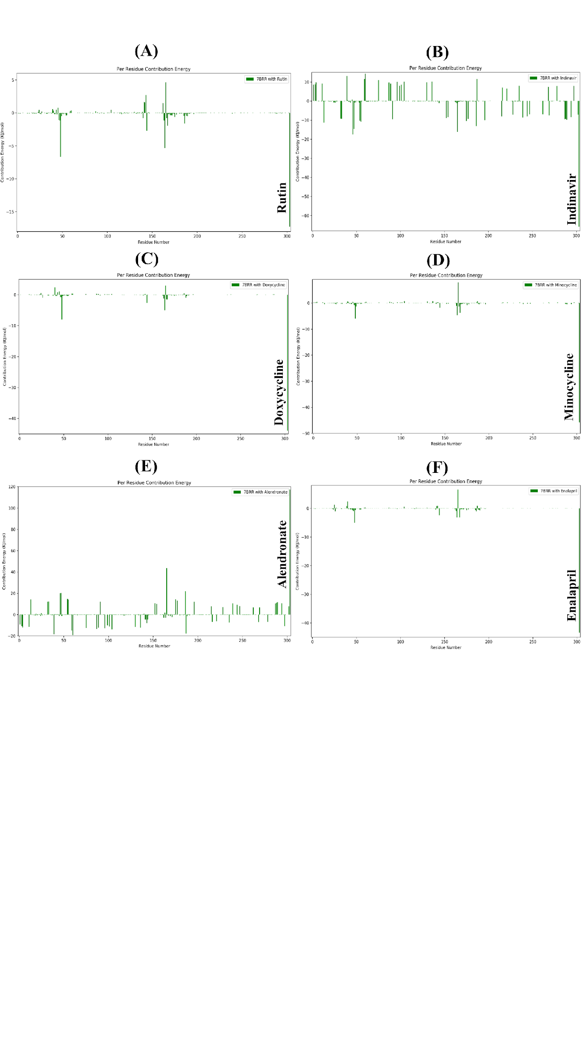
Figure S8. Per residue energy contribution during 15 ns of MD simulation when SARS COV-2 main protease complexed with drugs which are in clinical use.
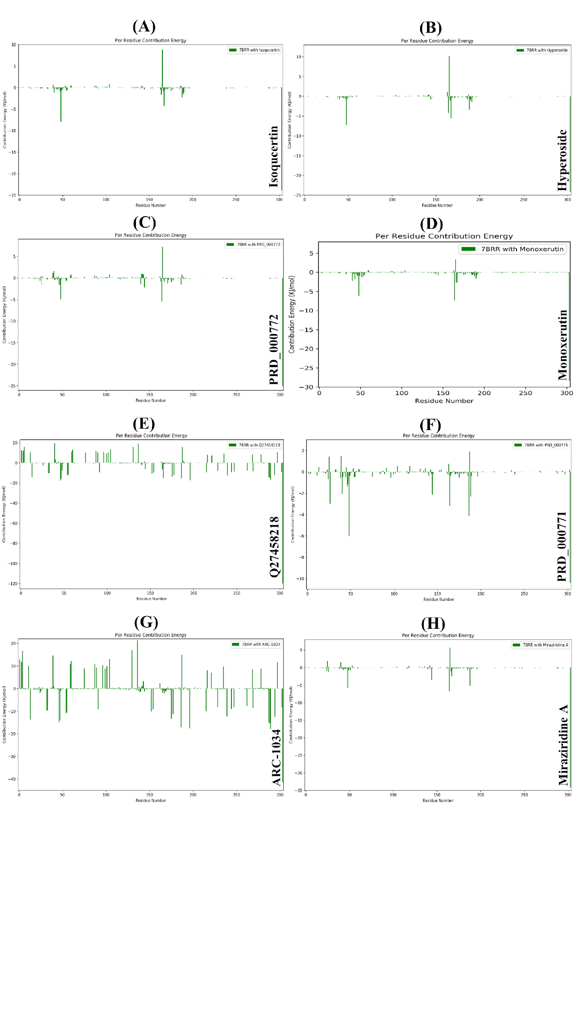
Figure S9. Per residue energy contribution during 15 ns of MD simulation when SARS COV-2 main protease complexed with compounds which are in experimental/investigational phase.
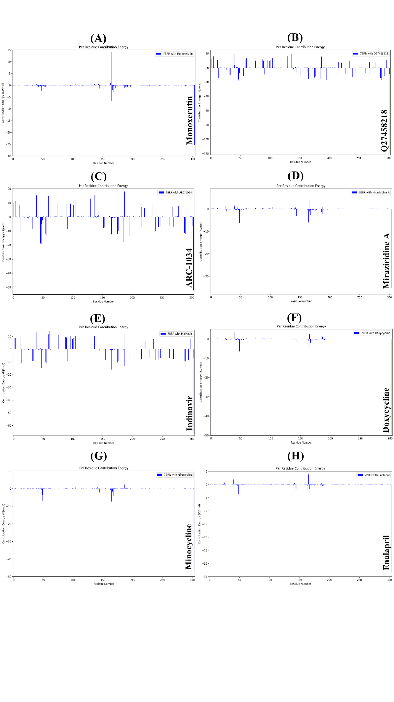
Figure S10. Per residue energy contribution during 100 ns of MD simulation when SARS COV-2 main protease complexed with different ligands.

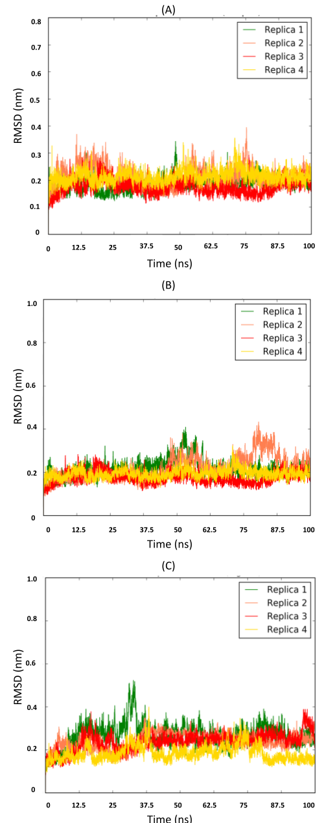
Figure S11. Root mean square fluctuation of protein backbone atoms during REMD simulation in presence of Q27458218.

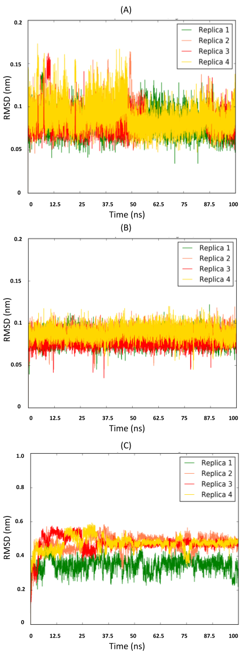
Figure S12. Root mean square fluctuation of Q27458218 during REMD simulation.

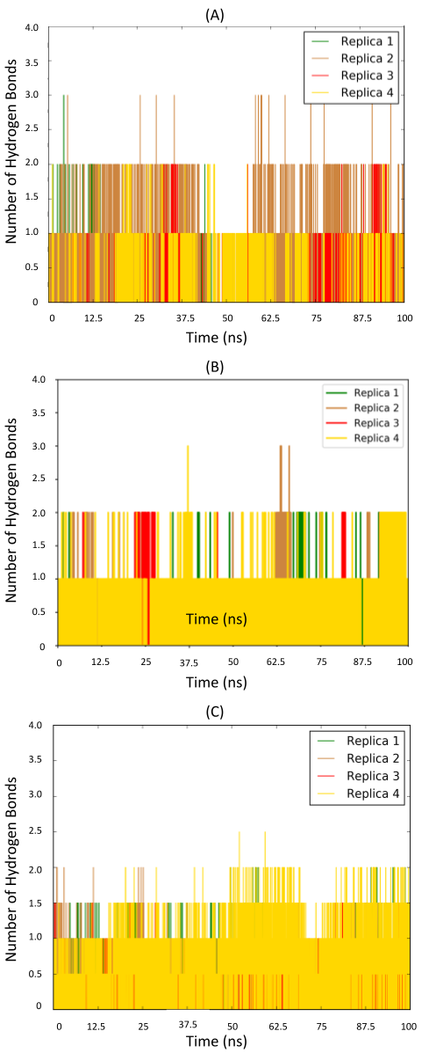
Figure S13. Number of hydrogen bonds formed by Q27458218 with protein during REMD simulation.

