In Vitro Antioxidant, Membrane Stabilizing and Antimicrobial Properties of Murayya paniculata Wild Plant of Amarkantak (M.P)
Shruti Sonter, Shringika Mishra, Manish Kumar Dwivedi and Prashant Kumar Singh*
Department of Biotechnology, Indira Gandhi National Tribal University, Amarkantak, (Madhya Pradesh) India

Shruti Sonter, Research Scholar,
Department of Biotechnology, Indira Gandhi National Tribal University, Anuppur, 484887, Madhya Pradesh, India.
E-mail: shrutiasonter07@gmail.com

Shringika Mishra, Research Scholar,
Department of Biotechnology, Indira Gandhi National Tribal University, Anuppur, 484887, Madhya Pradesh, India.
E-mail: shringika99@gmail.com

Manish Kumar Dwivedi, Research Scholar
Department of Biotechnology, Indira Gandhi National Tribal University,
Anuppur, 484887, Madhya Pradesh, India.
E-mail: dwivedi.manish55@gmail.com

*Corresponding author:
Prashant Kumar Singh, PhD
Assistant Professor
Department of Biotechnology, Indira Gandhi National Tribal University,
Anuppur, 484887, Madhya Pradesh, India.
Tel: +91-9179122557
E-mail: prashant.singh@igntu.ac.in
ORCID ID: 0000-0002-6704-277X

Table S1. Phytoconstituents screening of M. paniculata leaf extracts
Phytoconstituents | Presence/Absence in M. paniculata
Phytoconstituents | MPH | MPA | MPC | MPM | MPW
Alkaloids | - | + | + | + | +
Flavonoids | + | + | - | + | +
Steroids | - | + | - | + | +
Tannins | + | + | - | - | +
Phlobatanins | - | - | - | - | -
Terpenoids | - | - | - | - | -
Saponins | - | - | - | + | +
Glycosides | - | + | - | - | -
+ = Represents presence of phytoconstituents, - = Represents absence of phytoconstituents
MPH: M. paniculata hexane, MPA: M. paniculata acetone, MPC: M. paniculata chloroform, MPM: M.paniculata methanol, MPW: M.paniculata water

Table S2. Pearson’s correlation coefficient (r) of dose dependent correlation between concentrations versus various extract with inhibition of hemolysis.
Treatment | r | P value
Indomethacin v/s Concentration | 0.9985 | <0.001***
MPH v/s Concentration | 0.8843 | 0.05*
MPA v/s Concentration | 0.9582 | 0.01*
MPC v/s Concentration | 0.9964 | <0.001***
MPM v/s Concentration | 0.9903 | 0.001**
MPW v/s Concentration | 0.9747 | 0.005**
***= Most significant **= Moderate significant *=Less significant
Table S3. Gradient solvent system used in the column-chromatography for the isolation of bioactive molecules from Hexane extract of M. paniculata

Solvent system | Ratio | Volume  (ml) | Elutes | Pooled fractions |  | Rf | % Yield (wt/wt)
Hexane | 100% | 50 | 1 | PC1 |  | 0.95 | 26
Hexane: Dichloromethane | 9:1 | 20 | 2 |  |  | 0.95 | 26
Hexane: Dichloromethane | 5:5 | 20 | 3 |  |  | 0.95 | 26
Hexane: Dichloromethane | 1:9 | 20 | 4 | 3 spots separated from repeated chromatography as | PC11 | 0.57 | 6.8
Dichloromethane | 100% | 20 | 5
Dichloromethane: Acetone | 9:1 | 20 | 6 | 3 spots separated from repeated chromatography as | PC2 | 0.42 | 6
Dichloromethane: Acetone | 5:5 | 20 | 7 | 3 spots separated from repeated chromatography as | PC22 | 0.38 | 8.4
Dichloromethane: Acetone | 1:9 | 20 | 8
Acetone | 100% | 20 | 9 | PC3 |  | 0.33 | 16
Acetone: Methanol | 9:1 | 20 | 10 |  |  | 0.33 | 16
Acetone: Methanol | 5:5 | 20 | 11 | PC4 |  | 0.23 | 24
Acetone: Methanol | 1:9 | 20 | 12 |  |  | 0.23 | 24
Methanol | 100% | 50 | 13 |  |  | 0.23 | 24

Legends to the figures
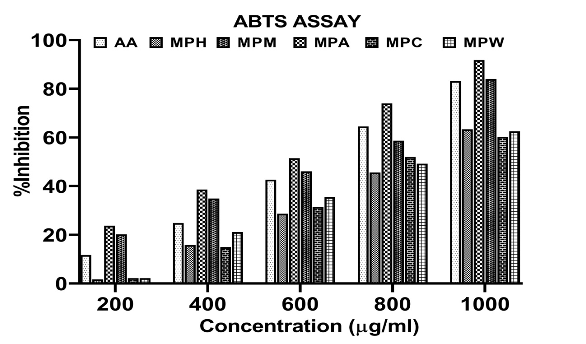
Figure S1. ABTS radical scavenging activity of different concentrations of M. paniculata leaf extracts. MPH: M. paniculata Hexane, MPA: M. paniculata Acetone, MPM: M. paniculata Methanol, MPC M. paniculata chloroform, MPW: M. paniculata water and AA: Ascorbic acid.

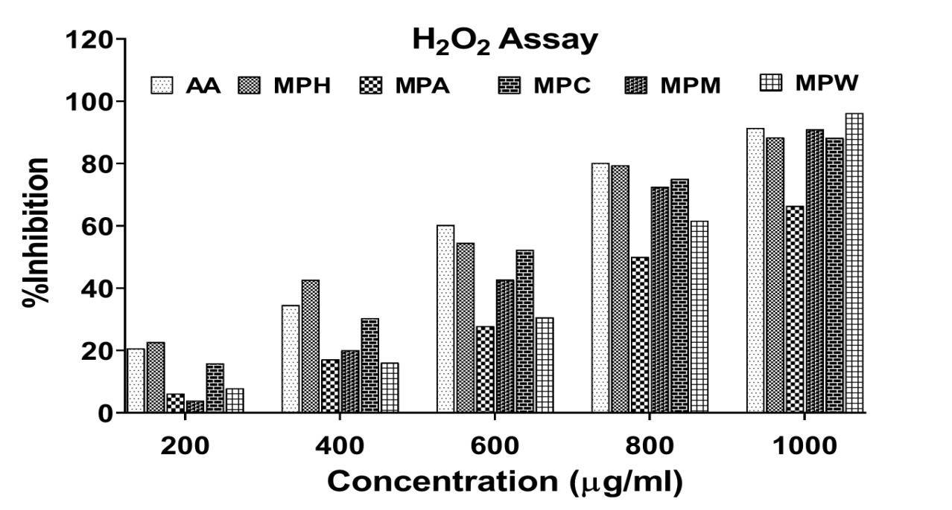
Figure S2. H₂O₂ radical scavenging activity of different concentrations of M. paniculata leaf extracts. MPH: M. paniculata Hexane, MPA: M. paniculata Acetone, MPM: M. paniculata Methanol, MPC: M. paniculata chloroform, MPW: M. paniculata water and AA: Ascorbic acid.

Figure S3. MS spectrum of major components identified through GC-MSMS analysis. The figure shows major 10 compounds MS spectrum of Fraction PC4

