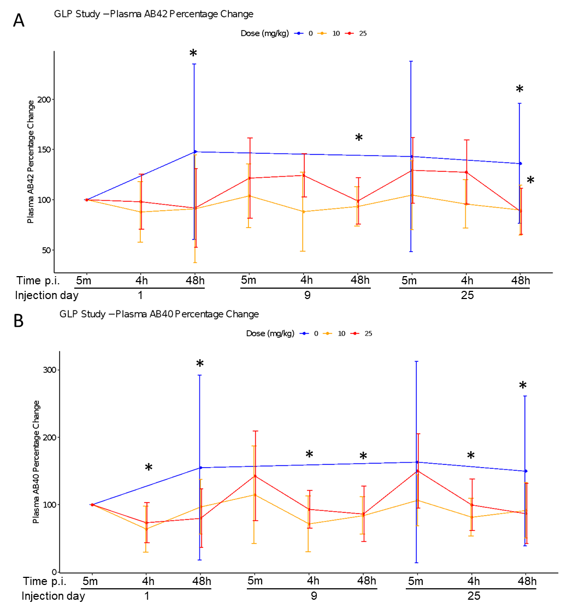

Figure S1: Plasma Aβ42 (A) and Aβ40 (B) levels following CS-6253 injection in the GLP study. A) The effect on Aβ42 levels in plasma at 48 h and accumulated treatment over time are significant (p = 0.005 and p = 0.041, respectively. B) The effect on Aβ40 levels in plasma at 4 h, 48 h, and accumulated treatment over time are significant (p < .001, p < .001 and p = 0.013, respectively. The values were shown as percent change from the first measurement point at 5 m p.i. on day 1.
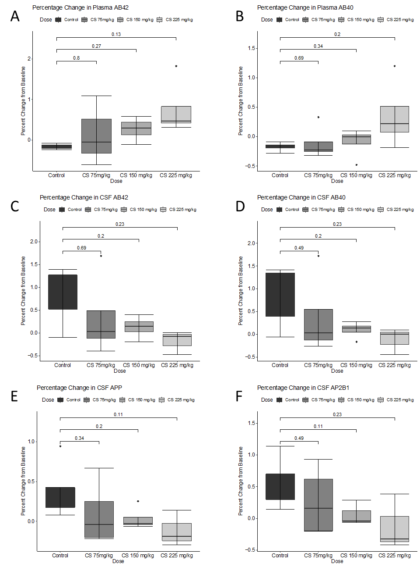
Figure S2: DRF study plasma and CSF Aβ42, Aβ40, and Aβ42/40 and CSF APP and AP2B1 levels. A and B) Both Aβ42 and Aβ40 levels were non-significantly increased in the plasma of DRF animals. C and D) Aβ42 and Aβ40 levels in the CSF. E) Although not significant CS-6253, decreased CSF APP levels. F) Similarly, a trend for decreased AP2B1 levels were observed but the changes are not significant. The values were shown as percent change from the baseline measurement.
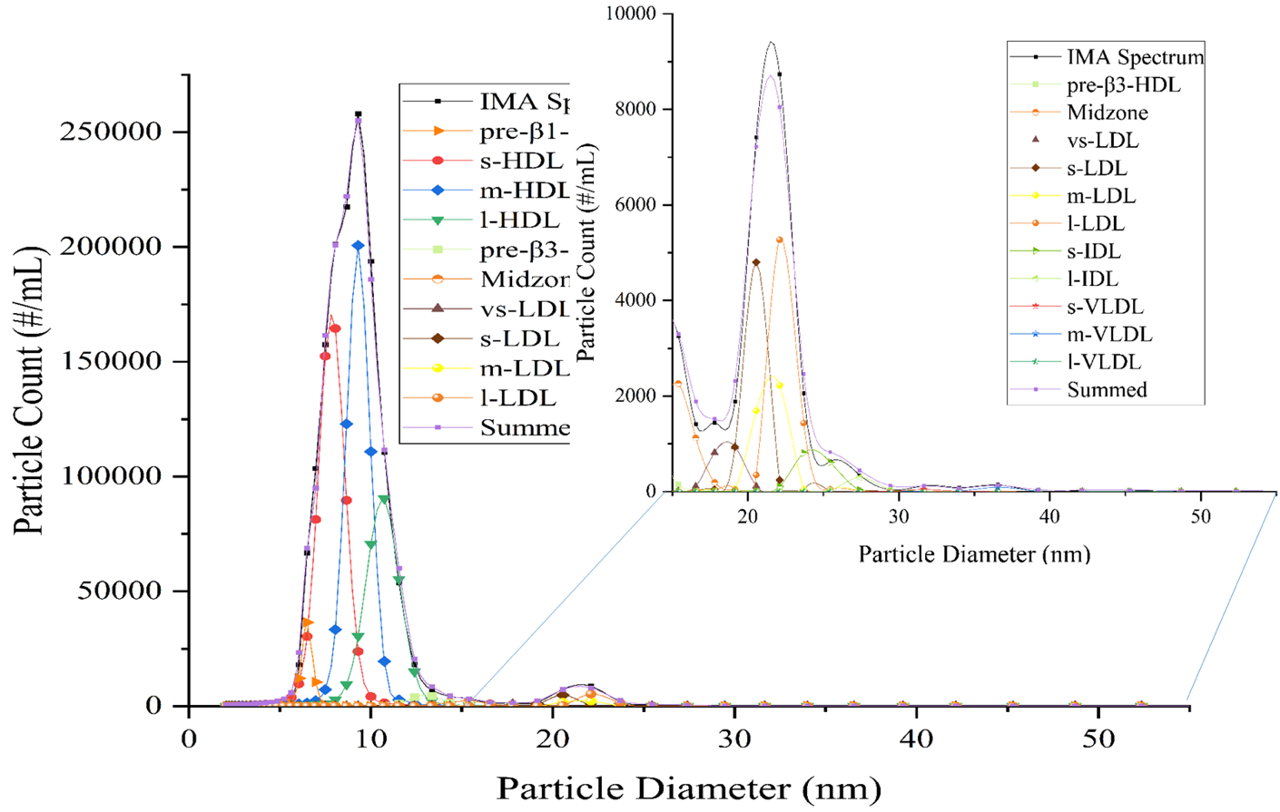

Figure S3: Ion-mobility spectrum of pre-injection monkey plasma lipoproteins’ profile distribution analyzed by Voigt probability distribution curves (R² = 0.998).

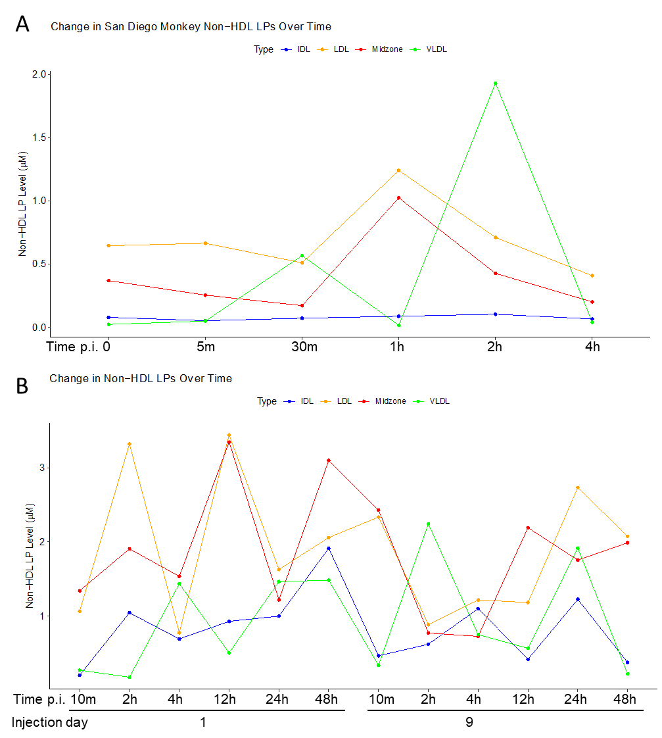
Figure S4: Analysis of IDL, LDL, Midzone, and VLDL particles A) for one monkey in the pilot study and B) for one monkey in the DRF study. Particle concentrations in the plasma were calculated using ion-mobility analysis.

Study Group | PK Pilot (San Diego Monkeys) | Dose-range finding (DRF) Study | GLP Study (Study 1478.01)
Cynomolgus monkeys: n= sex / age / weight | 2 male / 8 years old / 5 kg | 8 male & 8 females / 2 years, 3 months – 2 years, 10 months / 2.0 – 2.6 kg | 9-16 male & 9-16 female / 2-4 years old / males: 2.19 to 2.5 kg, females: 2.14 to 3.04 kg
Dosing (iv injection) regimen | single dose, 25 mg/kg | Plc, 75, 150, 225 mg/kg, q.a.d. for 11 days (5 injections) | Plc, 10, 25, 75 mg/kg q.a.d. for 30 days (15 injections)
PK (PD) curve start | Day 1 | Days 1 and 9 (5th injection) | Days 1, 9, 25
Tissue collection | Plasma  Before & after injection | Plasma and CSF  Before & after 1st and 5th injection | Plasma  After 1st, 5th & 13th injection
PK: CS-6253 half-life | 20h | 12-16 h | 11-19h
PD-lipids
Plasma | Preβ-HDL | apoA-I, apoE, total cholesterol, triglycerides | apoA-I, apoE, Cholesterol (total, HDL, LDL), triglycerides
AD biomarkers
Plasma |  | Aβ42, Aβ40 | Aβ42, Aβ40
CSF |  | Aβ42, Aβ40

Table S1: The details of the design of each study.

Table S2: Concentrations and percent distributions of s-, m-, and l-HDL particles in one monkey’s plasma in the pilot study.

