Supplementary Figure 1. Mean tau ¹⁸F-MK6240 SUVR images for the cohort: lower 95% versus top 5%
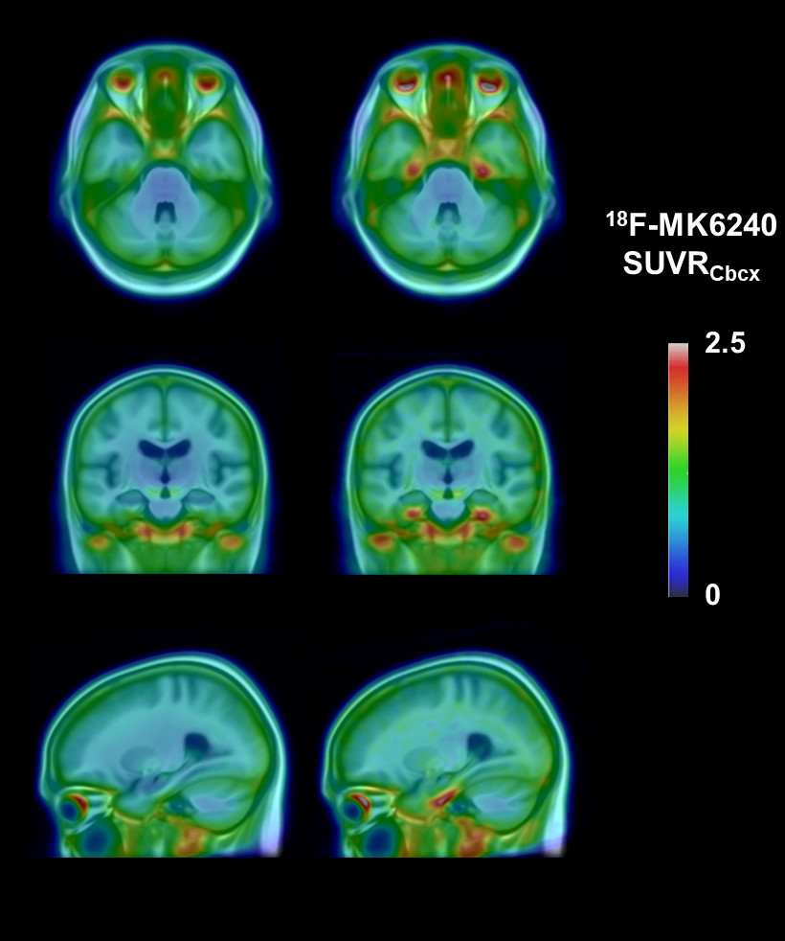

Mean tau ¹⁸F-MK6240 SUVR images overlaid on a T1 MRI template for the cohort, lower 95% (left) and top 5% Me SUVR (right) showing tau tracer retention confined to Braak stage I-II.

