Supplementary data
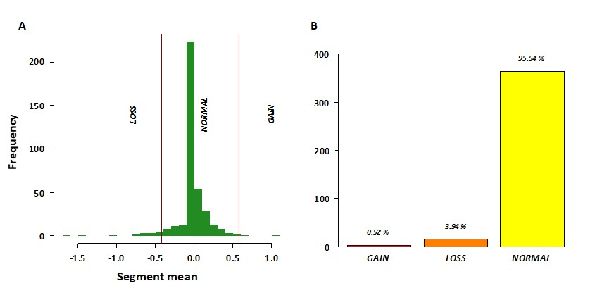
Supplementary Fig. 1 FGFR1 CNVs in TARGET-NB samples. (A) Histogram reporting the distribution (y axis) of segmented Log R Ratio LRR values (x axis) for the cohort of 381 samples in the TARGET-NB project. Red vertical lines represent the cutoffs we used to call copy number (CN) changes. LOSS: LRR < -0.42(CN<1.5); NORMAL: -0.42 ≥ LRR > 0.58 (CN ranging from 1.5 to 3); GAIN: 0.58 ≥ LRR > 1.3 (CN ranging from 3 to 4.9); AMPLIFICATION: LRR ≥ 1.3 (CN≥4.9). (B) Bar plot showing the three CN categories we identified by using the thresholds described above

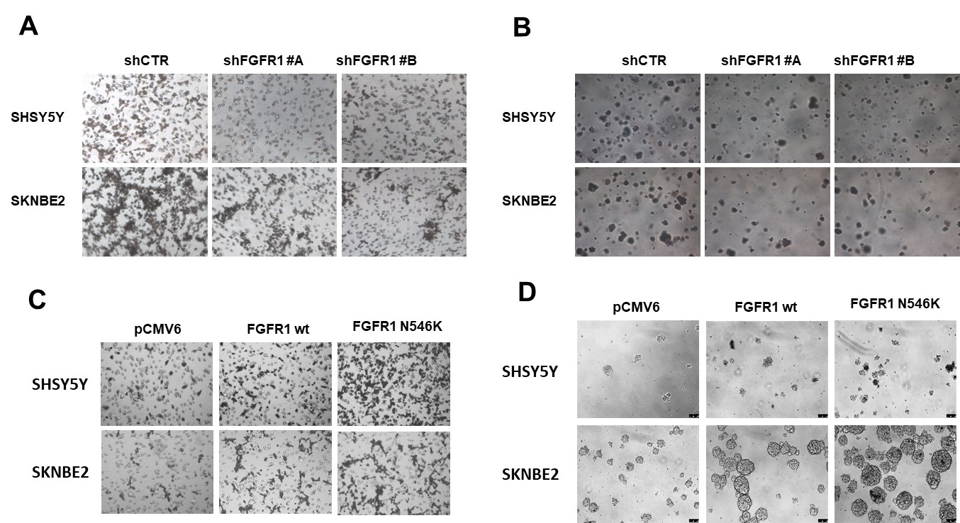

Supplementary Fig. 2 Representative images of (A) invasion and (B) soft-agar assays in silenced FGFR1 SHSY5Y and SKNBE2 cells. (C) Invasion and (D) neurosphere assays in FGFR1 overexpressing cells are shown

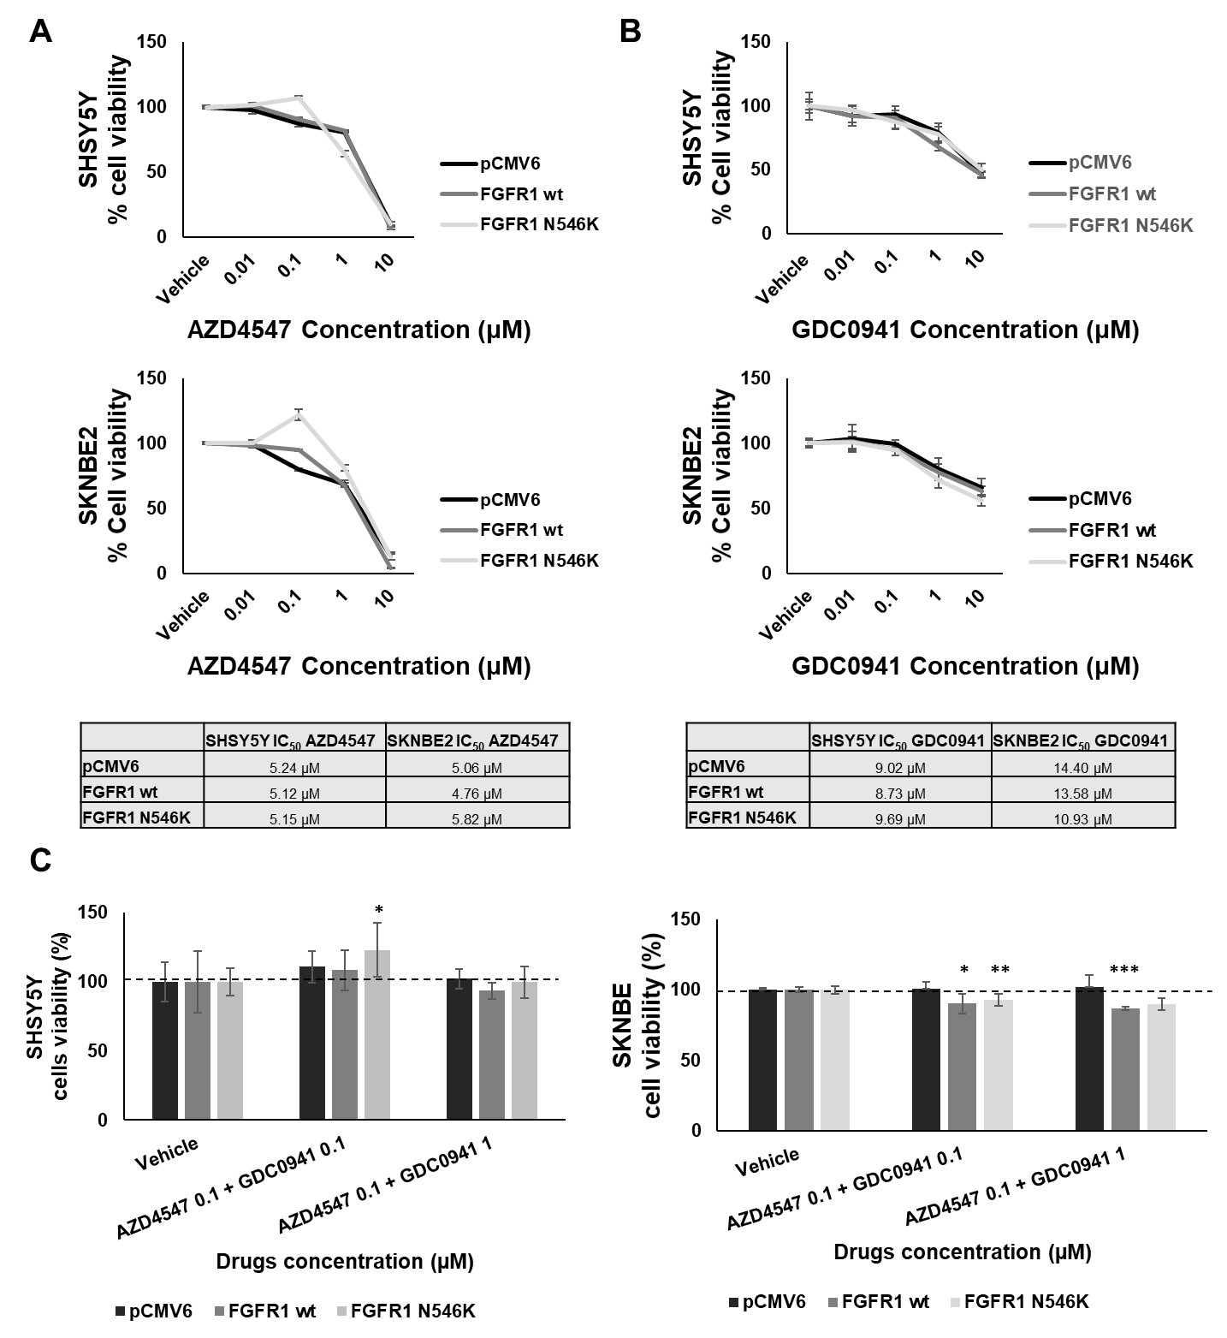
Supplementary Fig. 3 SH5YSY and SKNBE2 cells were transiently transfected with pCMV6- empty vector, pCMV6- -FGFR1^{wt}, pCMV6- - FGFR1^{N546K}.In these cell lines, MTT assay to determine the IC50 value of (A) AZD4547 and (B) GDC0941 to analyze their effect on cell viability (%). The IC50 value (that is, the concentration of drug which exhibited 50% cell) are reported in table under the corresponding graph. (C) Bar plot represented the cell viability (%) of described above cell lines treated with different concentrations of AZD4547 and GDC0941 combination. Vehicle=DMSO. * = p-value ≤ 0.05, ** = p-value ≤ 0.01, *** = p-value ≤ 0.001

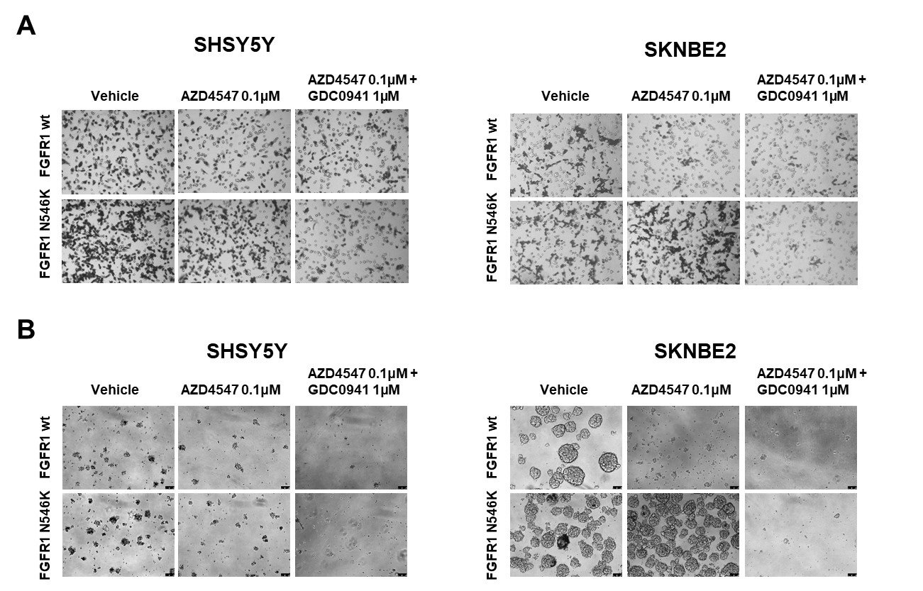

Supplementary Fig. 4 Representative images of (A) the invasion assay and (B) neurospheres assay in SHSY5Y and SKNBE2 overexpressing FGFR1^{wt} or FGFR1^{N546K} cells after treatment with AZD4547 0.1µM alone and in combination with GDC0941 1µM. Vehicle=DMSO

