Supplementary Materials

Network-based statistic
Network-based statistic (NBS) aims to identify pairwise associations with any significant differences between groups in the context of case-control studies. NBS (NBS V1.2 release, WWW.gnu.org/) is a method to control the population error rate by making the network of structural connections performing a large number of univariate tests on each connection and the results displays by BrainNet Viewer software (BrainNet Viewer V1.61 release, WWW.nitrc.org/projects/bnv). The method based on network level statistics was used to confirm whether significantly changed between morphological similarity network’s connectivity of C+, C- groups (Fig. S1).
In the graph model, pair-wise associations are represented as “connection” between a pair of different nodes. The N×N connectivity matrix stores N(N-1)/2 unique pairwise associations. For each association, the test statistics of interest are cocalculated independently using values stored in each subject's connectivity matrix. The network connection is constructed based on the region of the brain corresponding to the different ROIs of the AAL atlas. The correlation coefficient matrix of 2348×2348 nodes is normalized according to the AAL atlas, so that all subjects have the same number of ROIs (90 ROIs, excluding the cerebellar region). For normalization, each network node is assigned to each ROI in the AAL, and each ROI constitutes a node of the “Weighted Normalized Network” (WNN). We consider each pair of WNN nodes $v_{i}^{norm}$ and $v_{j}^{norm}$ to be connected to a weight $w_{ij}$, which corresponded to the sum of all possible connections between network nodes belong to ROI_i and ROI_j(Batalle, et al. 2013):
$w_{i\dot{J}}=\frac{Σ_{k=1}^{N_{i}}Σ_{l=1}^{N_{j}}P_{k_{l}}^{sig}}{{N_{i}N}_{j}}$ (1)
Here, $p_{kl}^{sig}$ is 1 when the correlation coefficient between $K^{th}$ node and $L^{th}$ node in network is greater than the threshold value and 0 otherwise, $N_{i}$ and $N_{j}$ are the total number of network nodes belonging to ROI_i and ROI_j in AAL, then the WM connection is modeled as a network of 90 nodes.
The implementation process of NBS was as follows: the correlation coefficient matrix of each case was 2348×2348. Age, sex, smoking, alcohol consumption and the total gray matter volume were removed as covariates, the residual was normalized to the ROI correlation coefficient matrix of 90×90, and the comparison statistics of the two groups were conducted in NBS by group level model. Each test statistic calculated by pair association was threshed to construct a set of links at a threshold, and then breadth-first search was used to determine all the link components that were likely to appear in the set of super-threshold links and stored the number or size of links they make up. Node of pretreatment process in the sequence correlation between nodes i and j was stored in the element (i, j), and then according to the stored in the elements of connectivity matrix of each subject values, for each in the two groups of each pair of associated numerical t inspection, to reach more than t=4.1 statistics associated values will be allowed to deposited in the collection of links on the threshold. When NBS statistics ran, M=5000 permutations ware generated to estimate the empty distribution of the maximum component size.
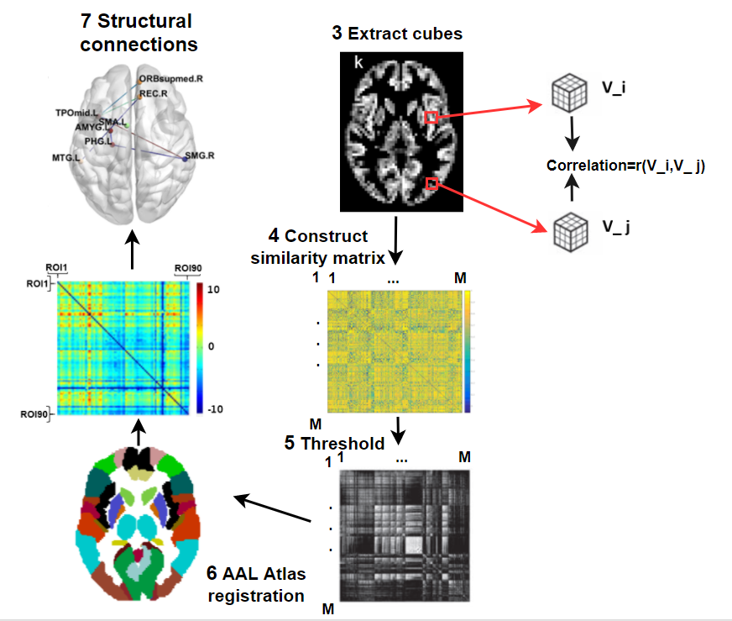
Fig. S1: The flowchart of Network-based statistic for individual morphological similarity networks. All steps ((3) ~ (5)) stayed the same corresponding to Fig.1 in the article. (6) Each binary raw network was parceled in 90 ROIs corresponding to AAL atlas then got weighted normalized network. (7) Network-based statistic shows different structural connections between groups.

Differences of Network-based statistic for ROI_based connectivity network
Removing the influence of covariates in connected network groups, we preformed two-sample t-test statistics by NBS and FDR check. Compared with C- group, the strength of connections between most pairs of brain regions in the subnetwork were weakened among C+ group. The result were any subnetworks of 15 nodes and 16 reductive strength connections (p<0.05, FDR correction, Fig. S2). Significant decreased network connections included PoCG. L-ORBmid. L, PoCG. L-ORBinf. L, PoCG. L-PCUN. L, SPG. R-STG. R, IPL. R-ITG. R, PoCG. L-MTG. R, PoCG. L-ITG. R, POCG. L-IFGtriang. R, SPG. R-ORBinf. R, SPG. R-SFGmed. R, SMG. R-Orbmid. R, TPOmid. L-TPOmid. R.
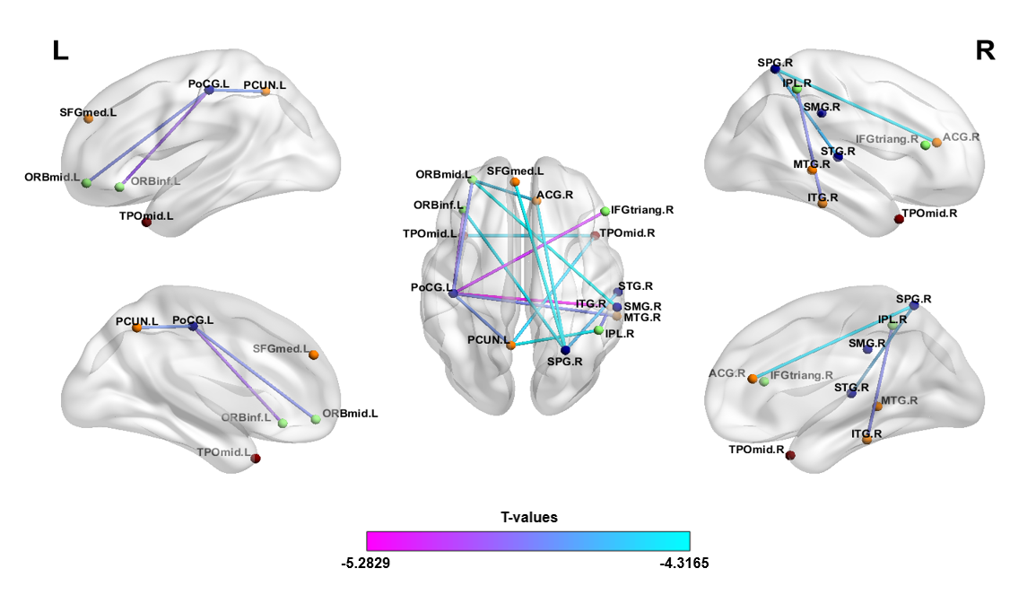
Fig. S2: Significant differences between structural connections of C+, C- groups. NSCLC, non-small-cell lung cancer; C+: NSCLC patients receiving chemotherapy; C-: NSCLC patients without chemotherapy; p<0.05.

Relationships between network connections and clinical measures
Partial correlation between network connections and clinical measures were calculated. Positive correlations between corrected number of granulocytes and network connections were found in ACG. R-SPG. R (r=0.305, p=0.018), STG. R-SPG. R (r=0.438, p=0.001), and between corrected number of thrombocytes and network connections were found in SFGmed. L-SPG. R (r=0.297, p=0.021), STG. R-SPG. R (r=0.426, p=0.001) and TPOmid. R-TPOmid. L (r=0.287, p=0.026), and also between corrected number of hemoglobin and network connections was found in ORBmid. L-SMG. R (r=0.349, p=0.016). Negative correlations between corrected cholesterol concentration and network connections were found in ACG. R-SPG. R (r=-0.335, p=0.01), STG. R-SPG. R (r=-0.295, p=0.023), and also between corrected triglyceride concentration and network connections was found in TPOmid. R-TPOmid. L (r=-0.258, p=0.048) (Fig. S3). Details of anatomical regions are shown in the Table S1.
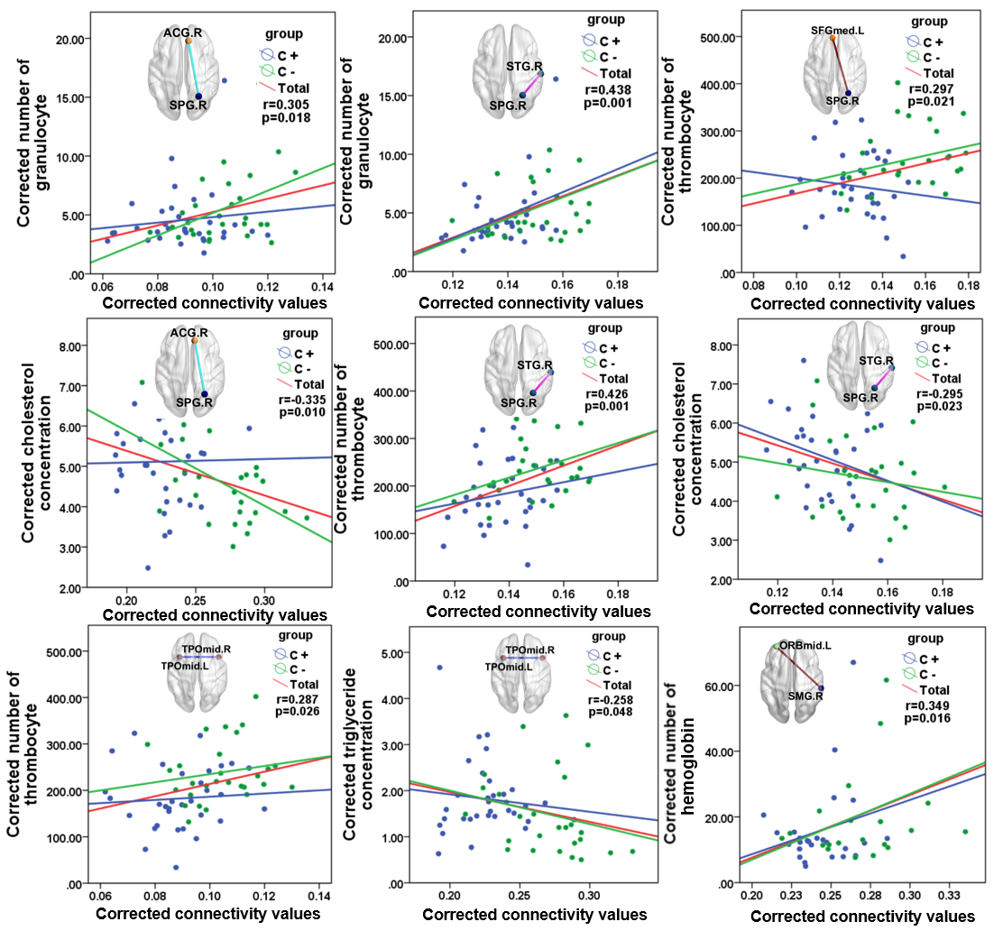
Fig. S3：Partial correlations between clinical measures and network connections in patient group. Red line: all patients; blue line: C+ group; green line: C- group.

Group differences of clinical measures
Compared with C- group, the number of thrombocytes, granulocytes and hemoglobin were significantly decreased in C+ group; the concentration of triglyceride and cholesterol were significantly increased in C+ group (Fig. S4).
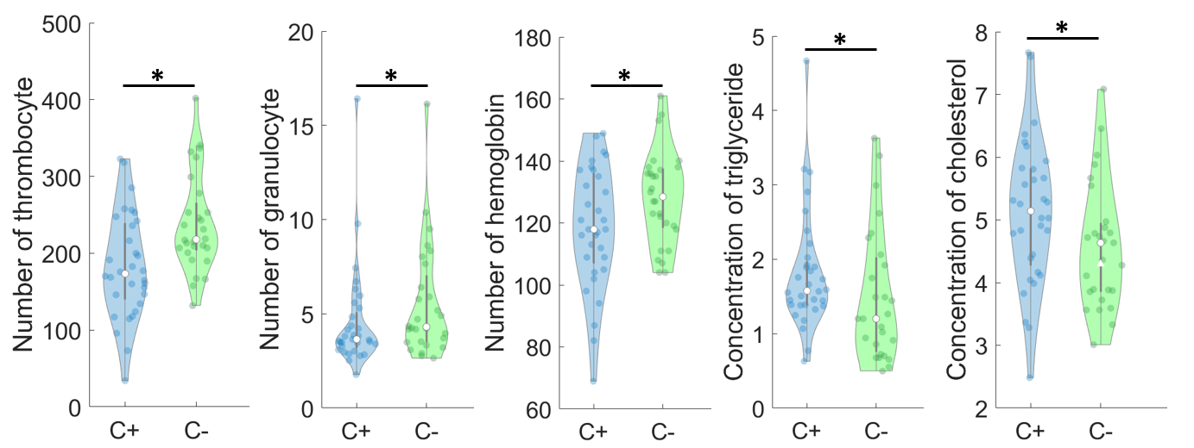
Fig. S4: Significant differences between clinical measures of C+ and C- groups. ﹡represents the significance of two sample t-test p<0.05. NSCLC, non-small-cell lung cancer; C+: NSCLC patients receiving chemotherapy; C-: NSCLC patients without chemotherapy.

Table S1. Anatomical regions of interest (ROIs)
Index | Regions | Abbreviation | Index | Regions | Abbreviation
(1,2) | Precental gyrus | PreCG | (47,48) | Lingual gyrus | LING
(3,4) | Superior frontal gyrus,dorsolateral | SFGdor | (49,50) | Superior occipital gyrus | SOG
(5,6) | Superior frontal gyrus,orbital part | ORBsup | (51,52) | Middle occipital gyrus | MOG
(7,8) | Middle frontal gyrus | MFG | (53,54) | Inferior occipital gyrus | IOG
(9,10) | Middle frontal gyrus,orbital part | ORBmid | (55,56) | Fusiform gyrus | FFG
(11,12) | Inferior frontal gyrus,opercular part | IFGoperc | (57,58) | Postcentral gyrus | PoCG
(13,14) | Inferior frontal gyrus,triangular part | IFGtriang | (59,60) | Superior parietal gyrus | SPG
(15,16) | Inferior frontal gyrus,orbital part | ORBinf | (61,62) | Inferior parietal,but supramarginal and angular gyri | IPL
(17,18) | Rolandic operculum | ROL | (63,64) | Supramarginal gyrus | SMG
(19,20) | Supplementary motor area | SMA | (65,66) | Angular gyrus | ANG
(21,22) | Olfactory cortex | OLF | (67,68) | Precuneus | PCUN
(23,24) | Superior frontal gyrus,medial | SFGmed | (69,70) | Paracentral lobule | PCL
(25,26) | Superior frontal gyrus.medial orbital | ORBsupmed | (71,72) | Caudata nucleus | CAU
(27,28) | Gyrus rectus | REC | (73,74) | Lenticular nucleus,putamen | PUT
(29,30) | Insula | INS | (75,76) | Lenticular nucleus,pallidium | PAL
(31,32) | Anterior cingulate and paracingulate gyri | ACG | (77,78) | Thalamus | THA
(33,34) | Median cingulate and paracingulate gyri | DCG | (79,80) | Heschl gyrus | HES
(35,36) | Posterior cingulate gyrus | PCG | (81,82) | Superior temporal gyrus | STG
(37,38) | Hippocampus | HIP | (83,84) | Temporal pole:superior temporal gyrus | TPOsup
(39,40) | Parahippocampal gyrus | PHG | (85,86) | Middle temporal gyrus | MTG
(41,42) | Amygdala | AMYG | (87,88) | Temporal pole:middle temporal gyrus | TPOmid
(43,44) | Calcarine fissure and surrounding cortex | CAL | (89,90) | Inferior temporal gyrus | ITG
(45,46) | Cuneus | CUN

Table S2：List of treatments for NSCLC chemotherapy patients. Abbreviation: M: male F: female A: pemetrexed C: carboplatin E: etoposide G: gemcitabine I: irinotecan P: cisplatin T: Taxol
Index | age | sex | Chemotherapy  regimen | Chemotherapy  cycle
1 | 41 | M | TP | 4
2  3  4  5  6  7  8  9  10  11  12  13  14  15  16  17  18  19  20  21  22  23  24  25  26  27  28  29  30  31  32 | 68  47  71  64  60  54  47  55  51  54  65  65  60  69  47  68  62  54  70  66  68  51  65  59  59  70  48  51  68  52  54 | F  M  M  F  M  M  M  M  M  M  F  M  M  M  M  F  F  F  M  M  M  M  M  M  M  F  M  F  M  F  F | AP  TC  GC  EC  TC  AP  EP  TC  EP  EP  TP  EP/IP  EP  IP  EP  EP  EP  TC  TP  TC  AP  AP  TP  AP  GP  AC  TP  IP  TP  GP/TC  GP | 3  2  4  3  5  4  2  1  2  3  5  2  1  4  4  4  4  5  4  5  1  6  4  4  4  4  1  6  4  3  4

References
Batalle, D., et al.
2013 Normalization of similarity-based individual brain networks from gray matter MRI and its association with neurodevelopment in infants with intrauterine growth restriction. Neuroimage 83:901-11.

