Supporting Figures
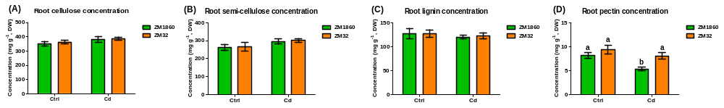
Figure S1 Compositions of root cell wall components of the Cd-resistant and Cd-sensitive genotypes. (A-B) Cellulose concentrations in the shoots (A) and roots (B); (C-D) semi-cellulose concentrations in the shoots (C) and roots (D); (E-F) lignin concentrations in the shoots (E) and roots (F); (G-H) pectin concentrations in the shoots (G) and roots (H). All the wheat plants were grown hydroponically under 10 μM Cd for 14 d. Data are means (± s.d.), n=3. Different letters indicate significant differences as determined by ANOVA and Tukey’s HSD test (P < 0.05).

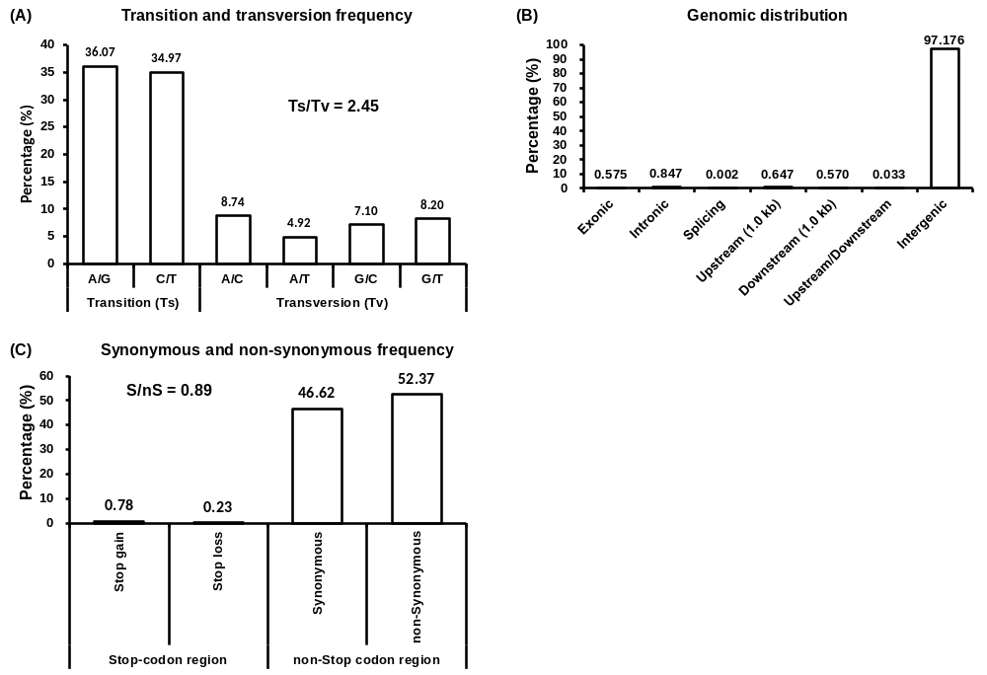
Figure S2 Annotation of single nucleotide polymorphisms (SNPs) identified between the Cd-resistant and Cd-sensitive genotypes. (A) Transition (Ts) and transversion (Tv) frequency of the SNPs. (B) Genomic distribution of the SNPs. (C) Number of the synonymous and non-synonymous SNPs. The upstream and downstream regions are defined as the 2.0-kb upstream intervals of the start codon (ATG) and the 1.0-kb downstream of the stop codons. The upstream/ downstream regions refer to the overlapped genomic intervals of the upstream and downstream areas between two neighboring genes.

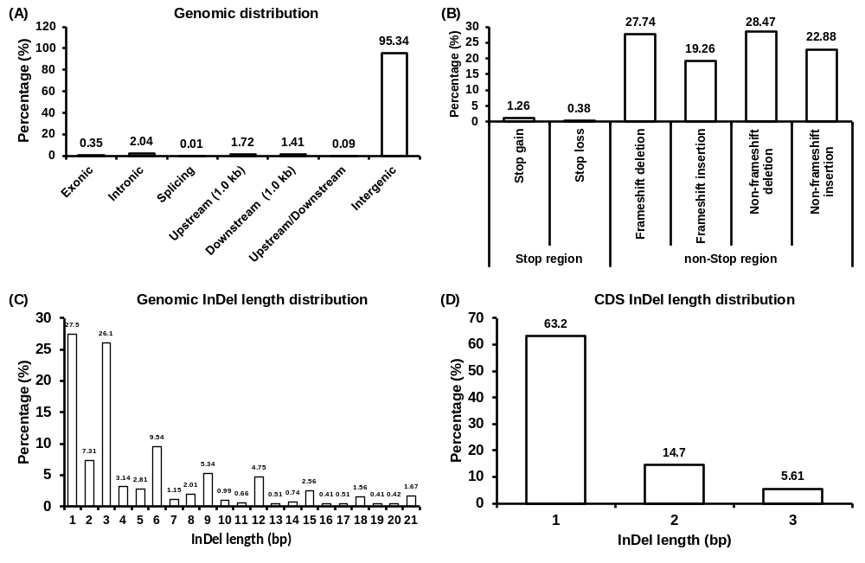
Figure S3 Annotation of insertions/deletions (InDels) identified between the Cd-resistant and Cd-sensitive genotypes. (A) Genomic distribution of the InDels. (B) Number of the synonymous and non-synonymous InDels. The upstream and downstream regions are defined as the 2.0-kb upstream intervals of the start codon (ATG) and the 1.0-kb downstream of the stop codons. The upstream/ downstream regions refer to the overlapped genomic intervals of the upstream and downstream areas between two neighboring genes. (C, D) The frequency distribution of different sizes of InDels occurring in the genomic (C) and genic regions (D). The x-axis represents the InDel sizes (bp).

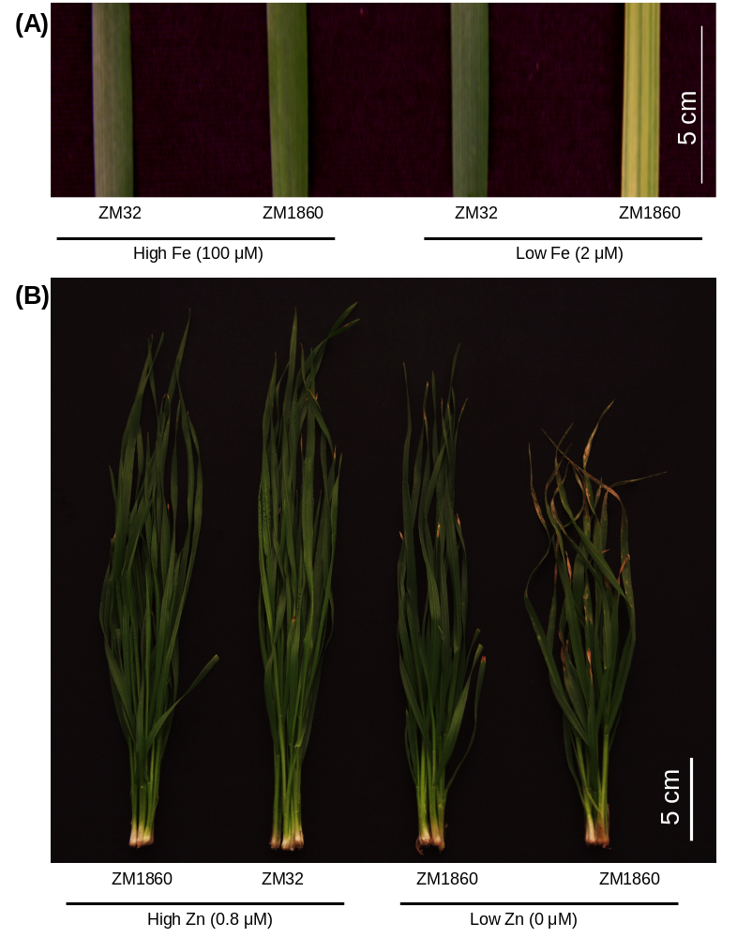
Figure S4 Growth performance of ‘ZM1860’ and ‘ZM32’ under low Fe and low Zn stresses. For the low Fe treatment, the wheat plants were grown hydroponically under high Fe (100 μM) and low Fe (2 μM) conditions for 10 d, respectively. For the low Zn treatment, the wheat plants were grown hydroponically under high Zn (0.8 μM) and low Zn (0 μM) conditions for 15 d, respectively.

