Estimated public health gains from German smokers switching to risk-reduced alternatives: Results from population health impact modelling

Short title: Public health gains from German smokers switching to risk-reduced alternatives.

Romana Rystar¹, Smilja Djurdjevic¹, Alexander K Nussbaum², Ashok Kaul³, Emanuel Bennewitz³, Peter N Lee⁴* and John S Fry⁵

¹ Philip Morris International Research and Development, Quai Jeanrenaud 5, 2000 Neuchâtel, Switzerland
² Philip Morris GmbH, Am Haag 14, 82166 Gräfelfing, Germany
³ Saarland University, Department of Economics, Saarbrücken, Germany
⁴ IPE Institute for Policy Evaluation, 60594 Frankfurt, Germany
⁵ P.N. Lee Statistics and Computing Ltd., 17 Cedar Road, Sutton, Surrey SM2 5DA
⁶ RoeLee Statistics Ltd., 17 Cedar Road, Sutton, Surrey SM2 5DA

ADDITIONAL FILE 2

This document describes the derivation of transition probabilities (TPs) for the Null Scenario for Germany.

Outline
As described elsewhere in the paper, annual data were available on the estimated proportion of never, current, and former smokers in Germany from 1980 to 2015 by sex and age group (10–14, 15–19…75–79 years). Data for 1995, 2000, 2005, 2010, and 2015 are shown in Table A2.1(A) – Men and Table A2.1(B) – Women, with data in each column representing a separate birth cohort.

From these data, by using the methodology described in section 2, monthly initiation, quitting, and re-initiation rates were derived by sex and age group separately for three time periods, representing 1–5, 6–10, and 11 or more years from the baseline in 1995. These monthly rates are shown in Table A2.2, expressed as per million per month.

Section 3 shows an example of the method, while section 4 compares the observed smoking prevalences for 1995–2015 with those predicted by using the estimated initiation, quitting, and re-initiation rates. The predictions were obtained by running ten simulations of the Population Health Impact Model (PHIM) for each sex, each with a sample size of 10,000 individuals. Each simulation starts with an initial smoking status representative of the German distribution for 1995. The fit was generally good.

Detailed methodology
One possible method of estimating initiation, quitting, and re-initiation rates is from data on the smoking habit distribution of the population (of the given sex) by year and 5-year age group. By comparing the distribution of smoking habits in a given year for a particular age group, with that 5 years later for the age group that is 5 years older, one is looking at changes within a particular birth cohort. While there are limitations to this approach, with no account being taken of immigration, emigration, differences in mortality among smoking groups (which is likely only to be a relevant issue for older age groups), or the difficulties associated with accurate and consistent determination of smoking habits from surveys, this nevertheless seems a reasonable approach for generating the required rates.

Suppose that, for a given birth cohort and 5-year period, one has the following prevalences of smoking habits:
 | Never | Current | Former
Baseline | N₀ | C₀ | F₀
5 years later | N₅ | C₅ | F₅

Let S, Q, and R be, respectively, the initiation, quitting, and re-initiation rates for the 5-year period. The following formulae can then be written:
N₅ = N_{o} (1 – S) (1)
C₅ = N_{o}S + C_{o} (1 – Q) + F_{o}R (2)
F₅ = C_{o}Q + F_{o} (1 – R) (3)

While these are three equations in three unknowns (S, Q, and R), one cannot estimate the unknowns uniquely, because they are not independent, owing to the constraint that
N_{o} + C_{o} + F_{o} = N₅ + C₅ + F₅ = 1

In order to estimate the unknowns, a further assumption is required, and we assume that X, the ratio of the re-initiation to quitting rates, can be derived from other sources. Given this, the rates can be estimated as follows:
S = (N_{o} – N₅) / N₀ (4)
Q = (N_{o} – N₅ + C_{o} – C₅) / (C_{o} – F_{o}X) (5)
R = XQ (6)

This gives us the 5-year rates, and we next wish to estimate the 1-year rates of initiation, quitting, and re-initiation, assuming that they do not change over the year. If we call these rates S₁, Q₁, and R₁, we can then estimate the proportions of never, current, and former smokers at each year (j) from those in the previous year (j – 1) by recurrence relationships:
N_{j} = N_{j–1} (1 – S₁) (7)
C_{j} = N_{j–1} S₁ + C_{j–1} (1 – Q₁) + F_{j–1} XQ₁ (8)
F_{j} = C_{j–1} Q₁ + F_{j–1} (1 – XQ₁) (9)

Starting with the known baseline distribution of smoking habits, we then find the estimates of S₁ and Q₁ that fit the known follow-up distribution.

Over the 5-year period, it is clear that we have the relationship
N₅ = N_{o} (1 – S₁)⁵ (10)
Since we also know that
N₅ = N_{o} (1 – S), (11)
it follows that
(1 – S₁)⁵ = (1 – S) (12)
S₁ = 1 – (1 – S)^{0.2} (13)

While it is easy to estimate the 1-year initiation rate from the 5-year estimate, estimating the 1-year quitting rate is not straightforward, because using the recurrence relationship to express N₅, C₅, and F₅ in terms of N_{o}, C_{o}, F_{o}, S, Q, and X gives a non-linear equation with no direct solution.

However, we can get an approximate solution by first taking
Q₁ = 1 – (1 – Q)^{0.2} and (14)
R₁ = 1 – (1 – R)^{0.2}, where R = XQ (15)
and then solving the above equations numerically, minimizing the square of the difference between the estimated 5-year rates for former and current smoking with the observed 5-year rates.

While this methodology is reasonably straightforward, there are some problems that can occur with real data.

One problem is that the observed proportion of never smokers might increase over the interval (i.e., N₅ > N_{o}). As ignoring this would lead to a negative estimate of S, which is not sensible, we instead take S to be half the estimate derived from the previous age category and then apply the 1 – (1 – S)^{0.2} formula to estimate the corresponding 1-year rate. In this situation, (N₅ – N_{o}) is set to zero in the calculation of C. Note that, in the final set of TPs, the initialization is set to zero by force for ages 35 years and above.

The second problem occurs when the selected value of X causes the re-initiation rate to rise dramatically with older age. To avoid this, the value of X is reduced until the estimate of R is less than the value for the previous age group. In this process, we start with X at 0.48, on the basis of a study by Weinberger et al. [1]. If this produces an increase, we use X = 0.36 and then X = 0.24, 0.12, and 0.06; we keep halving until there is a fall in the estimated re-initialization rate.

Finally, the 1-month rates are calculated from the yearly rates by using the formula
P (1 month) = 1– (1 – P (1 year)^{1/12}) (16)

This methodology produces the monthly initiation, quitting, and re-initiation rates for each age group from 10–14 to 70–74 years. The rates for age 75–79 years are assumed to be the same as those for age 70–74 years.

R code was developed to produce these rates for every possible year by using the data supplied from PMI. This gave us the TPs for years 1980 to 2010, because the original prevalences were from 1980 to 2015. To obtain the TPs for months 1–60, we took the mean of the TPs for 1995 to 1999; for months 61–120, we took the mean from 2000 to 2004; and for months 121+, we took the mean from 2005 to 2010.

Example of the method
Table A2.3 illustrates the results of applying the method to the data for 1985 and 1990. The first three columns on the first page of the table show the prevalences for 1985, and the next three columns show the prevalences for the same birth cohort 5 years later, when the cohort was 5 years older. The next four columns show the estimated 5-year rates (S, Q, and R) and the value of X used in the calculation. The final three columns on the first page give the exact 1-year initiation and approximate 1-year quitting and re-initiation rates, while the first three columns on the second page give the exact 1-month initiation and approximate 1-month quitting and re-initiation rates. The final two columns give the exact 1-month quitting and re-initiation rates.

Comparison of observed and predicted smoking prevalences for 1995–2015
Figure 1 compares the estimates of current and former smoking prevalences obtained from International Smoking Statistics (ISS) and Saarland University (UdS)—shown in solid lines—with those estimated by running the PHIM starting in 1995 and by using the Null Scenario initiation, quitting, and re-initiation rates given in Table A2.2 — shown in dashed lines. Data are shown in red for women and blue for men. Separate plots are shown for the age groups 30–34, 50–54, and 70–74 years. The fit generally seems not unreasonable and suggests that the Null Scenario rates should be adequate for further work.

Table A2.1. Distribution of smoking habits in Germany by birth cohort and year – (A) Men

(N = never smoked, C = current smoker, F = former smoker)

Age in 1995 | 10–14 |  |  |  | 15–19 |  |  |  | 20–24 |  |  |  | 25–29
 | N | C | F |  | N | C | F |  | N | C | F |  | N | C | F
1995 | 93.9 | 6.1 | 0.0 |  | 69.9 | 26.6 | 3.5 |  | 45.8 | 44.2 | 10.0 |  | 40.2 | 45.7 | 14.1
2000 | 71.8 | 25.9 | 2.3 |  | 48.9 | 41.3 | 9.9 |  | 43.8 | 43.1 | 13.1 |  | 39.7 | 42.9 | 17.5
2005 | 51.5 | 38.5 | 10.0 |  | 47.1 | 40.6 | 12.3 |  | 41.4 | 40.0 | 18.5 |  | 39.1 | 38.3 | 22.6
2010 | 50.3 | 38.1 | 11.5 |  | 42.5 | 37.3 | 20.2 |  | 40.0 | 35.6 | 24.4 |  | 39.2 | 35.8 | 25.0
2015 | 44.1 | 35.1 | 20.8 |  | 41.5 | 33.4 | 25.1 |  | 41.1 | 33.2 | 25.0 |  | 40.3 | 33.2 | 26.6
Age in 1995 | 30–34 |  |  |  | 35–39 |  |  |  | 40–44 |  |  |  | 45–49
 | N | C | F |  | N | C | F |  | N | C | F |  | N | C | F
1995 | 36.8 | 45.9 | 17.4 |  | 34.5 | 44.3 | 21.3 |  | 33.2 | 41.1 | 25.8 |  | 31.7 | 38.6 | 29.7
2000 | 37.4 | 41.2 | 21.4 |  | 35.2 | 39.9 | 24.9 |  | 31.7 | 39.3 | 29.0 |  | 32.6 | 35.2 | 32.2
2005 | 37.3 | 37.9 | 24.9 |  | 34.4 | 37.7 | 28.0 |  | 32.9 | 35.0 | 32.2 |  | 35.1 | 28.2 | 36.6
2010 | 37.7 | 35.4 | 27.0 |  | 32.9 | 34.8 | 32.3 |  | 35.7 | 27.1 | 37.2 |  | 35.3 | 22.0 | 42.7
2015 | 33.2 | 34.5 | 32.3 |  | 36.3 | 26.3 | 37.4 |  | 35.9 | 21.0 | 43.1 |  | 41.6 | 14.4 | 44.0
Age in 1995 | 50–54 |  |  |  | 55–59 |  |  |  | 60–64 |  |  |  | 65–69
 | N | C | F |  | N | C | F |  | N | C | F |  | N | C | F
1995 | 31.7 | 35.2 | 33.1 |  | 31.3 | 31.3 | 37.4 |  | 31.1 | 27.6 | 41.4 |  | 30.3 | 24.7 | 45.0
2000 | 34.0 | 29.6 | 36.4 |  | 33.8 | 25.3 | 40.8 |  | 34.4 | 21.7 | 43.8 |  | 34.2 | 17.9 | 48.0
2005 | 35.0 | 23.5 | 41.4 |  | 37.2 | 19.0 | 43.8 |  | 36.5 | 15.1 | 48.5 |  | 35.1 | 12.2 | 52.6
2010 | 39.6 | 16.4 | 44.0 |  | 38.4 | 12.3 | 49.3 |  | 42.2 | 10.0 | 47.8 |  | - | - | -
2015 | 40.2 | 10.2 | 49.6 |  | 45.8 | 8.3 | 45.9 |  | - | - | - |  | - | - | -
Age in 1995 | 70–74
 | N | C | F
1995 | 30.1 | 20.8 | 49.1
2000 | 28.3 | 14.6 | 57.1
2005 | - | - | -
2010 | - | - | -
2015 | - | - | -

Table A2.1. Distribution of smoking habits in Germany by birth cohort and year – (B) Women

(N = never smoked, C = current smoker, F = former smoker)

Age in 1995 | 10–14 |  |  |  | 15–19 |  |  |  | 20–24 |  |  |  | 25–29
 | N | C | F |  | N | C | F |  | N | C | F |  | N | C | F
1995 | 94.6 | 5.4 | 0.0 |  | 80.1 | 19.7 | 0.2 |  | 51.1 | 36.8 | 12.1 |  | 50.0 | 35.2 | 14.9
2000 | 77.4 | 21.7 | 0.9 |  | 52.1 | 37.0 | 10.9 |  | 52.2 | 33.0 | 14.8 |  | 49.0 | 32.7 | 18.4
2005 | 54.9 | 34.1 | 11.0 |  | 53.3 | 31.0 | 15.7 |  | 49.6 | 30.3 | 20.1 |  | 50.0 | 29.4 | 20.6
2010 | 53.7 | 29.1 | 17.2 |  | 49.5 | 28.0 | 22.5 |  | 51.9 | 27.2 | 20.9 |  | 48.8 | 29.6 | 21.6
2015 | 50.5 | 26.1 | 23.4 |  | 53.7 | 25.2 | 21.1 |  | 50.4 | 27.8 | 21.8 |  | 43.4 | 29.9 | 26.7
Age in 1995 | 30–34 |  |  |  | 35–39 |  |  |  | 40–44 |  |  |  | 45–49
 | N | C | F |  | N | C | F |  | N | C | F |  | N | C | F
1995 | 47.4 | 35.0 | 17.6 |  | 47.0 | 33.2 | 19.7 |  | 49.6 | 30.4 | 20.0 |  | 55.6 | 25.8 | 18.6
2000 | 48.4 | 31.5 | 20.1 |  | 47.3 | 32.0 | 20.7 |  | 51.6 | 27.5 | 20.9 |  | 56.8 | 23.4 | 19.8
2005 | 47.4 | 31.4 | 21.2 |  | 48.2 | 28.5 | 23.3 |  | 51.5 | 24.8 | 23.7 |  | 56.4 | 20.7 | 22.9
2010 | 44.9 | 29.4 | 25.7 |  | 45.9 | 26.2 | 27.9 |  | 50.2 | 21.8 | 28.0 |  | 59.3 | 16.4 | 24.4
2015 | 43.3 | 27.2 | 29.6 |  | 47.2 | 22.8 | 30.0 |  | 56.7 | 17.1 | 26.2 |  | 63.6 | 13.1 | 23.4
Age in 1995 | 50–54 |  |  |  | 55–59 |  |  |  | 60–64 |  |  |  | 65–69
 | N | C | F |  | N | C | F |  | N | C | F |  | N | C | F
1995 | 62.6 | 21.2 | 16.2 |  | 67.2 | 18.7 | 14.1 |  | 74.0 | 14.4 | 11.6 |  | 78.6 | 10.6 | 10.8
2000 | 62.3 | 19.7 | 18.1 |  | 70.0 | 14.9 | 15.1 |  | 76.9 | 10.6 | 12.5 |  | 83.3 | 7.4 | 9.3
2005 | 64.8 | 15.5 | 19.6 |  | 72.0 | 11.2 | 16.8 |  | 78.5 | 7.8 | 13.7 |  | 78.2 | 5.7 | 16.1
2010 | 66.2 | 12.2 | 21.7 |  | 72.5 | 8.8 | 18.8 |  | 76.7 | 5.6 | 17.7 |  | - | - | -
2015 | 69.1 | 10.6 | 20.4 |  | 75.1 | 6.6 | 18.3 |  | - | - | - |  | - | - | -
Age in 1995 | 70–74
 | N | C | F
1995 | 85.3 | 6.6 | 8.1
2000 | 79.6 | 5.7 | 14.7
2005 | - | - | -
2010 | - | - | -
2015 | - | - | -

TABLE A2.2. Estimated Null Scenario TPs (monthly per million) – Men

Age | Initiation | Quitting | Re-initiation |  | Initiation | Quitting | Re-initiation |  | Initiation | Quitting | Re-initiation
group | 1–60 (months) |  |  |  | 61–120 (months) |  |  |  | 121+ (months)
1–14 | 4,296 | 2,446 | 1,166 |  | 3,654 | 2,063 | 985 |  | 2,883 | 1,840 | 879
15–19 | 5,767 | 3,931 | 1,866 |  | 5,459 | 4,928 | 2,332 |  | 5,538 | 6,243 | 2,943
20–24 | 745 | 1,347 | 644 |  | 516 | 974 | 466 |  | 323 | 578 | 277
25–29 | 560 | 2,037 | 972 |  | 1,231 | 3,263 | 1,551 |  | 1,935 | 4,942 | 2,338
30–34 | 220 | 2,551 | 1,216 |  | 330 | 2,975 | 1,416 |  | 497 | 3,601 | 1,710
35–39 | 0 | 2,245 | 1,070 |  | 0 | 1,873 | 894 |  | 0 | 1,455 | 695
40–44 | 0 | 2,006 | 957 |  | 0 | 1,760 | 800 |  | 0 | 1,554 | 598
45–49 | 0 | 2,297 | 820 |  | 0 | 2,284 | 602 |  | 0 | 2,593 | 382
50–54 | 0 | 3,109 | 442 |  | 0 | 3,662 | 432 |  | 0 | 4,187 | 307
55–59 | 0 | 3,460 | 243 |  | 0 | 4,096 | 241 |  | 0 | 4,678 | 171
60–64 | 0 | 3,419 | 119 |  | 0 | 3,954 | 211 |  | 0 | 4,391 | 163
65–69 | 0 | 4,712 | 80 |  | 0 | 5,848 | 155 |  | 0 | 7,638 | 136
70–74 | 0 | 7,878 | 57 |  | 0 | 4,772 | 114 |  | 0 | 1,575 | 36
75–79 | 0 | 7,878 | 57 |  | 0 | 4,772 | 114 |  | 0 | 1,575 | 57

Table A2.2. Estimated Null Scenario TPs (monthly per million) – Women

Age | Initiation | Quitting | Re-initiation |  | Initiation | Quitting | Re-initiation |  | Initiation | Quitting | Re-initiation
group | 1–60 (months) |  |  |  | 61–120 (months) |  |  |  | 121+ (months)
1–14 | 3,462 | 1,454 | 695 |  | 2,986 | 2,210 | 1,054 |  | 2,072 | 3,593 | 1,706
15–19 | 6,728 | 7,159 | 3,366 |  | 5,213 | 7,249 | 3,407 |  | 4,627 | 9,383 | 4,382
20–24 | 3,030 | 5,018 | 2,374 |  | 1,981 | 5,150 | 2,435 |  | 767 | 4,563 | 2,161
25–29 | 724 | 3,152 | 1,499 |  | 958 | 4,390 | 2,080 |  | 1,155 | 6,037 | 2,848
30–34 | 358 | 2,546 | 1,213 |  | 472 | 2,472 | 1,178 |  | 567 | 2,098 | 1,001
35–39 | 0 | 807 | 387 |  | 0 | 902 | 432 |  | 0 | 928 | 444
40–44 | 0 | 1,589 | 257 |  | 0 | 2,185 | 259 |  | 0 | 3,112 | 368
45–49 | 0 | 1,617 | 130 |  | 0 | 2,342 | 139 |  | 0 | 3,029 | 233
50–54 | 0 | 2,161 | 86 |  | 0 | 2,689 | 80 |  | 0 | 3,004 | 181
55–59 | 0 | 2,805 | 57 |  | 0 | 2,714 | 57 |  | 0 | 2,446 | 138
60–64 | 0 | 3,480 | 35 |  | 0 | 3,334 | 35 |  | 0 | 2,710 | 73
65–69 | 0 | 2,245 | 22 |  | 0 | 4,040 | 21 |  | 0 | 2,323 | 41
70–74 | 0 | 20,834 | 16 |  | 0 | 16,169 | 15 |  | 0 | 5,489 | 31
75–79 | 0 | 20,834 | 16 |  | 0 | 16,169 | 15 |  | 0 | 5,489 | 16

Table A2.3. Example of the method based on data for 1985 and 1990

Age | 1985 prevalence |  |  | 1990 prevalence for the same cohort |  |  |  | 5-year rates |  |  | 1-year rates | Approx. | Approx.
 | CURRENT | FORMER | NEVER | CURRENT | FORMER | NEVER | X | Initiation | Quitting | Re-initiation | Initiation | Quitting | Re-initiation
10–14 | 8.4263 | 0.0000 | 91.5737 | 27.9930 | 3.5985 | 68.4085 | 0.48 | 0.2530 | 0.4271 | 0.2050 | 0.0567 | 0.1054 | 0.0448
15–19 | 31.3017 | 3.1749 | 65.5234 | 46.8225 | 11.8209 | 41.3567 | 0.48 | 0.3688 | 0.2903 | 0.1394 | 0.0879 | 0.0663 | 0.0296
20–24 | 49.7174 | 10.1896 | 40.0930 | 48.5467 | 14.9936 | 36.4597 | 0.48 | 0.0906 | 0.1072 | 0.0514 | 0.0188 | 0.0224 | 0.0105
25–29 | 51.2437 | 14.7585 | 33.9978 | 48.9164 | 20.7577 | 30.3260 | 0.48 | 0.1080 | 0.1359 | 0.0652 | 0.0226 | 0.0288 | 0.0134
30–34 | 50.9180 | 19.1453 | 29.9367 | 46.4789 | 24.9129 | 28.6082 | 0.48 | 0.0444 | 0.1382 | 0.0663 | 0.0090 | 0.0293 | 0.0136
35–39 | 48.3192 | 23.8133 | 27.8675 | 41.8672 | 26.9350 | 31.1978 | 0.48 | 0.0222 | 0.1749 | 0.0840 | 0.0045 | 0.0377 | 0.0174
40–44 | 44.2752 | 27.0235 | 28.7013 | 38.9355 | 30.0564 | 31.0081 | 0.36 | 0.0111 | 0.1546 | 0.0556 | 0.0022 | 0.0330 | 0.0114
45–49 | 42.0829 | 29.8614 | 28.0557 | 36.3379 | 34.2203 | 29.4417 | 0.24 | 0.0055 | 0.1645 | 0.0395 | 0.0011 | 0.0353 | 0.0080
50–54 | 40.2549 | 34.8473 | 24.8978 | 34.1669 | 39.0468 | 26.7863 | 0.12 | 0.0028 | 0.1688 | 0.0203 | 0.0006 | 0.0363 | 0.0041
55–59 | 38.6745 | 40.4829 | 20.8426 | 31.2352 | 44.5707 | 24.1941 | 0.06 | 0.0014 | 0.2052 | 0.0123 | 0.0003 | 0.0449 | 0.0025
60–64 | 36.0870 | 45.2892 | 18.6238 | 28.5724 | 52.3636 | 19.0640 | 0.03 | 0.0007 | 0.2164 | 0.0065 | 0.0001 | 0.0476 | 0.0013
65–69 | 32.9693 | 51.7213 | 15.3094 | 24.6221 | 58.3649 | 17.0130 | 0.015 | 0.0003 | 0.2593 | 0.0039 | 0.0001 | 0.0583 | 0.0008
70–74 | 28.8886 | 57.3342 | 13.7773 | 20.9892 | 65.0307 | 13.9801 | 0.0075 | 0.0002 | 0.2776 | 0.0021 | 0.0000 | 0.0630 | 0.0004

Table A2.3 (continued). Example of the method based on data for 1985 and 1990
Age | 1-month rates |  |  | After solving
 | Exact  initiation | Approx. quitting | Approx. re-  initiation | Exact  quitting | Exact re-  initiation
10–14 | 0.0048 | 0.0092 | 0.0038 | 0.0037 | 0.0018
15–19 | 0.0076 | 0.0057 | 0.0025 | 0.0041 | 0.0020
20–24 | 0.0016 | 0.0019 | 0.0009 | 0.0019 | 0.0009
25–29 | 0.0019 | 0.0024 | 0.0011 | 0.0024 | 0.0011
30–34 | 0.0008 | 0.0025 | 0.0011 | 0.0025 | 0.0012
35–39 | 0.0004 | 0.0032 | 0.0015 | 0.0025 | 0.0012
40–44 | 0.0002 | 0.0028 | 0.0010 | 0.0023 | 0.0008
45–49 | 0.0001 | 0.0030 | 0.0007 | 0.0027 | 0.0006
50–54 | 0.0000 | 0.0031 | 0.0003 | 0.0026 | 0.0003
55–59 | 0.0000 | 0.0038 | 0.0002 | 0.0029 | 0.0002
60–64 | 0.0000 | 0.0041 | 0.0001 | 0.0039 | 0.0001
65–69 | 0.0000 | 0.0050 | 0.0001 | 0.0044 | 0.0001
70–74 | 0.0000 | 0.0054 | 0.0000 | 0.0053 | 0.0000

Fig 1. Comparison of Null Scenario and ISS/UdS estimates of current and former smoking prevalence by sex, year, and age

Current smokers Former smokers
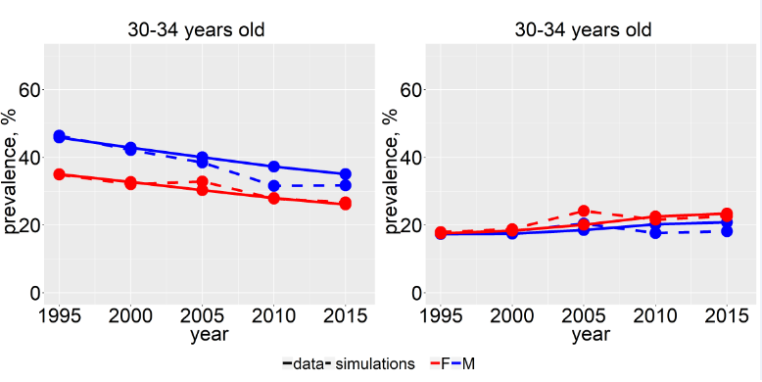

Current smokers Former smokers
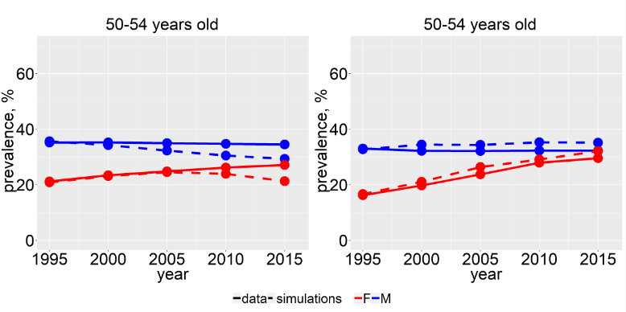

Fig 1 (continued). Comparison of Null Scenario and ISS/UdS
estimates of current and former smoking prevalence by sex, year, and age

Current smokers Former smokers
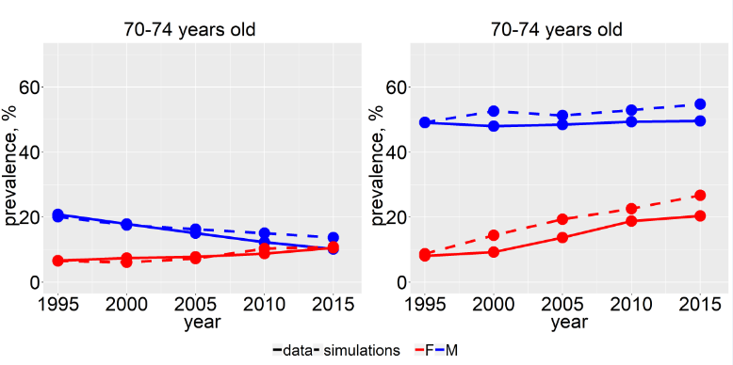

References

1. Weinberger AH, Pilver CE, Mazure CM, McKee SA. Stability of smoking status in the US population: a longitudinal investigation. Addiction 2014;109(9):1541-53. doi:10.1111/add.12647.

