Estimated public health gains from smokers in Germany switching to reduced-risk alternatives: Results from population health impact modelling by socioeconomic group

Romana Rytsar^{1*}, Smilja Djurdjevic¹, Alexander K Nussbaum², Ashok Kaul³, Emanuel Bennewitz⁴, Peter N Lee⁵, John S Fry⁶

¹PMI R&D, Philip Morris Products S.A., Neuchâtel, Switzerland
²Philip Morris GmbH, Gräfelfing, Germany
³DBU Digital Business University of Applied Sciences, Berlin, Germany
⁴FITT gGmbH, Saarbrücken, Germany
⁵P.N. Lee Statistics and Computing Ltd., Sutton, Surrey, UK
⁶RoeLee Statistics Ltd., Sutton, Surrey, UK

*Corresponding author: e-mail Romana.Rytsar@pmi.com

ADDITIONAL FILE S1

This document describes the methods used to classify individuals in Germany by socioeconomic group (SEG) and to derive estimates of their cigarette smoking habits by SEG.

CONTENTS

1 Socioeconomic groups in PHIM 3
2 Current and former smoking prevalence 6
3 Time quit 6
4 References 7
5 Tables 9
TABLE S1.1 The relationship of years of education to the degree of education in Germany 9
TABLE S1.2 Number of people by sex and SEG for the years 2002 and 2012 10
TABLE S1.3 Age-specific data on population and smoking habits for Germany for 1995 – men 11
TABLE S1.4 Age-specific data on population and smoking habits for Germany for 1995 – women 12
TABLE S1.5 Distribution of time quit used for baseline population (1995), SEG A 13
TABLE S1.6 Distribution of time quit used for baseline population (1995), SEG B 15
6 Figures 17
FIGURE S1.1 Inequalities among SEG groups A and B in years of education and net income per household 17
FIGURE S1.2 Distribution of SEG by age for each sex for the years 2002 and 2012 18
FIGURE S1.3 Current smoking prevalence by age for each sex for the years 2002 and 2012 19

Socioeconomic groups in PHIM
Socioeconomic parameters, such as education, income and occupation can potentially help to explain the differences in tobacco product usage (1-4). They can be combined and represented by a two group classification of individuals by socioeconomic status which helps towards describing and understanding smoking prevalence in the population (1). Higher smoking prevalence, higher exposure to smoking environments and lower success in quitting smoking are associated with lower socioeconomic status, lower education level and higher poverty level.
In our study, the classification of socioeconomic status relies on data published by Bennewitz and Kaul (2020) (5). They operationalized a variation of the Socio-demographic index (SDI) developed by researchers from the Global Burden of Disease Study 2019 (GBD). The GBD (http://www.healthdata.org/gbd/about), coordinated by the Institute for Health Metrics and Evaluation (IHME), is a tool to quantify health loss from diseases, injuries and risk factors (including smoking). The SDI (http://ghdx.healthdata.org/record/ihme-data/gbd-2019-socio-demographic-index-sdi-1950-2019) is a composite indicator of development status strongly correlated with health outcomes. The original SDI, intended as a measure of a location's socio-demographic development, takes into account average income per person, educational attainment, and total fertility rate as described by Foreman et al. (6). The modified operationalization used by Bennewitz and Kaul (2020) (5) combines the logarithm of net income per household in € per year (Z₁) and mean years of education per capita (Z₂). Both of these variables Z_{j} (j = 1, 2) are obtained from the German SOEP data by scaling the raw values X_{i} (i = 1: l) from 0 to 1
$Z_{j, i}=\frac{X_{j,i}-X_{j,min} }{X_{j,max}-X_{j,min}}$, 1)
where $X_{j,min}$ ${and X}_{j,max}$ are the lowest and highest possible values in each cross section (i.e. survey wave). The individuals are equally divided into higher (A) and lower (B) socioeconomic groups by the median of the geometric mean $\sqrt{Z_{1i}*Z_{2i}}$ of the two underlying indicators $Z_{1i}$ and $Z_{2i}$. The fertility rate is not considered by Bennewitz and Kaul (2020) (5) who state: “This measure is especially important for cross-country analyses and for shedding light on the differences between countries at different stages of economic development. Within a highly developed country such as Germany, the fertility rate does not serve the same purpose and including it as part of the SDI provides no substantial benefit.”
A higher socioeconomic group (SEG) is associated with a higher level of education and a higher income. Table S1.1 shows the relationship among years of education and the degree of education in Germany. Level of education and income, the two drivers of socioeconomic status, are almost uncorrelated, the Pearson correlation coefficients for income and educational years being 0.073 and 0.078 for 2002 and 2012, respectively. The inequalities among the SEG A and B groups due to these two drivers are shown in Figure S1.1.
The distributions of the population by SEG for 2002 and 2012 were derived from the German Socioeconomic Panel (5). Figure S1.2 shows the distributions by age. B, the lower SEG includes a higher proportion of older people than A. For historic reasons earlier birth cohorts have fewer years of education than more recent birth cohorts, and this affects the distribution of socioeconomic groups by age.
Subdivision by socioeconomic status has been based on various indicators involving income, education, occupation, social capital, and/or skills (7), often depending on the data available. Each of these different indicators may have their strengths and weaknesses, especially when it comes to specific questions such as gender-differentiated income equality or returns to education. While the concept that Bennewitz and Kaul used to subdivide by SEG may be open for discussion, we consider it to be an appropriate one. For Germany, data on smoking behaviour (prevalence and daily cigarette consumption) by SEG which is differentiated by age groups and gender is scarce. Many studies do not use a composite index of SEG, and simply relate smoking behaviour to single dimensions such as income or educational level (8-11). The few sources that use an SEG index show characteristics that are not suitable for our requirements. Either they only focus on children/adolescents (12) or do not sufficiently differentiate between SEG and age (9,13,14). Additionally, the definition used by Bennewitz and Kaul is transparent and replicable, is based on the SDI, so enlarging the comparability of our contribution to the health research compiled by the GBD, and is based on the German SOEP. The SOEP is the largest and longest-running longitudinal data set available in Germany and includes more than 20,000 individuals per year (5).
Considering the scarcity of smoking-related data differentiated by age groups, gender and SEG, the transparent definition of the SEG, and the use of the SOEP as the data source, the data provided by Bennewitz and Kaul seem to be the best available to fit our needs, even if the use of them might be connected to some limitations to our results that are driven by their operationalization to define SEG. By extending SOEP data to the German population we found that more people are allocated to B, the lower SEG (Table S1.2), a trend which is carried forward over the 20-year period. This feature of PHIM input data can have an effect on the results on mortality from the four main smoking-related diseases.
The SOEP data provides estimates of current smoking prevalence by sex, age and SEG for 2002 and 2012. As shown in Figure S1.3, which shows the pattern of prevalence by age, higher socioeconomic status correlates with a lower smoking prevalence.
Another issue is that, for any given year, disease, sex, or age group, the estimated number of deaths by SEG was derived from the reported number for the combined SEG by multiplying this number by the estimated proportions in A and B for that year, sex, and age group. This assumes the mean risk of death is identical in SEG groups A and B. While data are available from the NEM on the average RR (relative to never smokers) in each SEG group, no data are available on the absolute risk separately in A and B and, therefore, a precise test of this assumption is not possible. However, some idea of the potential effect of allowing for variation in risk by SEG can be gained from an example based on the data for men and all diseases combined. Overall there were 1,901,972 deaths, and, if one assumes that the risks per individual in A and B are the same, we can estimate on the basis of age-specific proportions in A and B that there would be 542,783 deaths in A and 1,359,189 in B. If, on the other hand, one assumes the average risks in B are twice those in A, one can readily calculate that the deaths would be split as 316,562 in A and 1,585,410 in B. In Alternative Scenario 6, the assumed 542,783 deaths in A would drop by 19,007 (3.51%) and the 1,359,189 deaths in B would drop by 37,256 (2.74%), a total DD of 56,263. Using these percentages and the revised numbers of deaths in A and B, the 316,562 deaths in A would drop by 11,085 and the 1,585,410 deaths in B by 43,437, a total DD of 54,542. Thus, even with this quite extreme assumption, the total DD is not changed that much, and there are still substantial DDs in both A and B, though the DD in A is decreased and that in B is increased.

Current and former smoking prevalence
Distributions of current and former smoking prevalence for Germany for individual years from 1995 to 2015 were derived by smoothing combined data from three sources: International Smoking Statistics (15) which provides results by five year age groups from 1980–2015 for current smoking, a report by Forey and Lee (2012) (16) which provides results by 15 year age groups from 1980–2005 for former smoking, and the German Socioeconomic Panel (GSOEP) (5) which provides prevalence data for 2002 and 2012 for current and former smoking by SEG. Data for other years for the two SEG groups was estimated using linear interpolation/extrapolation, for instance:
For any year having the GSOEP data in 2 points A (2002) and B (2012) (for each sex, age and SEG)

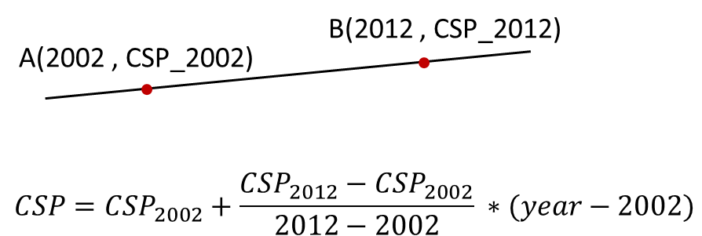

The data for each year was smoothed over age groups (20–24, … 75–79) using LOESS methodology (17) as described in Supplementary File S1 in the companion paper. For age groups 10–14 and 15–19 the values used were the same as for the general estimates from the previous paper. These values, as well as those for the general situation, are given in Supplementary File S2. The PHIM methodology uses the values in 1995 to produce the starting smoking states in the simulations. These values are given in Table S1.3 for men, and Table S1.4 for women.

Time quit
Bennewitz and Kaul (2020) (5) provide a table (D2) of the quit time distribution for 2002 by age group (20–24, … 75–79), but only for sexes combined. Based on the same sources, the authors also provided the data by sex seen in Table 3 of the paper. In the absence of data for ages 10–14 and 15–19, data for these age groups were taken from US estimates (18) and are included in Table S1.5 for SEG A and Table S1.6 for SEG B. These distributions were taken to apply in the simulations to the baseline population, in 1995.

References
1. Heilert, D. and A. Kaul: Smoking behaviour in Germany - Evidence from the SOEP; SOEP - The German Socio-Economic Panel study at DIW Berlin, Berlin, 2017. 920-2017. Available from: www.diw.de/documents/publikationen/73/diw_01.c.563343.de/diw_sp0920.pdf.
2. Westphal, C. and G. Doblhammer: The diffusion of smoking in East and West Germany: Smoking patterns by birth year; Population (English Edition) 67 (2012) 653-670. DOI: 10.2307/23391588
3. Schneider, B.S. and U. Schneider: Health behavious and health assessment: Evidence from German Microdata.; Economics Research International Article ID 135630, 13 pages (2012). DOI: 10.1155/2012/135630
4. Krebsforschungszentrum, D.: Rauchen und soziale Ungleichheit - Konsequenzen für die Tabakkontrollpolitik; Deutsches Krebsforschungszentrum, Heidelberg, 2004. Tecnhical Report. Available from: https://www.google.co.uk/url?sa=t&rct=j&q=&esrc=s&source=web&cd=&ved=2ahUKEwiOn5DC_fTpAhWDYsAKHbVdCNIQFjAAegQIARAB&url=https%3A%2F%2Fwww.abnr.de%2Fmedia%2Ffactdkfz04.pdf&usg=AOvVaw3z0dAKfIGnHbNkZixGGQzc.
5. Bennewitz, E. and A. Kaul: Quitting smoking in Germany: evidence from the SOEP; Saarland University, Germany, Saarbrücken, 2020. Available from: https://www.uni-saarland.de/fileadmin/user_upload/Professoren/fr12_ProfKaul/Research/2020_01_29_Quitting_Smoking.pdf.
6. Foreman, K.J., N. Marquez, A. Dolgert, K. Fukutaki, N. Fullman, M. McGaughey, M.A. Pletcher, A.E. Smith, K. Tang, C.W. Yuan, J.C. Brown, J. Friedman, J. He, K.R. Heuton, M. Holmberg, D.J. Patel, P. Reidy, A. Carter, K. Cercy, A. Chapin, D. Douwes-Schultz, T. Frank, F. Goettsch, P.Y. Liu, V. Nandakumar, M.B. Reitsma, V. Reuter, N. Sadat, R.J.D. Sorensen, V. Srinivasan, R.L. Updike, H. York, A.D. Lopez, R. Lozano, S.S. Lim, A.H. Mokdad, S.E. Vollset and C.J.L. Murray: Forecasting life expectancy, years of life lost, and all-cause and cause-specific mortality for 250 causes of death: reference and alternative scenarios for 2016-40 for 195 countries and territories; Lancet 392 (2018) 2052-2090. DOI: 10.1016/s0140-6736(18)31694-5
7. Cirino, P.T., C.E. Chin, R.A. Sevcik, M. Wolf, M. Lovett and R.D. Morris: Measuring socioeconomic status: reliability and preliminary validity for different approaches; Assessment 9 (2002) 145-155. DOI: 10.1177/10791102009002005
8. Kuntz, B. and T. Lampert: Educational differences in smoking among adolescents in Germany: what is the role of parental and adolescent education levels and intergenerational educational mobility?; Int. J. Environ. Res. Public Health 10 (2013) 3015-3032. DOI: 10.3390/ijerph10073015
9. Perelman, J., J. Alves, T.K. Pfoertner, I. Moor, B. Federico, M.A.G. Kuipers, M. Richter, A. Rimpela, A.E. Kunst and V. Lorant: The association between personal income and smoking among adolescents: a study in six European cities; Addiction 112 (2017) 2248-2256. DOI: 10.1111/add.13930
10. Kotz, D., M. Bockmann and S. Kastaun: The use of tobacco, e-cigarettes, and methods to quit smoking in Germany: A representative study using 6 waves of data over 12 months (the DEBRA study); Dtsch. Arztebl. Int. 115 (2018) 235-242. DOI: 10.3238/arztebl.2018.0235
11. Monfared, I.G., K. Harttgen and S. Vollmer: Individual and social predictors of smoking and obesity: A panel study in Germany; SSM Popul. Health 10 (2020) 100558. DOI: 10.1016/j.ssmph.2020.100558
12. Kuntz, B., L.E. Kroll, J. Hoebel, M. Schumann, J. Zeiher, A. Starker and T. Lampert: Zeitliche Entwicklung berufsgruppenspezifischer Unterschiede im Rauchverhalten von erwerbstätigen Männern und Frauen in Deutschland : Ergebnisse des Mikrozensus 1999-2013 [Time trends of occupational differences in smoking behaviour of employed men and women in Germany : Results of the 1999-2013 microcensus]; Bundesgesundheitsblatt Gesundheitsforschung Gesundheitsschutz 61 (2018) 1388-1398. DOI: 10.1007/s00103-018-2818-8
13. Lampert, T., L.E. Kroll, S. Müters and H. Stolzenberg: Messung des sozioökonomischen Status in der Studie "Gesundheit in Deutschland aktuell" (GEDA) [Measurement of the socioeconomic status within the German Health Update 2009 (GEDA)]; Bundesgesundheitsblatt Gesundheitsforschung Gesundheitsschutz 56 (2013) 131-143. DOI: 10.1007/s00103-012-1583-3
14. Kuntz, B. and T. Lampert: Social disparities in maternal smoking during pregnancy: Comparison of two birth cohorts (1996-2002 and 2003-2012) based on data from the German KiGGS study; Geburtshilfe Frauenheilkd. 76 (2016) 239-247. DOI: 10.1055/s-0042-100207
15. Forey, B., J. Hamling, J. Hamling, A. Thornton and P. Lee: International Smoking Statistics. A collection of worldwide historical data (2006-2016); available at: www.pnlee.co.uk/iss.htm.
16. Forey, B.A. and P.N. Lee: A comparison of smoking prevalence and quitting between countries which use either Virginia or blended tobacco cigarettes; P N Lee Statistics and Computing Ltd, Sutton, Surrey, 2012. Available from: www.pnlee.co.uk/Reports.htm [Download FOREY2012].
17. Cleveland, W.S., E. Grosse and W.M. Shyu: Local regression models: in: Statistical Models in S, edited by Chambers, J. M. and T. J. Hastie. Wadsworth & Brooks/Cole, 1992.
18. Lee, P.N., J.S. Fry, J.F. Hamling, Z. Sponsiello-Wang, G. Baker and R. Weitkunat: Estimating the effect of differing assumptions on the population health impact of introducing a Reduced Risk Tobacco Product in the USA; Regul. Toxicol. Pharmacol. 88 (2017) 192-213. DOI: 10.1016/j.yrtph.2017.06.009

Tables

TABLE S1.1 The relationship of years of education to the degree of education in Germany

Years of education | Degree
6 to 8.5 | 100% no degree
9 to 10 | ~89% lower secondary school (66%) or secondary school without vocational training (23%)
10.5 to 11 | ~100% lower secondary school with vocational training
11.5 to 12 | ~90% secondary school with vocational training
13 to 16 | ~90% technical college certification without vocational training (43%) or technical college degree (47%)
17 to 18 | 100% university degree

TABLE S1.2 Number of people by sex and SEG for the years 2002 and 2012

Year | Sex | A | B
2002 | Men | 165,683 | 185,770
 | Women | 160,781 | 195,488
2012 | Men | 169,418 | 175,927
 | Women | 172,271 | 176,183
SEG = socioeconomic group based on years of education and net income per household, with group A having the higher, and B the lower socioeconomic status.

TABLE S1.3 Age-specific data on population and smoking habits for Germany for 1995 – men

Age | Population (hundreds) | % current smokers | % former smokers | % current smokers | % former smokers
 |  | SEG A | SEG A | SEG B | SEG B
10–14 | 23,112 | 6.1 | 0.0 | 6.1 | 0.0
15–19 | 21,921 | 26.6 | 3.5 | 26.6 | 3.5
20–24 | 24,908 | 48.9 | 6.4 | 61.7 | 18.7
25–29 | 35,543 | 46.7 | 10.2 | 62.1 | 15.1
30–34 | 37,604 | 44.9 | 14.8 | 62.4 | 13.0
35–39 | 34,006 | 43.6 | 20.0 | 62.2 | 12.7
40–44 | 29,154 | 43.0 | 26.4 | 62.5 | 13.4
45–49 | 25,049 | 40.2 | 32.2 | 57.0 | 21.0
50–54 | 27,482 | 35.5 | 38.6 | 44.4 | 31.5
55–59 | 29,221 | 26.9 | 45.1 | 30.1 | 39.2
60–64 | 20,582 | 18.7 | 49.8 | 22.1 | 42.6
65–69 | 18,087 | 16.8 | 52.1 | 19.4 | 45.9
70–74 | 12,280 | 13.8 | 52.9 | 14.9 | 49.5
75–79 | 5,812 | 9.9 | 52.4 | 9.9 | 53.4
SEG = socioeconomic group based on years of education and net income per household, with group A having the higher, and B the lower socioeconomic status.

TABLE S1.4 Age-specific data on population and smoking habits for Germany for 1995 – women

Age | Population (hundreds) | % current smokers | % former smokers | % current smokers | % former smokers
 |  | SEG A | SEG A | SEG B | SEG B
10–14 | 23,112 | 5.4 | 0.0 | 5.4 | 0.0
15–19 | 21,921 | 19.7 | 0.2 | 19.7 | 0.2
20–24 | 24,908 | 27.8 | 23.0 | 51.3 | 2.0
25–29 | 35,543 | 30.2 | 21.5 | 51.3 | 8.1
30–34 | 37,604 | 32.0 | 21.9 | 51.2 | 12.7
35–39 | 34,006 | 33.0 | 23.5 | 50.8 | 15.9
40–44 | 29,154 | 33.9 | 28.1 | 51.9 | 17.8
45–49 | 25,049 | 31.0 | 25.8 | 41.5 | 18.1
50–54 | 27,482 | 25.7 | 20.3 | 28.7 | 14.9
55–59 | 29,221 | 19.2 | 17.0 | 18.5 | 9.5
60–64 | 20,582 | 15.8 | 19.8 | 11.0 | 6.5
65–69 | 18,087 | 14.5 | 23.1 | 6.3 | 8.2
70–74 | 12,280 | 12.5 | 21.5 | 3.3 | 10.0
75–79 | 5,812 | 10.5 | 16.4 | 2.3 | 12.7
SEG = socioeconomic group based on years of education and net income per household, with group A having the higher, and B the lower socioeconomic status.

TABLE S1.5 Distribution of time quit used for baseline population (1995), SEG A

 | Time quit (year)
Age Group | <1 | 1 | 2 | 3.5 | 6–10 | 11–15 | 16–20 | 21–30 | 31–40 | 41–50 | 51+
MEN
10–14 | 99.9 | 0.1 | 0 | 0 | 0 | 0 | 0 | 0 | 0 | 0 | 0
15–19 | 69.4 | 30.6 | 0 | 0 | 0 | 0 | 0 | 0 | 0 | 0 | 0
20–24 | 38.7 | 27.4 | 2.4 | 31.5 | 0 | 0 | 0 | 0 | 0 | 0 | 0
25–29 | 10.7 | 14.7 | 18.5 | 47.5 | 5.4 | 3.2 | 0 | 0 | 0 | 0 | 0
30–34 | 13.7 | 30.2 | 18.9 | 21.2 | 11.8 | 3.2 | 1 | 0 | 0 | 0 | 0
35–39 | 12.2 | 7.5 | 8.7 | 17.8 | 26.5 | 21.8 | 1.9 | 3.5 | 0 | 0 | 0
40–44 | 10.7 | 7.4 | 6.8 | 10.7 | 16.5 | 29.4 | 11.1 | 7.3 | 0 | 0 | 0
45–49 | 15.7 | 7.2 | 3.5 | 14.3 | 14.5 | 16.1 | 23 | 5.8 | 0 | 0 | 0
50–54 | 5.8 | 5.1 | 3.2 | 10.7 | 14.5 | 19.9 | 21.9 | 15.7 | 3.2 | 0 | 0
55–59 | 3.3 | 1.9 | 4.8 | 2.7 | 13 | 13.3 | 11.9 | 36.4 | 12.6 | 0 | 0
60–64 | 4.5 | 4.2 | 4.2 | 7.7 | 6.1 | 22.8 | 10.8 | 29 | 10.4 | 0.2 | 0
65–69 | 3.4 | 0.2 | 3.4 | 3.4 | 10.2 | 15.9 | 7.5 | 29.6 | 21.9 | 4.5 | 0
70–74 | 0 | 6.9 | 0.4 | 7.1 | 1.9 | 13 | 11.6 | 26.3 | 20.6 | 12.1 | 0
75–79 | 0 | 0 | 2.3 | 0.8 | 10.4 | 6.4 | 12.8 | 35 | 13.5 | 16.1 | 2.5
WOMEN
10–14 | 99.9 | 0.1 | 0 | 0 | 0 | 0 | 0 | 0 | 0 | 0 | 0
15–19 | 60.2 | 39.8 | 0 | 0 | 0 | 0 | 0 | 0 | 0 | 0 | 0
20–24 | 44.9 | 26 | 9.3 | 18.4 | 1.4 | 0 | 0 | 0 | 0 | 0 | 0
25–29 | 46.3 | 16.4 | 15.6 | 13.9 | 0.1 | 7.7 | 0 | 0 | 0 | 0 | 0
30–34 | 9.8 | 15.6 | 10.7 | 30.6 | 28.3 | 5 | 0 | 0 | 0 | 0 | 0
35–39 | 11.2 | 12.7 | 10.3 | 19.6 | 18.2 | 17 | 11 | 0 | 0 | 0 | 0
40–44 | 12.6 | 8.7 | 4.7 | 13.7 | 13.2 | 21.5 | 14.5 | 11.1 | 0 | 0 | 0
45–49 | 7.3 | 4.9 | 4.3 | 10.8 | 12.7 | 21.6 | 19.5 | 19.1 | 0 | 0 | 0
50–54 | 10.3 | 5.4 | 4.1 | 12.2 | 7.9 | 14.4 | 20.4 | 23.9 | 1.3 | 0 | 0
55–59 | 7.8 | 1.7 | 3.1 | 7.2 | 13.5 | 5.5 | 7.5 | 35.7 | 18.1 | 0 | 0
60–64 | 6.1 | 6.8 | 0 | 7.3 | 17.6 | 6.7 | 8.4 | 22.1 | 24.9 | 0 | 0
65–69 | 0.8 | 27.2 | 0 | 10.3 | 2 | 13 | 1.1 | 21.9 | 23.6 | 0 | 0
70–74 | 0 | 0 | 15.6 | 0 | 0.7 | 15.2 | 20.1 | 40.9 | 0 | 7.4 | 0
75–79 | 0 | 0 | 12.8 | 0 | 14.5 | 0 | 12.6 | 35.2 | 17.2 | 7.7 | 0
SEG = socioeconomic group based on years of education and net income per household, with group A having the higher socioeconomic status.

TABLE S1.6 Distribution of time quit used for baseline population (1995), SEG B

 | Time quit (year)
Age Group | <1 | 1 | 2 | 3.5 | 6–10 | 11–15 | 16–20 | 21–30 | 31–40 | 41–50 | 51+
MEN
10–14 | 99.9 | 0.1 | 0 | 0 | 0 | 0 | 0 | 0 | 0 | 0 | 0
15–19 | 69.4 | 30.6 | 0 | 0 | 0 | 0 | 0 | 0 | 0 | 0 | 0
20–24 | 51.1 | 29.3 | 12.4 | 7.2 | 0 | 0 | 0 | 0 | 0 | 0 | 0
25–29 | 41.8 | 19.9 | 3.4 | 34.8 | 0 | 0 | 0 | 0 | 0 | 0 | 0
30–34 | 19.5 | 22 | 14.7 | 14.2 | 7.6 | 22 | 0 | 0 | 0 | 0 | 0
35–39 | 29.4 | 10.2 | 12.1 | 12.6 | 22.2 | 11.6 | 2 | 0 | 0 | 0 | 0
40–44 | 19.1 | 12.9 | 2.4 | 12.3 | 22.7 | 14.3 | 12 | 4.4 | 0 | 0 | 0
45–49 | 14.2 | 5.4 | 13.3 | 7 | 17 | 24.7 | 5.7 | 11.9 | 0.8 | 0 | 0
50–54 | 9.1 | 2.5 | 10.7 | 23.9 | 13.8 | 15.5 | 7.4 | 15.4 | 1.8 | 0 | 0
55–59 | 4.2 | 2.7 | 8.5 | 11.4 | 17.8 | 11.7 | 15.5 | 17.3 | 10.8 | 0 | 0
60–64 | 5.6 | 1.2 | 5.2 | 11.5 | 8 | 13.9 | 13 | 29.4 | 12.1 | 0.2 | 0
65–69 | 5.2 | 4 | 0.9 | 3.5 | 16.6 | 15.8 | 13.4 | 21.3 | 16.6 | 2.7 | 0
70–74 | 5 | 3.3 | 2.6 | 7.6 | 10.1 | 16.2 | 6.5 | 28.4 | 13.8 | 5.8 | 0.6
75–79 | 4.6 | 0 | 0.6 | 0.4 | 11.4 | 12.6 | 12.4 | 22.6 | 19.6 | 15.7 | 0
WOMEN
10–14 | 99.9 | 0.1 | 0 | 0 | 0 | 0 | 0 | 0 | 0 | 0 | 0
15–19 | 60.2 | 39.8 | 0 | 0 | 0 | 0 | 0 | 0 | 0 | 0 | 0
20–24 | 32 | 15.1 | 13.3 | 37.6 | 2 | 0 | 0 | 0 | 0 | 0 | 0
25–29 | 20 | 21 | 2.6 | 33.9 | 22.6 | 0 | 0 | 0 | 0 | 0 | 0
30–34 | 29 | 2 | 12.9 | 19.1 | 26 | 10.5 | 0.7 | 0 | 0 | 0 | 0
35–39 | 10.2 | 8.9 | 20 | 11.9 | 29.5 | 8.2 | 11.3 | 0 | 0 | 0 | 0
40–44 | 25.6 | 9.9 | 5.2 | 6.4 | 13.3 | 10.5 | 4.3 | 24.7 | 0 | 0 | 0
45–49 | 8.5 | 15.9 | 6.2 | 8.1 | 13 | 18.1 | 19.2 | 11 | 0 | 0 | 0
50–54 | 12 | 6 | 6.1 | 4.2 | 24.8 | 18.5 | 13.9 | 13.2 | 1.3 | 0 | 0
55–59 | 25.8 | 2.3 | 0 | 6.6 | 11.6 | 22.6 | 13.5 | 8.5 | 9 | 0 | 0
60–64 | 12.3 | 0 | 0.9 | 10.3 | 17.1 | 23.2 | 9.1 | 17.1 | 10 | 0 | 0
65–69 | 8.8 | 2.5 | 6 | 14.9 | 13.1 | 16.6 | 4.5 | 23.1 | 8.9 | 1.7 | 0
70–74 | 9.1 | 6.1 | 2.7 | 9.2 | 6.7 | 9.8 | 12.7 | 29.8 | 12.2 | 1.8 | 0
75–79 | 6.4 | 3.1 | 0 | 23.6 | 18.8 | 11.6 | 16.6 | 13.6 | 0 | 6.3 | 0
SEG = socioeconomic group based on years education and net income per household, with group B having the lower socioeconomic status.

Figures

FIGURE S1.1 Inequalities among SEG groups A and B in years of education and net income per household

SEG = socioeconomic group defined based on years of education and net income per household, with group A having the higher, and B the lower socioeconomic status. (The percentages of people within each SEG total 100)

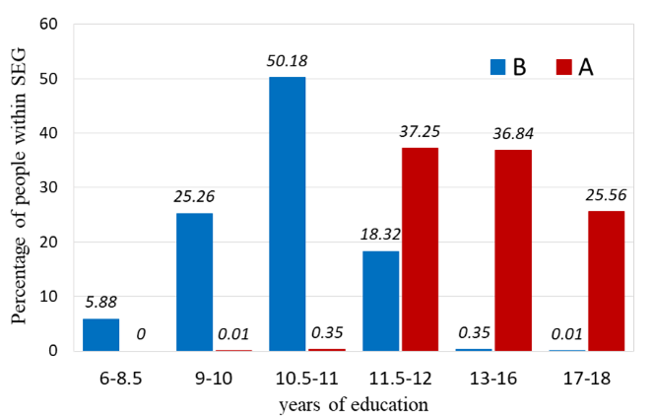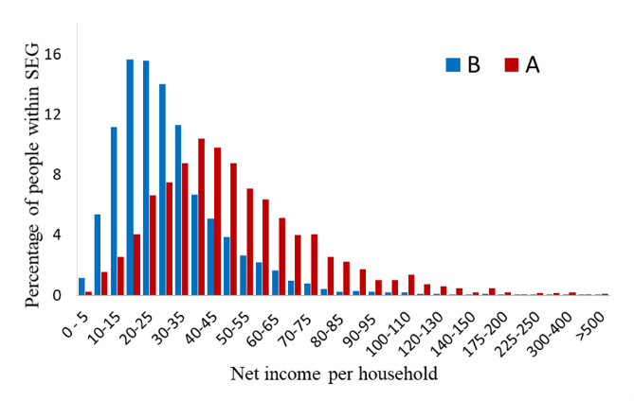
- b)

FIGURE S1.2 Distribution of SEG by age for each sex for the years 2002 and 2012

SEG = socioeconomic group defined based on years of education and net income per household, with group A having the higher, and B the lower socioeconomic status. (For each age category, the percentages by socioeconomic group total 100)

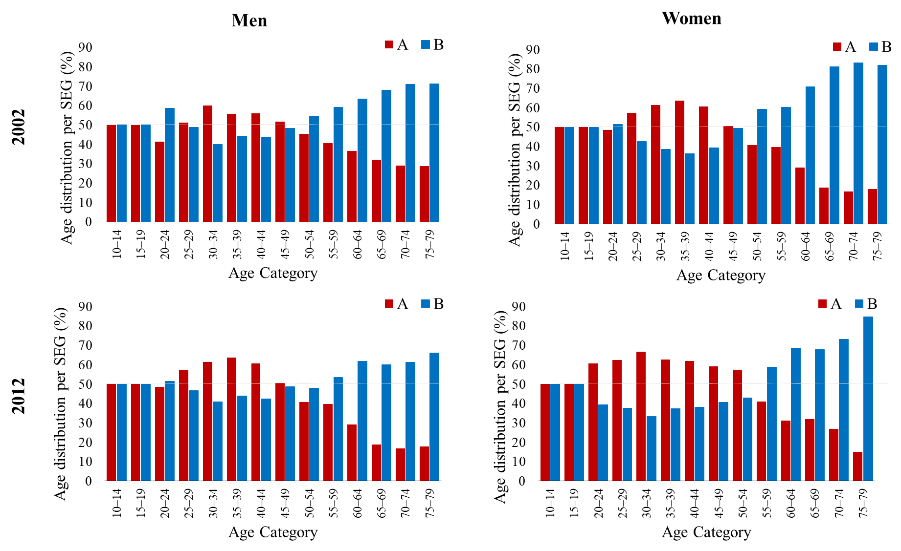

FIGURE S1.3 Current smoking prevalence by age for each sex for the years 2002 and 2012

Socioeconomic group defined based on years of education and net income per household, with group A having the higher, and B the lower socioeconomic status.

