Estimated public health gains from smokers in Germany switching to risk-reduced alternatives: Results from population health impact modelling by socioeconomic group

Short title: Public health gains from smokers in Germany switching to risk-reduced alternatives by socioeconomic group

Romana Rytsar^{1*}, Smilja Djurdjevic¹, Alexander K Nussbaum², Ashok Kaul³, Emanuel Bennewitz⁴, Peter N Lee⁵, John S Fry⁶

¹ Philip Morris International Research and Development, Quai Jeanrenaud 5, 2000 Neuchâtel, Switzerland
² Philip Morris GmbH, Am Haag 14, 82166 Gräfelfing, Germany
³ Saarland University, Department of Economics, Saarbrücken, Germany
⁴ IPE Institute for Policy Evaluation, 60594 Frankfurt, Germany
⁵ P.N. Lee Statistics and Computing Ltd., 17 Cedar Road, Sutton, Surrey SM2 5DA
⁶ RoeLee Statistics Ltd., 17 Cedar Road, Sutton, Surrey SM2 5DA

ADDITIONAL FILE 1
This document describes the methods used to classify individuals in Germany by socioeconomic group (SEG) and to derive estimates of their cigarette smoking habits by SEG.

CONTENTS

1 Socioeconomic groups in PHIM 3
2 Current and former smoking prevalence 5
3 Time quit 6
4 References 7
5 Tables 8
TABLE A1.1 The relationship of years of education to the degree of education in Germany 8
TABLE A1.2 Number of people by sex and SEG for the years 2002 and 2012 9
TABLE A1.3 Age-specific data on population and smoking habits for Germany for 1995 – men 10
TABLE A1.4 Age-specific data on population and smoking habits for Germany for 1995 – women 11
TABLE A1.5 Distribution of time quit used for baseline population (1995), SEG A 12
TABLE A1.6 Distribution of time quit used for baseline population (1995), SEG B 13
6 Figures 14
FIGURE A1.1 Inequalities among SEG groups A and B in years of education and net household income (The percentages of people within each SEG total 100) 14
FIGURE A1.2 Distribution of SEG by age for each sex for the years 2002 and 2012 (For each age category, the percentages by socioeconomic group total 100) 15
FIGURE A1.3 Current smoking prevalence by age for each sex for the years 2002 and 2012 16

Socioeconomic groups in PHIM

Socioeconomic parameters, such as education, income and occupation can potentially help to explain the differences in tobacco product usage [1-4]. They can be combined and represented by a two group classification of individuals by socioeconomic status which helps towards describing and understanding smoking prevalence in the population [1]. Higher smoking prevalence, higher exposure to smoking environments and lower success in quitting smoking are associated with lower socioeconomic status, lower education level and higher poverty level.

In our study, the classification of socioeconomic status combines the logarithm of net income per household in € per year (Z₁) and mean years education per capita (Z₂) in a manner comparable to that described by Foreman et al. [5]. Both these variables Z_{j} (j = 1, 2) are obtained from the German SOEP data by scaling the raw values X_{i} (i = 1: l) from 0 to 1
$Z_{j, i}=\frac{X_{j,i}-X_{j,min} }{X_{j,max}-X_{j,min}}$, 1)
where $X_{j,min}$ ${and X}_{j,max}$ are the smallest (worst) and largest (best) possible values in each cross section (i.e. survey wave). The individuals are equally divided into higher (A) and lower (B) socioeconomic groups by the median of the geometric mean $\sqrt{Z_{1i}*Z_{2i}}$ of the two underlying indicators $Z_{1i}$ and $Z_{2i}$. A higher socioeconomic group (SEG) is associated with a higher level of education and a higher income. Level of education and income, the two drivers of socioeconomic status, are almost uncorrelated, the Pearson correlation coefficients for income and educational years being 0.073 and 0.078 for 2002 and 2012, respectively. Table A1.1 shows the relationship among years of education and the degree of education in Germany. The inequalities among the SEG A and B groups due to these two drivers are shown in Figure A1.1.

The distributions of the population by SEG for 2002 and 2012 were derived from the German Socioeconomic Panel [6]. Figure A1.2 shows the distributions by age. B, the lower SEG includes a higher proportion of older people than A. For historic reasons earlier birth cohorts have fewer years of education than more recent birth cohorts, and this affects the distribution of socioeconomic groups by age.

By extending SOEP data to the German population we found that more people are allocated to B, the lower SEG (Table A1.2), a trend which is carried forward over the 20-year period. This feature of PHIM input data can have an effect on the results on mortality from the four main smoking-related diseases.

The SOEP data provides estimates of current smoking prevalence by sex, age and SEG for 2002 and 2012. As shown in Figure A1.3, which shows the pattern of prevalence by age, higher socioeconomic status correlates with a lower smoking prevalence.

Current and former smoking prevalence
Distributions of current and former smoking prevalence for Germany for individual years from 1995 to 2015 were derived by smoothing combined data from three sources: International Smoking Statistics [7] which provides results by five year age groups from 1980–2015 for current smoking, a report by Forey and Lee [8] which provides results by 15 year age groups from 1980–2005 for former smoking, and the German Socioeconomic Panel (GSOEP) [6] which provides prevalence data for 2002 and 2012 for current and former smoking by SEG. Data for other years for the two SEG groups was estimated using linear interpolation/extrapolation, for instance:

For any year having the GSOEP data in 2 points A (2002) and B (2012) (for each sex, age and SEG)

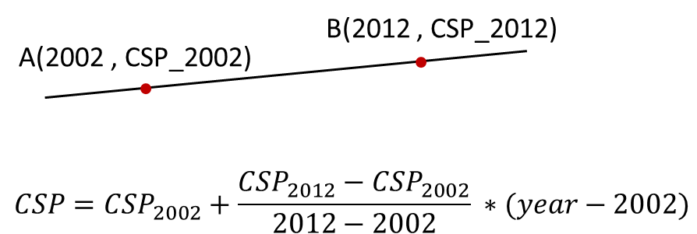

The data for each year was smoothed over age groups (20–24, … 75–79) using LOESS methodology [9] as described in Additional File A1 in the companion paper. For age groups 10–14 and 15–19 the values used were the same as for the general estimates from the previous paper. These values, as well as those for the general situation, are given in Additional File A2. The PHIM methodology uses the values in 1995 to produce the starting smoking states in the simulations. These values are given in Table A1.3 for men, and Table A1.4 for women.

Time quit
Bennewitz and Kaul [6] provide a table (D2) of the quit time distribution for 2002 by age group (20–24, … 75–79), but only for sexes combined. Based on the same sources, the authors also provided the data by sex seen in Table 3 of the paper. In the absence of data for ages 10–14 and 15–19, data for these age groups were taken from US estimates [10] and are included in Table A1.5 for SEG A and Table A1.6 for SEG B. These distributions were taken to apply in the simulations to the baseline population, in 1995.

References
1. Heilert D, Kaul A. Smoking behaviour in Germany - Evidence from the SOEP. (920-2017). SOEP Papers on Multidisciplinary Panel Data Research. Berlin: SOEP - The German Socio-Economic Panel study at DIW Berlin; 2017. Available: www.diw.de/documents/publikationen/73/diw_01.c.563343.de/diw_sp0920.pdf.

2. Westphal C, Doblhammer G. The diffusion of smoking in East and West Germany: Smoking patterns by birth year. Population (English Edition) 2012;67(4):653-70. doi:10.2307/23391588.

3. Schneider BS, Schneider U. Health behavious and health assessment: Evidence from German Microdata. Economics Research International 2012;Article ID 135630, 13 pages. doi:10.1155/2012/135630.

4. Krebsforschungszentrum D. Rauchen und soziale Ungleichheit - Konsequenzen für die Tabakkontrollpolitik. (Tecnhical Report). Heidelberg: Deutsches Krebsforschungszentrum; 2004. Available: https://www.google.co.uk/url?sa=t&rct=j&q=&esrc=s&source=web&cd=&ved=2ahUKEwiOn5DC_fTpAhWDYsAKHbVdCNIQFjAAegQIARAB&url=https%3A%2F%2Fwww.abnr.de%2Fmedia%2Ffactdkfz04.pdf&usg=AOvVaw3z0dAKfIGnHbNkZixGGQzc.

5. Foreman KJ, Marquez N, Dolgert A, Fukutaki K, Fullman N, McGaughey M, et al. Forecasting life expectancy, years of life lost, and all-cause and cause-specific mortality for 250 causes of death: reference and alternative scenarios for 2016-40 for 195 countries and territories. Lancet 2018;392(10159):2052-90.(Epub 20181016): doi:10.1016/s0140-6736(18)31694-5.

6. Bennewitz E, Kaul A. Quitting smoking in Germany: evidence from the SOEP. Saarbrücken: Saarland University, Germany; 2020. Available: https://www.uni-saarland.de/fileadmin/user_upload/Professoren/fr12_ProfKaul/Research/2020_01_29_Quitting_Smoking.pdf.

7. Forey B, Hamling J, Hamling J, Thornton A, Lee P. International Smoking Statistics. A collection of worldwide historical data (2006-2016). P N Lee Statistics and Computing Ltd, Sutton, Surrey. 2016. www.pnlee.co.uk/iss.htm.

8. Forey BA, Lee PN. A comparison of smoking prevalence and quitting between countries which use either Virginia or blended tobacco cigarettes. Sutton, Surrey: P N Lee Statistics and Computing Ltd; 2012. Available: www.pnlee.co.uk/Reports.htm [Download FOREY2012].

9. Cleveland WS, Grosse E, Shyu WM. Local regression models. In: Chambers JM, Hastie TJ, editors. Statistical Models in S. Wadsworth & Brooks/Cole; 1992.

10. Lee PN, Fry JS, Hamling JF, Sponsiello-Wang Z, Baker G, Weitkunat R. Estimating the effect of differing assumptions on the population health impact of introducing a Reduced Risk Tobacco Product in the USA. Regul Toxicol Pharmacol 2017;88:192-213.(Epub 20170623): doi:10.1016/j.yrtph.2017.06.009.

Tables

TABLE A1.1 The relationship of years of education to the degree of education in Germany

Years of education | Degree
6 to 8.5 | 100% no degree
9 to 10 | ~89% lower secondary school (66%) or secondary school without vocational training (23%)
10.5 to 11 | ~100% lower secondary school with vocational training
11.5 to 12 | ~90% secondary school with vocational training
13 to 16 | ~90% technical college certification without vocational training (43%) or technical college degree (47%)
17 to 18 | 100% university degree

TABLE A1.2 Number of people by sex and SEG for the years 2002 and 2012

Year | Sex | A | B
2002 | Men | 165,683 | 185,770
 | Women | 160,781 | 195,488
2012 | Men | 169,418 | 175,927
 | Women | 172,271 | 176,183
SEG = socioeconomic group defined based on education and income, with group A having the higher, and B the lower socioeconomic status.

TABLE A1.3 Age-specific data on population and smoking habits for Germany for 1995 – men

Age | Population (hundreds) | % current smokers | % former smokers | % current smokers | % former smokers
 |  | SEG A | SEG A | SEG B | SEG B
10–14 | 23,112 | 6.1 | 0.0 | 6.1 | 0.0
15–19 | 21,921 | 26.6 | 3.5 | 26.6 | 3.5
20–24 | 24,908 | 48.9 | 6.4 | 61.7 | 18.7
25–29 | 35,543 | 46.7 | 10.2 | 62.1 | 15.1
30–34 | 37,604 | 44.9 | 14.8 | 62.4 | 13.0
35–39 | 34,006 | 43.6 | 20.0 | 62.2 | 12.7
40–44 | 29,154 | 43.0 | 26.4 | 62.5 | 13.4
45–49 | 25,049 | 40.2 | 32.2 | 57.0 | 21.0
50–54 | 27,482 | 35.5 | 38.6 | 44.4 | 31.5
55–59 | 29,221 | 26.9 | 45.1 | 30.1 | 39.2
60–64 | 20,582 | 18.7 | 49.8 | 22.1 | 42.6
65–69 | 18,087 | 16.8 | 52.1 | 19.4 | 45.9
70–74 | 12,280 | 13.8 | 52.9 | 14.9 | 49.5
75–79 | 5,812 | 9.9 | 52.4 | 9.9 | 53.4
SEG = socioeconomic group defined based on education and income, with group A having the higher, and B the lower socioeconomic status.

TABLE A1.4 Age-specific data on population and smoking habits for Germany for 1995 – women

Age | Population (hundreds) | % current smokers | % former smokers | % current smokers | % former smokers
 |  | SEG A | SEG A | SEG B | SEG B
10–14 | 23,112 | 5.4 | 0.0 | 5.4 | 0.0
15–19 | 21,921 | 19.7 | 0.2 | 19.7 | 0.2
20–24 | 24,908 | 27.8 | 23.0 | 51.3 | 2.0
25–29 | 35,543 | 30.2 | 21.5 | 51.3 | 8.1
30–34 | 37,604 | 32.0 | 21.9 | 51.2 | 12.7
35–39 | 34,006 | 33.0 | 23.5 | 50.8 | 15.9
40–44 | 29,154 | 33.9 | 28.1 | 51.9 | 17.8
45–49 | 25,049 | 31.0 | 25.8 | 41.5 | 18.1
50–54 | 27,482 | 25.7 | 20.3 | 28.7 | 14.9
55–59 | 29,221 | 19.2 | 17.0 | 18.5 | 9.5
60–64 | 20,582 | 15.8 | 19.8 | 11.0 | 6.5
65–69 | 18,087 | 14.5 | 23.1 | 6.3 | 8.2
70–74 | 12,280 | 12.5 | 21.5 | 3.3 | 10.0
75–79 | 5,812 | 10.5 | 16.4 | 2.3 | 12.7
SEG = socioeconomic group defined based on education and income, with group A having the higher, and B the lower socioeconomic status.

TABLE A1.5 Distribution of time quit used for baseline population (1995), SEG A

 | Time quit (year)
Age Group | <1 | 1 | 2 | 3.5 | 6–10 | 11–15 | 16–20 | 21–30 | 31–40 | 41–50 | 51+
MEN
10–14 | 99.9 | 0.1 | 0 | 0 | 0 | 0 | 0 | 0 | 0 | 0 | 0
15–19 | 69.4 | 30.6 | 0 | 0 | 0 | 0 | 0 | 0 | 0 | 0 | 0
20–24 | 38.7 | 27.4 | 2.4 | 31.5 | 0 | 0 | 0 | 0 | 0 | 0 | 0
25–29 | 10.7 | 14.7 | 18.5 | 47.5 | 5.4 | 3.2 | 0 | 0 | 0 | 0 | 0
30–34 | 13.7 | 30.2 | 18.9 | 21.2 | 11.8 | 3.2 | 1 | 0 | 0 | 0 | 0
35–39 | 12.2 | 7.5 | 8.7 | 17.8 | 26.5 | 21.8 | 1.9 | 3.5 | 0 | 0 | 0
40–44 | 10.7 | 7.4 | 6.8 | 10.7 | 16.5 | 29.4 | 11.1 | 7.3 | 0 | 0 | 0
45–49 | 15.7 | 7.2 | 3.5 | 14.3 | 14.5 | 16.1 | 23 | 5.8 | 0 | 0 | 0
50–54 | 5.8 | 5.1 | 3.2 | 10.7 | 14.5 | 19.9 | 21.9 | 15.7 | 3.2 | 0 | 0
55–59 | 3.3 | 1.9 | 4.8 | 2.7 | 13 | 13.3 | 11.9 | 36.4 | 12.6 | 0 | 0
60–64 | 4.5 | 4.2 | 4.2 | 7.7 | 6.1 | 22.8 | 10.8 | 29 | 10.4 | 0.2 | 0
65–69 | 3.4 | 0.2 | 3.4 | 3.4 | 10.2 | 15.9 | 7.5 | 29.6 | 21.9 | 4.5 | 0
70–74 | 0 | 6.9 | 0.4 | 7.1 | 1.9 | 13 | 11.6 | 26.3 | 20.6 | 12.1 | 0
75–79 | 0 | 0 | 2.3 | 0.8 | 10.4 | 6.4 | 12.8 | 35 | 13.5 | 16.1 | 2.5
WOMEN
10–14 | 99.9 | 0.1 | 0 | 0 | 0 | 0 | 0 | 0 | 0 | 0 | 0
15–19 | 60.2 | 39.8 | 0 | 0 | 0 | 0 | 0 | 0 | 0 | 0 | 0
20–24 | 44.9 | 26 | 9.3 | 18.4 | 1.4 | 0 | 0 | 0 | 0 | 0 | 0
25–29 | 46.3 | 16.4 | 15.6 | 13.9 | 0.1 | 7.7 | 0 | 0 | 0 | 0 | 0
30–34 | 9.8 | 15.6 | 10.7 | 30.6 | 28.3 | 5 | 0 | 0 | 0 | 0 | 0
35–39 | 11.2 | 12.7 | 10.3 | 19.6 | 18.2 | 17 | 11 | 0 | 0 | 0 | 0
40–44 | 12.6 | 8.7 | 4.7 | 13.7 | 13.2 | 21.5 | 14.5 | 11.1 | 0 | 0 | 0
45–49 | 7.3 | 4.9 | 4.3 | 10.8 | 12.7 | 21.6 | 19.5 | 19.1 | 0 | 0 | 0
50–54 | 10.3 | 5.4 | 4.1 | 12.2 | 7.9 | 14.4 | 20.4 | 23.9 | 1.3 | 0 | 0
55–59 | 7.8 | 1.7 | 3.1 | 7.2 | 13.5 | 5.5 | 7.5 | 35.7 | 18.1 | 0 | 0
60–64 | 6.1 | 6.8 | 0 | 7.3 | 17.6 | 6.7 | 8.4 | 22.1 | 24.9 | 0 | 0
65–69 | 0.8 | 27.2 | 0 | 10.3 | 2 | 13 | 1.1 | 21.9 | 23.6 | 0 | 0
70–74 | 0 | 0 | 15.6 | 0 | 0.7 | 15.2 | 20.1 | 40.9 | 0 | 7.4 | 0
75–79 | 0 | 0 | 12.8 | 0 | 14.5 | 0 | 12.6 | 35.2 | 17.2 | 7.7 | 0
SEG = socioeconomic group defined based on education and income, with group A having the higher socioeconomic status.

TABLE A1.6 Distribution of time quit used for baseline population (1995), SEG B

 | Time quit (year)
Age Group | <1 | 1 | 2 | 3.5 | 6–10 | 11–15 | 16–20 | 21–30 | 31–40 | 41–50 | 51+
MEN
10–14 | 99.9 | 0.1 | 0 | 0 | 0 | 0 | 0 | 0 | 0 | 0 | 0
15–19 | 69.4 | 30.6 | 0 | 0 | 0 | 0 | 0 | 0 | 0 | 0 | 0
20–24 | 51.1 | 29.3 | 12.4 | 7.2 | 0 | 0 | 0 | 0 | 0 | 0 | 0
25–29 | 41.8 | 19.9 | 3.4 | 34.8 | 0 | 0 | 0 | 0 | 0 | 0 | 0
30–34 | 19.5 | 22 | 14.7 | 14.2 | 7.6 | 22 | 0 | 0 | 0 | 0 | 0
35–39 | 29.4 | 10.2 | 12.1 | 12.6 | 22.2 | 11.6 | 2 | 0 | 0 | 0 | 0
40–44 | 19.1 | 12.9 | 2.4 | 12.3 | 22.7 | 14.3 | 12 | 4.4 | 0 | 0 | 0
45–49 | 14.2 | 5.4 | 13.3 | 7 | 17 | 24.7 | 5.7 | 11.9 | 0.8 | 0 | 0
50–54 | 9.1 | 2.5 | 10.7 | 23.9 | 13.8 | 15.5 | 7.4 | 15.4 | 1.8 | 0 | 0
55–59 | 4.2 | 2.7 | 8.5 | 11.4 | 17.8 | 11.7 | 15.5 | 17.3 | 10.8 | 0 | 0
60–64 | 5.6 | 1.2 | 5.2 | 11.5 | 8 | 13.9 | 13 | 29.4 | 12.1 | 0.2 | 0
65–69 | 5.2 | 4 | 0.9 | 3.5 | 16.6 | 15.8 | 13.4 | 21.3 | 16.6 | 2.7 | 0
70–74 | 5 | 3.3 | 2.6 | 7.6 | 10.1 | 16.2 | 6.5 | 28.4 | 13.8 | 5.8 | 0.6
75–79 | 4.6 | 0 | 0.6 | 0.4 | 11.4 | 12.6 | 12.4 | 22.6 | 19.6 | 15.7 | 0
WOMEN
10–14 | 99.9 | 0.1 | 0 | 0 | 0 | 0 | 0 | 0 | 0 | 0 | 0
15–19 | 60.2 | 39.8 | 0 | 0 | 0 | 0 | 0 | 0 | 0 | 0 | 0
20–24 | 32 | 15.1 | 13.3 | 37.6 | 2 | 0 | 0 | 0 | 0 | 0 | 0
25–29 | 20 | 21 | 2.6 | 33.9 | 22.6 | 0 | 0 | 0 | 0 | 0 | 0
30–34 | 29 | 2 | 12.9 | 19.1 | 26 | 10.5 | 0.7 | 0 | 0 | 0 | 0
35–39 | 10.2 | 8.9 | 20 | 11.9 | 29.5 | 8.2 | 11.3 | 0 | 0 | 0 | 0
40–44 | 25.6 | 9.9 | 5.2 | 6.4 | 13.3 | 10.5 | 4.3 | 24.7 | 0 | 0 | 0
45–49 | 8.5 | 15.9 | 6.2 | 8.1 | 13 | 18.1 | 19.2 | 11 | 0 | 0 | 0
50–54 | 12 | 6 | 6.1 | 4.2 | 24.8 | 18.5 | 13.9 | 13.2 | 1.3 | 0 | 0
55–59 | 25.8 | 2.3 | 0 | 6.6 | 11.6 | 22.6 | 13.5 | 8.5 | 9 | 0 | 0
60–64 | 12.3 | 0 | 0.9 | 10.3 | 17.1 | 23.2 | 9.1 | 17.1 | 10 | 0 | 0
65–69 | 8.8 | 2.5 | 6 | 14.9 | 13.1 | 16.6 | 4.5 | 23.1 | 8.9 | 1.7 | 0
70–74 | 9.1 | 6.1 | 2.7 | 9.2 | 6.7 | 9.8 | 12.7 | 29.8 | 12.2 | 1.8 | 0
75–79 | 6.4 | 3.1 | 0 | 23.6 | 18.8 | 11.6 | 16.6 | 13.6 | 0 | 6.3 | 0
SEG = socioeconomic group defined based on education and income, with group B having the lower socioeconomic status.

Figures

FIGURE A1.1 Inequalities among SEG groups A and B in years of education and net household income (The percentages of people within each SEG total 100)
SEG = socioeconomic group defined based on education and income, with group A having the higher, and B the lower socioeconomic status.

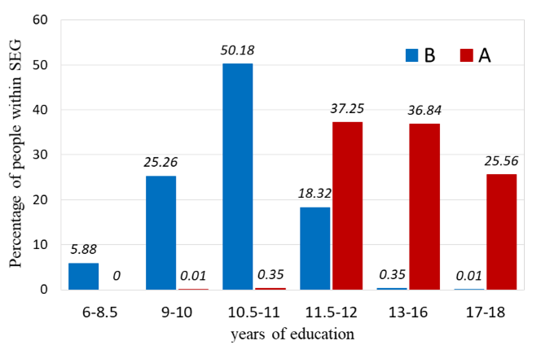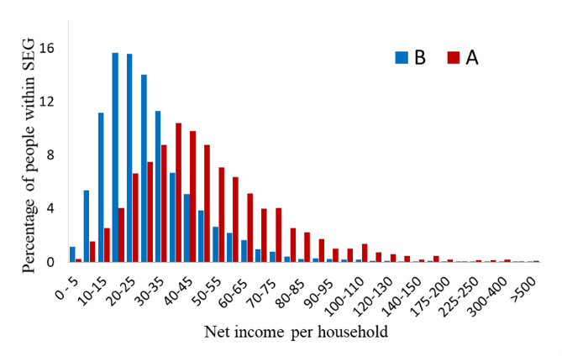
- b)

FIGURE A1.2 Distribution of SEG by age for each sex for the years 2002 and 2012 (For each age category, the percentages by socioeconomic group total 100)
SEG = socioeconomic group defined based on education and income, with group A having the higher, and B the lower socioeconomic status.

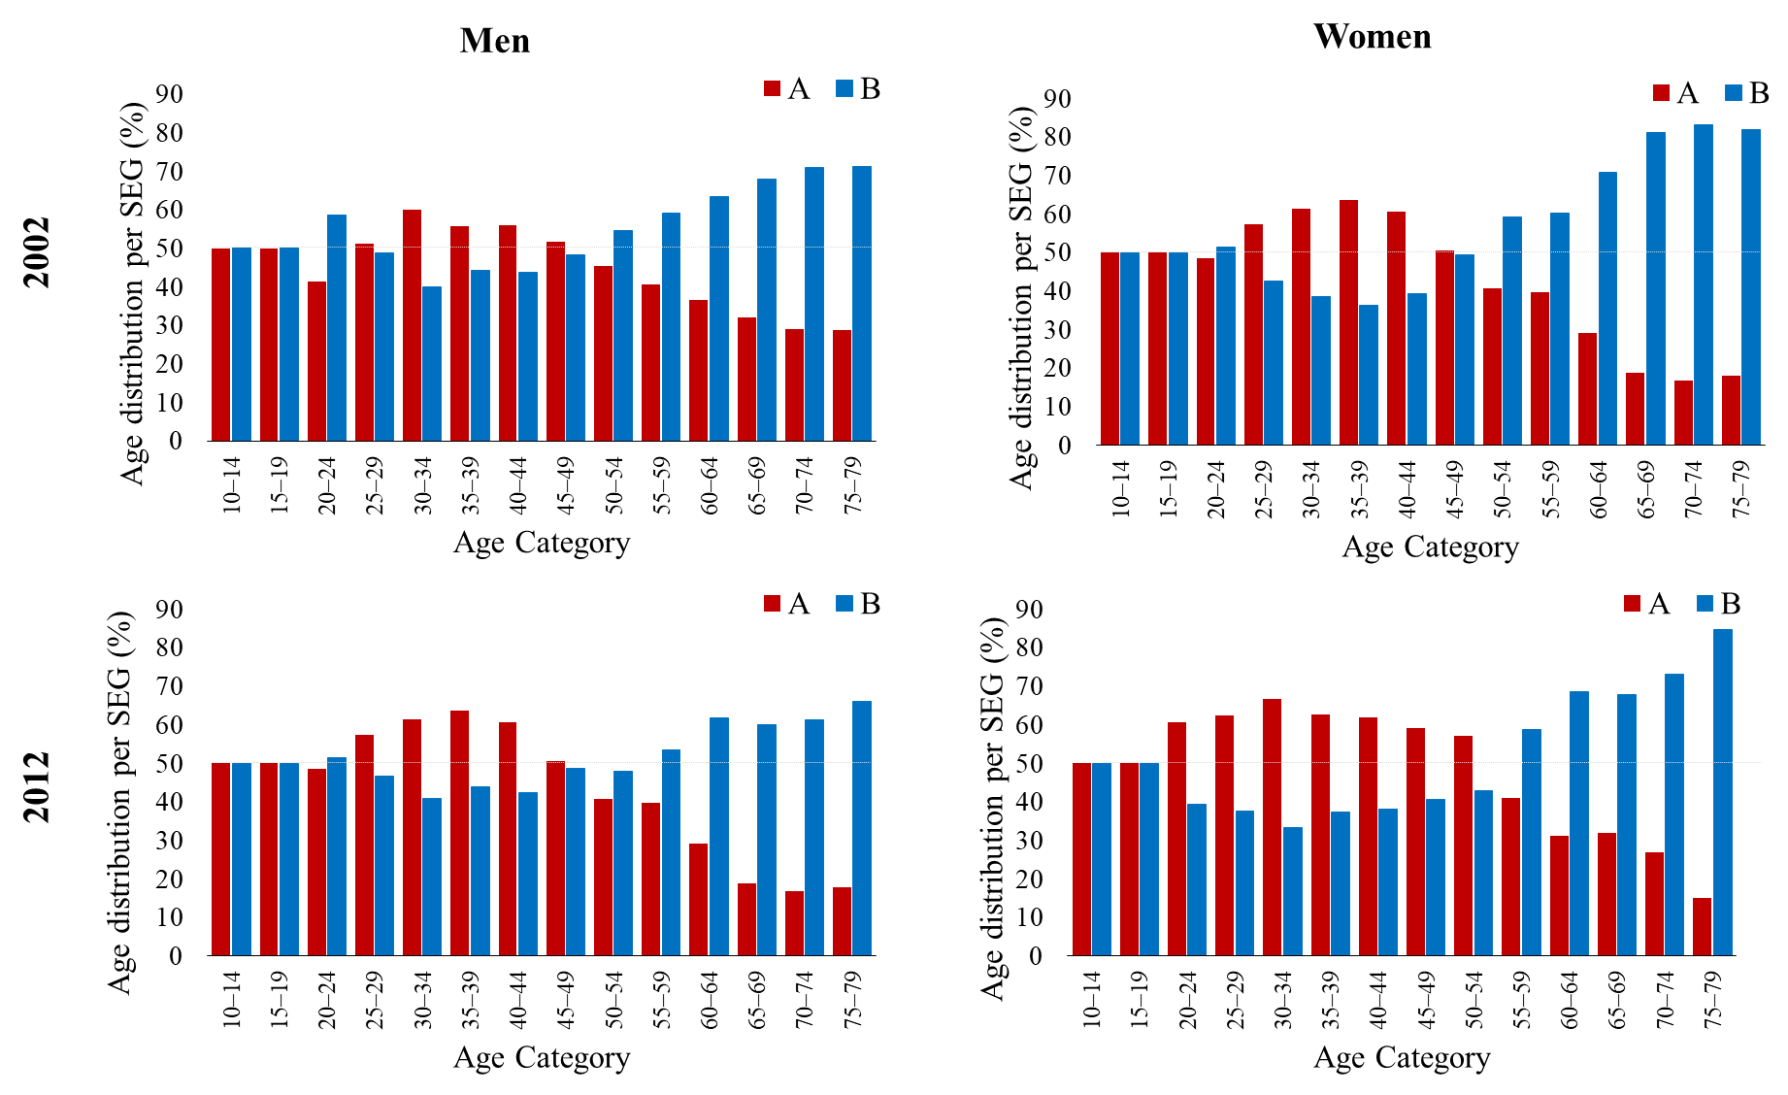

FIGURE A1.3 Current smoking prevalence by age for each sex for the years 2002 and 2012
Socioeconomic group defined based on education and income, with group A having the higher, and B the lower socioeconomic status.

