Carcinoma-associated fibroblast-derived lysyl oxidase-rich extracellular vesicles mediate collagen crosslinking and promote epithelial-mesenchymal transition

Supplementary figures

Figure S1

Figure S1. The biological functions of CAFs.
(a) Immunofluorescent staining for pan-cytokeratin, vimentin, FSP-1, FAP, α-SMA and LOX in CAF-S1/S2/S3/S4 and NF. Scale bar = 50 µm. (b) Western blot analysis of vimentin, FSP-1, FAP and α-SMA in NF and CAF-S1/S2/S3/S4. Left: images of protein bands. Right: quantification results. (c) CCK-8 assay to compare UM-SCC6 proliferation induced by NF and CAF-S1/S2/S3/S4 CM. (d) Wound healing assay to evaluate UM-SCC6 migration abilities induced by NF and CAF-S1/S2/S3/S4 CM. Left: Images of UM-SCC6 migration induced by the indicated CM. Right: quantification analysis of UM-SCC6 migration rate. ns, not significant; * p < 0.05; ** p < 0.01; *** p < 0.001.
Figure S2

Figure S2. sEV separation and characteristics.
(a) Steps of sEV separation. (b) TEM images of sEVs. Scale bar = 100 nm. (c) Western blot analysis of CD63, CD9, HSP70, and CALNEXIN in sEVs. (d) Size distribution and concentration of sEVs.
Figure S3

Figure S3. Interaction of UM-SCC6 sEVs with NFs and ECM.
(a) NFs (red) were cultured for 12 h, then incubated with UM-SCC6 sEVs (green) for another 12 h. sEVs were internalized into NFs (red) in large numbers (arrows). (b) NF (red) were cultured for 72 h, then incubated with UM-SCC6 sEVs (green) for another 12 h. sEV were mostly internalized into NFs (arrows). Small numbers of sEVs bound to the ECM (arrowheads). Scale bar = 10 µm.
Figure S4
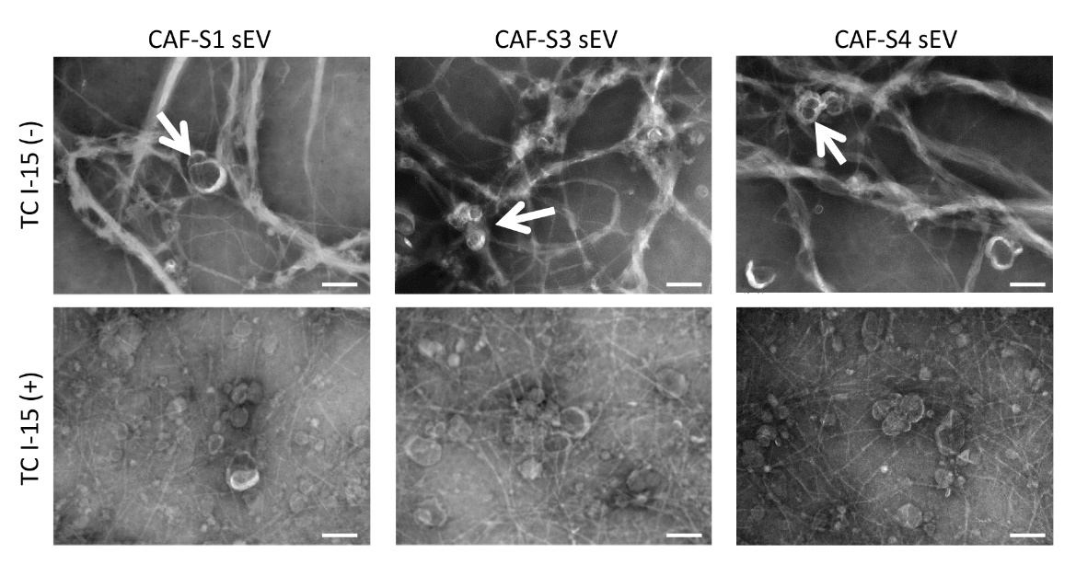

Figure S4. TEM images of collagen crosslinking induced by CAF-S1/S3/S4 sEVs.
Thick collagen fibers associated with sEVs (arrow) were observed (top panel). TC I-15 treatment inhibited CAF sEV-induced collagen crosslinking (bottom panel). Scale bar = 100 nm.

Figure S5

Figure S5. Examination of UM-SCC6 xenografts treated with CAF sEVs with or without BAPN.
(a) The volumes of UM-SCC6 xenografts in the CAF-S2/S4 sEV group were significantly larger than those in the CAF-S2/S4 sEVs+ BAPN group. (b) Photos of nude mice with subcutaneous xenografts in different groups. (c) Weights of nude mice and xenografts. Mouse weight did not differ significantly between the CAF-S2/S4 sEV and CAF-S2/S4 sEVs + BAPN groups. BAPN treatment decreased the weight of xenograft tumors induced by CAF-S2/S4 sEVs. *p < 0.05; ns, not significant.

