Title Page
Supplementary material for: The relationship between perceived barriers for physical activity and depression in low active community-dwelling women

C.A. Figueroa¹, A. Aguilera^{1,3}, T.J. Hoffmann², Y. Fukuoka⁴

¹School of Social Welfare, University of California, Berkeley, United States
²Department of Epidemiology & Biostatistics, University of California, San Francisco, and Office of Research, School of Nursing, University of California, San Francisco
³Zuckerberg San Francisco General Hospital, Department of Psychiatry and Behavioral Sciences, University of California, San Francisco

⁴Department of Physiological Nursing, School of Nursing, University of California, San Francisco

Number of Supplementary Figures: 1
Number of Supplementary Tables: 5
*Corresponding author
Caroline Figueroa
102 Haviland Hall
Berkeley, CA 94720-7400
c.a.figueroa@berkeley.edu

Supplementary Figure 1. The relationship between the Physical Activity Barriers score and depression using a linear spline model

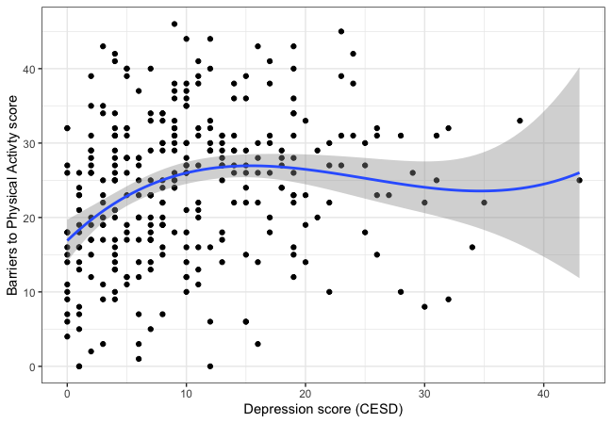

Supplementary Table 1. Mean and total barriers subscale scores for women with high and low depression scores (based on CESD cut-off scores of 16). For not normally distributed scales, we present the percentages of women with greater or lower than the sample’s median subscale scores.

 | <16 (low depression) | ≥16 (high depression)
 | (n=245) | (n=73)
Barriers sum score
Mean (SD) | 23.5 (10.0) | 26.2 (9.65)
Time
Mean (SD) | 4.12 (2.72) | 4.60 (2.55)
Social Influence
Mean (SD) | 3.44 (2.09) | 3.82 (2.10)
Lack of energy
Mean (SD) | 4.04 (2.66) | 4.67 (2.56)
Will power
<median | 144 (58.8%) | 34 (46.6%)
≥median | 101 (41.2%) | 39 (53.4%)
Fear of injury
<median | 130 (53.1%) | 34 (46.6%)
≥median | 115 (46.9%) | 39 (53.4%)
Lack of skills
<median | 128 (52.2%) | 34 (46.6%)
≥median | 117 (47.8%) | 39 (53.4%)
Lack of resources
<median | 140 (57.1%) | 37 (50.7%)
≥median | 105 (42.9%) | 36 (49.3%)

Multivariate regression analyses to examine relationships with depression scores and the barrier subscales

Supplementary Table 2. Relationship between lack of time and depression scores
 | Time
Predictors | Estimates | CI | p
(Intercept) | 6.18 | 4.03 – 8.32 | <0.001
age 10 year¹ | -0.04 | -0.07 – -0.02 | 0.001
Paid full or part-time  employment | 1.30 | 0.65 – 1.95 | <0.001
Children living at home | 0.16 | -0.55 – 0.86 | 0.661
Never married² | -0.13 | -0.79 – 0.54 | 0.711
Divorced/widowed² | -0.29 | -1.05 – 0.48 | 0.460
Driving in past week | 0.25 | -0.50 – 1.00 | 0.510
BMI | -0.03 | -0.08 – 0.02 | 0.228
Depression scores (CESD) | 0.02 | -0.01 – 0.06 | 0.193

Supplementary Table 3. Relationship between fear of injury and depression scores
 | Fear of Injury
Predictors | Odds Ratios | CI | p
(Intercept) | 0.12 | 0.02 – 0.71 | 0.019
age 10 year¹ | 1.03 | 1.01 – 1.05 | 0.010
Paid full or part-time  employment | 1.33 | 0.78 – 2.26 | 0.293
Children living at home | 0.75 | 0.42 – 1.34 | 0.334
Never married² | 0.80 | 0.47 – 1.37 | 0.416
Divorced/widowed² | 1.23 | 0.66 – 2.27 | 0.517
Driving in past week | 0.42 | 0.23 – 0.78 | 0.006
BMI | 1.03 | 0.99 – 1.07 | 0.147
Depression scores (CESD) | 1.02 | 1.00 – 1.05 | 0.100

Supplementary Table 4. Relationship between lack of skill and depression scores
 | Lack of skill
Predictors | Odds Ratios | CI | p
(Intercept) | 0.94 | 0.17 – 5.25 | 0.947
age 10 year¹ | 1.01 | 0.99 – 1.03 | 0.205
Paid full or part-time  employment | 0.79 | 0.47 – 1.33 | 0.376
Children living at home | 0.83 | 0.48 – 1.46 | 0.526
Never married² | 0.96 | 0.57 – 1.62 | 0.876
Divorced/widowed² | 0.99 | 0.54 – 1.82 | 0.974
Driving in past week | 0.50 | 0.27 – 0.91 | 0.024
BMI | 0.99 | 0.96 – 1.03 | 0.700
Depression scores (CESD) | 1.03 | 1.00 – 1.06 | 0.057

Supplementary Table 5. Relationship between lack of resources and depression scores
 | Lack of resources
Predictors | Odds Ratios | CI | p
(Intercept) | 8.81 | 1.47 – 52.97 | 0.017
age 10 year¹ | 0.97 | 0.94 – 0.99 | 0.001
Paid full or part-time  employment | 1.59 | 0.92 – 2.74 | 0.094
Children living at home | 0.71 | 0.40 – 1.27 | 0.251
Never married² | 1.26 | 0.73 – 2.16 | 0.400
Divorced/widowed₂ | 0.94 | 0.50 – 1.77 | 0.855
Driving in past week | 0.79 | 0.43 – 1.46 | 0.457
BMI | 0.97 | 0.93 – 1.01 | 0.135
Depression scores (CESD) | 1.03 | 1.00 – 1.06 | 0.061

Supplementary Table 6. Relationship between lack of willpower and depression scores
 | Lack of will power
Predictors | Odds Ratios | CI | p
(Intercept) | 3.58 | 0.64 – 20.10 | 0.147
age 10-year¹ | 0.97 | 0.95 – 0.99 | 0.013
Paid full or part-time  employment | 0.86 | 0.51 – 1.45 | 0.570
Children living at home | 0.86 | 0.49 – 1.51 | 0.591
Never married² | 0.92 | 0.54 – 1.56 | 0.755
Divorced/widowed² | 0.68 | 0.36 – 1.26 | 0.220
Driving in past week | 1.15 | 0.63 – 2.10 | 0.658
BMI | 0.99 | 0.96 – 1.03 | 0.735
Depression scores (CESD) | 1.03 | 1.00 – 1.05 | 0.073
CES-D: Center for Epidemiological Studies Depression Scale. ¹Age was divided into 10-year intervals to increase interpretability. ²being married was the reference level.

