Supplementary Materials for
Understanding the Efficacy of Concentrated Interstitial Carbon in Enhancing the Pitting Corrosion Resistance of Stainless Steel

Tianshu Li,ª Szu-Chia Chien,^{b} Zhe Ren,^{c} Wolfgang Windl,^{b} Frank Ernst,^{c} and G. S. Frankel^{a,*}
ªFontana Corrosion Center, The Ohio State University, Columbus, OH 43210, USA
^{b}Department of Materials Science and Engineering, The Ohio State University, Columbus, OH 43210, USA
^{c}Department of Materials Science and Engineering, Case Western Reserve University, Cleveland, OH 44106, USA
*E-mail: frankel.10@osu.edu

This file includes:
Supplementary Text
Supplementary Figures 1 to 4
Supplementary References

Supplementary Text
Pit Growth Stability
The concentration of dissolved metal cations at the pit surface (C_{surf}) must be maintained above a critical value (C_{crit}) to sustain the aggressive local environment required for the active metal dissolution.^{1, 2, 3, 4} The resistance to stable pitting corrosion after the passive film breakdown thus depends on the competition between the diffusion rate of the metal cations out of pit and the maximum pit dissolution rate at the pit surface (i_{diss,max}),² as depicted in Supplementary Figure 1. For a fixed temperature and pit chemistry, i_{diss,max} is determined by E_{max} = E_{app} − Φ_{sol}, where E_{max} is the maximum potential that can be applied at the pit surface at a given applied potential (E_{app}), and Φ_{sol} is the total ohmic potential drop in the bulk solution and pit solution.² Note that Φ_{sol} does not include the potential drop across the salt film. When i_{diss,max} is larger than the critical diffusion current density (i_{diff,crit}) associated with C_{crit}, the least aggressive local environment required for active dissolution can be maintained and thus a stable pit can form, otherwise, the pit will repassivate.² If i_{diss,max} further exceeds the diffusion-limited current density (i_{lim}) associated with saturation concentration of metal cation (C_{sat}), a salt film will precipitate on the pit surface, ignoring supersaturation. Consequently, the pit growth will transition from charge transfer control to diffusion control.² Therefore, stable pits are more likely to form in an alloy with large i_{diss,max} and are more likely to transition from charge transfer to diffusion control. In contrast, if an alloy has a small i_{diss,max}, pit growth stability will be low and the transition to stable growth will be inhibited. Therefore, the pitting corrosion resistance of such an alloy can still be high even if the passive film is not very protective.
Characterization of Carburized Foils and Wires
Phase composition analysis was performed on foil samples using an X-ray diffractometer (Discover D8, Bruker) operating with mono-chromatic Co-K_{α1} radiation (λ = 0.179 nm). Supplementary Figure 2 shows X-ray diffractograms of the near-surface region for the carbon infused zone on both untreated and carburized SS316 foils. The patterns are plotted as a function of spatial frequency (reciprocal spacing) q := 2sin[θ]/λ, where θ denotes the usual diffraction angle. Therefore, the abscissa is independent of the X-ray wavelength λ. Four characteristic peaks of austenite were observed in the untreated foil, which correspond to the spatial frequencies q₁₁₁, q₂₀₀, q₂₂₀, q₃₁₁. The diffractograms from the carburized foils exhibit the same peaks, but they are broader and shifted towards lower spatial frequencies, q, i.e. larger plane spacings, d. The near-surface lattice parameter of carburized foils has been reported to be 2.2% to 2.3% larger than that of untreated foils.⁵ Apart from austenite peaks, no other peaks are observed, indicating that the volume fraction of hypothetical carbide precipitates is below the detection threshold (0.01 volume fraction) of XRD under the conditions employed here. Accordingly, it can be assumed that all carbon atoms reside in octahedral interstices of the austenite’s A1 crystal structure.
To gain insights into the spatial distribution of elements in the carburized wire, a cross section of LTC-treated SS316 wire was prepared. The wire was mounted in epoxy and polished with diamond suspension down to 1 µm. To avoid sample charging issues during scanning electron microscopy (SEM) imaging, a 15 nm Pd coating was sputtered on the mount surface by a sputter coater (Denton Vacuum Desk IV). Then, the sputter coated cross section of the wire was characterized by SEM (Helios NanoLab 650, FEI), equipped with energy-dispersive X-ray spectroscopy (EDS) operating with a silicon drift detector (Oxford Instruments). Supplementary Figures 3a and 3b are secondary electron (SE) and backscattered electron (BSE) images of a polished cross section of a carburized SS316 wire, respectively. Both the SE image, which reflects primarily the surface morphology, and the BSE image, which is sensitive to the atomic number, Z, exhibit homogeneity in grayscale. EDS maps of the major elements, including Fe, Ni, Cr, and C, are uniform across the carburized SS316 wire, as shown in Supplementary Figure 3c. The average atomic fraction of carbon in the entire cross section is X_{C} = 0.10. Based on the diffractogram in Supplementary Figure 2, the carbon is entirely distributed in interstitial sites of the austenite. Additionally, the diameter of the SS316 wire increased about 5% after LTC treatment. This expected global dimension increase arises from lattice expansion induced by concentrated interstitial carbon, as shown in X-ray diffractograms in Supplementary Figure 2.

Decrease in Conduction Electron Concentration
According to Mott,^{6, 7} the s-electrons should be itinerant. Therefore, SS316 with an assumed composition of 67 wt.% Fe (2 s electrons), 14 wt.% Ni (2 s electrons), 17 wt.% Cr (1 s electron) and 2 wt.% Mo (1 s electron) should on average have 1.8 itinerant electrons per metal atom. If there are 10 at.% interstitial carbon in the alloy as in the samples of Supplementary Reference 8,⁸ each of them will localize 6 s-electrons from its metal neighbors in its 6 covalent bonds, which will decrease the average number of itinerant electrons per metal atom by 6 × 0.1 = 0.6 electrons or 0.6/1.8 = 33%, which is in excellent agreement with the 29% measured in Supplementary Reference 8.⁸

Supplementary Figures
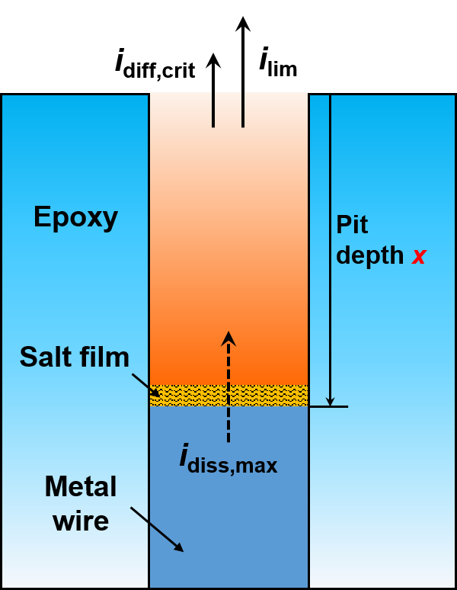
Supplementary Figure 1. Schematic view of an one-dimensional (1D) pit with depth x. i_{diss,max} represents the maximum dissolution current density at the pit surface. i_{diff,crit} represents the critical diffusion current density associated with critical concentration for repassivation (C_{crit}). i_{lim} represents the diffusion limited current density associated with saturation concentration (C_{sat}).

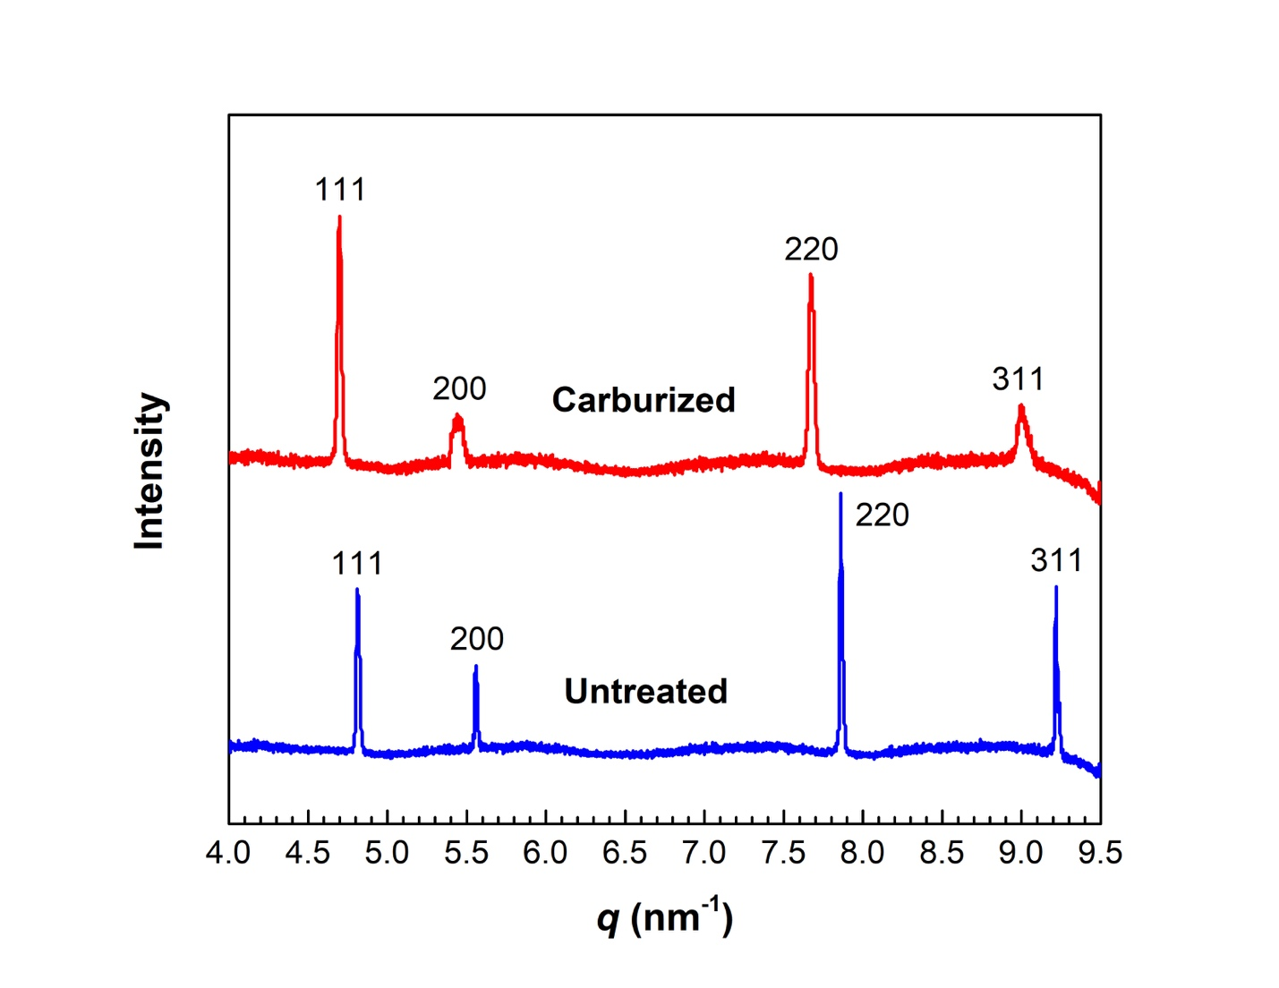
Supplementary Figure 2. X-ray diffraction patterns of untreated and carburized SS316 foils.

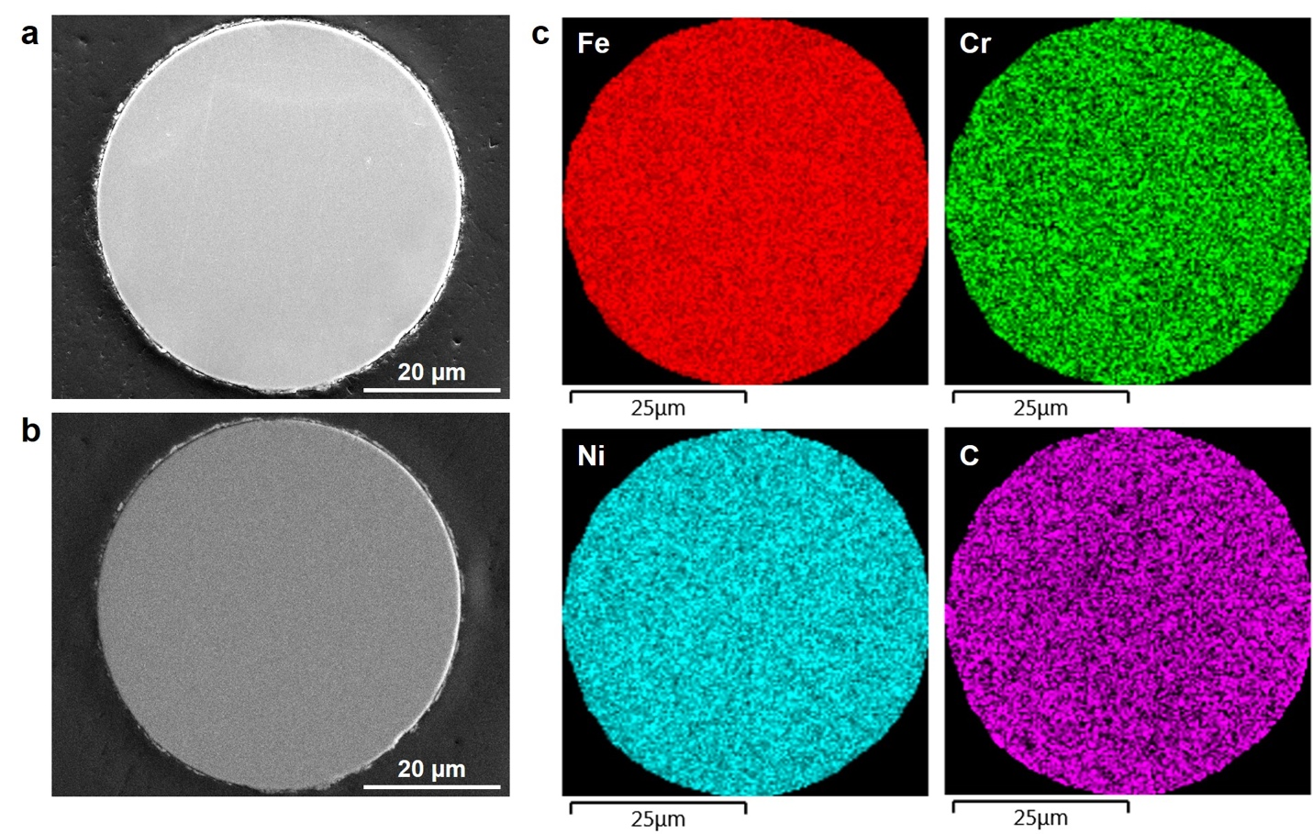
Supplementary Figure 3. Cross section of carburized SS316 wire. (a) Secondary electron image. (b) Backscattered electron image. (c) EDS elemental maps.

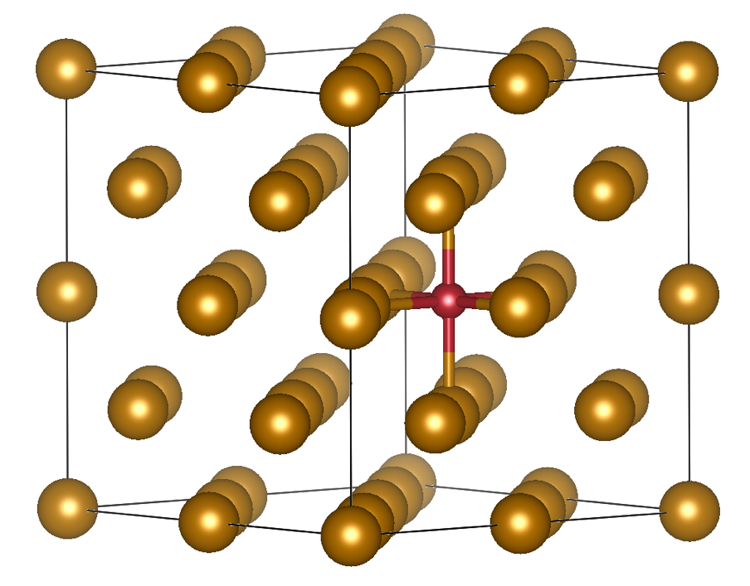
Supplementary Figure 4. One interstitial carbon atom (small red) occupying an octahedral site formed by 6 metal atoms (large gold) in a 32-metal-atom supercell obtained by stacking FCC cells.
Supplementary Reference
1. Gaudet GT, Mo WT, Hatton TA, Tester JW, Tilly J, Isaacs HS, et al. MASS-TRANSFER AND ELECTROCHEMICAL KINETIC INTERACTIONS IN LOCALIZED PITTING CORROSION. Aiche Journal 1986, 32(6): 949-958.

2. Li T, Scully JR, Frankel GS. Localized Corrosion: Passive Film Breakdown vs. Pit Growth Stability: Part III. A Unifying Set of Principal Parameters and Criteria for Pit Stabilization and Salt Film Formation. Journal of The Electrochemical Society 2018, 165(11): C762-C770.

3. Li T, Scully JR, Frankel GS. Localized Corrosion: Passive Film Breakdown vs. Pit Growth Stability: Part IV. The Role of Salt Film in Pit Growth: A Mathematical Framework. Journal of The Electrochemical Society 2019, 166(6): C115-C124.

4. Li T, Scully JR, Frankel GS. Localized Corrosion: Passive Film Breakdown vs Pit Growth Stability: Part V. Validation of a New Framework for Pit Growth Stability Using One-Dimensional Artificial Pit Electrodes. Journal of The Electrochemical Society 2019, 166(11): C3341-C3354.

5. Ren Z, Heuer AH, Ernst F. Ultrahigh-strength AISI-316 austenitic stainless steel foils through concentrated interstitial carbon. Acta Materialia 2019, 167: 231-240.

6. Mott NF. A discussion of the transition metals on the basis of quantum mechanics. Proceedings of the Physical Society 1935, 47(4): 571-588.

7. Mott NF. The electrical conductivity of transition metals. Proceedings of the Royal Society of London Series A-Mathematical and Physical Sciences 1936, 153(880): 699-717.

8. Ren Z, Ernst F. Electronic impact of concentrated interstitial carbon on physical properties of AISI-316 austenitic stainless steel. Acta Materialia 2019, 173: 96-105.

