Supplementary materials
Supplementary Table S1 The prevalence of metabolic abnormalities in RA patients with MAFLD or NAFLD
Characteristics | RA patients  (n=513) | No-MAFLD  (n=403) | MAFLD  (n=110) | P* |  | No-NAFLD  (n=408) | NAFLD  (n=105) | P#
BMI, kg/m² | 21.7±3.4 | 21.1±3.0 | 24.1±3.7 | <0.001 |  | 21.1±3.0 | 24.1±3.7 | <0.001
Overweight/obese, n (%) | 168 (32.7) | 99 (24.6) | 69 (62.7) | <0.001 |  | 104 (25.5) | 64 (61.0) | <0.001
WC (male), cm | 82.3±9.6 | 80.8±8.8 | 87.8±10.8 | 0.003 |  | 81.1±8.9 | 86.6±11.1 | 0.018
WC (female), cm | 78.7±9.7 | 76.6±8.5 | 87.0±9.7 | <0.001 |  | 76.7±8.5 | 86.2±10.4 | <0.001
Elevated WC, n (%) | 198 (38.6) | 126 (31.3) | 72 (65.5) | <0.001 |  | 132 (32.4) | 66 (62.9) | <0.001
SBP, mmHg | 125.7±20.0 | 124.4±19.9 | 130.4±19.8 | 0.005 |  | 124.3±19.9 | 131.1±19.6 | 0.002
DBP, mmHg | 78.8±11.3 | 78.3±11.0 | 80.8±11.9 | 0.044 |  | 78.3±11.1 | 81.1±11.8 | 0.021
Elevated BP, n (%) | 255 (49.7) | 183 (45.4) | 72 (65.5) | <0.001 |  | 186 (45.6) | 69 (65.7) | 0.001
HbA1C% | 5.72±1.08 | 5.59±0.82 | 6.18±1.61 | 0.001 |  | 5.59±0.82 | 6.19±1.63 | 0.001
FPG, mmol/L | 5.62±2.19 | 5.52±2.11 | 5.95±2.46 | 0.095 |  | 5.51±2.11 | 6.02±2.46 | 0.052
FINS, IU/mL | 9.96±6.26 | 9.06±5.32 | 13.72±8.26 | <0.001 |  | 9.18±5.42 | 13.24±8.24 | <0.001
HOMA-IR | 2.54±2.33 | 2.27±1.99 | 3.67±3.18 | 0.002 |  | 2.29±2.00 | 3.56±3.19 | 0.004
T2DM, n (%) | 79 (15.4) | 45 (11.2) | 34 (30.9) | <0.001 |  | 48 (11.8) | 31 (29.5) | <0.001
Prediabetes, n (%) | 183 (35.7) | 145 (36.0) | 38 (34.5) | 0.781 |  | 148 (36.3) | 35 (33.3) | 0.707
Elevated HOMA-IR, n (%) | 105 (20.5) | 69 (17.1) | 36 (32.7) | <0.001 |  | 71 (17.4) | 34 (32.4) | 0.001
TC, mmol/L | 4.90±1.22 | 4.77±1.10 | 5.36±1.48 | <0.001 |  | 4.77±1.10 | 5.39±1.48 | <0.001
TG, mmol/L | 1.12±0.68 | 1.03±0.52 | 1.47±1.00 | <0.001 |  | 1.04±0.53 | 1.46±1.00 | <0.001
Elevated TG, n (%) | 63 (12.3) | 36 (8.9) | 27 (24.5) | <0.001 |  | 38 (9.3) | 25 (23.8) | <0.001
HDL-C, mmol/L | 1.32±0.36 | 1.31±0.35 | 1.34±0.36 | 0.440 |  | 1.31±0.36 | 1.34±0.36 | 0.464
Reduced HDL-C, n (%) | 239 (46.6) | 180 (44.7) | 59 (53.6) | 0.095 |  | 183 (44.9) | 56 (53.3) | 0.120
LDL-C, mmol/L | 3.09±0.88 | 3.00±0.79 | 3.40±1.07 | <0.001 |  | 3.00±0.79 | 3.44±1.07 | <0.001
CRP, mg/L | 7.6 (3.3,27.6) | 8.3 (3.3,30.6) | 6.4 (3.3,21.4) | 0.628 |  | 8.1 (3.3,30.5) | 7.2 (3.3,21.6) | 0.869
Elevated CRP, n (%) | 296 (57.7) | 233 (57.8) | 63 (57.3) | 0.919 |  | 235 (57.6) | 61 (58.1) | 0.927
BMI, body mass index; WC, waist circumference; BP, blood pressure; SBP, systolic blood pressure; DBP, diastolic blood pressure; HbA1C, hemoglobin A1c; FPG, fasting plasma glucose; FINS, fasting insulin; TC, total cholesterol; TG, triglyceride; HDL-C, high-density lipoprotein cholesterol; LDL-C, low-density lipoprotein cholesterol; CRP, C reactive protein
* Compared between RA patients with or without MAFLD
# Compared between RA patients with or without NAFLD

Supplementary Table S2 Comparisons of disease characteristics among RA patients with three subtypes of MAFLD
Characteristics | Overweight/obesity  (n=48) | Lean/normal weight  (n=28) | T2DM  (n=34) | P
Age, years, mean ± SD | 51.9±9.9 | 53.0±9.3 | 58.9±7.6* | 0.003
Female, n (%) | 40 (83.3) | 19 (67.9) | 26 (76.5) | 0.297
Active smoking, n (%) | 7 (14.6) | 6 (21.4) | 9 (26.5) | 0.405
Disease duration, months, median (IQR) | 60 (25,153) | 67 (22,121) | 50 (13,123) | 0.521
Positive RF, n (%) | 35 (72.9) | 20 (71.4) | 24 (70.6) | 0.972
Positive ACPA, n (%) | 32 (66.7) | 20 (71.4) | 29 (85.3) | 0.161
Core disease activity indicators
28TJC, median (IQR) | 2 (0,7) | 4 (1,14) | 4 (1,8) | 0.509
28SJC, median (IQR) | 1 (0,6) | 1 (0,5) | 2 (1,7) | 0.322
PtGA, cm, median (IQR) | 3 (2,6) | 5 (2,6) | 5 (3,7) | 0.509
PrGA, cm, median (IQR) | 3 (2,6) | 4 (2,7) | 5 (3,7) | 0.508
Pain VAS, cm, median (IQR) | 3 (2,5) | 4 (2,5) | 4 (3,6) | 0.404
ESR, mm/h, median (IQR) | 31 (21,52) | 38 (14,78) | 47 (21,66) | 0.287
CRP, mg/L, median (IQR) | 6.4 (3.3,18.9) | 5.7 (3.3,22.8) | 7.0 (3.3,21.8) | 0.121
CDAI, median (IQR) | 14 (5,20) | 15.0 (4.5,32.8) | 17.5 (8.0,28.3) | 0.514
Functional indicator
HAQ-DI, median (IQR) | 0.50 (0.12,1.00) | 0.56 (0.13,1.38) | 0.69 (0.25,1.13) | 0.545
Radiographic indicators
mTSS, median (IQR) | 6 (2,27) | 9 (0,31) | 12 (4,33) | 0.332
JSN subscore, median (IQR) | 1 (0,17) | 4 (0,19) | 3 (0,11) | 0.219
JE subscore, median (IQR) | 7 (2,20) | 9 (3,28) | 10 (4,25) | 0.494
Previous medications
Treatment naïve△, n (%) | 15 (31.3) | 7 (25.0) | 12 (35.3) | 0.682
Glucocorticoid, n (%) | 26 (54.2) | 17 (60.7) | 17 (50.0) | 0.699
csDMARDs, n (%) | 26 (54.2) | 20 (71.4) | 18 (52.9) | 0.257
Biologic agents, n (%) | 2 (4.2) | 1 (3.6) | 5 (14.7) | 0.133
△Treatment naive, without previous corticosteroids or DMARDs treatment for six months before recruited.
RF, rheumatoid factor; ACPA, anti-cyclic citrullinated peptide antibody; 28TJC, 28-joint tender joint counts; 28SJC, 28-joint swollen joint counts; PtGA, patient global assessment of disease activity; PrGA, provider global assessment of disease activity; Pain VAS, pain visual analogue scale; ESR, erythrocyte sedimentation rate; CRP, C reactive protein; CDAI, clinical disease activity index; HAQ-DI, health assessment questionnaire disability index; mTSS, modified total Sharp score; JE, joint erosion; JSN, joint space narrowing; csDMARDs, conventional synthetic disease-modifying anti-rheumatic drugs.
*compared with overweight/obesity group, P<0.05

Supplementary Table S3 Comparisons of liver biochemistry and fibrosis indices among RA patients with three subtypes of MAFLD
Characteristics | Overweight/obesity  (n=48) | Lean/normal weight  (n=28) | T2DM  (n=34) | P
liver biochemistry
ALT, UI/L | 19 (14,28) | 14 (10,23) | 15 (10,25) | 0.031
ULT<ALT<2ULT, n (%) | 6 (12.5) | 4 (14.3) | 3 (8.8) | 0.788
2ULT<ALT<3ULT, n (%) | 0 (0) | 0 (0) | 2 (5.9) | 0.103
3ULT<ALT, n (%) | 0 (0) | 0 (0) | 0 (0) | NA
AST, UI/L | 17 (14,22) | 17 (14,20) | 16 (13,23) | 0.760
ULN <AST<2 ULN, n (%) | 4 (8.3) | 1(3.6) | 4 (11.8) | 0.503
2 ULN <AST< 3 ULN, n (%) | 0 (0) | 0 (0) | 0 (0) | NA
3 ULN <AST, n (%) | 0 (0) | 0 (0) | 0 (0) | NA
GGT, UI/L | 28 (19,42) | 23 (18,39) | 27 (20,56) | 0.595
ULN <GGT<2ULN, n (%) | 9 (18.8) | 3 (10.7) | 4 (11.8) | 0.322
2ULN<GGT<3ULN, n (%) | 1 (2.1) | 2 (7.1) | 1 (2.9) | 0.507
3ULN<GGT, n (%) | 0 (0) | 0 (0) | 4 (11.8)* | 0.010
ALP, UI/L | 74 (63,96) | 84 (64,99) | 86 (71,113) | 0.086
ULN < ALP <2 ULN, n (%) | 1 (2.1) | 1 (3.6) | 4 (11.8) | 0.144
2 ULN <ALP <3 ULN n (%) | 0 (0) | 0 (0) | 0 (0) | NA
3 ULN < ALP, n (%) | 0 (0) | 0 (0) | 0 (0) | NA
TBIL, μmol/L | 8.7 (7.0,10.3) | 9.3 (6.6,10.6) | 7.6 (6.7,10.6) | 0.799
ULN<TBIL<2 ULN, n (%) | 0 (0) | 0 (0) | 1 (2.9) | 0.324
2 ULN <TBIL<3 ULN, n (%) | 0 (0) | 0 (0) | 0 (0) | NA
3 ULN <TBIL, n (%) | 0 (0) | 0 (0) | 0 (0) | NA
ALB, g/L | 35.5 (32.7,39.8) | 34.0 (30.7,36.9) | 34.3 (32.0,36.2) | 0.098
ALB<LLN, n (%) | 16 (33.3) | 13 (46.4) | 18 (52.9) | 0.189
Abnormal LFTs, n (%) | 13 (27.1) | 6 (21.4) | 13 (38.2) | 0.322
Hepatic steatosis scores
FLI | 42.6 (24.3,56.5)# | 10.5 (6.5,18.0) | 29.7 (14.3,66.0)# | <0.001
FLI ≥ 60, n (%) | 3 (6.3) | 0 (0) | 1 (2.9) | 0.361
Liver fibrosis score
FIB-4 | 0.72 (0.51,1.04) | 0.79 (0.51,1.01) | 0.95 (0.71,1.31)* | 0.036
Advanced fibrosis, n (%) | 3 (6.3) | 3 (10.7) | 10 (29.4)* | 0.011
NFS | -1.84 (-2.88,-0.79) | -2.36 (-3.01,-0.80) | -0.64 (-1.27,-0.01)*# | <0.001
Advanced fibrosis, n (%) | 14 (29.2) | 6 (21.4) | 20 (58.8)*# | 0.004
Forns index | 4.84 (4.11,5.77) | 4.61 (3.80,6.22) | 5.62 (4.95,6.77)*# | 0.008
Advanced fibrosis, n (%) | 11 (22.9) | 8 (28.6) | 18 (52.9)* | 0.015
ALT, alanine aminotransferase; AST, aspartate aminotransferase; GGT, γ-glutamyl transferase; ALP, alkaline phosphatase; TBIL, total bilirubin; ALB, albumin; ULN, upper limit of normal; LLN, lower limit of normal; LFTs, liver function tests; FLI, fatty liver index; FIB-4, fibrosis-4 index; NFS, NAFLD fibrosis score
*compared with overweight/obesity group, P<0.05
#compared with lean/normal weight group, P<0.05

Supplementary Table S4 Comparisons of accuracy between MAFLD and NAFLD in identifying CVD events and high 10-years CVD risk in RA patients
Characteristics | NRI |  |  | IDI
Characteristics | OR (95% CI) | P |  | OR (95% CI) | P
CVD events
NAFLD | Ref | Ref |  | Ref | Ref
MAFLD | -0.011 (-0.025, 0.003) | 0.131 |  | -0.002 (-0.007, 0.002) | 0.294
High 10-year CVD risk
NAFLD | Ref | Ref |  | Ref | Ref
MAFLD | 0.012 (-0.014, 0.038) | 0.350 |  | 0.005 (-0.003, 0.013) | 0.197
NRI, net reclassification index; IDI, integrated discrimination improvement

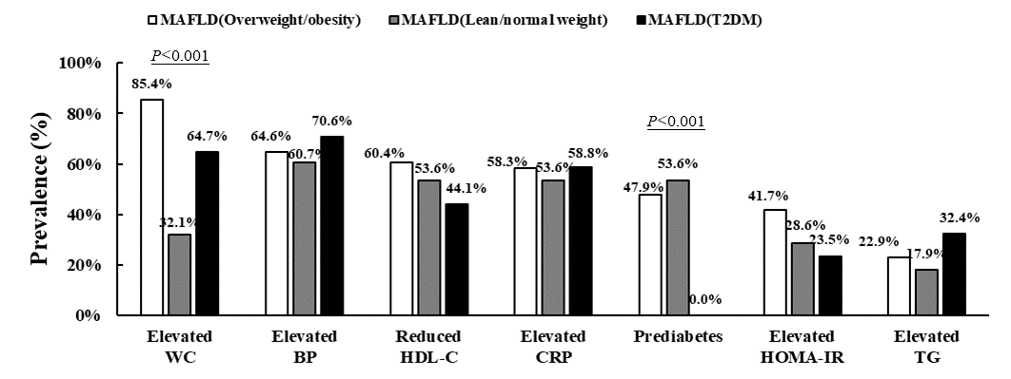
Supplementary Figure S1 The prevalence of metabolic abnormalities among RA patients with three subtypes of MAFLD

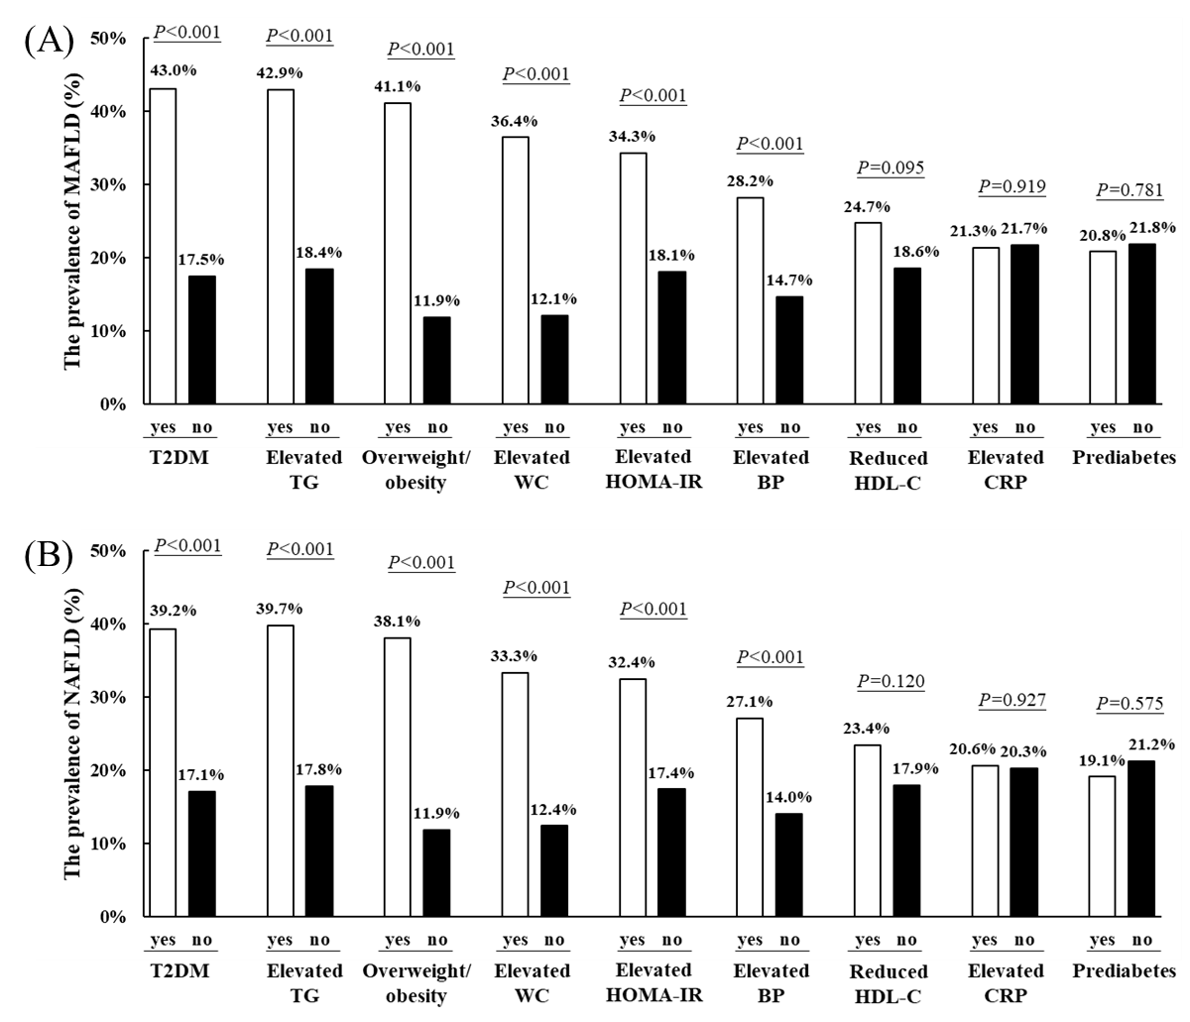
Supplementary Figure S2 The prevalence of MAFLD (A) and NAFLD (B) in RA patients with different metabolic abnormalities

