Supplementary information

Synthesis of 7-alkoxy-isoflavones as potential α-glucosidase inhibitors

Dolores G. Aguila-Muñoz¹, Elizabeth Cervantes-Espinoza², Carlos H. Escalante³, Rsuini U. Gutiérrez³, María C. Cruz-López¹, Fabiola E. Jiménez-Montejo¹, Nemesio Villa-Ruano⁴, Omar Gómez-García³, Joaquín Tamariz³, Aarón Mendieta-Moctezuma^{1,5*}

¹ Centro de investigación en Biotecnología Aplicada, Instituto Politécnico Nacional, Carretera Estatal Santa Inés Tecuexcomax-Tepetitla, Km 1.5, Tepetitla de Lardizábal, 90700 Tlaxcala, Mexico

² Facultad de Ciencias Básicas, Ingeniería y Tecnología, Universidad Autónoma de Tlaxcala, Carretera Apizaquito S/N, San Luis Apizaquito, 90401 Tlaxcala, Mexico

³ Departamento de Química Orgánica, Escuela Nacional de Ciencias Biológicas, Instituto Politécnico Nacional, Prol. Carpio y Plan de Ayala S/N, 11340 Mexico City, Mexico

⁴ Centro Universitario de Vinculación y Transferencia de Tecnología, Benemérita Universidad Autónoma de Puebla, DITCo, Cd. Universitaria, 72579 Puebla, Mexico

⁵ Instituto Tecnológico del Altiplano de Tlaxcala, Carretera Federal San Martin Texmelucan-Tlaxcala, Km 7.5, San Diego Xocoyucan, 90122 Tlaxcala, Mexico

Author to whom correspondence should be addressed; e-mail: amendietam@ipn.mx; epsilon_1409@yahoo.com.mx

Appendix 1. In vitro antifungal activity of the synthesized compounds S1
Appendix 2. ¹H, ¹³C NMR and HRMS spectra of all compounds S2-S44

Table S1 In vitro antifungal activity of synthesized compounds (MIC±SD, n= 15, mg/mL)ª
Compound | C. albicans | S. cerevisiae | S. typhi
2a | 1.27 ± 0.16 | 1.6 ± 0.1 | 1.07 ± 0.2
2b | 2.0 ± 0.01 | 1.67 ± 0.01 | 2.5 ± 0.08
2c | 3.13 ± 0.02 | 1.25 ± 0.05 | 2.50 ± 0.11
3a | 2.07 ± 0.06 | 0.52 ± 0.03
3b | 2.33 ± 0.14 | 1.2 ± 0.29 | 0.80 ± 0.24
4a | 2.13 ± 0.16 | 1.67 ± 0.26 | 2.50 ± 0.19
4b | 2.13 ± 0.10 | 1.73 ± 0.01 | 1.73 ± 0.01
7a | 2.47 ± 0.32 | 2.55 ± 0.1 | 5.1 ± 0.13
7c | 2.27 ± 0.03 | 2.5 ± 0.1 | 5.0 ± 0.11
9a | 1.0 ± 0.01 | 1.3 ± 0.01 | 0.87 ± 0.06
9b | 2.07 ± 0.02 | 1.25 ± 0.03 | 1.67 ± 0.01
Fluconazole | 0.83^{b}
ª MIC values are expressed in mg/mL with significant differences (p<0.05).
^{b} Value is expressed in µg/mL.

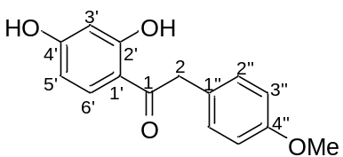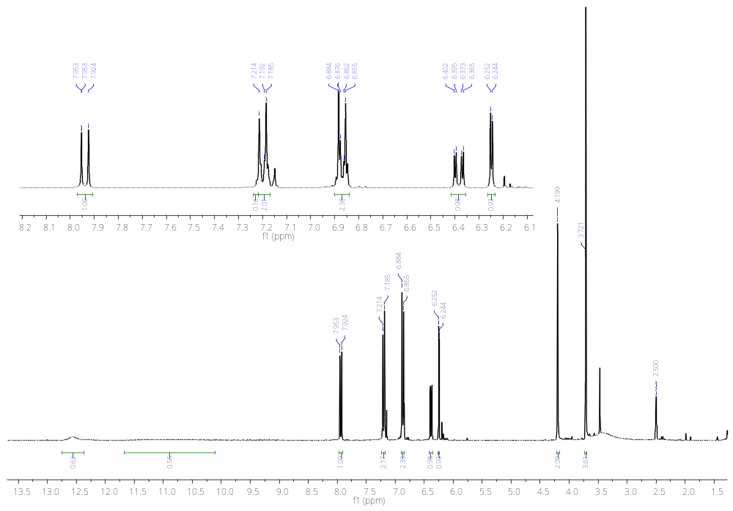
OH
C-4’
OH
C-2’
CH₃O
H-2
H-3’
H-5’
H-2’’
H-3’’
H-6’
Figure S2. ¹H-NMR spectra of compound 7a (300 MHz, DMSO-d₆).
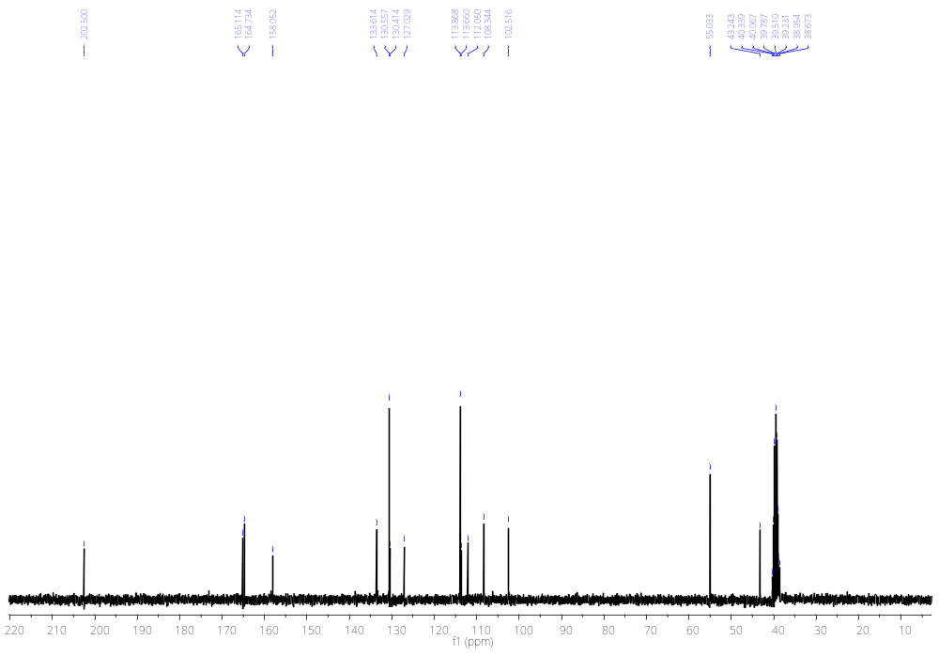
C-2’
C-4’
C-1
C-1’
C-5’
C-2
CH₃O
C-3’
C-3’’
C-1’’
C-2’’
C-6’
Figure S3. ¹³C-NMR spectra of compound 7a (75 MHz, DMSO-d₆).
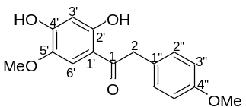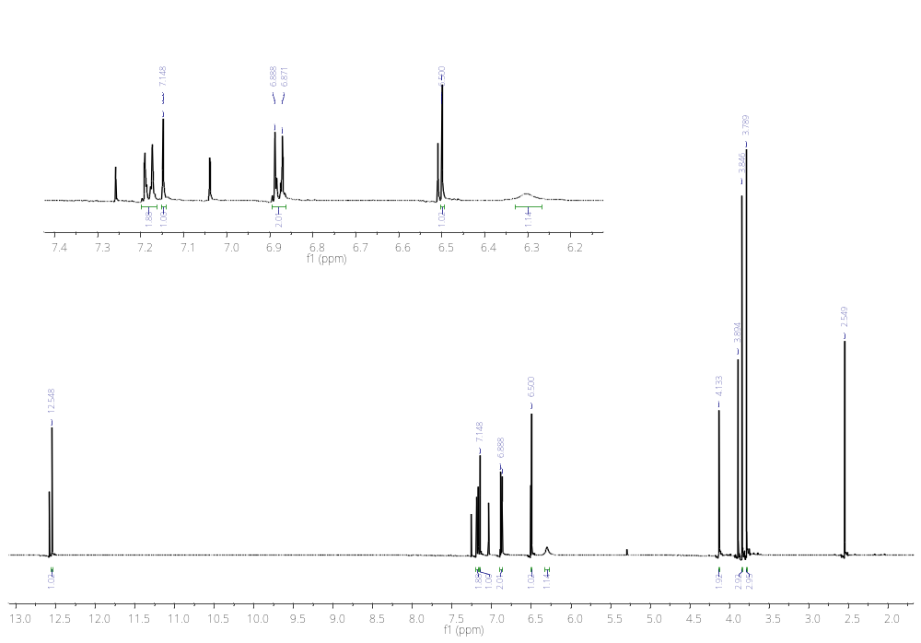
H-2’’
H-3’
OH
C-4’
H-2
CH₃O
H-3’’
H-6’
OH
C-2’
Figure S4. ¹H-NMR spectra of compound 7b (500 MHz, CDCl₃).
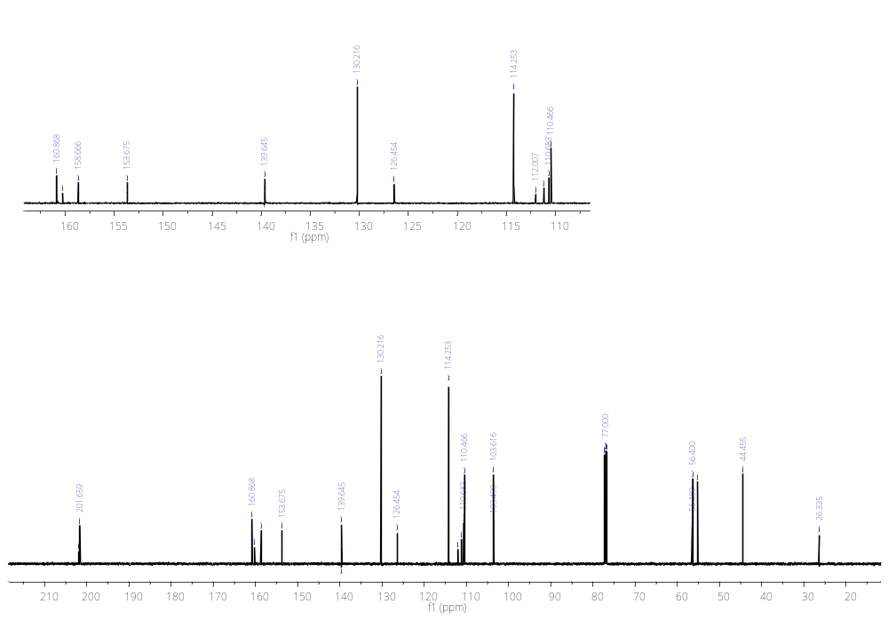
C-2’’
C-3’’
C-1’
C-6’
C-3’
C-1’’
C-5’
C-4’’
C-4’
C-2’
C-1
C-2
CH₃O
Figure S5. ¹³C-NMR spectra of compound 7b (125 MHz, CDCl₃).
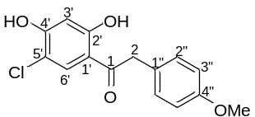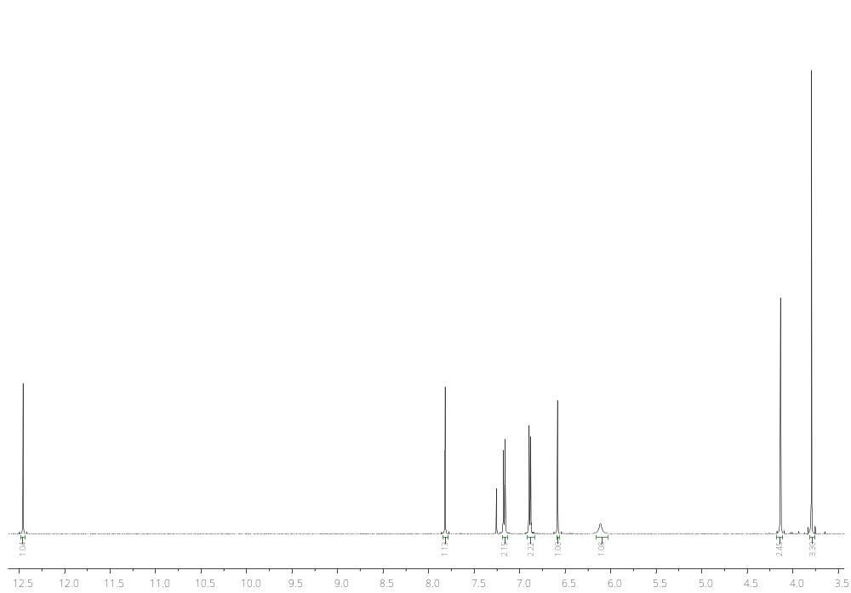
H-3’
CH₃O
H-2
OH
C-4’
H-2’’
H-3’’
OH
C-2
H-6’
Figure S6. ¹H-NMR spectra of compound 7c (500 MHz, CDCl₃).

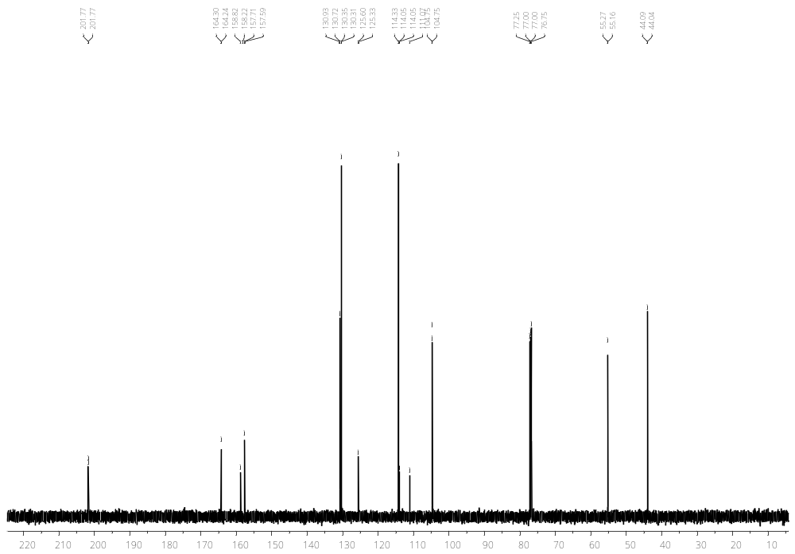
C-2
C-2’
C-4’’
C-4’
C-1’’
C-1’
C-3’
C-5’
C-3’
C-1
CH₃O
C-2’’
C-6’
C-1’
Figure S7. ¹³C-NMR spectra of compound 7c (125 MHz, CDCl₃).
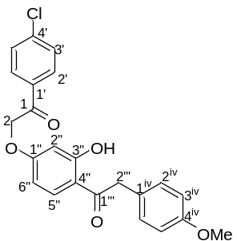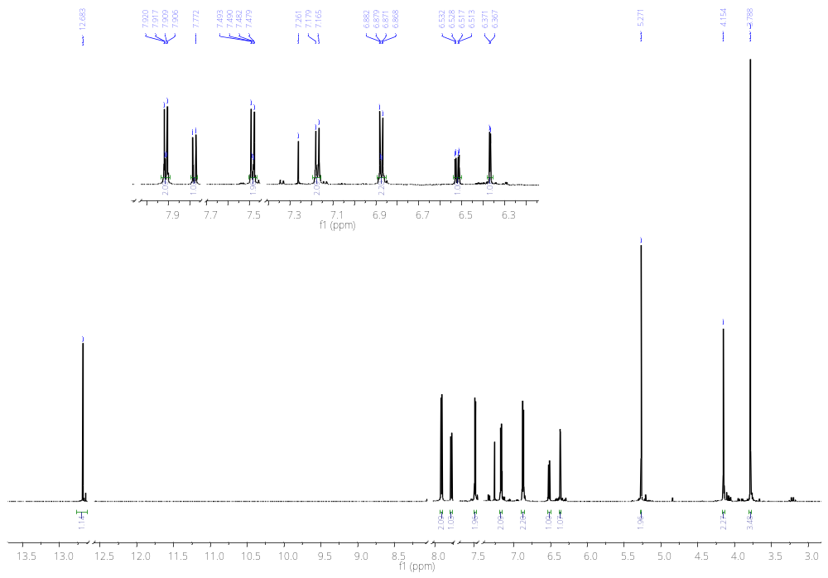
OH
H-3^{iv}
H-2’’’
CH₃O
H-2’’
H-6’’
H-2^{iv}
H-3’
H-2’
H-5’’
H-2
Figure S8. ¹H-NMR spectra of compound 9a (600 MHz, CDCl₃).
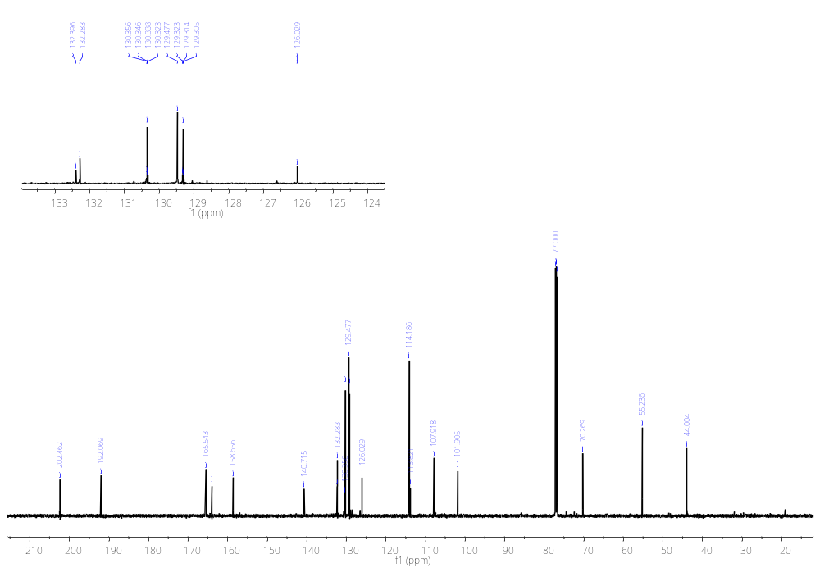
C-1
C-3’
C-2’
C-2^{iv}
C-1’
C-5’’
C-1’’’
C-3’’
C-1’’
C-4^{iv}
C-4’
C-2’’
C-6’’
C-2
CH₃O
C-2’’’
C-1^{iv}
C-3^{iv}
C-4’’
Figure S9. ¹³C-NMR spectra of compound 9a (150 MHz, CDCl₃).
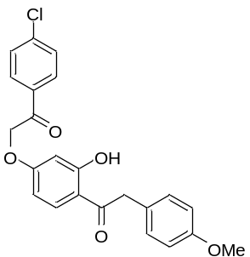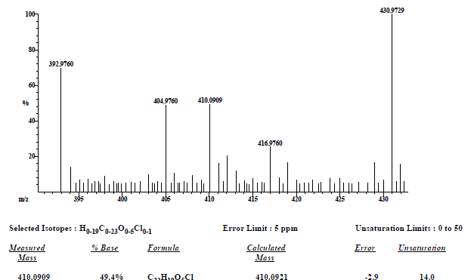
Figure S10. HRMS (EI) spectra of compound 9a.

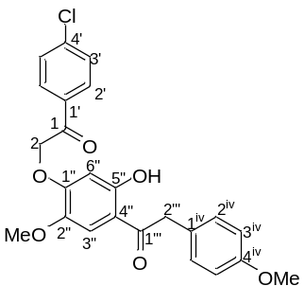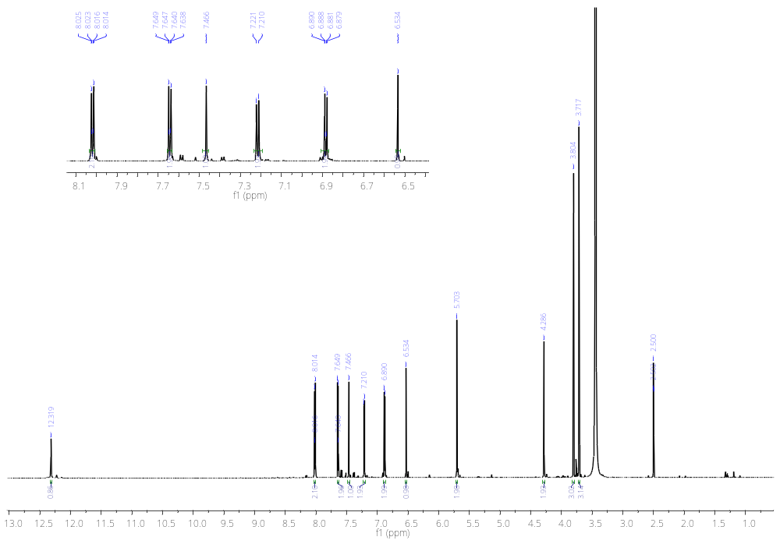
CH₃O
C-2’’
CH₃O
C-4^{iv}
H-2’’
H-2
OH
H-6’’
H-3^{iv}
H-2^{iv}
H-3’
H-3’’
H-2’
Figure S11. ¹H-NMR spectra of compound 9b (600 MHz, DMSO-d₆).
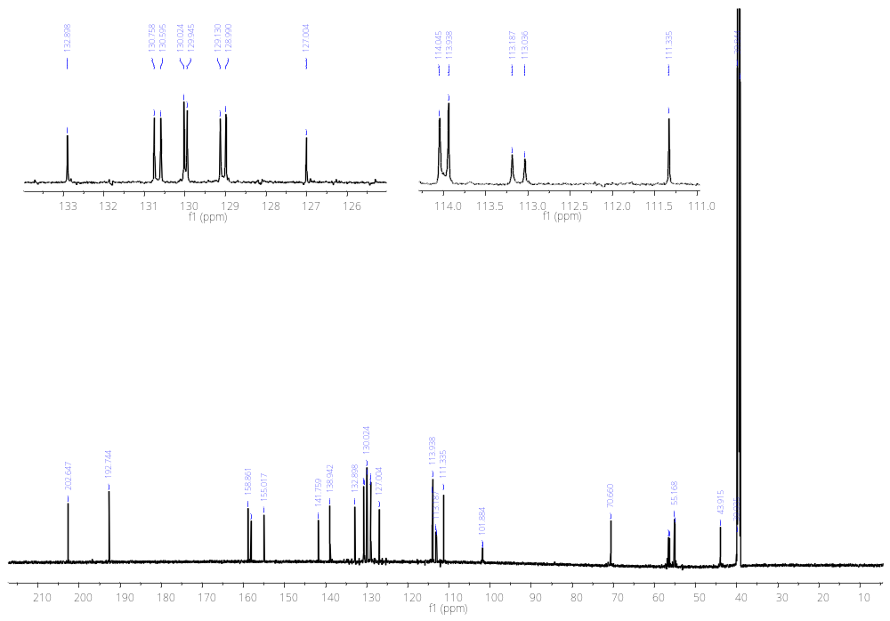
C-4’
C-4^{iv}
C-5’’
C-1’’
C-2’’
C-2
C-3’
C-2’
C-3^{iv}
C-4’’
C-3’’
C-2’’’
CH₃O
C-2’’
CH₃O
C-4^{iv}
C-1
C-1’’’
C-1^{iv}
C-2^{iv}
C-1’
C-6’’
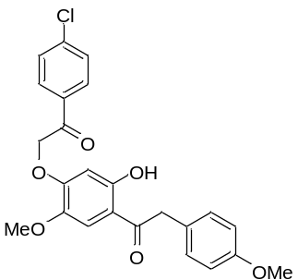Figure S12. ¹³C-NMR spectra of compound 9b (150 MHz, DMSO-d₆).

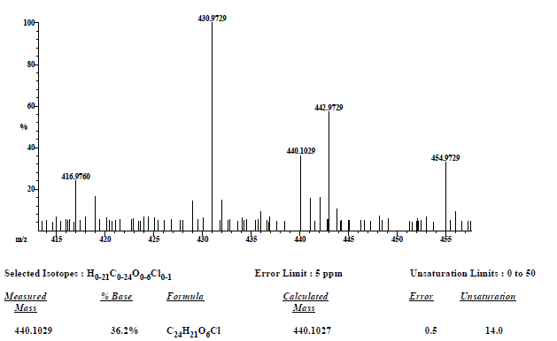
Figure S13. HRMS (EI) spectra of compound 9b.

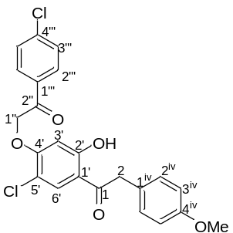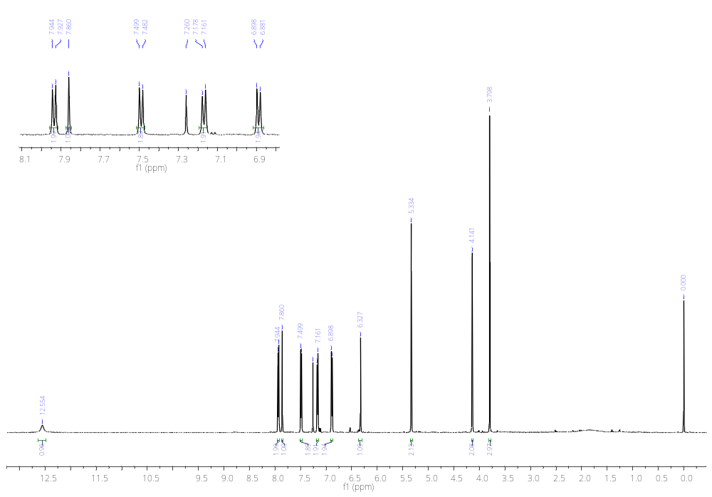
H-2’’’
H-1’’
H-2
H-6’
OH
CH₃O
H-3’
H-3^{iv}
H-2^{iv}
H-3’’’
Figure S14. ¹H-NMR spectra of compound 9c (500 MHz, CDCl₃).
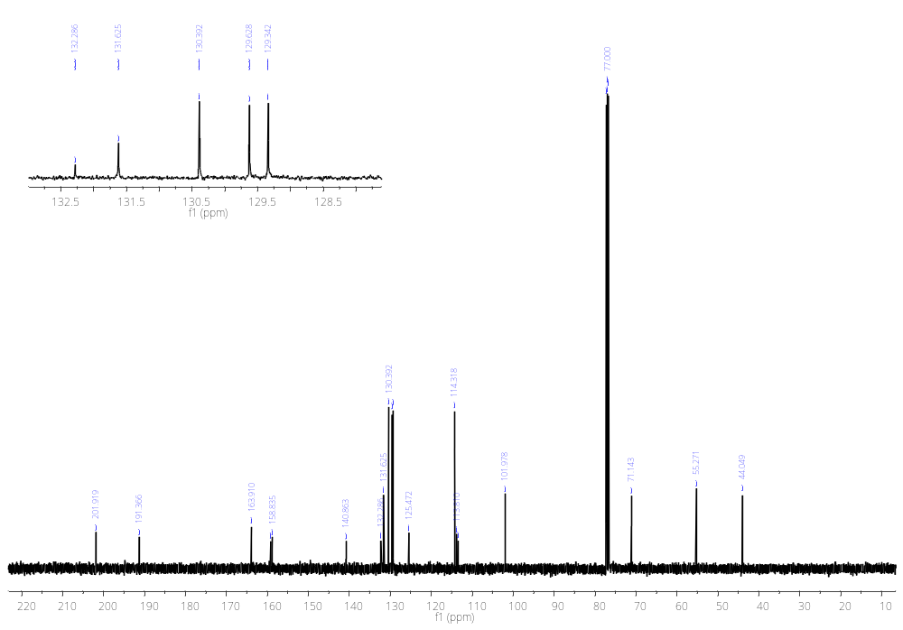
C-3^{iv}
C-1’
C-5’
C-2’
C-4’’’
C-1
C-2’’
C-4’
C-4^{iv}
C-2^{iv}
C-1^{iv}
C-1’’
C-3’’’
C-2’’’
C-6’
C-1’’’
C-3’
C-2
CH₃O
Figure S15. ¹³C-NMR spectra of compound 9c (125 MHz, CDCl₃).
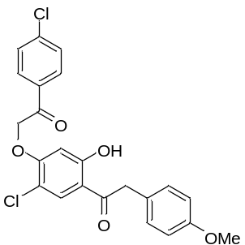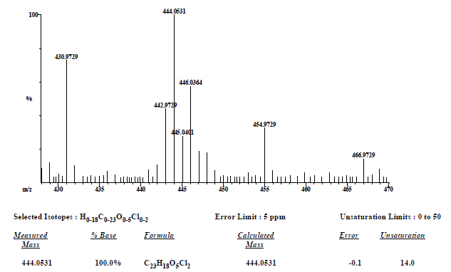
Figure S16. HRMS (EI) spectra of compound 9c.

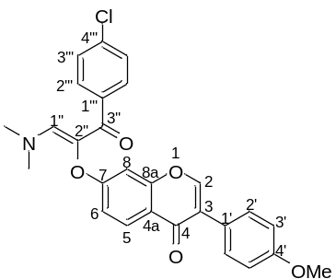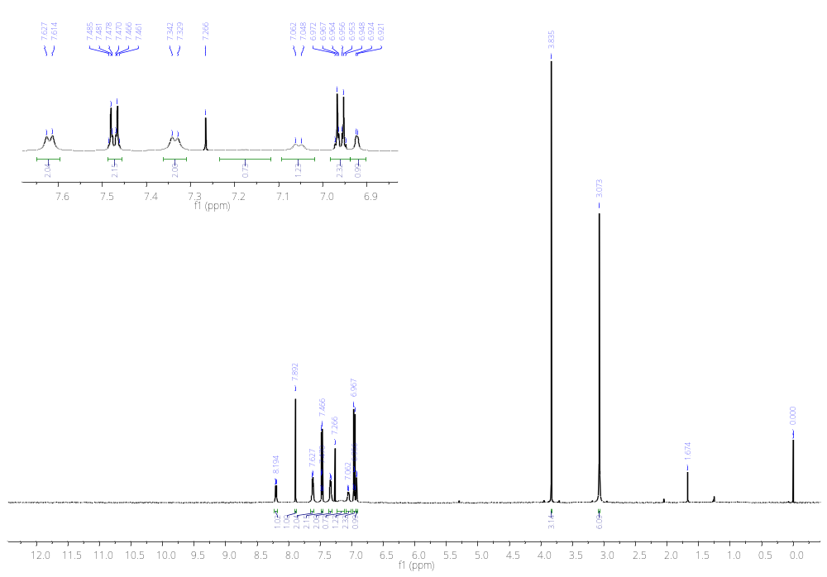
H-5
H-2
H-3’’’
H-1’’
N(CH₃)₂
CH₃O
H-8
H-6
H-3’
H-2’’’
H-2’
Figure S17. ¹H-NMR spectra of compound 3a (600 MHz, CDCl₃).
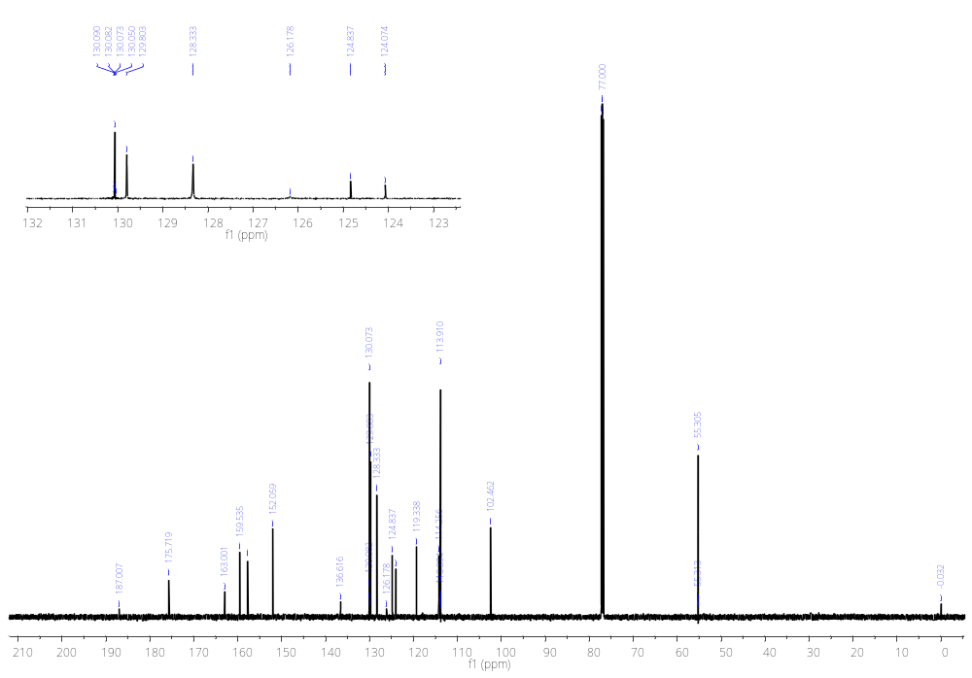
C-2
C-1’’
C-4’
C-8a
C-1’’’
C-4’’’
C-2’’’
C-5
C-3’’’
C-3
C-4a
C-6
C-3’
C-8
N(CH₃)₂
C-7
C-4
C-3’’
C-1’
C-2’’
C-2’
CH₃O
Figure S18. ¹³C-NMR spectra of compound 3a (150 MHz, CDCl₃).
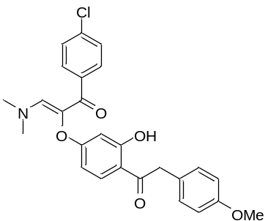
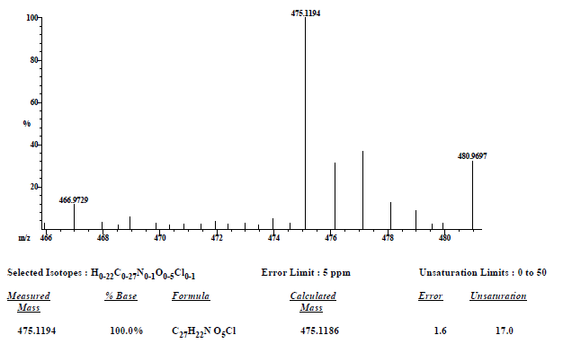
Figure S19. HRMS (EI) spectra of compound 3a.

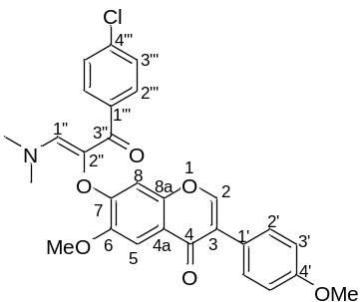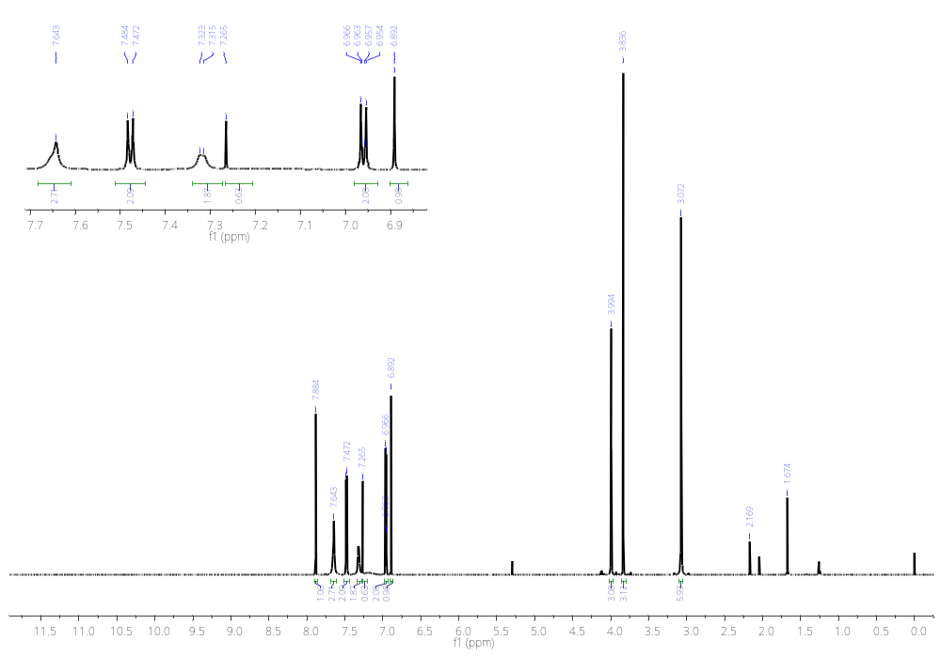
H-2’’’
H-5
H-2
H-3’
H-8
CH₃O
C-6
CH₃O
C-4’
N(CH₃)₂
H-1’’
H-3’’’
H-2’
Figure S20. ¹H-NMR spectra of compound 3b (600 MHz, CDCl₃).
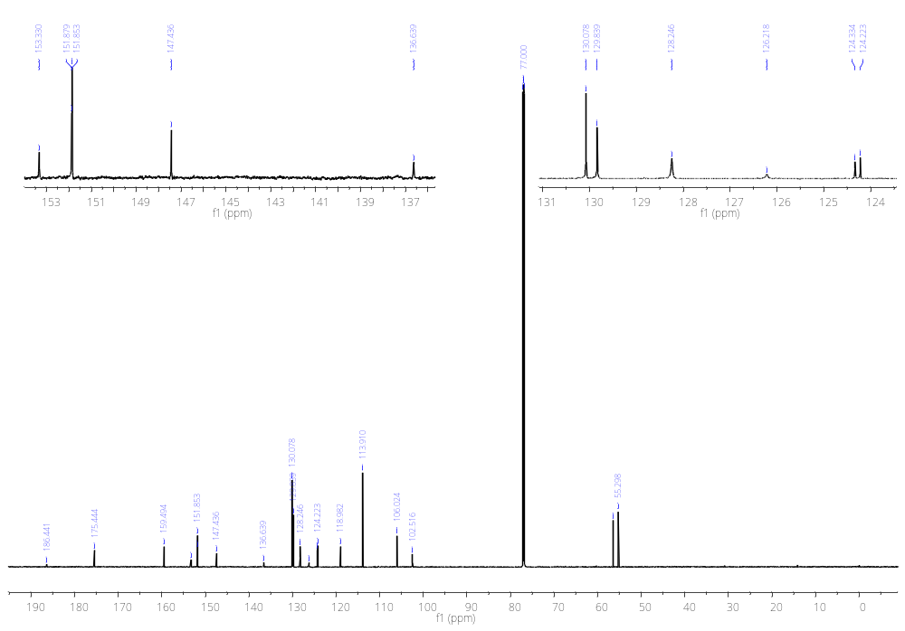
C-1’’
N(CH₃)₂
CH₃O
C-6
CH₃O
C-4’
C-7
C-2’’’
C-2’
C-2’’
C-1’
C-3
C-5
C-8
C-3’
C-4a
C-4’
C-4
C-3’’
C-6
C-8a
C-2
C-4’’’
C-1’’’
C-3’’’
Figure S21. ¹³C-NMR spectra of compound 3b (150 MHz, CDCl₃).
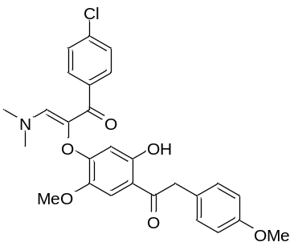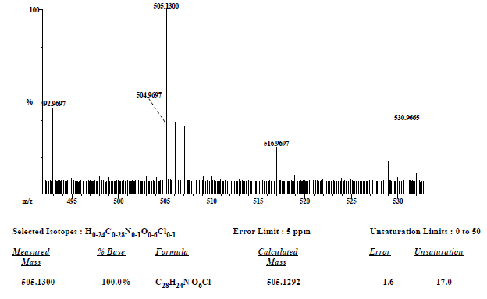
Figure S22. HRMS (EI) spectra of compound 3b.

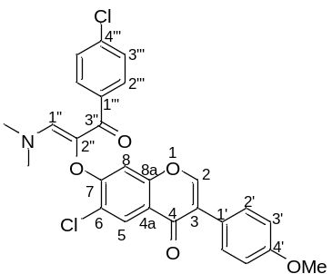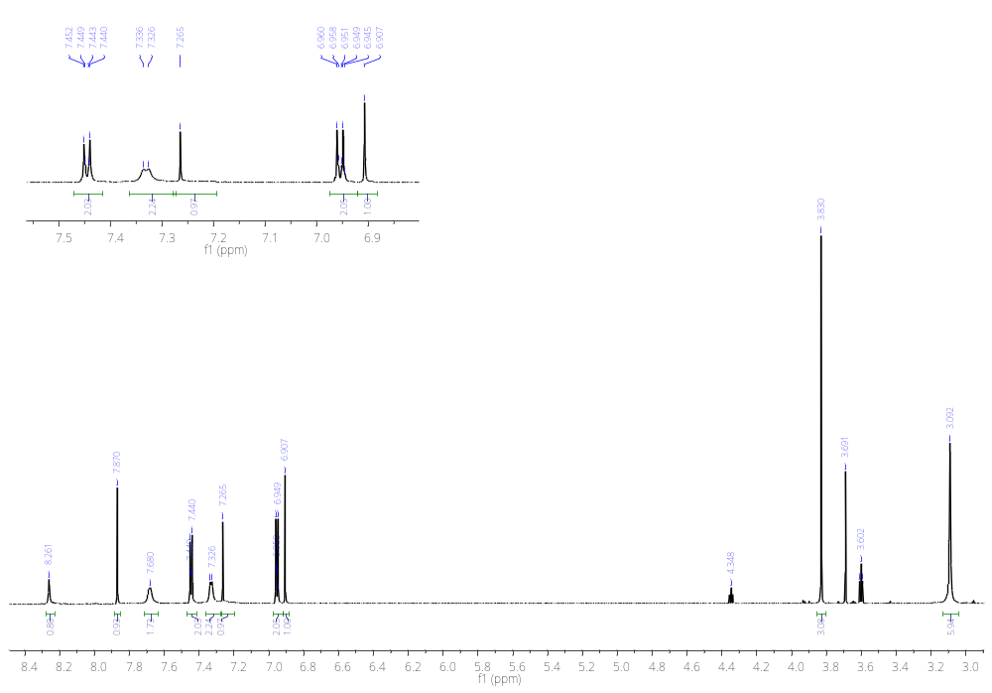
H-2’’’
H-2’
H-3’’’
H-1’’
CH₃O
N(CH₃)₂
H-5
H-8
H-3’
H-2
Figure S23. ¹H-NMR spectra of compound 3c (750 MHz, CDCl₃).
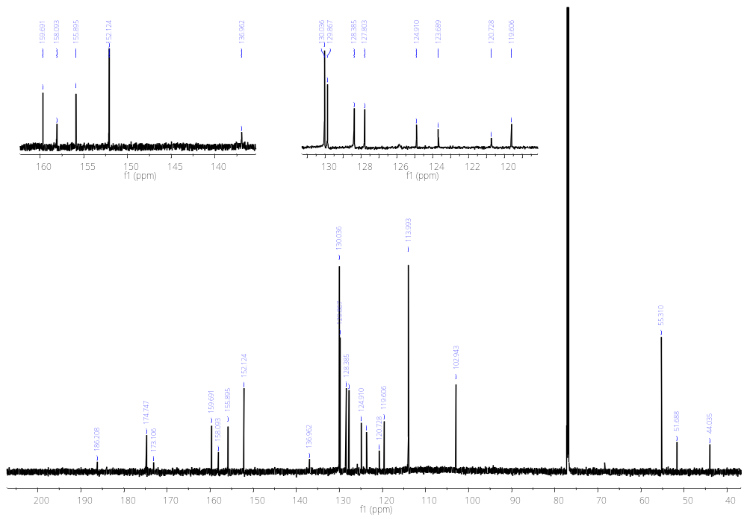
C-7
C-4’
C-8a
C-1’’
C-4’’’
C-1’’’
C-5
C-3’
CH₃O
C-4
C-3’’
C-8
C-2
C-3
C-1’
C-6
C-4a
C-3’’’
C-2’
C-2’’’
N(CH₃)₂
Figure S24. ¹³C-NMR spectra of compound 3c (187.5 MHz, CDCl₃).
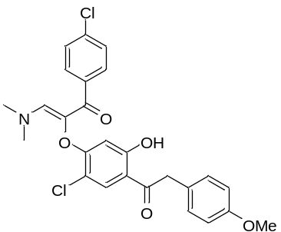

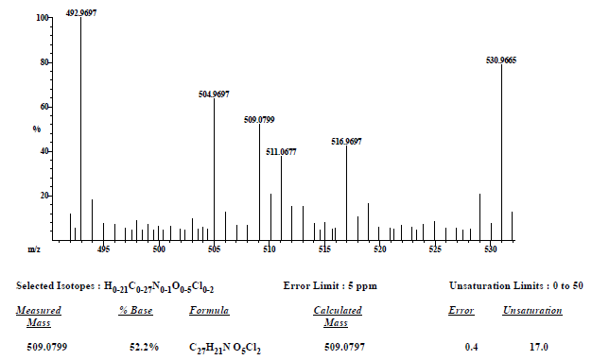
Figure S25. HRMS (EI) spectra of compound 3c.

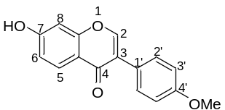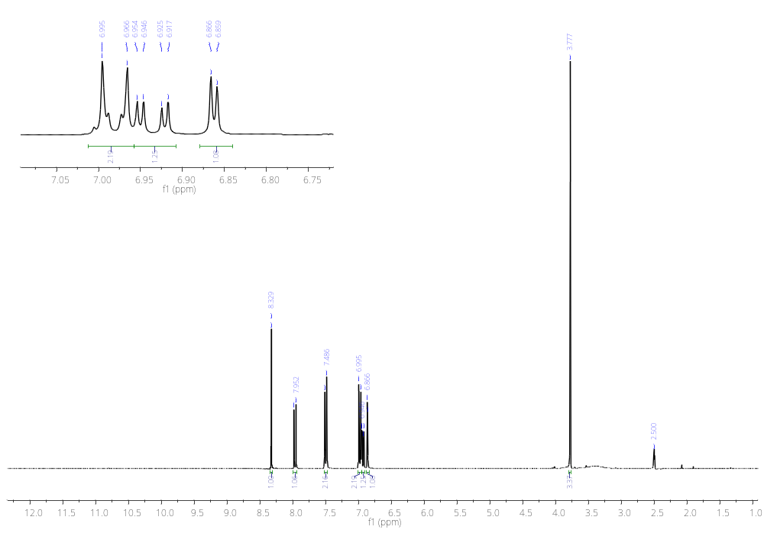
CH₃O
H-6
H-3’
H-8
H-2’
H-5
H-2
Figure S26. ¹H-NMR spectra of compound 2a (300 MHz, DMSO-d₆).
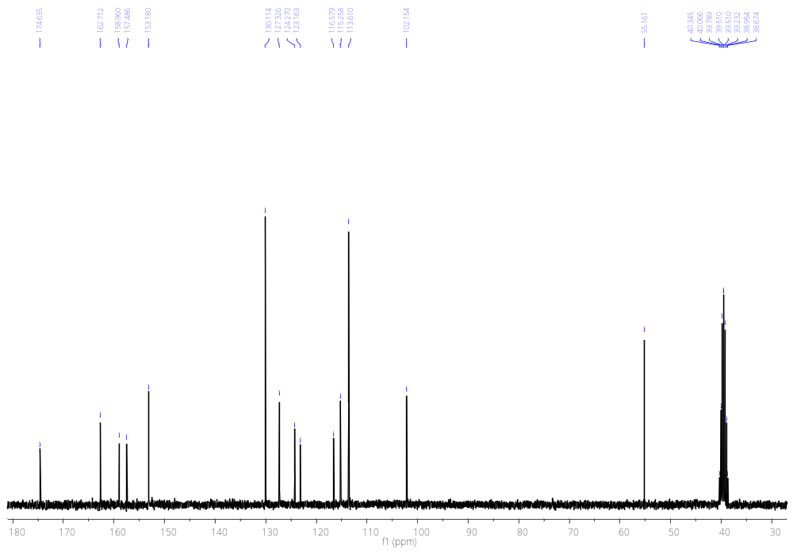
C-2’
C-4
C-4’
C-8a
C-7
C-6
C-4a
C-1’
C-3
C-8
CH₃O
C-3’
C-5
C-2
Figure S27. ¹³C-NMR spectra of compound 2a (75 MHz, DMSO-d₆).
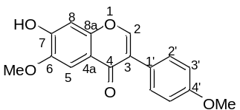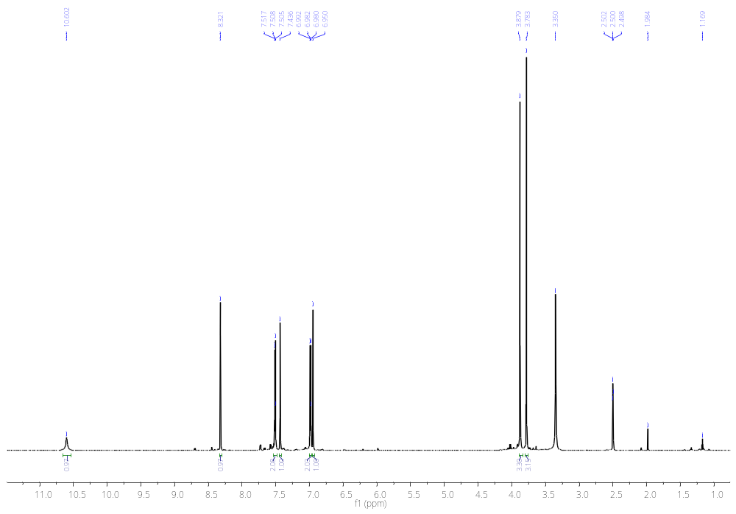
H-8
H-3’
CH₃O
C-4’
CH₃O
C-6
H-5
H-2’
H-2
OH
Figure S28. ¹H-NMR spectra of compound 2b (600 MHz, DMSO-d₆).
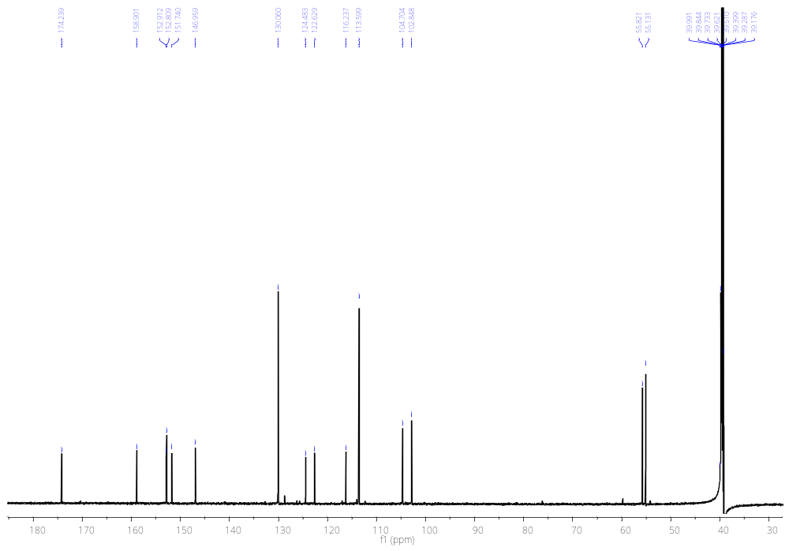
CH₃O
C-6
CH₃O
C-4’
C-8
C-5
C-1’
C-3
C-4a
C-2
C-7
C-8a
C-4’
C-6
C-2’
C-4
C-3’
Figure S29. ¹³C-NMR spectra of compound 2b (150 MHz, DMSO-d₆).
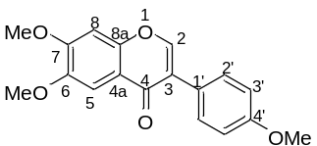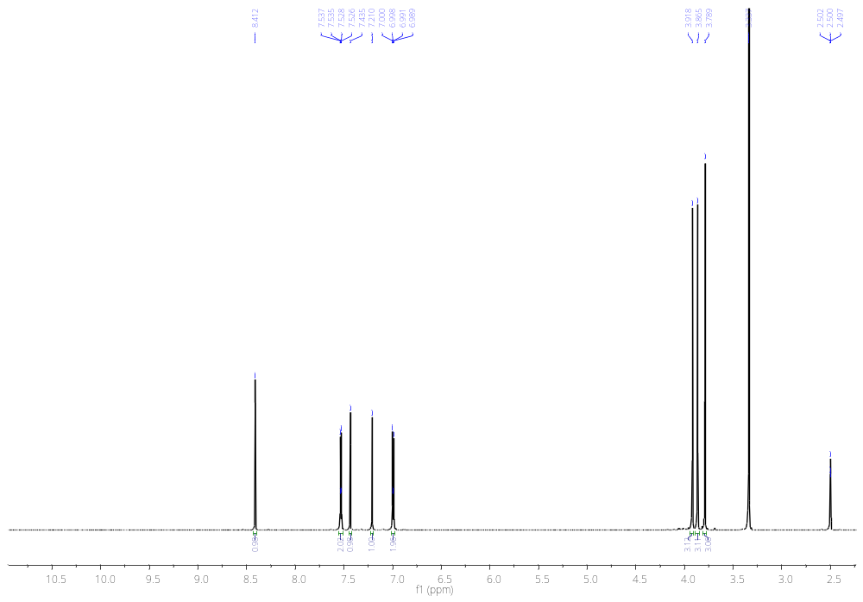
H-8
H-3’
CH₃O
C-6
CH₃O
C-4’
CH₃O
C-7
H-5
H-2’
H-2
Figure S30. ¹H-NMR spectra of compound 10a (600 MHz, DMSO-d₆).
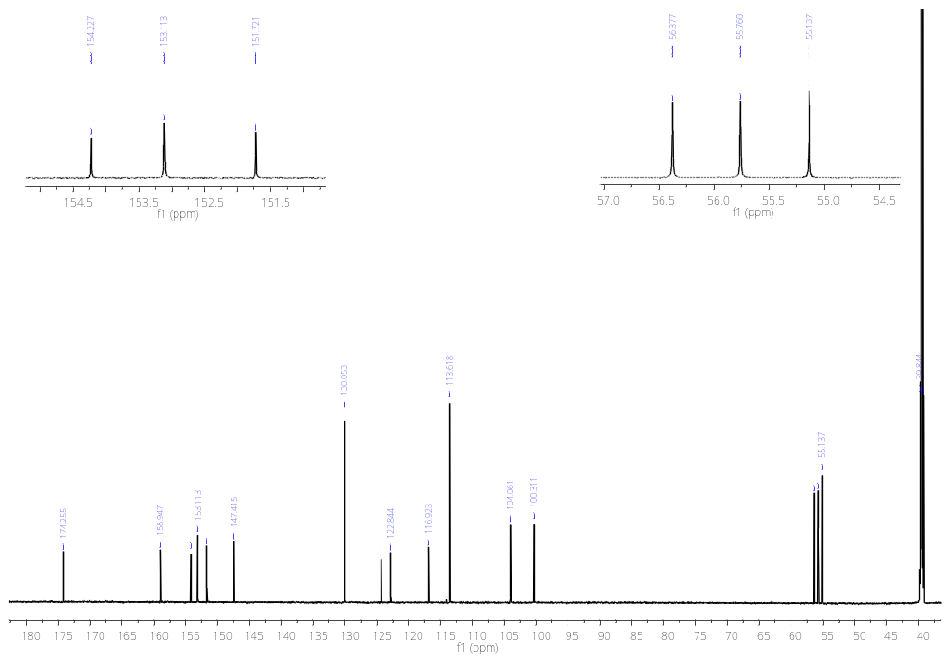
C-8a
C-8
CH₃O
C-7
CH₃O
C-4’
CH₃O
C-6
C-4
C-4’
C-6
C-2
C-7
C-2’
C-3’
C-5
C-4a
C-1’
C-3
Figure S31. ¹³C-NMR spectra of compound 10a (150 MHz, DMSO-d₆).
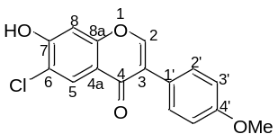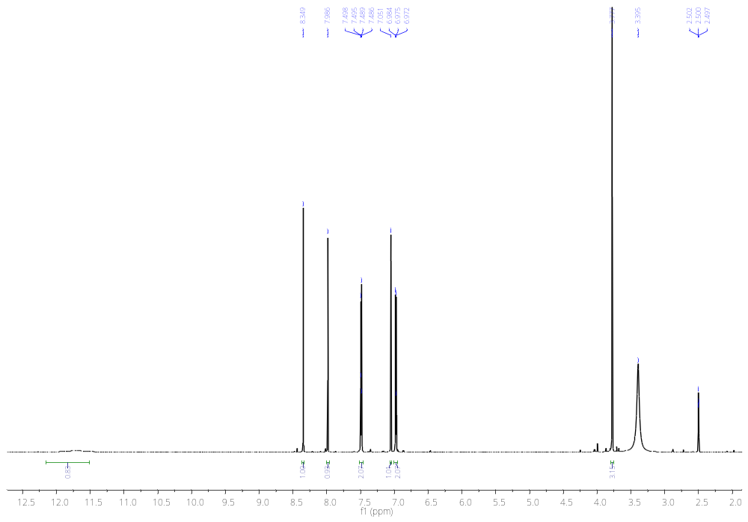
OH
H-5
H-2
H-2’
H-3’
H-8
CH₃O
Figure S32. ¹H-NMR spectra of compound 2c (600 MHz, DMSO-d₆).
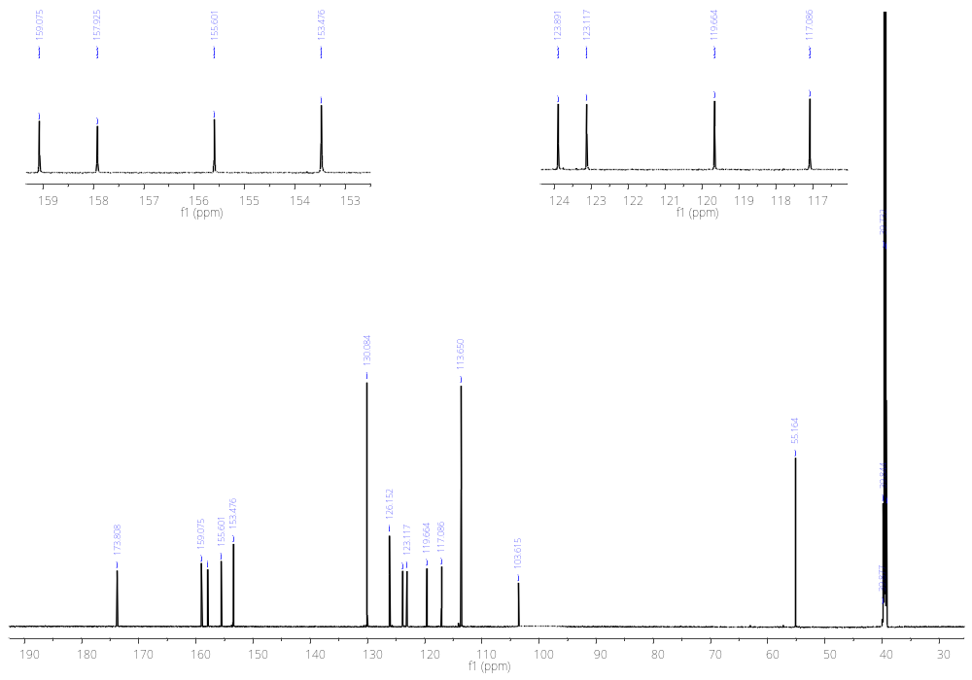
C-4
CH₃O
C-8
C-5
C-3’
C-2’
C-7
C-4’
C-8a
C-2
C-3
C-1’
C-6
C-4a
Figure S33. ¹³C-NMR spectra of compound 2c (150 MHz, DMSO-d₆).
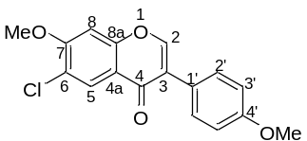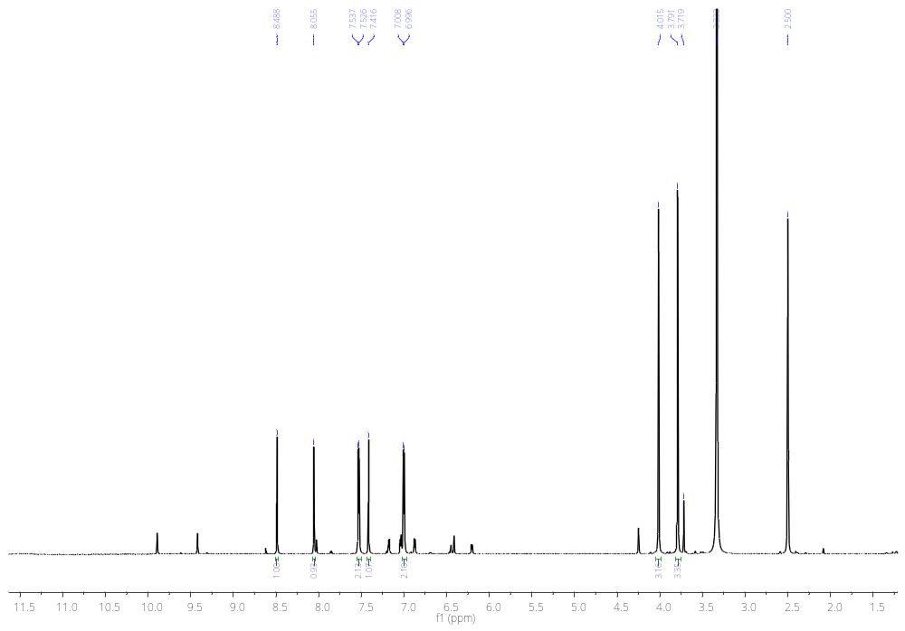
CH₃O
C-7
CH₃O
C-4’
H-3’
H-2’
H-8
H-5
H-2
Figure S34. ¹H-NMR spectra of compound 10b (600 MHz, DMSO-d₆).
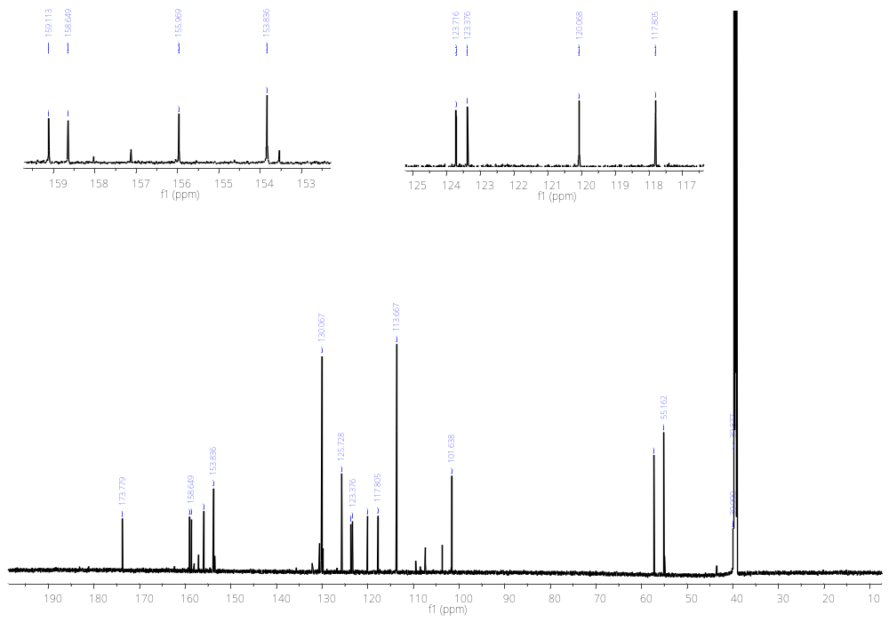
C-3
C-1’
C-4
C-4’
C-8a
C-2
CH₃O
C-7
CH₃O
C-4’
C-8
C-3’
C-2’
C-5
C-7
C-4a
C-6
Figure S35. ¹³C-NMR spectra of compound 10b (150 MHz, DMSO-d₆).
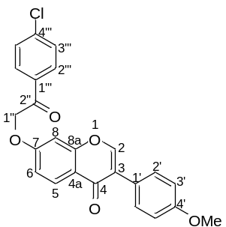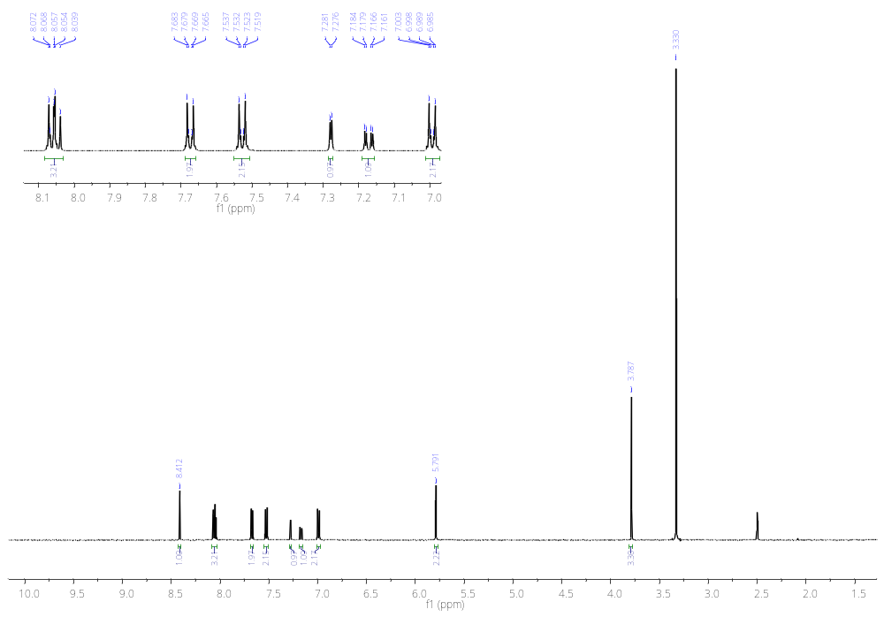
H-2
H-2’’’
H-5
H-2’
CH₃O
H-3’’’
H-8
H-6
H-3’
H-1’’
Figure S36. ¹H-NMR spectra of compound 4a (500 MHz, DMSO-d₆).
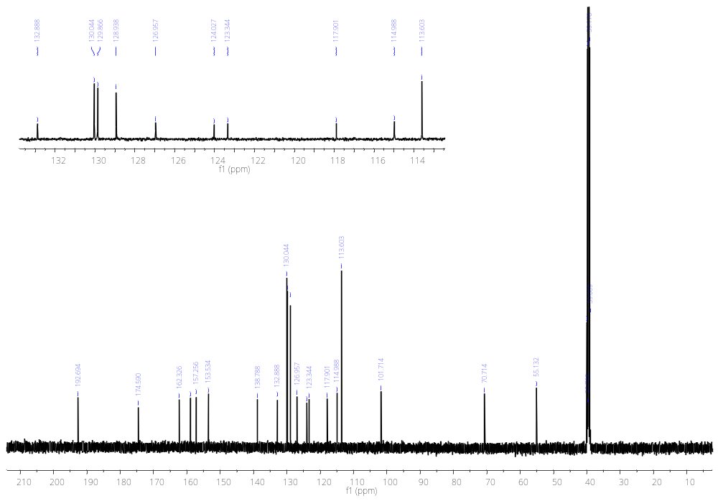
C-2’
C-8
C-8a
C-4’

C-4’’’
C-1’’’
C-2’’’
C-3’’’
C-5
C-1’
C-1’’
CH₃O
C-4
C-7
C-2
C-3
C-3’
C-6
C-4a
C-2’’
Figure S37. ¹³C-NMR spectra of compound 4a (125 MHz, DMSO-d₆).
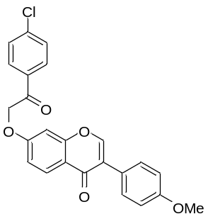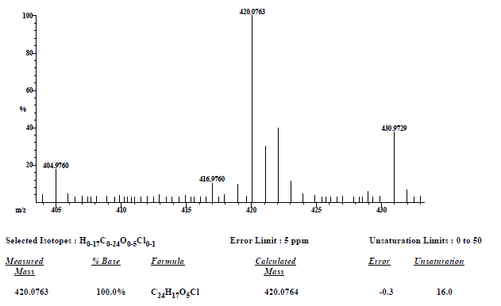
Figure S38. HRMS (EI) spectra of compound 4a.

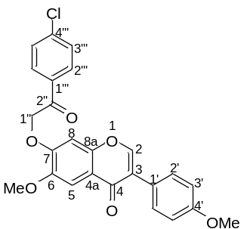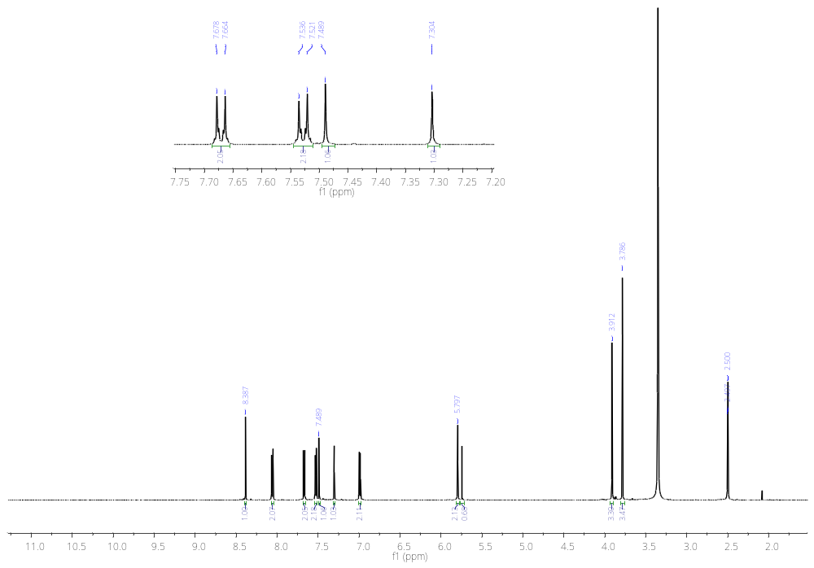
H-2’’’
H-8
H-3’’’
H-5
H-2’
H-2
H-3’
CH₃O
C-6
H-1’’
CH₃O
C-4’
Figure S39. ¹H-NMR spectra of compound 4b (600 MHz, DMSO-d₆).
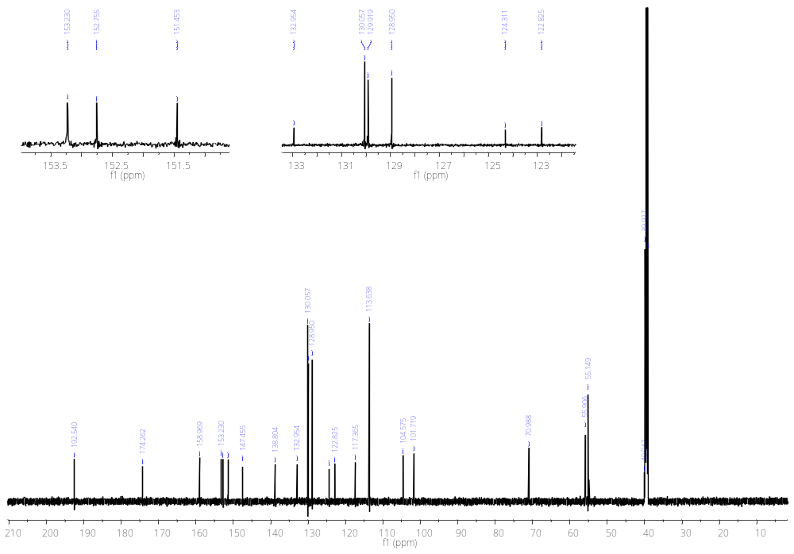
C-2’
C-4’’’
C-2
C-7
C-8a
C-1’’’
C-2’’’
C-3’’’
C-3
C-4a
C-3’
C-4
C-2’’
C-4’
C-6
C-1’
C-5
C-8
CH₃O
C-4’
CH₃O
C-6
C-1’’
Figure S40. ¹³C-NMR spectra of compound 4b (150 MHz, DMSO-d₆).

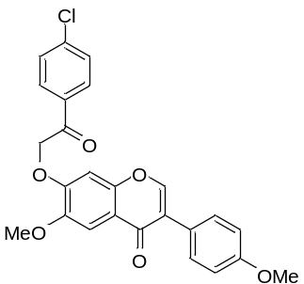
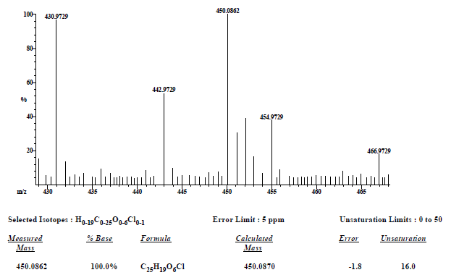
Figure S41. HRMS (EI) spectra of compound 4b.

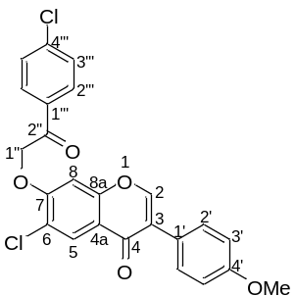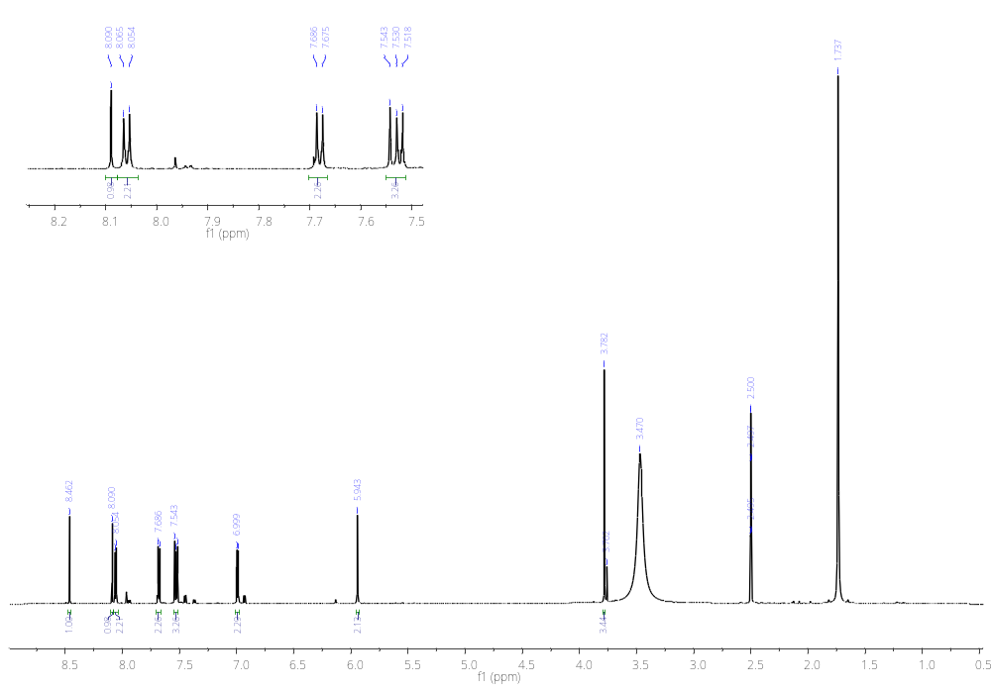
H-5
H-1’’
CH₃O
H-3’
H-2
H-2’’’
H-3’’’
H-8
H-2’
Figure S42. ¹H-NMR spectra of compound 4c (750 MHz, DMSO-d₆).
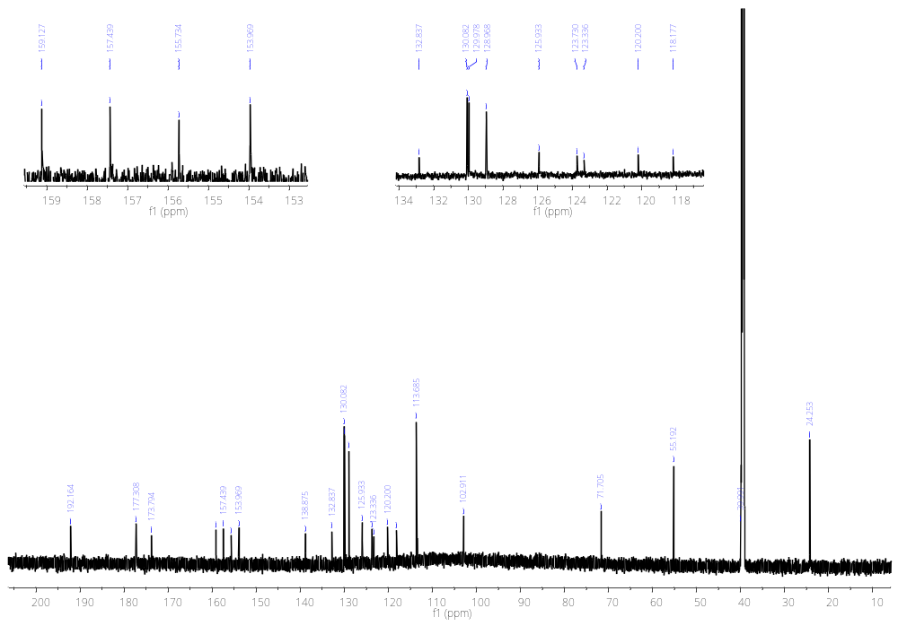
C-4
C-2’’’
C-2’
C-5
C-3’’’
C-4’’’
C-2’’
C-2
C-8a
C-7
C-4’
C-1’’’
C-1’
C-3
C-6
C-4a
C-3’
C-8
C-1’’
CH₃O
Figure S43. ¹³C-NMR spectra of compound 4c (187.5 MHz, DMSO-d₆).
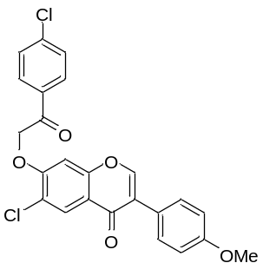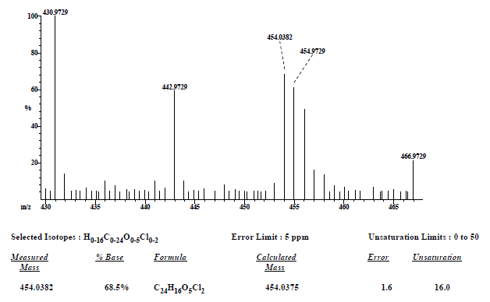
Figure S44. HRMS (EI) spectra of compound 4c.

