Supplementary Information

Green approach for the regioselective synthesis of β-thiol-1,4-disubstituted-1,2,3-triazoles using Fe₃O₄@SiO₂-PMA-Cu as a novel and efficient magnetically recoverable nanocatalyst

Ronak Eisavi* and Fereshteh Ahmadi

Department of Chemistry, Payame Noor Universtiy (PNU), P.O. BOX 19395-4697, Tehran, Iran
Email: roonak.isavi@gmail.com

Spectral data of β-thiol-1,4-disubstituted-1,2,3-triazoles (1-11)b:

2-Phenyl-2-(4-phenyl-1H-1,2,3-triazol-1-yl) ethane-1-thiol )1b (
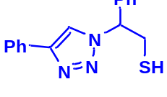
White solid: m.p. 122-124 °C, FT-IR (KBr): ν/cm⁻¹ 3371, 3085, 3026, 2927, 2365, 1584, 1450, 1270, 1029, 762, 695; ¹H NMR (500 MHz, CDCl₃) δ 7.78-7.71 (m, 2H, Ar-H), 7.44-7.23 (m, 9H, Ar-H) 5.69 (dd, J = 7, 4.5 Hz, 1H, CHN), 4.63 (dd, J = 12.5, 5 Hz, 1H, CH₂), 4.23 (dd, J = 15, 5 Hz, 1H, CH₂), 3.63 (bs, 1H, SH); ¹³C NMR (125 MHz, CDCl₃) δ 146.7 (=CN), 135.0 (NCH=), 128.1, 127.8, 127.2, 126.1, 124.7, 119.5 (10 × ArC), 66.2 (CHCH₂), 28.6 (CH₂). HRMS (EI) m/z calcd for C₁₆H₁₅N₃S 281.0987, found 281.0985.

1-Phenoxy-3-(4-phenyl-1H-1,2,3-triazol-1-yl)propane-2-thiol )2b(
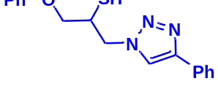
Milky solid: m.p. 113-114 °C, FT-IR (KBr): ν/cm⁻¹ 3302, 3086, 2919, 2873, 2365, 1587, 1638, 1599, 1497, 1474, 1466, 1303, 1044, 764, 752, 712, 691; ¹H NMR (500 MHz, CDCl₃) δ 7.86 (s, 1H, NCH=C), 7.67-7.65 (m, 2H, Ar-H_{o}), 7.35-7.31 (m, 2H, OAr-H_{m}), 7.29-7.26 (m, 3H, Ar-H_{m,p}), 7.00-6.87 (m, 3H, OAr-H_{o,p}), 4.96 (bs, 1H, SH), 4.67 (dd, J = 13, 5 Hz, 1H, CH₂O), 4.52 (dd, J = 13, 5 Hz, 1H, CH₂O), 4.47 (dd, 1H, J = 12.5, 5 Hz, CH₂N), 4.08 (dd, 1H, J = 12.5, 5 Hz, CH₂N), 4.05-3.72 (m, 1H, CHS); ¹³C NMR (125 MHz, CDCl₃) δ 157.1 (=CN), 146.53, 129.1 (2 × ArC), 128.6, 128.5, 127.8, 127.1, 124.6, 120.5, 120.4 (10 × ArCH), 113.5 (NCH=), 67.8 (CH₂O), 52.2 (CH₂N), 28.6 (CHS). HRMS (EI) m/z calcd for C₁₇H₁₇N₃OS 311.1092, found 311.1092.

1-Chloro-3-(5-phenyl-1H-1,2,3-triazol-1-yl)propane-2-thiol) 3b(
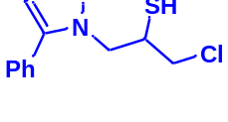
Mint white solid: mp. 154-157 °C FT-IR (KBr): ν/cm⁻¹ 3690, 3100, 2920, 2363, 2344, 1561, 1441, 1364, 1045, 764, 692, 668. ¹H NMR (500 MHz, CDCl₃) δ 7.93 (s, 1H, NCH=C), 7.88-7.23 (m, 5H, Ar-H), 4.61-4.41 (m, 2H, CH₂N), 4.39-4.31 (m, 1H, CH₂Cl), 4.00-3.94 (m, 1H, CH₂Cl), 3.90-3.37 (m, 1H, CHS), 2.07 (bs, 1H, SH); ¹³C NMR (125 MHz, CDCl₃) δ 148.0 (=CN), 130.1 (ArC, NCH=), 128.9, 128.4, 125.7, 117.6 (5 × ArCH), 55.9 (CH₂N), 34.4 (CH₂Cl), 29.6 (CHS). HRMS (EI) m/z calcd for C₁₁H₁₂ClN₃S 253.0441, found 253.0442.

1-(4-phenyl-1H-1,2,3-triazol-1-yl)butane-2-thiol (4b)
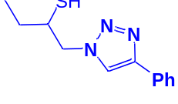
White solid: mp. 104-106 °C, FT-IR (KBr): ν/cm⁻¹ 3692, 3139, 2958, 2873, 2366, 2345, 1585, 1439, 1230, 1072, 765, 694; ¹H NMR (500 MHz, CDCl₃) δ 7.83 (s, 1H, NCH=C), 7.68-7.23 (m, 5H, Ar-H), 4.49 (dd, J = 14, 5 Hz, 1H, CH₂N), 4.24 (dd, J = 14, 8 Hz, 1H, CH₂N), 4.09-4.04 (m, 1H, CHS), 3.43 (bs, 1H, SH), 1.61-1.55 (m, 2H, CH₂), 1.06 (t, J = 7.5 Hz, 3H, CH₃); ¹³C NMR (125 MHz, CDCl₃) δ 147.3 (=CN), 130.3 (NCH=), 128.7, 128.0, 125.5, 121.1 (6 × ArC), 71.7 (CH₂N), 55.9 (CHS), 27.4 (CH₂), 9.8 (CH₃). HRMS (EI) m/z calcd for C₁₂H₁₅N₃S 233.0987, found 233.0986.

1-Isopropoxy-3-(4-phenyl-1H-1,2,3-triazol-1-yl)propane-2-thiol (5b)
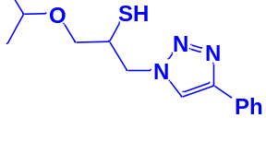
Yellow solid: mp. 74-75 °C, FT-IR (KBr): ν/cm⁻¹ 3177, 2968, 2875, 2369, 2345, 1583, 1460, 1444, 1366, 1071, 767, 702; ¹H NMR (500 MHz, CDCl₃) δ 7.86 (s, 1H, NCH=C), 7.67–7.65 (m, 2H, Ar-H), 7.33–7.23 (m, 3H, Ar-H), 4.53 (dd, J = 14, 4 Hz, 1H, CH₂N), 4.34 (dd, J = 14, 7.5 Hz, 1H, CH₂N), 4.21-4.16 (m, 2H, OCH₂), 3.58-3.51 (m, 1H, CHO), 3.46-3.35 (m, 2H, CHS overlapped with SH), 1.11 (d, J = 5 Hz, 6H, 2CH₃); ¹³C NMR (125 MHz, CDCl₃) δ 147.9 (=CN), 130.3 (NCH=), 128.7, 128.0, 125.5, 121.4 (6 × ArC), 72.3 (CHO), 69.2 (OCH₂), 69.1 (CH₂N), 53.4 (CHS), 21.9 (2 × CH₃). HRMS (EI) m/z calcd for C₁₄H₁₉N₃OS 277.1249, found 277.1247.

2-(4-Phenyl-1H-1,2,3-triazol-1-yl)cyclohexane-1-thiol (6b)
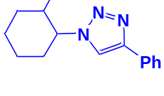
Pale green solid: mp. 156-159 °C, FT-IR (KBr): ν/cm⁻¹ 3305, 3094, 2936, 2853, 2364, 1586, 1440, 1236, 1055, 766, 698; ¹H NMR (500 MHz, CDCl₃) δ 7.83 (s, 1H, NCH=C), 7.63–7.25 (m, 5H, Ar-H), 4.12–4.04 (m, 1H, CHN), 3.57–2.94 (m, 1H, CHS), 2.04-1.22 (m, 4 × CH₂ overlapped with 1H, SH); ¹³C NMR (125 MHz, CDCl₃) δ 146.6 (=CN), 132.4 (NCH=), 130.2, 128.6, 127.9, 125.4, 119.8 (6 × ArC), 72.5 (CHN), 67.2 (CHS), 28.6 (CHS), 33.8, 31.5, 24.8, 24.0 (4 × CH₂). HRMS (EI) m/z calcd for C₁₄H₁₇N₃S 259.1143, found 259.1143.

1-(Allyloxy)-3-(4-phenyl-1H-1,2,3-triazol-1-yl)propane-2-thiol (7b)
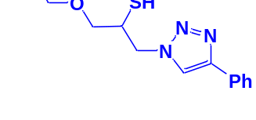
Cream solid: mp. 70 °C, FT-IR (KBr): ν/cm⁻¹ 3233, 3141, 2930, 2872, 2366, 1590, 1438, 1350, 1230, 1000, 767, 696; ¹H NMR (500 MHz, CDCl₃) δ 7.85 (s, 1H, NCH=C), 7.55-7.23 (m, 5H, Ar-H), 5.80-5.87 (m, 1H, =CH), 5.22 (dt, J = 17, 1.2 Hz, 1H, C=CH₂), 5.14 (dt, J = 10, 1.2 Hz, 1H, C=CH₂), 4.55-4.50 (m, 2H, CH₂O), 4.35 (dd, J = 15, 7 Hz, 1H, CH₂N), 4.26-4.23 (m, 1H, CH₂N), 4.00-3.88 (m, 2H, OCH₂), 348-3.41 (m, 1H, CHS), 2.91 (bs, 1H, SH); ¹³C NMR (125 MHz, CDCl₃) δ 147.1 (=CN), 134.2 (NCH=), 130.2 (=CH), 128.7, 128.0, 125.5, 121.5 (6 × ArC), 117.4 (=CH₂), 72.3 (OCH₂), 71.2 (CH₂O), 69.0 (CH₂N), 53.4 (CHS). HRMS (EI) m/z calcd for C₁₄H₁₇N₃OS 275.1092, found 275.1094.

2-Mercapto-3-(4-phenyl-1H-1,2,3-triazol-1-yl)propyl methacrylate (8b)
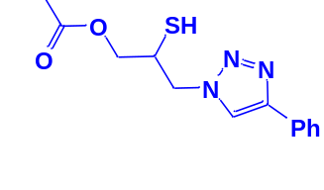
Milky solid: mp. 86-92 °C, FT-IR (KBr): ν/cm⁻¹ 3000, 2925, 2367, 1719, 1593, 1438, 1294, 1097, 762, 695; ¹H NMR (300 MHz, CDCl₃): δ 7.86 (s, 1H, NCH=C), 7.66 -7.64 (m, 2H, Ar-H), 7.34-7.25 (m, 3H, Ar-H), 6.10 (d, J = 10 Hz, 1H, =CH₂), 5.93 (d, J = 10 Hz, 1H, =CH₂), 4.48-4.12 (m, 2H, OCH₂), 3.57 (m, 2H, CH₂N), 3.66 (bs, 1H, SH), 3.33-3.32 (m, 1H, CSH), 2.05 (s, 3H, CH₃); ¹³C NMR (125 MHz, CDCl₃): δ = 161.6 (C=O), 147.3 (=CN), 135.7 (C=), 128.9 (NCH=), 128.8, 128.2, 125.5, 121.6 (6 × ArC), 70.6 (OCH₂), 63.6 (CH₂N), 53.0 (CHS), 18.3 (CH₃). HRMS (EI) m/z calcd for C₁₅H₁₇N₃O₂S 303.1042, found 303.1045.

2-(4-Cyclohexyl-1H-1,2,3-triazol-1-yl)-2-phenylethane-1-thiol (9b):

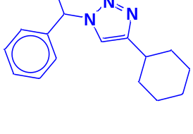
White solid: m.p. 125-128 °C, FT-IR (KBr): ν/cm⁻¹ 3233, 3117, 3061, 2923, 2849, 1448, 1067, 889, 756, 697; ¹H NMR (500 MHz, CDCl₃): δ 7.60 (s, 1H, NCH=C), 7.42-7.26 (m, 5H, Ar-H), 5.68 (dd, J= 8.7, 4.8 Hz, 1H, NCHCH₂), 4.40-4.28, 4.15-4.03 (2 m, 2H, CH₂S), 3.32 (t, J = 5.9 Hz, 1H, SH), 2.76-2.68 (m, 1H, CH₂CHCH₂), 1.76-1.65 (m, 4H, 2 × CH₂CH₂CH), 1.43-1.36 (m, 4H, 2 × CH₂CH₂CH), 1.27-1.18 [m, 2H, (CH₂)₂CH₂(CH₂)₂]. ¹³C NMR (125 MHz, CDCl₃): δ = 153.9 (NCCH), 138.5 (ArC), 129.7, 129.3, 128.1 (5 × ArCH), 120.9 (NCCH), 64.7 (NCHCH₂), 53.3 (CH₂S), 36.1 (CH₂CHCH₂), 33.8, 26.9, 26.8 [(CH₂)₅]; HRMS (EI) m/z calcd for C₁₆H₂₁N₃S 287.1456, found 287.1455.

(1-(2-Mercapto-1-phenylethyl)-1H-1,2,3-triazol-4-yl)methanol (10b)
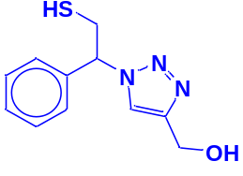
Colorless solid. m.p. 101-105 °C, FT-IR (KBr): ν/cm⁻¹ 3340, 3167, 2932, 2893, 1454, 1234, 1119, 1084, 1011, 849, 795, 702. ¹H NMR (500 MHz, CDCl₃): δ 7.62 (s, 1H, NCH=C), 7.37-7.28 (m, 5H, Ar-H), 5.68 (dd, J= 8.7, 4.8 Hz, 1H, NCHCH₂), 4.52 (s, 2H, CH₂O), 4.38-4.30, 4.13-4.02 (2 m, 2H, CH₂S), 3.76 (bs, 1H, OH), 3.32 (t, J = 5.9 Hz, 1H, SH), ¹³C NMR (125 MHz, CDCl₃): δ = 147.1 (=CN), 130.1 (ArC), 128.5, 128.0, 125.7 (5 × ArCH), 121.3 (=CHN), 71.8 (CHN), 55.7 (CH₂O), 27.3 (CH₂S). HRMS (EI) m/z calcd for C₁₁H₁₃N₃OS 235.0779, found 235.0781.

2-(4-(4-Methoxyphenyl)-1H-1,2,3-triazol-1-yl)-2-phenylethane-1-thiol (11b)
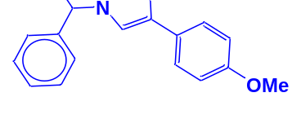
White solid: m.p. 130-132°C, FT-IR (KBr): ν/cm⁻¹ 3371, 3085, 3026, 2927, 2365, 1584, 1450, 1270, 1074, 1041, 1029, 762, 695; ¹H NMR (500 MHz, CDCl₃) δ 7.76-7.71 (m, 3H, Ar-H), 7.44-7.21 (m, 7H, Ar-H) 5.71 (dd, J = 7, 4.5 Hz, 1H, CHN), 4.15 (s, 3H, OCH₃), 3.76 (dd, J = 12.5, 5 Hz, 1H, CH₂), 3.37 (dd, J = 15, 5 Hz, 1H, CH₂), 2.75 (bs, 1H, SH); ¹³C NMR (125 MHz, CDCl₃) δ 146.6 (=CN), 135.0 (NCH=), 128.1, 127.7, 127.2, 126.1, 124.7, 119.1 (10 × ArC), 66.2 (CHN), 58.26 (OCH₃), 28.6 (CH₂S). HRMS (EI) m/z calcd for C₁₇H₁₇N₃OS 311.1092, found 311.1095.

FT-IR, ¹H NMR and ¹³C NMR spectra of β-Thiol-1,4-disubstituted-1,2,3-triazoles (1-11)b are presented as following:

2-Phenyl-2-(4-phenyl-1H-1,2,3-triazol-1-yl)ethane-1-thiol )1b (

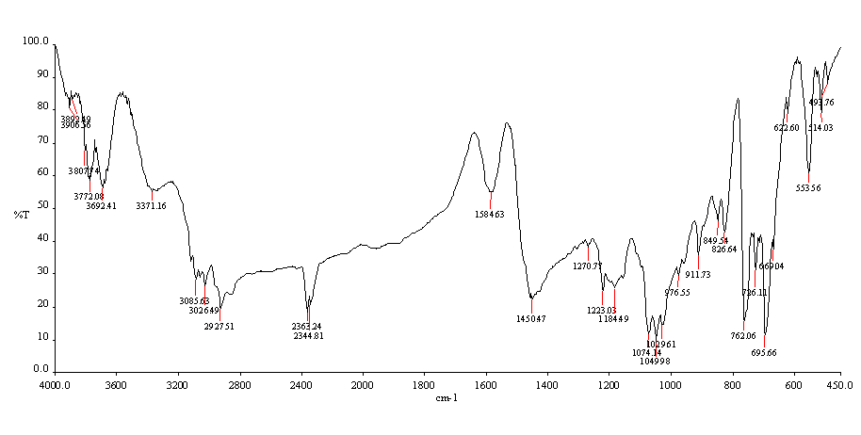
Figure S1. FT-IR Spectrum of 2-phenyl-2-(4-phenyl-1H-1,2,3-triazol-1-yl)ethane-1-thiol (1b)

Figure S2. ¹H NMR Spectrum of 2-phenyl-2-(4-phenyl-1H-1,2,3-triazol-1-yl)ethane-1-thiol (1b)

Figure S3. ¹³C NMR Spectrum of 2-phenyl-2-(4-phenyl-1H-1,2,3-triazol-1-yl)ethane-1-thiol (1b)
1-Phenoxy-3-(4-phenyl-1H-1,2,3-triazol-1-yl)propane-2-thiol )2b(
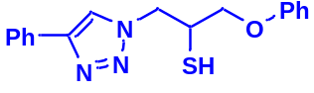
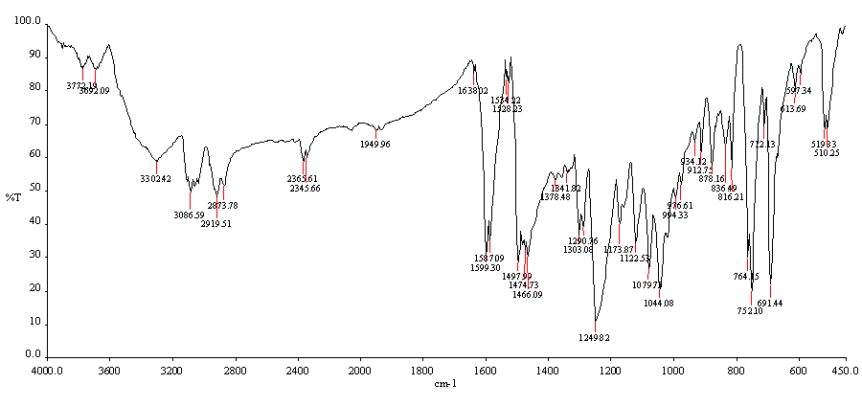
Figure S4. FT-IR Spectrum of 1-phenoxy-3-(4-phenyl-1H-1,2,3-triazol-1-yl)propane-2-thiol )2b(

Figure S5. ¹H NMR Spectrum of 1-phenoxy-3-(4-phenyl-1H-1,2,3-triazol-1-yl)propane-2-thiol )2b(
Figure S6. ¹³C NMR Spectrum of 1-phenoxy-3-(4-phenyl-1H-1,2,3-triazol-1-yl)propane-2-thiol )2b(

1-Chloro-3-(5-phenyl-1H-1,2,3-triazol-1-yl)propane-2-thiol) 3b(
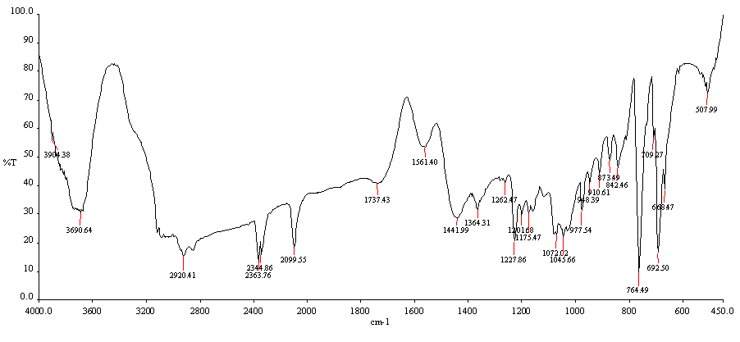
Figure S7. FT-IR Spectrum of 1-chloro-3-(5-phenyl-1H-1,2,3-triazol-1-yl)propane-2-thiol) 3b(

Figure S8. ¹H NMR Spectrum of 1-chloro-3-(5-phenyl-1H-1,2,3-triazol-1-yl)propane-2-thiol) 3b(
Figure S9. ¹³C NMR Spectrum of 1-chloro-3-(5-phenyl-1H-1,2,3-triazol-1-yl)propane-2-thiol) 3b(

1-(4-Phenyl-1H-1,2,3-triazol-1-yl)butane-2-thiol (4b)
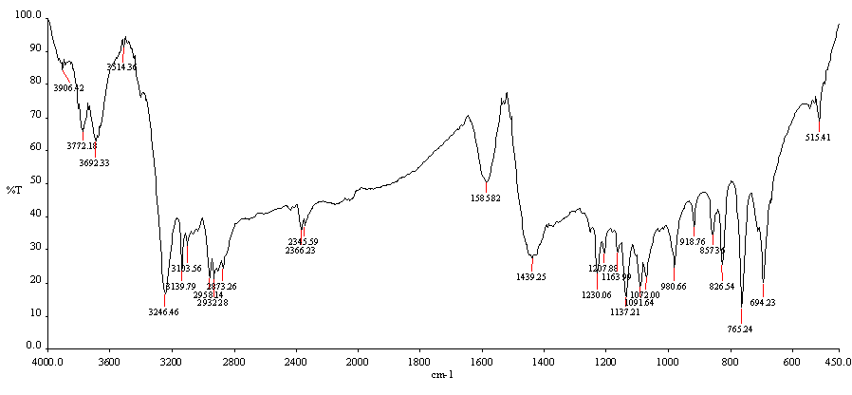
Figure S10. FT-IR Spectrum of 1-(4-phenyl-1H-1,2,3-triazol-1-yl)butane-2-thiol (4b)

Figure S11. ¹H NMR Spectrum of 1-(4-phenyl-1H-1,2,3-triazol-1-yl)butane-2-thiol (4b)
Figure S12. ¹³C NMR Spectrum of 1-(4-phenyl-1H-1,2,3-triazol-1-yl)butane-2-thiol (4b)

1-Isopropoxy-3-(4-phenyl-1H-1,2,3-triazol-1-yl)propane-2-thiol (5b)
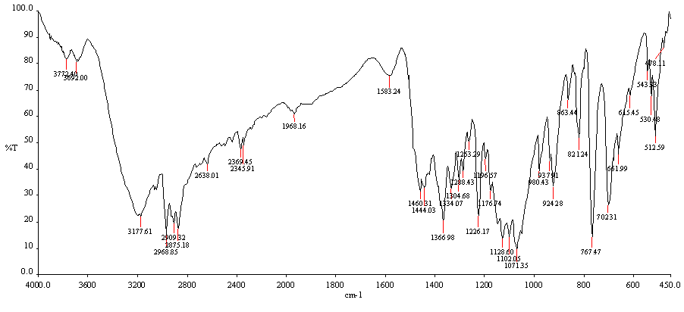
Figure S13. FT-IR Spectrum of 1-isopropoxy-3-(4-phenyl-1H-1,2,3-triazol-1-yl)propane-2-thiol (5b)
Figure S14. ¹H NMR Spectrum of 1-isopropoxy-3-(4-phenyl-1H-1,2,3-triazol-1-yl)propane-2-thiol (5b)

Figure S15. ¹³C NMR Spectrum of 1-isopropoxy-3-(4-phenyl-1H-1,2,3-triazol-1-yl)propane-2-thiol (5b)
2-(4-Phenyl-1H-1,2,3-triazol-1-yl)cyclohexane-1-thiol (6b)

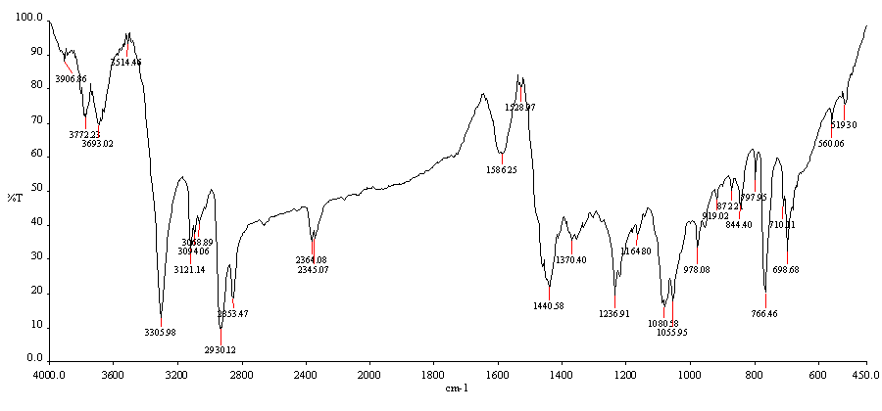
Figure S16. FT-IR Spectrum of 2-(4-phenyl-1H-1,2,3-triazol-1-yl)cyclohexane-1-thiol (6b)

Figure S17. ¹H NMR Spectrum of 2-(4-phenyl-1H-1,2,3-triazol-1-yl)cyclohexane-1-thiol (6b)

Figure S18. ¹³C NMR Spectrum of 2-(4-phenyl-1H-1,2,3-triazol-1-yl)cyclohexane-1-thiol (6b)
1-(Allyloxy)-3-(4-phenyl-1H-1,2,3-triazol-1-yl)propane-2-thiol (7b)

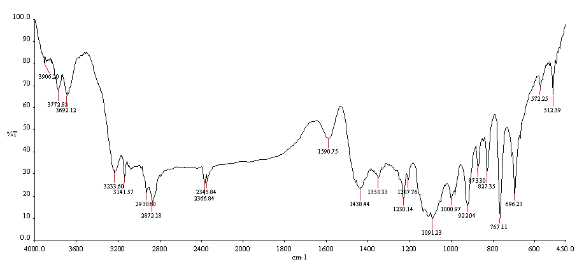
Figure S19. FT-IR Spectrum of 1-(allyloxy)-3-(4-phenyl-1H-1,2,3-triazol-1-yl)propane-2-thiol (7b)
Figure S20. ¹H NMR Spectrum of 1-(allyloxy)-3-(4-phenyl-1H-1,2,3-triazol-1-yl)propane-2-thiol (7b)
Figure S21. ¹³C NMR Spectrum of 1-(allyloxy)-3-(4-phenyl-1H-1,2,3-triazol-1-yl)propane-2-thiol (7b)
2-Mercapto-3-(4-phenyl-1H-1,2,3-triazol-1-yl)propyl methacrylate (8b)
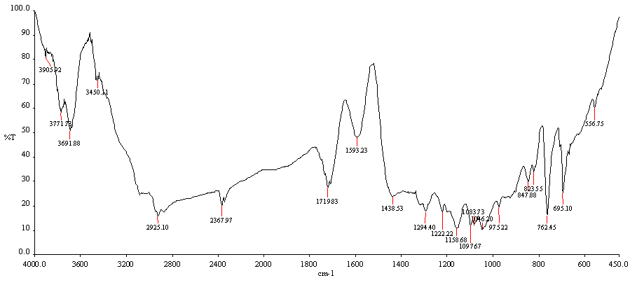
Figure S22. FT-IR Spectrum of 2-mercapto-3-(4-phenyl-1H-1,2,3-triazol-1-yl)propyl methacrylate (8b)

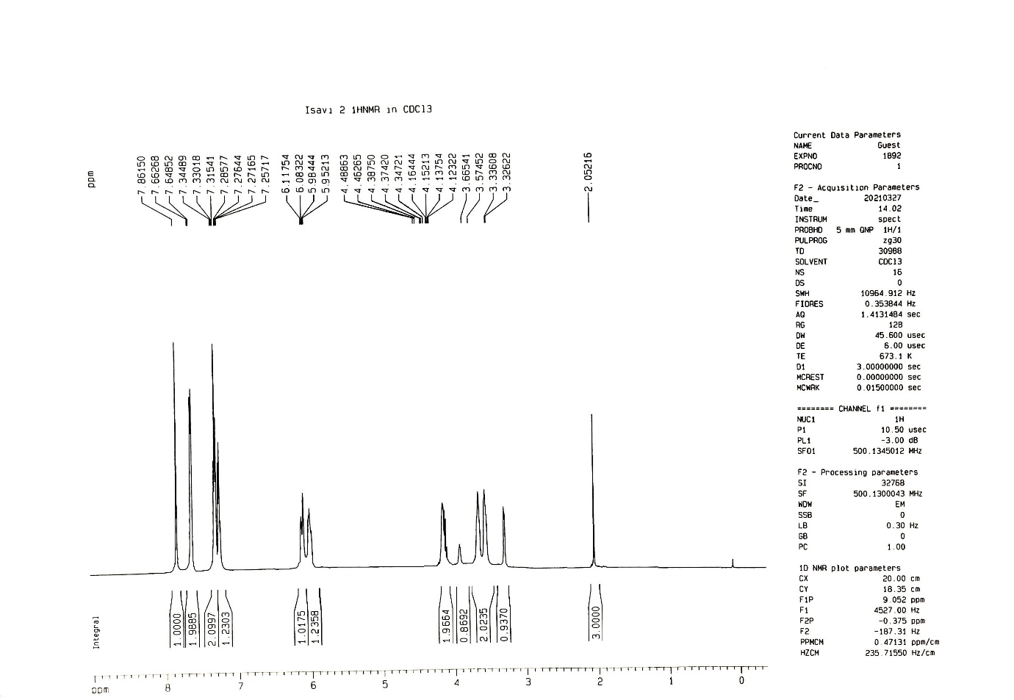
Figure S23. ¹H NMR Spectrum of 2-mercapto-3-(4-phenyl-1H-1,2,3-triazol-1-yl)propyl methacrylate (8b)

Figure S24. ¹³C NMR Spectrum of 2-mercapto-3-(4-phenyl-1H-1,2,3-triazol-1-yl)propyl methacrylate (8b)
2-(4-Cyclohexyl-1H-1,2,3-triazol-1-yl)-2-phenylethane-1-thiol (9b)

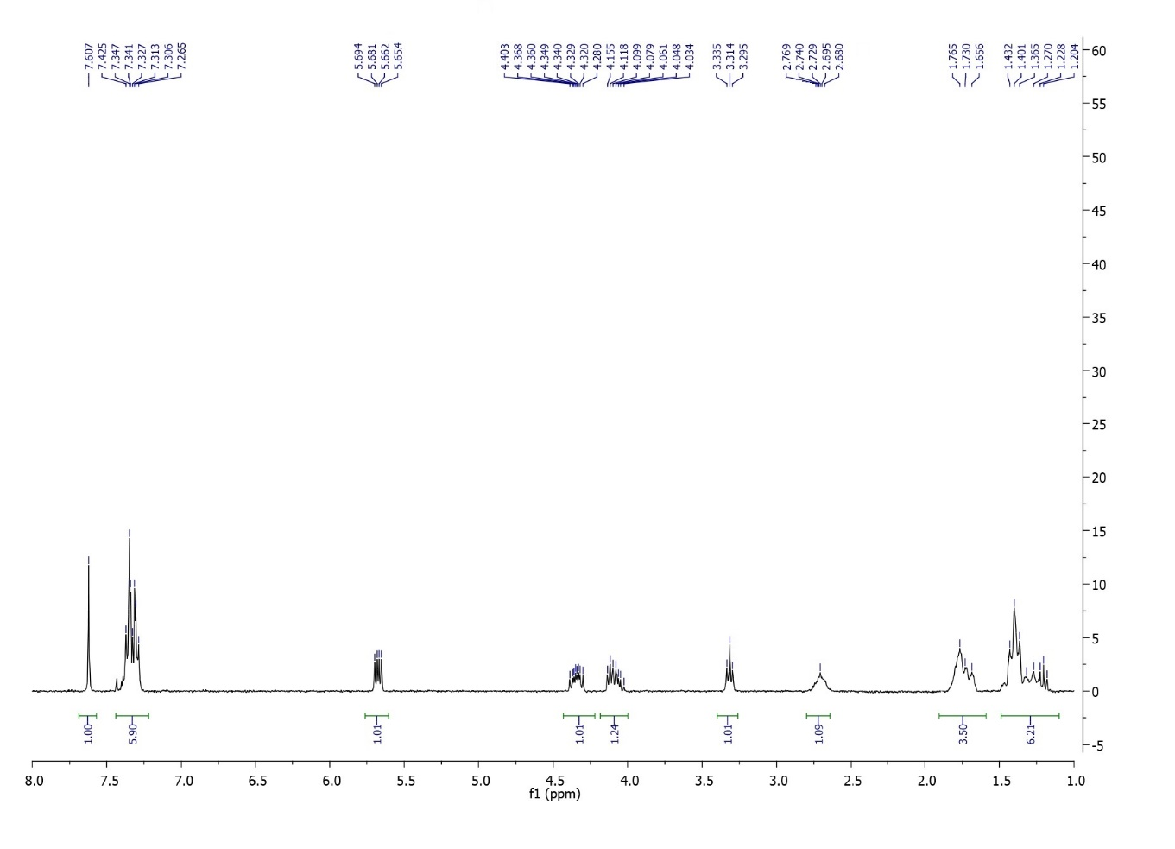
Figure S25. ¹H NMR Spectrum of 2-(4-cyclohexyl-1H-1,2,3-triazol-1-yl)-2-phenylethane-1-thiol (9b)
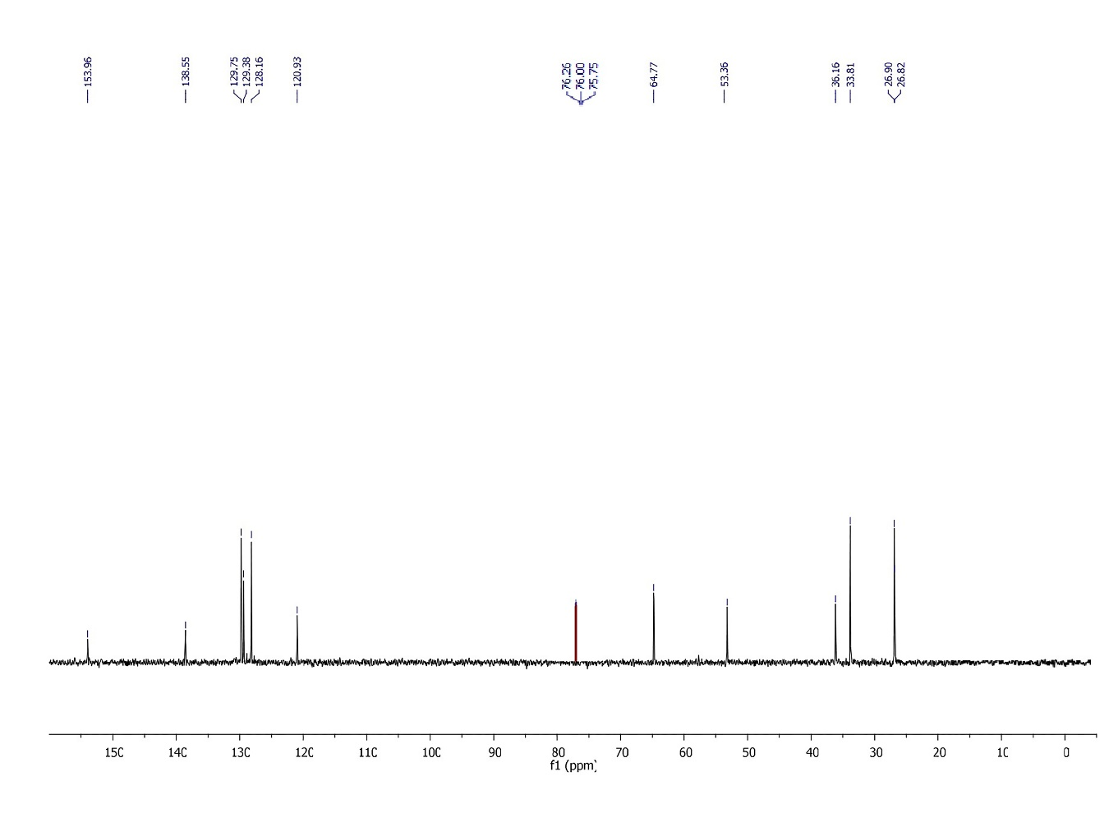
Figure S26. ¹³C NMR Spectrum of 2-(4-cyclohexyl-1H-1,2,3-triazol-1-yl)-2-phenylethane-1-thiol (9b)

(1-(2-Mercapto-1-phenylethyl)-1H-1,2,3-triazol-4-yl)methanol (10b)
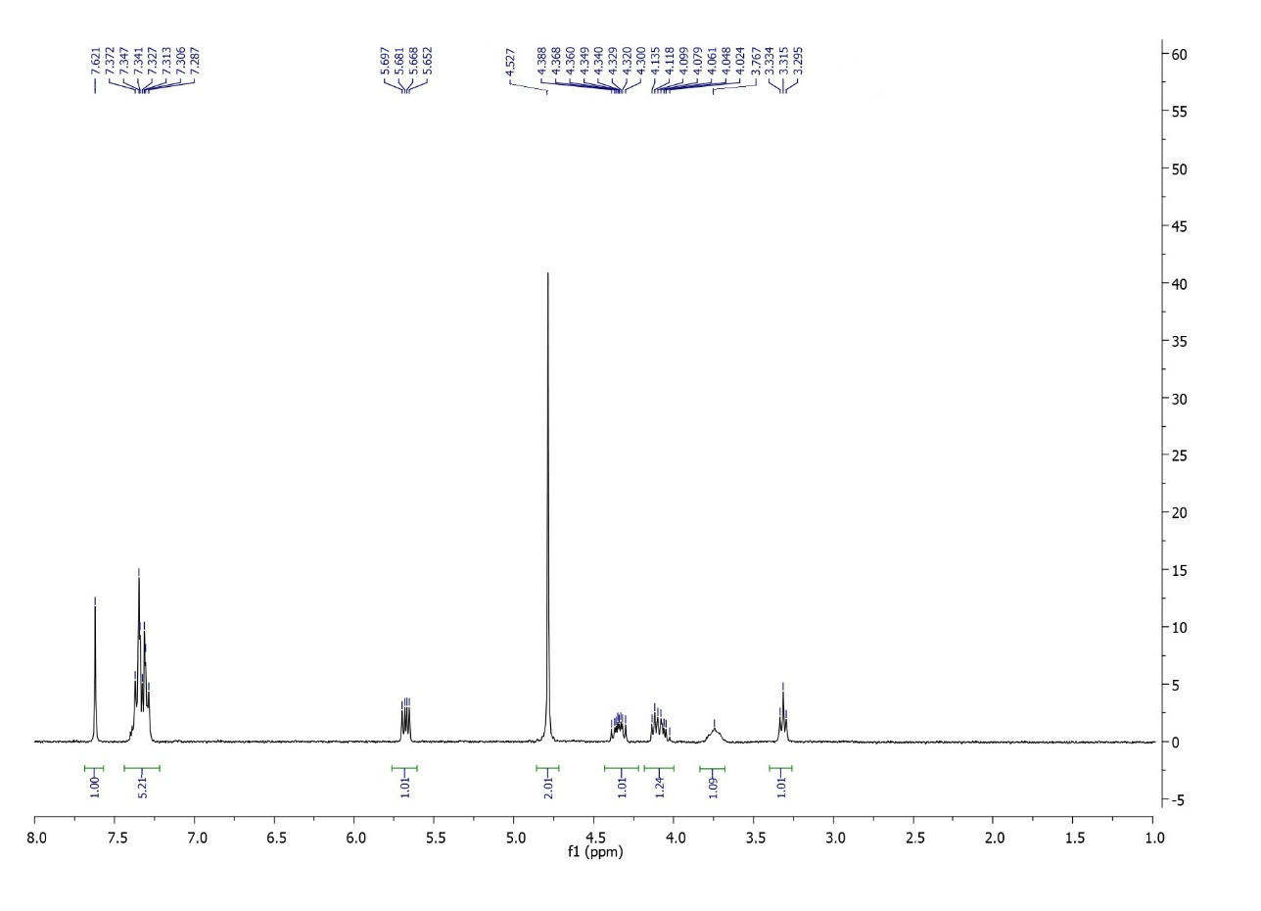
Figure S27. ¹H NMR Spectrum of (1-(2-mercapto-1-phenylethyl)-1H-1,2,3-triazol-4-yl)methanol (10b)
Figure S28. ¹³C NMR Spectrum of (1-(2-mercapto-1-phenylethyl)-1H-1,2,3-triazol-4-yl)methanol (10b)
2-(4-(4-Methoxyphenyl)-1H-1,2,3-triazol-1-yl)-2-phenylethane-1-thiol (11b)

Figure S29. ¹H NMR Spectrum of 2-(4-(4-methoxyphenyl)-1H-1,2,3-triazol-1-yl)-2-phenylethane-1-thiol (11b)
Figure S30. ¹³C NMR Spectrum of 2-(4-(4-methoxyphenyl)-1H-1,2,3-triazol-1-yl)-2-phenylethane-1-thiol (11b)

