Table 2. Synthesis of β-thiol-1,2,3-triazoles from thiiranes in the presence of Fe₃O₄@SiO₂-PMA-Cu nanocatalystª
Entry | Thiirane (a) | Alkyne | Triazole (b) | Time (h) | Yield (%)^{b}
1 | 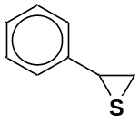 |  | 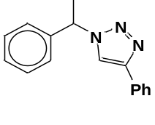 | 1.5 | 98
2 | 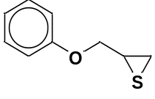 |  | 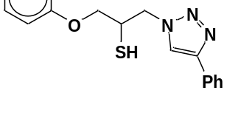 | 2.5 | 90
3 | 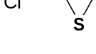 |  | 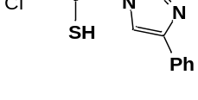 | 2.5 | 86
4 | 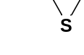 |  | 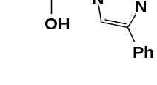 | 3 | 90
5 | 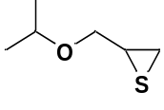 |  | 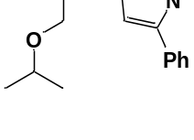 | 3 | 88
6 | 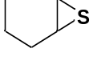 |  | 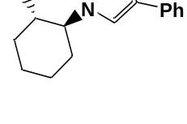 | 2 | 90
7 | 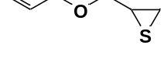 |  | 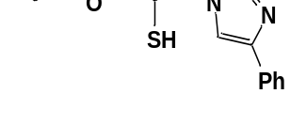 | 2.4 | 92
8 | 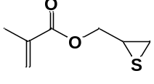 |  | 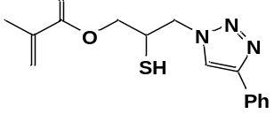 | 3.5 | 85
9 |  | 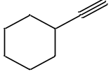 | 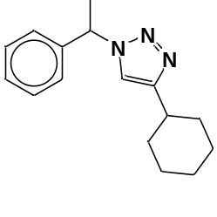 | 2.3 | 92
10 |  | 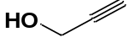 | 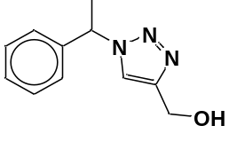 | 3.5 | 90
11 |  | 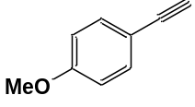 | 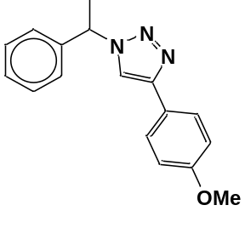 | 1.8 | 95
ªAll reactions were performed with of thiirane (1 mmol), alkyne (1 mmol), sodium azide (1.2 mmol) and nano- Fe₃O₄@SiO₂-PMA-Cu (0.1 g) in water at 55 °C. ^{b}Yields are related to isolated pure triazoles.

