Supplementary Material

Social information processing across the life-span in Barbary macaques

Eva-Maria Rathke^{1,2,3}, Roger Mundry^{1,2,3} & Julia Fischer^{1,2,3}
¹Cognitive Ethology Laboratory, German Primate Center, Leibniz Institute for Primate Research, Kellnerweg 4, 37077 Göttingen, Germany
²Department for Primate Cognition, Georg-August-University Göttingen
³Leibniz ScienceCampus Primate Cognition, Göttingen

Supplementary Methods
Supplementary Table 1. Study population by group, age, and sex.
Group PB (2017) |  |  |  | Group GB (2018)
Female ID | Age [years] | Male ID | Age  [years] | Female ID | Age [years] | Male ID | Age  [years]
B121 | <1 | B122 | <1 | X93 | 4 | C2 | <1
B120 | <1 | A115 | 1 | V71 | 5 | C3 | <1
Z104 | 2 | A118 | 1 | T63 | 6 | B123 | 1
T60 | 5 | Z102 | 2 | R50 | 7 | A111 | 2
T61 | 5 | X95 | 3 | R51 | 7 | A113 | 2
R52 | 6 | X87 | 3 | R53 | 7 | X82 | 4
O30 | 8 | V72 | 4 | O32 | 9 | X92 | 4
O31 | 8 | V73 | 4 | M20 | 10 | V70 | 5
M21 | 9 | V74 | 4 | M23 | 10 | T61 | 6
L11 | 10 | T60 | 5 | M24 | 10 | T62 | 6
K431 | 11 | R52 | 6 | K430 | 12 | T63 | 6
H412 | 13 | R55 | 6 | K432 | 12 | R57 | 7
G400 | 14 | R56 | 6 | I420 | 13 | P41 | 8
D370 | 17 | P40 | 7 | I421 | 13 | O31 | 9
C360 | 18 | M21 | 9 | I422 | 13 | M23 | 10
B350 | 19 | L10 | 10 | H410 | 14 | L14 | 11
B353 | 19 | L12 | 10 | F390 | 16 | K430 | 12
B355 | 19 | I421 | 12 | E380 | 17 | K431 | 12
A330 | 20 | I422 | 12 | B354 | 20 | G401 | 15
A331 | 20 | H410 | 13 | Y310 | 23 | G402 | 15
Z320 | 21 | H412 | 13 | Y311 | 23 | D372 | 18
T268 | 26 | H416 | 13 | W291 | 25 | B352 | 20
T274 | 26 | G403 | 14 | T261 | 27 | T262 | 27
T277 | 26 | F391 | 15 | T264 | 27
P227 | 28 | E380 | 16 | T275 | 27
M189 | 30 | D370 | 17 | R248 | 28
 |  | C361 | 18 | R253 | 28
 |  | A337 | 20 | O200 | 30
 |  | A340 | 20
 |  | Z321 | 21
 |  | W283 | 24
 |  | U282 | 25
 |  | R247 | 27
 |  | O202 | 29
 |  | M189 | 30
Note: Age is given for the respective years in which the data were collected.

Supplementary Table 2. Statistical software and R packages used, with version number and reference
Software/Package | Version | Reference
R | 4.0.3 | (R Core Team, 2020)
MASS | 7.3.54 | (Venables & Ripley, 2002)
car | 3.0-10 | (Fox & Weisberg, 2019)
lme4 | 1.1-25 | (Bates, 2005)
brms | 2.14.4 | (Bürkner, 2017, 2018)
lmerTest | 3.1.3 | (Kuznetsova et al., 2017)
irr | 0.84.1 | (Gamer et al., 2019)
EloRating | 0.43 | (Neumann & Kulik, 2014)

Supplementary Table 3. Description of the different response types and sample size for the analysis of variation in response type to agonistic signals by females (model 4). Total N = 1594 responses.
Response | N | Description
Make room (MR) | 303 | The subject leans away from an approaching monkey.
Give ground (GG) | 722 | The subject walks away from an approaching monkey.
Present  (PR) | 47 | The monkey approaches another monkey with its hindquarters first and presents its anogenital region towards the interaction partner. The subject may bend the front legs and/ or look back at the interaction partner.
Teeth chatter (TC) | 522 | The lips and corners of the mouth are retracted and the teeth and sometimes the gums are exposed. The mouth is opened and closed rapidly, sometimes with a flapping tongue. The teeth sometimes produce a clicking sound. The eyebrows and scalp are pulled up, and the ears are flattened against the head. Teeth chatter can occur in response to both affiliative and agonistic signals.

Supplementary Results

Supplementary Table 4. Influence of age and sex on the use of agonistic signals (model 1)
Term | Est. | SE | z value | Cl (lower) | Cl (upper) | P
(Intercept) | -0.07 | 0.09 | -0.77 | -0.24 | 0.11 | ⁽¹⁾
z.age ⁽²⁾ | -0.30 | 0.07 | -4.38 | -0.46 | -0.15 | <0.001
sex_male ⁽³⁾ | 0.54 | 0.14 | 3.84 | 0.26 | 0.81 | <0.001
Note: Estimates (Est.) with standard error (SE), test statistic z, lower and upper Confidence limit (Cl), and P-values are given (N = 84 subjects).
⁽¹⁾ not indicated because of being of very limited interpretability
⁽²⁾ z-transformed to a mean of zero and a standard deviation (sd) of one; mean and sd of the original variable were 16.1 and 7.2 years, respectively
⁽³⁾ dummy coded with female being the reference category

Supplementary Table 5. Influence of age, sex and rank on the use of affiliative signals (model 2)
Term | Est. | SE | z value | Cl (lower) | Cl (upper) | P
(Intercept) | -0.42 | 0.11 | -3.92 | -0.62 | -0.20 | ⁽¹⁾
z.age ⁽²⁾ | 0.31 | 0.07 | -4.19 | -0.45 | -0.17 | < 0.001
sex_male ⁽³⁾ | -0.49 | 0.21 | -2.37 | -0.89 | -0.09 | 0.02
z.rank ⁽⁴⁾ | 0.44 | 0.11 | 4.08 | 0.24 | 0.64 | < 0.001
Note: Estimates (Est.) with standard error (SE), test statistic z, lower and upper Confidence limits (Cl) and P-values are given. ⁽¹⁾ not indicated because being of very limited interpretability (N = 84 subjects).
⁽²⁾ z-transformed to a mean of zero and a standard deviation (sd) of one; mean and sd of the original variable were 16.0 and 7.2 years, respectively
⁽³⁾ dummy coded with female being the reference category
⁽⁴⁾ z-transformed to a mean of zero and a standard deviation (sd) of one; mean and sd of the original variable were 20.61 and 4.92, respectively

Supplementary Table 6. Results of the full model for the probability of showing any response (model 3)
Term | Est. | SE | Cl_{low} | Cl_{up} | c² | df | P | min | max
Intercept | 1.198 | 0.205 | 0.809 | 1.571 |  |  | ⁽¹⁾ | 1.132 | 1.247
Receiver age ⁽²⁾ | 0.194 | 0.214 | -0.193 | 0.604 |  |  |  | 0.080 | 0.253
Signal Category ⁽³⁾ | 0.005 | 0.232 | -0.462 | 0.443 |  |  |  | -0.052 | 0.124
Signaler age ⁽⁴⁾ | -0.314 | 0.084 | -0.475 | -0.155 | 13.22 | 1 | <0.001 | -0.347 | -0.281
Signaler sex_male ⁽⁵⁾ | -0.233 | 0.210 | -0.560 | 0.071 | 1.28 | 1 | 0.258 | -0.365 | -0.133
Receiver age:  Signal Category | -0.104 | 0.234 | -0.568 | 0.319 | 0.27 | 1 | 0.606 | -0.174 | 0.046
Note: estimates with standard errors (SE), confidence limits (lower and upper CI), and range of estimates (min, max) obtained when excluding the levels of random effects one at a time). N = 3115 events with N = 50 receivers.
⁽¹⁾ not indicated because being of very limited interpretability
⁽²⁾ z-transformed to a mean of zero and a standard deviation (sd) of one;
mean and sd the of original age were 14.9 and 8.2 years, respectively
⁽³⁾ dummy coded with affiliative being the reference level
⁽⁴⁾ z-transformed to a mean of zero and a standard deviation (sd) of one;
mean and sd the of original age were 14.5 and 6.0 years, respectively
⁽⁵⁾ dummy coded with female being the reference level

Supplementary Table 7. Results of the model of the type of response after aggressive signals (model 4).
Term | Estimate | Est. Error | Lower CI | Upper CI
MR_Intercept | -1.345 | 0.189 | -1.735 | -0.993
PR_Intercept | -3.337 | 0.431 | -4.309 | -2.609
TC_Intercept | -0.143 | 0.166 | -0.471 | 0.180
MR_z.Receiver_age | -0.221 | 0.119 | -0.462 | 0.009
MR_z.Signaller_age | 0.161 | 0.109 | -0.052 | 0.375
MR_Signaller_sexmale | 0.401 | 0.242 | -0.071 | 0.890
PR_z.Receiver_age | -0.281 | 0.274 | -0.874 | 0.196
PR_z.Signaller_age | 0.021 | 0.246 | -0.480 | 0.486
PR_Signaller_sexmale | -0.336 | 0.482 | -1.306 | 0.601
TC_z.Receiver_age | 0.227 | 0.136 | -0.038 | 0.498
TC_z.Signaller_age | -0.169 | 0.093 | -0.348 | 0.016
TC_Signaller_sexmale | -0.934 | 0.200 | -1.334 | -0.557
Note: Indicated are estimated effects and standard errors as well as limits of 95% credible intervals. Signaler and receiver age were z-transformed to a mean of zero and a standard deviation of one; mean and sd for the original variables were 13.8 and 5.5 (signaler age) and 15.1 and 8.4 years (receiver age); sex was dummy coded with female being the reference category.

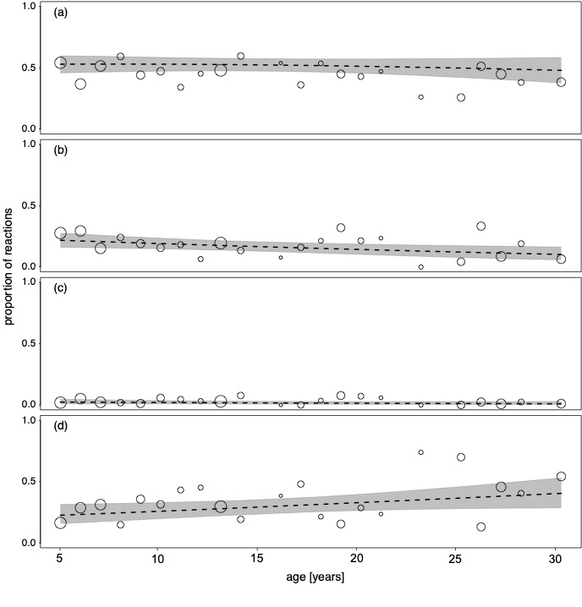
Supplementary Figure 1. Effects of receiver age on the type of response. a) Give Ground; b) Make Room; c) Present; d) Teeth Chatter. Dots show the occurrence probability of response type in a given year of age, whereby the area of the dots is proportionate to the total number of observed reactions (of all types) per year of age (range: 3 to 215). Dashed lines depict the fitted model (posterior median) and shaded polygons the limits of its 95% credible interval for both signaler age and sex centered to a mean of zero.

Supplementary Table 8. Results of the Likelihood ratio test for the analysis of the first look (model 5a).
Term | df | AIC | BIC | logLik | deviance | c² | df | P
Null model | 16 | 287.3 | 337.1 | -127.7 | 255.3 | - | - | -
Full model | 18 | 289.8 | 345.8 | -126.9 | 253.8 | 1.56 | 2 | 0.457
Note: N = 166 trials

Supplementary Table 9. Results of the model with duration of the first look as the response (model 5b).
Term | Est. | SE | t | df | Pr(>|t|)
(Intercept) | 0.918 | 0.101 | 9.129 | 54.6 | 0.000
z.age ⁽¹⁾ | -0.069 | 0.058 | -1.189 | 135.5 | 0.237
type_n ⁽²⁾ | -0.077 | 0.076 | -1.020 | 25.8 | 0.317
ID_sex_male ⁽³⁾ | 0.218 | 0.119 | 1.827 | 23.7 | 0.080
picture_sexmale ⁽⁴⁾ | 0.170 | 0.099 | 1.712 | 22.4 | 0.101
pair_second ⁽⁵⁾ | -0.171 | 0.093 | -1.848 | 20.3 | 0.079
z.age:type_n | 0.029 | 0.075 | 0.390 | 110.6 | 0.697
Note: Estimates, standard errors (SE), test statistic t, degrees of freedom (df),
and P-value are given.
⁽¹⁾ z-transformed to a mean of zero and a standard deviation (sd) of 1
Mean and sd for the original variable were 13.89 and 7.75.
⁽²⁾ dummy coded with agonistic facial expression being the reference level
⁽³⁾ dummy coded with ID sex = female being the reference level
⁽⁴⁾ dummy coded with picture ID sex = female being the reference level
⁽⁵⁾ dummy coded with pair = first being the reference level

Supplementary Table 10. Results of the Likelihood ratio test for the analysis of the total looking time (model 5b)
Term | Df | AIC | BIC | logLik | deviance | c² | df | P
Null model | 16 | 435.5 | 485.3 | -201.8 | 403.5 | - | - | -
Full model | 18 | 438.5 | 494.5 | -201.3 | 402.5 | 1.02 | 2 | 0.601
Note: N = 166 trials.

Supplementary Table 11. Results of the model with total looking time as the response.
Term | Est. | SE | t | df | Pr(>|t|)
(Intercept) | 1.523 | 0.149 | 10.254 | 89.972 | 0.000
z.age ⁽¹⁾ | -0.082 | 0.112 | -0.728 | 38.321 | 0.471
type_n ⁽²⁾ | -0.014 | 0.122 | -0.117 | 39.142 | 0.907
ID_sex_male ⁽³⁾ | 0.216 | 0.207 | 1.043 | 25.598 | 0.306
picture_sex_male ⁽⁴⁾ | 0.140 | 0.112 | 1.248 | 51.259 | 0.218
pair_second ⁽⁵⁾ | -0.376 | 0.117 | -3.229 | 56.980 | 0.002
z.age:typen | 0.001 | 0.152 | 0.005 | 12.385 | 0.996
Note: Estimates (Est.), standard errors (SE), test statistic t, degrees of freedom (df), and P values for the predictor variables age, picture type, sex of the subject, sex of the animal shown in the picture and interaction between age and type are given.
⁽¹⁾ z-transformed to a mean of zero and a standard deviation (sd) of 1.
Mean and sd for the original variable were 13.89 and 7.75.
⁽²⁾ dummy coded with agonistic facial expression being the reference level
⁽³⁾ dummy coded with ID sex = female being the reference level
⁽⁴⁾ dummy coded with picture ID sex = female being the reference level
⁽⁵⁾ dummy coded with pair = first being the reference level

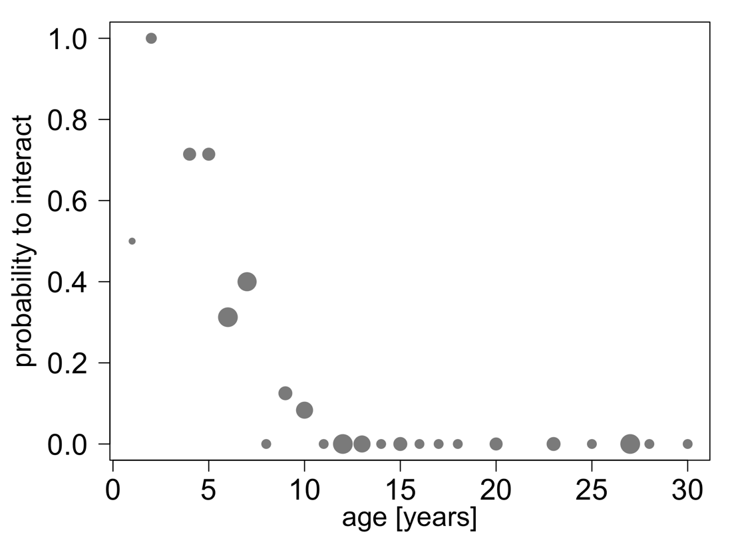

Supplementary Figure 2. Proportion of occurrences that the subject touched or sniffed at the picture, in relation to age.

Supplementary References
Bates, D. M. (2005). Fitting linear mixed models in R. Using the lme4 package. R News, 5(1), 27–30. https://doi.org/10.1159/000323281
Bürkner, P.-C. (2017). brms : An R Package for Bayesian Multilevel Models Using Stan. Journal of Statistical Software, 80(1), 1–28. https://doi.org/10.18637/jss.v080.i01
Bürkner, P.-C. (2018). Advanced Bayesian Multilevel Modeling with the R Package brms. The R Journal, 10(1), 395–411. https://doi.org/10.32614/RJ-2018-017
Fox, J., & Weisberg, S. (2019). An R Companion to Applied Regression (3rd ed.). Sage.
Gamer, M., Lemon, J., & Fellows, I. P. S. (2019). irr: Various Coefficients of Interrater Reliability and Agreement. R package version 0.84.1. (0.84.1).
Kuznetsova, A., Brockhoff, P. B., & Christensen, R. H. B. (2017). lmerTest Package: Tests in Linear Mixed Effects Models. Journal of Statistical Software, 82(13), 1–26. https://doi.org/10.18637/jss.v082.i13
Neumann, C., & Kulik, L. (2014). EloRating: Animal dominance hierarchies by Elo rating R. In R package version 0.43. (p. http://CRAN.R-project.org/package=EloRating).
R Core Team. (2020). R: A Language and Environment for Statistical Computing. R Foundation for Statistical Computing. https://www.r-project.org/
Venables, W. N., & Ripley, B. D. (2002). Modern Applied Statistics with S. Springer.

