Supplementary Material

Instantaneous synthesis of organic-inorganic laccase-cobalt phosphate hybrid nanoflowers: Structural and biocatalytic characterization
Khashayar Vojdanitalab^{a,b,#}, Hossein Jafari-Nodoushan^{a,#}, Somayeh Mojtabaviª, Mahtab Shokri^{a,b}, Hoda Jahandar^{b}, and Mohammad Ali Faramarzi^{a,*}

ª Department of Pharmaceutical Biotechnology, Faculty of Pharmacy & Biotechnology Research Center, Tehran University of Medical Sciences, P.O. Box 14155−6451, Tehran 1417614411, Iran
^{b} Pharmaceutical Sciences Research Center, Tehran Medical Sciences Branch, Islamic Azad University, Tehran, Iran
-------------------------------------------------
*Corresponding author: M.A. Faramarzi, Telefax: +98-21-66954712, E-mail: faramarz@tums.ac.ir
#K. Vojdanitalab and H. Jafari-Nodoushan contributed equally as first author.

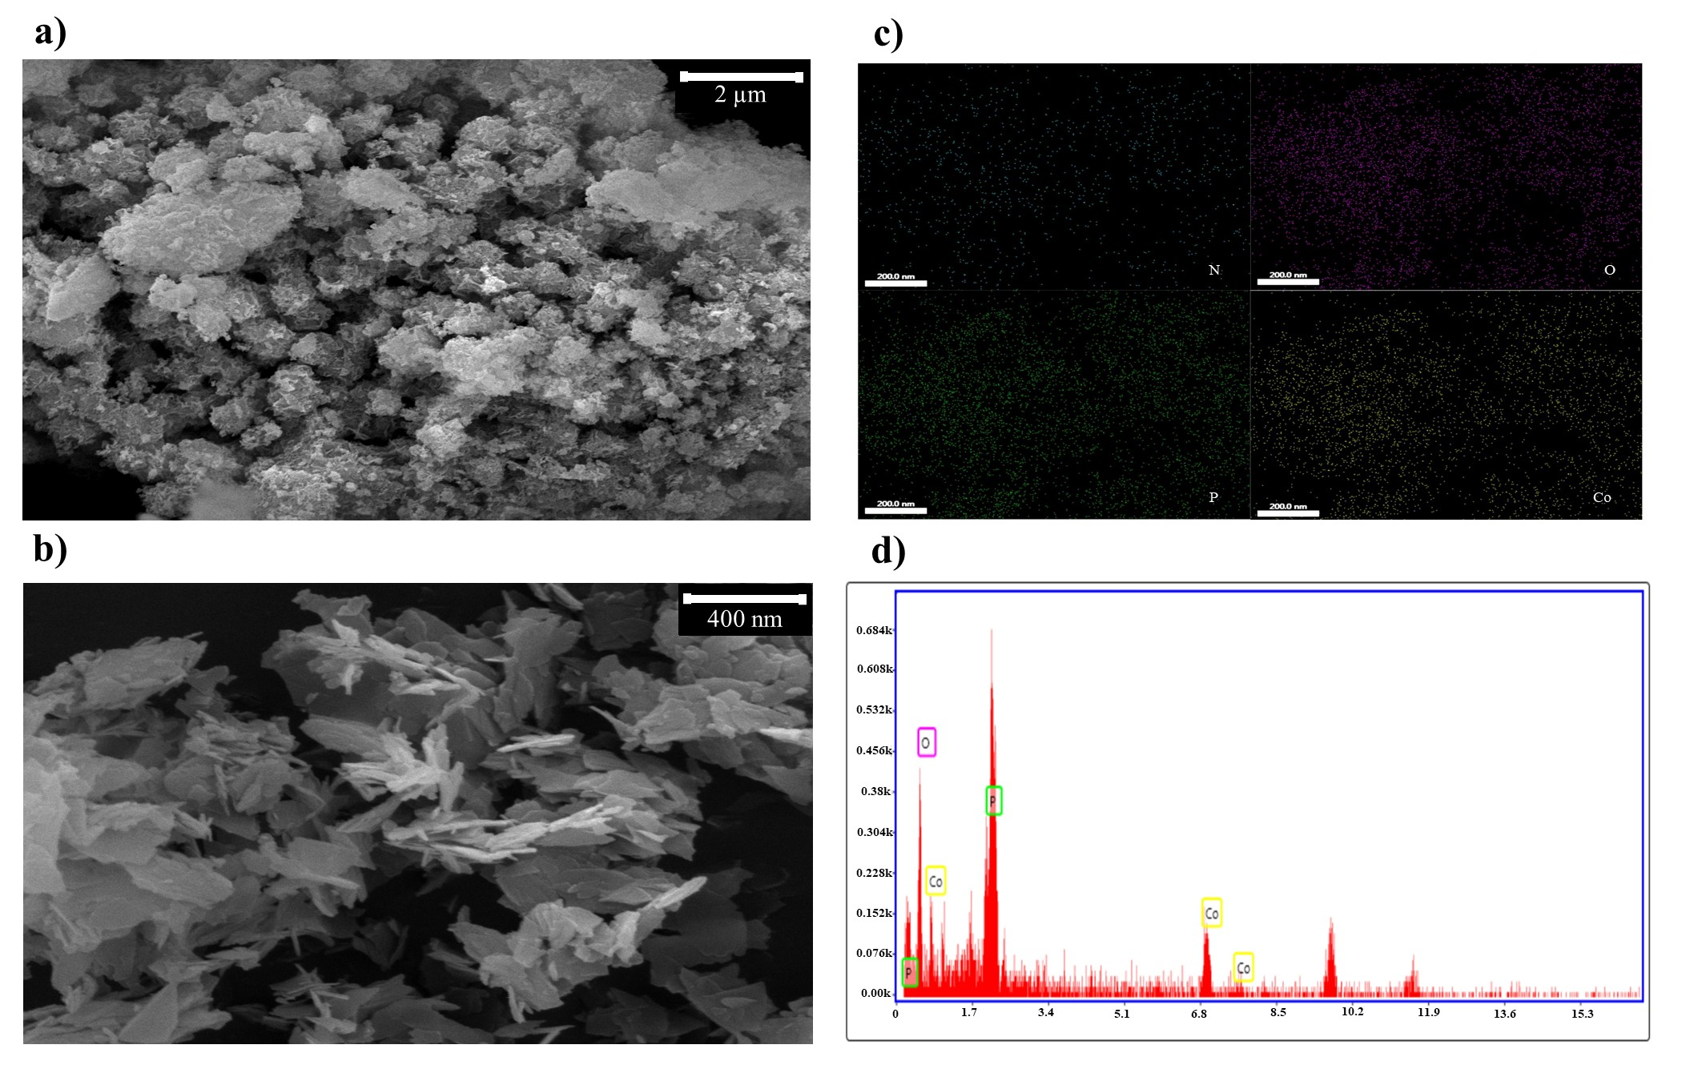
Fig. S1. Scanning electron microscopy (SEM) image of the constructed Co₃(PO₄)₂•NFs. The spherical flower-shaped nanostructures are formed by the “concentrated method.”
Fig. S2. Scanning electron microscopy (SEM) image of the constructed Co₃(PO₄)₂•NFs revealed that the flower-shaped nanostructures were composed of ultrathin nanosheets.

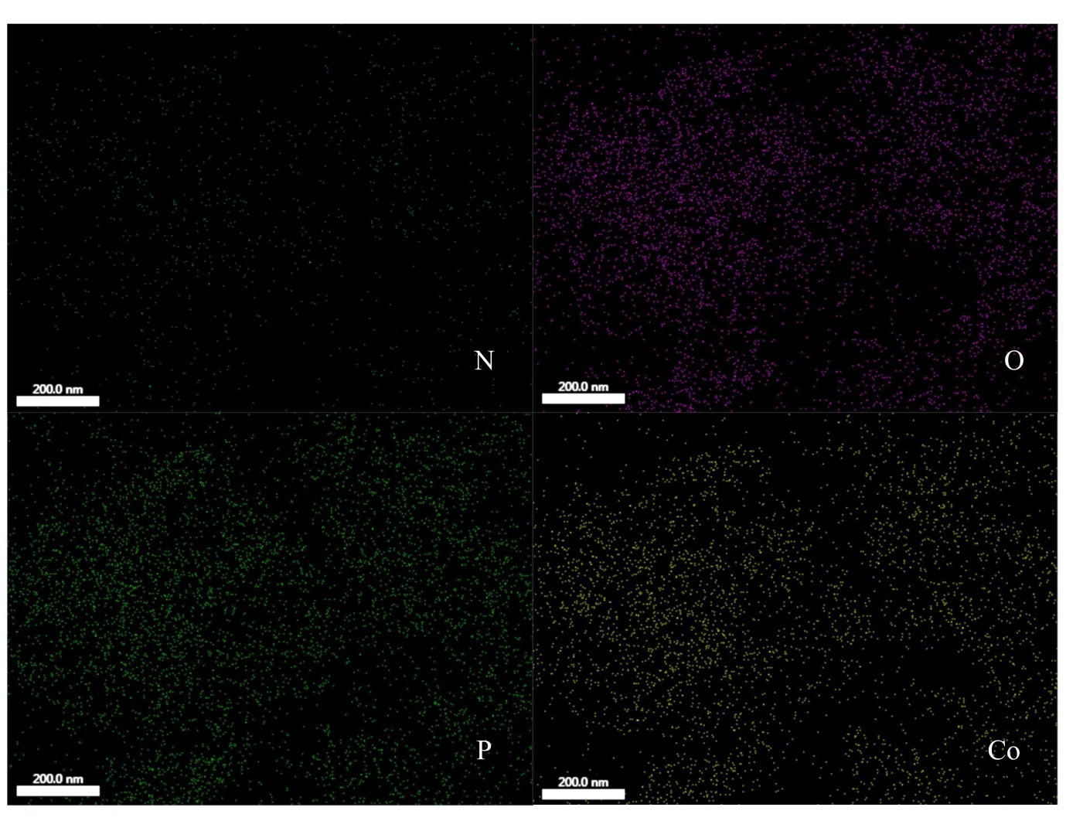
Fig. S3. Elemental map analysis of Co₃(PO₄)₂•NFs that mostly composed of P, Co, and O elements.
Fig. S4. Energy dispersive X-Ray spectroscopy (EDX) analysis of the constructed Co₃(PO₄)₂•NFs.
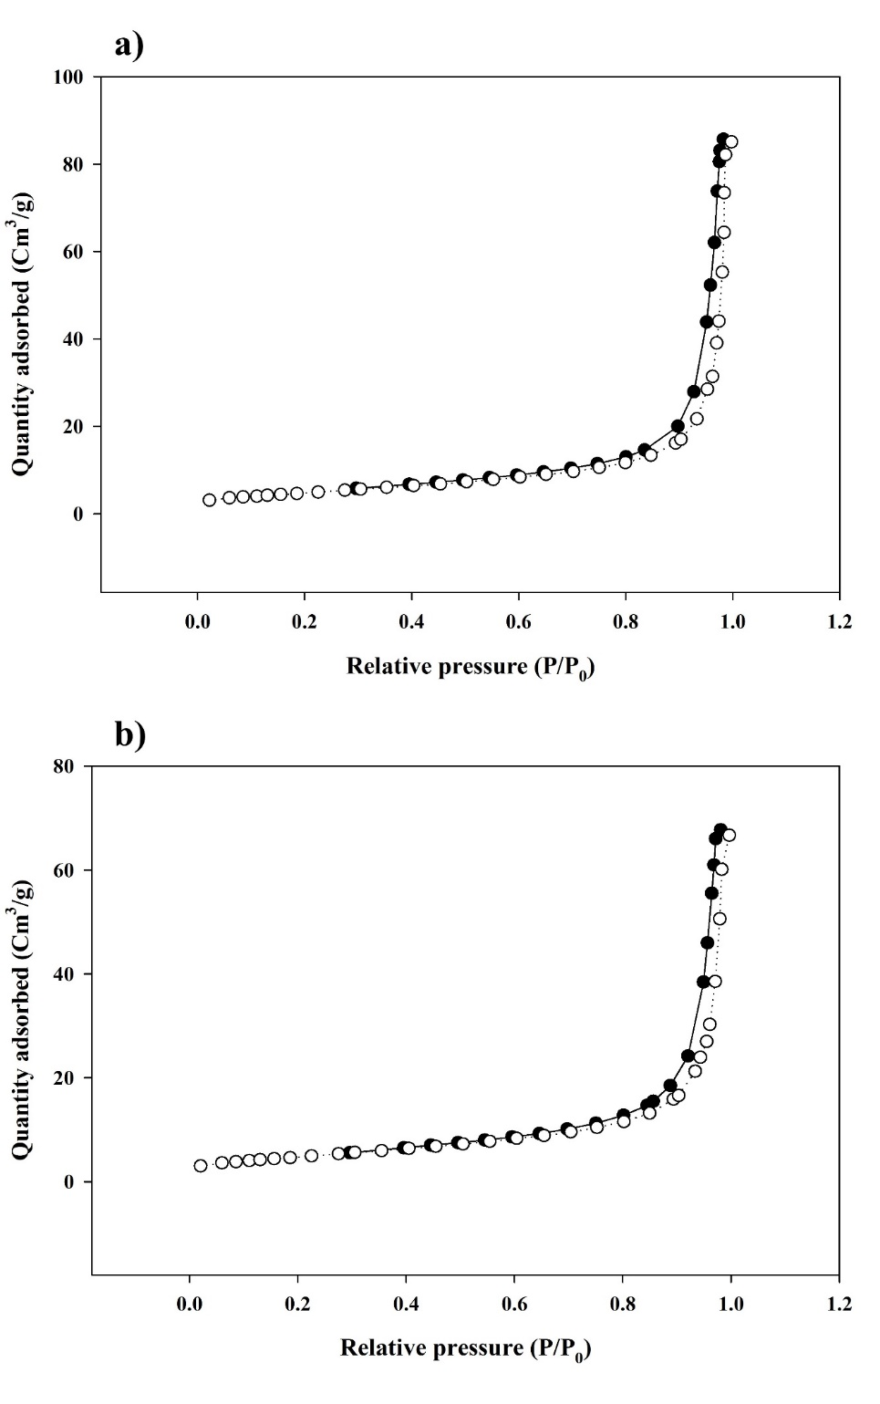
Fig. S5. Brunauer-Emmett-Teller (BET) plot of laccase@Co₃(PO₄)₂•HNFs (a) and Co₃(PO₄)₂•NFs (b). Both materials exhibited type IV isotherm with a narrow hysteresis loop, which is attributed to the mesoporous structure of the synthesized HNFs and NFs.
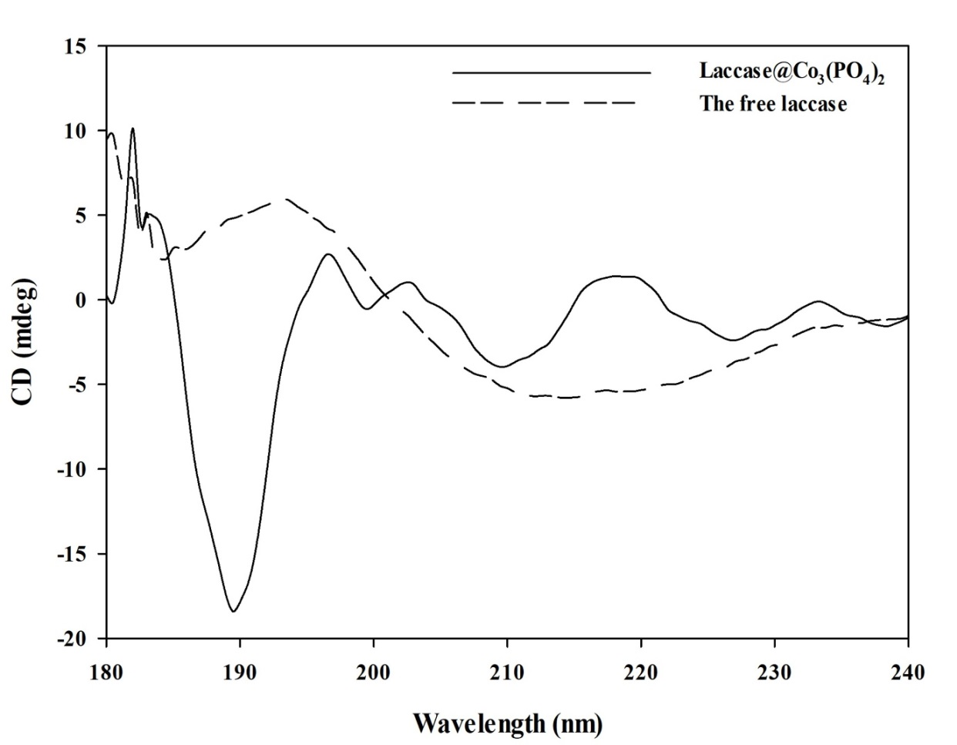
Figure S6. Circular dichroism (CD) spectra of laccase@Co₃(PO₄)₂•HNFs and the free enzyme recorded at 180–240 nm. Coordination of laccase with zinc phosphate significantly altered the secondary structure of the enzyme.
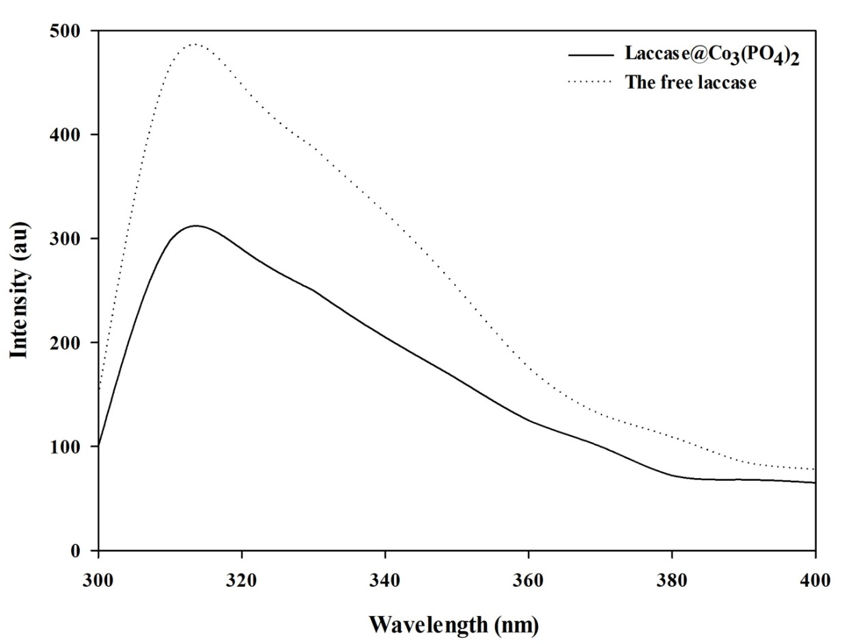
Figure S7. Tryptophan fluorescence intensity of laccase@Co₃(PO₄)₂•HNFs and the free enzyme for estimation the protein 3rd structure.
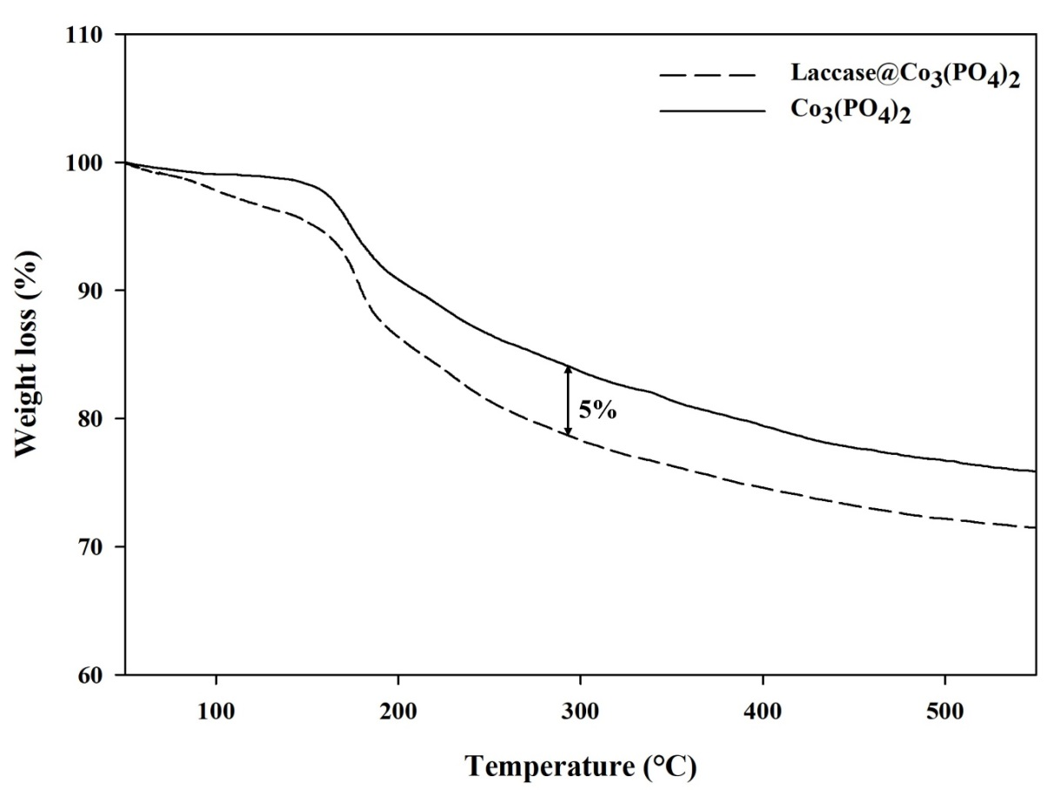
Figure S8. Thermogravimetric analysis of laccase@Co₃(PO₄)₂•HNFs and Co₃(PO₄)₂. Laccase composed 5% of the weight of the synthesized HNFs. The experiment was conducted after the complete degassing of samples under N₂ atmosphere with a heating rate of 10 °C/min.
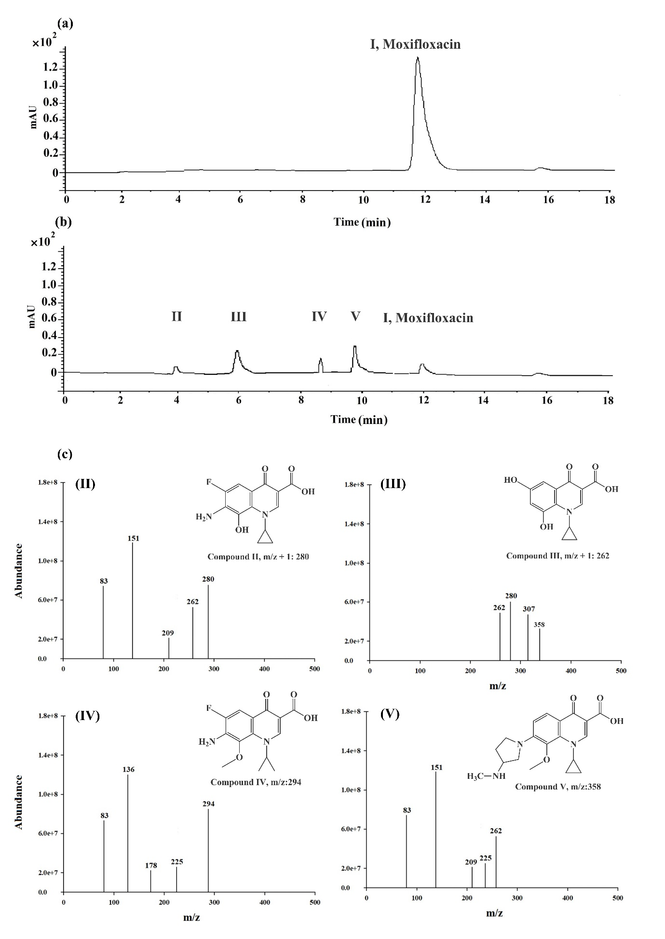
Figure S9. Liquid chromatography-mass spectrometry (LC-MS) analysis of moxifloxacin (R_{t} = 11.9 min) (a) and its corresponding detected degradation products (b). Mass spectra of the degradation products are presented as II) compound II (m/z: 280, R_{t} = 3.9 min), III) compound III (m/z: 262, R_{t} = 6 min), IV) compound IV (m/z: 294, R_{t} = 8.7 min), and V) compound V (m/z: 358, R_{t} = 9 min) (c).

Table S1. Weight percentage of elements in laccase@Co₃(PO₄)₂•HNFs and Co₃(PO₄)₂ measured by Energy dispersive X-Ray spectroscopy (EDX) analysis.
Type of material | Co (%) | O (%) | P (%) | N (%)
Laccase@Co₃(PO₄)₂•HNFs | 42.3 | 29.5 | 16.7 | 11.5
Co₃(PO₄)₂•NFs | 54.7 | 10 | 31.3 | 4

Table S2. Mean pore diameter, total pore volume, and Brunauer-Emmett-Teller (BET) specific surface area of laccase@Co₃(PO₄)₂•HNFs.
Material | Mean pore diameter (nm) | Total pore volume × 10⁻³ (cm³/g) | Specific surface area (m²/g)
Laccase@Co₃(PO₄)₂•HNFs | 29.5 | 128.5 | 17.4
Co₃(PO₄)₂•NFs | 22.3 | 98.1 | 17.6

Table S3. Growth inhibition percentage (GI%) of untreated and treated antibiotics with laccase@Co₃(PO₄)₂ HNFs against four bacterial strains. Values are averages of three replicates ± standard deviation.
Antibiotics | Bacterial strains
Antibiotics | S. aureus |  | S. epidermidis |  | P. aeruginosa |  | E. coli
Antibiotics | Untreated | Treated | Untreated | Treated | Untreated | Treated | Untreated | Treated
Moxifloxacin | 75.2 ± 0.6 % | 56.7 ± 1.2 % | 81.2 ± 0.4 % | 41.6 ± 0.7 % | 76.2 ± 0.3 % | 25.1 ± 2.1 % | 64.5 ± 0.4 % | 56.7 ± 1.2 %
* p < 0.05 vs. untreated

