Extended Data
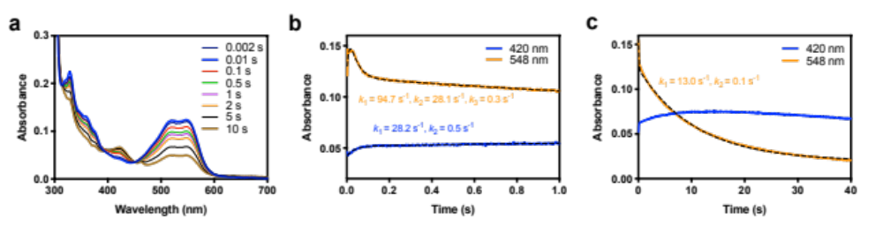
Extended Data Fig. 1 | Stopped-flow analysis of TaAA9-LPMO oxidation. Cu^{I}-TaAA9 (100 µM) mixed with m-CPBA (500 uM) in MES buffer (50 mM, pH 6) at 3 ˚C. (a) Raw UV-vis absorbance spectra at selected time points. (b) Kinetic transients at 420 nm and 548 nm over 1 s. The transient at 420 nm was fitted to a double exponential model and the transient at 548 nm was fitted to a triple exponential model, yielding rates of formation of 28.2 s⁻¹ for the tyrosyl radical and 94.7 s⁻¹ for the tryptophanyl radical, respectively. (c) Kinetic transients at 420 nm and 548 nm over 40 s, showing the full decay of the tryptophanyl radical with rates of 13.0 s⁻¹ and 0.1 s⁻¹. Black dashed lines show the fits of the data to the exponentials described.

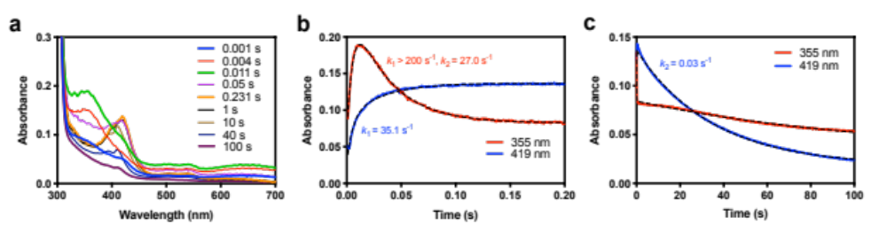
Extended Data Fig. 2 | Stopped-flow analysis of CvAA9-LPMO oxidation. Cu^{I}-CvAA9 (100 µM) mixed with m-CPBA (500 uM) in MES buffer (50 mM, pH 6) at 3 ˚C. (a) Raw UV-vis absorbance spectra at selected time points. (b) Kinetic transients at 355 nm and 419 nm over 1 s. The transient at 355 nm was fitted to a double exponential model, yielding rates of formation and decay of Int1 of > 200 s⁻¹ and 27.0 s⁻¹ respectively. The transient at 419 nm was fitted to a single exponential model to yield a rate of formation of Int2 of 35.1 s⁻¹. (c) Kinetic transients at 355 nm and 419 nm, showing the decay ofInt2 over 100 s. The transient at 419 nm was fitted to a single exponential, giving the decay rate of 0.03 s⁻¹. All transients are overlaid with fits by black dashed lines.

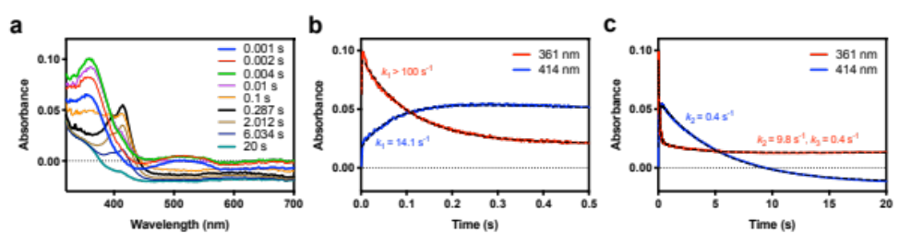
Extended Data Fig. 3 | Stopped-flow analysis of LsAA9-LPMO oxidation. Cu^{I}-LsAA9 (100 µM) mixed with m-CPBA (500 uM) in KPi buffer (50 mM, pH 6) at 3 ˚C. (a) Raw UV-vis absorbance spectra at selected time points. (b-c) Kinetic transients at 361 nm and 414 nm over 0.5 s amd 20 s. The transient at 361 nm was fitted to a triple exponential, yielding a rate of formation of Int1 > 100 s⁻¹ and decay rates of 9.8 s⁻¹ and 0.4 s⁻¹. The transient at 414 nm was fitted to a double exponential, yielding a rates of formation and decay of Int2 of 14.1 s⁻¹ 0.4 s⁻¹ respectively. All transients are overlaid with fits by black dashed lines.

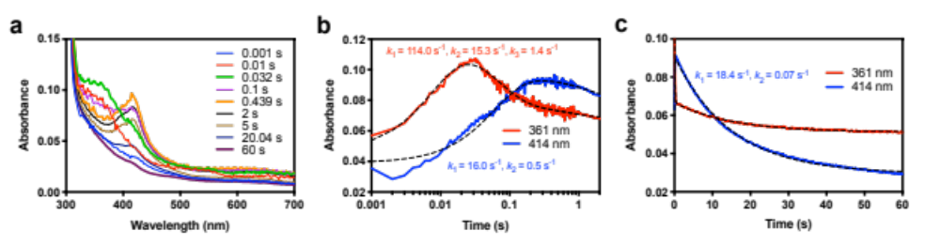
Extended Data Fig. 4 | Stopped-flow analysis of LsAA9 oxidation. Cu^{I}-LsAA9 (100 µM, expressed in Aspergillus oryzae) mixed with m-CPBA (100 uM) in Kpi buffer (50 mM, pH 6) at 3 ˚C. (a) Raw UV-vis absorbance spectra at selected time points. (b) Kinetic transients at 361 nm and 414 nm over 2 s. The transient at 361 nm was fitted to a triple exponential, yielding a formation rate of Int1 of 114 s⁻¹, and the decay rates 15.3 s⁻¹ and 1.4 s⁻¹. The transient at 414 nm was fitted to a double exponential, yielding a formation rate of Int2 of 16.0 s⁻¹ and the decay rate 0.5 s⁻¹. (c) Kinetic transients at 361 nm and 414 nm over 60 s. The transient at 414 nm was fitted to a double exponential to yield a rate of formation of Int2 of 18.4 s⁻¹ and a rate of decay of 0.07 s⁻¹. All transients are overlaid with fits by black dashed lines.

Conditions | Int1 formation rate (s⁻¹)
PAA (1 eq.) | 38.9 ± 0.1
m-CPBA (1 eq.) | 38.1 ± 0.1
H₂O₂ (50 eq.) | 99.1 ± 0.3
H₂O₂ (10 eq.) | 14.8 ± 0.2
H₂O₂ (1 eq.) | –
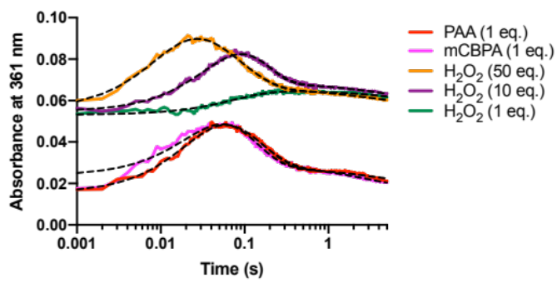
Extended Data Fig. 5 | Stopped-flow analysis of LsAA9 oxidation using different oxidants.
Cu^{I}-LsAA9 (50 µM) was mixed with various oxidants in KPi buffer (50 mM, pH 6) at 3 ˚C. Kinetic transients of Int1 at 361 nm are overlaid with fits by black dashed lines. Int1 formation rates are listed in the table.

Conditions | Int1 formation rate (s⁻¹) in KPi (50 mM in D₂O, pD 6) | Int1 formation rate (s⁻¹) in KPi (50 mM in H₂O, pH 6) | KIE
PAA (1 eq.) | 22.7 | 28.9 | 1.3
m-CPBA (1 eq.) | 15.6 | 24.2 | 1.6
H₂O₂ (50 eq.) | 33.5 | 56.9 | 1.7
H₂O₂ (10 eq.) | 20.4 | 33.6 | 1.6

Extended Data Table. 1 | Stopped-flow analysis of LsAA9 oxidation showing a solvent Kinetic Isotope Effect (KIE). Cu^{I}-LsAA9 (50 µM) was mixed with various oxidants in KPi buffer (50 mM in D₂O or H₂O) at 5 ˚C. Int1 formation rates are listed in the table. KIE = (Int1 formation rate in H₂O)/ (Int1 formation rate in D₂O).

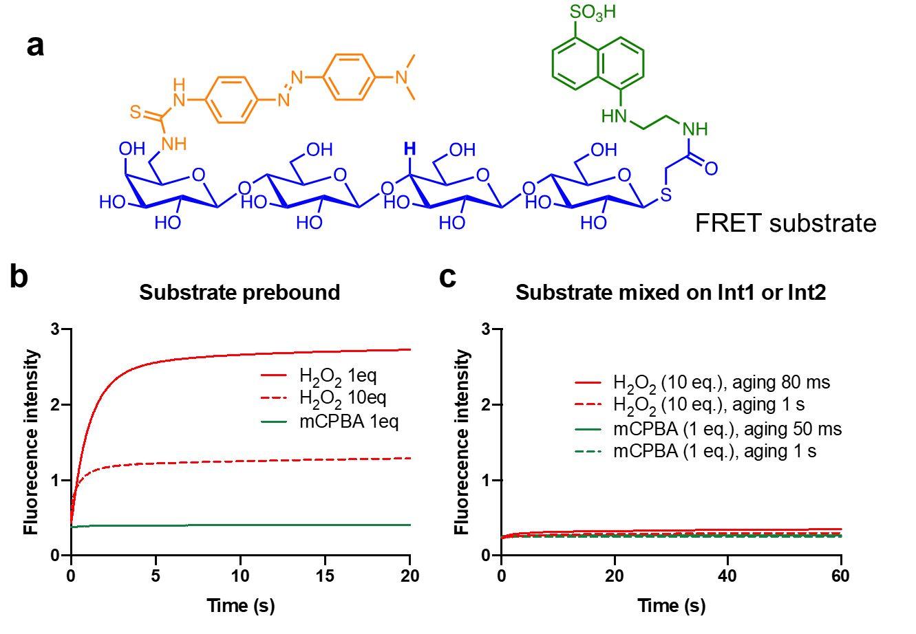
Extended Data Fig. 6 | Determining reactivity of Int1 and Int2 with a fluorescence resonance energy transfer (FRET) substrate. (a) The chemical structure of the FRET substrate. (b) Stopped-flow kinetics showing fluorescence upon mixing of Cu^{I}-LsAA9 (50 µM), pre-bound with FRET substrate (100 µM), with either m-CPBA (50 µM) or H₂O₂ (50 µM, 500 µM) in KPi buffer (50 mM, pH 6) at 3 ˚C. (c) Double mixing stopped-flow kinetics showing fluorescence changes upon mixing Int1 or Int2 with FRET substrate. Reduced Cu^{I}-LsAA9 (50 µM) was first mixed with m-CPBA (50 µM) or H₂O₂ (500 µM), allowed to age for either 50 ms, 80 ms or 1 s, then mixed with the FRET substrate (100 µM). An excitation wavelength of 330 nm and a 455 nm high-pass filter was used in all stopped-flow experiments.

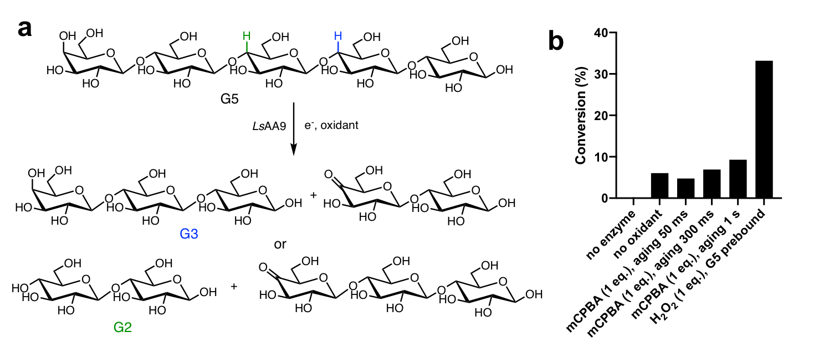
Extended Data Fig. 7 | Determining reactivity of Int1 and Int2 with a soluble cellopentaose substrate (G5). (a) LsAA9 catalyzes the degradation of G5 substrate, forming G3 and oxidized G2, or G2 and oxidized G3 products. (b) Product conversion by LC-MS after anaerobic double-mixing experiments using a quench-flow device. Reduced Cu^{I}-LsAA9 (50 µM) was first mixed with m-CPBA (50 µM), allowed to age for either 50 ms, 300 ms or 1 s, then mixed with the G5 substrate (250 µM). The final reaction mixture (200 µL) was recovered from the quench-flow device, immediately quenched with 200 µL MeCN and analyzed by LC-MS. The final concentration of G2, G3 and G5 were calculated based on standard curves using reference compounds. The reaction conversion was calculated by ([G2]+[G3])/([G2]+[G3]+[G5])*100%.

