Supplementary material 1: Definition of treatment groups based on the observational data in the sequential emulated trials

We used data from the ComPaRe e-cohort to emulate a sequence of three trials that we subsequently pooled.
For each patient, we divided his/her follow-up in the ComPaRe cohort into consecutive shorter periods defined by his/her “observation time points” (T0, T1, T2 …) during follow-up in the cohort. Therefore, for each patient, his follow-up in the cohort was divided in periods T0-T1, T1-T2, T2-T3, etc.
For each patient and for each period, we ascertained if he/she was eligible in for analyses (e.g., if the patient still had COVID-19 symptoms at the beginning of the period) and, if so, identified whether he/she received the first dose of COVID-19 vaccine during the period. For each vaccinated patient, we matched one patient who had not been vaccinated in the same period (e.g., vaccinated patients in the T1-T2 period were matched to unvaccinated patients in the T1-T2 period). Matching was based on the propensity score (probability of getting vaccinated against COVID-19 given the patient’s baseline covariates. Newly vaccinated persons remained eligible for inclusion in a sequential trial, even if they had previously been selected as a control.
For vaccinated patients and their matched control, the time point defining the start of the period was considered as the patient’s baseline in the emulated trial.
Each patient was followed for 120 days after his/her baseline (for example, patients whose baseline was their 1st observation point in the ComPaRe cohort were followed-up to their 3rd observation point; and patients whose baseline was the second observation point in the cohort were followed-up to their fourth observation point). Follow-up was artificially censored at the time of vaccination for unvaccinated controls.

The following figure details how baseline was defined for patients and how data were handled when observation times were missing.
Among vaccinated patients, we could not define a bassline for patients who were vaccinated before T0 (their first observation point) OR whose last observation time before receiving the vaccination was missing. These patients were excluded from the trial which baseline was the missing observation time. However, in the second case, if earlier observation periods were available before the missing time point, they were still eligible for the control group.
In the vaccination group, if the earliest observation time after receiving COVID-19 vaccination was missing, as long as they received a vaccine injection in the 60 days after baseline, we considered that they were eligible in the specific trial, and data from D60 was treated as missing.
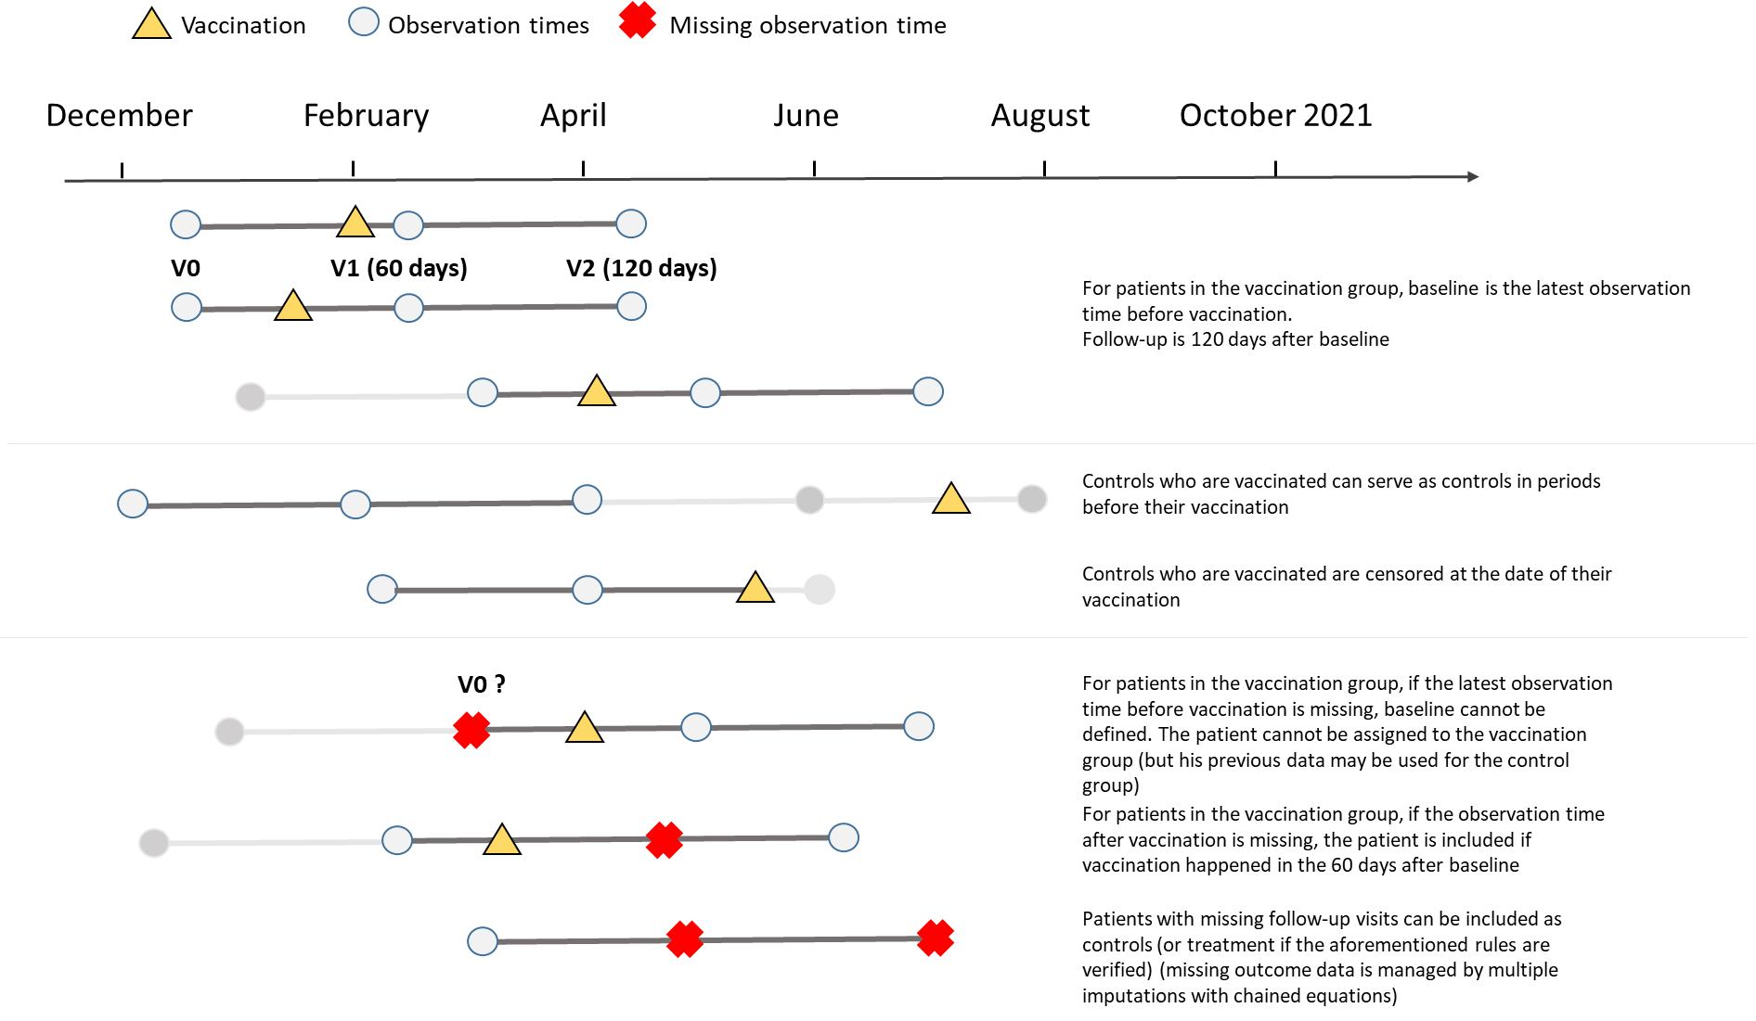

Supplementary material 2: Study flow chart
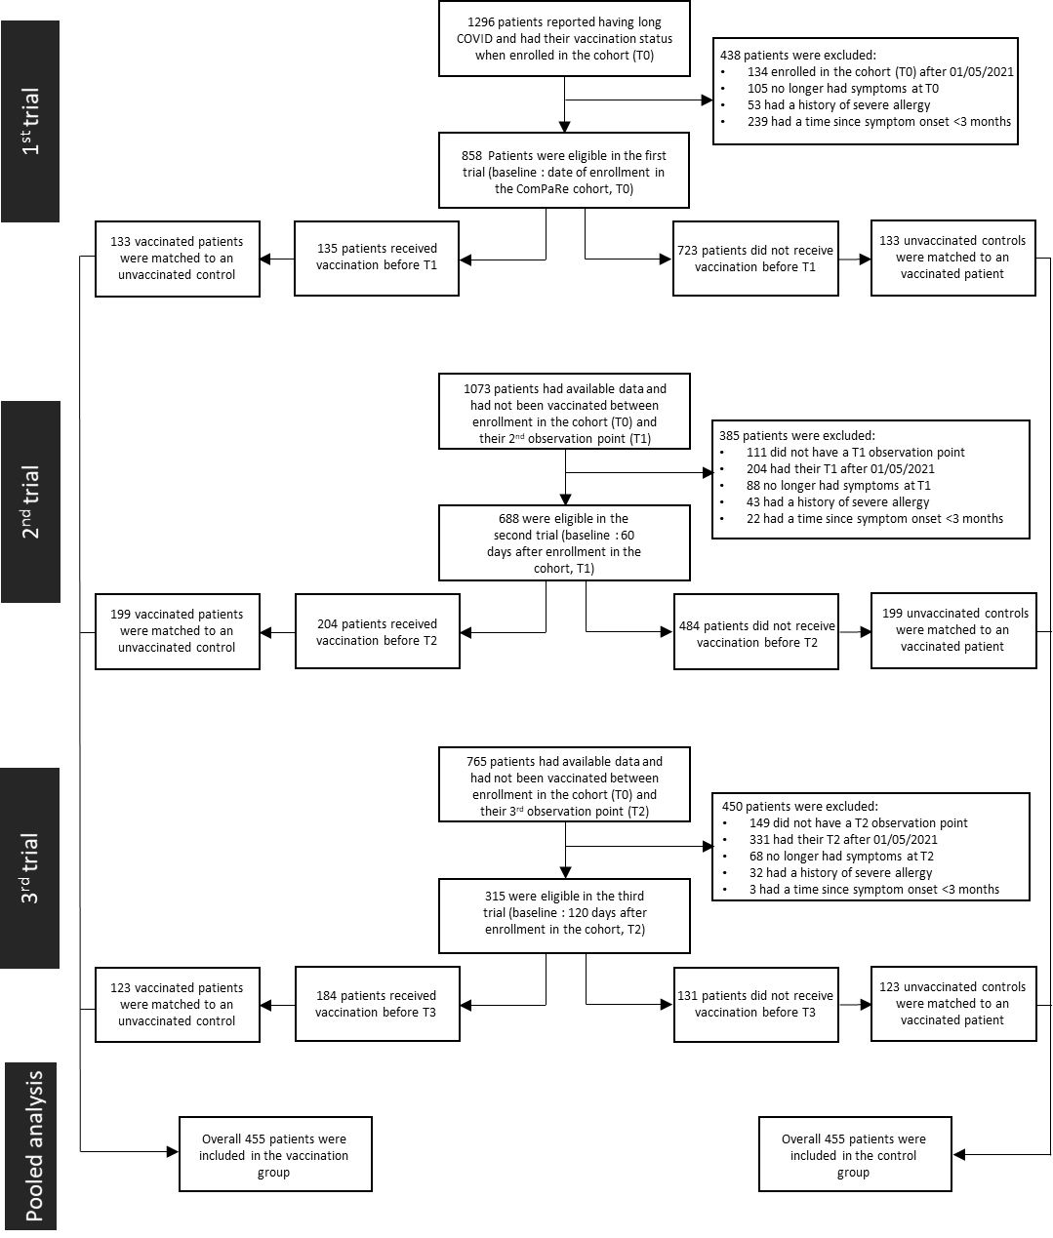

Supplementary material 3a: Propensity score development for the first trial (n=266)
Before matching
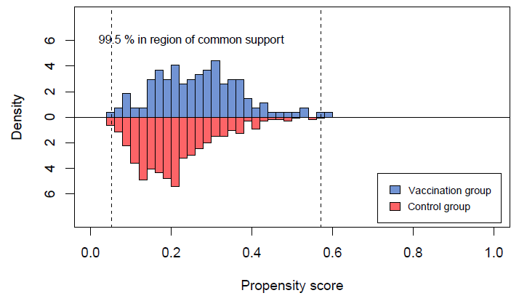
After matching
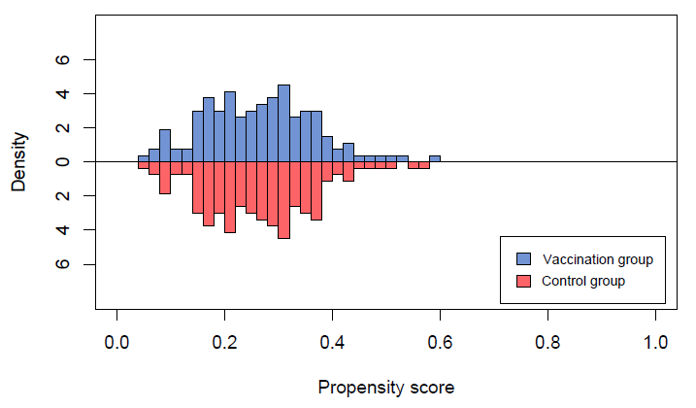

Supplementary material 3b: Standardised differences of variables used to generate the propensity score for the first trial (n=266)

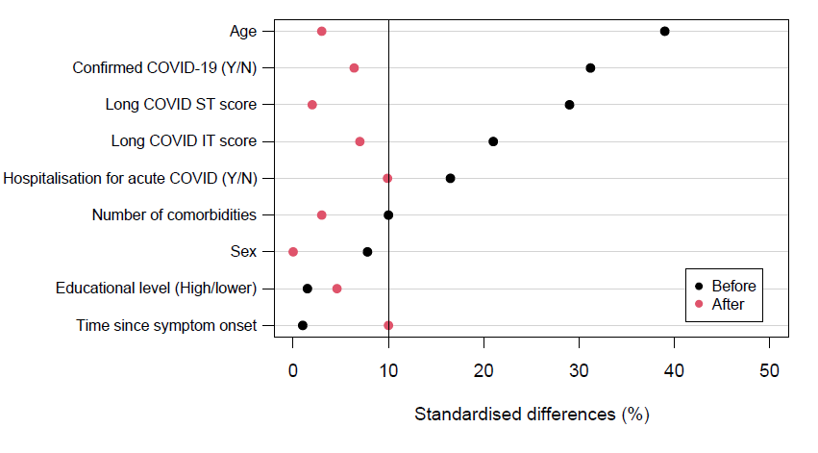

Supplementary material 4a: Propensity score development for the second trial (n=398)

Before matching
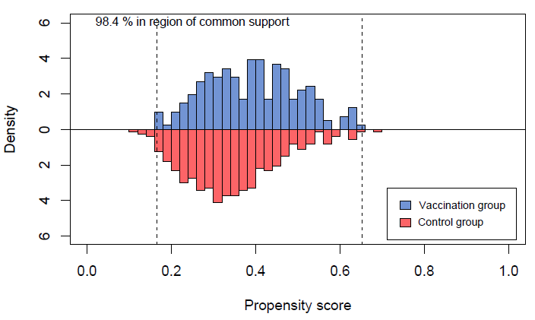

After matching 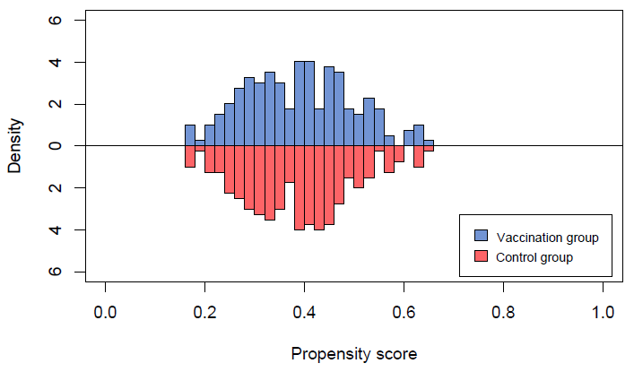

Supplementary material 4b: Standardised differences of variables used to generate the propensity score for the second trial (n=398)

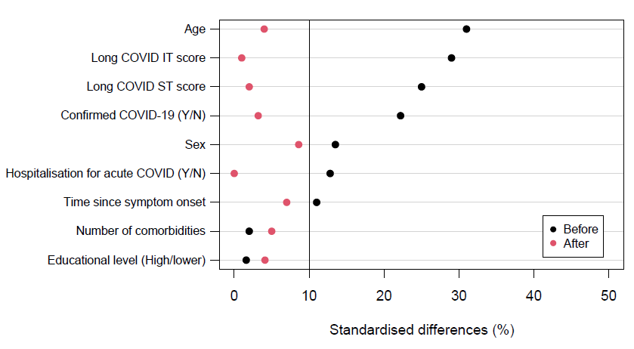

Supplementary material 5a: Propensity score development for the third trial (n=246)

Before matching

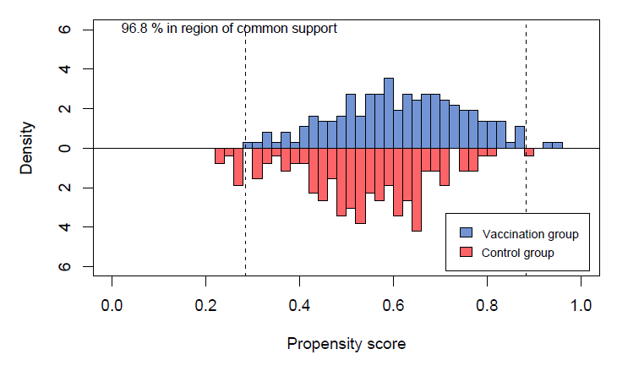

After matching

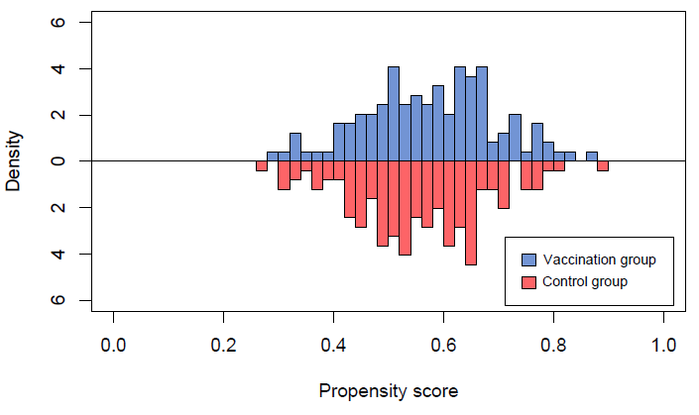

Supplementary material 5b: Standardised differences of variables used to generate the propensity score for the third trial (n=246)

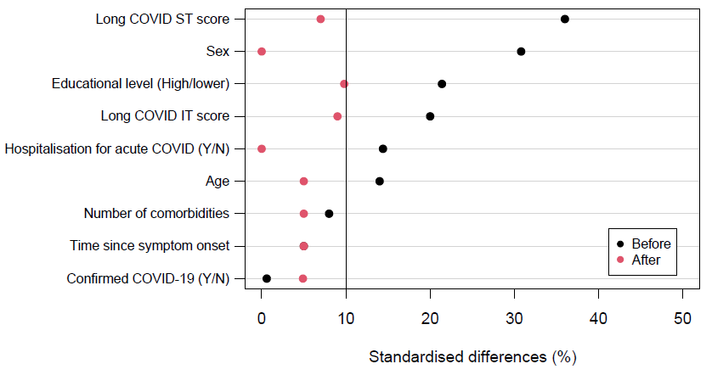

Supplementary material 6: Standardised differences of variables used to generate the propensity score in the pooled analysis (n=910)

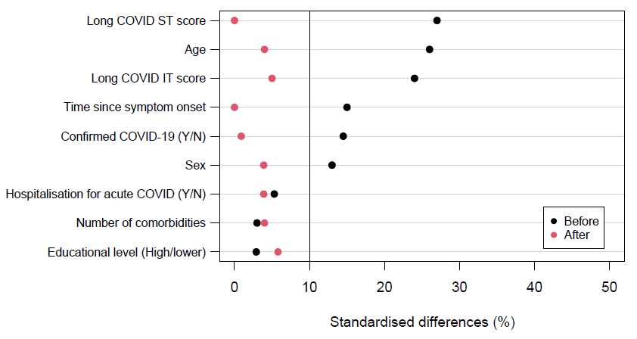

Supplementary material 7: Primary and secondary outcomes at 120 days after baseline in the subgroup of patients with confirmed COVID-19 (n=510).
¹For 158 patients in the control group, data were censored at the date of their vaccination before 120 days; ²Outcome data were missing for 26 (10·2 %) and 14 (5·5 %) patients in the vaccination and control group respectively. Missing outcome data were handled by multiple imputations using chained equations.
 | Vaccinated patients  (n=255) | Unvaccinated controls  (n=255)¹ | Mean difference  or difference of proportion  (95% CI)²
Long COVID ST score  at 120 days - Mean (SD) | 12.0 (8.5) | 13.8 (8.7) | -1.8 (-3.4 to -0.2)
Long COVID IT score  at 120 days - Mean (SD) | 22.7 (16.1) | 26·4 (16.3) | -3.8 (-6.7 to -0.9)

Supplementary material 8a: Primary and secondary outcomes at 120 days after baseline in the subgroup of patients whose time since symptom onset was ≤ 12 months (n=582).
¹For 176 patients in the control group, data were censored at the date of their vaccination before 120 days; ²Outcome data were missing for 22 (7·6 %) and 22 (7·6 %) patients in the vaccination and control group respectively. Missing outcome data were handled by multiple imputations using chained equations.
 | Vaccinated patients  (n=291) | Unvaccinated controls  (n=291)¹ | Mean difference  or difference of proportion  (95% CI)²
Long COVID ST score  at 120 days - Mean (SD) | 12.0 (9.1) | 13.9 (9.2) | -1.9 (-3.4 to -0.5)
Long COVID IT score  at 120 days - Mean (SD) | 23.5 (16.3) | 26.4 (16.3) | -2.9 (-5.6 to -0.2)

Supplementary material 8b: Primary and secondary outcomes at 120 days after baseline in the subgroup of patients whose time since symptom onset was > 12 months (n=294).
¹For 58 patients in the control group, data were censored at the date of their vaccination before 120 days; ²Outcome data were missing for 7 (4.8 %) and 11 (7.5 %) patients in the vaccination and control group respectively. Missing outcome data were handled by multiple imputations using chained equations.
 | Vaccinated patients  (n=255) | Unvaccinated controls  (n=255)¹ | Mean difference  or difference of proportion  (95% CI)²
Long COVID ST score  at 120 days - Mean (SD) | 15.3 (9.9) | 17 (9.4) | -1.7 (-3.8 to 0.4)
Long COVID IT score  at 120 days - Mean (SD) | 27.8 (17.1) | 30.6 (15.1) | -2.8 (-6.5 to 0.9)

Supplementary material 9: Primary and secondary outcomes at 120 days in a sensitivity analysis with the study population is limited to patients who had been included in only one of the three sequential trial (n=652).

¹For 156 patients in the control group, data were censored at the date of their vaccination before 120 days; ² Outcome data was missing for 29 (8·9 %) and 22 (6·7 %) patients in the vaccination and control group respectively. Missing outcome data were handled by multiple imputations using chained equations.
 | Vaccinated patients  (n=255) | Unvaccinated controls  (n=255)¹ | Mean difference  or difference of proportion  (95% CI)²
Long COVID ST score  at 120 days - Mean (SD) | 13·2 (9·6) | 14·9 (10·2) | -1·6 (-3.1 to -0.2)
Long COVID IT score  at 120 days - Mean (SD) | 24·1 (16·9) | 27·2 (17·0) | -3.1 (-5.8 to 0.4)

Supplementary material 10: Value of the long COVID ST and IT score at 120 days after baseline, as a function of the time to vaccination, among patients who were vaccinated (n=618).
