Supporting Information
Table S1 Number of quadrats in canopy gaps in 21 subalpine autumn colour-leaved forest plots.
Plot number | Gap area (m²) | Number of quadrats | Plot number | Gap area (m²) | Number of quadrats | Plot number | Gap area (m²) | Number of quadrats | Plot number | Gap area (m²) | Number of quadrats
S1 | 461 | 1 | S11 | 145 | 1 | S13 | 20 | 1 | S16 | 63 | 1
S1 | 324 | 2 | S11 | 11 | 1 | S13 | 2 | 1 | S16 | 8 | 1
S1 | 232 | 2 | S11 | 2 | 1 | S13 | 44 | 1 | S16 | 19 | 1
S1 | 190 | 2 | S11 | 8 | 1 | S13 | 2 | 2 | S16 | 32 | 1
S1 | 93 | 1 | S11 | 19 | 1 | S13 | 412 | 1 | S16 | 30 | 1
S1 | 73 | 1 | S11 | 83 | 1 | S13 | 20 | 1 | S17 | 3 | 1
S1 | 42 | 1 | S11 | 100 | 1 | S13 | 54 | 1 | S17 | 3 | 1
S1 | 17 | 1 | S11 | 16 | 1 | S13 | 14 | 5 | S17 | 2 | 1
S1 | 30 | 1 | S11 | 49 | 1 | S13 | 1142 | 1 | S17 | 2 | 1
S1 | 30 | 1 | S11 | 86 | 1 | S13 | 5 | 1 | S17 | 6 | 1
S1 | 25 | 1 | S11 | 7 | 1 | S13 | 3 | 1 | S17 | 7 | 1
S1 | 24 | 1 | S11 | 5 | 1 | S13 | 8 | 1 | S17 | 2 | 1
S1 | 11 | 1 | S11 | 9 | 1 | S13 | 2 | 1 | S17 | 2 | 1
S1 | 9 | 1 | S11 | 7 | 1 | S13 | 14 | 1 | S17 | 20 | 1
S1 | 79 | 1 | S11 | 7 | 1 | S14 | 1 | 1 | S17 | 34 | 1
S1 | 115 | 1 | S11 | 25 | 1 | S14 | 3 | 1 | S17 | 16 | 1
S1 | 39 | 1 | S11 | 99 | 1 | S14 | 1 | 1 | S17 | 21 | 1
S1 | 1203 | 3 | S11 | 26 | 1 | S14 | 3 | 1 | S17 | 1 | 1
S2 | 15 | 1 | S11 | 34 | 1 | S14 | 2 | 1 | S17 | 3 | 1
S3 | 60 | 1 | S11 | 9 | 1 | S14 | 5 | 1 | S17 | 3 | 1
S3 | 190 | 2 | S11 | 34 | 1 | S14 | 3 | 1 | S17 | 2 | 1
S3 | 62 | 1 | S11 | 4 | 1 | S14 | 30 | 1 | S17 | 2 | 1
S3 | 15 | 1 | S11 | 5 | 1 | S14 | 5 | 1 | S17 | 2 | 1
S3 | 85 | 1 | S11 | 4 | 1 | S14 | 10 | 1 | S17 | 2 | 1
S3 | 328 | 2 | S11 | 6 | 1 | S14 | 31 | 1 | S17 | 4 | 1
S3 | 293 | 2 | S11 | 33 | 1 | S14 | 12 | 1 | S17 | 4 | 1
S3 | 4 | 1 | S11 | 4 | 1 | S14 | 5 | 1 | S17 | 3 | 1
S3 | 5 | 1 | S11 | 31 | 1 | S14 | 7 | 1 | S17 | 3 | 1
S4 | 184 | 2 | S11 | 19 | 1 | S14 | 9 | 1 | S17 | 5 | 1
S4 | 80 | 1 | S11 | 4 | 1 | S14 | 3 | 1 | S17 | 5 | 1
S4 | 65 | 1 | S11 | 8 | 1 | S14 | 4 | 1 | S17 | 2 | 1
S4 | 143 | 1 | S11 | 138 | 1 | S14 | 9 | 1 | S17 | 5 | 1
S4 | 112 | 1 | S11 | 41 | 1 | S14 | 7 | 1 | S17 | 2 | 1
S4 | 13 | 1 | S12 | 69 | 1 | S14 | 1 | 1 | S17 | 7 | 1
S4 | 641 | 2 | S12 | 11 | 1 | S14 | 1 | 1 | S17 | 7 | 1
S5 | 296 | 2 | S12 | 10 | 1 | S14 | 11 | 1 | S17 | 1 | 1
S5 | 189 | 1 | S12 | 133 | 1 | S14 | 22 | 1 | S17 | 1 | 1
S5 | 32 | 1 | S12 | 88 | 1 | S14 | 2 | 1 | S17 | 7 | 1
S5 | 29 | 1 | S12 | 20 | 1 | S14 | 8 | 1 | S17 | 5 | 1
S5 | 40 | 1 | S12 | 46 | 1 | S14 | 16 | 1 | S17 | 2 | 1
S5 | 53 | 1 | S12 | 66 | 1 | S14 | 35 | 1 | S17 | 2 | 1
S5 | 34 | 1 | S12 | 60 | 1 | S14 | 4 | 1 | S17 | 5 | 1
S5 | 11 | 1 | S12 | 66 | 1 | S14 | 1 | 1 | S17 | 8 | 1
S5 | 18 | 1 | S12 | 31 | 1 | S14 | 2 | 1 | S17 | 1 | 1
S5 | 41 | 1 | S12 | 4 | 1 | S14 | 28 | 1 | S17 | 1 | 2
S5 | 217 | 1 | S12 | 6 | 1 | S14 | 2 | 1 | S17 | 1 | 1
S6 | 24 | 1 | S12 | 11 | 1 | S14 | 6 | 1 | S17 | 2 | 2
S6 | 37 | 1 | S12 | 3 | 1 | S14 | 5 | 1 | S17 | 5 | 1
S6 | 2 | 1 | S12 | 3 | 1 | S14 | 6 | 1 | S17 | 1 | 1
S6 | 3 | 1 | S12 | 7 | 1 | S14 | 12 | 1 | S17 | 1 | 1
S6 | 88 | 1 | S12 | 30 | 1 | S14 | 4 | 1 | S17 | 8 | 1
S6 | 104 | 1 | S12 | 66 | 1 | S14 | 3 | 1 | S17 | 6 | 1
S6 | 44 | 1 | S12 | 48 | 1 | S14 | 14 | 1 | S17 | 7 | 1
S6 | 38 | 1 | S12 | 10 | 1 | S14 | 12 | 1 | S17 | 7 | 1
S6 | 16 | 1 | S12 | 28 | 1 | S14 | 2 | 1 | S17 | 16 | 1
S7 | 8 | 1 | S12 | 27 | 1 | S14 | 4 | 1 | S17 | 1 | 1
S7 | 9 | 1 | S12 | 51 | 1 | S14 | 4 | 1 | S18 | 4 | 1
S7 | 19 | 1 | S12 | 47 | 1 | S14 | 7 | 1 | S18 | 839 | 3
S7 | 5 | 1 | S12 | 4 | 1 | S14 | 2 | 1 | S18 | 696 | 1
S7 | 29 | 1 | S12 | 85 | 1 | S14 | 37 | 1 | S18 | 69 | 1
S7 | 965 | 3 | S12 | 26 | 1 | S14 | 8 | 1 | S18 | 94 | 1
S8 | 489 | 2 | S12 | 38 | 1 | S15 | 24 | 1 | S18 | 426 | 1
S8 | 1612 | 3 | S12 | 4 | 1 | S15 | 12 | 1 | S18 | 194 | 4
S8 | 46 | 1 | S12 | 8 | 1 | S15 | 98 | 1 | S19 | 78 | 2
S8 | 251 | 1 | S12 | 19 | 1 | S15 | 26 | 1 | S19 | 3468 | 5
S8 | 545 | 2 | S12 | 1 | 1 | S15 | 18 | 1 | S19 | 74 | 1
S8 | 567 | 3 | S12 | 6 | 1 | S15 | 11 | 1 | S19 | 67 | 1
S8 | 244 | 1 | S12 | 90 | 1 | S15 | 4 | 1 | S19 | 55 | 1
S9 | 31 | 1 | S12 | 4 | 1 | S15 | 6 | 1 | S19 | 48 | 1
S9 | 7 | 1 | S12 | 35 | 1 | S15 | 52 | 1 | S19 | 39 | 1
S9 | 276 | 2 | S12 | 11 | 1 | S15 | 13 | 1 | S19 | 33 | 1
S9 | 61 | 1 | S12 | 13 | 1 | S15 | 16 | 1 | S20 | 11 | 1
S9 | 303 | 2 | S12 | 50 | 1 | S15 | 27 | 1 | S20 | 1969 | 6
S9 | 28 | 1 | S12 | 24 | 1 | S15 | 2 | 1 | S20 | 197 | 2
S9 | 62 | 1 | S12 | 20 | 1 | S15 | 3 | 1 | S20 | 964 | 2
S10 | 1475 | 5 | S12 | 34 | 1 | S15 | 13 | 1 | S20 | 2 | 1
S10 | 70 | 2 | S12 | 3 | 1 | S15 | 8 | 1 | S20 | 26 | 1
S10 | 100 | 1 | S12 | 7 | 1 | S15 | 13 | 1 | S20 | 114 | 1
S10 | 342 | 1 | S13 | 376 | 1 | S15 | 6 | 1 | S20 | 63 | 1
S10 | 66 | 1 | S13 | 77 | 1 | S15 | 10 | 1 | S20 | 7 | 1
S10 | 63 | 1 | S13 | 44 | 1 | S15 | 25 | 1 | S20 | 52 | 1
S10 | 47 | 1 | S13 | 55 | 1 | S15 | 3 | 1 | S20 | 38 | 1
S10 | 44 | 1 | S13 | 91 | 1 | S15 | 32 | 1 | S20 | 55 | 1
S10 | 5 | 1 | S13 | 84 | 1 | S15 | 83 | 1 | S20 | 31 | 1
S10 | 18 | 1 | S13 | 33 | 1 | S15 | 3 | 1 | S20 | 42 | 1
S10 | 12 | 1 | S13 | 34 | 1 | S15 | 35 | 1 | S20 | 209 | 1
S10 | 9 | 1 | S13 | 25 | 1 | S15 | 4 | 1 | S20 | 79 | 1
S10 | 6 | 1 | S13 | 21 | 1 | S15 | 13 | 1 | S21 | 277 | 3
S10 | 5 | 1 | S13 | 15 | 1 | S15 | 17 | 1 | S21 | 71 | 1
S10 | 6 | 1 | S13 | 3 | 1 | S15 | 12 | 1 | S21 | 1634 | 5
S10 | 5 | 1 | S13 | 6 | 1 | S15 | 67 | 1 | S21 | 55 | 1
S10 | 5 | 1 | S13 | 4 | 1 | S15 | 16 | 1 | S21 | 189 | 1
S10 | 5 | 1 | S13 | 1 | 1 | S15 | 8 | 1 | S21 | 153 | 1
S10 | 6 | 1 | S13 | 3 | 1 | S15 | 24 | 1 | S21 | 112 | 2
S10 | 4 | 1 | S13 | 3 | 1 | S15 | 51 | 1 | S21 | 54 | 1
S10 | 4 | 1 | S13 | 45 | 1 | S16 | 34 | 1 | S21 | 214 | 2
S10 | 4 | 1 | S13 | 9 | 1 | S16 | 9 | 1 | S21 | 45 | 1
S11 | 17 | 1 | S13 | 1 | 1 | S16 | 212 | 1 | S21 | 142 | 2
S11 | 61 | 1 | S13 | 4 | 1 | S16 | 9 | 1 | S21 | 251 | 3
S11 | 70 | 1 | S13 | 1 | 1 | S16 | 13 | 1 | S21 | 49 | 1
S11 | 35 | 1 | S13 | 5 | 1 | S16 | 45 | 1
Table S2 Basic demographics of questionnaire subjects (n = 179)
Characteristics | Categories | Percent (individuals) (%)
Gender | Male | 37.43 (67)
Gender | Female | 62.57 (112)
Residence | City | 53.07 (95)
Residence | Village | 46.93 (54)
Age | 18 < | 19.55 (35)
Age | 18–25 | 30.17 (54)
Age | 26–45 | 43.02 (77)
Age | 46–60 | 5.03 (9)
Age | > 60 | 2.23 (4)
Job | Professionals | 5.03 (9)
Job | Students (Professionals) | 12.29 (22)
Job | Students (Non-professionals) | 35.75 (64)
Job | Others (Non-professionals) | 46.93 (84)
Education | Less than high school | 11.73 (21)
Education | High school | 26.26 (47)
Education | 4year college degree | 28.29 (51)
Education | Advanced degree beyond 4year degree | 33.52 (60)
Note: professionals – belong to the major of landscape, gardening, ecology; non-professionals – does not belong to the major of landscape, gardening, ecology.

Table S3 Gap characteristics in 21 subalpine autumn colour-leaved forest plots.
Plot number | GN | TGA | AGA | Range of gap area |  | GMSI | GMENN | Number of gaps in different gap size classes (percentage (%))
 |  |  |  | Min | Max | GMSI | GMENN | ≤ 50 m² | 51–100 m² | 101–500 m² | 501–1000 m² | > 1000 m²
S1 | 18 | 2997 | 166.50 ± 67.54 | 9 | 1203 | 1.96 | 2.21 | 9 (50.00) | 3 (16.67) | 5 (27.78) | 0 (0.00) | 1 (5.56)
S2 | 1 | 15 | 15.00 ± 0.00 | 15 | 15 | 2.02 | 0.00 | 1 (100.00) | 0 (0.00) | 0 (0.00) | 0 (0.00) | 0 (0.00)
S3 | 9 | 1042 | 115.78 ± 41.47 | 4 | 328 | 1.47 | 8.68 | 3 (33.33) | 3 (33.33) | 3 (33.33) | 0 (0.00) | 0 (0.00)
S4 | 7 | 1238 | 176.86 ± 80.12 | 13 | 641 | 1.80 | 7.24 | 1 (14.29) | 2 (28.57) | 3 (42.86) | 1 (14.29) | 0 (0.00)
S5 | 11 | 960 | 87.27 ± 29.57 | 11 | 296 | 1.77 | 6.80 | 7 (63.64) | 1 (9.09) | 3 (27.27) | 0 (0.00) | 0 (0.00)
S6 | 9 | 356 | 39.56 ± 11.83 | 2 | 104 | 1.69 | 9.06 | 7 (77.78) | 1 (11.11) | 1 (11.11) | 0 (0.00) | 0 (0.00)
S7 | 6 | 1035 | 172.50 ± 158.54 | 5 | 965 | 1.83 | 13.98 | 5 (83.33) | 0 (0.00) | 0 (0.00) | 1 (16.67) | 0 (0.00)
S8 | 7 | 3754 | 536.29 ± 193.19 | 46 | 1612 | 1.78 | 2.32 | 1 (14.29) | 0 (0.00) | 3 (42.86) | 2 (28.57) | 1 (14.29)
S9 | 7 | 768 | 109.71 ± 47.08 | 7 | 303 | 1.96 | 8.42 | 3 (42.86) | 2 (28.57) | 2 (28.57) | 0 (0.00) | 0 (0.00)
S10 | 22 | 2301 | 104.59 ± 67.10 | 4 | 1475 | 1.73 | 1.41 | 16 (72.73) | 4 (18.18) | 1 (4.55) | 0 (0.00) | 1 (4.55)
S11 | 37 | 1261 | 34.08 ± 6.29 | 2 | 145 | 1.72 | 2.81 | 29 (78.38) | 6 (16.22) | 2 (5.41) | 0 (0.00) | 0 (0.00)
S12 | 45 | 1423 | 31.62 ± 4.47 | 1 | 133 | 1.69 | 3.00 | 35 (77.78) | 9 (20.00) | 1 (2.22) | 0 (0.00) | 0 (0.00)
S13 | 37 | 2682 | 72.49 ± 33.10 | 1 | 1142 | 1.67 | 1.88 | 29 (78.38) | 5 (13.51) | 2 (5.41) | 0 (0.00) | 1 (2.70)
S14 | 47 | 409 | 8.70 ± 1.37 | 1 | 37 | 1.53 | 3.15 | 47 (100.00) | 0 (0.00) | 0 (0.00) | 0 (0.00) | 0 (0.00)
S15 | 34 | 755 | 22.21 ± 3.95 | 2 | 98 | 1.60 | 3.16 | 29 (85.29) | 5 (14.71) | 0 (0.00) | 0 (0.00) | 0 (0.00)
S16 | 11 | 474 | 43.09 ± 17.67 | 8 | 212 | 1.72 | 4.98 | 9 (81.82) | 1 (9.09) | 1 (9.09) | 0 (0.00) | 0 (0.00)
S17 | 51 | 271 | 5.31 ± 0.86 | 1 | 34 | 1.39 | 3.45 | 51 (100.00) | 0 (0.00) | 0 (0.00) | 0 (0.00) | 0 (0.00)
S18 | 7 | 2396 | 342.29 ± 120.22 | 69 | 839 | 1.66 | 4.49 | 0 (0.00) | 3 (42.86) | 2 (28.57) | 2 (28.57) | 0 (0.00)
S19 | 8 | 3795 | 474.38 ± 427.72 | 11 | 3468 | 1.85 | 3.68 | 4 (50.00) | 3 (37.50) | 0 (0.00) | 0 (0.00) | 1 (12.50)
S20 | 16 | 3930 | 245.63 ± 128.52 | 2 | 1969 | 1.95 | 1.80 | 6 (37.50) | 5 (31.25) | 3 (18.75) | 1 (6.25) | 1 (6.25)
S21 | 13 | 3246 | 249.69 ± 117.46 | 45 | 1634 | 1.72 | 3.77 | 2 (15.38) | 3 (23.08) | 7 (53.85) | 0 (0.00) | 1 (7.69)
Total | 403 | 35108 | 87.18 ± 13.63 | 1 | 3468 | 1.74 | 4.59 | 294 | 56 | 39 | 7 | 7
Note: GN – number of gaps, TGA – total gap area (m²), AGA – average of gap area (mean ± SE) (m²), Min – the minimum gap area (m²), Max – the maximum gap area (m²), GMSI – the mean shape index of all gaps in each plot, GMENN – the mean Euclidean nearest-neighbour distance of all gaps in each plot (m).
Figure S1 Classification of nineteen colours.
Figure S2 Proportions of gap area in five size classes in 21 subalpine autumn colour-leaved forest plots. Contribution of total gap area of five different size classes to forest area in absolute percentage at each plot.

Appendix S1
Evaluation of landscape aesthetic service of subalpine autumn colour-leaved forests in southwestern China
Dear Lady/Sir:
Thank you very much for participating in the survey. The purpose of the survey is to understand the public’s assessment of the landscape aesthetic service of the subalpine autumn colour-leaved forests in western Sichuan, China. The survey will take approximately 5 minutes. The survey information is completely confidential, and the information obtained is for research use only. Your serious answers are of great help to this research. Thank you again for your participation and support, and wish you a happy life!
1. What is your gender?
○ Male
○ Female
2. What is residence you live in?
○ City
○ Village
3. What is your age by category?
○ < 18
○18 ~ 25
○ 26~45
○ 46 ~ 60
○ > 60
4. What is your occupation?
○ Professionals (belong to the major of landscape, gardening, ecology)
○ Students (belong to the major of landscape, gardening, ecology)
○ Students (does not belong to the major of landscape, gardening and ecology)
○ others
5. What is your education level?
○ Less than high school
○ High school
○ 4year college degree
○Advanced degree beyond 4year degree
Please take a look at following the colour-leaved forest landscapes that need to evaluate.
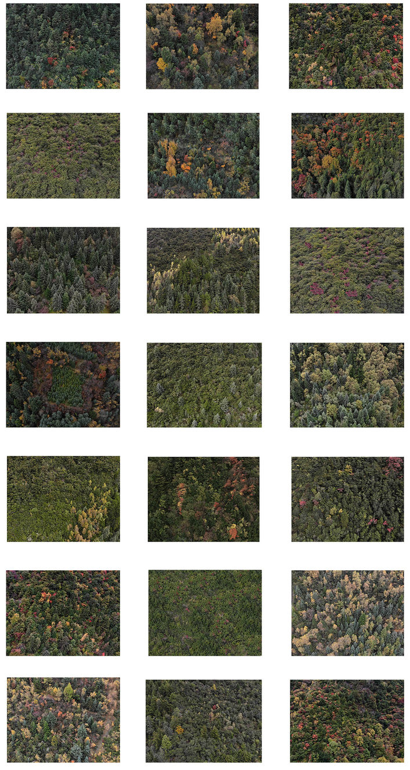
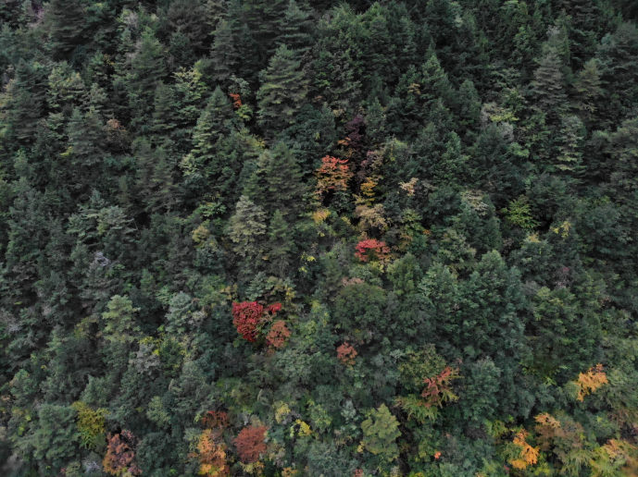
6. Please choose the degree of beauty for this landscape according to your perception
○ -3 (Dislike very much)
○ -2 (Very dislike)
○ -1 (Dislike)
○ 0 (Feel so-so)
○ 1 (Like)
○ 2 (Very like)
○ 3 (Like very much)
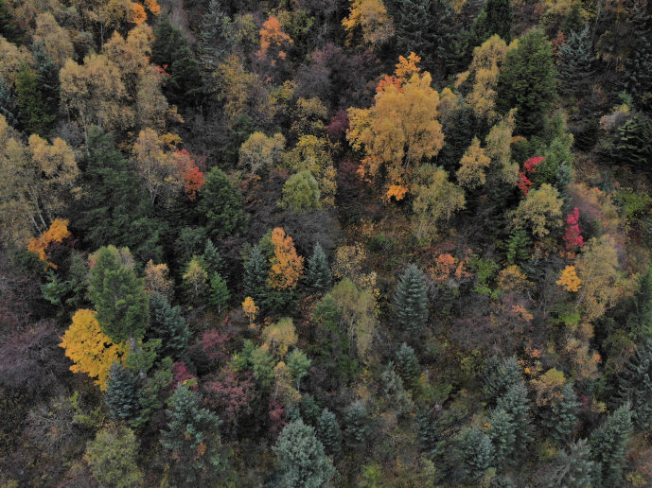
7. Please choose the degree of beauty for this landscape according to your perception
○ -3 (Dislike very much)
○ -2 (Very dislike)
○ -1 (Dislike)
○ 0 (Feel so-so)
○ 1 (Like)
○ 2 (Very like)
○ 3 (Like very much)
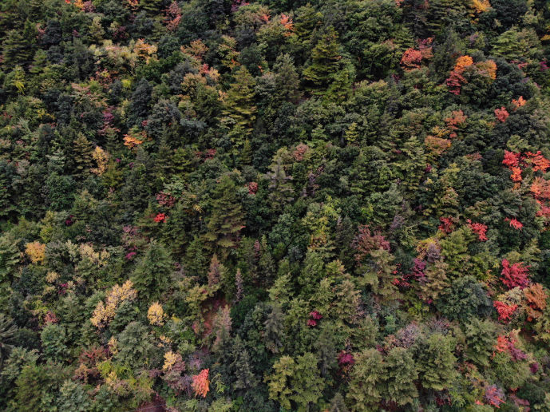
8. Please choose the degree of beauty for this landscape according to your perception
○ -3 (Dislike very much)
○ -2 (Very dislike)
○ -1 (Dislike)
○ 0 (Feel so-so)
○ 1 (Like)
○ 2 (Very like)
○ 3 (Like very much)
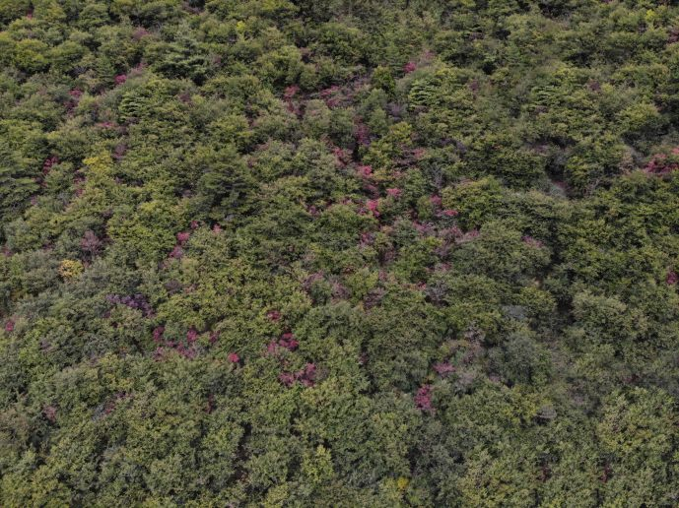
9. Please choose the degree of beauty for this landscape according to your perception
○ -3 (Dislike very much)
○ -2 (Very dislike)
○ -1 (Dislike)
○ 0 (Feel so-so)
○ 1 (Like)
○ 2 (Very like)
○ 3 (Like very much)
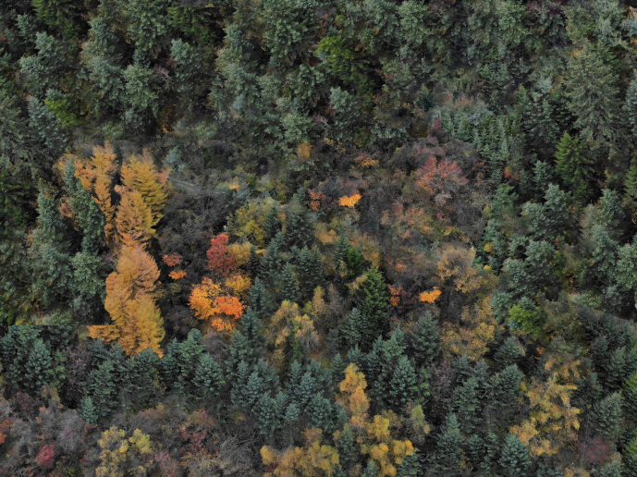
10. Please choose the degree of beauty for this landscape according to your perception
○ -3 (Dislike very much)
○ -2 (Very dislike)
○ -1 (Dislike)
○ 0 (Feel so-so)
○ 1 (Like)
○ 2 (Very like)
○ 3 (Like very much)
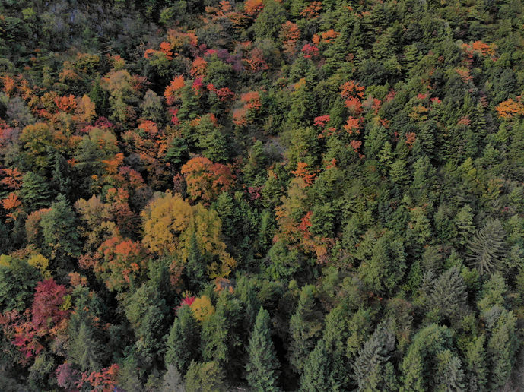
11. Please choose the degree of beauty for this landscape according to your perception
○ -3 (Dislike very much)
○ -2 (Very dislike)
○ -1 (Dislike)
○ 0 (Feel so-so)
○ 1 (Like)
○ 2 (Very like)
○ 3 (Like very much)
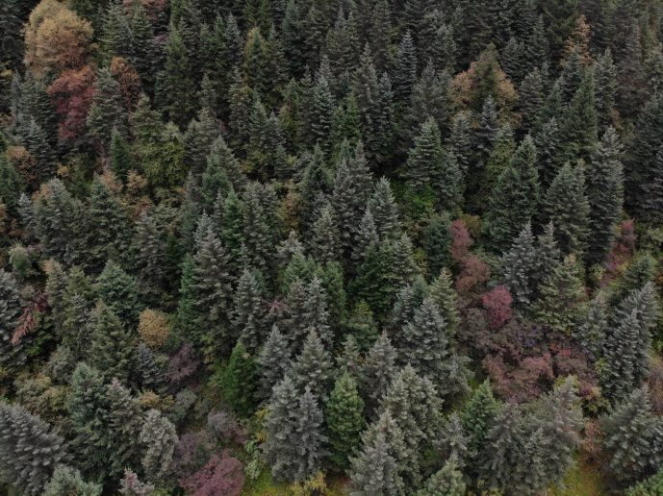
12. Please choose the degree of beauty for this landscape according to your perception
○ -3 (Dislike very much)
○ -2 (Very dislike)
○ -1 (Dislike)
○ 0 (Feel so-so)
○ 1 (Like)
○ 2 (Very like)
○ 3 (Like very much)
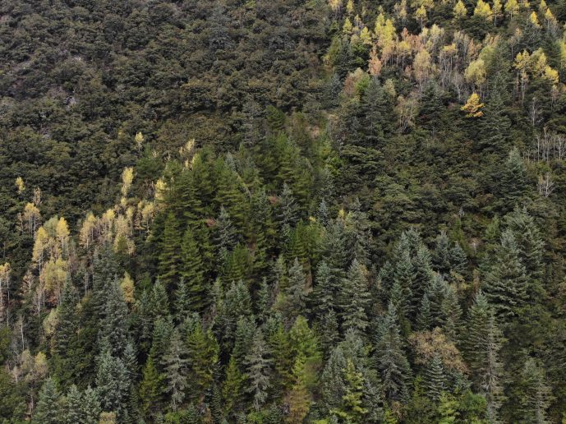
13. Please choose the degree of beauty for this landscape according to your perception
○ -3 (Dislike very much)
○ -2 (Very dislike)
○ -1 (Dislike)
○ 0 (Feel so-so)
○ 1 (Like)
○ 2 (Very like)
○ 3 (Like very much)
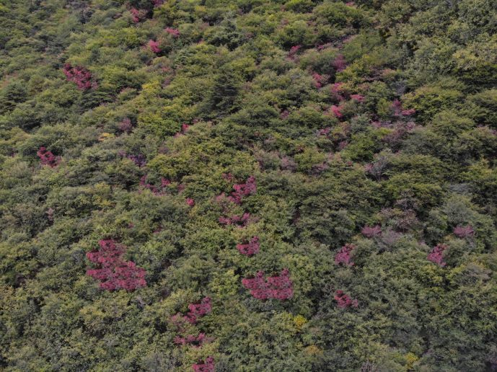
14. Please choose the degree of beauty for this landscape according to your perception
○ -3 (Dislike very much)
○ -2 (Very dislike)
○ -1 (Dislike)
○ 0 (Feel so-so)
○ 1 (Like)
○ 2 (Very like)
○ 3 (Like very much)
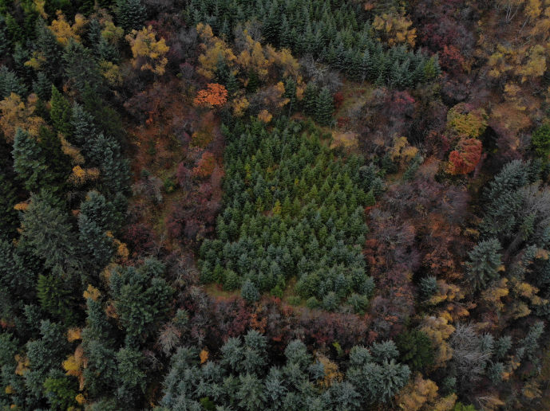
15. Please choose the degree of beauty for this landscape according to your perception
○ -3 (Dislike very much)
○ -2 (Very dislike)
○ -1 (Dislike)
○ 0 (Feel so-so)
○ 1 (Like)
○ 2 (Very like)
○ 3 (Like very much)
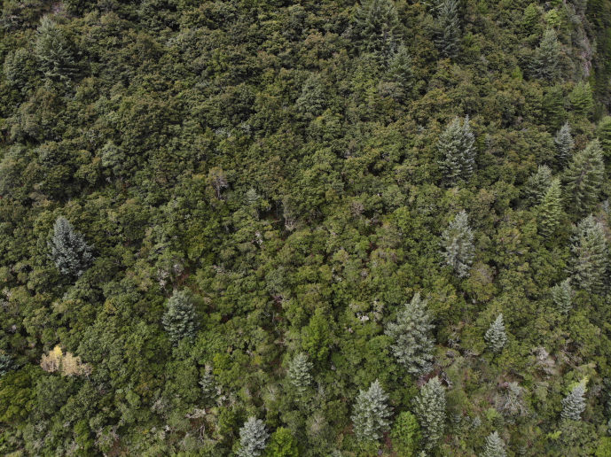
16. Please choose the degree of beauty for this landscape according to your perception
○ -3 (Dislike very much)
○ -2 (Very dislike)
○ -1 (Dislike)
○ 0 (Feel so-so)
○ 1 (Like)
○ 2 (Very like)
○ 3 (Like very much)
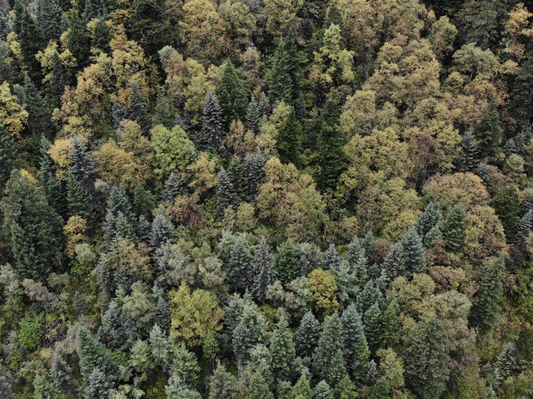
17. Please choose the degree of beauty for this landscape according to your perception
○ -3 (Dislike very much)
○ -2 (Very dislike)
○ -1 (Dislike)
○ 0 (Feel so-so)
○ 1 (Like)
○ 2 (Very like)
○ 3 (Like very much)
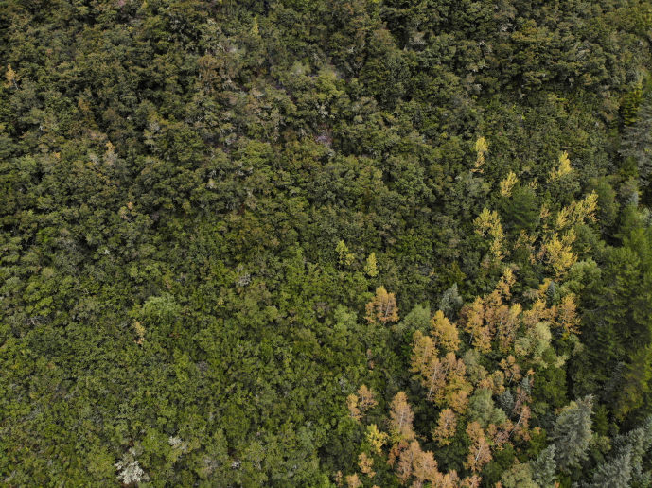
18. Please choose the degree of beauty for this landscape according to your perception
○ -3 (Dislike very much)
○ -2 (Very dislike)
○ -1 (Dislike)
○ 0 (Feel so-so)
○ 1 (Like)
○ 2 (Very like)
○ 3 (Like very much)
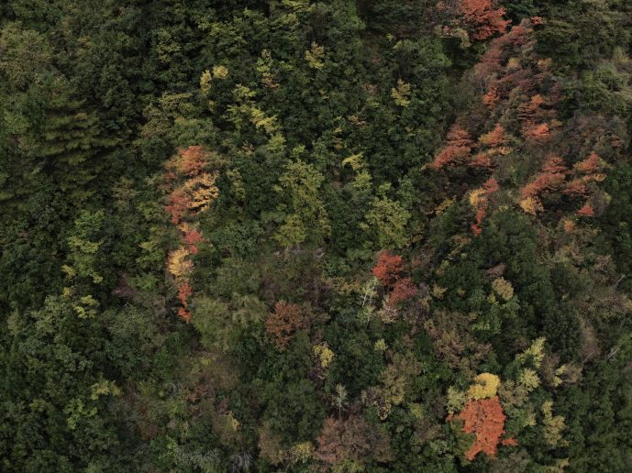
19. Please choose the degree of beauty for this landscape according to your perception
○ -3 (Dislike very much)
○ -2 (Very dislike)
○ -1 (Dislike)
○ 0 (Feel so-so)
○ 1 (Like)
○ 2 (Very like)
○ 3 (Like very much)
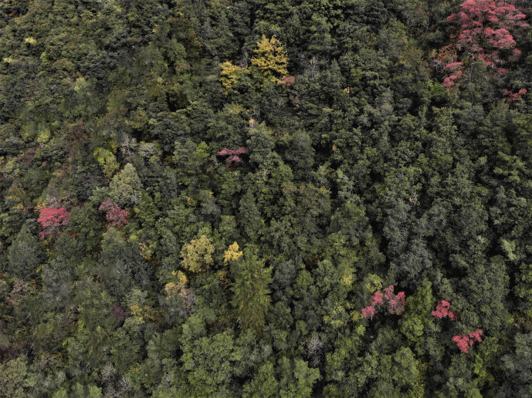
20. Please choose the degree of beauty for this landscape according to your perception
○ -3 (Dislike very much)
○ -2 (Very dislike)
○ -1 (Dislike)
○ 0 (Feel so-so)
○ 1 (Like)
○ 2 (Very like)
○ 3 (Like very much)
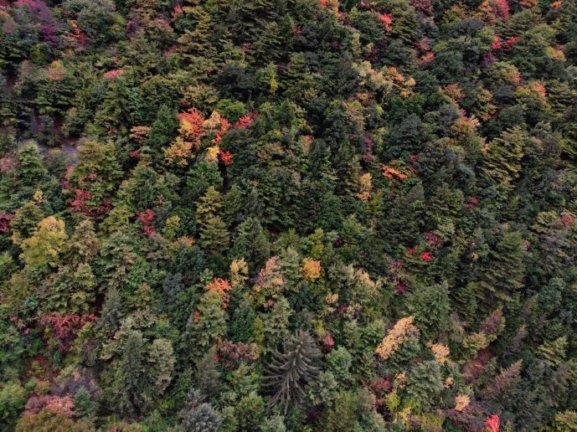
21. Please choose the degree of beauty for this landscape according to your perception
○ -3 (Dislike very much)
○ -2 (Very dislike)
○ -1 (Dislike)
○ 0 (Feel so-so)
○ 1 (Like)
○ 2 (Very like)
○ 3 (Like very much)
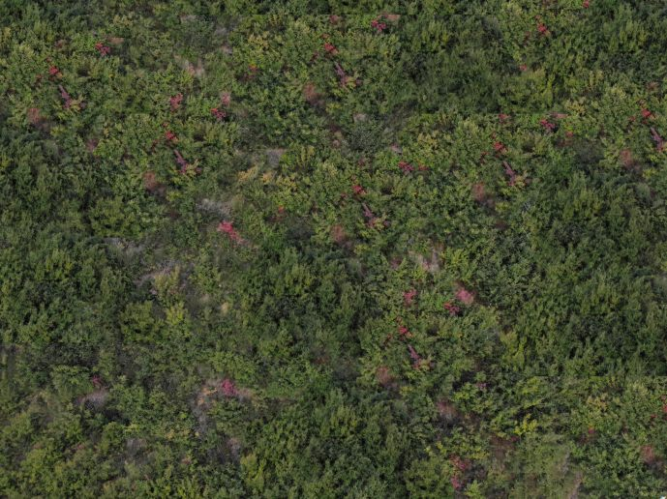
22. Please choose the degree of beauty for this landscape according to your perception
○ -3 (Dislike very much)
○ -2 (Very dislike)
○ -1 (Dislike)
○ 0 (Feel so-so)
○ 1 (Like)
○ 2 (Very like)
○ 3 (Like very much)
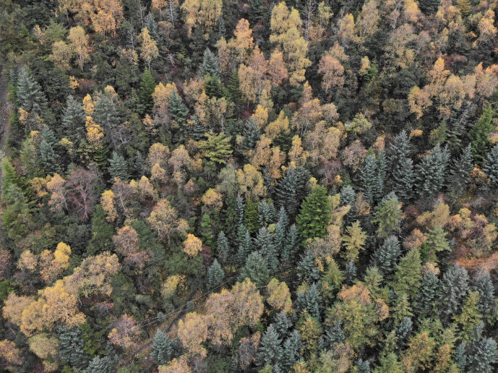
23. Please choose the degree of beauty for this landscape according to your perception
○ -3 (Dislike very much)
○ -2 (Very dislike)
○ -1 (Dislike)
○ 0 (Feel so-so)
○ 1 (Like)
○ 2 (Very like)
○ 3 (Like very much)
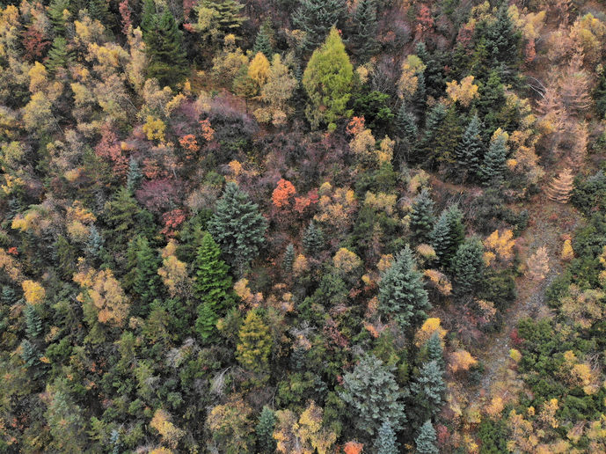
24. Please choose the degree of beauty for this landscape according to your perception
○ -3 (Dislike very much)
○ -2 (Very dislike)
○ -1 (Dislike)
○ 0 (Feel so-so)
○ 1 (Like)
○ 2 (Very like)
○ 3 (Like very much)
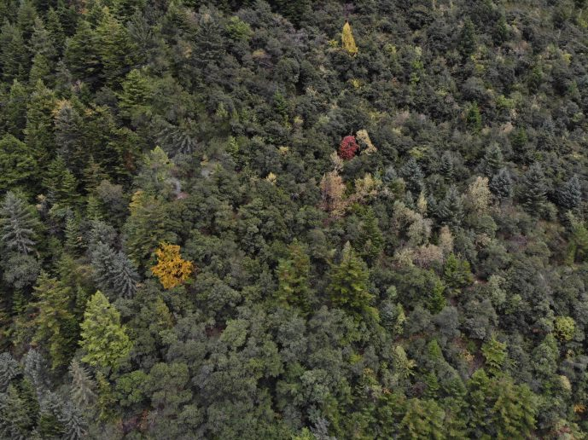
25. Please choose the degree of beauty for this landscape according to your perception
○ -3 (Dislike very much)
○ -2 (Very dislike)
○ -1 (Dislike)
○ 0 (Feel so-so)
○ 1 (Like)
○ 2 (Very like)
○ 3 (Like very much)
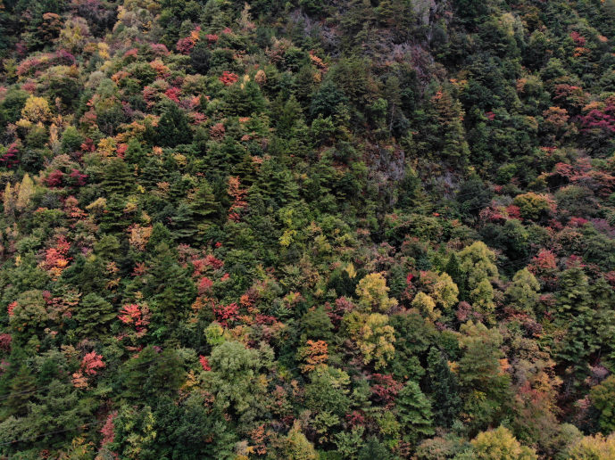
26. Please choose the degree of beauty for this landscape according to your perception
○ -3 (Dislike very much)
○ -2 (Very dislike)
○ -1 (Dislike)
○ 0 (Feel so-so)
○ 1 (Like)
○ 2 (Very like)
○ 3 (Like very much)

