Supplementary material, Figure SI. Rates of caregivers involved in patient daily activities at baseline, M12 and M24 per group.

- Supportive interventional group | B) Control group
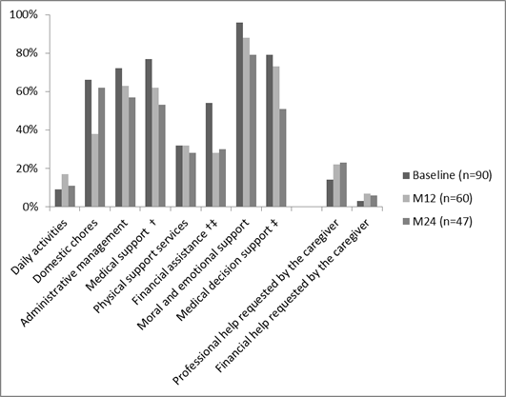 | 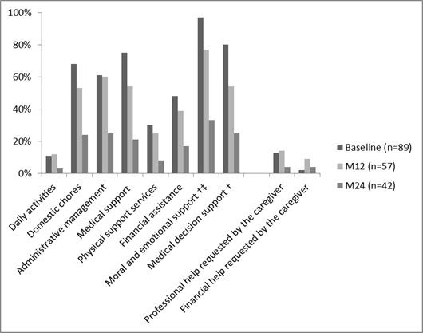

Involvement included total (caregiving exclusively provided by the caregiver), and partial (caregiver requiring the help of another person) involvement at baseline, and follow-up timepoints by type of support received in each group with frequency and percentages. A Chi-2 McNemar test was used to test any statistically difference over time compared to baseline per randomized group. Significant difference †from baseline to M12; ‡from baseline to M24.
Daily activities (grooming/ dressing…); domestic chores (cleaning, grocery shopping, meals…); Administrative management (accounting, mails, decisions); Medical support (accompaniment to medical appointments, medical cares); Physical support services; Financial assistance; Moral and emotional support; Medical decision support; Professional support; Financial support.

Supplementary material, Figure SII. Caregivers mean HRQoL scores of the nine SF-36 subscales at baseline, M12 and M24

- Supportive interventional group |  | - Control group
Baseline M12 M24

MID was fixed at 5 points for SF36 scores. MID significant difference †between baseline and M12 scores; ‡between baseline and M24 scores.
MID: Minimal important differences.
Supplementary material, Table SIII. Caregivers adjusted mean change over time (mixed model for repeated measures)

 | SIG | CG
 | Adjusted mean change [95%CI] | Adjusted mean change [95%CI]
MOS SF-36
SF-36 PCS | -2.9 [-4.2 – -1.6] | -3.4 [-4.8 – -2.1]
M12 | -4.1 [-6.0 – -2.3] | -3.6 [-5.6 – -1.7]
M24 | -2.6 [-4.6 – -0.5] | -4.4 [-6.5 – -2.2]
SF-36 MCS | -0.9 [-2.6 – 0.7] | -0.3 [-2.0 – 1.4]
M12 | -0.5 [-2.8 – 1.7] | -1.0 [-3.3 – 1.4]
M24 | -0.3 [-2.8 – 2.2] | 0.5 [-2.1 – 3.1]
HADS
Anxiety | -0.3 [-0.9 – 0.2] | -0.2 [-0.7 – 0.4]
M12 | -0.3 [-1.0 – 0.5] | 0.3 [-0.5 – 1.1]
M24 | -0.4 [-1.2 – 0.4] | -0.3 [-1.1 – 0.6]
Depression | 0.8 [0.2 – 1.4] | 1.1 [0.5 – 1.8]
M12 | 0.6 [-0.2 – 1.4] | 1.3 [0.5 – 2.1]
M24 | 1.3 [0.4 – 2.1] | 3.4 [0.6 – 2.5]*
Burden (ZBI) | 1.2 [-1.2 –3.6] | 5.2 [2.8 – 7.6]
M12 | 2.0 [-0.9 – 5.0] | 5.7 [2.7 – 8.7]
M24 | 1.4 [-1.8 – 4.6] | 6.4 [3.0 – 9.7]

SIG: Supportive interventional group; CG: control group. CI: Confidence interval. Minimal important differences (MID) was fixed at 5 points for SF-36 PCS and MCS scores, 1.32 points for HADS anxiety score, 1.4 points for HADS depression score, and 7.2 points for ZBI score. In bold: MID significant; *p<0.05.

