Supplement document: detail search strategies and results

Medline Ovid (last search on 09/20/2020)
- exp Diabetic Retinopathy/
- ((diabet$ or proliferative or non-proliferative) adj4 retinopath$).tw.
- (diabet$ adj3 (eye$ or vision or visual$ or sight$)).tw.
- (DR adj3 (eye$ or vision or visual$ or sight$)).tw.
- (diabet$ adj3 maculopath$).tw.
- or/1-5
- exp Polymorphism, Single Nucleotide/
- SNP$.tw.
- Polymorphism$.tw.
- or/7-9
- uncoupling protein.tw.
- uncoupling proteins.tw.
- UCP$.tw.
- or/11-13
- 6 and 10 and 14

Search results
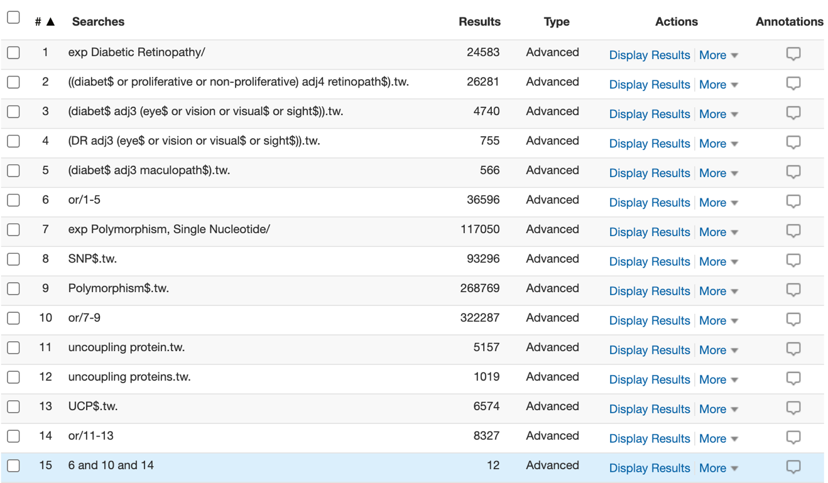

Embase Ovid (last search on 09/20/2020)
- exp Diabetic Retinopathy/
- ((diabet$ or proliferative or non-proliferative) adj4 retinopath$).tw.
- (diabet$ adj3 (eye$ or vision or visual$ or sight$)).tw.
- (DR adj3 (eye$ or vision or visual$ or sight$)).tw.
- (diabet$ adj3 maculopath$).tw.
- or/1-5
- exp Polymorphism, Single Nucleotide/
- SNP$.tw.
- Polymorphism$.tw.
- or/7-9
- uncoupling protein.tw.
- uncoupling proteins.tw.
- UCP$.tw.
- or/11-13
- 6 and 10 and 14

Search results
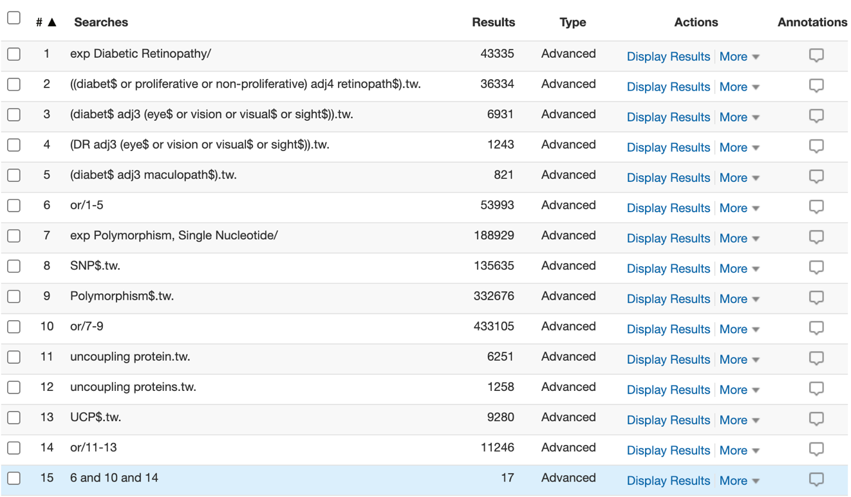

CENTRAL_11 papers (last search on 09/20/2020)
- MeSH descriptor: [Diabetic Retinopathy] explode all trees
- (diabet* or proliferat* or non-proliferat*) near4 retinopath*
- diabet* near3 (eye* or vision or visual* or sight*)
- DR near3 (eye* or vision or visual* or sight*)
- diabet* near3 maculopath*
- #1 OR #2 OR #3 OR #4 OR #5
- MeSH descriptor: [Polymorphism, Single Nucleotide] explode all trees
- SNP*
- polymorphism*
- #7 OR #8 OR #9
- uncoupling proteins
- uncoupling protein
- UCP*
- #11 OR #12 OR #13
- #6 AND #10 AND #14

Search results
