Supplementary Information

Synthesis, characterization and biological activities of Co(II), Cu(II), Zn(II), and Cd(II) metal complexes of 1,10 phenanthroline based Schiff base
Pichandi Mahadevi and Shanmugam Sumathi*
Department of chemistry, VIT, Vellore – 632014, Tamil Nadu, India.
*Corresponding author: sumathishanmugam2003@gmail.com; ssumathi@vit.ac.in

Content

Figure S1 | FTIR spectra of Schiff base metal complexes (1-4)
Figure S2 | ¹H NMR spectrum of CdL1L2 complex
Figure S3 | ¹³C NMR spectrum of CdL1L2 complex
Figure S4 | Mass spectrum of CoL1L2 complex
Figure S5 | Mass spectrum of CuL1L2 complex
Figure S6 | Mass spectrum of ZnL1L2 complex
Figure S7 | Mass spectrum of CdL1L2 complex
Figure S8 | UV-Visible absorption spectra of complexes 1-4 (left). b) d-d absorption spectra of CoL1L2, CuL1L2, ZnL1L2 and CdL1L2 complexes at high concentration (right)
Figure S9 | Powder X-ray diffraction pattern of complexes 1-4
Figure S10 | Cyclic voltammogram of A) CoL1L2, B) CuL1L2, C) ZnL1L2 and D) CdL1L2 complexes (1-4)
Figure S11 | TGA and DTA curves of CoL1L2, CuL1L2 and ZnL1L2 complexes
Figure S12 | Stability study absorption spectra of complexes 1-4.
Data S13 | CHNS data

Figures

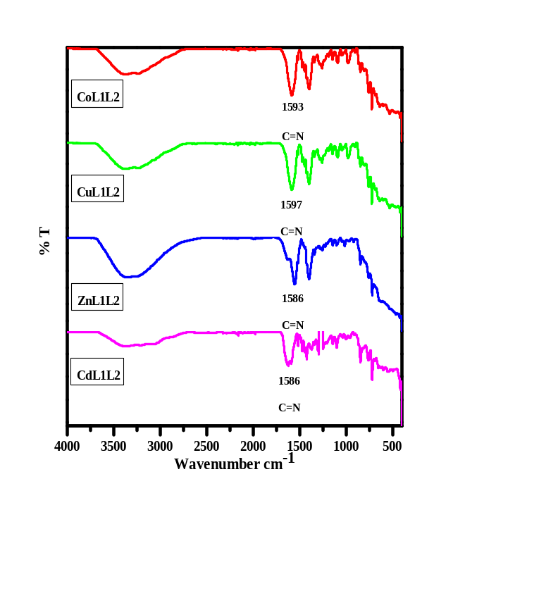
Fig. S1 FTIR spectra of Schiff base metal complexes (1-4)
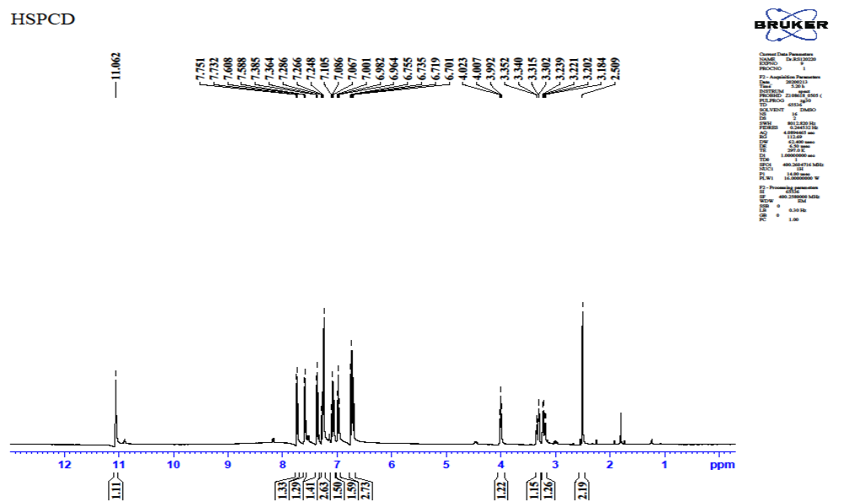
Fig. S2 ¹H NMR spectrum of CdL1L2 complex

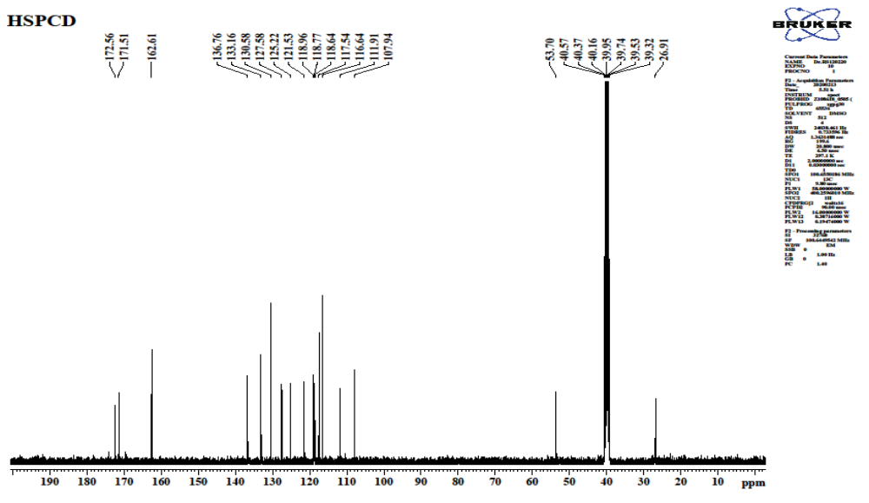
Fig. S3 ¹³C NMR spectrum of CdL1L2 complex

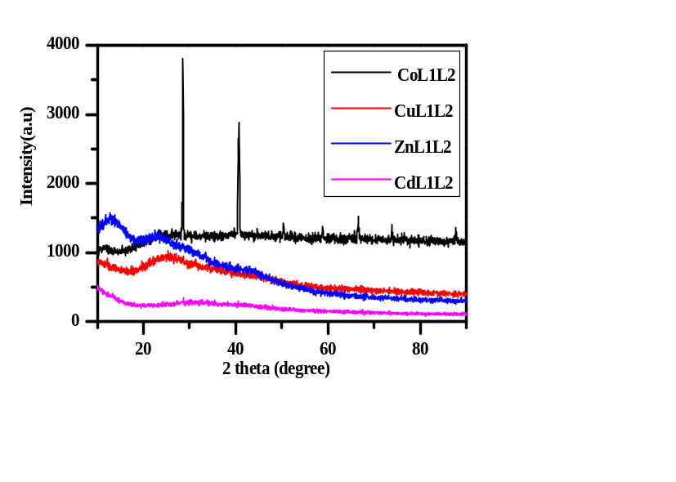
Fig. S4 Powder X-ray diffraction pattern of complexes 1-4

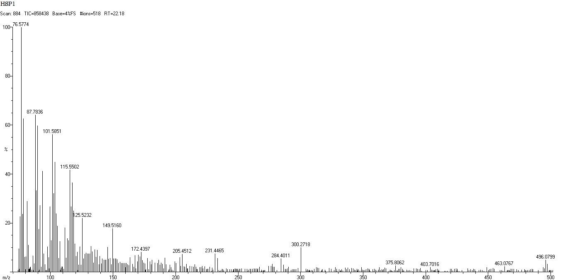
Fig. S5 Mass spectrum of CoL1L2 complex

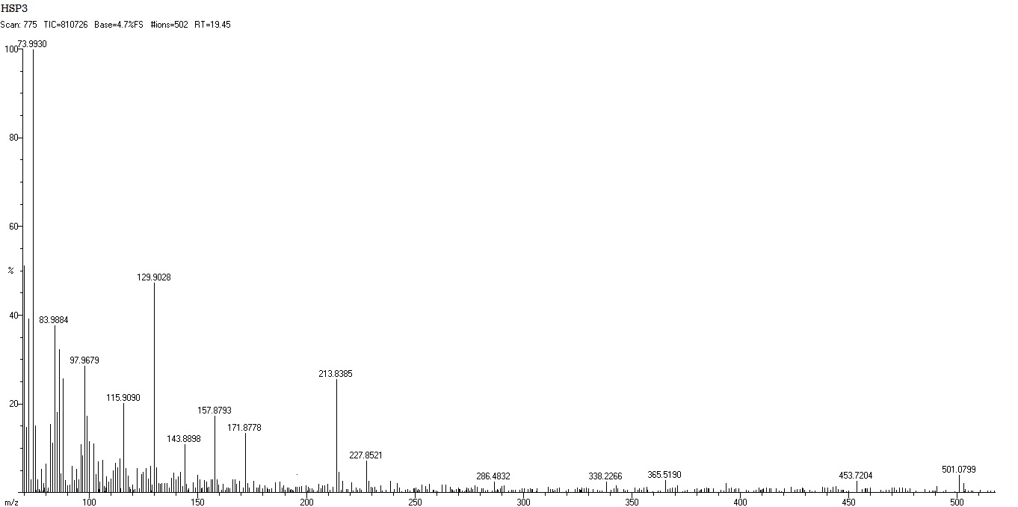

Fig. S6 Mass spectrum of CuL1L2 complex

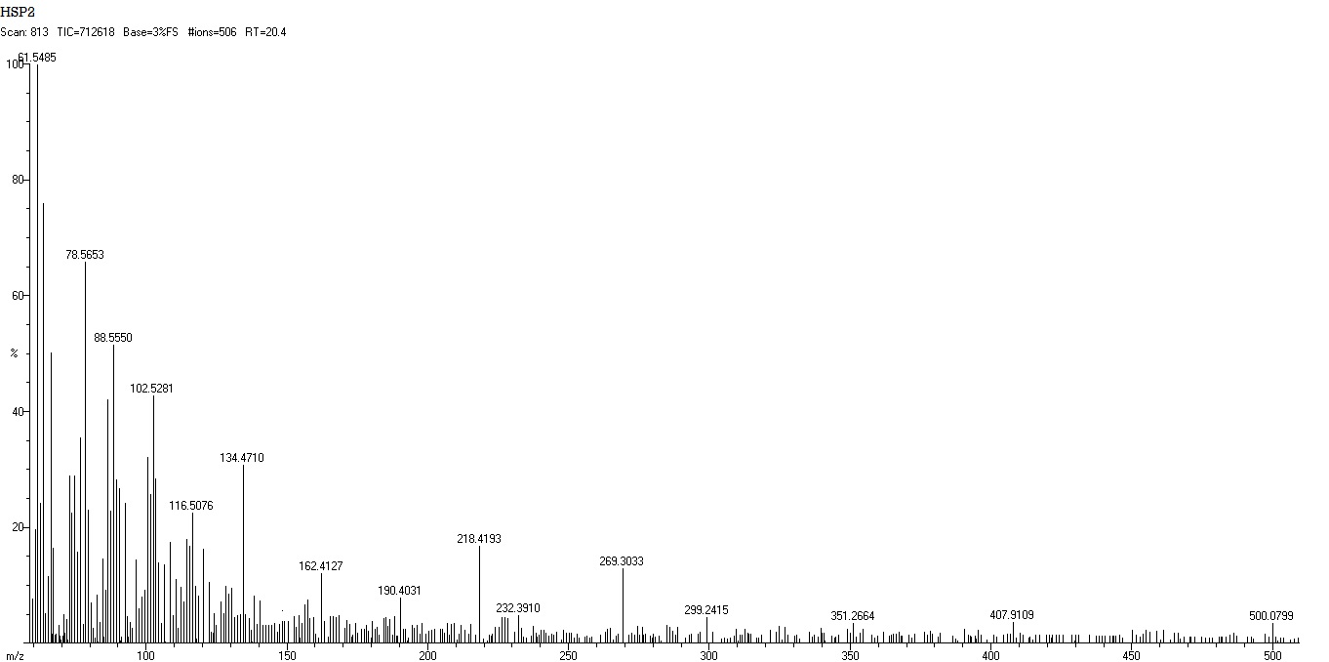
Fig. S7 Mass spectrum of ZnL1L2 complex

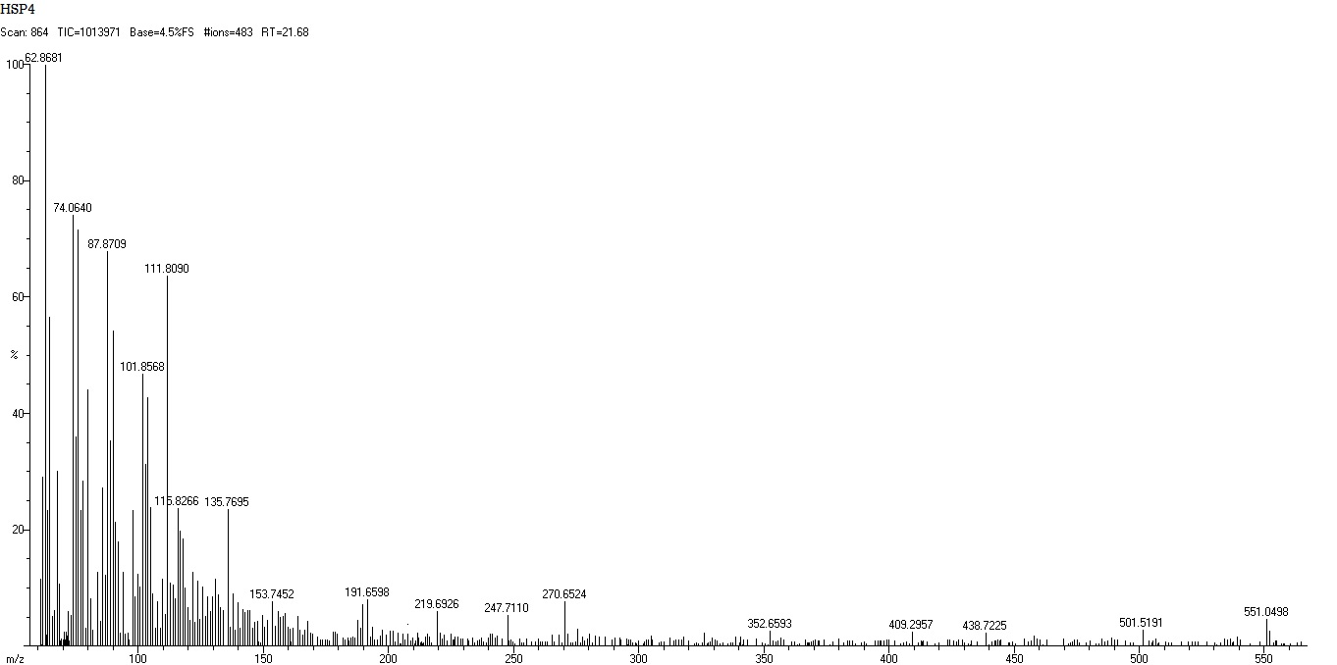
Fig. S8 Mass spectrum of CdL1L2 complex

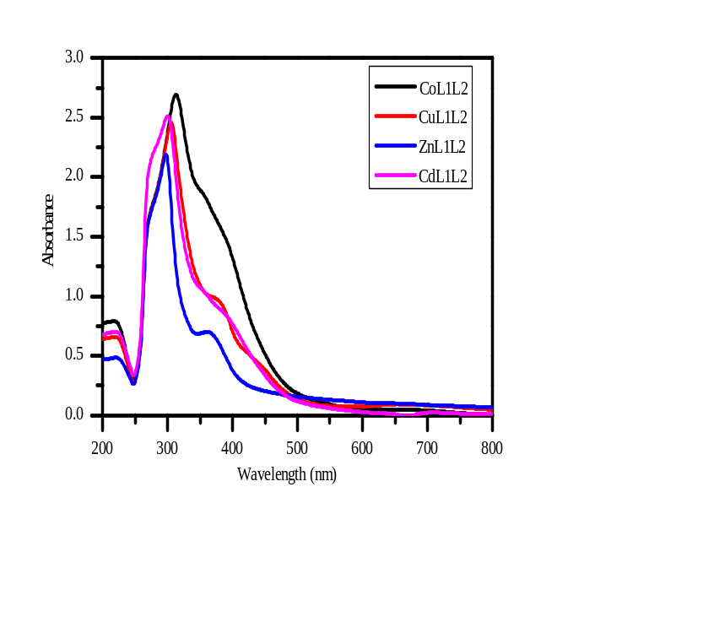
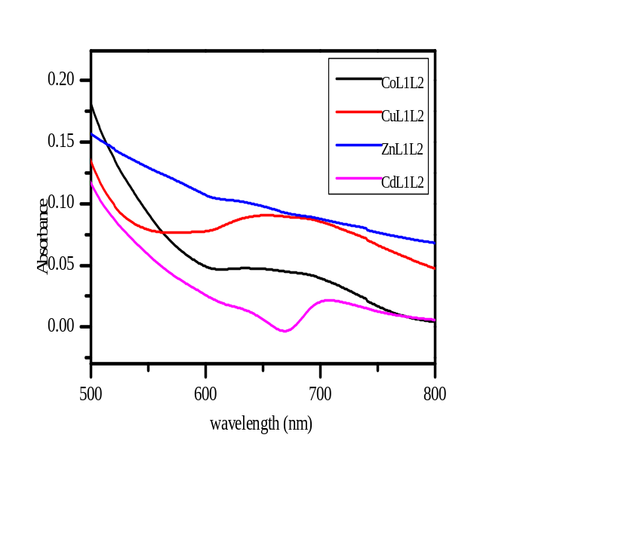
a
b

Fig. S9 UV-Visible absorption spectra of complexes 1-4 (left). b) d-d absorption spectra of CoL1L2, CuL1L2, ZnL1L2 and CdL1L2 complexes at high concentration (right)

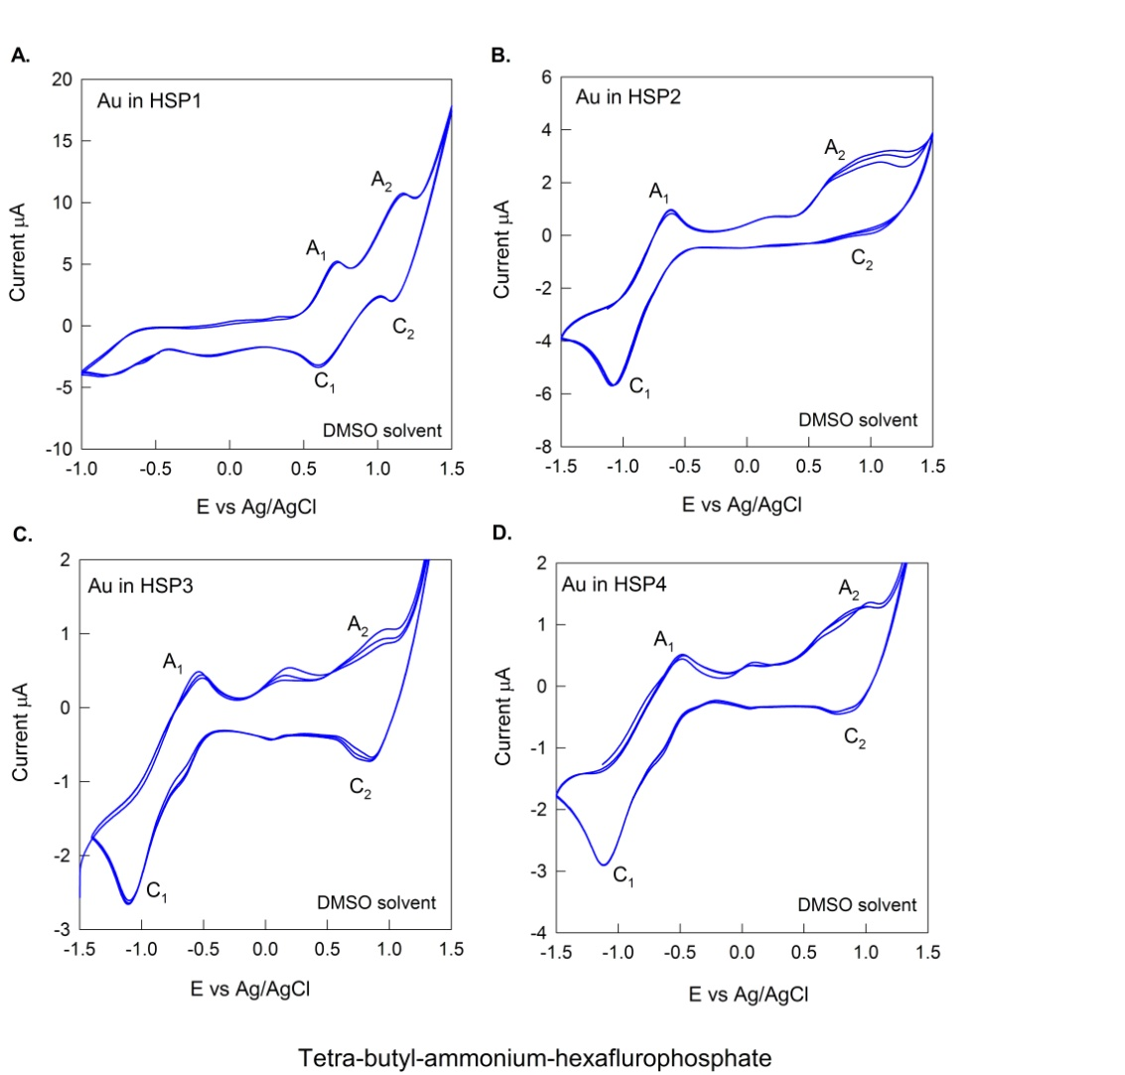Fig. S10 Cyclic voltammogram of CoL1L2, CuL1L2, ZnL1L2 and CdL1L2 complexes (a-d)

Fig. S11 TGA and DTA curves of CoL1L2, CuL1L2 and ZnL1L2 complexes
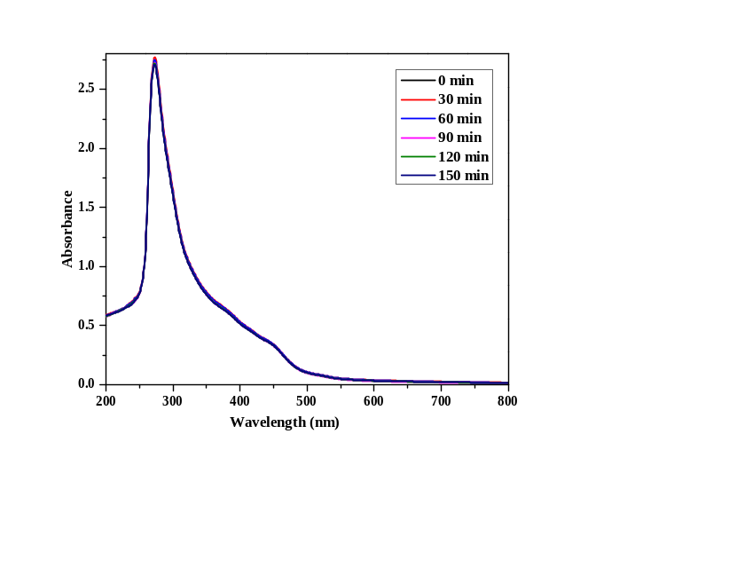
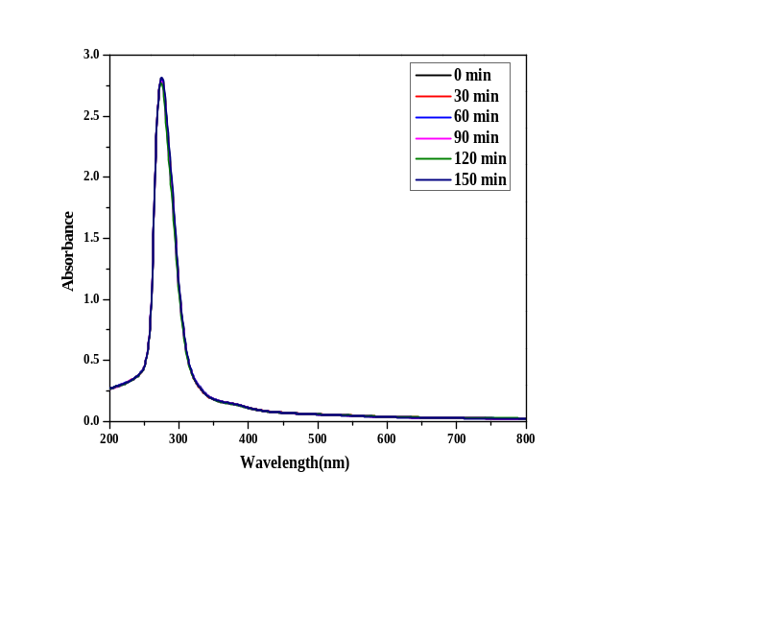
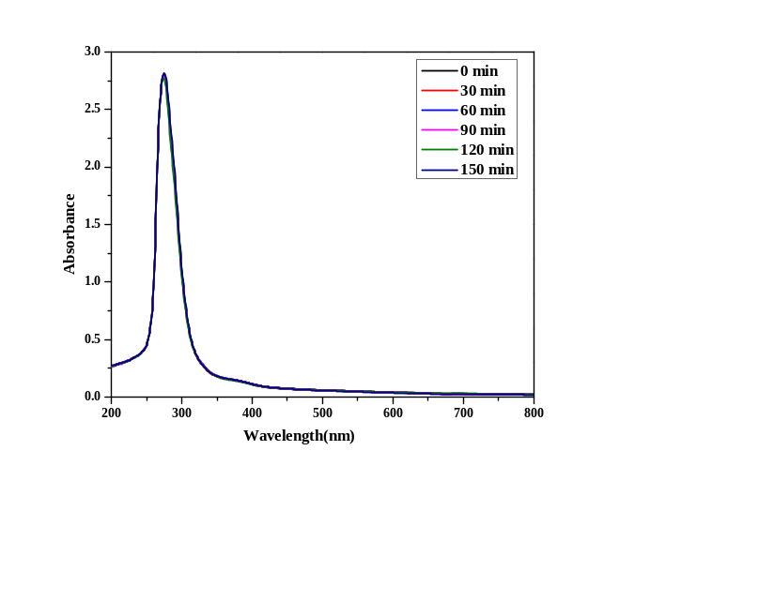
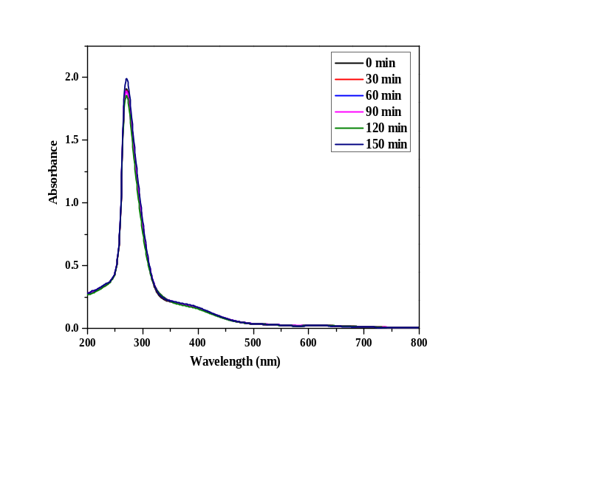

Fig. S12 Stability study absorption spectra of complexes 1-4

CHNS DATA S13


