Alpine rockwall erosion patterns follow elevation-dependent climate trajectories
Daniel Draebing^{1,2,3,*}, Till Mayer^{1,3}, Benjamin Jacobs³ and Samuel McColl⁴

¹Chair of Geomorphology, University of Bayreuth, Germany.
²Department of Physical Geography, Utrecht University, Utrecht, Netherlands.
³Chair of Landslide Research, Technical University of Munich, Germany.
⁴School of Agriculture and Environment, Massey University, Palmerston North, New Zealand.
*email: d.draebing@uni-bayreuth.de

Supplementary Information
Supplementary Table 1. Rockwall erosion rates in the European Alps
Location | Longitude  Latitude  (WGS 84) | Lithology | Elevation (m) | Rockwall erosion rate (mm a⁻¹) | Method | Integration Time (a) | Ref
Short-term erosion rates

Lauterbrunnen | 46.592522°N  7.908153°E | limestone | 1,300 ±500 | $${0.05}_{-0.02}^{+0.03}$$ | LS | 5.2 | ¹
Hoher Ifen | 47.354558°N  10.099522°E | limestone | 1,900 ±200 | $${0.065}_{-0.035}^{+0.035}$$ | RC | 4 | ²
Kühtai | 47.205714°N  11.026183°E | gneiss, mica schist | 2,550 ±450 | $${0.10}_{-0.05}^{+0.50}$$ | RC | 3 | ²
Tegelberg | 47.553889°N  10.772778°E | limestone, dolostone | 1,550 ±250 | $${0.14}_{-0.06}^{+0.06}$$ | RC | 3 | ²
Dammkar | 47.435353°N  11.305375°E | limestone | 1,800 ±500 | $${0.2}_{-0.1}^{+0.1}$$ | RC | 5 | ²
Parzinn | 47.239892°N  10.57525°E | dolostone | 2,350 ±250 | $${0.225}_{-0.075}^{+0.075}$$ | RC | 2 | ²
Zugspitze | 47.420564°N  10.985539°E | limestone | 2,650 ±250 | $${0.4}_{-0.3}^{+0.3}$$ | RC | 2 | ²
Chlein Schwarzhorn | 46.751159°N  9.94856°E | amphibolite | 2,703 ±193 | 0.64 | LS | 9 | ³
Location | Longitude  Latitude  (WGS 84) | Lithology | Elevation (m) | Rockwall erosion rate (mm a⁻¹) | Method | Integration Time (a) | Ref
Kitzsteinhorn | 47.183333°N  12.683333°E | mica schist | 2,900 ±160 | $${1.9}_{-1.55}^{+8.40}$$ | LS | 6 | ^{4,5}
Gemsstock | 46.601789°N  8.611396°E | granodiorite | 2,939 ±23 | $$6.5$$ | LS | 3 | ⁶
Tour Ronde | 45.844048°N  6.90766°E | granite | 3,606 ±186 | 8.4 | LS | 1 | ⁷
Le Drus | 45.934257°N  6.962167°E | granite | 3,427 ±327 | 14.4 | LS | 6 | ⁸
Mid-term erosion rates

Kühtai | 47.205714°N  11.026183°E | gneiss, mica schist | 2,660 ±240 | $${0.83}_{-0.416}^{+0.629}$$ | LI | 400 | ⁹
Murtel I | 46.408742°N  9.807017°E | granite, schist | 3,170 ±164 | $${1.5}_{-0.5}^{+0.5}$$ | RG | 2,000 | ¹⁰
Reintal | 47.411381°N  11.074081°E | limestone | 1,750 ±450 | $${1.61}_{-0.63}^{+0.63}$$ | RC, VM, FM | 1,000 | ¹¹
Le Drus | 45.934257°N  6.962167°E | granite | 3,427 ±327 | 2.9 | LS, FM | 111 | ⁸
Long-term erosion rates

Zugspitze | 47.420564°N  10.985539°E | limestone | 2,770 ±130 | $${0.252}_{-0.142}^{+0.148}$$ | GP | 10,000 | ^{12,13}
Wolfeben | 47.3163°N  10.392411°E | dolostone | 2,335 ±85 | $${0.27}_{-0.07}^{+0.23}$$ | GP | 10,000 | ¹²
Dammkar | 47.435353°N  11.305375°E | limestone | 1,825 ±273 | $${0.3}_{-0.163}^{+0.066}$$ | GP | 10,000 | ¹³
Lauterbrunnen | 46.592522°N  7.908153°E | limestone | 1,300 ±500 | $${0.33}_{-0.06}^{+0.05}$$ | VM | 11,000 | ¹
Tegelberg | 47.553889°N  10.772778°E | dolostone | 1,700 ±100 | $${0.4}_{-0.15}^{+0.40}$$ | GP | 15,000 | ¹²
Gradenbachtal | 46.975892°N  12.824172°E | crystalline | 2,810 ±474 | $${0.471}_{-0.441}^{+0.449}$$ | GP | 11,000 | ¹⁴
Parzinn | 47.239892°N  10.57525°E | dolostone | 2,450 ±250 | $${0.475}_{-0.325}^{+0.325}$$ | GP | 10,000 | ¹²
Reintal | 47.411381°N  11.074081°E | limestone | 1,650 ±350 | $${0.483}_{-0.233}^{+0.317}$$ | GP | 12,000 | ¹²
Location | Longitude  Latitude  (WGS 84) | Lithology | Elevation (m) | Rockwall erosion rate (mm a⁻¹) | Method | Integration Time (a) | Ref
Hoher Ifen | 47.354558°N  10.099522°E | limestone | 1,950 ±150 | $${0.5}_{-0.15}^{+0.5}$$ | GP | 10,000 | ¹²
Reintal | 47.411381°N  11.074081°E | limestone | 1,458 ±406 | $${0.5}_{-0.4}^{+0.5}$$ | GP | 12,250 ±1,250 | ¹⁵
Kühtai | 47.205714°N  11.026183°E | gneiss, mica schist | 2,660 ±240 | $${0.55}_{-0.15}^{+0.45}$$ | GP | 10,000 | ¹²
Mer de Glace | 45.920682°N  6.928452°E | granite | 2,320 ±226 | $${0.66}_{-0.657}^{+4.240}$$ | CN | 13,465 ±2,768 | ¹⁶
Eiger | 46.577622°N  8.005411°E | limestone, gneiss | 2,826 ±296 | $${1.78}_{-1.38}^{+1.82}$$ | CN | 14,750 ±3,250 | ^{17,18}
Lanserlia | 45.0125°N  6.410833°E | limestone, schist | 2,800 ±100 | $${2.2}_{-1.0}^{+1.0}$$ | VM | 15,000 | ¹⁹
Murtel I | 46.408742°N  9.807017°E | granite, schist | 3,170 ±164 | $${2.5}_{-1.8}^{+1.7}$$ | RG | 8,000 ±2,000 | ²⁰
Macun I | 46.726508°N  10.140292°E | gneiss | 2,890 ±60 | $${3.2}_{-1.8}^{+1.3}$$ | RG | 8,000 ±2,000 | ²⁰
CN = cosmogenic nuclides, GP = geophysics, FM = frequency-magnitude distribution, LI = lichenometry, LS = laserscanning, RC = rockfall collection, RG = rock glaciers and VM = volumetric estimation.
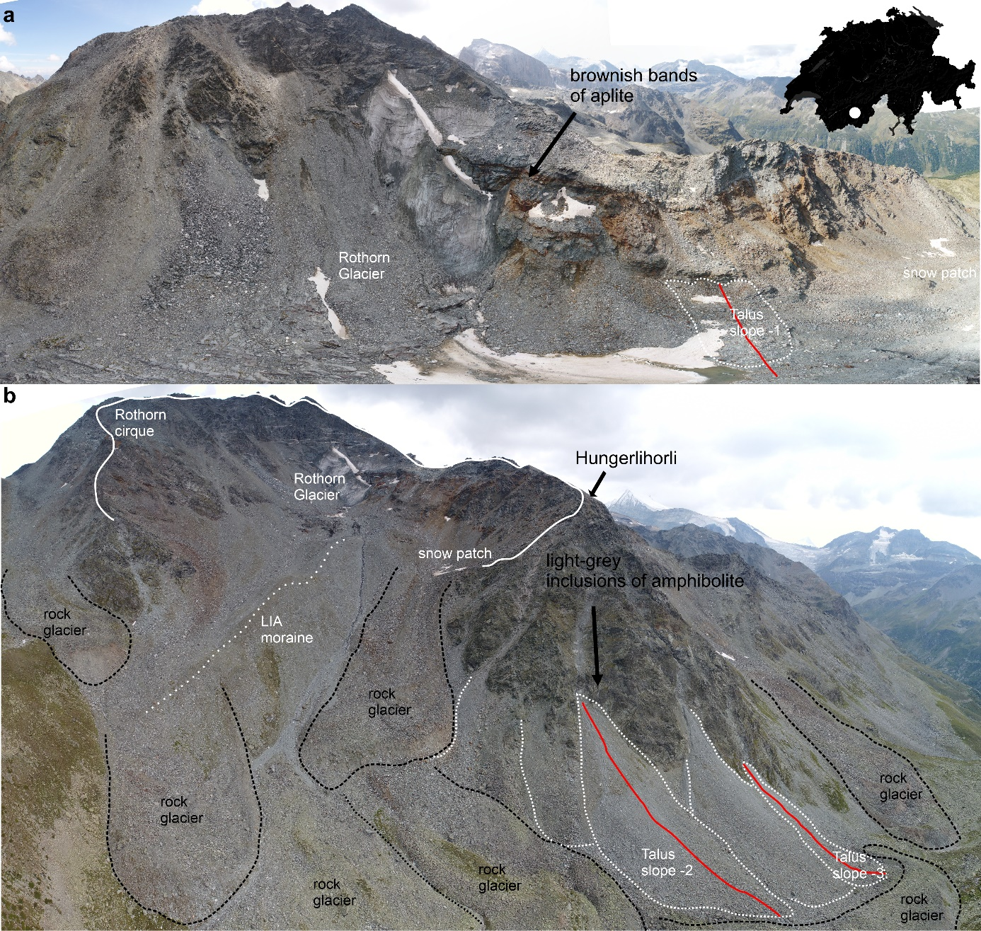
Supplementary Figure 1. Photomosaic of the a, Rothorn cirque (looking in southeast) and b, the north-facing rockwalls of the Hungerli Valley (looking in south direction). The inset map highlights the location of the Hungerli within Switzerland. Main lithology is schisty quartz slate with inclusions of aplite in the Rothorn cirque highlighted by brownish colour and amphibolite and aplite in the Hungerlihorli. Red lines indicate geophysical transects used to quantify talus slope volumes.
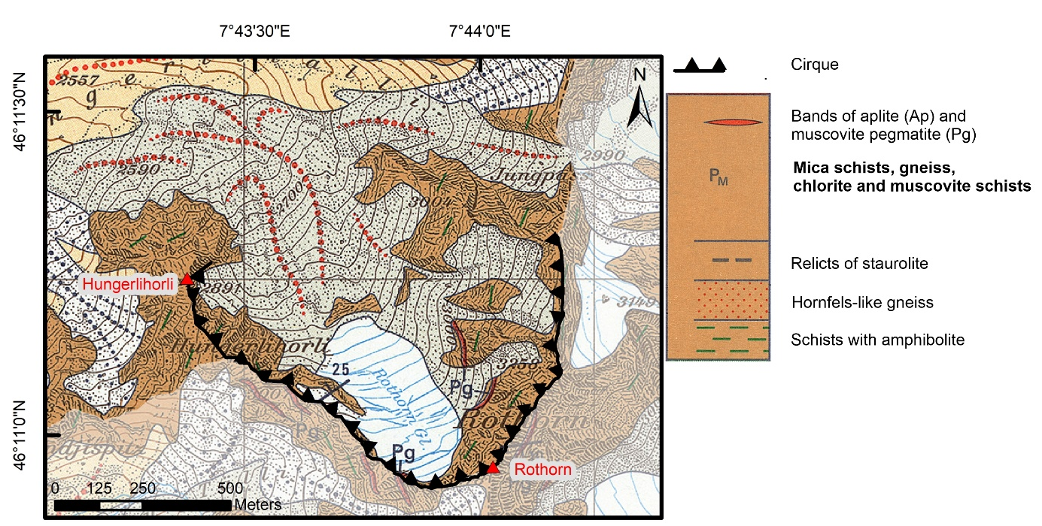
Supplementary Figure 2. Geologic map 1:25,000 of the Hungerli Valley²¹ (source: swissTopo). Brown areas highlight the occurrence of schisty quartz slate (P_{M}) while red and green lines highlight aplite and amphibolite inclusions. All contour and spot heights are in meters above sea level.
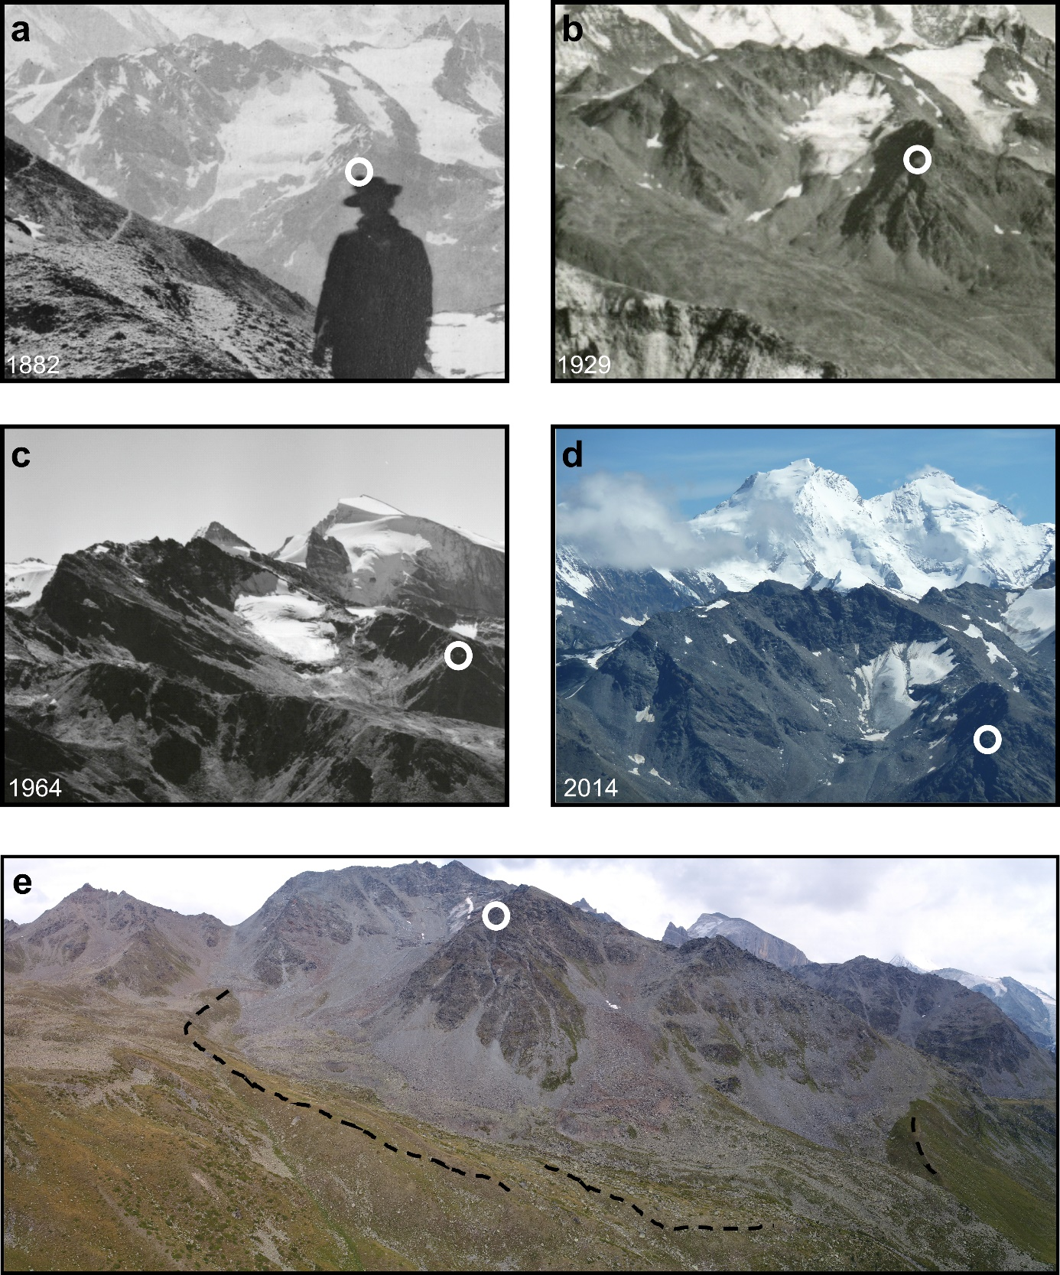
Supplementary Figure 3. Historic photos of the Rothorn Glacier. a, Excerpt of a photo by Jules Beck in 1882. b, Excerpt of a photo by E. Gyger in 1929 with permission by Photo Klopfenstein, Adelboden, Switzerland. c, Excerpt of a photo by Swiss Air AG in 1964 (CC BY-SA 4.0)²². d, Excerpt of a photo by Daniel Draebing in 2014. e, Photo of the Hungerli Valley with highlighted Egesen (Younger Dryas) moraine. The white circle highlights the Hungerlihorli for a common point of reference in each photo.

Supplementary Note 1: Rock temperature measurements.

Our temperature logger data revealed that MARST decreases with increasing elevation (Supplementary Table 2) with lower rock surface temperatures found at higher elevation loggers (Supplementary Fig. 4). The rockwalls were snow covered for between 164 and 251 days each year, with a consistent seasonal pattern. The duration of snow cover is longer than expected based on the recorded MARST, possibly due to the step-like topography permitting increased snow accumulation²³⁻²⁵. Snow cover has an effect on the thermal regime of rockwalls^{23,26,27}, and therefore we incorporate snow cover data in our model of frost cracking at Hungerli Valley.

Supplementary Table 2. Rockwall temperature logger properties.
Logger | Elevation (m) | Aspect(°) | Slope (°) | MARST (°C) |  |  | Snow duration (d)
 |  |  |  | 2016/17 | 2017/18 | 2018/19 | 2016/17 | 2017/18 | 2018/19
RW1* | 3148 | 33 | 74 | NA | -3.2 | -2.0 | NA | 207 | 244
RW2 | 2935 | 75 | 81 | -2.5 | -2.8 | -2.0 | 229 | 242 | 251
RW3 | 2907 | 70 | 78 | -1.7 | -1.7 | -1.4 | 207 | 224 | 245
RW4 | 2678 | 311 | 81 | 1.7 | 0.7 | 1.6 | 178 | 164 | 229
RW5 | 2580 | 17 | 87 | 0.7 | 1.5 | 1.8 | 220 | 220 | 223
*29 Aug 2017 - 28 Aug 2019

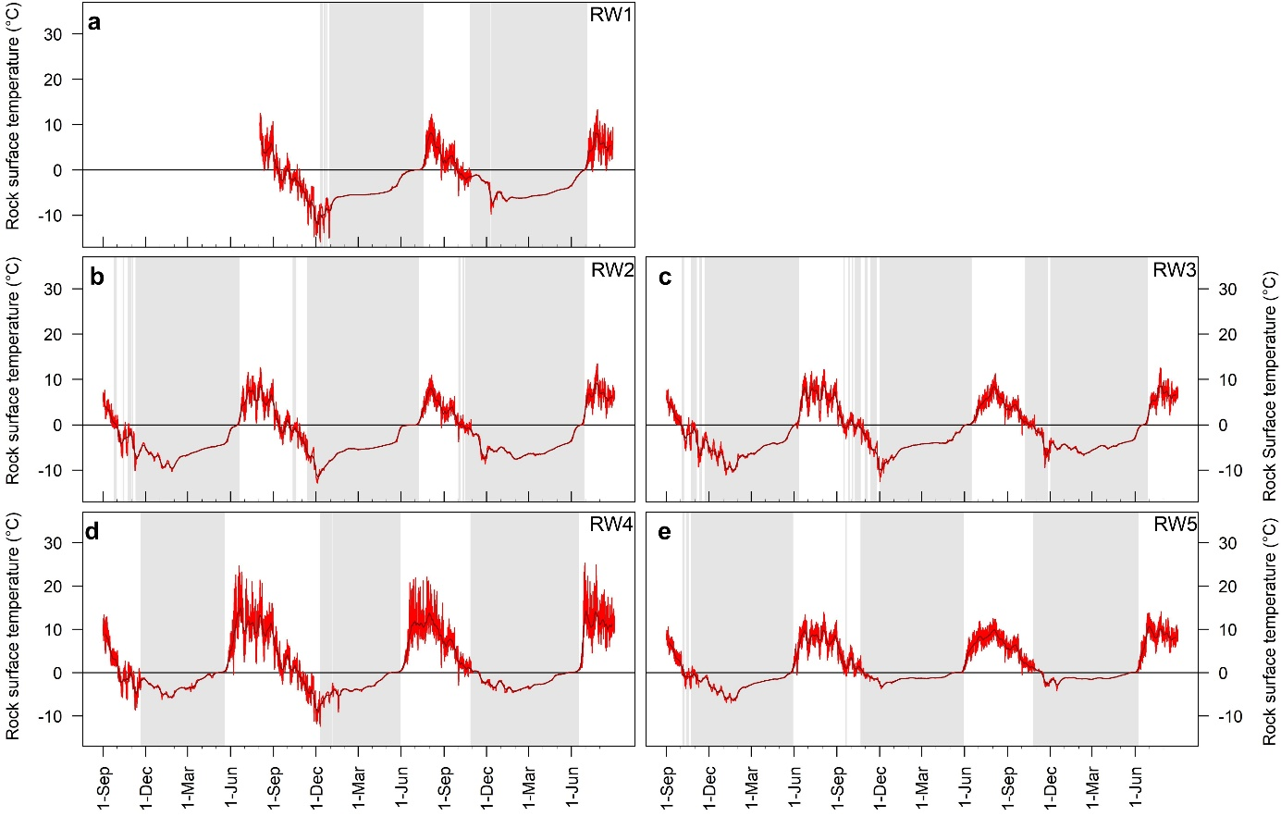
Supplementary Figure 4. Rock surface temperature data for the Hungerli Valley for 2016 to 2019, as measured by iButton temperature loggers at 0.1 m depth at: a, the Steintaelli at 3,148 m, b, the Rothorn cirque at 2,935 m, c, the Rothorn cirque at 2,907 m, d, the Hungerlihorli at 2,678 m and e, the Hungerlihorli at 2,580 m above mean sea level. Grey rectangles highlight the snow cover period. For logger location, see Fig. 2.

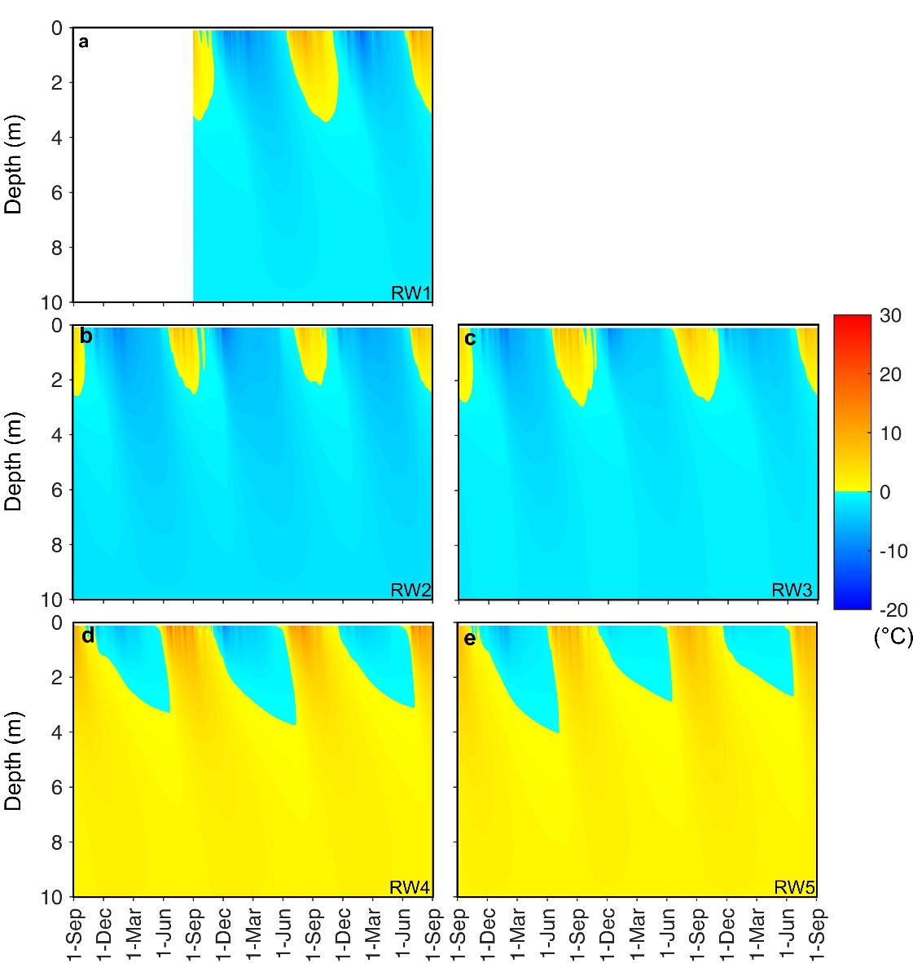
Supplementary Figure 5. Modelled rock temperatures for a, the Steintaelli at 3,148 m, b, the Rothorn cirque at 2,935 m, c, the Rothorn cirque at 2,907 m, d, the Hungerlihorli at 2,678 m and e, the Hungerlihorli at 2,580 m. For logger location, see Fig. 2.

Supplementary Note 2: Frost cracking modelling.
Mechanical tests were performed on rock samples from the Hungerli in a previous study²⁸. Uniaxial compressive strengths range from ${143.8}_{-5.3}^{+5.3}$MPa for schisty quartz slate to ${193.0}_{-2.9}^{+2.9}$MPa for aplite, and ${270.1}_{-33.5}^{+33.5}$ MPa for amphibolite²⁸. Tensile strength of schisty quartz slate is ${6.4}_{-0.4}^{+0.4}$ MPa and increases to ${14.1}_{-0.6}^{+0.6}$ MPa for aplite and ${21.5}_{-1.1}^{+1.1}$ MPa for amphibolite²⁸. Fracture toughness ranges from 1.7 MPa m^{1/2} for schisty quartz slate to 1.7 MPa m^{1/2} for aplite and 2.2 MPa m^{1/2} for amphibolite²⁸. The spatial variability of lithology results in differences in rock mass strength. We infer that the differences in rock strength (i.e. lithology), at our study site affect cracking processes and rockfall activity, and therefore, we included rock strength in our frost cracking model approach²⁹. The major geology is schisty quartz slate and inclusions of aplite or amphibolite have a thickness of less than 100 m (Supplementary Figs. 1 and 2). Consequently, analysing our rockfall data at 100 m elevation bands was deemed to be of an adequate resolution to account for differences in lithological variation in rock strength.

Supplementary Table 3. Parameters of the frost cracking model
Parameter |  | RW2-3 | RW4 | RW1, RW5 | Ref.
Lithology |  | aplite | amphibolite | schisty quartz slate
Rock density (kg m⁻³) | ρ_{r} | 2,760 | 2,970 | 2,800
Rock porosity (%) | n_{r} | 3
Rock thermal conductivity (W m⁻¹ K⁻¹) | κ_{r} | 2.8 | 1.54 | 2.5 | ³⁰
Rock specific heat capacity (kJ kg⁻¹ K⁻¹) | c_{r} | 0.80 | 0.75 | 0.80 | ³⁰
Latent heat (kJ kg⁻¹) | L | 334
Rock water content (%) | W | 3 |  |  | ^{23,31}
Water content below pore freezing point (%) | W_{u} | 5 |  |  | ³²
Ice density (kg m⁻³) | ρ_{i} | 920
Ice thermal conductivity (W m⁻¹ K⁻¹) | κ_{i} | 2.24
Ice specific heat capacity (kJ kg⁻¹ K⁻¹) | c_{i} | 2.09
Water density (kg m⁻³) | ρ_{w} | 1000
Water thermal conductivity (W m⁻¹ K⁻¹) | κ_{w} | 0.56
Water specific heat capacity (kJ kg⁻¹ K⁻¹) | c_{w} | 4.18
Water viscosity (mPa s) | μ | 1.8 |  |  | ²⁹
Initial crack radius (m) | x_{i} | 0.05 |  |  | ²⁹
Angle between crack plane and rockwall (°) | ϕ | 0
Critical fracture toughness (MPa m^{1/2}) | K_{C} | 1.87 | 2.19 | 1.66 | ²⁸
Bulk melting temperature (K) | T_{m} | 273 |  |  | ²⁹
Unfrozen permeability (m²) | k_{p0} | 10⁻¹⁸ | 10⁻¹⁸ | 10⁻¹⁸ | ³³
Power law exponent () | α | 4 |  |  | ²⁹
Undercooling for ice formation (°C) | ∆T_{f} | 0.1

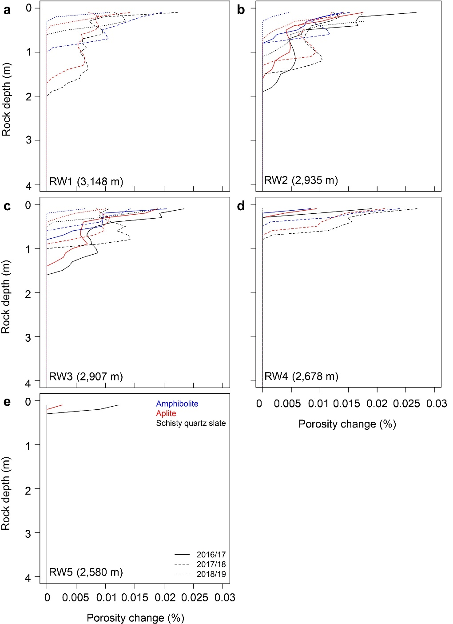

Supplementary Figure 6. Frost cracking induced porosity change plotted versus rock depth.

Our frost cracking model revealed that frost cracking is sensitive to rock strength³⁴, with rockwalls consisting of schisty quartz slate experiencing more intense frost cracking compared to aplite and amphibolite, when applying identical rock temperature profiles (Supplementary Fig. 6). Frost cracking expressed as porosity change was limited to the upper 0.5 m to 1 m at RW4 and RW5 and increased up to 2 m depth at RW1 to RW3. Again, these shallow depths reinforce the view that frost cracking is likely to be limited to triggering relatively small rockfalls compared to permafrost processes.

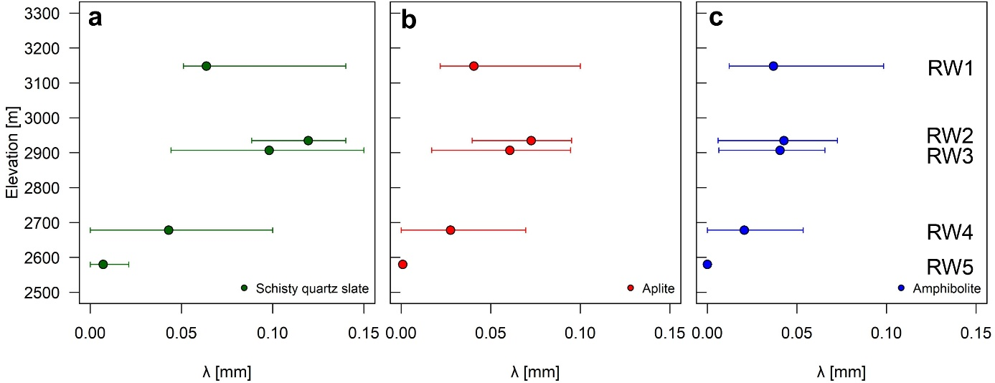
Supplementary Figure 7. Mean annual depth-integrated frost cracking (i.e. mean total rock expansion) between 2016 and 2019 along elevation for a, schisty quartz slate, b, aplite and c, amphibolite, at different rockwall elevations. The error bars are the minimum and maximum annual rock expansion measured, to show the range (i.e. annual variability) over the monitoring period.

Our depth-integrated modelling results (Supplementary Fig. 7) show that the mean annual frost cracking increased with elevation from RW5 at 2,580 m to RW2 at 2,935 m and then slightly decreased at RW1 at 3,148 m. There was strong annual variability in frost cracking. The minimum value was modelled for 2018/19 and ranged for amphibolite from 0 to 0.01 mm, for aplite from 0 to 0.04 mm and for schisty quartz slate from 0 to 0.09 mm. The maximum value ranged for amphibolite and aplite from 0 to 0.1 mm (2017/18) and for schist quartz slate from 0 to 0.15 mm (2016/17). While lithological variation in rock strength affects frost cracking, the observed relationship between depth-integrated frost cracking and elevation is consistent between each year, and therefore we used the mean frost cracking value for each lithology for the analysis in Fig. 4b. We recognise that our results have a coarse vertical spatial resolution (i.e. from only 5 observation sites) whereas alternative modelling approaches that use air temperature^{29,35,36} achieve better vertical resolution through interpolation using an altitudinal temperature lapse rate. However, models driven by air temperature data do not directly measure rockwall temperature or integrate the effect of snow cover or aspect. In most alpine environments, such as the rockwalls in the Hungerli Valley, snow cover plays a significant role in decoupling the rock thermal regime from the air temperature^{23,26,27}, which makes air temperature data less appropriate for frost cracking modelling. Therefore, we consider our approach that uses RST and incorporates snow-cover effects and aspect, to provide a more accurate model of frost cracking.

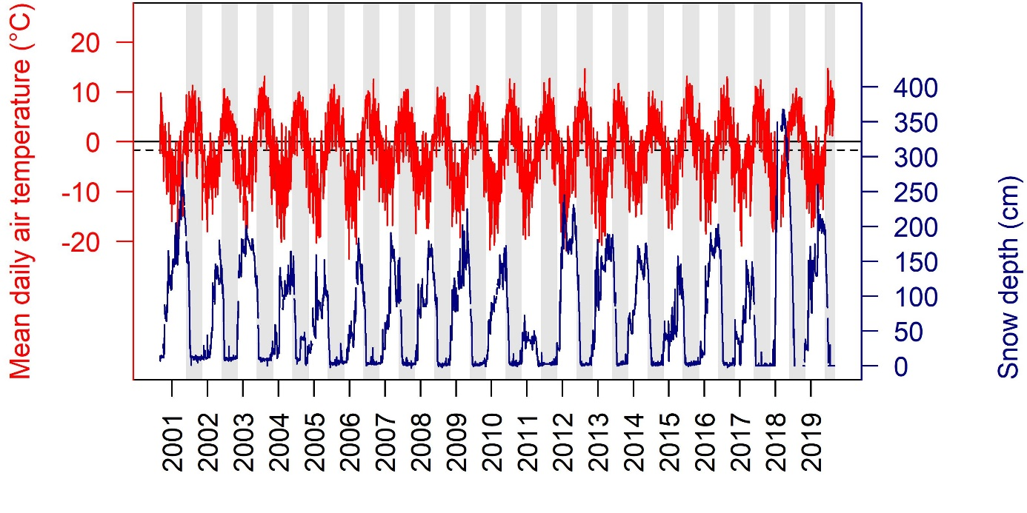
Supplementary Figure 8. Mean daily air temperature and daily snow depth from September 2000 to August 2019 recorded at meteorological station Oberer Stelligletscher at 2,910 m. The dotted line highlights the 30-year MAAT average between 1990 and 2019 and grey rectangles the snow-free period from June to October used for permafrost modelling.

Supplementary Table 4. Meteo station and Logger properties used for rock permafrost model.
Logger | Location  (WGS84) | Elevation (m) | Aspect (°) | Slope (°) | MAAT/MARST (°C)
 |  |  |  |  | 2017/18 | 2018/19
Meteo Station | 46.168490°N  7.750674°E | 2910 | 0 | 0 | -1.7 (1991-2019)
RW1-S | 46.195410°N  7.718510°E | 2743 | 166 | 90 | 5.4 | 5.9
RW2-S | 46.196050°N  7.71930°E | 2697 | 145 | 79 | 4.9 | 5.6

Supplementary Table 5. Statistical quality of rock permafrost model
Parameter | Value | Significance level
Intercept | -4.399 | ***
PISR (Wm⁻²) | 0.04336 | ***
MAAT | 1.63782 | ***
R² | 0.94
R²_{adj} | 0.93
MSE (°C) | 0.52
RMS (°C) | 0.72
*** significance 0.001

Supplementary Table 6. Laserscanning parameters
Parameter | Riegl VZ400 | Riegl VZ2000i
Range (90% reflectivity) | 600 m | 1,850 m
Range (20% reflectivity) | 280 m | 950 m
Laser repetition rate | 100 kHz | 100 kHz
Raw range accuracy | 5 mm @ 100 m | 5 mm @ 100 m
Field of view (horizontal x vertical) | 360 ° x 100 ° | 360 ° x 100 °
Angular step width | 0.01° | 0.01°
Laser beam divergence | 0.3 mrad | 0.27 mrad

Supplementary Table 7. Results of Principal Component Analysis.
 | PC1 | PC2 | PC3 | PC4 | PC5
Slope.angle | -0.04 | -0.01 | -0.01 | 0.01 | 0.15
rockfall.volume | -0.20 | 0.98 | 0.03 | -0.01 | 0.00
Elevation | -0.85 | -0.09 | 0.28 | 0.44 | 0.00
Deglaciation.age | 0.84 | 0.11 | -0.30 | 0.43 | 0.00
MARST | 0.72 | 0.03 | 0.69 | 0.01 | 0.00
Eigenvalue | 2.00 | 0.98 | 0.65 | 0.38 | 0.02
Proportion of variance | 49.61 | 24.39 | 16.13 | 9.33 | 0.53
cum. Proportion | 49.61 | 74.01 | 90.14 | 99.47 | 100
Supplementary Table 8. Rockwall erosion rates in the Hungerli per 100 m elevation bandwidth for the period 2016-2019.
Elevation (m) | Rockwall area (m²) | Rockwall  Area (%) | Rockfall number | Maximum volume (m³) | Rockfall volume (m³) | Erosion rate (mm a⁻¹)
2,500 – 2,600 | 3,458 | 1.6 | 0 | 0.00 | 0.00 | 0.00
2,600 – 2,700 | 40,959 | 18.4 | 8 | 0.59 | 2.07 | 0.02
2,700 – 2,800 | 45,684 | 20.5 | 39 | 3.19 | 15.48 | 0.11
2,800 – 2,900 | 31,372 | 14.1 | 33 | 11.95 | 29.1 | 0.31
2,900 – 3,000 | 50,450 | 22.7 | 105 | 159.39 | 309.68 | 2.04
3,000 – 3,100 | 14,093 | 6.3 | 42 | 11.80 | 64.32 | 1.52
3,100 – 3,200 | 29,474 | 13.2 | 35 | 60.70 | 153.46 | 1.73
3,200 – 3,300 | 7,071 | 3.2 | 1 | 0.39 | 0.39 | 0.02
Total | 222,561 | 100.0 | 263 | 159.39 | 574.50 | 0.86

Supplementary Table 9. Rockwall erosion rates for deglaciation periods in the Hungerli Valley.
Time period | Deglaciation age (a) | Mean elevation (m) | Q25 | Q75 | Rockwall area (m²) | Volume (m³) | Rockwall erosion rate (mm a⁻¹)
1964 - 2019 | 28 ±27 | 3,059 | 2,986 | 3,127 | $${19,365}_{-5\%}^{+5\%}$$ | $${331.28}_{-25.74}^{+25.74}$$ | $${5.69}_{-0.44}^{+0.44}$$
1929 - 1964 | 72.5 ±17.5 | 2,977 | 2,933 | 2,982 | $${10,123}_{-5\%}^{+5\%}$$ | $${27.85}_{-26.77}^{+26.77}$$ | $${0.92}_{-0.88}^{+0.88}$$
1882 - 1929 | 113.5 ±23.5 | 2,958 | 2,909 | 2,983 | $${27,239}_{-5\%}^{+5\%}$$ | $${19.25}_{-10.66}^{+10.66}$$ | $${0.24}_{-0.13}^{+0.13}$$
Egesen - 1882 | 6,067.5 ±5,932.5 | 3,020 | 2,886 | 3,162 | $${66,534}_{-2\%}^{+42\%}$$ | $${172.69}_{-9.42}^{+10.20}$$ | $${0.79}_{-0.20}^{+0.13}$$
LGM - Egesen | 15,000 ±3,000 | 2,653 | 2,631 | 2,680 | $${41,958}_{-56\%}^{+3\%}$$ | $${4.08}_{-2.13}^{+2.86}$$ | $${0.04}_{-0.01}^{+0.01}$$
Nunatak | >18,000 | 2,793 | 2,728 | 2,819 | $${57,322}_{-50\%}^{+43\%}$$ | $${36.06}_{-2.87}^{+1.93}$$ | $${0.25}_{-0.10}^{+0.14}$$

Supplementary Table 10. Rockwall erosion rates for MARST classes in the Hungerli Valley.
MARST (°C) | Mean elevation (m) | 1st Q | 3rd Q | Rockwall area (m²) | Volume (m³) | Rockwall erosion rate (mm a⁻¹)
< -3 | 3,113 | 2,989 | 3,190 | $${60,061}_{-2.16\%}^{+2.16\%}$$ | 342.81 | $${1.90}_{-0.04}^{+0.04}$$
-3 to -2 | 3,024 | 2,923 | 3,140 | $${45,628}_{-2.16\%}^{+2.16\%}$$ | 133.52 | $${0.97}_{-0.02}^{+0.03}$$
-2 to -1 | 2,974 | 2,882 | 3,113 | $${43,711}_{-2.16\%}^{+2.16\%}$$ | 35.51 | $${0.27}_{-0.01}^{+0.01}$$
-1 to 0 | 2,901 | 2,765 | 3,034 | $${34,455}_{-2.16\%}^{+2.16\%}$$ | 44.89 | $${0.43}_{-0.01}^{+0.01}$$
> 0 | 2,710 | 2,648 | 2,761 | $${43,502}_{-2.16\%}^{+2.16\%}$$ | 17.77 | $${0.14}_{-0.01}^{+0.00}$$
Overall permafrost area |  |  |  | $${183,855}_{-2.16\%}^{+2.16\%}$$ | 556.73 | $${1.01}_{-0.02}^{+0.02}$$

Supplementary Note 3: Mid- and long-term rockwall erosion using talus slopes
We applied geophysical techniques to quantify the thickness of three talus slopes in the Hungerli Valley (Fig. 2a and Supplementary Fig. 1), calculate talus volumes and quantify rockwall erosion rates similar to previous studies^{12,13,15}. We used electric resistivity and seismic refraction tomography to image talus slope structure and thickness, over 100 – 200 m longitudinal transects from the rockwall to the toe of the talus slope.
Seismic refraction signals were triggered by 5 kg sledgehammer shots between each geophone and with several offset shots (Supplementary Table 11). The seismic data were recorded using a Geometrics Geode with 24 Geophones. The data were processed using ReflexW 9.1.3. First-arrivals were picked manually following a standard approach^{37,38} to derive the travel-time of the refracted seismic waves. These travel-time raw data were analysed to identify seismic layers³⁷⁻³⁹. Raw data showed much higher seismic velocities at Talus slope-1 (TS1) suggesting the occurrence of frozen ice, while Talus slope-2 (TS2) and Talus slope-3 (TS3) lacked these high velocities. Seismic refraction tomography modelling requires a starting model. A layered starting model with initial velocity of 300 m s⁻¹ was chosen in accordance with previous studies⁴⁰. The gradient of increasing velocity with depth of the starting model was selected at 400 m s⁻¹ for TS1, similar to previous permafrost measurements on talus slopes³⁹, due to the talus slope appearing to contain high-velocity layers indicative of ground ice or buried glacier ice. For TS2 and TS3, a lower gradient of 100 m s⁻¹ was chosen. Seismic modelling is non-sensitive to the chosen gradient⁴¹ and the quality of the final seismic refraction tomographies is in accordance with previous studies^{14,40}.

Supplementary Table 11. Acquisition and processing of geophysical data in the Hungerli Valley.
Talus slope | Talus slope-1 | Talus slope-2 | Talus slope-3
Electrical Resistivity Tomography
Instrument used for acquisition | ABEM Terrameter LS
Array | Wenner and Schlummberger
Transect length (m) | 100 | 200 | 200
Electrode number/spacing (m) | 41/2.5 | 41/5 | 41/5
Processing | Res2DInv
Number of iterations | 5 | 5 | 5
RMS (%) | 4.0 | 6.0 | 13.8
Seismic Refraction Tomography
Instrument used for acquisition | Geometrics Geode
Transect length (m) | 98 | 200 | 180
Geophone number/spacing (m) | 24/4 | 24/5 | 24/5
Geophone positions (m) | 0 - 92 | 35 – 150 | 15 - 130
Offset shots (m) | 94, 98 | 12.5 – 32.5  152.5 – 197.5 | 2.5 – 12.5  132.5 - 177.5
Processing | Reflex W 9.1.3
Start Model/Gradient (m s⁻¹) | 300/400 | 300/100 | 300/100
RMS (ms) | 2.3 | 4.3 | 4.5
total absolute time difference (ms) | 1.8 | 3.5 | 3.6

ERT and SRT data were evaluated together to interpret the thickness of the talus sediments. We used 1D vertical profiles of electrical resistivity and seismic velocity every 12.5 m to derive sediment thickness (Supplementary Fig. 9). Sedimentary layer changes induce a change of resistivity or seismic velocity and we interpreted sudden changes in these properties as changes in internal structure. The thickness of TS1 ranged from 0 to 8 m with a mean thickness of 5.3 m (Supplementary Fig. 9). TS2 and TS3 possessed electrical and seismic properties that suggest the occurrence of till (i.e. glacial sediments associated with moraine) covered by talus deposits, in accordance with previous studies^{12,13}. The buried moraine material is interpreted to be left-lateral moraine equivalent to the right-lateral Egesen moraine identified on the opposite side of the valley (Supplementary Fig. 3e). The identification of this material as moraine (or other non-talus accumulation) influences the talus volume calculations. To account for the possibility that this interpretation is incorrect, two scenarios for talus thickness for TS2 and TS3 were calculated. For the first, assuming the absence of moraine material, talus slope thickness ranged from 7.5 to 31.25 m with a mean thickness of 18.4 m at TS2, and a range from 11.75 to 33.75 m with a mean thickness of 18.9 m at TS3. For the second scenario, incorporating moraine below the talus, the resulting thickness is reduced, with a range from 7.5 to 20 m with a mean of 13.3 m at TS2, and from 11.75 to 17 m with a mean value of 11.8 m at TS3.

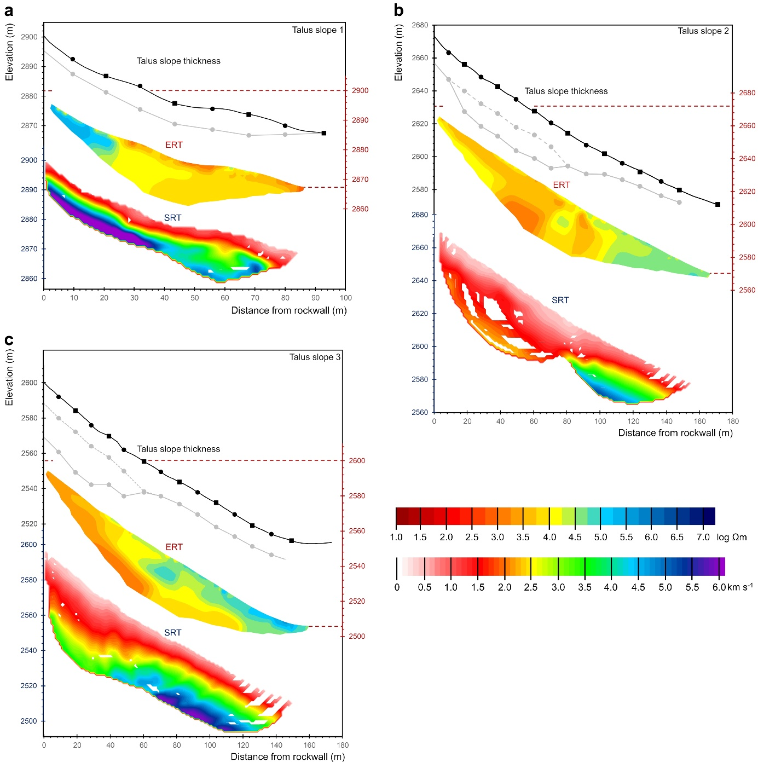
Supplementary Figure 9. Estimated sediment thickness, electrical resistivity tomography and seismic refraction tomography of a, Talus slope-1 located in the Rothorn cirque, b, Talus slope-2 and c, Talus slope-3 located at the Hungerlihorli.

Supplementary Table 12. Talus-derived long-term erosion rates. Scenario I assumes no moraine material buried by talus deposits while Scenario II assumes the existence of a moraine.
Talus slope | Talus slope-1 | Talus slope-2 |  | Talus slope-3
 |  | Scenario I | Scenario II | Scenario I | Scenario II
Talus slope volume (m³) | 38,650 ±5 % | 456,578 ±5 % | 335,842 ±5 % | 250,110 ±5 % | 183,047 ±5 %
Talus slope density (kg m⁻³) | 2,000 – 2,500 | 2,000 – 2,500 | 2,000 – 2,500 | 2,000 – 2,500 | 2,000 – 2,500
Rockwall density (kg m⁻³) | 2,800 | 2,800 | 2,800 | 2,800 | 2,800
Rockwall surface area (m²) | 11,676 ±5 % | 24,983 ±5 % | 24,983 ±5 % | 15,455 ±5 % | 15,455± 5 %
Talus slope age (a) | 55 | 11,000 ±1,000 | 11,000 ±1,000 | 11,000 ±1,000 | 11,000 ±1,000
Rockwall erosion rate (mm a⁻¹) | $${50.7}_{-10.3}^{+10.9}$$ | $${1.4}_{-0.4}^{+0.4}$$ | $${1.0}_{-0.3}^{+0.3}$$ | $${1.2}_{-0.3}^{+0.4}$$ | $$0{.9}_{-0.3}^{+0.3}$$
Rockwall erosion rate (mm a⁻¹) | $${50.7}_{-10.3}^{+10.9}$$ | $${1.2}_{-0.5}^{+0.6}$$ |  | $${1.0}_{-0.4}^{+0.6}$$

Supplementary References
1 Mohadjer, S. et al. Temporal variations in rockfall and rock-wall retreat rates in a deglaciated valley over the past 11 k.y. Geology 48, 594-598 (2020).
2 Sass, O. Spatial patterns of rockfall intensity in the northern Alps. Z. Geomorphol. Supp. 138, 51-65 (2005).
3 Kenner, R. Mass wasting processes affecting the surface of an alpine talus slope: Annual sediment budgets 2009–2018 at Flüelapass, eastern Swiss Alps. Land Degrad. Dev. 31, 451-462 (2020).
4 Hartmeyer, I. et al. A 6-year lidar survey reveals enhanced rockwall retreat and modified rockfall magnitudes/frequencies in deglaciating cirques. Earth Surf. Dynam. 8, 753-768 (2020).
5 Hartmeyer, I. et al. Current glacier recession causes significant rockfall increase: the immediate paraglacial response of deglaciating cirque walls. Earth Surf. Dynam. 8, 729-751 (2020).
6 Kenner, R. et al. Investigation of rock and ice loss in a recently deglaciated mountain rock wall using terrestrial laser scanning: Gemsstock, Swiss Alps. Cold Reg. Sci. Technol. 67, 157-164 (2011).
7 Rabatel, A., Deline, P., Jaillet, S. & Ravanel, L. Rock falls in high-alpine rock walls quantified by terrestrial lidar measurements: A case study in the Mont Blanc area. Geophys. Res. Lett. 35, L10502 (2008).
8 Guerin, A., Ravanel, L., Matasci, B., Jaboyedoff, M. & Deline, P. The three-stage rock failure dynamics of the Drus (Mont Blanc massif, France) since the June 2005 large event. Sci. Rep.-UK 10, 17330 (2020).
9 Sass, O. Spatial and temporal patterns of talus activity – a lichenometric approach in the stubaier alps, austria. Geogr. Ann. A 92, 375-391 (2010).
10 Haeberli, W. et al. Pollen analysis and 14C age of moss remains in a permafrost core recovered from the active rock glacier Murtèl-Corvatsch, Swiss Alps: geomorphological and glaciological implications. J. Glaciol. 45, 1-8 (1999).
11 Krautblatter, M., Moser, M., Schrott, L., Wolf, J. & Morche, D. Significance of rockfall magnitude and carbonate dissolution for rock slope erosion and geomorphic work on Alpine limestone cliffs (Reintal, German Alps). Geomorphology 167, 21-34 (2012).
12 Sass, O. Bedrock detection and talus thickness assessment in the European Alps using geophysical methods. J. Appl. Geophys. 62, 254-269 (2007).
13 Sass, O. & Wollny, K. Investigations regarding Alpine talus slopes using ground-penetrating radar (GPR) in the Bavarian Alps, Germany. Earth Surf. Proc. Land. 26, 1071-1086 (2001).
14 Goetz, J., Otto, J. C. & Schrott, L. Postglacial sediment storage and rockwall retreat in a semi-closed inner-Alpine sedimentary basin (Gradenmoos, Hohe Tauern, Austria). Geogr. Fis. Din. Quat. 36, 63-80 (2013).
15 Hoffmann, T. & Schrott, L. Modelling sediment thickness and rockwall retreat in an Alpine valley using 2D seismic refraction (Reintal, Bavarian Alps). Z. Geomorphol. Supp. 127, 153-173 (2002).
16 Lehmann, B. et al. Postglacial erosion of bedrock surfaces and deglaciation timing: New insights from the Mont Blanc massif (western Alps). Geology 48, 139–144 (2019).
17 Mair, D. et al. The role of frost cracking in local denudation of steep Alpine rockwalls over millennia (Eiger, Switzerland). Earth Surf. Dynam. 8, 637-659 (2020).
18 Mair, D. et al. Fast long-term denudation rate of steep alpine headwalls inferred from cosmogenic 36Cl depth profiles. Sci. Rep.-UK 9, 11023 (2019).
19 Kaiser, B. Variations spatiales et temporelles dans les rythmes d'évolution des versants alpins (Variability in time and space concerning alpine slope evolution). Bull. Assoc. Geogr. Fr. 69, 265-270 (1992).
20 Barsch, D. Rockglaciers. Indicators for the present and former geoecology in high mountain environments. (Springer, 1996).
21 Bearth, P. Geologischer Atlas der Schweiz 1:25000. Erläuterungen zum Atlasblatt 71 (1308 St. Niklaus). (Schweizer Geologische Kommission, 1980).
22 Swissair Photo AG. Turtmanntal, Barrhorn (1964).
23 Draebing, D., Haberkorn, A., Krautblatter, M., Kenner, R. & Phillips, M. Thermal and Mechanical Responses Resulting From Spatial and Temporal Snow Cover Variability in Permafrost Rock Slopes, Steintaelli, Swiss Alps. Permafrost Periglac. 28, 140-157 (2017).
24 Haberkorn, A. et al. Distributed snow and rock temperature modelling in steep rock walls using Alpine3D. Cryosphere 11, 585-607 (2017).
25 Phillips, M., Haberkorn, A. & Rhyner, H. Snowpack characteristics on steep frozen rock slopes. Cold Reg. Sci. Technol. 141, 54-65 (2017).
26 Haberkorn, A., Hoelzle, M., Phillips, M. & Kenner, R. Snow as a driving factor of rock surface temperatures in steep rough rock walls. Cold Reg. Sci. Technol. 118, 64-75 (2015).
27 Haberkorn, A. et al. Thermal regime of rock and its relation to snow cover in steep alpine rock walls: Gemsstock, Central Swiss Alps. Geogr. Ann. A 97, 579-597 (2015).
28 Draebing, D. & Krautblatter, M. The Efficacy of Frost Weathering Processes in Alpine Rockwalls. Geophys. Res. Lett. 46, 6516-6524 (2019).
29 Rempel, A. W., Marshall, J. A. & Roering, J. J. Modeling relative frost weathering rates at geomorphic scales. Earth Planet. Sc. Lett. 453, 87-95 (2016).
30 Cermák, V. & Rybach, L. in Landolt–Börnstein Zahlenwerte and Funktionen aus Naturwissenschaften und Technik, Neue Serie, Physikalische Eigenschaften der Gesteine (V/1a) (ed G. Angeneister) 305–343 (Springer, 1982).
31 Noetzli, J., Gruber, S., Kohl, T., Salzmann, N. & Haeberli, W. Three-dimensional distribution and evolution of permafrost temperatures in idealized high-mountain topography. J. Geophys. Res.-Earth 112, F02S13 (2007).
32 Anderson, R. S., Anderson, S. P. & Tucker, G. E. Rock damage and regolith transport by frost: an example of climate modulation of the geomorphology of the critical zone. Earth Surf. Proc. Land. 38, 299-316 (2013).
33 Krautblatter, M. Detection and quantification of permafrost change in alpine rock walls and implications for rock instability PhD Thesis thesis, Universität Bonn, (2009).
34 Walder, J. & Hallet, B. A Theoretical-Model of the Fracture of Rock During Freezing. Geol. Soc. Am. Bull. 96, 336-346 (1985).
35 Scherler, D. Climatic limits to headwall retreat in the Khumbu Himalaya, eastern Nepal. Geology 42, 1019-1022 (2014).
36 Hales, T. C. & Roering, J. J. Climatic controls on frost cracking and implications for the evolution of bedrock landscapes. J. Geophys. Res.-Earth 112, F02033 (2007).
37 Krautblatter, M. & Draebing, D. Pseudo 3D - P-wave refraction seismic monitoring of permafrost in steep unstable bedrock. J. Geophys. Res.-Earth 119, 287-299 (2014).
38 Cody, E., Draebing, D., McColl, S., Cook, S. & Brideau, M.-A. Geomorphology and geological controls of an active paraglacial rockslide in the New Zealand Southern Alps. Landslides 17, 755-776 (2020).
39 Hilbich, C. Time-lapse refraction seismic tomography for the detection of ground ice degradation. Cryosphere 4, 243-259 (2010).
40 McClymont, A. F., Hayashi, M., Bentley, L. R., Muir, D. & Ernst, E. Groundwater flow and storage within an alpine meadow-talus complex. Hydrol. Earth Syst. Sci. 14, 859-872 (2010).
41 Lanz, E., Maurer, H. & Green, A. G. Refraction tomography over a buried waste disposal site. Geophysics 63, 1414-1433 (1998).

