Figure S1 Principal component analysis (PCA) plot of 164 rice accessions.

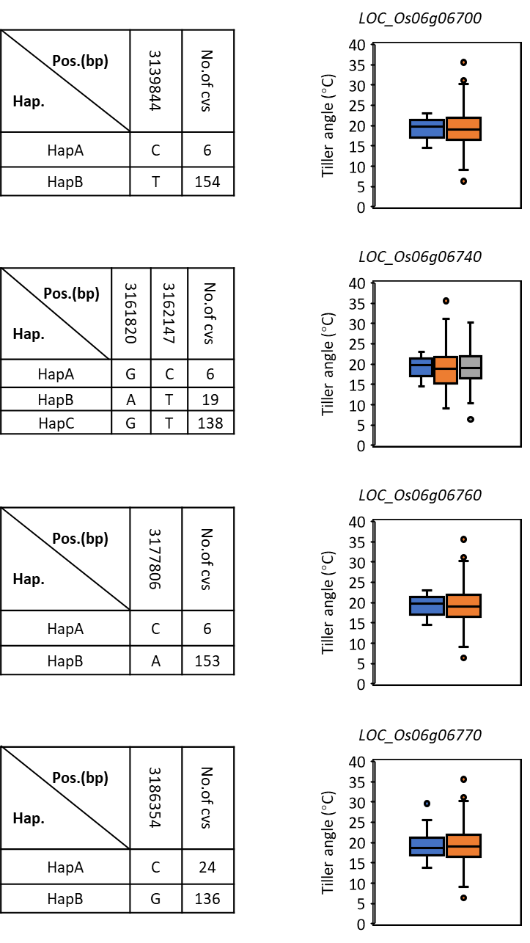
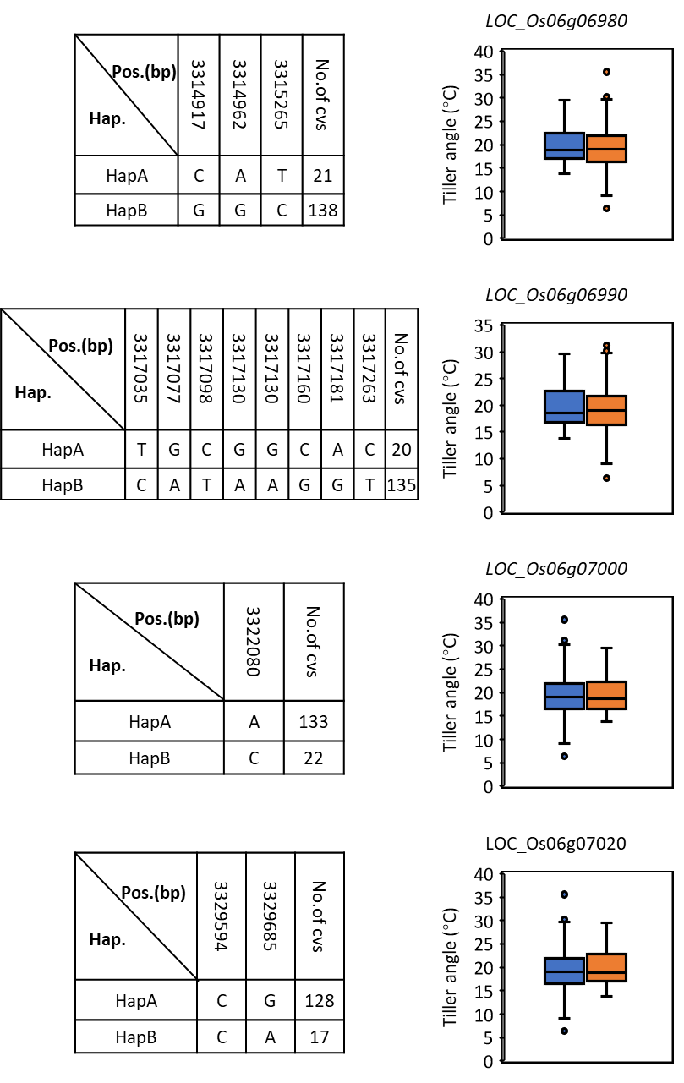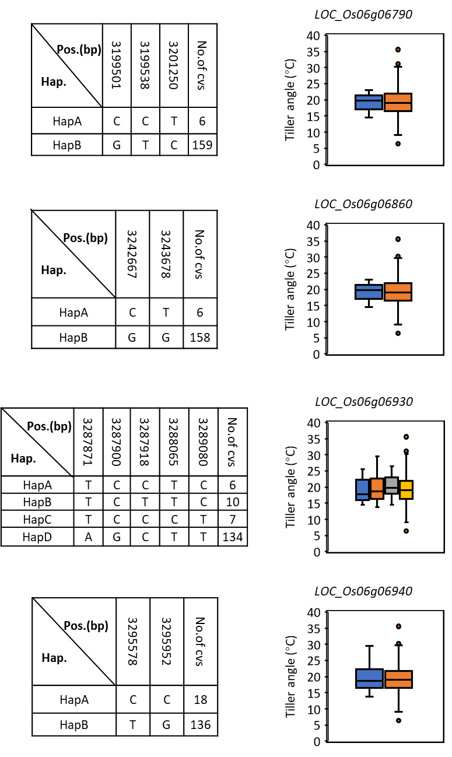
Figure S2. Haplotype analysis of targeted genes
The SNP position (left) and different haplotypes (right)

