·Supporting Online Material
The Three Gorges Dam accelerates acidification of upland soils

Materials and Methods
Experimental and Control Watersheds. The experimental watershed is located in Zigui County of Hubei Province (31.04° - 31.10° N, 110.59° - 110.68° E) (Fig. S1). It is about 50 km upstream of the TGD and is representative of a typical agro-ecological system in the TGRA. The climate is humid subtropical monsoonal, with a mean annual temperature range of 16-19 °C and precipitation of 1114.9 mm (1). Mountainous and hilly areas account for 97.3% of the TGRA. Soils are mainly comprised of Udepts and Udalfs according to the Soil Information System of China, and most of the cultivated land is sloped (76.7% of the cultivated land has slopes >10º) (2). The control watershed is located at Shiyan City (32.01° - 32.10° N, 110.43° - 110.47° E), about 80 km north of the TGD (Fig. S1B). Its geographical characteristics (i.e, soil and vegetation types) and agricultural management (i.e., crop types and fertilization regimes) are the same as the experimental watershed.
Field Experiments
Experimental design. A total of 59 sampling points were set up in the experimental watershed and were divided into three altitude groups: low (200-600 m), intermediate (600-900 m) and high (900-1200 m) altitude. The corresponding respective number of sampling points is 16, 33 and 10 (Fig. S1C). Each sampling point represents 5-7 ha, and these are concentrated in typical farming plots relative to the center of each sampling unit. Since 1998, the land use types and management methods of the sampling sites has remained virtually unchanged. Sampling sites below 600 m are used to grow navel oranges, with a fertilizer application rate of 330 kg/N/ha/yr. The 600 m to 1200 m sites are planted with maize (Summer-Autumn) and wheat (Winter-Spring), with a 300 kg/N/ha/yr fertilizer regime. The soil pH data in the experimental watershed before dam construction (1990-2002) were derived from literature reports (the original data sources are listed in Table S3). The soil pH data of the control watershed were collected from the local agricultural bureau.
Soil sample collection and analysis. Soil sample collection, pre-treatment and analyses for the different years were consistently conducted according to the Standards of Long-term Ecological Monitoring Systems, Chinese Academy of Sciences. Three topsoil (0-20 cm) samples were randomly collected at each sampling site using a soil auger in September of every year from 2003 to 2018, and then mixed and air-dried. Samples were ground to pass through a 2-mm sieve for measuring soil pH, exchangeable acidity (Al³⁺ and H⁺), and exchangeable base cations (Ca²⁺, Mg²⁺, Na⁺ and K⁺). Based on a standard method, soil pH was determined with a pH combination electrode in a 1:2.5 soil/distilled water suspension. The parameters mentioned above were determined as the year of collecting soil samples. To keep the data in high quality, we repeatedly determined some parameters using the stocked soil samples in 2018 and 2020 if the values of these parameters were of obvious deviations (ANOVA, no significance).
The exchangeable acidity (Al³⁺ and H⁺) was determined by extracting the soil with 1.0 mol/L KCl and titrating with a standardized solution of 0.25 mol/L NaOH buffered to pH 7.0. One milliliter of 3.5 % NaF was added to 100 mL of soil solution, and the mixed solution was titrated with 0.02 mol/L NaOH (phenolphthalein endpoint) to obtain exchangeable H⁺. The difference between exchangeable acidity and exchangeable H⁺ is exchangeable Al³⁺.
Soil exchangeable base cations were extracted with 1.0 mol/L ammonium acetate at pH 7.0 Ca²⁺ and Mg²⁺ were then measured by atomic absorption spectrometry (AAS), and K⁺ and Na⁺ were determined by flame photometry.
Soil samples from the same altitude group were mixed for high-throughput sequencing of 16S rRNA genes and internal transcribed spacer (ITS). Species relative abundance was defined as the proportion of a series of specific operational taxonomic units (OTUs) in the sample total OTUs (3, 4). To keep the data in high quality, 10 soil samples that had been polluted during transportation were re-determined for 16S rRNA and ITS analyses in May 2020. The combined results were presented in this study.
The weather station is located at an altitude of 224 m in the experimental watershed (31°3.53' N, 110°40.55' E). The data were obtained by the WatchDog2000 automatic meteorological observatory (Spectrum Technologies, Inc., Aurora, USA) supplemented by manual observation records. Since 2004, meteorological observations have been carried out daily, including temperature, precipitation, evaporation, relative humidity, sunshine duration and soil temperature. Meteorological parameters of the control watershed were collected from the China National Meteorological Data Services Centre.
Simulation experiment. In order to test whether the rapid decrease in soil pH is related to the construction of the TGD, we carried out a series of controlled experiments. Firstly, we collected soil from low (200 m) and intermediate (700 m) altitude areas of the experimental watershed. Soil (30-35% moisture content) samples (0-20 cm) were collected from the navel orange orchards (200 m, pH=5.31) and cereal crop (700 m, pH=5.36) fields in the experimental watershed. Soil samples were passed through a 3.35 mm mesh sieve to remove plant roots and other debris.
We simulated microclimatic conditions before and after dam constructions. The parameters and their values of the simulated microclimatic conditions before dam construction were air temperature = 25±1ºC and relative humidity = 75±3%. The parameters and their values of the simulated microclimatic conditions after dam construction were air temperature =21±1ºC and relative humidity = 70±3%. Four treatments before and after dam construction were set: low altitude without fertilizer, intermediate altitude without fertilizer, low altitude with fertilizer, intermediate altitude with fertilizer, low-altitude fertilization treatment, high-altitude fertilization treatment.
The collected soil samples (60 g, wet weight) were cultured in 50 ml beakers under simulated microclimatic conditions. For the fertilizer treatment, 0.064g ammonium sulfate fertilizer (According to the average soil bulk density of 1.45 g/cm³, 0-20 cm soil layer sampling calculation, equivalent to 330 kg/N/ha fertilization.) was put into each beaker and fully mixed with soil.
Throughout the experiment, the flask was weighed every 1 to 2 days and sterile distilled water was added to replace the water lost by evaporation. Samples were taken at 0 d, 15 d, 30 d, 45 d, 60 d and 75 d. The determination method of soil pH was consistent with that of soil collected in the experimental watershed. The controlled experiments were performed in triplicate.
Statistical analyses. To clarify the mechanisms causing soil acidification, the linear regression method was used to analyze the relationships between the changes in soil base cations (Ca²⁺, Mg²⁺, Na⁺ and K⁺) and soil pH. In addition, linear or logarithmic regression analysis was used to test the relationship between microorganisms abundance and soil pH. The analyses were conducted with the statistical software, IBM SPSS Statistics version 22. The effects of climatic parameters on soil microorganisms were visualized by redundancy analysis (RDA) using the “vegan” package in R (developed by Oksanen et al., 2017). Partial least squares path modelling (PLS-PM) was used to quantify the effects of various factors on soil pH. PLS-PM is a statistical method for studying complex multivariate relationships among observed and latent variables.
References
1. MEE (2018) Bulletin on ecological and environmental monitoring of the Three Gorges Project of the Yangtze River in 2018 (Beijing).
2. Bing H, et al. (2016) Current state, sources, and potential risk of heavy metals in sediments of Three Gorges Reservoir, China. Environmental Pollution 214:485-496.
3. Christ S, Wubet T, Theuerl S, Herold N, & Buscot F (2011) Fungal communities in bulk soil and stone compartments of different forest and soil types as revealed by a barcoding ITS rDNA and a functional laccase encoding gene marker. Soil Biology & Biochemistry 43(6):1292-1299.
4. Jiang CY, Sheng XF, Qian M, & Wang QY (2008) Isolation and characterization of a heavy metal-resistant Burkholderia sp from heavy metal-contaminated paddy field soil and its potential in promoting plant growth and heavy metal accumulation in metal-polluted soil. Chemosphere 72(2):157-164.

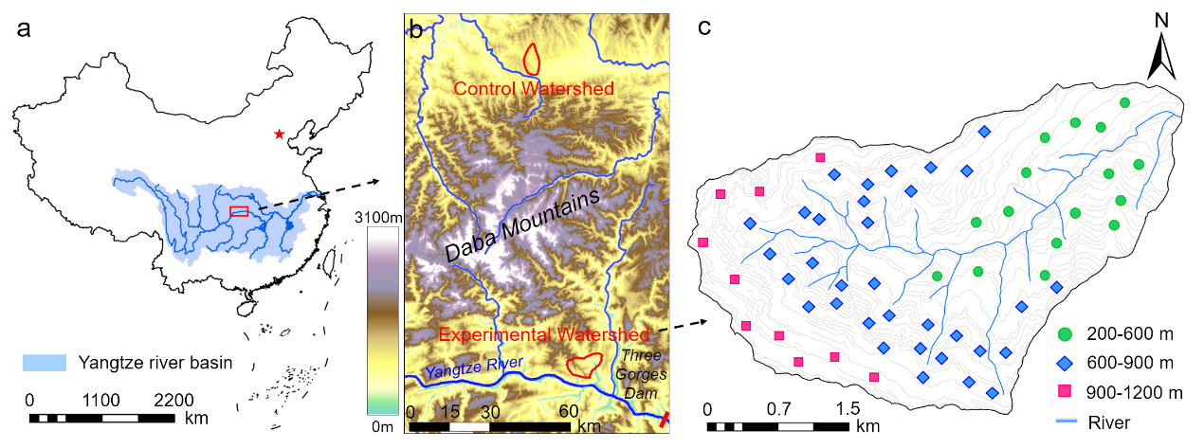
Fig. S1 (a) Location of the Three Gorges Dam (TGD) and Yangtze River System, (b) the experimental and control watersheds, and (c) soil sampling plots in the experimental watershed. The 59 sampling plots were distributed across three altitude groups; low (200-600 m), intermediate (600-900 m) and high (900-1200 m) altitude.

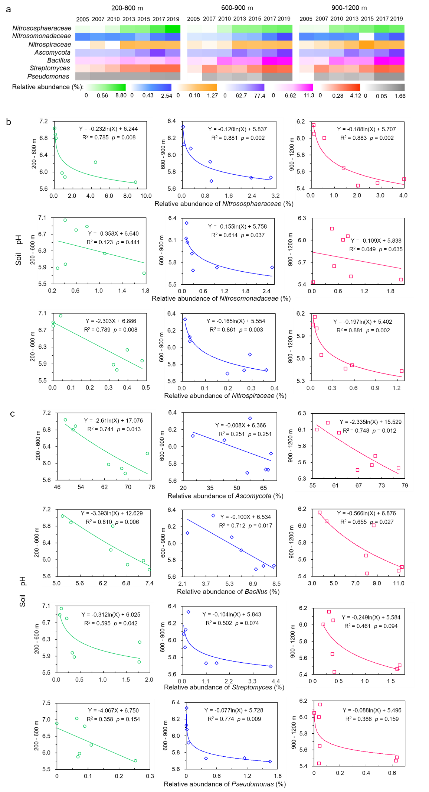
Fig. S2 (a) Relative abundances of nitrifying and soil organic matter-decomposer microorganisms at low (200-600 m), intermediate (600-900 m) and high (900-1200 m) altitudes in the experimental watershed from 2005 to 2019. The deeper the color, the higher the relative abundance of the microorganisms. (b) The relationships between soil pH and the relative abundances of the nitrifying microorganisms and (c) the soil organic matter-decomposer microorganisms. Regression analyses were used to test the relationships between the microorganism abundances and pH values. R² values indicate the proportion of variances explained by each variable. p is the significance level.

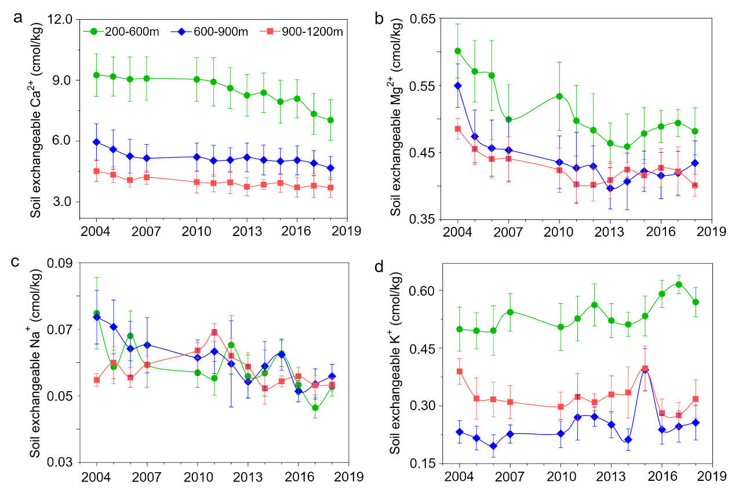
Fig. S3 Trends in major exchangeable base cations in the experimental watershed.

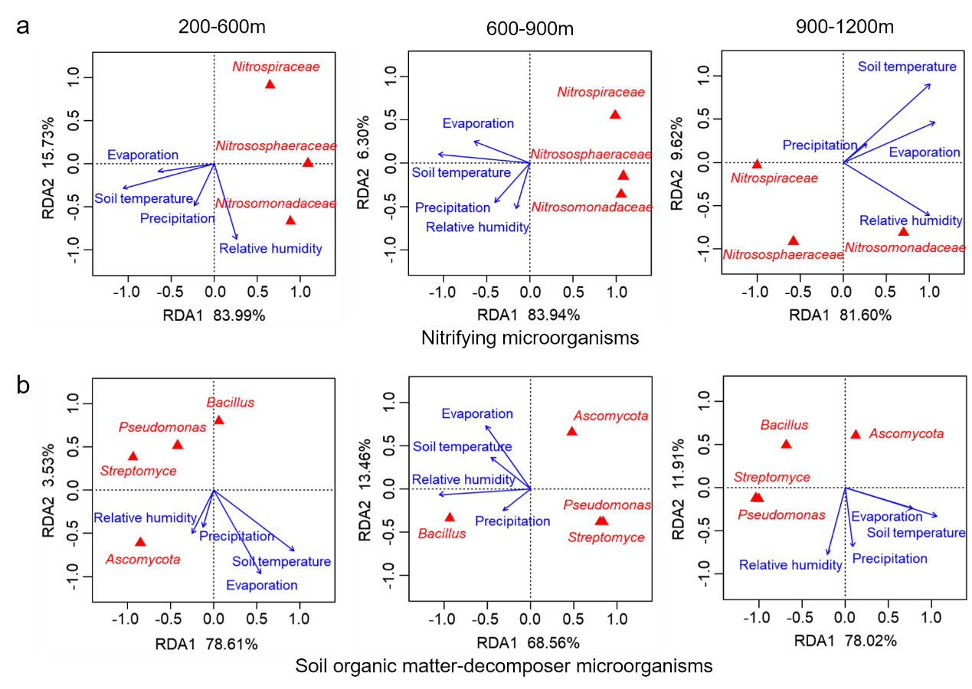
Fig. S4 Redundancy analysis (RDA) of microclimatic parameters and relative abundances of (a) nitrifying and (b)soil organic matter-decomposer microorganisms at different altitudes in the experimental watershed. The longer the arrowed line, the more likely this climatic parameter influenced the community composition. The closer a species point to the arrowed line or its extension line, the more significant the relative abundance of this species was correlated with the microclimatic parameter.

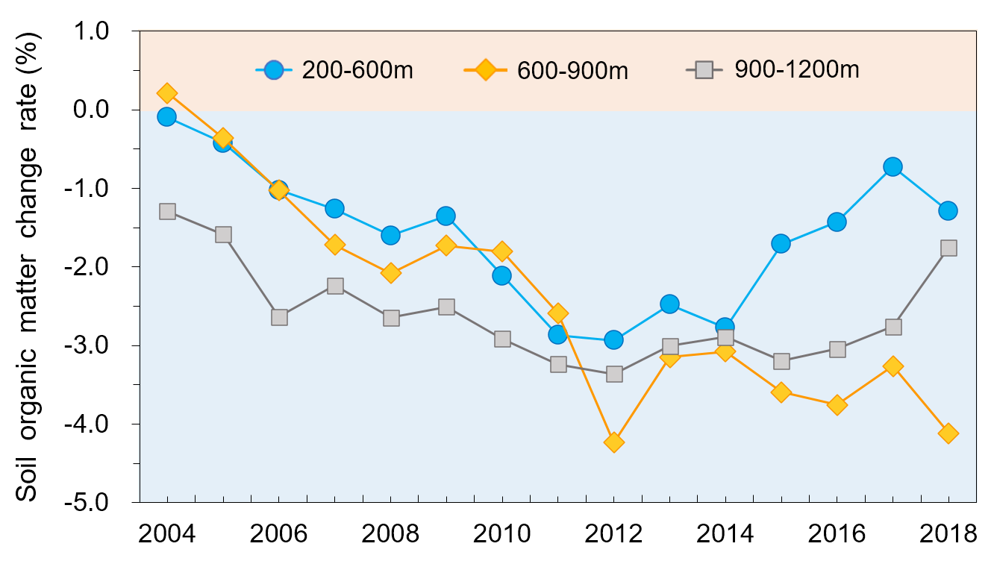
Fig. S5 The change in soil organic matter in the experimental watershed from 2004 to 2018. Soil organic matter change is expressed as the difference between organic matter for a given year and the value in the first year (2003) after reservoir impoundment.

Table S1 Rainwater pH values in the Three Gorges Dam (TGD) experimental watershed.
Sampling date | Rainwater pH
2016.5.4 | 6.80
2016.11.10 | 6.38
2016.12.29 | 6.58
2017.4.5 | 6.98
2017.4.30 | 7.10
2017.8.30 | 6.24
2017.10.10 | 7.30
Average over the sampling period | 6.77

Table S2 Analysis of correlations between soil particle size and exchangeable base cations over the period 2004-2018.
Altitude | Soil particles size | Exchangeable Ca²⁺ (cmol/kg) | Exchangeable Mg²⁺  (cmol/kg) | Exchangeable Na⁺  (cmol/kg)
200-600m | Sand (2-0.05 mm) | -0.831* | -0.801* | -0.464
200-600m | Silt (0.05-0.002 mm) | 0.748* | 0.822* | 0.472
200-600m | Clay (< 0.002 mm) | 0.886** | 0.666 | 0.473
600-900m | Sand (2-0.05 mm) | -0.853** | -0.703 | -0.854**
600-900m | Silt (0.05-0.002 mm) | 0.832* | 0.671 | 0.787*
600-900m | Clay (< 0.002 mm) | 0.743* | 0.694 | 0.947**
900-1200m | Sand (2-0.05 mm) | -0.855** | -0.777* | -0.298
900-1200m | Silt (0.05-0.002 mm) | 0.838* | 0.797* | 0.246
900-1200m | Clay (< 0.002 mm) | 0.342 | 0.148 | 0.400
Significance levels are denoted with *, p < 0.05; **, p < 0.01.

Table S3 Sources of the soil pH data for 1990-2002, collected from previous literature.

Year | Soil pH | Article or book title | Journal or book publisher in English /  Chinese | Authors | Reference pages
1990 | 6.49 | Basic properties of limestone soil and purple soil in Hubei Province (In Chinese) | Chinese Journal of Soil Science | Wang Qingyun, Liu Ziqing, Xu Fenglin, Guo Herong | 1990, 6:  241-243
1990 | 6.55
1990 | 7.43
1990 | 7.38
1991 | 6.90 | Studies on the properties of colloidal charge in purple paddy soils in Sichuan (In Chinese) | Journal of Southwest Agricultural University | Wang Jun, Chen Shizheng | 1991, 5:  511-517
1991 | 7.89
1991 | 5.92
1991 | 6.50 | A study on mineral nutrition for sweet orange trees on purple soil (In Chinese) | Journal of Southwest Agricultural University | Zhou Xuewu, Li Zhiyi, Chen Xuenian, Fu Keyong, Lv Bin, Cheng Changfeng,  Chen Yonghua | 1991,1:  1-7
1992 | 8.10 | A study on the kinetics of nitrogen mineralization in purple soils (In Chinese) | Journal of Southwest Agricultural University | Wang Zhengyin,  Qing Changle | 1992, 2:  158-161
1992 | 6.90
1992 | 5.25
Table S3 continues overleaf
1992 | 7.15 | The effects of high polymers on the structural properties of purple upland soil (In Chinese) | Journal of Southwest Agricultural University | Chen Meng, Zeng Jueting | 1992, 6:  487-491
1992 | 6.85
1992 | 6.91
1992 | 6.80 | Study on water characteristics and drought resistance of purple soil in southern Sichuan Basin (In Chinese) | Chinese Journal of Agrometeorology | Wei Chaofu | 1992, 4:  40-43
1992 | 5.00
1992 | 6.30
1992 | 5.60
1992 | 6.80
1992 | 6.60
1992 | 6.80
1992 | 7.00
Table S3 continues overleaf
1993 | 7.50 | Study on the effect of three soil amendments on the pore structure of purple soil (In Chinese) | Chinese Journal of Soil Science | Zeng Jueting, Chen Meng | 1993, 6:  250-252
1993 | 6.85
1993 | 6.91
1993 | 6.70 | Study of the effect of P-Zn combinations on the yield of maize grown on calcareous and neutral purple soils (In Chinese) | Journal of Southwest Agricultural University | Zhu Yaping, Yang Xuechun | 1994, 1:  49-53
1993 | 7.60
1993 | 7.01 | Land resources potential and ecological environment construction in the head area of the Three Gorges Reservoir (In Chinese) | China Water & Power Press | Yang Linzhang, Dong Yuanhua, Ma Yijie | 2007, P153:  Table 11-5; Table 11-24
1993 | 6.86
1993 | 5.80
1993 | 5.76
1993 | 5.64
1993 | 7.03
1993 | 7.01
1993 | 7.00
Table S3 continues overleaf
1994 | 5.50 | Soil and Ecological Environment Construction in the Yangtze River Basin (In Chinese) | Science Press | Yang Qixiu | 1994, P37:  Table 2-17
1994 | 7.00
1994 | 7.20
1994 | 6.00 | Plants and Compound Agricultural Ecosystem in the Three Gorges Reservoir Area (In Chinese) | Science Press | Yang Qixiu | 1994, P30: Table 5-6;  P41: Table 6-1
1994 | 6.10 |  |  |  | P42: Table 6-2
1994 | 6.70
1994 | 6.58
1994 | 6.02
1994 | 7.90
1994 | 8.00
1994 | 6.95
1994 | 7.27
Table S3 continues overleaf
1994 | 5.80 | Effect of different soil and crop conditions on Zinc fixation in purple soil (In Chinese) | Chinese Journal of Soil Science | Wei Shiqiang, Zhou Zefang, Liu Chen | 1994, 1:  34-36
1994 | 7.12
1994 | 8.01
1995 | 5.25 | Effect of nitrogen fertilizer on lettuce nutrition in purple soils (In Chinese) | Plant Nutrition and Fertilizing Science | Wang Zhengyin, Li Liantie, Xiong Hailin | 1996, 2:  153-161
1995 | 6.90
1995 | 8.10
1995 | 7.45 | Impact of Three Gorges Project on ecology and environment and countermeasure research (In Chinese) | Science Press | Chen Guojie, Xu Qi, Du Rongheng | 1995, P192: Table 4-32
1995 | 7.00
1995 | 5.20 | Evaluation of fertility and yield on long term experiment in waterlogged field (In Chinese) | Journal of Sichuan Agricultural University | Wang Yunbin, Zhu Xingming, Zeng Qingxi, Liu Zhiming, Chen Qide | 1996, 14: 317-320
1995 | 6.60
1995 | 5.20
1995 | 6.80
1995 | 7.50
Table S3 continues overleaf

1996 | 7.90 | Effect of organic fertilizer on available Silicon in purple paddy soil (In Chinese) | Journal of Southwest Agricultural University | Gao Ming, Wei Zhaofu, Xie Deti | 1996,3:  272-275
1996 | 6.50
1996 | 6.70
1997 | 7.75 | Land resources potential and ecological environment construction in the head area of the Three Gorges Reservoir (In Chinese) | China Water & Power Press | Yang Linzhang, Dong Yuanhua, Ma Yijie | 2007, P87: Table 7-6; P100: Table 11-24; P153:  Table 11-5
1997 | 8.25
1997 | 8.20
1997 | 8.40
1997 | 5.40
1997 | 5.60
1997 | 5.61
1997 | 6.90
Table S3 continues overleaf

1997 | 6.50 | Potassium release and its availability in paddy soils developed from purple soils (In Chinese) | Plant Nutrition and Fertilizing Science | Wei Zhaofu, Yang Jianhong, Qu Ming, Xie Deti, Wei Shiqiang | 1998, 4: 352-359
1997 | 5.20
1997 | 7.00
1997 | 6.70
1997 | 7.90
1997 | 7.90
1998 | 7.00 | Comprehensive evaluation soil fertility of a small watershed in Three Gorge Area using GIS (In Chinese) | Journal of Soil Erosion and Soil and Water  Conservation | Shi Zhihua, Cai Chongfa, Ding Shuwen, Zhang Guangyuan | 1999, 1:  74-78
1998 | 6.80 | Effect of nitrogen supplying levels on uptake and utilization of purple soil potassium by various rice varieties (In Chinese) | Plant Nutrition and Fertilizing Science | Wang Zhengyin,  Yao Jianxiang | 1998, 4:  183-187
1999 | 7.26 | Changes of nitrogen in three purple soils during lettuce growth under different light conditions (In Chinese) | Soils and Fertilizers | Zeng Xibo, Xie Deti, Qing Changle, Hou Guangjiong | 1999, 2:  11-16
1999 | 6.94
1999 | 6.46
Table S3 continues overleaf

1999 | 7.70 | Movement and leaching characteristics of chlorine in purple soil (In Chinese) | Soil | Yu Guifang, Mao Zhiyun, Zhou Zefang | 1999, 4:  214-216
1999 | 7.20
1999 | 5.20
1999 | 6.83 | Study on the soil enzyme activity and its affecting factors in citrus orchard with purple soil (In Chinese) | South China fruits | Wang Chengqiu, Wang Shuliang, Yang Jianhong, Wei Caofu, Qu Ming, Xie Deti | 1999, 5:  7-10
1999 | 6.78
1999 | 6.91
1999 | 6.78
1999 | 7.50
1999 | 7.45
1999 | 7.08
2000 | 5.25 | Effect of nitrogen application and rice cultivars on forms ofpotassium in different purple paddy soils (In Chinese) | Plant Nutrition and Fertilizing Science | Xu Weihong, Wang Zhengyin, Li Chuanlin | 2000, 6:  389-396
2000 | 6.90
2000 | 7.80
2000 | 8.10
Table S3 continues overleaf
2000 | 7.44 | Profile differentiation of fertility elements and fertility potential of purple soil (In Chinese) | Southwest China Journal of Agricultural Sciences | Zhu bo, Luo Xiaomei, Xu Pei, Peng Kui, He Jianzhang | 2000, 4:  50-56
2000 | 5.20
2001 | 7.40 | The effect of long-term fix-point application on  the potassium forms in purple soil (In Chinese) | Journal of Sichuan Agricultural University | Xiong Mingbiao, Shu Fen, Song Guangyu, Shi Xiaojun, Mao Zhiyun | 2001, 1:  44-47
2001 | 6.90 | A study on mechanism and prediction model of hillslope water and soil loss in three gorges area (In Chinese) | Southwest Agricultural University | Fu Tao | 2002, PhD, P26
2002 | 7.48 | Study on fraction characters of aggregates of dryland purple soil developed from different parent material (In Chinese) | Journal of Soil Water Conservation | Luo Dongqi, Hou Chunxia, Wei Chaofu, Xie Deti, Zhu Bo | 2003, 1:  131-133
2002 | 7.37
2002 | 6.72
2002 | 6.77
2002 | 7.88
2002 | 7.82
2002 | 8.10
2002 | 7.48
2002 | 6.90 | Study on the indices to the features of purple soil aggregates (In Chinese) | Journal of mountain science | Luo Dongqi, Hou Chunxia, Wei Chaofu, Xie Deti, Zhu Bo | 2003, 3:  348-353

