Supplementary Information

AQUEOUS PREPARATION OF SELF-SUPPORTED HYDROXYPROPYL METHYLCELLULOSE-POLYANILINE CONDUCTING FILMS AND THE EVALUATION OF THEIR ELECTRICAL AND MECHANICAL PROPERTIES

Vinicius Cavalheiro Maedaª, Cintia Marques Correaª, Marcos Henrique Mamoru Otsuka Hamanaka^{b}, Viviane Nogueira Hamanaka^{b}, Celso Molinaª and Fernanda F. Camiloª*

ªDepartment of Chemistry, Federal University of São Paulo, Rua São Nicolau, 210 – Laboratório de Materiais Híbridos, CEP: 09913-030, Diadema, SP, Brazil
^{b}Autocoat Equipamentos e Processos de Deposição LTDA, Rua Daniel Hogan, 434 - sala 25 - Cidade Universitária, CEP 13083-836, Campinas, SP, Brazil

Corresponding author: Fernanda Ferraz Camilo
Laboratório de Materiais Híbridos, Instituto de Ciências Ambientais, Químicas e Farmacêuticas, Universidade Federal de São Paulo
Rua São Nicolau, 210, CEP: 09913-030, Diadema – SP, Brazil
Phone: +55 11 3319-3568
E-mail: ffcamilo@unifesp.br

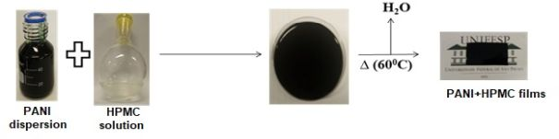
Figure 1S: Artwork representing the preparation of PANI_HPMC films

Figure 2S: SEM images of HPMC (A), PANI (B) and PANI_40%HPMC (C)

Figure 3S: Stress–strain curves of the samples

Note 1
Chemical equation of polymerization of aniline by ammonium persulfate
Table 1S: Amounts of reagents
 | Aniline | (NH₄)₂S₂O₈ | PANI/ doped with 2 Cl⁻ | PVP*
molar mass (g mol⁻¹) | 93 | 228 | 435 | --
Initial number of mol (mmol) | 20 | 25 | ---- | ----
Final number of mol (mmol) | ---- |  | 5.0
Final mass (g) | ---- | ---- | 2.18 | 2.00
*it was added 50 mg of an aqueous solution of PVP (40 g L^{–1})
- Considering the stoichiometry of the reaction and the complete conversion (100 % yield), the total mass of the dispersion would be 4.18 g (2.18 g (PANI/2Cl⁻) + 2.00 g (PVP)
- Therefore, the PANI dispersion has 52 wt % of PANI and 48 wt% of PVP.

