Appendix S1: Additional methods, results and sensitivity analyses

Section S1 Additional methods
Equation S1 Jaccard dissimilarity coefficient ¹ = 1- a/(a + b + c), where
a = number of species shared by focal and comparison grid cells,
b = number of species unique to the EBBA1 focal grid cell,
c = number of species unique to the EBBA2 comparison grid cell.

S1.1 Response variables: community composition shift distance and direction
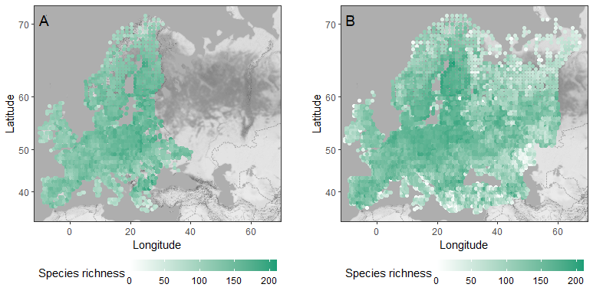
Figure S1. Breeding bird species richness and the data coverage of the European Breeding Bird Atlas surveys. Panel A shows the species richness during the first atlas (EBBA1: 1985-1988; ²) and panel B the species richness during the second atlas (EBBA2: 2013-2017; ³). Each colored dot represents the number of species in one 50 x 50 kilometer grid cell in which all breeding birds were recorded during the study period years. Dashed lines indicate country borders.
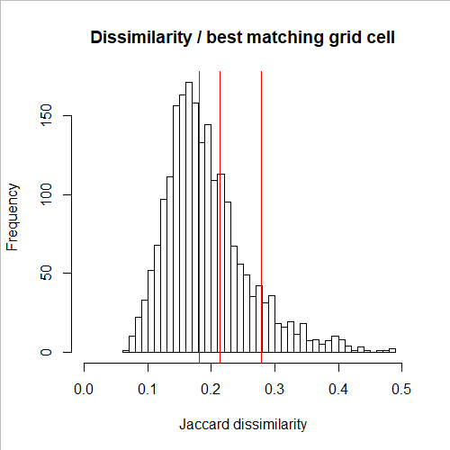
Figure S2. Variation in Jaccard dissimilarity index values among pairs of EBBA1-EBBA2 grid cells. The dissimilarity between focal EBBA1 grid cell and the best matching EBBA2 comparison grid cell is included. The higher the dissimilarity value, the less similar the community compositions between the two grid cells. The red vertical lines from left to right indicate 50%, 70% and 90% quantiles, respectively.

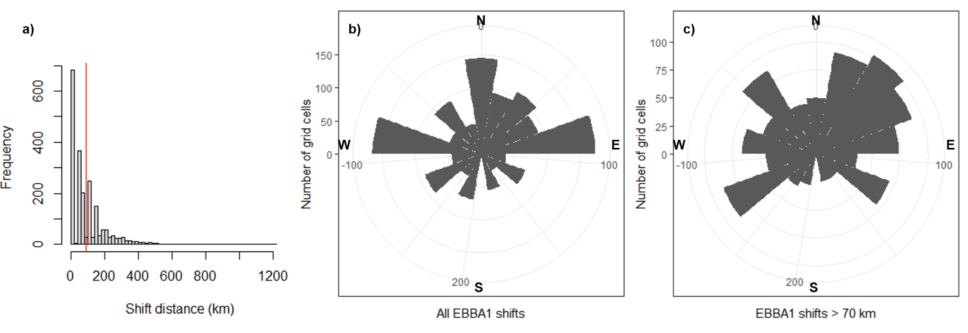
Figure S3. Variation in community shift distance (panel a) and direction (panels b and c). In panel a), the red vertical line indicates the mean distance among those grid cells that had non-zero shifts. In panels b) and c), compass directions are indicated on the circular plots. Panel b) illustrates the shift directions of all EBBA1 grid cells that shifted, while panel c) illustrates the shift directions of those EBBA1 grid cells that shifted more than one grid cell (~70 km).

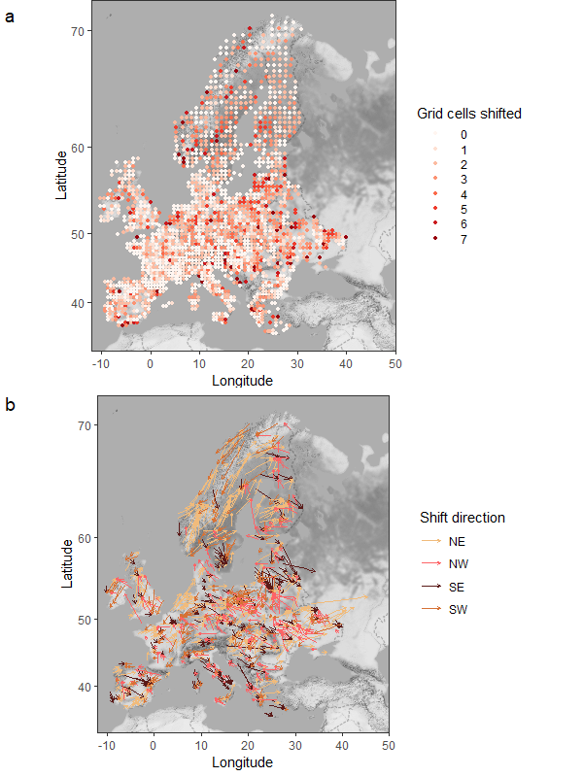
Figure S4. Distance (panel a) and direction (panel b) of breeding bird community shift between 1980’s and 2010’s. Color gradient in panel a) shows the distance of community shift in numbers of grid cells shifted, such that the darker the color the further the best matching community is in 2010’s. The shift distances are assigned in ordinal groups similarly as in the shift distance models. Arrows in panel b) indicate the direction of community shift, such that the starting point of the arrow is at the focal EBBA1 grid cell centroid and the ending point of the arrow is at the best matching EBBA2 comparison grid cell centroid. For clarity, only directions of shifts further than one grid cell (i.e., ordinal classes 0-7) are plotted on the map. For illustrative purposes, shift directions have been grouped into 25% compass direction quantiles and colored accordingly.

S1.2 Predictor variables: ecological barriers
We quantified ecological barriers using multiple measures (Table 1 in the main text). We did not find strong correlations among the barrier variables (Figure S5).

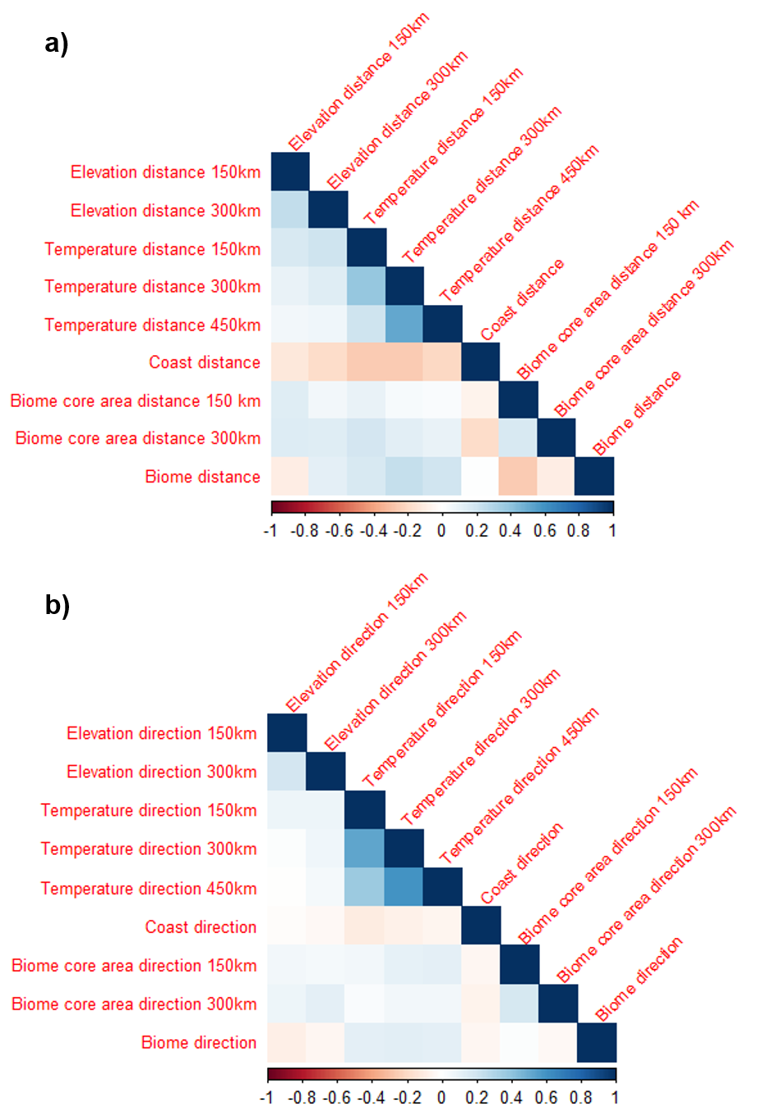
Figure S5. Correlation matrices of ecological barriers relating to the community shift distance (panel a) and direction (panel b).

S1.2.1 Terrestrial biome boundaries
Our study area covered six different biomes (Figure S6; WWF 2017). The distance and direction to the nearest terrestrial biome boundary varied across the study area (Figure S7).
i) The Mediterranean forests, woodlands, and scrublands are located around the Mediterranean Sea. The area has hot and dry summers, but cool and moist winters. The area has a long history of intensive agricultural use and is mainly characterized by semi-natural landscapes. Urbanization is ongoing and threatens the coastal woodland remnants. Human-induced forest fires and degradation due to agricultural intensification are typical.
ii) The temperate coniferous forests are located at the Alps and the Carpathian Mountains. They have high faunal diversity and altitudinal specialization. Areas include pristine habitats, but they have been fragmented by increasing human pressure. The native mixed forests have been replaced by spruce monocultures due to logging.
iii) The temperate broadleaf and mixed forests cover the majority of mainland Europe and the British islands. The biome is highly fragmented due to intensive agricultural land use that stretches a very long time period. Biodiversity patterns are rather robust, and many dominant species have widespread distributions. However, for example due to unusual soils, local endemics also occur. The biome includes several Important Bird Areas (IBAs), which are under the pressure of agricultural expansion and intensification. Anthropogenic effects increase with urbanization and lead to pollution of air, water and soil.
iv) The boreal forest or taiga covers most of Fennoscandia. The biome typically has low temperatures and possible snow cover during the winter. Pristine areas prevail. Species richness and endemism are typically low, and many species are widespread (i.e., low alpha and beta diversity).
v) The temperate grasslands, savannas and shrublands within our study area cover a small area in northern Africa. They have relatively low alpha, beta, and gamma diversities.
vi) The tundra is located in the Scandinavian mountains and in the high Scandinavian arctic. The treeless tundra had long dark winters and short summers. This leads to extremely seasonal occurrences of birds. Species have typically widespread distributions, resulting in low alpha and beta diversities. Human pressure has increased also in remote areas and the biome is particularly sensitive and strongly influenced by climate change.

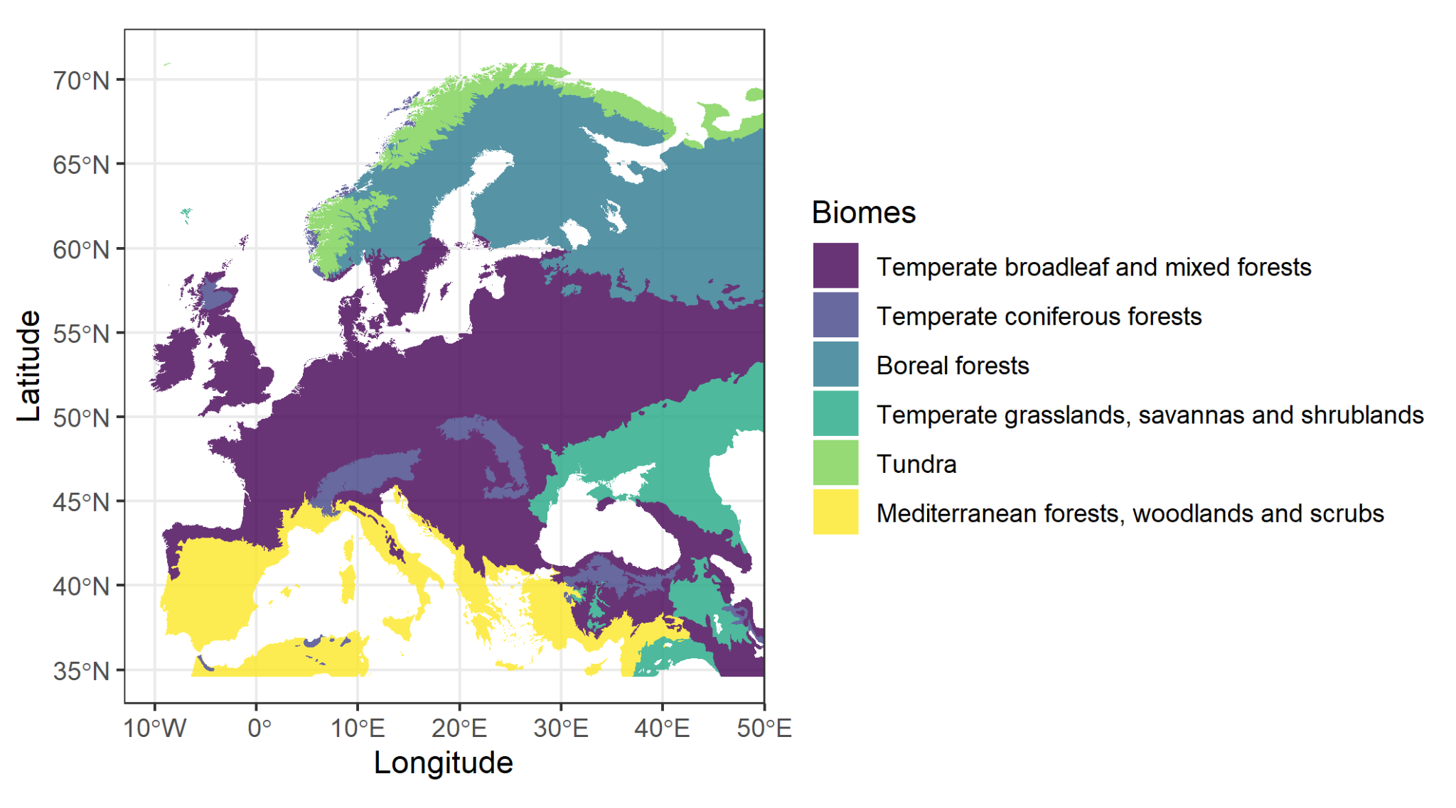
Figure S6. The full spatial distribution of the terrestrial biomes that overlapped the EBBA data used in our study. For the spatial extents of EBBA1 and EBBA2 data, see Figure S1.
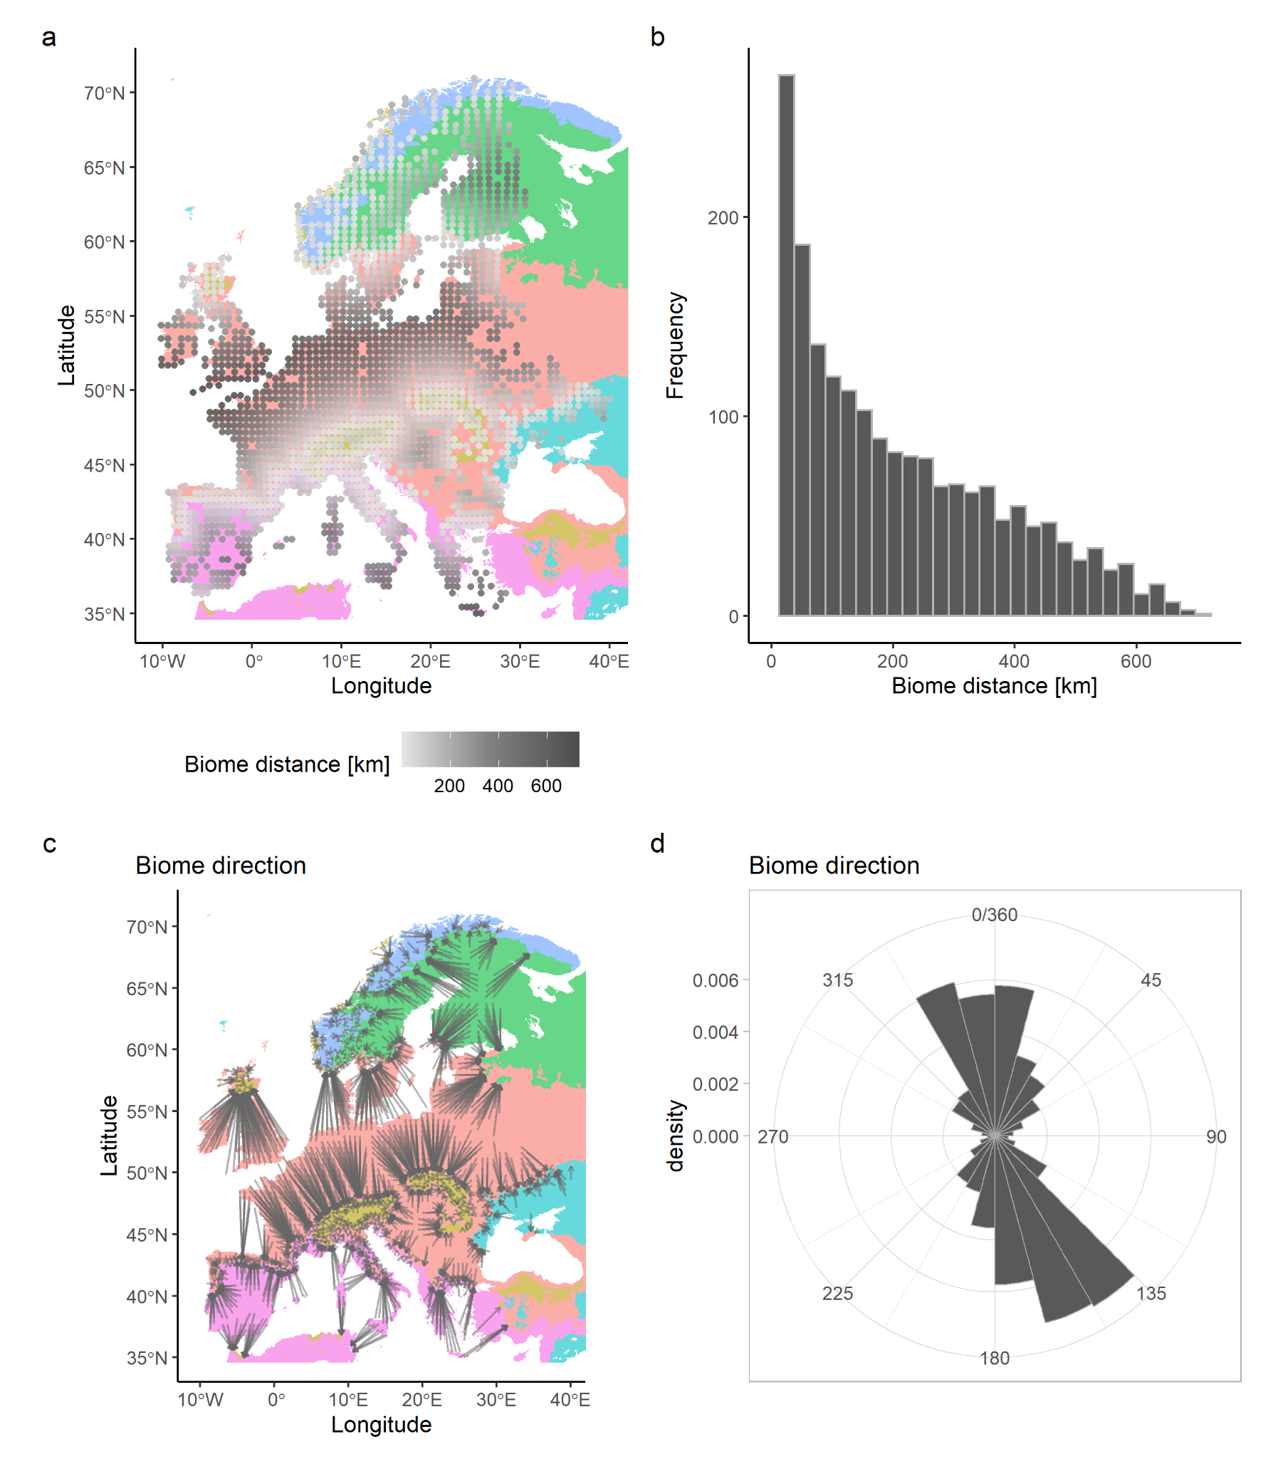
Figure S7. Panel a illustrates the spatial distribution of the shortest distance in kilometers from all 2092 EBBA1 grid cells to the nearest terrestrial biome boundary. Panel b shows the distribution of the distance values. Panel c illustrates the direction towards the nearest terrestrial biome boundary such that the gray arrows point from the focal EBBA1 grid cells to the nearest terrestrial biome boundary. Panel d shows the distribution of the direction values, weighted by distance.

S1.2.2 Biome core area
In addition to the barrier variables described in the methods in the main text, we also calculated biome core area distance (150/300) and direction (150/300) variables (Figure S8). That is, we studied how the spatial position of an EBBA1 grid cell within a biome influences the bird community’s ability to shift. To do so, we first calculated the biome class specific mean of core area (‘core_mn’) around each EBBA1 and EBBA2 grid centroid smoothed within the 150 km and 300 km buffers (functions ‘sample_lsm’ and ‘lsm_c_core_mn’ in the R package ‘landscapemetrics’, ⁴). Next, we calculated the difference in core area value between each focal EBBA1 and all surrounding grid cells within the two buffer areas (150 km and 300 km). In all geographic directions (i.e., 0-360 degrees) around the focal EBBA1 grid cell, we then selected the first grid cell (i.e., the one closest to the focal EBBA1 grid cell) with a change in core area value (difference > 0) and among those grids, selected the one furthest away. For cases where all surrounding grid cells had the same core area value as the focal EBBA1 grid cell (difference = 0), we chose the grid cell furthest away from the focal grid cell. We then calculated the distance and direction to this selected grid cell using the functions ‘bearing’ (R package geosphere, ⁵) and ‘pointDistance’ (R package raster, ⁶). Thus, we quantified how far and in which direction a community could have potentially shifted before experiencing a change in biome core area value within the two buffer areas (‘biome core area distance’ and ‘biome core area direction’). We observed variation between the direction and distance values for the two buffer radii (Figure S9). We expected the communities to shift depending on the biome core area barrier (Figure S10).
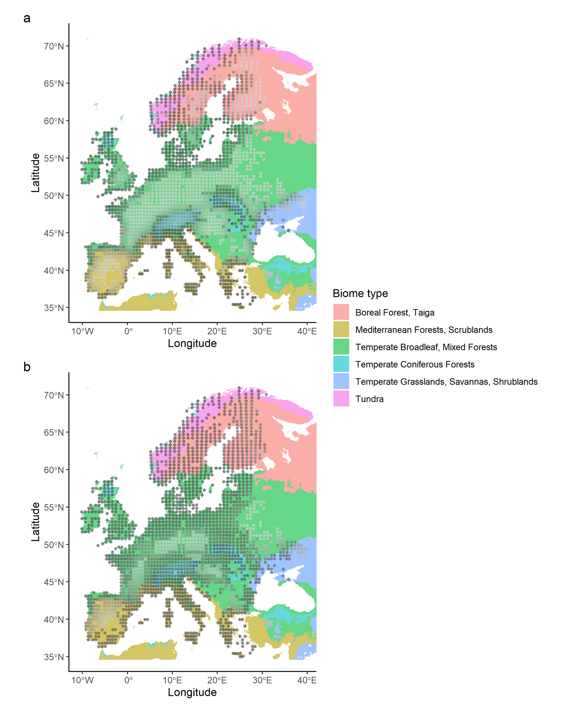Figure S8. Raw values of mean biome core area in each EBBA1 grid cell using 150 km (panel a) and 300 km (panel b) buffers, shown as gray-scale points ranging from low core area (i.e. edges, dark gray) to high core area values (light gray).

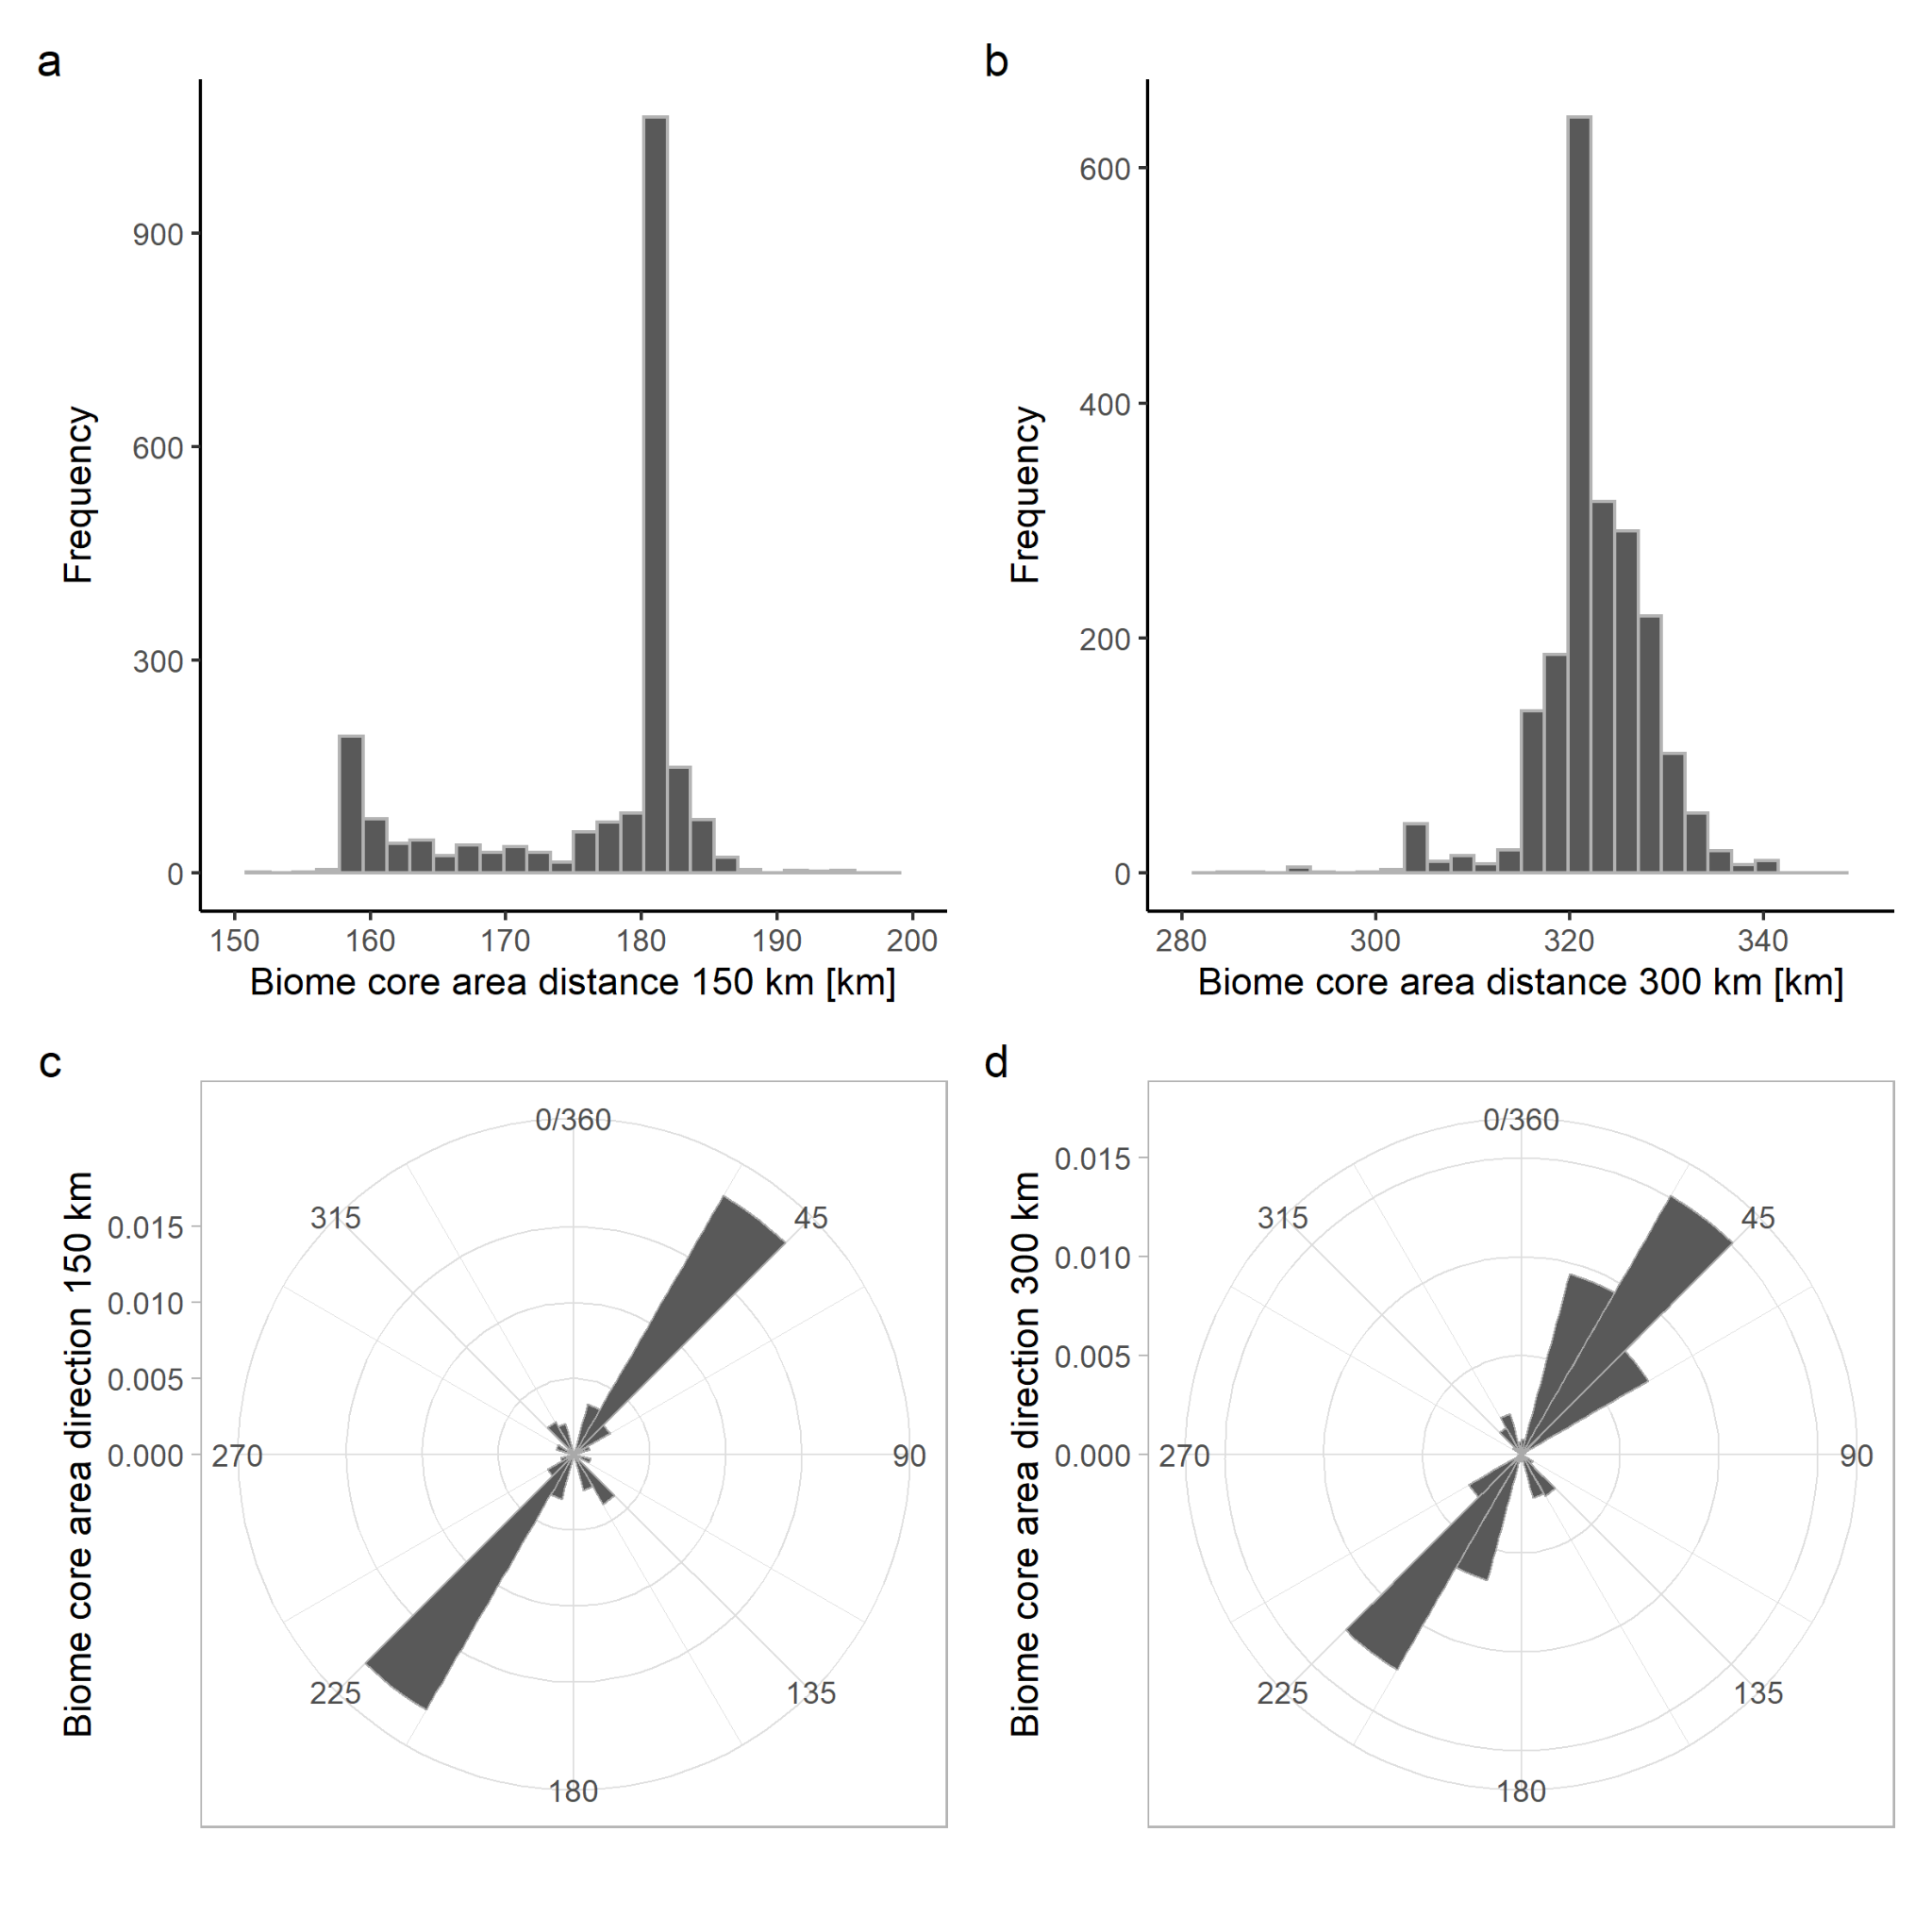
Figure S9. Panel a and b show the variation in biome core area distance values within 150 km and 300 km buffers, respectively. The biome core area distance was quantified as the longest distance until terrestrial biome core area changes within the buffer. Panels c and d show the variation in biome core area direction values within 150 km and 300 km buffers, respectively. The biome core area direction was quantified as the direction to the longest distance until terrestrial biome core area changes within the buffer. The illustrated directions have been weighted by distance.

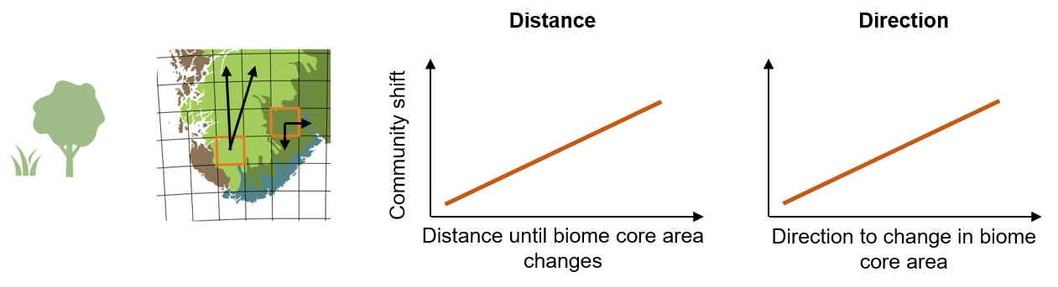
Figure S10. The icon illustrates the ecological barrier of the biome core area. The panel illustrates the hypothesized effect of a barrier on community shift distance and direction. In the hypothesis map, orange squares indicate focal EBBA1 grid cells and the black arrows the potential distances and directions of community shift. Terrestrial biome boundaries are indicated with colored biome-polygons. The graphs show the expected relationships between community shift distance and direction (y-axes) and increasing barrier variable value (x-axis).

S1.2.3 Coastlines
We quantified the shortest distance from each focal EBBA1 grid cell to the coastline. The distance and direction to the shortest distance to coastline varied greatly across the study area (Figure S11).
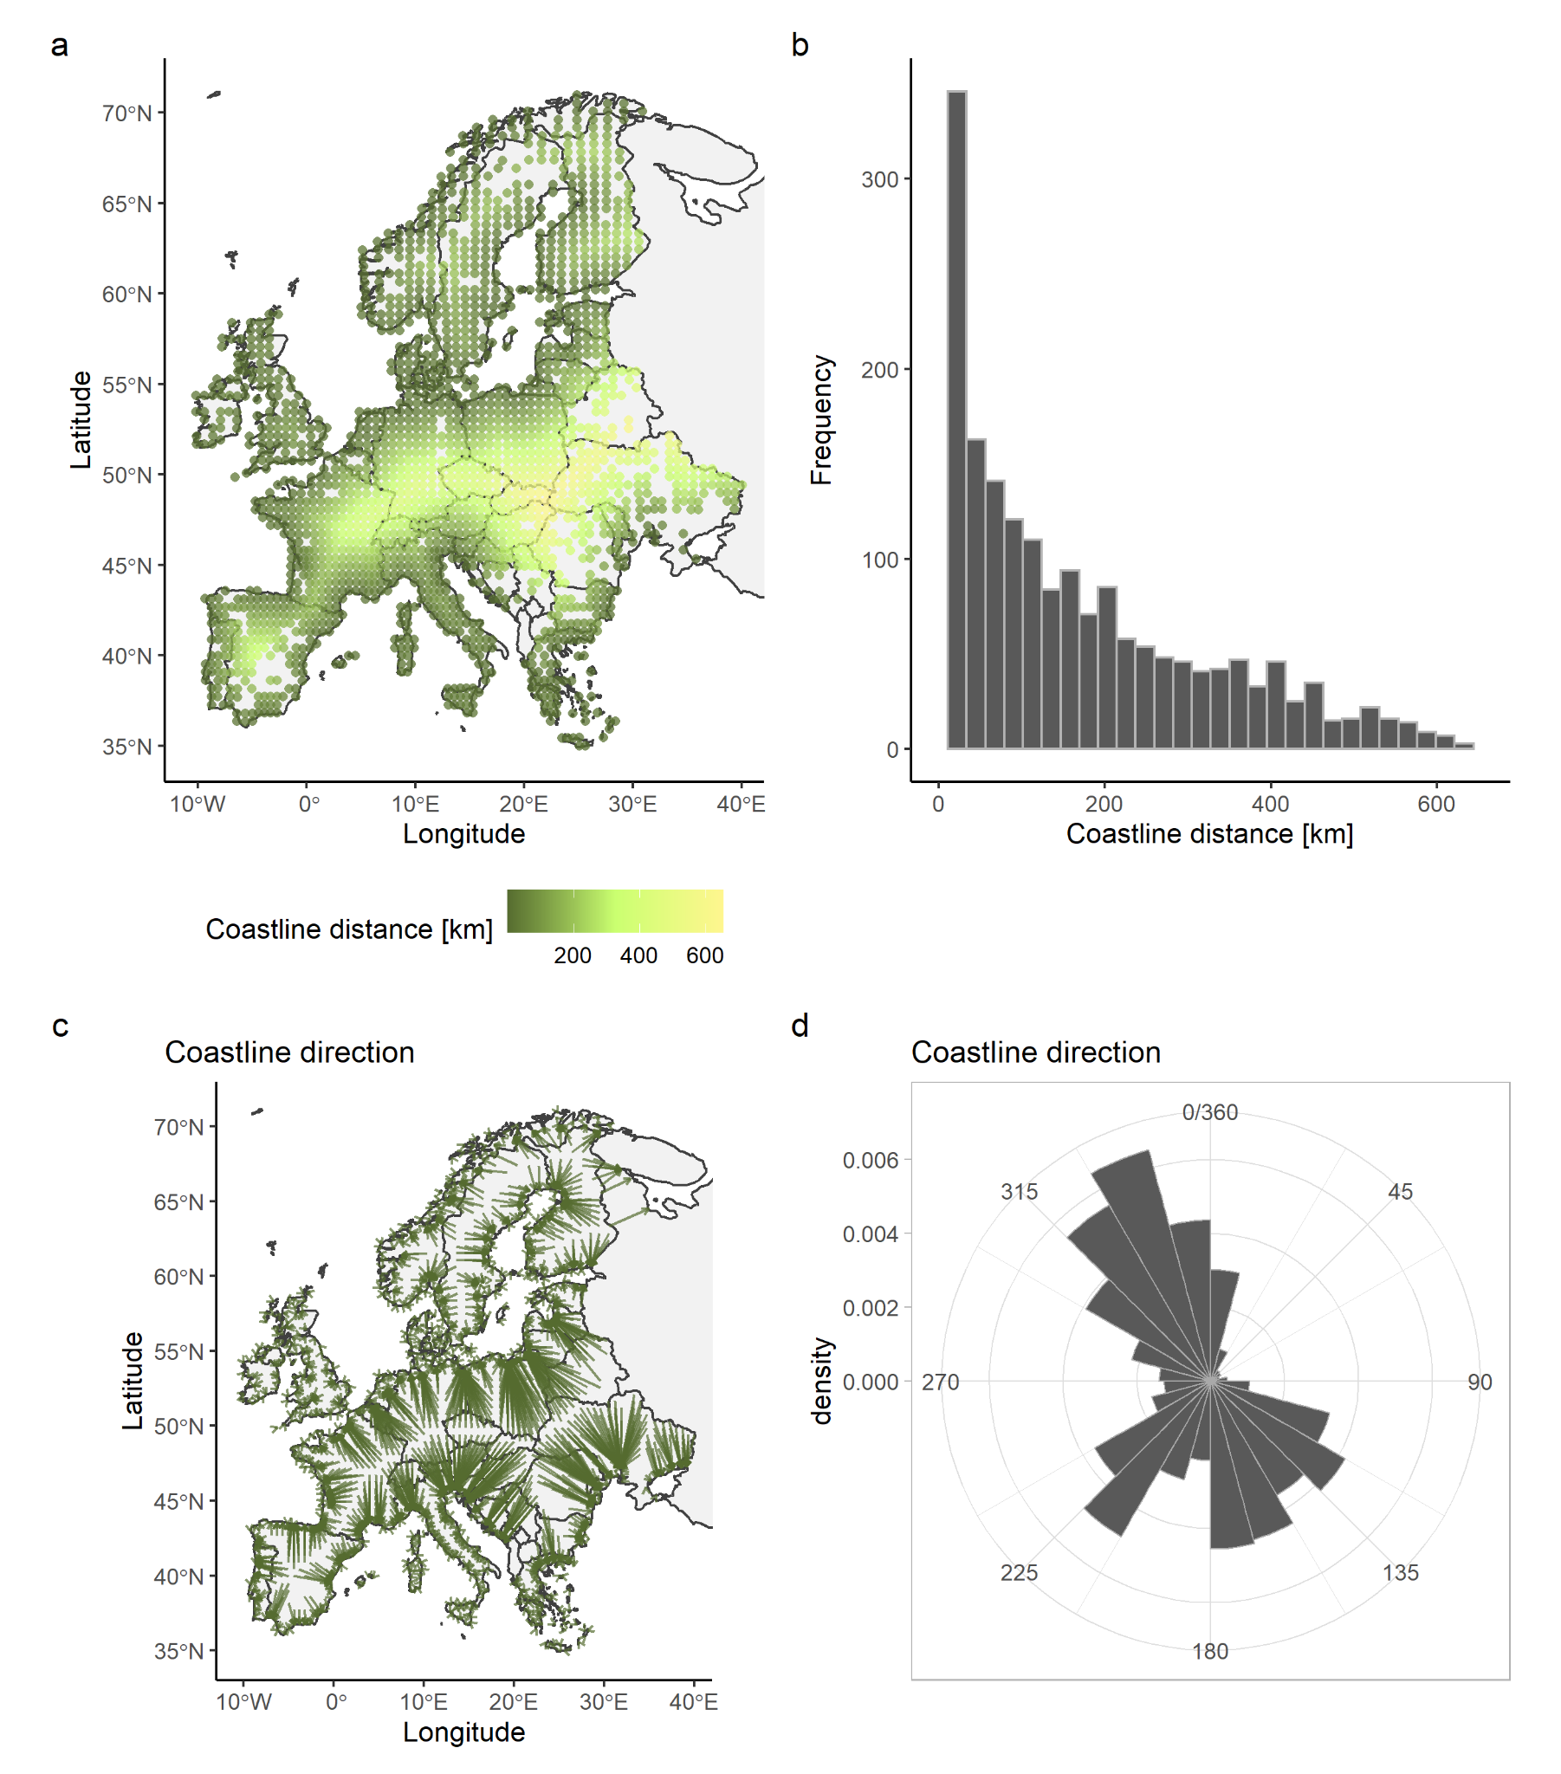Figure S11. Panel a shows the spatial variation in coastline distance and panel b the variation in the coastline distance values. Panel c depicts the direction to the shortest distance from all 2092 EBBA1 grid cells to the coastline (green arrows). Panel d shows the direction values, weighted by distance.

S1.2.4 Elevation
We used the average elevation in each EBBA1 and EBBA2 grid cell to quantify elevation distance and direction (Figure S12). We quantified the distance to the most different elevation within 150 km and 300 km buffers as well as the direction along most similar average elevation within 150 km and 300 km buffers (Figure S13).

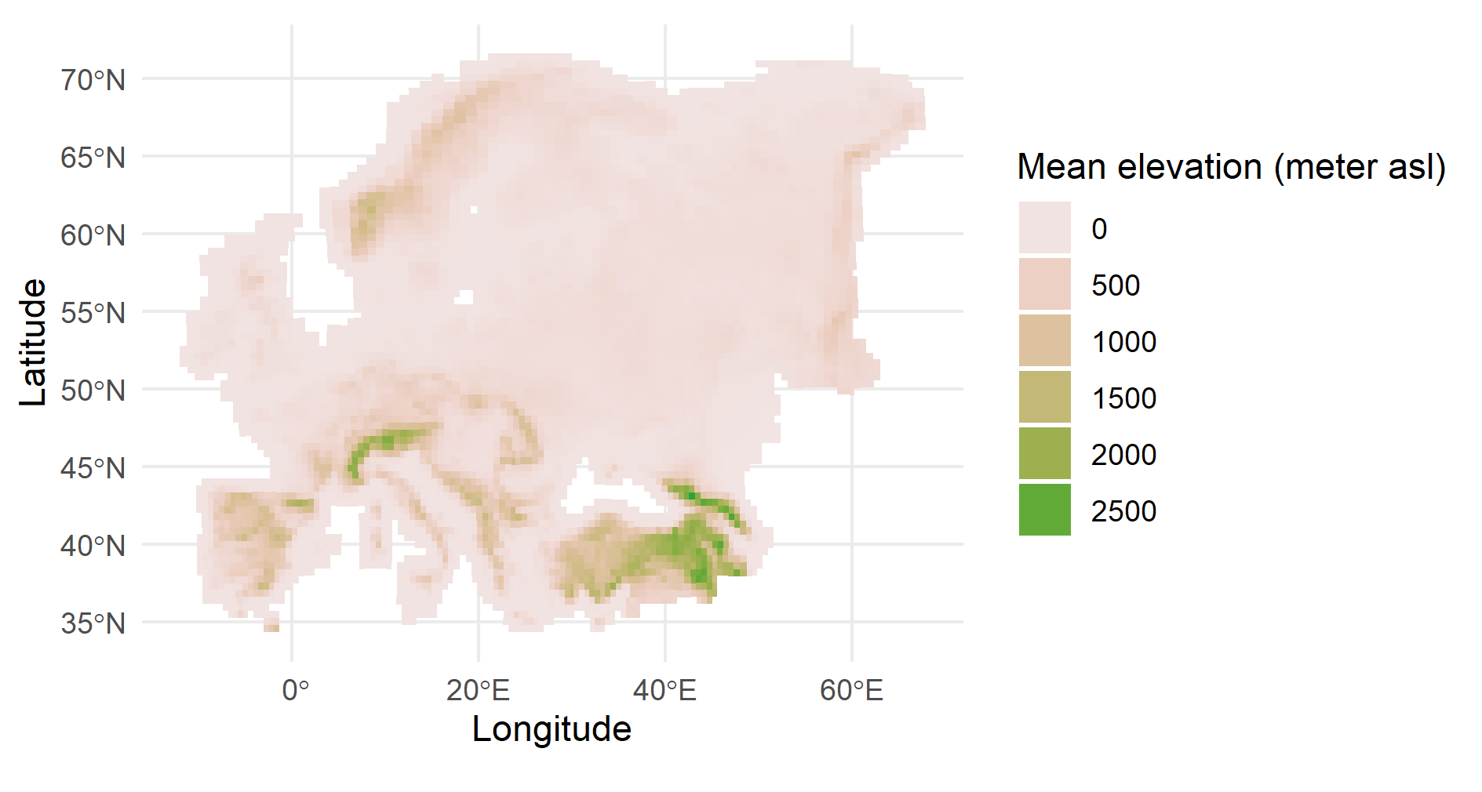
Figure S12. Map showing the average elevation (m a.s.l.) for all EBBA1 and EBBA2 grid cells across the study area.

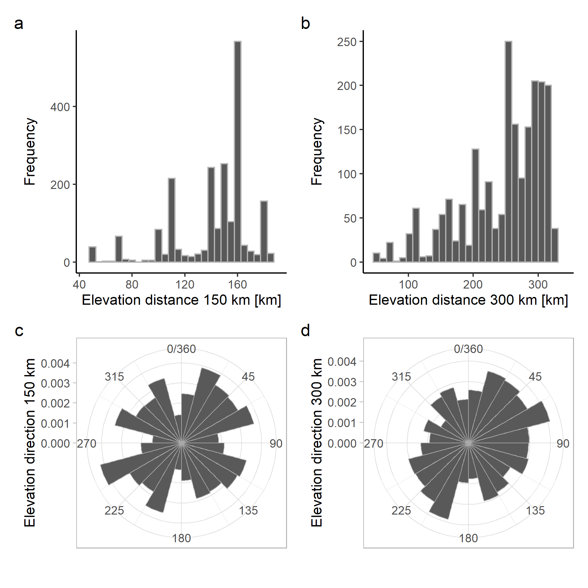
Figure S13. Panels a and b show the variation in elevation distance within 150 km and 300 km buffers, respectively. Panels c and d show the variation in the elevation direction (weighted by distance) within 150 km and 300 km buffers, respectively.

S1.2.5 Temperature change
We used mean temperature data for each EBBA1 and EBBA2 grid cell to quantify temperature distance and direction. There were missing values in the original temperature data (Figure S14) that were imputed (see Methods for details). We quantified the distance to most similar temperatures between EBBA1 and EBBA2 within 150 km, 300 km and 450 km buffers. We quantified the direction to most similar temperatures between EBBA1 and EBBA2 within 150km, 300 km and 450 km buffers (Figure S15).

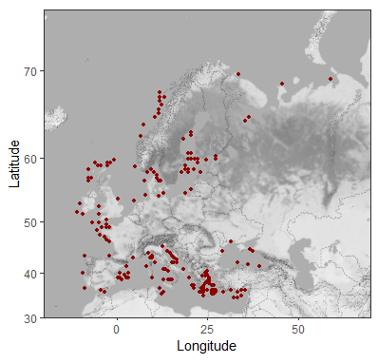
Figure S14. EBBA1 and EBBA2 grid cells with missing temperature data.

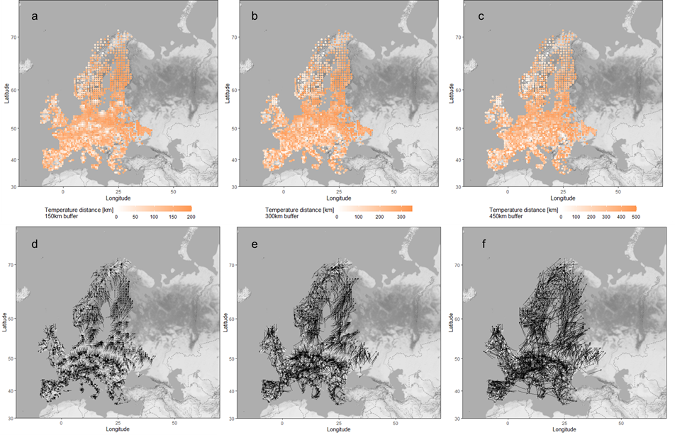

Figure S15. Panels a, b and c show the spatial variation in temperature distance values within 150 km, 300 km and 450 km buffers, respectively. Panels d, e, and f show the spatial variation in temperature directions within 150 km, 300 km and 450 km buffers, respectively.

Section S2 Additional results

S2.1 Model results
We fitted models with all barrier variables described in Methods, as well as with biome core area variables.

Table S1. Model output summaries from single-predictor models for shift distance and direction (eastness and northness). Asterisks (*) in the last column indicate those variables included in the full models. Effects with p < 0.1 are shown in bold. The predictor coefficients of the distance models are odd ratios. The significant additional effect of biome core area direction (northness) on community shift northness are shown in Figure S20.
Barrier type | Model | Predictor coefficient | Predictor SE | Predictor p-value | Model AIC | Follows hypothesis
Shift distance
Biome | Shift distance ~ biome distance | -0.021 | 0.045 | 0.640 | 5699.24 | No
Biome | Shift distance ~ biome core area distance 150 km | -0.022 | 0.045 | 0.625 | 5699.22 | No
Biome | Shift distance ~ biome core area distance 300 km | 0.037 | 0.046 | 0.411 | 5698.78 | Yes
Coastline | Shift distance ~ coastline distance | 0.158 | 0.047 | 0.000 | 5688.31 | Yes*
Elevation | Shift distance ~ elevation distance 150 km | 0.014 | 0.044 | 0.755 | 5699.36 | Yes
Elevation | Shift distance ~ elevation distance 300 km | 0.031 | 0.043 | 0.710 | 5698.95 | Yes
Temperature change | Shift distance ~ temperature distance 300 km | 0.045 | 0.045 | 0.332 | 5698.48 | Yes
Temperature change | Shift distance ~ temperature distance 450 km | 0.090 | 0.045 | 0.046 | 5695.45 | Yes*
Shift direction
Biome | Shift direction eastness ~ biome direction eastness | -0.090 | 0.039 | 0.023 | 2954.65 | Yes*
Biome | Shift direction eastness ~ biome core area eastness 150 km | 0.017 | 0.034 | 0.621 | 2959.59 | Yes
Biome | Shift direction eastness ~ biome core area eastness 300 km | 0.052 | 0.035 | 0.137 | 2957.64 | Yes
Biome | Shift direction northness ~ biome direction northness | -0.028 | 0.028 | 0.318 | 2714.33 | Yes
Biome | Shift direction northness ~ biome core area northness 150 km | 0.052 | 0.024 | 0.027 | 2710.40 | Yes
Biome | Shift direction northness ~ biome core area northness 300 km | -0.018 | 0.024 | 0.450 | 2714.75 | No
Coastline | Shift direction eastness ~ coastline direction eastness | -0.057 | 0.035 | 0.099 | 2957.18 | Yes*
Coastline | Shift direction northness ~ coastline direction northness | -0.038 | 0.030 | 0.195 | 2713.68 | Yes
Elevation | Shift direction eastness ~ elevation direction eastness 150 km | 0.068 | 0.025 | 0.007 | 2952.46 | Yes*
Elevation | Shift direction eastness ~ elevation direction eastness 300 km | 0.018 | 0.026 | 0.493 | 2959.37 | Yes
Elevation | Shift direction northness ~ elevation direction northness 150 km | 0.090 | 0.024 | <0.001 | 2700.71 | Yes*
Elevation | Shift direction northness ~ elevation direction northness 300 km | 0.047 | 0.024 | 0.056 | 2711.68 | Yes
Temperature change | Shift direction eastness ~ temperature direction eastness 150 km | 0.054 | 0.032 | 0.091 | 2957.01 | Yes*
Temperature change | Shift direction eastness ~ temperature direction eastness 300 km | 0.045 | 0.031 | 0.153 | 2957.82 | Yes
Temperature change | Shift direction eastness ~ temperature direction eastness 450 km | 0.040 | 0.030 | 0.182 | 2958.06 | Yes
Temperature change | Shift direction northness ~ temperature direction northness 150 km | 0.058 | 0.029 | 0.045 | 2711.34 | Yes*
Temperature change | Shift direction northness ~ temperature direction northness 300 km | 0.055 | 0.028 | 0.051 | 2711.50 | Yes
Temperature change | Shift direction northness ~ temperature direction northness 450 km | 0.034 | 0.028 | 0.232 | 2713.90 | Yes

Table S2. Model estimates ± standard error (SE), t- and p-values and odd ratios from the full model for the distance of the community shift. Effects with p < 0.1 are shown in bold.
Predictor | Estimate ± SE | t-value | p-value | Odd-ratio
Temperature distance 450 km | 0.089 ± 0.045 | 1.969 | 0.049 | 1.092
Coastline distance | 0.157 ± 0.047 | 3.318 | <0.001 | 1.170
Longitude | 0.017± 0.005 | 3.747 | <0.001 | 1.017
Latitude | 0.018 ± 0.006 | 2.974 | 0.003 | 1.018

Table S3. Model estimates ± standard error (SE), t- and p-values from full models for community shift direction (eastness and northness separately). Effects with p < 0.1 are shown in bold.
Predictor | Estimate ± SE | t-value | p-value
Eastness
Intercept | 0.008 ± 0.033 | 0.251 | 0.802
Elevation direction 150 km | 0.061 ± 0.025 | 2.434 | 0.015
Coastline direction | -0.059 ± 0.035 | -1.690 | 0.091
Biome direction | -0.090 ± 0.039 | -2.287 | 0.022
Temperature direction 150 km | 0.044 ± 0.032 | 1.360 | 0.174
Northness
Intercept | 0.097 ± 0.032 | 3.016 | 0.003
Elevation direction 150 km | 0.089 ± 0.024 | 3.757 | <0.001
Temperature direction 150 km | 0.054 ± 0.029 | 1.862 | 0.063

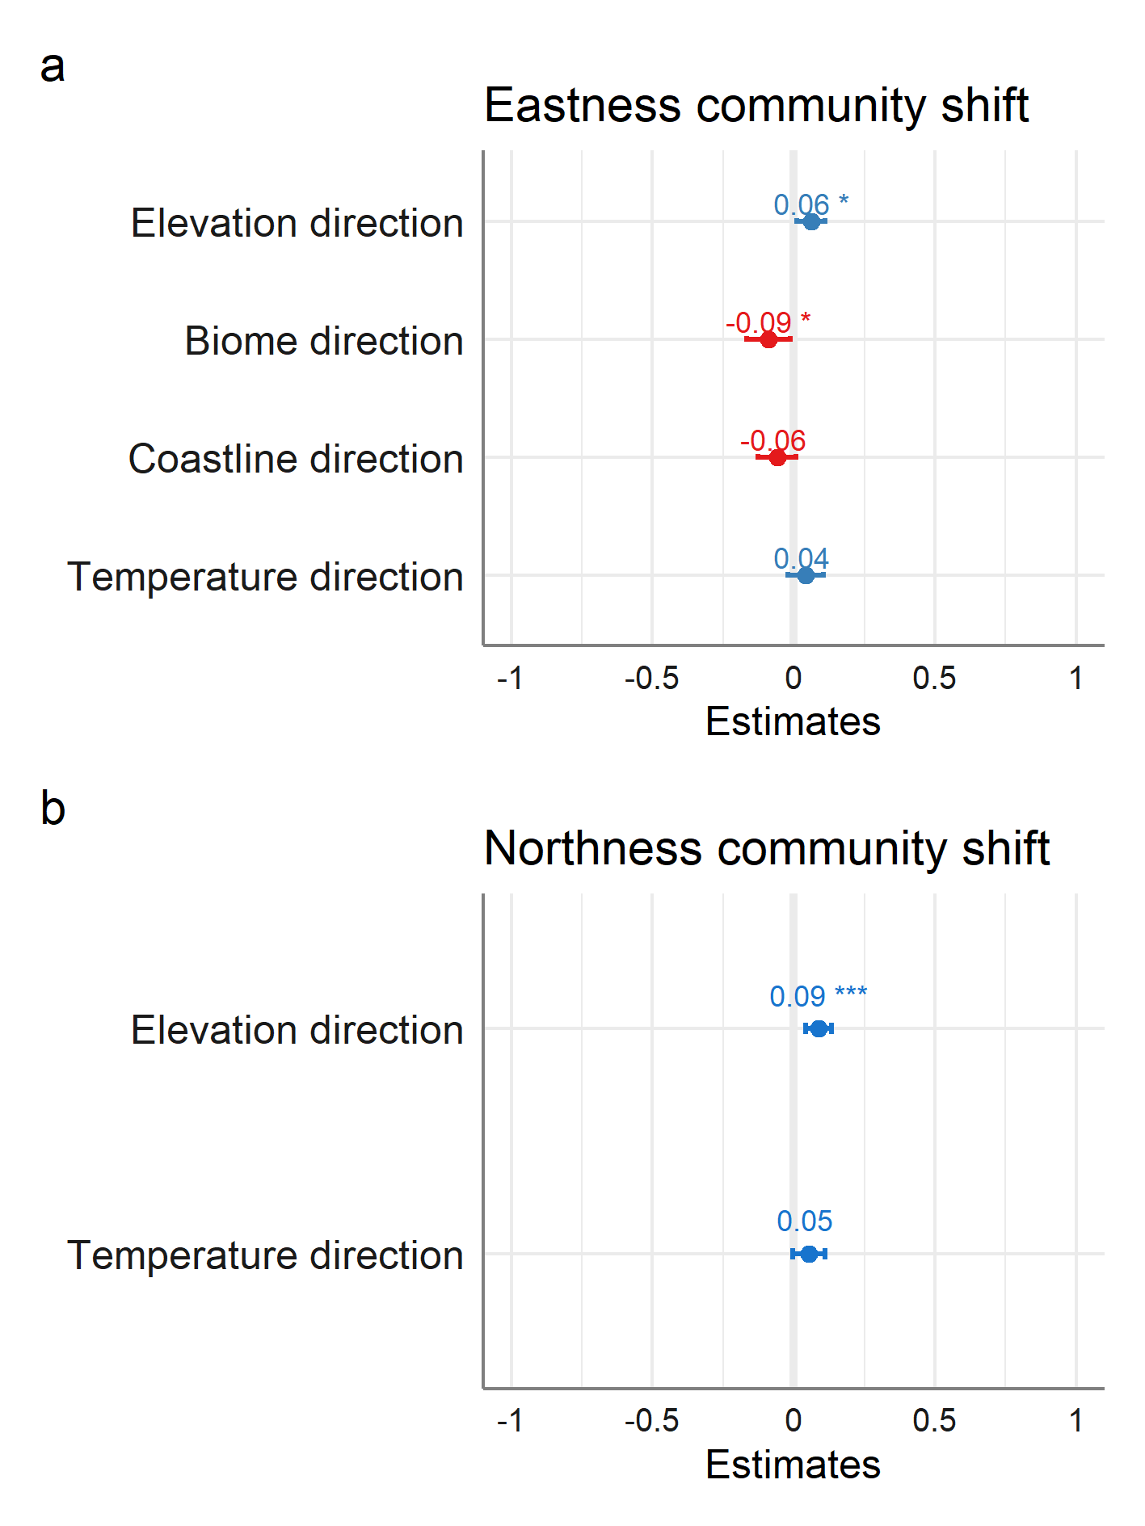
Figure S16. Effect sizes given as estimates ± SE (error bars) for the predictors in the full eastness (a) and northness (b) direction models. Significance levels are given by asterisks, positive effects shown in blue, negative in red. Overall, effect sizes of all predictors (even significant ones) were small, indicating that factors other than the ones measured here, also influence community shift directions.

S2.1.1 Accounting for spatial autocorrelation in model fitting
Shift distance. To account for spatial autocorrelation in the data, we added the X and Y coordinates in the ordinal models as covariates. This was done as clm() does not allow adding a spatial autocorrelation structure to the model. To confirm that we correctly corrected for a spatial structure in the data, we visually inspected the variogram of the model residuals. As clm() does not generate residuals, we constructed surrogate-based residuals (function ‘resids’ in the R package ‘sure’; ⁷). This R package is specially for constructing surrogate-based residuals and diagnostics for ordinal and general regression models and is based on the approach described in ⁸. The variogram was constructed by using the function ‘variog’ in the R package ‘geoR’ ⁹. Residual spatial autocorrelation was observed in the model without XY coordinates as covariate (Figure S17a) and no apparent spatial autocorrelation was observed in the final model (Figure S17b).
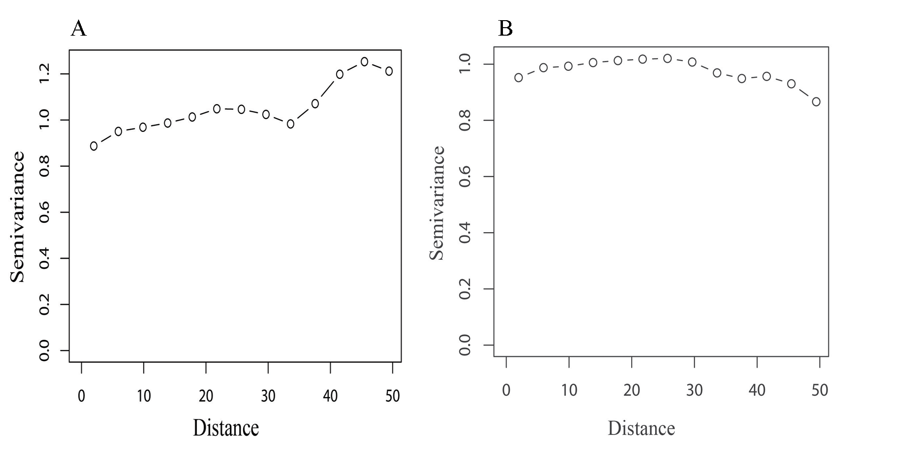
Figure S17. A) Surrogate residual spatial autocorrelation from the model without XY coordinates as covariates of the distance in community shifts. Plotted as semivariance against distance, with a visible change over distance. B) Surrogate residual spatial autocorrelation from the full model of the distance in community shifts. Plotted as semivariance against distance, with no apparent change over distance, except for a slight decrease towards larger distances.

Shift direction. To account for spatial autocorrelation in the data before fitting the models, we implemented Moran’s I test for distance-based autocorrelation (function ‘testSpatialAutocorrelation’ in the R package ‘DHARMa’, ¹⁰). Subsequently, we included a spatial correlation structure in the models (correlation function ‘corGaus’ in the R package ‘nlme’; ¹¹). We visually inspected variograms (function ‘Variogram’, R package ‘nlme’) of the residuals to check for remaining spatial autocorrelation of the final gls models, finding no strong residual spatial autocorrelation (Figures S18 and S19).
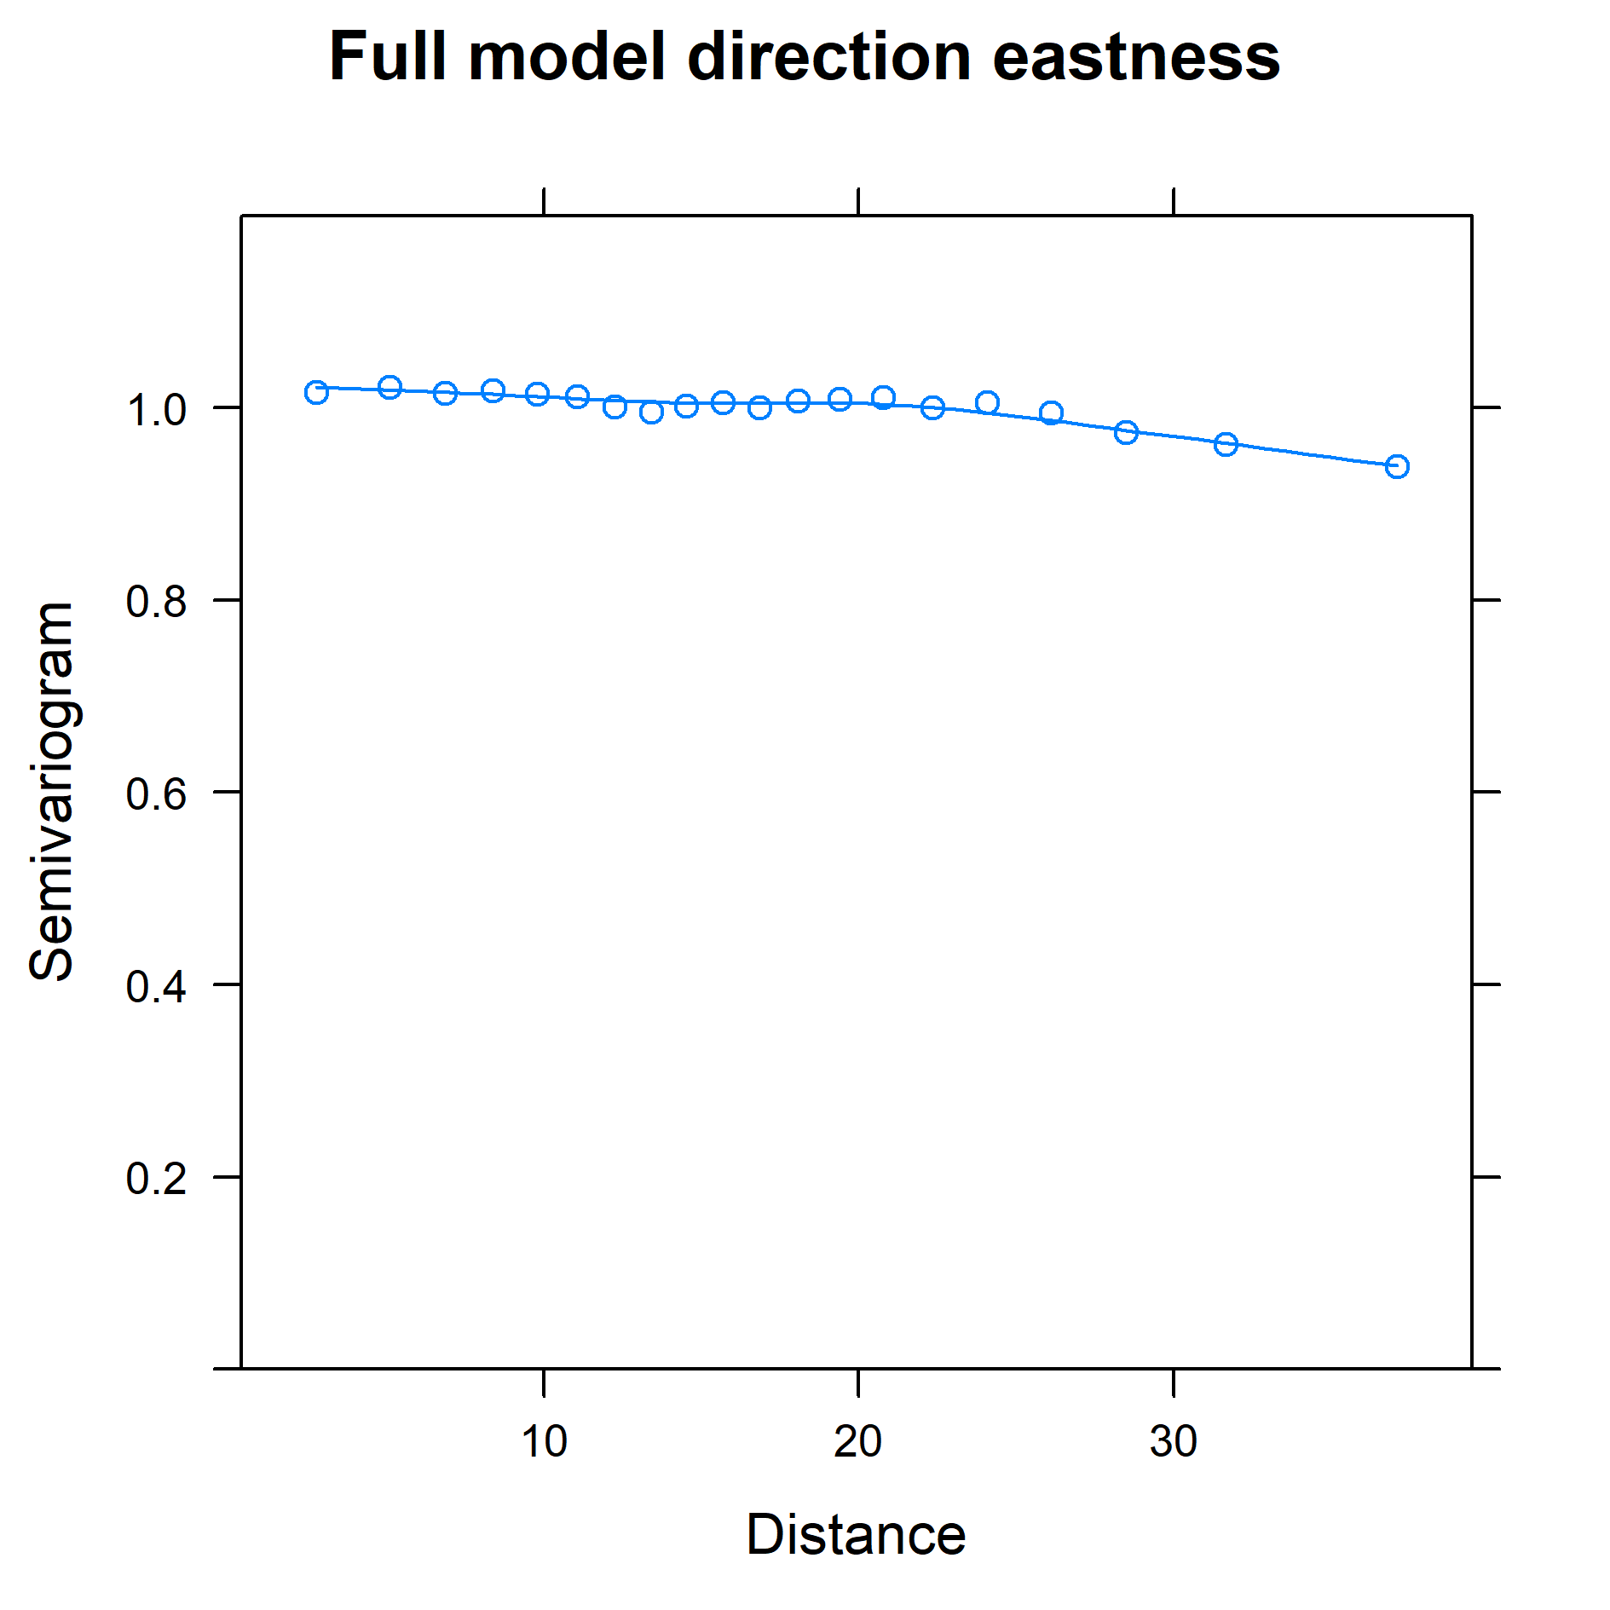
Figure S18. Residual spatial autocorrelation from the full model of community shift eastness. Plotted as a semivariogram against distance, with no apparent change over distance, except for a slight decrease towards larger distances. Plot call was based on the variogram function of the package ‘nmle’ with X and Y coordinates specified as ‘form’ and normalized residuals.
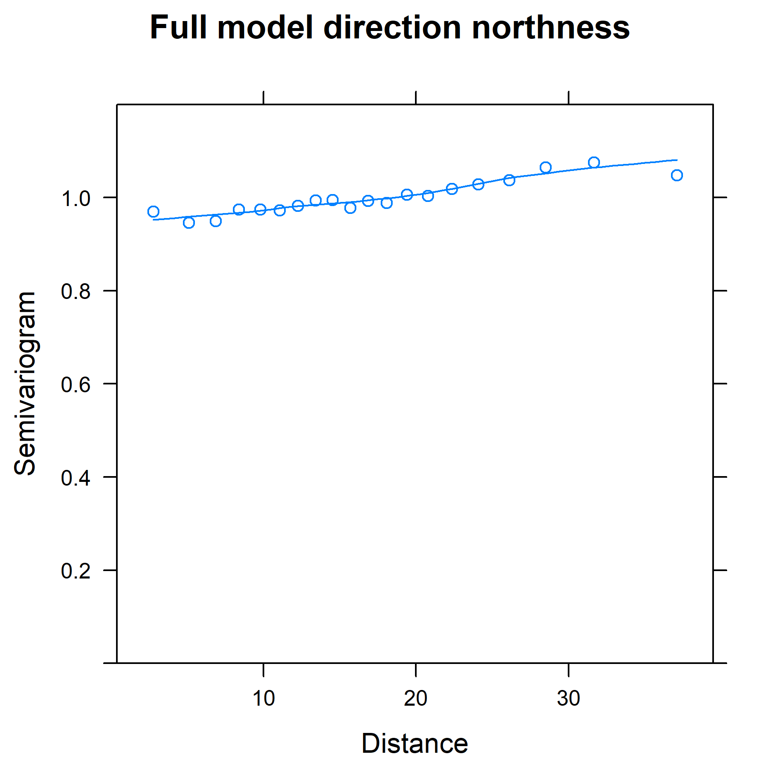
Figure S19. Residual spatial autocorrelation from the full model of community shift northness. Plotted as semivariogram against distance, with a slight increase towards larger distances. Plot call was based on the variogram function of the package ‘nmle’ with X and Y coordinates specified as ‘form’ and normalized residuals.

S2.2 Biome core area direction: effects on northness community shifts
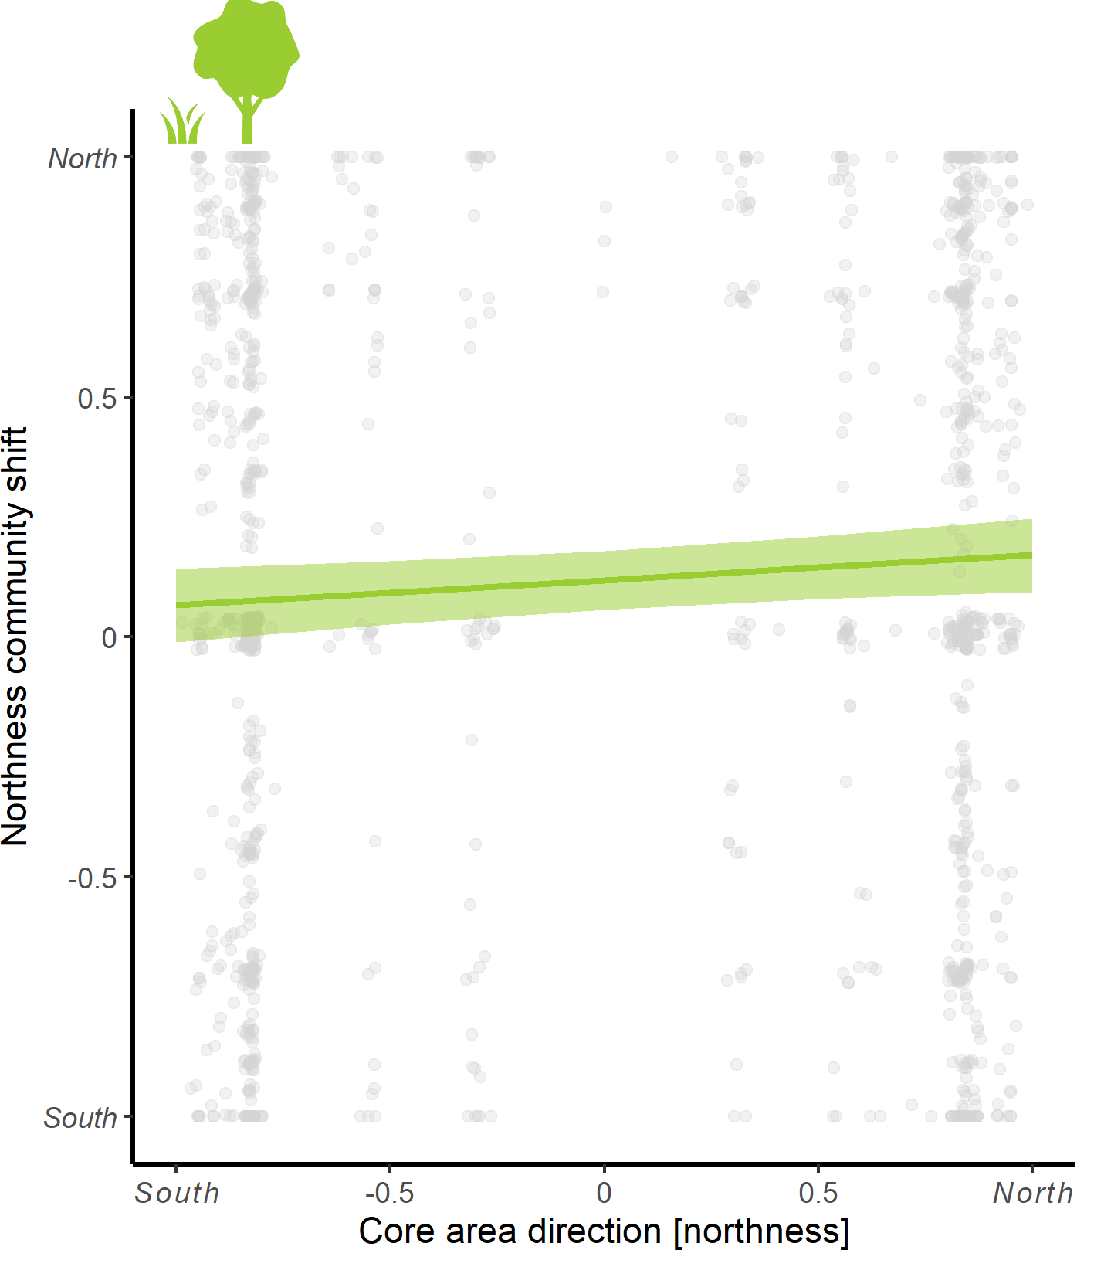
Figure S20. Significant positive relation of terrestrial biome core area distance (northness) to northness community shifts from single predictor modeling (model estimates in Table S2). The predictor is based on the change in terrestrial core area/edge values within biomes, measuring the direction into which a community can potentially shift the longest distance before encountering a change in said value. Thus, the illustrated positive relationship is in line with our hypothesis, i.e. the community shifts along the latitudinal axis seem to move into directions in which the core or edge value remain the same for the longest distance. This may indicate that communities located in core areas (within the biomes) in EBBA1 prefer to shift within such core areas, while edge communities in EBBA1 prefer to shift along edge zones (i.e. biome transition zones). No such effects were found for eastness shift directions.

Section S3 Sensitivity analyses
We conducted several sensitivity analyses to test how the data selection affected the results. First, we tested whether coastal communities shift differently than communities located in the inland. This is expected, since coastal communities likely consist of species adapted to coastal or marine ecosystems and would thus not shift away but shift along coastlines in order to remain in the same or similar habitat type.
Second, we tested how selection of species influenced the observed community shift ~ ecological barrier -relationships. We did this to disentangle how particular groups of species influenced the overall shifts of communities in relation to ecological barriers. For example, the coastal and marine species may shift along coastlines instead of moving away from them unlike other, more terrestrial species.
Then, we tested how the community shift directions and community shift direction ~ ecological barrier -relationships varied across biomes and latitudes. The latter analysis we conducted only for community shift directions as the interaction effects for ordinal classes of community shift distances would be difficult to interpret.
Finally, we tested whether the weights (community similarity value) affected the full model results, by running the same models for shift distance and direction (eastness and northness) without weights.

S3.1 Effect of bird community location: coastal vs inland communities
We did a sensitivity analysis to test whether coastal communities are more likely to stay in the coastal areas rather than shifting inland, i.e. away from coastlines. This was conducted by bootstrapping analyses where each coastal community was allowed to move randomly to available grids within 1.55 degree (c. 155 km radius, 3 grids to cardinal directions). After the simulated shift we collected information whether the shift happened to a coastal or inland grid. This was conducted for all 491 communities which were situated in coastal areas during the first atlas period and had moved maximum 155 kilometers (EBBA1). The simulation was repeated 10000 times. We then calculated the frequency distribution for coastal communities that shifted along coastal grids vs those shifting inland. These distributions were compared to observed changes between EBBA1 and EBBA2. The analyses were repeated using only grids where the communities had moved at least one grid (n=227).

The communities were more likely to stay in coastal areas in both analyses. Among all coastal communities during EBBA1 442 communities stayed in coastal grids in EBBA2, whereas in the simulated shifts on average only 341 did the same (99.9% confidence intervals, 310–370). Correspondingly, among all coastal communities, only 49 communities moved to inland grids whereas in the simulated shifts 150 communities moved to inland (99.9% confidence intervals, 121–180).
Among the communities which had moved at least one grid, 178 communities stayed in coastal grids whereas in the simulated shifts on average only 154 did the same (99.9% confidence intervals, 132–172; Fig. S21a). Among the communities which had moved at least one grid, only 49 communities moved to inland grids whereas in the simulated shifts 74 communities moved to inland (99.9% confidence intervals, 55–94; Fig. S21b).
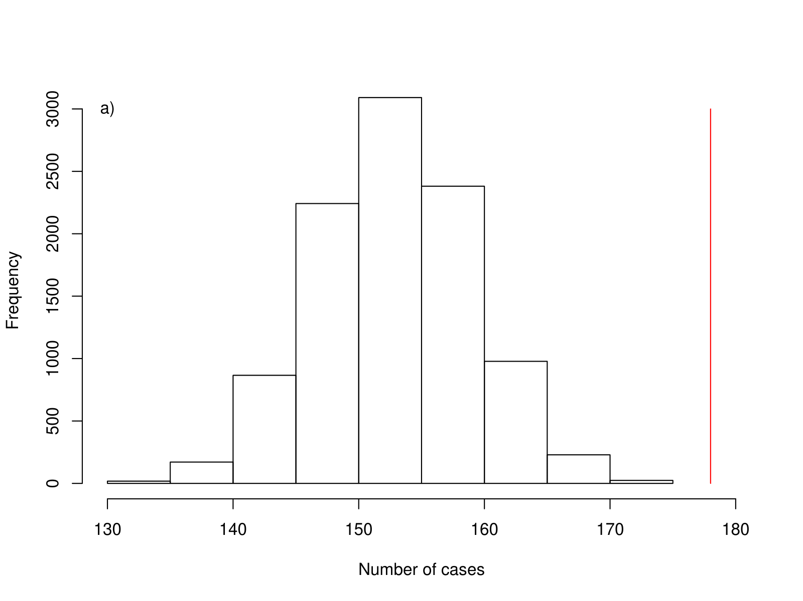
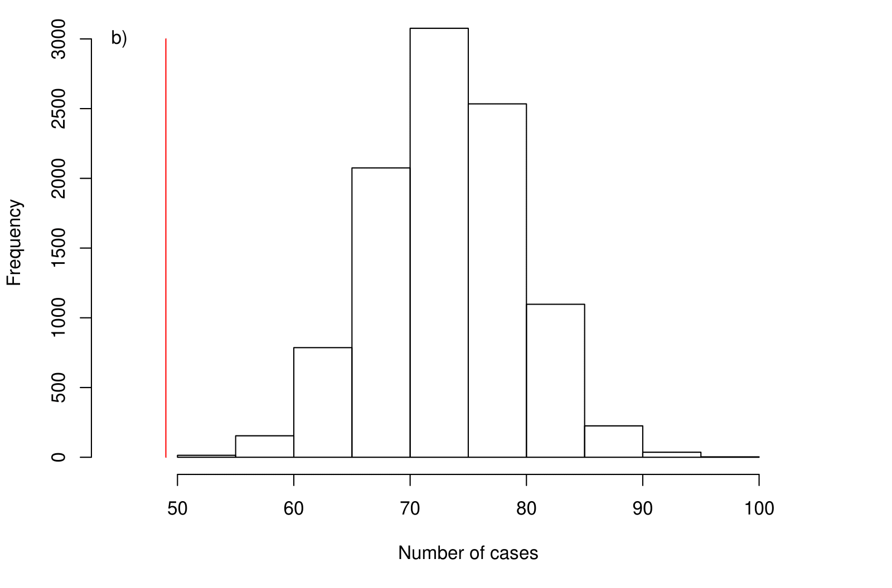
Figure S21. Distribution of amount cases where simulated random shift of coastal communities would have ended to a) another coastal grid and b) an inland grid. The red line shows the observed pattern between EBBA1 and EBBA2. N is 10000 simulations.

S3.2 Effect of species selection
We repeated the analyses on community shift for a subset of species data such that we excluded 1) coastal and marine species, 2) rare species, and 3) rare and non-native species. Below we compare the results of the full analyses and the analyses conducted with a subset of species. For the lists of marine, rare, and non-native species, see Appendix S2.
Community shift distance. In the case of marine species, we found that when marine species were excluded (subset), temperature (at 450 km buffer) influences community shifts more significantly than when marine species were included (full data). In the case of rare species, model outcomes did not differ between the full model and the model without rare species. In the case of rare and non-native species, when these groups of species are excluded (subset), temperature and coastline effects on community shifts were no longer significant. Therefore, the patterns of bird community shift distances are likely driven by non-native species (Table S4).
Table S4. Model outputs from sensitivity analyses with 1) marine species, 2) rare species, and 3) rare and non-native species excluded from the original dataset. Presented are the estimates (±SE), t- and p-values and odd ratios of final full models, where all variables with p-value < 0.1 from single-predictor models were combined.
Predictor | Estimate ± SE | t-value | p-value | Odd-ratio
1) Marine species excluded
Temperature distance 450 km | 0.099± 0.044 | 2.236 | 0.024 | 1.1050
Coastline distance | 0.143± 0.047 | 3.029 | 0.002 | 1.1539
Longitude | 0.018± 0.005 | 3.928 | <0.001 | 1.0181
Latitude | 0.011 ± 0.006 | 1.951 | 0.091 | 1.0118
2) Rare species excluded
Temperature distance 450 km | 0.089± 0.045 | 1.969 | 0.049 | 1.0930
Coastline distance | 0.015± 0.047 | 3.318 | <0.001 | 1.1700
Longitude | 0.017± 0.004 | 3.747 | <0.001 | 1.0174
Latitude | 0.018 ± 0.006 | 2.974 | 0.002 | 1.0183
3) Rare and nonnative species excluded
Temperature distance 450 km | 0.068± 0.044 | 1.535 | 0.124 | 1.0711
Coastline distance | 0.063± 0.047 | 1.348 | 0.177 | 1.0653
Longitude | 0.027± 0.004 | 5.982 | <0.001 | 1.0279
Latitude | 0.010 ± 0.006 | 1.659 | 0.097 | 1.0100

Community shift direction. In the case of marine species, we found that with marine species (full data) elevation seems to influence community shifts more significantly, while without marine species (subset) temperature was significantly related, and core area resistance at 300 km. Distance to coastline and biome edges were equally important in both datasets. For northness we detected no differences between the two datasets, so that in both elevation and temperature direction were (near-)significantly related to community shifts.
In the case of rare species (full data), coastline and biome directions influence eastness of community shifts, while without rare species (subset), coastline and biome directions are not significant predictors, but biome core area (within 300 km buffer) and temperature direction are. Elevation direction (within 150 km buffer) is a significant predictor in both full and subset data when describing community shift eastness. With rare species (full data), temperature direction influences northness of community shifts, while without rare species (subset), temperature direction is no longer a significant predictor. Elevation is a significant predictor in both full and subset data.
In the case of rare and non-native species (full data), coastline and elevation direction influence eastness of community shifts, while without rare and non-native species (subset), coastlines and elevation are no longer significant, but core area resistance and temp are. Biome direction are significant predictors in both full and subset data when describing community shift eastness. With rare and non-native species (full data), temperature influences northness of community shifts, while without rare and non-native species (subset), temperature is no longer significant. Elevation direction is a significant predictor in both full and subset data when describing community shift northness.
In summary, elevation direction has the most consistent effect on community shift directions across the full and the three subset data analyses (Table S5).

Table S5. Model outputs from sensitivity analyses where (1) marine species, (2) rare species, and (3) rare and nonnative species were excluded from the original dataset. Presented are beta estimates and standard errors (SE), t- and p-values of final full models, where all variables with p < 0.1 from single-predictor models were combined, separately for eastness and northness of community shift directions.
Term | Beta | SE | t-value | p-value
- Direction Eastness: marine species excluded
Intercept | 0.025 | 0.034 | 0.731 | 0.465
Elevation direction 150 km | 0.048 | 0.025 | 1.953 | 0.051
Temperature direction 150 km | 0.073 | 0.032 | 2.308 | 0.021
Coastline direction | -0.055 | 0.033 | -1.657 | 0.098
Biome direction | -0.079 | 0.038 | -2.051 | 0.040
Core area direction 300km | 0.068 | 0.034 | 2.008 | 0.045
- Direction Northness: marine species excluded
Intercept | 0.111 | 0.031 | 3.540 | <0.001
Elevation direction 150 km | 0.072 | 0.023 | 3.180 | 0.002
Temperature direction 150 km | 0.048 | 0.028 | 1.700 | 0.089
- Direction Eastness: rare species excluded
Intercept | 0.031 | 0.032 | 0.977 | 0.329
Elevation direction 150km | 0.043 | 0.024 | 1.770 | 0.077
Temperature direction 150km | 0.089 | 0.031 | 2.893 | 0.004
Core area direction 300km | 0.085 | 0.034 | 2.504 | 0.012
(2) Direction Northness: rare species excluded
Intercept | 0.135 | 0.029 | 4.711 | <0.001
Elevation direction 150km | 0.078 | 0.022 | 3.566 | <0.001
- Direction Eastness: rare and nonnative species excluded
Intercept | 0.032 | 0.032 | 1.005 | 0.315
Temperature direction 150km | 0.087 | 0.031 | 2.837 | 0.005
Biome direction | -0.086 | 0.037 | -2.288 | 0.022
Core area direction 300km | 0.077 | 0.034 | 2.274 | 0.023
(3) Direction Northness: rare and nonnative species excluded
Intercept | 0.134 | 0.028 | 4.768 | <0.001
Elevation direction 150km | 0.085 | 0.022 | 3.851 | <0.001

S3.3 Effect of biome type and latitude on community shift directions and responses to ecological barriers
We studied whether the community shift directions varied spatially, i.e. as a function of the biome type or the latitude. For across-biome variation, we used the same biome categories as described in section S1.2.1. For latitudinal variation, we divided the focal EBBA1 grid cells into three latitudinal classes based on the grid cell centroid coordinates: 35N-45N (category name “Mediterranean”), 45N-60N (“Temperate”), and 60N-70N (“Boreal”). For the biomes category “Temperate broadleaf forests” and of the latitudinal classes category “Boreal” were used as the reference categories in the analyses.
First, we explored the potential differences in community shift eastness and northness among six different biomes and found no significant differences, except for a marginal difference among temperate forests and temperate grasslands in shift northness (Table S6). Second, we explored the potential differences in community shift eastness and northness among the latitudinal categories and found no significant differences.
Then, we tested for interactive effects of ecological barriers and latitudinal categories. We found that some ecological barrier variables had varying effects on community shift direction depending on the latitude (Table S7, Figure S21).

Table S6. Model outputs of analyses for community shift direction differences among biomes and latitudinal categories. Significant and marginal effects (in bold) are reported separately for eastness and northness.
Predictor | Beta | SE | t-value | p-value
Eastness: shift eastness ~ latitudinal category
Intercept | 0.055 | 0.075 | 0.735 | 0.462
Mediterranean | -0.038 | 0.101 | -0.372 | 0.710
Temperate | -0.021 | 0.087 | -0.240 | 0.811
Northness: shift northness ~ latitudinal category
Intercept | 0.185 | 0.065 | 2.854 | 0.004
Mediterranean | -0.111 | 0.087 | -1.277 | 0.202
Temperate | -0.064 | 0.075 | -0.859 | 0.391
Eastness: shift eastness ~ biome category
Intercept | 0.039 | 0.045 | 0.863 | 0.388
Temperate Coniferous Forests | -0.154 | 0.103 | -1.494 | 0.136
Boreal forests | 0.011 | 0.087 | 0.121 | 0.903
Temperate grasslands | -0.032 | 0.140 | -0.229 | 0.819
Tundra | -0.025 | 0.126 | -0.200 | 0.841
Mediterranean Forests | 0.023 | 0.082 | 0.283 | 0.777
Northness: shift northness ~ biome category
Intercept | 0.112 | 0.039 | 2.908 | 0.004
Temperate Coniferous Forests | 0.002 | 0.093 | 0.026 | 0.979
Boreal forests | 0.071 | 0.076 | 0.940 | 0.347
Temperate grasslands | 0.227 | 0.125 | 1.822 | 0.069
Tundra | -0.012 | 0.111 | -0.110 | 0.913
Mediterranean Forests | -0.056 | 0.072 | -0.783 | 0.434

Table S7. Model outputs of analyses for community shift direction ~ ecological barrier -relationship differences among latitudinal categories. Significant and marginal effects (in bold) are reported separately for eastness and northness.
Predictor | Beta | SE | t-value | p-value
Eastness: shift eastness ~ temperature direction 300 * latitudinal category
Intercept | 0.065 | 0.074 | 0.872 | 0.383
Mediterranean | -0.049 | 0.100 | -0.495 | 0.621
Temperate | -0.029 | 0.087 | -0.335 | 0.738
Temperature direction 300 | 0.166 | 0.089 | 1.857 | 0.063
Mediterranean:Temperature 300 | -0.073 | 0.107 | -0.679 | 0.497
Temperate:Temperature 300 | -0.179 | 0.100 | -1.793 | 0.073
Eastness: shift eastness ~ coast direction* latitudinal category (Fig. S20)
Intercept | 0.035 | 0.073 | 0.481 | 0.631
Mediterranean | -0.013 | 0.098 | -0.136 | 0.892
Temperate | 0.004 | 0.085 | 0.046 | 0.963
Coast direction | -0.211 | 0.076 | -2.789 | 0.005
Mediterranean:Coast direction | 0.086 | 0.101 | 0.847 | 0.397
Temperate:Coast direction | 0.250 | 0.092 | 2.735 | 0.006
Eastness: shift eastness ~ biome direction* latitudinal category
Intercept | 0.044 | 0.075 | 0.587 | 0.558
Mediterranean | -0.026 | 0.101 | -0.254 | 0.799
Temperate | -0.005 | 0.087 | -0.055 | 0.956
Biome direction | -0.204 | 0.081 | -2.516 | 0.012
Mediterranean:Biome direction | 0.205 | 0.120 | 1.699 | 0.089
Temperate:Biome direction | 0.171 | 0.100 | 1.723 | 0.085
Northness: shift northness ~ elevation direction 300 * latitudinal category
Intercept | 0.185 | 0.065 | 2.856 | 0.004
Mediterranean | -0.112 | 0.087 | -1.286 | 0.199
Temperate | -0.065 | 0.075 | -0.869 | 0.385
Elevation direction 300 | -0.006 | 0.055 | -0.103 | 0.918
Mediterranean:Elevation direction 300 | 0.136 | 0.075 | 1.798 | 0.072
Temperate:Elevation direction 300 | 0.021 | 0.065 | 0.333 | 0.740
Northness: shift northness ~ temperature direction 450 * latitudinal category
Intercept | 0.161 | 0.068 | 2.371 | 0.018
Mediterranean | -0.066 | 0.091 | -0.718 | 0.473
Temperate | -0.061 | 0.079 | -0.768 | 0.443
Temperature direction 450 | 0.077 | 0.066 | 1.177 | 0.239
Mediterranean:temperature direction 450 | -0.155 | 0.09 | -1.729 | 0.084
Temperate:temperature direction 450 | -0.017 | 0.076 | -0.22 | 0.826

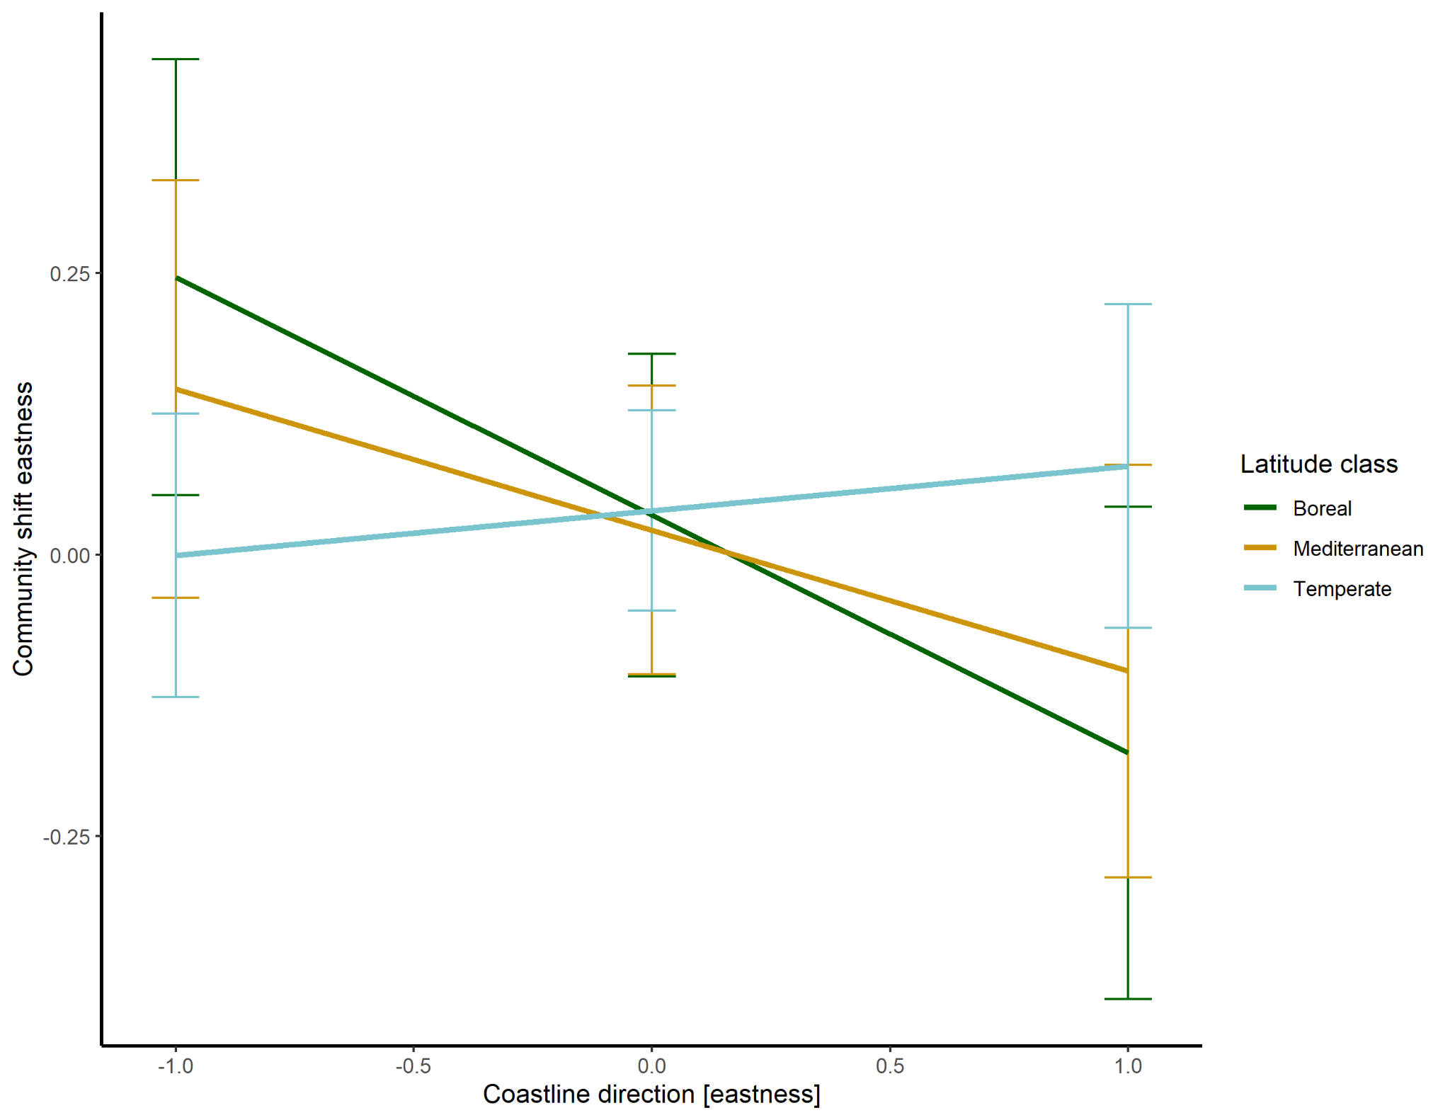
Figure S22. Coastline direction effects on community shift eastness as a function of the latitude represented as three categories (based on the significant interaction between latitude class and coastline distance). The temperate category is significantly different from the boreal and Mediterranean categories, such that the eastward shift due to the coastline barrier is mainly driven by the boreal and Mediterranean communities.

S3.4 Effect of model weights
Community shift distance. Inclusion of model weights did not substantially influence the strength nor direction of predictor effects on community shift distances (Table S8).
Table S8. Model estimates ± standard error (SE), t- and p-values from full models for community shift direction (eastness and northness separately) with model weights excluded. Effects with p < 0.1 are shown in bold.
Predictor | Estimate ± SE | t-value | p-value | Odd-ratio
Model weights excluded
Temperature distance 450 km | 0.082 ± 0.040 | 2.027 | 0.042 | 1.085
Coastline distance | 0.156 ± 0.042 | 3.699 | <0.001 | 1.170
Longitude | 0.017± 0.004 | 4.314 | <0.001 | 1.017
Latitude | 0.016 ± 0.005 | 3.076 | 0.002 | 1.016

Community shift direction. Inclusion of model weights did not substantially influence the predictor effect, neither in their effect size nor the direction (positive or negative) of the relationship (Table S9). Effects were generally slightly less pronounced when including model weights.
Table S9. Model estimates ± standard error (SE), t- and p-values from full models for community shift direction (eastness and northness separately) with model weights excluded. Effects with p < 0.1 are shown in bold.
Term | Beta | SE | t-value | p-value
Direction Eastness: model weights excluded
Intercept | 0.013 | 0.034 | 0.395 | 0.693
Elevation direction 150 km | 0.064 | 0.025 | 2.545 | 0.011
Coastline direction | -0.062 | 0.035 | -1.757 | 0.079
Biome direction | -0.095 | 0.039 | -2.399 | 0.017
Temperature direction 150 km | 0.048 | 0.032 | 1.500 | 0.134
Direction Northness: model weights excluded
Intercept) | 0.100 | 0.033 | 3.075 | 0.002
Elevation direction 150 km | 0.088 | 0.024 | 3.739 | <0.001
Temperature direction 150 km | 0.053 | 0.029 | 1.834 | 0.067

Section S4 Supplementary references
1. Jaccard, P. The distribution of the flora in the alpine zone. 1. New Phytol. 11, 37–50 (1912).
2. Hagemeijer, E. J. M. & Blair, M. J. The EBCC Atlas of European Breeding Birds: Their Distribution and Abundance. (T & A D Poyser, 1997).
3. Keller, V. et al. European Breeding Bird Atlas 2: Distribution, Abundance and Change. (European Breeding Bird Council & Lynx Edition, 2020).
4. Hesselbarth, M. H. K., Sciaini, M., With, K. A., Wiegand, K. & Nowosad, J. landscapemetrics: an open-source R tool to calculate landscape metrics. Ecography (Cop.). 42, 1648–1657 (2019).
5. Hijmans, R. J. geosphere: Spherical Trigonometry. (2019).
6. Hijmans, R. J. raster: Geographic Data Analysis and Modeling. (2020).
7. Greenwell, B. M., McCarthy, A. J., Boehmke, B. C. & Liu, D. Residuals and diagnostics for binary and ordinal regression models: an introduction to the sure package. R J. 10, 381 (2018).
8. Liu, D. & Zhang, H. Residuals and diagnostics for ordinal regression models: a surrogate approach. J. Am. Stat. Assoc. 113, 845–854 (2018).
9. Ripley, B. D., Ribeiro, P. J. & Diggle, P. J. geoR: A Package for Geostatistical Analysis. (2001).
10. Hartig, F. DHARMa: Residual Diagnostics for Hierarchical (Multi-Level / Mixed) Regression Models. (2021).
11. Pinheiro, J., Bates, D., DebRoy, S., Sarkar, D. & Team, R. C. nlme: Linear and Nonlinear Mixed Effects Model. (2020).

