Extended Data (online only display items)
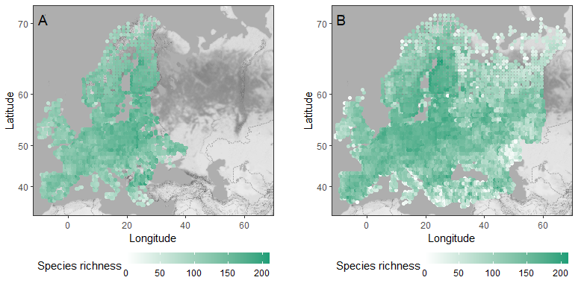
Extended Data Fig. 1 Breeding bird species richness and the data coverage of the European Breeding Bird Atlases. Panel A shows the species richness during the first atlas (EBBA1: 1985-1988; ²) and panel B the species richness during the second atlas (EBBA2: 2013-2017; ³). Each colored dot represents the number of species in one 50 x 50 kilometer grid cell in which all breeding birds were recorded during the study period years. Dashed lines indicate country borders.

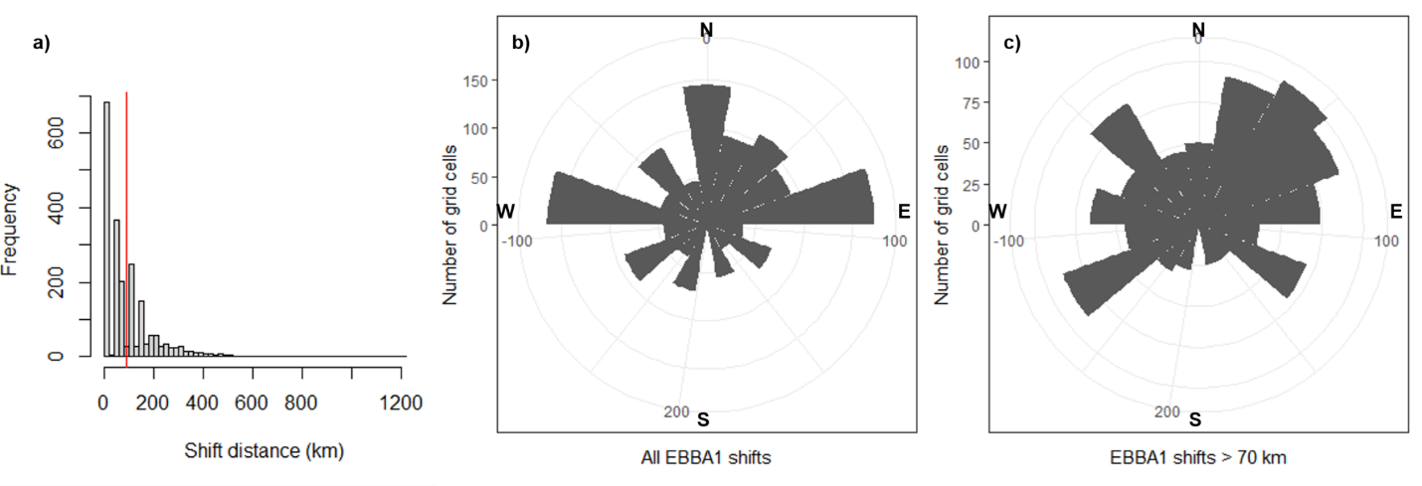
Extended Data Fig. 2 Variation in community composition shift distance and direction. In panel a, the red vertical line indicates the mean distance among those grid cells that had non-zero shifts. In panels b and c, compass directions are indicated on the circular plots. Panel b illustrates the shift directions of all EBBA1 grid cells that shifted, while panel c illustrates the shift directions of those EBBA1 grid cells that shifted more than one grid cell (~70 km).

Extended Data Table 1 Model output summaries from single-predictor models for shift distance and direction (eastness and northness). Asterisks (*) in the last column indicate those variables included in the full models. Effects with p < 0.1 are shown in bold. The predictor coefficients of the distance models are odd ratios. The significant additional effect of biome core area direction (northness) on community shift northness are shown in Appendix S1, Fig. S20.
Barrier type | Model | Predictor coefficient | Predictor SE | Predictor p-value | Model AIC | Follows hypothesis
Shift distance
Biome | Shift distance ~ biome distance | -0.021 | 0.045 | 0.640 | 5699.24 | No
Biome | Shift distance ~ biome core area distance 150 km | -0.022 | 0.045 | 0.625 | 5699.22 | No
Biome | Shift distance ~ biome core area distance 300 km | 0.037 | 0.046 | 0.411 | 5698.78 | Yes
Coastline | Shift distance ~ coastline distance | 0.158 | 0.047 | 0.000 | 5688.31 | Yes*
Elevation | Shift distance ~ elevation distance 150 km | 0.014 | 0.044 | 0.755 | 5699.36 | Yes
Elevation | Shift distance ~ elevation distance 300 km | 0.031 | 0.043 | 0.710 | 5698.95 | Yes
Temperature change | Shift distance ~ temperature distance 300 km | 0.045 | 0.045 | 0.332 | 5698.48 | Yes
Temperature change | Shift distance ~ temperature distance 450 km | 0.090 | 0.045 | 0.046 | 5695.45 | Yes*
Shift direction
Biome | Shift direction eastness ~ biome direction eastness | -0.090 | 0.039 | 0.023 | 2954.65 | Yes*
Biome | Shift direction eastness ~ biome core area eastness 150 km | 0.017 | 0.034 | 0.621 | 2959.59 | Yes
Biome | Shift direction eastness ~ biome core area eastness 300 km | 0.052 | 0.035 | 0.137 | 2957.64 | Yes
Biome | Shift direction northness ~ biome direction northness | -0.028 | 0.028 | 0.318 | 2714.33 | Yes
Biome | Shift direction northness ~ biome core area northness 150 km | 0.052 | 0.024 | 0.027 | 2710.40 | Yes
Biome | Shift direction northness ~ biome core area northness 300 km | -0.018 | 0.024 | 0.450 | 2714.75 | No
Coastline | Shift direction eastness ~ coastline direction eastness | -0.057 | 0.035 | 0.099 | 2957.18 | Yes*
Coastline | Shift direction northness ~ coastline direction northness | -0.038 | 0.030 | 0.195 | 2713.68 | Yes
Elevation | Shift direction eastness ~ elevation direction eastness 150 km | 0.068 | 0.025 | 0.007 | 2952.46 | Yes*
Elevation | Shift direction eastness ~ elevation direction eastness 300 km | 0.018 | 0.026 | 0.493 | 2959.37 | Yes
Elevation | Shift direction northness ~ elevation direction northness 150 km | 0.090 | 0.024 | <0.001 | 2700.71 | Yes*
Elevation | Shift direction northness ~ elevation direction northness 300 km | 0.047 | 0.024 | 0.056 | 2711.68 | Yes
Temperature change | Shift direction eastness ~ temperature direction eastness 150 km | 0.054 | 0.032 | 0.091 | 2957.01 | Yes*
Temperature change | Shift direction eastness ~ temperature direction eastness 300 km | 0.045 | 0.031 | 0.153 | 2957.82 | Yes
Temperature change | Shift direction eastness ~ temperature direction eastness 450 km | 0.040 | 0.030 | 0.182 | 2958.06 | Yes
Temperature change | Shift direction northness ~ temperature direction northness 150 km | 0.058 | 0.029 | 0.045 | 2711.34 | Yes*
Temperature change | Shift direction northness ~ temperature direction northness 300 km | 0.055 | 0.028 | 0.051 | 2711.50 | Yes
Temperature change | Shift direction northness ~ temperature direction northness 450 km | 0.034 | 0.028 | 0.232 | 2713.90 | Yes

Extended Data Table 2 Full model outputs for community composition shift distance. estimates ± standard error (SE), t- and p-values and odd ratios from the full model for the distance of the community shift. Effects with p < 0.1 are shown in bold.
Predictor | Estimate ± SE | t-value | p-value | Odd ratio
Temperature distance 450 km | 0.089 ± 0.045 | 1.969 | 0.049 | 1.092
Coastline distance | 0.157 ± 0.047 | 3.318 | <0.001 | 1.170
Longitude | 0.017± 0.005 | 3.747 | <0.001 | 1.017
Latitude | 0.018 ± 0.006 | 2.974 | 0.003 | 1.018

Extended Data Table 3 Full model outputs for community composition shift directions. Model estimates ± standard error (SE), t- and p-values from full models for community shift direction (eastness and northness separately). Effects with p < 0.1 are shown in bold.
Predictor | Estimate ± SE | t-value | p-value
Eastness
Intercept | 0.008 ± 0.033 | 0.251 | 0.802
Elevation direction 150 km | 0.061 ± 0.025 | 2.434 | 0.015
Coastline direction | -0.059 ± 0.035 | -1.690 | 0.091
Biome direction | -0.090 ± 0.039 | -2.287 | 0.022
Temperature direction 150 km | 0.044 ± 0.032 | 1.360 | 0.174
Northness
Intercept | 0.097 ± 0.032 | 3.016 | 0.003
Elevation direction 150 km | 0.089 ± 0.024 | 3.757 | <0.001
Temperature direction 150 km | 0.054 ± 0.029 | 1.862 | 0.063

