Supplementary information for:
Nano-scale mechanism of crack nucleation/propagation and lithium penetration in solid electrolyte

Megan Diaz,¹ Qingsong Howard Tu,² and Akihiro Kushima^{1,3*}

¹ Department of Materials Science and Engineering, University of Central Florida, Orlando, FL 32816
² Department of Mechanical Engineering, Rochester Institute of Technology, Rochester, NY 14623
³ Advanced Materials Processing and Analysis Center, and NanoScience Technology Center, University of Central Florida, Orlando, FL 32816

Lithium dendrite growth on flat surface of Li₆PS₅Cl (LPS)
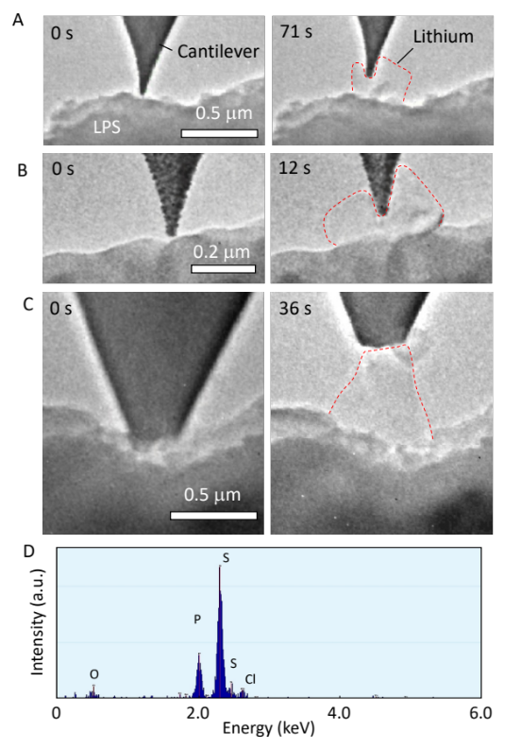
Figure S1. Three experiments measuring the maximum forces of dendrites grown through LPS. (A) Maximum force was 46 nN. (B) Maximum force was 87 nN. (C) Maximum force was 219 nN. (D) Energy dispersion X-ray (EDS) spectrum of the LPS.

Lithium dendrites were grown on the flat defect-free areas on the LPS surface, as seen in Figure S1. The maximum growth forces observed were 46, 87, and 219 nN. During the growth of the three dendrites, no visible structure change in the LPS solid state electrolyte (SSE) surface was observed (see also Supplementary Movies S3-5). During the growth of these dendrites, the cantilever was imparting force onto the lithium, and in turn the lithium was imparting that force to the LPS substrate. Assuming circular cross-sections for the contacts, stresses at the cantilever tip contacting lithium were estimated to be 7.3, 9.6, and 6.2 MPa for each dendrite, and the corresponding stresses at the LPS surface through the dendrites were 0.52, 0.93, and 0.78 MPa. Here, the LPS surface did not noticeably change throughout the tests, indicating that the electron beam does not damage the LPS under these conditions. Therefore, all experiments discussed in this paper were performed using a similar beam current.
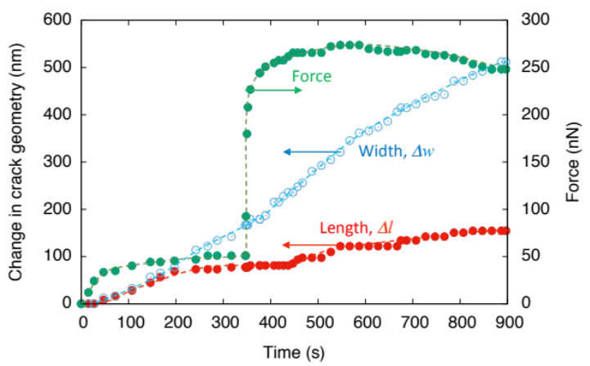
Figure S2. Force evolution and change in the geometries of the crack under Li plating.

Quantification of the crack growth force in LPS
Figure S2 shows the force evolution and the change in the crack geometry during the lithium plating on the LPS surface. The first part (0 – 348 s) measures the force necessary to initiate crack propagation. In the second part (348 – 352 s), additional force was imposed to the crack wall by pushing the LPS particle against the cantilever tip. This was to accelerate the crack growth. Finally, the third part (377 s – End) investigated the effect of plating and stripping on the strength of the LPS SSE. The detailed explanations of the first and the third parts are provided in the main text.
In the second part (348-352s), rapid compression was induced on the crack surface by intentionally pushing the LPS SSE surface towards the cantilever using the piezomanipulator of the TEM holder. During this rapid compression, there was no obvious change in the crack geometry as well as the lithium as evidenced by the lithium size remaining constant. After the compression, the residual motion of the piezomanipulator was relaxed before applying a negative potential to continue the lithium plating. At this time, a small change in the crack width and length was observed due to the increased force imposed by the drifted manipulator.
During the compression, positive potential was applied on the cantilever to prevent further lithium plating because electrons supplied from the beam interact with the SSE and promote lithium plating. In another experiment using the same beam condition, we found that a potential greater than +5V is required to strip lithium, thus overcoming the electron current supplied from the beam. The effect of this beam interaction on the plating/stripping of lithium was determined. Figure S4 shows the effect of biasing and the beam on the lithium dendrite plating/stripping behavior (see also Movie S6). The shrinking of the lithium dendrite was used to determine the required bias potential to induce lithium stripping. Starting with a pre-grown dendrite, a positive (+5V) potential was applied to the dendrite via the conductive cantilever. As seen in Fig. S4(A,B), the dendrite shrank, a sign of lithium stripping. The outlines in images B, D, and F are superimposed onto images A, C and E, respectively, to clearly show stripping, plating, and minor stripping, respectively, of the dendrites. After 169 seconds, the potential was then changed to 0V to observe the effect of the electron beam on the dendrite. The dendrite grew rapidly, as seen in Fig. S4(C, D). To verify that a high-enough positive potential was able to strip lithium again, the positive potential +5V was reapplied. Figure S4(E, F) clearly shows the shrinking of the lithium dendrite.
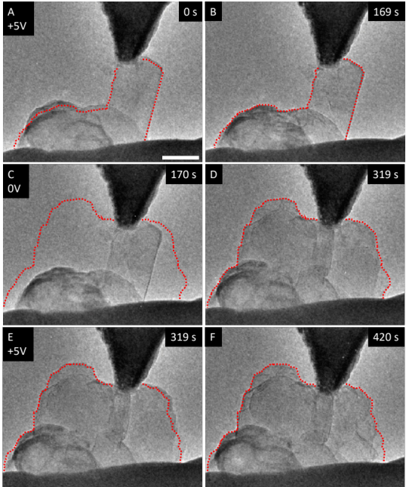
Figure S4. Effect of biasing and electron beam on the plating and shrinking behavior of lithium.

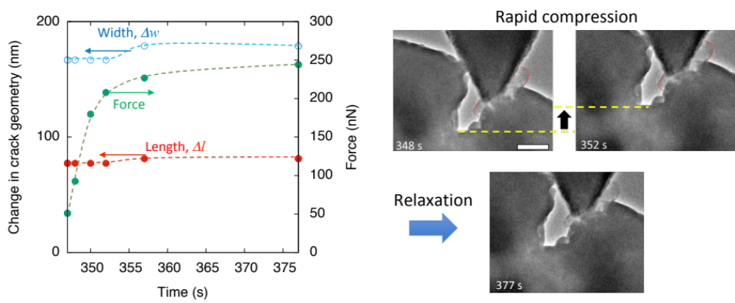
Figure S3. Force evolution and change in the geometries of the crack when external force was applied to the crack wall.

Figure S5 summarizes the change in the crack size under (A) compression (with no lithium plating/stripping = stoichiometric LPS), (B) lithium plating, and (C) stripping. The magnified images of the crack tip are shown in the left panels of each process. In (A), there is no obvious change in the geometries of the crack and lithium. In (B), the thickness of the lithium increases under the plating potential, thereby increasing the force. This resulted in the large increase in the crack length and width. The TEM images of the crack tip clearly show that the fresh surface was exposed as a result of the crack growth. In (C), a positive potential (+5V) was applied to the cantilever to strip the plated lithium. This can be clearly seen with the decreased thickness of the lithium. During this time frame, the force decreased as seen in Fig. S2. However, the crack length and width continued to increase as seen in the TEM micrographs of the crack tip in Fig. S5C.
Crack growth was observed in both plating and stripping, but the changes were minimum when there was no change in the lithium, which indicates that a flow of lithium and resulting change in the concentration may affect the mechanical strength of the LPS. This hypothesis was explored via atomistic simulation.
Figure S5. Effect of force, biasing, and lithium plating on crack growth.

DFT Simulation of the LPS under tension
Atomic structures of the LPS under tension for stoichiometric, lithium deficient (-4%), and lithium excess (+4%) are shown in Figures S6, S7, and S8, respectively. The change in the length of the selected bonds is shown in Fig. S9. For the stoichiometric structure, the bond stretched uniformly under tension throughout the structure, as seen in rows two and three of Figure S6. After the maximum stress was reached at 35% strain, the length of bond B increased rapidly and bonds A and C shrunk, indicating that bond B was broken. Since the lithium atom is no longer bonded to the sulfur atom with bond B, it relaxed towards the sulfur atoms on the opposite side connected by bonds A and C, as evidenced by their decrease in the bond length. This breaking of the bond took place uniformly in the unit cell showing the highest strength of the three models.
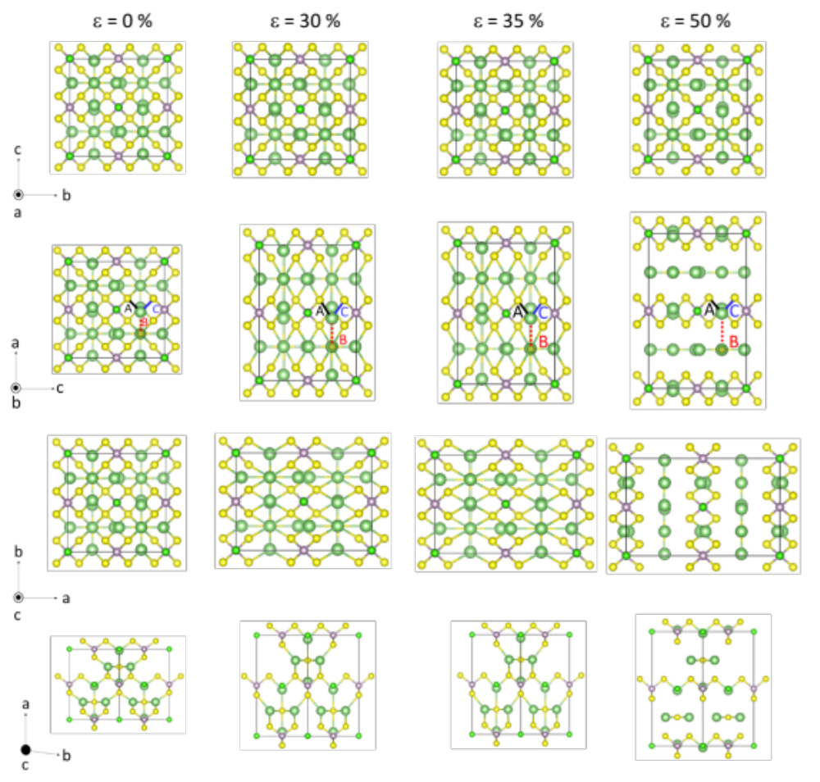
Figure S6. Atomic structure of the stochiometric LPS under tension seen from multiple orientations. Lines A-C track changing lengths between a selected Li atom and its surrounding atoms as the structure is strained.

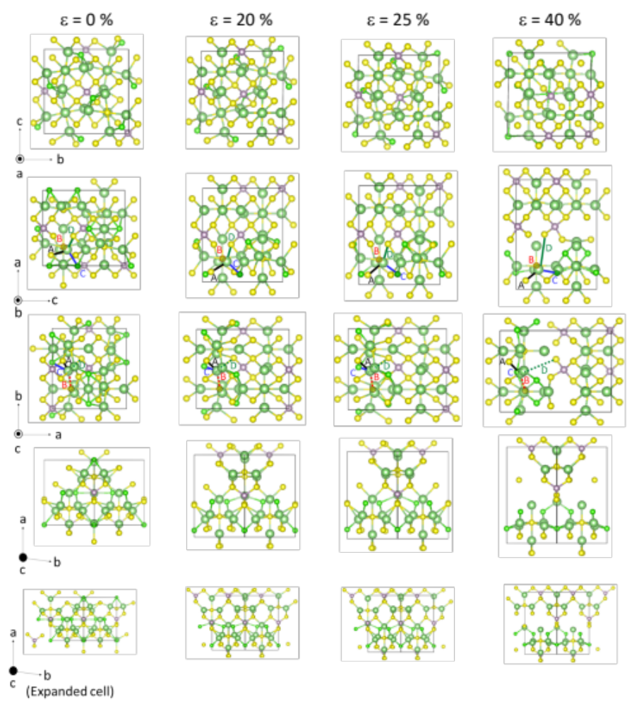
Figure S7. Atomic structure of the LPS with -4% Li under tension seen from multiple orientations. Lines A-D track changing lengths between a selected Li atom and its surrounding atoms as the structure is strained. Bonds are labeled in both the second and third rows to visualize the bonds hidden behind some atoms when seen from certain orientations.

However, in the lithium deficient and lithium excess cases, the strain is localized, with non-uniform bonds stretching/shrinking, as shown in the plots in Figure S9. This caused a drastic increase in some bond lengths (bond D for lithium deficient and B for lithium excess model) at lower strain compared to the stoichiometric structure. This led to the formation of large voids as seen in the last columns of Figures S7 and S8.
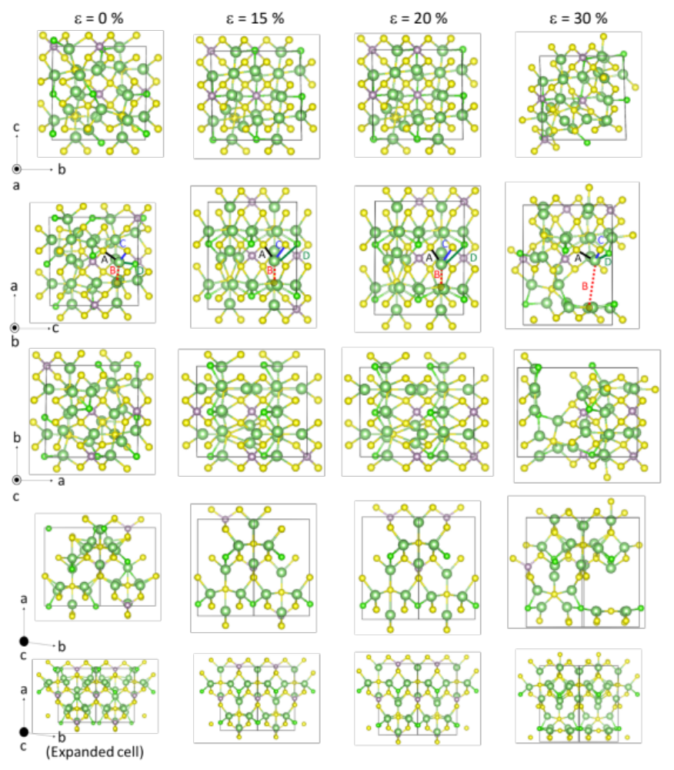
Figure S8. Atomic structure of the LPS with +4% Li under tension seen from multiple orientations. Lines A-D track changing lengths between a selected Li atom and its surrounding atoms as the structure is strained.

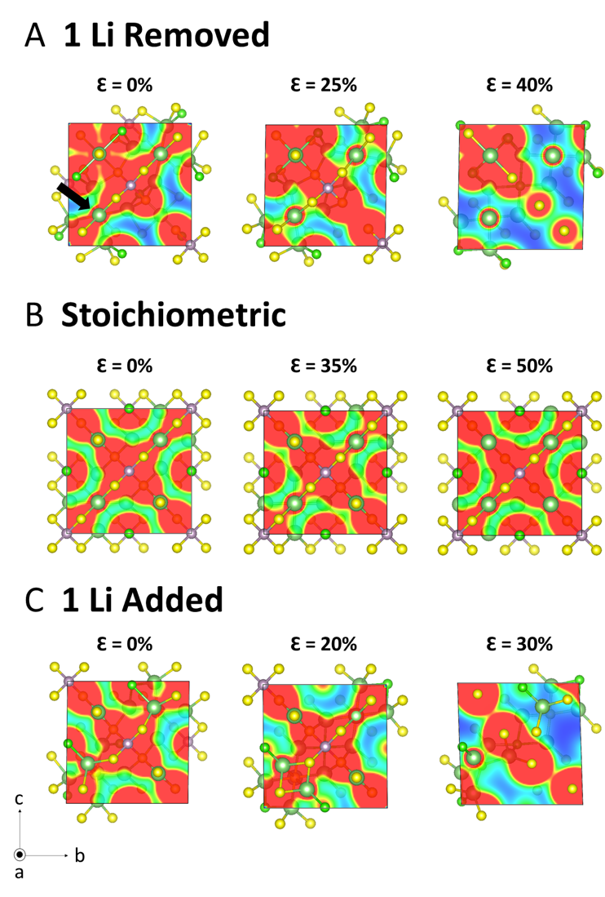
Figure S10. Electron charge distribution on the [100] plane at the location of the Li atom specified in image (A) at Ɛ=0%. (A) -4% Li, (B) stoichiometric, and (C) +4% Li structures at the zero strain (left column), the maximum stress (middle column), and after the stress drop (right column). The results show both addition and removal of Li to the stoichiometry causes the disorder in both electronic and atomic structures leading to the formation of voids and lowered mechanical strength.
x
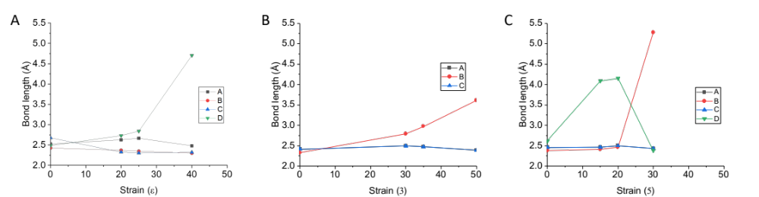
Figure S9. Change in the length of the selected bonds under tension for the three structures shown in (A) Figures S6, (B) S7, and (C) S8.

