Supplementary Materials for
Machine learning-based prediction of survival prognosis in cervical cancer
Dongyan Ding^{1,2#}, Tingyuan Lang^{1,2,3#*} ,Dongling Zou² ,Jiawei Tan⁴ ,Jia Chen⁴ ,Lei Zhou^{5,6,7} ,Dong Wang² ,Rong Li² ,Yunzhe Li^{1,2} ,Jingshu Liu^{1,2} ,Cui Ma⁸ ,Qi Zhou^{1,2,3*}
¹Key Laboratory of Biorheological Science and Technology (Chongqing University), Ministry of Education, Bioengineering College, Chongqing University, Chongqing, 400044, People's Republic of China; ²Department of Gynecologic Oncology, Chongqing University Cancer Hospital, School of Medicine, Chongqing University, Chongqing, 400030, People's Republic of China; ³Chongqing Key Laboratory of Translational Research for Cancer Metastasis and Individualized Treatment, Chongqing University Cancer Hospital, School of Medicine, Chongqing University, Chongqing, 400030, People's Republic of China; ⁴School of Mathematics and Statistics, Changchun University of Technology, Changchun, 130012, People's Republic of China; ⁵Singapore Eye Research Institute, The academia, 20 College Road, Discovery Tower Level 6, Singapore, 169856, Singapore; ⁶Department of Ophthalmology, Yong Loo Lin School of Medicine, National University of Singapore, Singapore; ⁷Ophthalmology and Visual Sciences Academic Clinical Research Program, Duke-NUS Medical School, National University of Singapore, Singapore; ⁸Department of Pediatric Hematology, First hospital of Jilin University, Changchun 130023, Jilin, People's Republic of China.
# Dongyan Ding and Tingyuan Lang contributed equally to this work.
*Correspondence: Qi Zhou, Department of Gynecologic Oncology, Chongqing University Cancer Hospital, School of Medicine, Chongqing University, Chongqing, 400030, People's Republic of China, (cqzl_zq@163.com) and Tingyuan Lang, Department of Gynecologic Oncology, Chongqing University Cancer Hospital, School of Medicine, Chongqing University, Chongqing, 400030, People's Republic of China, (michaellang2009@163.com).

Supplementary Figures

Figure. S1.
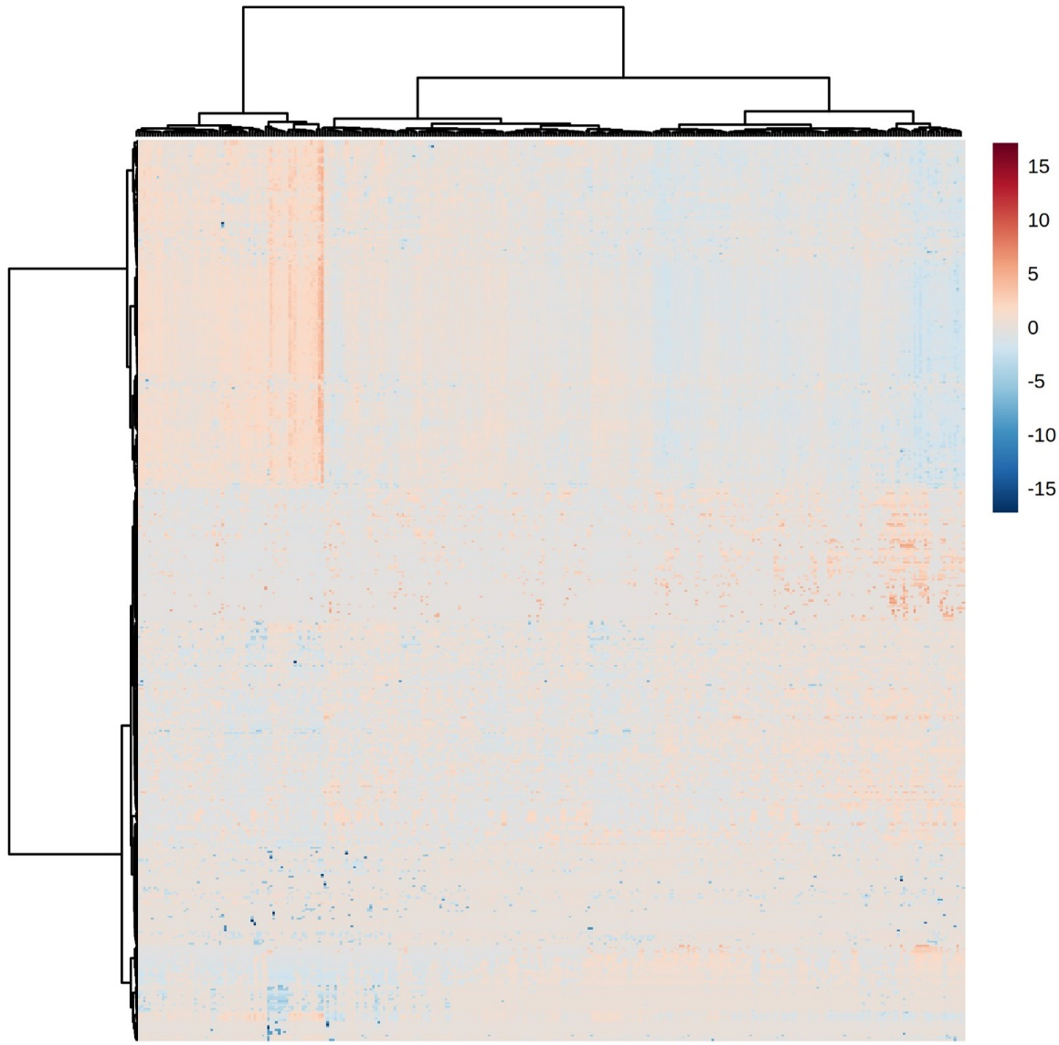
Supplementary Figure 1. Expression prolife of miRNAs in cervical cancer samples.
The TCGA data of 309 cervical and endocervical cancer samples and 3 control samples were downloaded by Firehose online tools (http://gdac.broadinstitute.org/), which includes the expression data of 1046 miRNAs and clinical information. Subsequently, 3 control samples, 2 metastasis samples and 707 miRNAs with missing values ≥ 20% were excluded. The rest missing values were replaced by KNN (K-Nearest Neighbor) method. The data was then normalized and scaled. The outliers were identified by IQR (Interquartile Range) method followed by KNN replacement. The preprocessed data was presented as heatmap.

Supplementary Tables

Supplementary Table 2. Summary of clinical information of patients.
Characteristics | Cohort (n=307)
Characteristics | No. | %
Age at initial pathologic diagnosis
Age <= 35 | 56 | 18.24
35 < Age <= 60 | 192 | 62.54
Age > 60 | 59 | 19.22
NA | 0 | 0.00
Age began smoking
Age <= 30 | 75 | 24.43
Age > 30 | 10 | 3.26
NA | 222 | 72.31
Neoplasm pathologic margin involved text
Margins free of tumor | 23 | 7.49
Others | 17 | 5.54
NA | 267 | 86.97
Neoplasm pathologic margin involved type
Macroscopic and microscopic parametrial involvement | 10 | 3.26
Other location, specify | 40 | 13.03
Positive bladder and vaginal margin | 13 | 4.23
NA | 244 | 79.48
Survival (years)
<=3 | 46 | 14.98
>3 | 69 | 22.48
Loss to follow up <=3 | 192 | 62.54
Height (cm)
< 150 | 15 | 4.89
150 - 160 | 119 | 38.76
160 - 170 | 111 | 36.16
>= 170 | 19 | 6.19
NA | 43 | 14.01
Histological type
Adenosquamous | 6 | 1.95
Cervical squamous cell carcinoma | 254 | 82.74
Endocervical adenocarcinoma of the usual type | 6 | 1.95
Endocervical type of adenocarcinoma | 21 | 6.84
Endometrioid adenocarcinoma of endocervix | 3 | 0.98
Mucinous adenocarcinoma of endocervical type | 17 | 5.54
NA | 0 | 0.00
Race
American Indian or Alaska Native | 8 | 2.61
Asian | 20 | 6.51
Black or African American | 30 | 9.77
Native Hawaiian or other Pacific Islander | 2 | 0.65
White | 211 | 68.73
NA | 36 | 11.73
Clinical stage
Stage I - IIa | 189 | 61.56
Stage IIb - IVb | 111 | 36.16
NA | 7 | 2.28
HPV infection
HPV16 | 172 | 56.03
HPV18 | 39 | 12.70
Others | 73 | 23.78
NA | 23 | 7.49
NA: Not available, HPV: Human Paplillomavirus.

