Appendix

Table A1: Variable Definitions
Variable | Variable description
Dependent Variables
SI | Logarithm of SO₂ emissions to real total output by firm i in year t.
Primary independent and control variables
AI | Application volume of industrial robots by firm i in year t, calculated as the cumulative number of imported industrial robots in that year
Size | Logarithm of total sales by firm i in year t.
Profitr | The ratio of total profits to total assets by firm i in year t.
Far | The ratio of net fix assets to total assets by firm i in year t.
Lprod | The ratio of real total output to the number of employees by firm i in year t.
Age | Logarithm of firm’s age in year t since the firm’s establishment.
Fdi | Equal 1 if the type of firm registration is foreign-invested or Hong Kong, Macao and Taiwan invested firm.
Hhi | Herfindahl index of four-digit industry j, which is the square sum of firm’s sales as a percentage of industry sales.
Ers | The ratio of provincial sewage charges to real GDP.
Pergdp | Logarithm of provincial real GDP per capita.

Table A2: Panel quantile regression with a two-way fixed effect
 | Quantiles
 | 10th | 20th | 30th | 40th | 50th | 60th | 70th | 80th | 90th
R | -1.024*** | -0.966*** | -0.900*** | -0.868*** | -0.837*** | -0.800*** | -0.764*** | -0.718*** | -0.645***
 | (0.093) | (0.076) | (0.076) | (0.071) | (0.065) | (0.064) | (0.063) | (0.066) | (0.069)
Size | -0.441*** | -0.445*** | -0.450*** | -0.446*** | -0.448*** | -0.454*** | -0.458*** | -0.467*** | -0.475***
 | (0.007) | (0.005) | (0.004) | (0.004) | (0.004) | (0.004) | (0.005) | (0.005) | (0.006)
Profitr | -0.334*** | 0.369*** | -0.399*** | -0.474*** | -0.526*** | -0.538*** | -0.515*** | -0.539*** | -0.641***
 | (0.047) | (0.030) | (0.023) | (0.021) | (0.019) | (0.021) | (0.021) | (0.024) | (0.033)
Far | 0.716*** | 0.606*** | 0.626*** | 0.684*** | 0.706*** | 0.703*** | 0.673*** | 0.660*** | 0.719***
 | (0.030) | (0.019) | (0.016) | (0.015) | (0.015) | (0.015) | (0.017) | (0.019) | (0.024)
Lprod | -0.337*** | -0.315*** | -0.302*** | -0.299*** | -0.293*** | -0.284*** | -0.275*** | -0.259*** | -0.243***
 | (0.009) | (0.006) | (0.005) | (0.005) | (0.005) | (0.005) | (0.005) | (0.006) | (0.008)
Age | -0.017*** | -0.038*** | -0.034*** | -0.039*** | -0.052*** | -0.060*** | -0.060*** | -0.055*** | -0.074***
 | (0.010) | (0.007) | (0.006) | (0.005) | (0.005) | (0.005) | (0.005) | (0.006) | (0.007)
Fdi | -0.554*** | -0.441*** | -0.421*** | -0.399*** | -0.379*** | -0.361*** | -0.343*** | -0.330*** | -0.325***
 | (0.022) | (0.014) | (0.012) | (0.011) | (0.011) | (0.010) | (0.011) | (0.012) | (0.014)
HHI | -6.192*** | -5.279*** | -4.915*** | -5.033*** | -4.995*** | -4.703*** | -4.462*** | -4.282*** | -4.088***
 | (0.444) | (0.294) | (0.252) | (0.209) | (0.204) | (0.199) | (0.203) | (0.224) | (0.257)
Ers | 14.527*** | 9.070*** | 8.110*** | 7.189*** | 5.971*** | 5.229*** | 4.378*** | 3.551*** | 2.364***
 | (0.995) | (0.637) | (0.561) | (0.519) | (0.469) | (0.451) | (0.480) | (0.587) | (0.773)
Ers2 | -55.388*** | -31.407*** | -26.495*** | -21.591*** | -15.658*** | -12.251*** | -7.986*** | -2.068 | 4.242
 | (5.314) | (3.305) | (2.807) | (2.604) | (2.432) | (2.300) | (2.558) | (3.230) | (3.939)
Pergdp | -0.287*** | -0.411*** | -0.453*** | -0.492*** | -0.536*** | -0.583*** | -0.624*** | -0.682 | -0.796***
 | (0.017) | (0.011) | (0.010) | (0.010) | (0.010) | (0.010) | (0.009) | (0.010) | (0.013)
_cons | 5.787*** | 7.986*** | 8.776*** | 9.370*** | 10.048*** | 10.739*** | 11.378*** | 12.233 | 13.883***
 | (0.182) | (0.129) | (0.115) | (0.108) | (0.106) | (0.101) | (0.100) | (0.111) | (0.148)
Note: This table shows the results of the panel quantile regression model used in Koenker(2004). The penalty term of individual fixed effects is set to 1 and we employ equally weighted quantiles. *, **, and *** indicate significance at the 10%, 5%, and 1% levels, respectively whereas bootstrap standard errors are in parentheses.

Table A3: Balancing tests of propensity score matching (PSM)
Variables |  | Mean |  | T-test
 |  | Treatment | Control | t | P＞| t |
Size | Before Matching  After Matching  Before Matching | 13.275 | 10.511 | 6.34 | 0.000
Size | Before Matching  After Matching  Before Matching | 13.275 | 13.165 | 0.19 | 0.854
Profitr | Before Matching  After Matching  Before Matching | 0.135 | .050 | 3.43 | 0.001
Profitr | After Matching | 0.135 | 0.148 | -0.21 | 0.837
Far | Before Matching | 0.433 | 0.412 | 0.36 | 0.721
Far | After Matching | 0.433 | 0.434 | -0.02 | 0.985
Lprod | Before Matching | 6.150 | 4.789 | 4.91 | 0.000
Lprod | After Matching | 6.150 | 5.962 | 0.42 | 0.677
Age | Before Matching | 1.940 | 2.619 | -2.34 | 0.019
Age | After Matching | 1.940 | 2.005 | -0.39 | 0.689
Note: This table reports balancing tests of propensity score matching(PSM) in 2000.The result of 2001-2013 are not reported here, but the conclusions are consistent. T-value and corresponding p-value of difference-in-means are reported in columns (5) and (6).

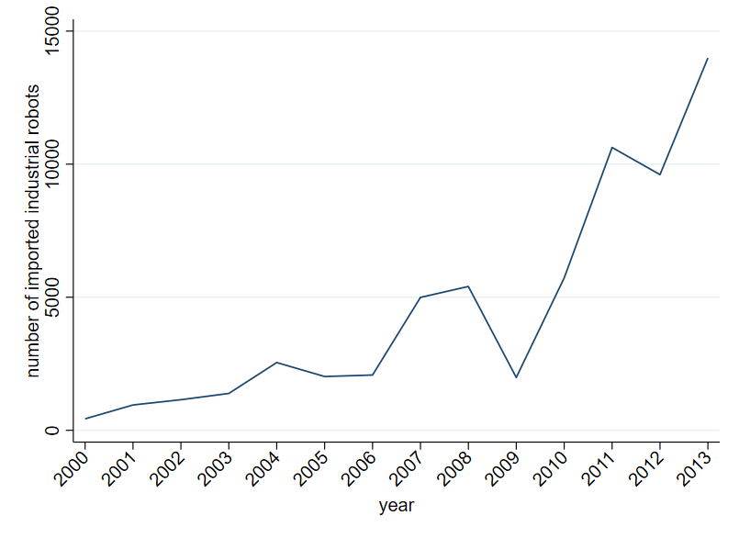
Fig.A1. Imported industrial robots in the merging data of CIED and CCD.

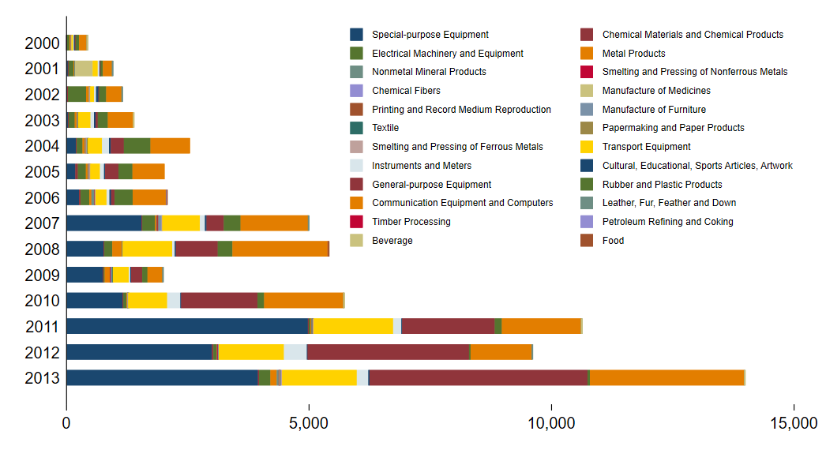
Fig.A2. The industry distribution of imported industrial robots in the merging data of CIED and CCD.

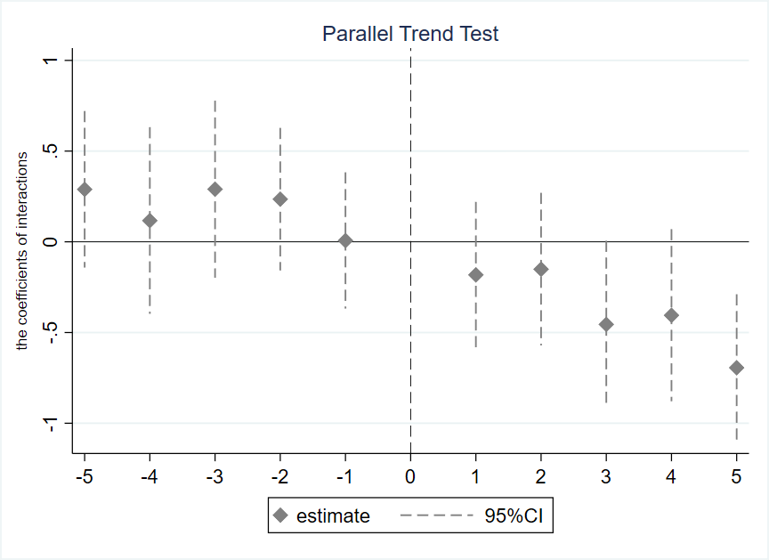
Fig.A3-1. The coefficients and the 95% confidence intervals for the D according to model (3). Regression sample are obtained from the PSM by 1:2.
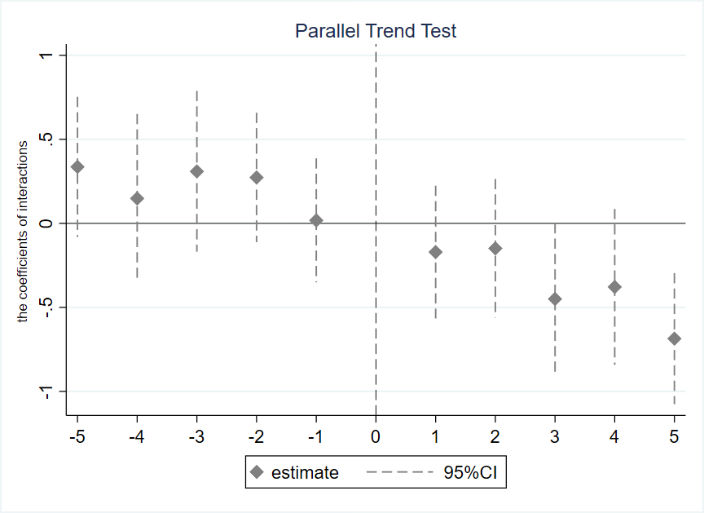
Fig.A3-2. The coefficients and the 95% confidence intervals for the D according to Model (3). Regression sample are obtained from the PSM by 1:3.
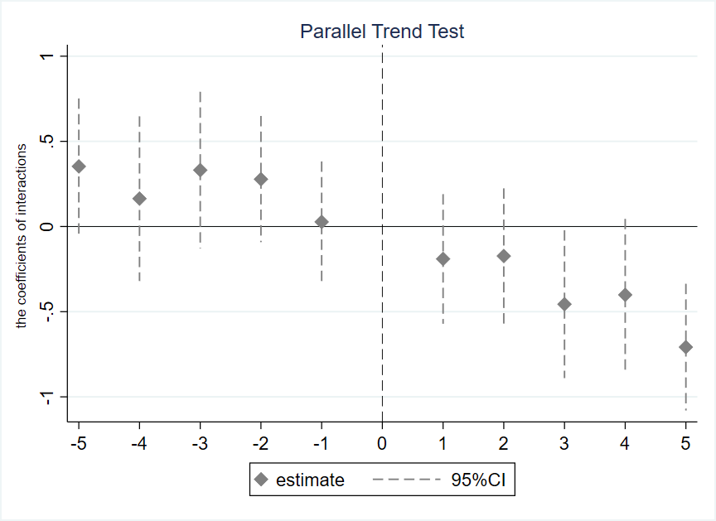
Fig.A3-3. The coefficients and the 95% confidence intervals for the D according to Model (3). Regression sample are obtained from the PSM by 1:4.

