Docking result of 1-32 phytochemical against COX-1
Ligand | Binding Affinity | rmsd/ub | rmsd/lb
3KK6_1.cdx_uff_E=768.14 | -9 | 0 | 0
3KK6_1.cdx_uff_E=768.14 | -8.8 | 26.428 | 21.34
3KK6_1.cdx_uff_E=768.14 | -8.7 | 33.163 | 29.838
3KK6_1.cdx_uff_E=768.14 | -8.5 | 2.658 | 1.937
3KK6_1.cdx_uff_E=768.14 | -8.5 | 9.833 | 2.435
3KK6_1.cdx_uff_E=768.14 | -8.2 | 48.574 | 44.943
3KK6_1.cdx_uff_E=768.14 | -8.2 | 5.294 | 3.435
3KK6_1.cdx_uff_E=768.14 | -8.1 | 38.385 | 31.56
3KK6_1.cdx_uff_E=768.14 | -8.1 | 9.855 | 2.199
3KK6_11_uff_E=804.11 | -9.3 | 0 | 0
3KK6_11_uff_E=804.11 | -8.7 | 48.04 | 45.385
3KK6_11_uff_E=804.11 | -8.5 | 27.158 | 22.322
3KK6_11_uff_E=804.11 | -8.5 | 47.779 | 45.248
3KK6_11_uff_E=804.11 | -8.1 | 51.752 | 49.339
3KK6_11_uff_E=804.11 | -8 | 26.959 | 22.381
3KK6_11_uff_E=804.11 | -8 | 25.49 | 21.212
3KK6_11_uff_E=804.11 | -7.9 | 48.631 | 45.081
3KK6_11_uff_E=804.11 | -7.7 | 57.809 | 55.148
3KK6_12.cdx_uff_E=773.01 | -8.7 | 0 | 0
3KK6_12.cdx_uff_E=773.01 | -8.5 | 3.428 | 1.893
3KK6_12.cdx_uff_E=773.01 | -8.4 | 8.206 | 1.601
3KK6_12.cdx_uff_E=773.01 | -8.3 | 50.49 | 48.142
3KK6_12.cdx_uff_E=773.01 | -8.1 | 50.151 | 47.817
3KK6_12.cdx_uff_E=773.01 | -8.1 | 30.117 | 26.428
3KK6_12.cdx_uff_E=773.01 | -7.9 | 57.169 | 54.465
3KK6_12.cdx_uff_E=773.01 | -7.8 | 57.705 | 55.659
3KK6_12.cdx_uff_E=773.01 | -7.6 | 56.863 | 53.645
3KK6_13.cdx_uff_E=441.87 | -9.1 | 0 | 0
3KK6_13.cdx_uff_E=441.87 | -8.6 | 22.744 | 20.723
3KK6_13.cdx_uff_E=441.87 | -7.9 | 46.552 | 44.295
3KK6_13.cdx_uff_E=441.87 | -7.9 | 44.665 | 42.387
3KK6_13.cdx_uff_E=441.87 | -7.9 | 40.153 | 36.528
3KK6_13.cdx_uff_E=441.87 | -7.6 | 46.086 | 44.397
3KK6_13.cdx_uff_E=441.87 | -7.5 | 9.851 | 3.744
3KK6_13.cdx_uff_E=441.87 | -7.4 | 26.291 | 22.142
3KK6_13.cdx_uff_E=441.87 | -7.4 | 41.408 | 38.024
3KK6_14.cdx_uff_E=450.77 | -9.4 | 0 | 0
3KK6_14.cdx_uff_E=450.77 | -9.4 | 9.464 | 4.838
3KK6_14.cdx_uff_E=450.77 | -9.4 | 27.552 | 24.225
3KK6_14.cdx_uff_E=450.77 | -9 | 26.982 | 22.991
3KK6_14.cdx_uff_E=450.77 | -8.8 | 4.897 | 3.134
3KK6_14.cdx_uff_E=450.77 | -8.5 | 27.21 | 23.66
3KK6_14.cdx_uff_E=450.77 | -8.3 | 37.934 | 36.44
3KK6_14.cdx_uff_E=450.77 | -8 | 23.099 | 19.565
3KK6_14.cdx_uff_E=450.77 | -7.9 | 24.416 | 18.734
3KK6_15.cdx_uff_E=797.75 | -9.1 | 0 | 0
3KK6_15.cdx_uff_E=797.75 | -8.9 | 51.494 | 48.676
3KK6_15.cdx_uff_E=797.75 | -8.7 | 8.414 | 2.822
3KK6_15.cdx_uff_E=797.75 | -8.6 | 49.342 | 46.71
3KK6_15.cdx_uff_E=797.75 | -8.5 | 9.159 | 1.966
3KK6_15.cdx_uff_E=797.75 | -8.3 | 48.139 | 45.404
3KK6_15.cdx_uff_E=797.75 | -8 | 9.018 | 2.252
3KK6_15.cdx_uff_E=797.75 | -7.9 | 48.591 | 46.264
3KK6_15.cdx_uff_E=797.75 | -7.9 | 25.936 | 22.255
3KK6_16.cdx_uff_E=639.30 | -9.1 | 0 | 0
3KK6_16.cdx_uff_E=639.30 | -8.7 | 3.188 | 2.081
3KK6_16.cdx_uff_E=639.30 | -8.7 | 51.692 | 48.515
3KK6_16.cdx_uff_E=639.30 | -8.7 | 51.896 | 48.715
3KK6_16.cdx_uff_E=639.30 | -8.6 | 7.235 | 2.038
3KK6_16.cdx_uff_E=639.30 | -8.4 | 52.4 | 49.055
3KK6_16.cdx_uff_E=639.30 | -8.4 | 8.089 | 2.692
3KK6_16.cdx_uff_E=639.30 | -8.4 | 7.533 | 2.406
3KK6_16.cdx_uff_E=639.30 | -8.3 | 45.885 | 43.496
3KK6_17.cdx_uff_E=598.04 | -9 | 0 | 0
3KK6_17.cdx_uff_E=598.04 | -8.9 | 51.394 | 48.447
3KK6_17.cdx_uff_E=598.04 | -8.5 | 7.999 | 2.139
3KK6_17.cdx_uff_E=598.04 | -8.4 | 31.208 | 29.266
3KK6_17.cdx_uff_E=598.04 | -8.3 | 50.609 | 47.534
3KK6_17.cdx_uff_E=598.04 | -7.9 | 26.141 | 22.797
3KK6_17.cdx_uff_E=598.04 | -7.9 | 30.404 | 28.341
3KK6_17.cdx_uff_E=598.04 | -7.9 | 45.7 | 42.698
3KK6_17.cdx_uff_E=598.04 | -7.7 | 57.359 | 54.872
3KK6_18.cdx_uff_E=767.72 | -8.9 | 0 | 0
3KK6_18.cdx_uff_E=767.72 | -8.7 | 4.636 | 2.847
3KK6_18.cdx_uff_E=767.72 | -8.6 | 3.812 | 2.58
3KK6_18.cdx_uff_E=767.72 | -8.6 | 52.057 | 50.025
3KK6_18.cdx_uff_E=767.72 | -8.2 | 50.863 | 48.828
3KK6_18.cdx_uff_E=767.72 | -8.2 | 3.282 | 1.862
3KK6_18.cdx_uff_E=767.72 | -7.8 | 25.457 | 23.481
3KK6_18.cdx_uff_E=767.72 | -7.7 | 43.116 | 39.289
3KK6_18.cdx_uff_E=767.72 | -7.6 | 50.132 | 47.905
3KK6_19.cdx_uff_E=846.55 | -8.3 | 0 | 0
3KK6_19.cdx_uff_E=846.55 | -8.2 | 36.088 | 30.645
3KK6_19.cdx_uff_E=846.55 | -8.1 | 48.476 | 46.072
3KK6_19.cdx_uff_E=846.55 | -8.1 | 48.401 | 45.259
3KK6_19.cdx_uff_E=846.55 | -8 | 34.058 | 28.462
3KK6_19.cdx_uff_E=846.55 | -7.9 | 2.081 | 1.55
3KK6_19.cdx_uff_E=846.55 | -7.7 | 9.364 | 5.1
3KK6_19.cdx_uff_E=846.55 | -7.7 | 34.994 | 28.742
3KK6_19.cdx_uff_E=846.55 | -7.6 | 6.835 | 4.341
3KK6_2.cdx_uff_E=730.47 | -9.5 | 0 | 0
3KK6_2.cdx_uff_E=730.47 | -9.4 | 49.655 | 45.456
3KK6_2.cdx_uff_E=730.47 | -9 | 49.26 | 45.658
3KK6_2.cdx_uff_E=730.47 | -9 | 4.885 | 2.067
3KK6_2.cdx_uff_E=730.47 | -8.6 | 31.776 | 26.009
3KK6_2.cdx_uff_E=730.47 | -8.5 | 31.129 | 26.462
3KK6_2.cdx_uff_E=730.47 | -8.4 | 48.997 | 44.695
3KK6_2.cdx_uff_E=730.47 | -8.4 | 30.668 | 24.608
3KK6_2.cdx_uff_E=730.47 | -8.2 | 47.716 | 45.375
3KK6_20_uff_E=670.90 | -9 | 0 | 0
3KK6_20_uff_E=670.90 | -9 | 5.514 | 3.559
3KK6_20_uff_E=670.90 | -8.9 | 46.131 | 44.145
3KK6_20_uff_E=670.90 | -8.6 | 9.121 | 2.043
3KK6_20_uff_E=670.90 | -8.4 | 4.434 | 2.334
3KK6_20_uff_E=670.90 | -8.3 | 43.865 | 39.515
3KK6_20_uff_E=670.90 | -8.2 | 47.84 | 45.504
3KK6_20_uff_E=670.90 | -8 | 28.485 | 24.961
3KK6_20_uff_E=670.90 | -8 | 48.421 | 45.132
3KK6_21.cdx_uff_E=748.48 | -9.2 | 0 | 0
3KK6_21.cdx_uff_E=748.48 | -8.8 | 31.402 | 24.758
3KK6_21.cdx_uff_E=748.48 | -8.7 | 31.316 | 25.749
3KK6_21.cdx_uff_E=748.48 | -8.5 | 41.812 | 39.089
3KK6_21.cdx_uff_E=748.48 | -8 | 25.879 | 22.587
3KK6_21.cdx_uff_E=748.48 | -8 | 30.417 | 27.312
3KK6_21.cdx_uff_E=748.48 | -7.9 | 48.911 | 45.938
3KK6_21.cdx_uff_E=748.48 | -7.9 | 40.301 | 36.134
3KK6_21.cdx_uff_E=748.48 | -7.9 | 48.483 | 45.83
3KK6_23.cdx_uff_E=863.27 | -8.5 | 0 | 0
3KK6_23.cdx_uff_E=863.27 | -8.2 | 8.747 | 1.544
3KK6_23.cdx_uff_E=863.27 | -7.9 | 5.699 | 4.111
3KK6_23.cdx_uff_E=863.27 | -7.9 | 42.155 | 39.762
3KK6_23.cdx_uff_E=863.27 | -7.9 | 50.309 | 48.47
3KK6_23.cdx_uff_E=863.27 | -7.8 | 32.304 | 28.587
3KK6_23.cdx_uff_E=863.27 | -7.6 | 3.764 | 2.472
3KK6_23.cdx_uff_E=863.27 | -7.4 | 52.336 | 50.453
3KK6_23.cdx_uff_E=863.27 | -7.4 | 3.99 | 1.99
3KK6_24.cdx_uff_E=818.24 | -8.3 | 0 | 0
3KK6_24.cdx_uff_E=818.24 | -8.1 | 2.902 | 2.157
3KK6_24.cdx_uff_E=818.24 | -7.7 | 8.864 | 2.523
3KK6_24.cdx_uff_E=818.24 | -7.6 | 48.695 | 44.322
3KK6_24.cdx_uff_E=818.24 | -7.4 | 56.443 | 53.555
3KK6_24.cdx_uff_E=818.24 | -7.3 | 47.525 | 43.243
3KK6_24.cdx_uff_E=818.24 | -7.1 | 41.02 | 36.623
3KK6_24.cdx_uff_E=818.24 | -7 | 50.28 | 46.077
3KK6_24.cdx_uff_E=818.24 | -7 | 44.868 | 40.464
3KK6_25.cdx_uff_E=294.74 | -8.1 | 0 | 0
3KK6_25.cdx_uff_E=294.74 | -8.1 | 49.786 | 48.73
3KK6_25.cdx_uff_E=294.74 | -7.4 | 25.891 | 25.089
3KK6_25.cdx_uff_E=294.74 | -7.2 | 25.613 | 25.046
3KK6_25.cdx_uff_E=294.74 | -7.1 | 25.507 | 25.109
3KK6_25.cdx_uff_E=294.74 | -7.1 | 25.609 | 24.516
3KK6_25.cdx_uff_E=294.74 | -7 | 25.452 | 24.824
3KK6_25.cdx_uff_E=294.74 | -7 | 25.758 | 25.135
3KK6_25.cdx_uff_E=294.74 | -7 | 32.174 | 31.352
3KK6_26.cdx_uff_E=296.56 | -7.9 | 0 | 0
3KK6_26.cdx_uff_E=296.56 | -7.9 | 30.892 | 29.056
3KK6_26.cdx_uff_E=296.56 | -7.8 | 29.903 | 29.24
3KK6_26.cdx_uff_E=296.56 | -7.8 | 42.763 | 41.301
3KK6_26.cdx_uff_E=296.56 | -7 | 3.006 | 1.251
3KK6_26.cdx_uff_E=296.56 | -6.7 | 32.247 | 29.316
3KK6_26.cdx_uff_E=296.56 | -6.6 | 41.328 | 39.983
3KK6_26.cdx_uff_E=296.56 | -6.5 | 40.993 | 40.077
3KK6_26.cdx_uff_E=296.56 | -6.3 | 32.134 | 30.739
3KK6_27.cdx_uff_E=307.53 | -8.2 | 0 | 0
3KK6_27.cdx_uff_E=307.53 | -7.7 | 25.945 | 24.882
3KK6_27.cdx_uff_E=307.53 | -7.7 | 26.532 | 25.289
3KK6_27.cdx_uff_E=307.53 | -7.6 | 26.32 | 25.038
3KK6_27.cdx_uff_E=307.53 | -7.6 | 26.168 | 24.64
3KK6_27.cdx_uff_E=307.53 | -7.5 | 25.837 | 25.258
3KK6_27.cdx_uff_E=307.53 | -7.5 | 25.766 | 25.082
3KK6_27.cdx_uff_E=307.53 | -7.2 | 6.752 | 2.24
3KK6_27.cdx_uff_E=307.53 | -7.1 | 25.585 | 24.855
3KK6_28.cdx_uff_E=307.63 | -8.1 | 0 | 0
3KK6_28.cdx_uff_E=307.63 | -7.9 | 50.098 | 48.672
3KK6_28.cdx_uff_E=307.63 | -7.7 | 49.401 | 47.93
3KK6_28.cdx_uff_E=307.63 | -7.6 | 25.783 | 24.406
3KK6_28.cdx_uff_E=307.63 | -7.6 | 48.122 | 46.715
3KK6_28.cdx_uff_E=307.63 | -7.5 | 25.743 | 25.197
3KK6_28.cdx_uff_E=307.63 | -7.3 | 34.078 | 32.578
3KK6_28.cdx_uff_E=307.63 | -7.3 | 51.231 | 50.425
3KK6_28.cdx_uff_E=307.63 | -7 | 31.735 | 30.903
3KK6_29_uff_E=325.24 | -8.2 | 0 | 0
3KK6_29_uff_E=325.24 | -7.1 | 3.058 | 1.405
3KK6_29_uff_E=325.24 | -6.9 | 6.989 | 2.929
3KK6_29_uff_E=325.24 | -6.8 | 5.546 | 3.795
3KK6_29_uff_E=325.24 | -6.7 | 34.163 | 32.635
3KK6_29_uff_E=325.24 | -6.7 | 21.528 | 19.558
3KK6_29_uff_E=325.24 | -6.6 | 7.098 | 5.307
3KK6_29_uff_E=325.24 | -6.5 | 23.391 | 20.751
3KK6_29_uff_E=325.24 | -6.3 | 6.317 | 4.618
3KK6_3.cdx_uff_E=434.42 | -8.8 | 0 | 0
3KK6_3.cdx_uff_E=434.42 | -8.1 | 49.022 | 47.103
3KK6_3.cdx_uff_E=434.42 | -8 | 48.094 | 45.92
3KK6_3.cdx_uff_E=434.42 | -8 | 40.898 | 38.246
3KK6_3.cdx_uff_E=434.42 | -8 | 49.136 | 46.43
3KK6_3.cdx_uff_E=434.42 | -7.9 | 31.801 | 28.558
3KK6_3.cdx_uff_E=434.42 | -7.9 | 18.708 | 16.019
3KK6_3.cdx_uff_E=434.42 | -7.8 | 31.128 | 25.856
3KK6_3.cdx_uff_E=434.42 | -7.8 | 30.783 | 25.744
3KK6_30.cdx_uff_E=324.58 | -8.2 | 0 | 0
3KK6_30.cdx_uff_E=324.58 | -8.1 | 5.367 | 1.034
3KK6_30.cdx_uff_E=324.58 | -7.4 | 25.757 | 24.737
3KK6_30.cdx_uff_E=324.58 | -7.3 | 59.109 | 57.698
3KK6_30.cdx_uff_E=324.58 | -7.1 | 50.328 | 49.343
3KK6_30.cdx_uff_E=324.58 | -7.1 | 2.964 | 1.331
3KK6_30.cdx_uff_E=324.58 | -6.9 | 7.221 | 4.652
3KK6_30.cdx_uff_E=324.58 | -6.7 | 7.175 | 2.999
3KK6_30.cdx_uff_E=324.58 | -6.7 | 7.548 | 4.956
3KK6_31.cdx_uff_E=236.47 | -8.2 | 0 | 0
3KK6_31.cdx_uff_E=236.47 | -8 | 1.976 | 0.962
3KK6_31.cdx_uff_E=236.47 | -7.1 | 2.978 | 1.748
3KK6_31.cdx_uff_E=236.47 | -6.9 | 5.406 | 3.493
3KK6_31.cdx_uff_E=236.47 | -6.9 | 6.721 | 4.415
3KK6_31.cdx_uff_E=236.47 | -6.8 | 6.162 | 3.751
3KK6_31.cdx_uff_E=236.47 | -6.8 | 51.182 | 48.779
3KK6_31.cdx_uff_E=236.47 | -6.7 | 22.589 | 18.701
3KK6_31.cdx_uff_E=236.47 | -6.6 | 53.303 | 50.823
3KK6_32.cdx_uff_E=345.83 | -9 | 0 | 0
3KK6_32.cdx_uff_E=345.83 | -8.3 | 51.868 | 49.879
3KK6_32.cdx_uff_E=345.83 | -8.2 | 2.578 | 1.594
3KK6_32.cdx_uff_E=345.83 | -7.8 | 3.774 | 2.114
3KK6_32.cdx_uff_E=345.83 | -7.7 | 51.116 | 49.4
3KK6_32.cdx_uff_E=345.83 | -7.5 | 42.872 | 41.342
3KK6_32.cdx_uff_E=345.83 | -7.4 | 35.456 | 33.576
3KK6_32.cdx_uff_E=345.83 | -7 | 5.812 | 2.822
3KK6_32.cdx_uff_E=345.83 | -7 | 9.623 | 5.43
3KK6_4.cdx_uff_E=654.42 | -9.1 | 0 | 0
3KK6_4.cdx_uff_E=654.42 | -8.1 | 45.821 | 44.045
3KK6_4.cdx_uff_E=654.42 | -8 | 2.468 | 1.728
3KK6_4.cdx_uff_E=654.42 | -7.7 | 7.93 | 4.029
3KK6_4.cdx_uff_E=654.42 | -7.7 | 49.604 | 46.823
3KK6_4.cdx_uff_E=654.42 | -7.7 | 49.471 | 47.798
3KK6_4.cdx_uff_E=654.42 | -7.6 | 57.659 | 54.303
3KK6_4.cdx_uff_E=654.42 | -7.6 | 47.196 | 45.294
3KK6_4.cdx_uff_E=654.42 | -7.5 | 57.137 | 54.632
3KK6_5.cdx_uff_E=719.24 | -8.8 | 0 | 0
3KK6_5.cdx_uff_E=719.24 | -8.5 | 37.032 | 34.742
3KK6_5.cdx_uff_E=719.24 | -8.4 | 51.291 | 47.215
3KK6_5.cdx_uff_E=719.24 | -8.3 | 36.776 | 34.522
3KK6_5.cdx_uff_E=719.24 | -8.1 | 36.281 | 33.04
3KK6_5.cdx_uff_E=719.24 | -7.9 | 39.159 | 37.44
3KK6_5.cdx_uff_E=719.24 | -7.8 | 40.035 | 37.404
3KK6_5.cdx_uff_E=719.24 | -7.8 | 60.446 | 57.95
3KK6_5.cdx_uff_E=719.24 | -7.8 | 50.294 | 46.814
3KK6_6.cdx_uff_E=669.07 | -10.7 | 0 | 0
3KK6_6.cdx_uff_E=669.07 | -9.1 | 2.762 | 1.755
3KK6_6.cdx_uff_E=669.07 | -8.6 | 4.166 | 2.348
3KK6_6.cdx_uff_E=669.07 | -8.5 | 41.024 | 38.876
3KK6_6.cdx_uff_E=669.07 | -8.2 | 5.471 | 3.994
3KK6_6.cdx_uff_E=669.07 | -8 | 41.48 | 39.552
3KK6_6.cdx_uff_E=669.07 | -8 | 36.119 | 32.2
3KK6_6.cdx_uff_E=669.07 | -7.9 | 41.218 | 37.638
3KK6_6.cdx_uff_E=669.07 | -7.8 | 6.939 | 3.764
3KK6_7.cdx_uff_E=772.09 | -10.4 | 0 | 0
3KK6_7.cdx_uff_E=772.09 | -9.1 | 2.816 | 1.691
3KK6_7.cdx_uff_E=772.09 | -9 | 50.07 | 46.86
3KK6_7.cdx_uff_E=772.09 | -9 | 7.96 | 2.369
3KK6_7.cdx_uff_E=772.09 | -8.7 | 40.181 | 36.291
3KK6_7.cdx_uff_E=772.09 | -8.6 | 5.089 | 3.232
3KK6_7.cdx_uff_E=772.09 | -8.5 | 4.296 | 2.394
3KK6_7.cdx_uff_E=772.09 | -8.5 | 36.2 | 32.765
3KK6_7.cdx_uff_E=772.09 | -8.4 | 48.251 | 45.282
3KK6_8.cdx_uff_E=714.00 | -10.1 | 0 | 0
3KK6_8.cdx_uff_E=714.00 | -10 | 50.384 | 48.306
3KK6_8.cdx_uff_E=714.00 | -8.3 | 27.235 | 24.13
3KK6_8.cdx_uff_E=714.00 | -8 | 48.784 | 46.427
3KK6_8.cdx_uff_E=714.00 | -7.6 | 35.187 | 31.614
3KK6_8.cdx_uff_E=714.00 | -7.6 | 56.331 | 54.323
3KK6_8.cdx_uff_E=714.00 | -7.6 | 58.174 | 55.299
3KK6_8.cdx_uff_E=714.00 | -7.6 | 46.88 | 44.916
3KK6_8.cdx_uff_E=714.00 | -7.5 | 6.665 | 3.686
3KK6_9.cdx_uff_E=619.83 | -9.3 | 0 | 0
3KK6_9.cdx_uff_E=619.83 | -9.1 | 50.584 | 48.089
3KK6_9.cdx_uff_E=619.83 | -8.8 | 8.037 | 2.478
3KK6_9.cdx_uff_E=619.83 | -8.6 | 39.957 | 35.974
3KK6_9.cdx_uff_E=619.83 | -8.6 | 48.654 | 44.254
3KK6_9.cdx_uff_E=619.83 | -8.4 | 57.815 | 56.031
3KK6_9.cdx_uff_E=619.83 | -8.3 | 8.093 | 3.168
3KK6_9.cdx_uff_E=619.83 | -8.3 | 41.707 | 37.621
3KK6_9.cdx_uff_E=619.83 | -7.8 | 48.847 | 46.045

Docking result of 1-32 phytochemical against COX-2
Ligand | Binding Affinity | rmsd/ub | rmsd/lb
3ln1_1.cdx_uff_E=768.14 | -9.7 | 0 | 0
3ln1_1.cdx_uff_E=768.14 | -8.8 | 33.008 | 30.139
3ln1_1.cdx_uff_E=768.14 | -8.7 | 41.121 | 38.17
3ln1_1.cdx_uff_E=768.14 | -8.5 | 69.375 | 65.238
3ln1_1.cdx_uff_E=768.14 | -8.4 | 27.66 | 25.759
3ln1_1.cdx_uff_E=768.14 | -8.3 | 21.334 | 16.534
3ln1_1.cdx_uff_E=768.14 | -8.2 | 66.871 | 62.515
3ln1_1.cdx_uff_E=768.14 | -8.1 | 32.377 | 29.868
3ln1_1.cdx_uff_E=768.14 | -8.1 | 44.324 | 40.981
3ln1_11_uff_E=804.11 | -9.5 | 0 | 0
3ln1_11_uff_E=804.11 | -9.4 | 75.979 | 71.449
3ln1_11_uff_E=804.11 | -8.9 | 30.388 | 27.534
3ln1_11_uff_E=804.11 | -8.9 | 82.754 | 77.181
3ln1_11_uff_E=804.11 | -8.8 | 31.421 | 27.808
3ln1_11_uff_E=804.11 | -8.5 | 38.537 | 34.728
3ln1_11_uff_E=804.11 | -8.4 | 38.847 | 34.131
3ln1_11_uff_E=804.11 | -8.4 | 4.494 | 2.445
3ln1_11_uff_E=804.11 | -8.3 | 37.532 | 33.926
3ln1_12.cdx_uff_E=773.01 | -9 | 0 | 0
3ln1_12.cdx_uff_E=773.01 | -8.8 | 34.037 | 31.573
3ln1_12.cdx_uff_E=773.01 | -8.7 | 76.698 | 73.982
3ln1_12.cdx_uff_E=773.01 | -8.6 | 33.357 | 31.038
3ln1_12.cdx_uff_E=773.01 | -8.3 | 41.376 | 37.465
3ln1_12.cdx_uff_E=773.01 | -8.2 | 78.222 | 75.05
3ln1_12.cdx_uff_E=773.01 | -8.1 | 74.243 | 70.61
3ln1_12.cdx_uff_E=773.01 | -8 | 44.561 | 42.676
3ln1_12.cdx_uff_E=773.01 | -8 | 89.184 | 86.095
3ln1_13.cdx_uff_E=441.87 | -9.5 | 0 | 0
3ln1_13.cdx_uff_E=441.87 | -9.4 | 77.978 | 72.898
3ln1_13.cdx_uff_E=441.87 | -9.4 | 29.58 | 26.504
3ln1_13.cdx_uff_E=441.87 | -9.1 | 27.799 | 25.343
3ln1_13.cdx_uff_E=441.87 | -9.1 | 31.546 | 28.141
3ln1_13.cdx_uff_E=441.87 | -9 | 29.609 | 26.242
3ln1_13.cdx_uff_E=441.87 | -9 | 43.356 | 40.736
3ln1_13.cdx_uff_E=441.87 | -9 | 78.502 | 76.669
3ln1_13.cdx_uff_E=441.87 | -8.9 | 38.764 | 35.613
3ln1_14.cdx_uff_E=450.77 | -8.7 | 0 | 0
3ln1_14.cdx_uff_E=450.77 | -8.7 | 32.646 | 28.188
3ln1_14.cdx_uff_E=450.77 | -8.6 | 77.347 | 73.173
3ln1_14.cdx_uff_E=450.77 | -8.3 | 76.226 | 72.035
3ln1_14.cdx_uff_E=450.77 | -8.3 | 52.558 | 49.531
3ln1_14.cdx_uff_E=450.77 | -8.2 | 41.576 | 37.422
3ln1_14.cdx_uff_E=450.77 | -8.2 | 7.222 | 3.137
3ln1_14.cdx_uff_E=450.77 | -8.1 | 33.675 | 29.494
3ln1_14.cdx_uff_E=450.77 | -8.1 | 54.05 | 49.736
3ln1_15.cdx_uff_E=797.75 | -9.5 | 0 | 0
3ln1_15.cdx_uff_E=797.75 | -8.9 | 2.292 | 1.724
3ln1_15.cdx_uff_E=797.75 | -8.7 | 41.632 | 39.231
3ln1_15.cdx_uff_E=797.75 | -8.7 | 33.232 | 26.223
3ln1_15.cdx_uff_E=797.75 | -8.7 | 2.875 | 1.964
3ln1_15.cdx_uff_E=797.75 | -8.6 | 4.137 | 2.705
3ln1_15.cdx_uff_E=797.75 | -8.6 | 7.82 | 6.041
3ln1_15.cdx_uff_E=797.75 | -8.5 | 37.509 | 34.013
3ln1_15.cdx_uff_E=797.75 | -8.3 | 28.265 | 24.191
3ln1_16.cdx_uff_E=639.30 | -8.4 | 0 | 0
3ln1_16.cdx_uff_E=639.30 | -8.1 | 46.512 | 44.313
3ln1_16.cdx_uff_E=639.30 | -8.1 | 72.346 | 67.948
3ln1_16.cdx_uff_E=639.30 | -8 | 26.181 | 20.583
3ln1_16.cdx_uff_E=639.30 | -7.9 | 6.268 | 2.996
3ln1_16.cdx_uff_E=639.30 | -7.9 | 72.362 | 68.004
3ln1_16.cdx_uff_E=639.30 | -7.9 | 27.826 | 22.601
3ln1_16.cdx_uff_E=639.30 | -7.8 | 72.34 | 70.009
3ln1_16.cdx_uff_E=639.30 | -7.7 | 75.83 | 72.196
3ln1_17.cdx_uff_E=598.04 | -9.1 | 0 | 0
3ln1_17.cdx_uff_E=598.04 | -9 | 65.231 | 59.818
3ln1_17.cdx_uff_E=598.04 | -8.8 | 52.562 | 47.958
3ln1_17.cdx_uff_E=598.04 | -8.8 | 60.164 | 56.512
3ln1_17.cdx_uff_E=598.04 | -8.7 | 58.379 | 54.896
3ln1_17.cdx_uff_E=598.04 | -8.6 | 55.381 | 53.042
3ln1_17.cdx_uff_E=598.04 | -8.6 | 33.756 | 30.931
3ln1_17.cdx_uff_E=598.04 | -8.6 | 51.697 | 47.774
3ln1_17.cdx_uff_E=598.04 | -8.5 | 20.849 | 17.686
3ln1_18.cdx_uff_E=767.72 | -8.7 | 0 | 0
3ln1_18.cdx_uff_E=767.72 | -8.4 | 45.168 | 42.484
3ln1_18.cdx_uff_E=767.72 | -8.2 | 45.576 | 43.587
3ln1_18.cdx_uff_E=767.72 | -8.1 | 63.167 | 60.402
3ln1_18.cdx_uff_E=767.72 | -8.1 | 44.846 | 42.342
3ln1_18.cdx_uff_E=767.72 | -8 | 29.512 | 26.579
3ln1_18.cdx_uff_E=767.72 | -7.9 | 78.491 | 76.033
3ln1_18.cdx_uff_E=767.72 | -7.9 | 69.073 | 66.87
3ln1_18.cdx_uff_E=767.72 | -7.7 | 24.348 | 19.428
3ln1_19.cdx_uff_E=846.55 | -8.8 | 0 | 0
3ln1_19.cdx_uff_E=846.55 | -8.8 | 30.455 | 28.009
3ln1_19.cdx_uff_E=846.55 | -8.7 | 35.804 | 33.671
3ln1_19.cdx_uff_E=846.55 | -8.6 | 88.353 | 82.897
3ln1_19.cdx_uff_E=846.55 | -8.3 | 57.062 | 54.171
3ln1_19.cdx_uff_E=846.55 | -8.2 | 13.655 | 8.845
3ln1_19.cdx_uff_E=846.55 | -8.1 | 11.574 | 7.975
3ln1_19.cdx_uff_E=846.55 | -8.1 | 49.8 | 47.658
3ln1_19.cdx_uff_E=846.55 | -8 | 109.973 | 106.771
3ln1_2.cdx_uff_E=730.47 | -9.2 | 0 | 0
3ln1_2.cdx_uff_E=730.47 | -8.8 | 105.919 | 103.39
3ln1_2.cdx_uff_E=730.47 | -8.8 | 96.164 | 92.709
3ln1_2.cdx_uff_E=730.47 | -8.6 | 84.418 | 82.266
3ln1_2.cdx_uff_E=730.47 | -8.6 | 97.527 | 94.261
3ln1_2.cdx_uff_E=730.47 | -8.5 | 77.597 | 74.921
3ln1_2.cdx_uff_E=730.47 | -8.4 | 97.387 | 93.452
3ln1_2.cdx_uff_E=730.47 | -8.4 | 65.909 | 62.742
3ln1_2.cdx_uff_E=730.47 | -8.4 | 96.27 | 92.783
3ln1_20_uff_E=670.90 | -8.7 | 0 | 0
3ln1_20_uff_E=670.90 | -8.7 | 73.406 | 68.719
3ln1_20_uff_E=670.90 | -8.5 | 104.143 | 100.92
3ln1_20_uff_E=670.90 | -8.5 | 43.58 | 39.741
3ln1_20_uff_E=670.90 | -8.3 | 29.912 | 27.718
3ln1_20_uff_E=670.90 | -8.3 | 72.182 | 66.767
3ln1_20_uff_E=670.90 | -8.3 | 74.668 | 71.141
3ln1_20_uff_E=670.90 | -8.3 | 104.365 | 101.755
3ln1_20_uff_E=670.90 | -7.9 | 71.175 | 64.953
3ln1_21.cdx_uff_E=748.48 | -8.8 | 0 | 0
3ln1_21.cdx_uff_E=748.48 | -8.6 | 101.906 | 95.983
3ln1_21.cdx_uff_E=748.48 | -8.6 | 24.86 | 22.598
3ln1_21.cdx_uff_E=748.48 | -8.5 | 35.314 | 33.08
3ln1_21.cdx_uff_E=748.48 | -8.4 | 61.19 | 56.183
3ln1_21.cdx_uff_E=748.48 | -8.2 | 61.183 | 57.221
3ln1_21.cdx_uff_E=748.48 | -8.1 | 100.643 | 96.732
3ln1_21.cdx_uff_E=748.48 | -7.7 | 98.659 | 93.996
3ln1_21.cdx_uff_E=748.48 | -7.7 | 63.186 | 58.311
3ln1_23.cdx_uff_E=863.27 | -8.8 | 0 | 0
3ln1_23.cdx_uff_E=863.27 | -8.2 | 67.972 | 65.753
3ln1_23.cdx_uff_E=863.27 | -8.2 | 51.106 | 45.974
3ln1_23.cdx_uff_E=863.27 | -8.1 | 47.585 | 42.621
3ln1_23.cdx_uff_E=863.27 | -7.9 | 28.671 | 26.256
3ln1_23.cdx_uff_E=863.27 | -7.8 | 87.787 | 85.268
3ln1_23.cdx_uff_E=863.27 | -7.7 | 59.379 | 57.081
3ln1_23.cdx_uff_E=863.27 | -7.5 | 50.322 | 45.35
3ln1_23.cdx_uff_E=863.27 | -7.5 | 29.85 | 27.222
3ln1_24.cdx_uff_E=818.24 | -8.4 | 0 | 0
3ln1_24.cdx_uff_E=818.24 | -8 | 40.988 | 36.285
3ln1_24.cdx_uff_E=818.24 | -8 | 47.432 | 44.881
3ln1_24.cdx_uff_E=818.24 | -7.9 | 47.4 | 42.671
3ln1_24.cdx_uff_E=818.24 | -7.9 | 51.492 | 48.266
3ln1_24.cdx_uff_E=818.24 | -7.8 | 39.954 | 35.404
3ln1_24.cdx_uff_E=818.24 | -7.7 | 47.85 | 44.833
3ln1_24.cdx_uff_E=818.24 | -7.7 | 40.604 | 36.636
3ln1_24.cdx_uff_E=818.24 | -7.7 | 42.094 | 39.27
3ln1_25.cdx_uff_E=294.74 | -7.3 | 0 | 0
3ln1_25.cdx_uff_E=294.74 | -7.2 | 11.941 | 10.813
3ln1_25.cdx_uff_E=294.74 | -7 | 15.599 | 12.877
3ln1_25.cdx_uff_E=294.74 | -7 | 11.72 | 11.061
3ln1_25.cdx_uff_E=294.74 | -6.9 | 36.714 | 35.764
3ln1_25.cdx_uff_E=294.74 | -6.9 | 24.328 | 23.273
3ln1_25.cdx_uff_E=294.74 | -6.9 | 8.149 | 4.513
3ln1_25.cdx_uff_E=294.74 | -6.8 | 58.177 | 56.519
3ln1_25.cdx_uff_E=294.74 | -6.7 | 5.21 | 2.306
3ln1_26.cdx_uff_E=296.56 | -8 | 0 | 0
3ln1_26.cdx_uff_E=296.56 | -7.8 | 75.443 | 74.093
3ln1_26.cdx_uff_E=296.56 | -7.7 | 74.94 | 73.595
3ln1_26.cdx_uff_E=296.56 | -7.7 | 74.29 | 73.328
3ln1_26.cdx_uff_E=296.56 | -7.6 | 57.206 | 56.395
3ln1_26.cdx_uff_E=296.56 | -7.1 | 30.61 | 29.179
3ln1_26.cdx_uff_E=296.56 | -7 | 29.116 | 27.846
3ln1_26.cdx_uff_E=296.56 | -6.7 | 70.842 | 69.614
3ln1_26.cdx_uff_E=296.56 | -6.6 | 51.575 | 50.598
3ln1_27.cdx_uff_E=307.53 | -7.4 | 0 | 0
3ln1_27.cdx_uff_E=307.53 | -7.3 | 33.026 | 32.482
3ln1_27.cdx_uff_E=307.53 | -7.2 | 81.017 | 79.449
3ln1_27.cdx_uff_E=307.53 | -7.2 | 32.235 | 31.287
3ln1_27.cdx_uff_E=307.53 | -7 | 51.007 | 49.889
3ln1_27.cdx_uff_E=307.53 | -6.9 | 31.595 | 29.575
3ln1_27.cdx_uff_E=307.53 | -6.9 | 20.304 | 18.006
3ln1_27.cdx_uff_E=307.53 | -6.9 | 82.033 | 80.492
3ln1_27.cdx_uff_E=307.53 | -6.7 | 80.821 | 79.656
3ln1_28.cdx_uff_E=307.63 | -8.1 | 0 | 0
3ln1_28.cdx_uff_E=307.63 | -8.1 | 45.442 | 43.516
3ln1_28.cdx_uff_E=307.63 | -7.9 | 4.622 | 2.508
3ln1_28.cdx_uff_E=307.63 | -7.8 | 46.785 | 44.953
3ln1_28.cdx_uff_E=307.63 | -7.3 | 46.691 | 44.793
3ln1_28.cdx_uff_E=307.63 | -7.2 | 6.077 | 3.504
3ln1_28.cdx_uff_E=307.63 | -7.2 | 48.138 | 47.695
3ln1_28.cdx_uff_E=307.63 | -7.1 | 41.529 | 39.234
3ln1_28.cdx_uff_E=307.63 | -7.1 | 25.53 | 24.935
3ln1_29_uff_E=325.24 | -8.2 | 0 | 0
3ln1_29_uff_E=325.24 | -8.1 | 5.927 | 0.911
3ln1_29_uff_E=325.24 | -8 | 3.064 | 1.52
3ln1_29_uff_E=325.24 | -8 | 45.811 | 43.695
3ln1_29_uff_E=325.24 | -8 | 3.56 | 2.265
3ln1_29_uff_E=325.24 | -7.8 | 5.192 | 3.014
3ln1_29_uff_E=325.24 | -7.6 | 44.979 | 43.612
3ln1_29_uff_E=325.24 | -7.6 | 61.452 | 58.466
3ln1_29_uff_E=325.24 | -7.4 | 6.46 | 4.399
3ln1_3.cdx_uff_E=434.42 | -8.3 | 0 | 0
3ln1_3.cdx_uff_E=434.42 | -8.1 | 29.353 | 26.389
3ln1_3.cdx_uff_E=434.42 | -8 | 68.473 | 65.625
3ln1_3.cdx_uff_E=434.42 | -8 | 67.892 | 65.591
3ln1_3.cdx_uff_E=434.42 | -7.9 | 55.087 | 52.754
3ln1_3.cdx_uff_E=434.42 | -7.9 | 31.861 | 29.425
3ln1_3.cdx_uff_E=434.42 | -7.9 | 99.657 | 96.049
3ln1_3.cdx_uff_E=434.42 | -7.8 | 98.951 | 95.343
3ln1_3.cdx_uff_E=434.42 | -7.6 | 47.073 | 43.771
3ln1_30.cdx_uff_E=324.58 | -8.2 | 0 | 0
3ln1_30.cdx_uff_E=324.58 | -8.1 | 74.595 | 73.479
3ln1_30.cdx_uff_E=324.58 | -8.1 | 45.435 | 43.053
3ln1_30.cdx_uff_E=324.58 | -8.1 | 75.126 | 73.868
3ln1_30.cdx_uff_E=324.58 | -7.9 | 5.287 | 1.274
3ln1_30.cdx_uff_E=324.58 | -7.9 | 57.39 | 56.559
3ln1_30.cdx_uff_E=324.58 | -7.6 | 5.991 | 1.788
3ln1_30.cdx_uff_E=324.58 | -7.5 | 74.855 | 73.661
3ln1_30.cdx_uff_E=324.58 | -7.2 | 39.792 | 37.078
3ln1_31.cdx_uff_E=236.47 | -7.2 | 0 | 0
3ln1_31.cdx_uff_E=236.47 | -6.8 | 51.616 | 50.202
3ln1_31.cdx_uff_E=236.47 | -6.8 | 45.88 | 44.583
3ln1_31.cdx_uff_E=236.47 | -6.3 | 46.157 | 43.115
3ln1_31.cdx_uff_E=236.47 | -6.3 | 32.364 | 30.862
3ln1_31.cdx_uff_E=236.47 | -6.2 | 86.275 | 83.655
3ln1_31.cdx_uff_E=236.47 | -6.1 | 88.291 | 85.063
3ln1_31.cdx_uff_E=236.47 | -6.1 | 48.705 | 46.412
3ln1_31.cdx_uff_E=236.47 | -6.1 | 57.573 | 55.294
3ln1_32.cdx_uff_E=345.83 | -9.9 | 0 | 0
3ln1_32.cdx_uff_E=345.83 | -9.6 | 48.012 | 44.677
3ln1_32.cdx_uff_E=345.83 | -8.8 | 25.351 | 22.459
3ln1_32.cdx_uff_E=345.83 | -8.7 | 26.796 | 23.642
3ln1_32.cdx_uff_E=345.83 | -8.7 | 2.332 | 1.629
3ln1_32.cdx_uff_E=345.83 | -8.2 | 76.883 | 74.292
3ln1_32.cdx_uff_E=345.83 | -8 | 49.451 | 48.088
3ln1_32.cdx_uff_E=345.83 | -8 | 52.481 | 49.328
3ln1_32.cdx_uff_E=345.83 | -8 | 12.758 | 8.008
3ln1_4.cdx_uff_E=654.42 | -9 | 0 | 0
3ln1_4.cdx_uff_E=654.42 | -8.6 | 8.218 | 4.251
3ln1_4.cdx_uff_E=654.42 | -8.3 | 55.826 | 52.723
3ln1_4.cdx_uff_E=654.42 | -8.1 | 7.773 | 4.327
3ln1_4.cdx_uff_E=654.42 | -8.1 | 44.769 | 40.817
3ln1_4.cdx_uff_E=654.42 | -8.1 | 38.093 | 35.125
3ln1_4.cdx_uff_E=654.42 | -8 | 49.406 | 45.575
3ln1_4.cdx_uff_E=654.42 | -7.8 | 57.018 | 53.787
3ln1_4.cdx_uff_E=654.42 | -7.7 | 4.322 | 2.742
3ln1_5.cdx_uff_E=719.24 | -9.3 | 0 | 0
3ln1_5.cdx_uff_E=719.24 | -9.2 | 83.918 | 81.137
3ln1_5.cdx_uff_E=719.24 | -9 | 32.585 | 31.039
3ln1_5.cdx_uff_E=719.24 | -8.8 | 86.002 | 83.367
3ln1_5.cdx_uff_E=719.24 | -8.7 | 47.934 | 45.728
3ln1_5.cdx_uff_E=719.24 | -8.6 | 13.246 | 6.573
3ln1_5.cdx_uff_E=719.24 | -8.4 | 69.454 | 66.876
3ln1_5.cdx_uff_E=719.24 | -8.2 | 11.143 | 8.452
3ln1_5.cdx_uff_E=719.24 | -8.2 | 43.203 | 39.244
3ln1_6.cdx_uff_E=669.07 | -10.2 | 0 | 0
3ln1_6.cdx_uff_E=669.07 | -9.2 | 2.238 | 1.771
3ln1_6.cdx_uff_E=669.07 | -9.2 | 59.584 | 56.227
3ln1_6.cdx_uff_E=669.07 | -9 | 29.215 | 26.409
3ln1_6.cdx_uff_E=669.07 | -9 | 29.376 | 26.547
3ln1_6.cdx_uff_E=669.07 | -8.4 | 97.891 | 95.417
3ln1_6.cdx_uff_E=669.07 | -8.3 | 41.605 | 38.762
3ln1_6.cdx_uff_E=669.07 | -8.2 | 79.875 | 77.731
3ln1_6.cdx_uff_E=669.07 | -8.1 | 41.887 | 39.254
3ln1_7.cdx_uff_E=772.09 | -9.4 | 0 | 0
3ln1_7.cdx_uff_E=772.09 | -9.4 | 87.7 | 84.44
3ln1_7.cdx_uff_E=772.09 | -9.3 | 88.36 | 85.439
3ln1_7.cdx_uff_E=772.09 | -9.3 | 13.021 | 8.964
3ln1_7.cdx_uff_E=772.09 | -9 | 11.427 | 8.321
3ln1_7.cdx_uff_E=772.09 | -9 | 91.129 | 88.281
3ln1_7.cdx_uff_E=772.09 | -8.9 | 90.112 | 87.808
3ln1_7.cdx_uff_E=772.09 | -8.7 | 11.732 | 8.349
3ln1_7.cdx_uff_E=772.09 | -8.4 | 12.911 | 10.258
3ln1_8.cdx_uff_E=714.00 | -8.7 | 0 | 0
3ln1_8.cdx_uff_E=714.00 | -8.5 | 64.609 | 62.049
3ln1_8.cdx_uff_E=714.00 | -8.5 | 90.454 | 86.945
3ln1_8.cdx_uff_E=714.00 | -8.4 | 55.301 | 52.035
3ln1_8.cdx_uff_E=714.00 | -8.3 | 88.883 | 85.231
3ln1_8.cdx_uff_E=714.00 | -8.3 | 64.197 | 62.212
3ln1_8.cdx_uff_E=714.00 | -8.2 | 54.778 | 52.166
3ln1_8.cdx_uff_E=714.00 | -7.9 | 90.308 | 86.98
3ln1_8.cdx_uff_E=714.00 | -7.9 | 61.88 | 58.151
3ln1_9.cdx_uff_E=619.83 | -8.7 | 0 | 0
3ln1_9.cdx_uff_E=619.83 | -8.7 | 43.07 | 39.201
3ln1_9.cdx_uff_E=619.83 | -8.6 | 5.344 | 3.081
3ln1_9.cdx_uff_E=619.83 | -8.1 | 10.959 | 4.514
3ln1_9.cdx_uff_E=619.83 | -8.1 | 51.491 | 48.46
3ln1_9.cdx_uff_E=619.83 | -8.1 | 79.973 | 76.595
3ln1_9.cdx_uff_E=619.83 | -8 | 10.866 | 4.127
3ln1_9.cdx_uff_E=619.83 | -8 | 87.989 | 84.25
3ln1_9.cdx_uff_E=619.83 | -8 | 80.625 | 76.797

DOCKING INTRACTION OF LIGAND WITH COX-2
5  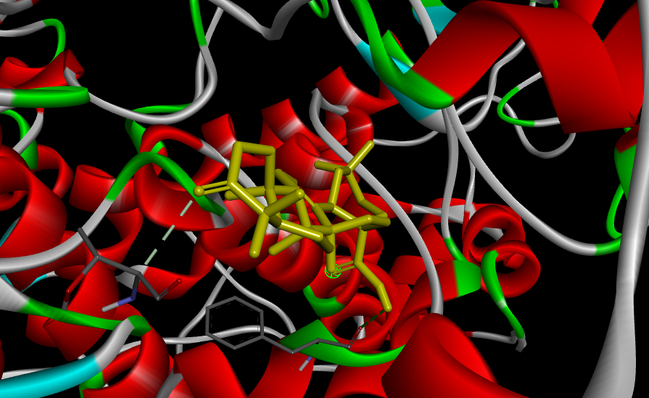 | 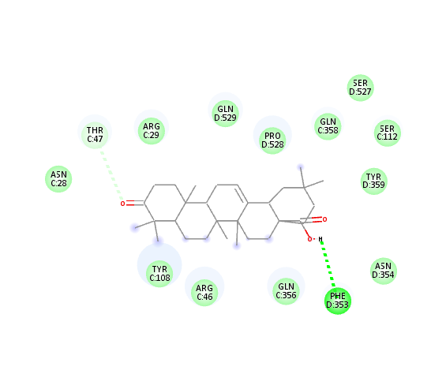
4  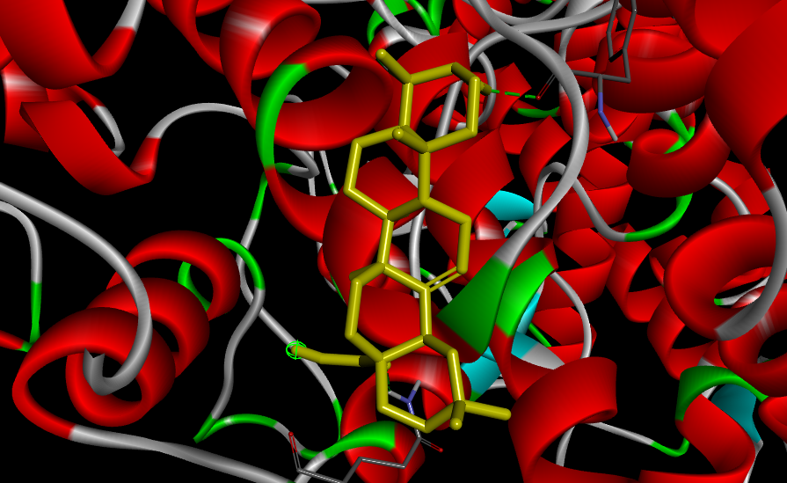 | 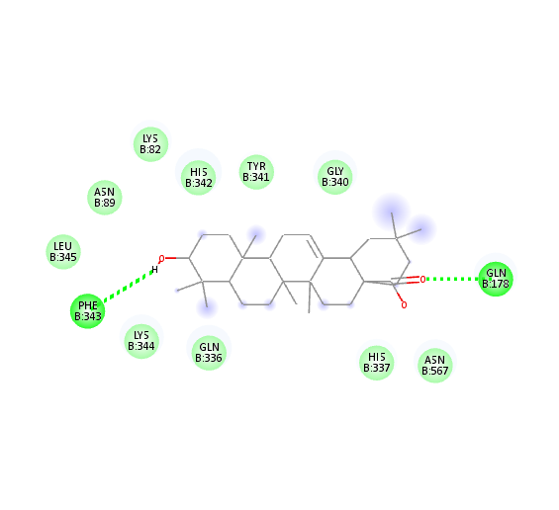
1  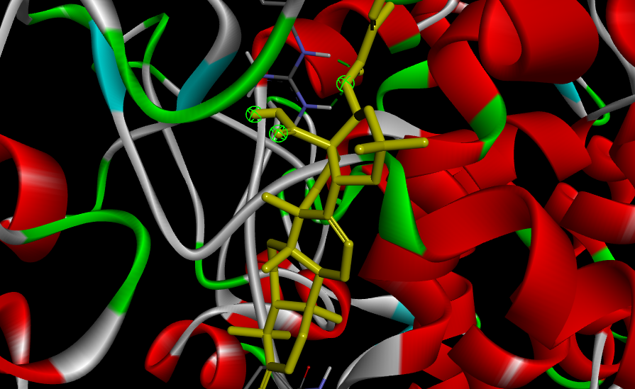 | 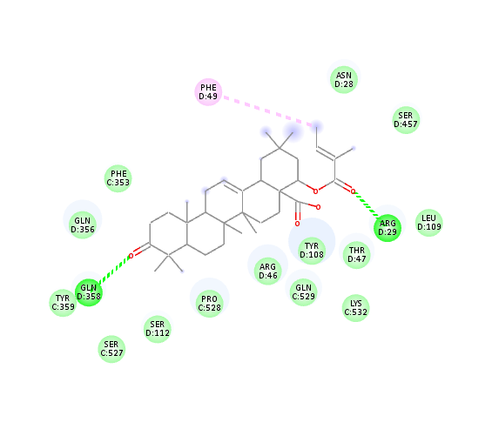
6  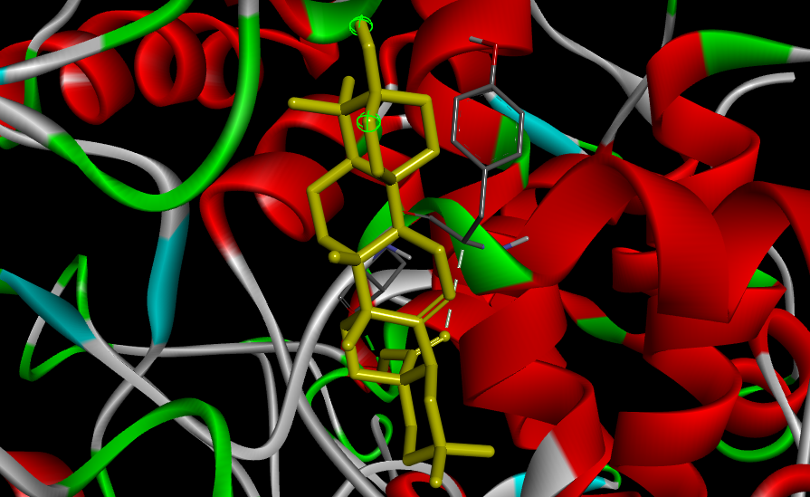 | 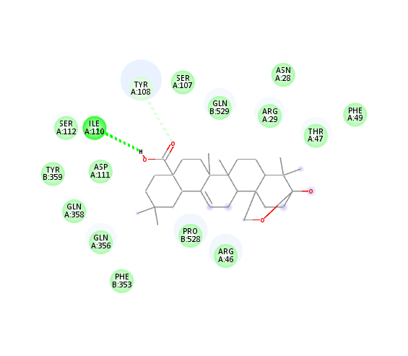
7  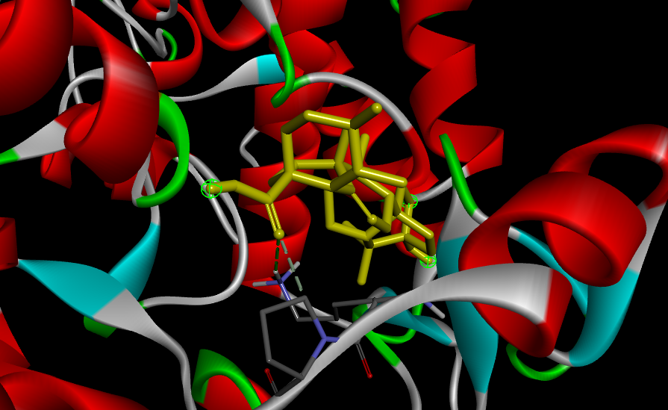 | 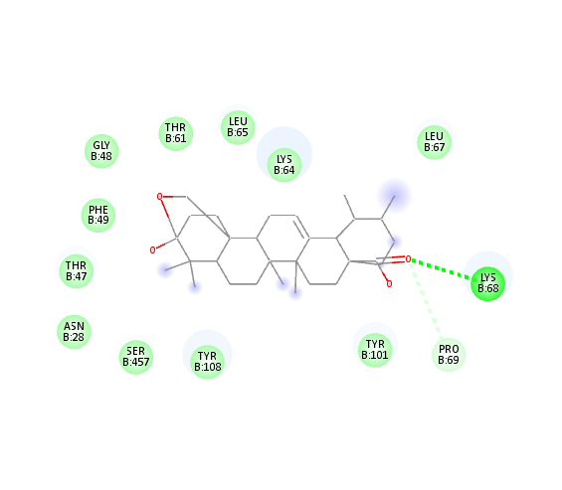
8  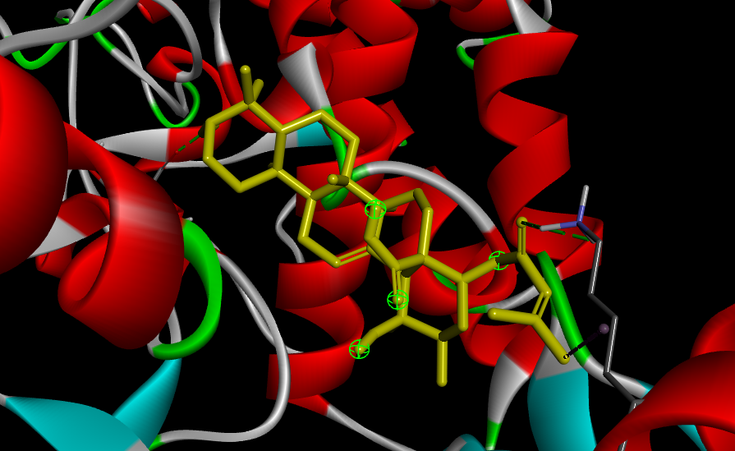 | 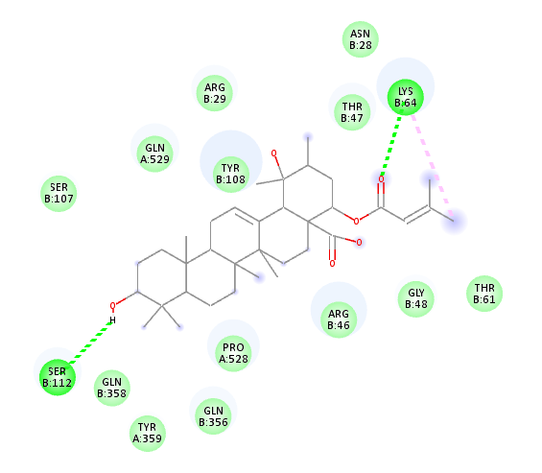
11
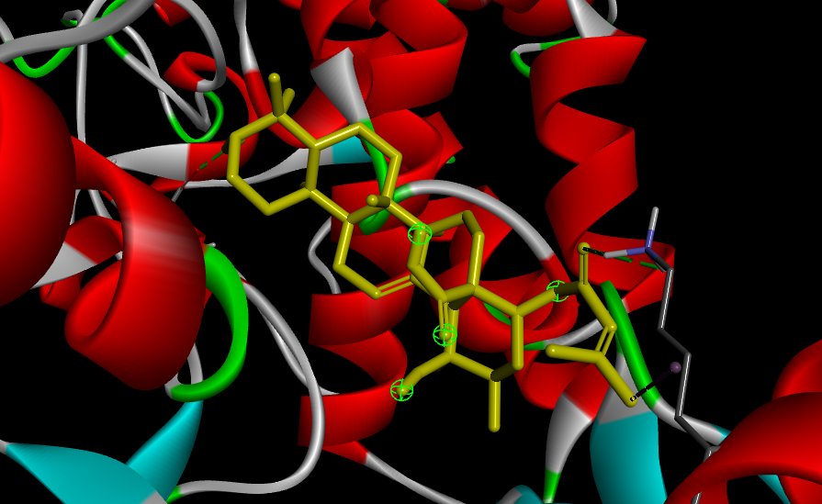
13  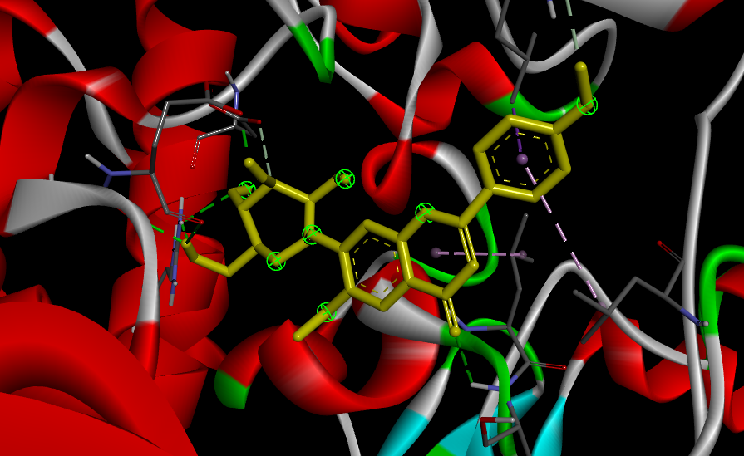 | 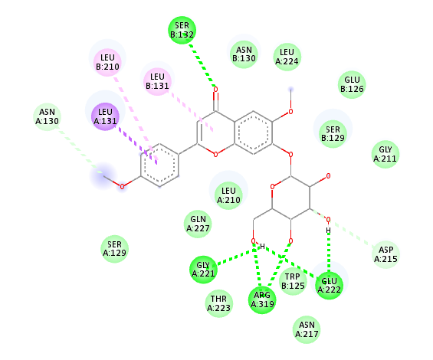
14  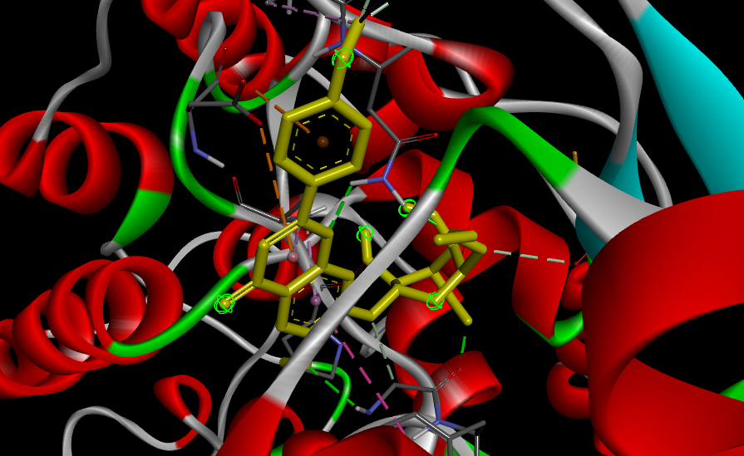 | 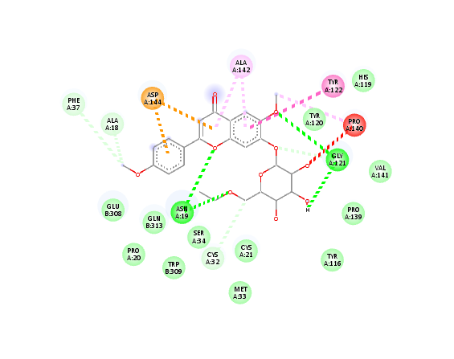
12  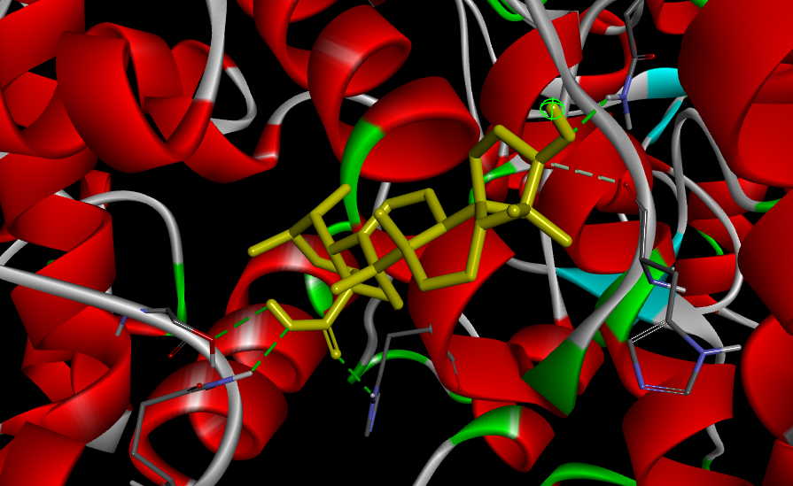 | 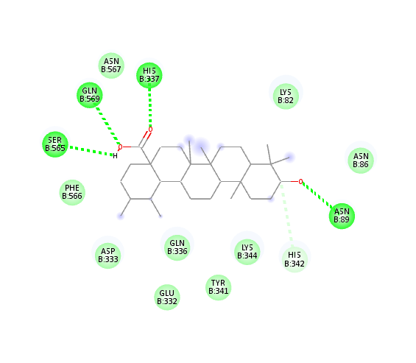
15  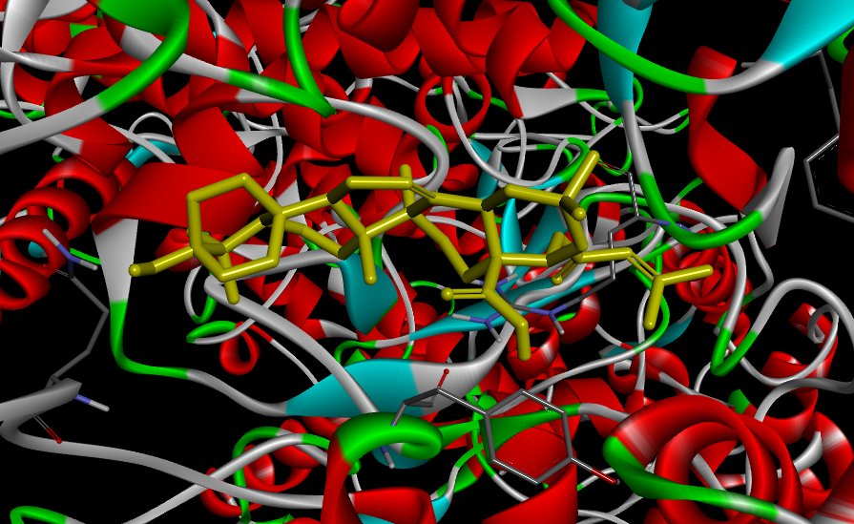 | 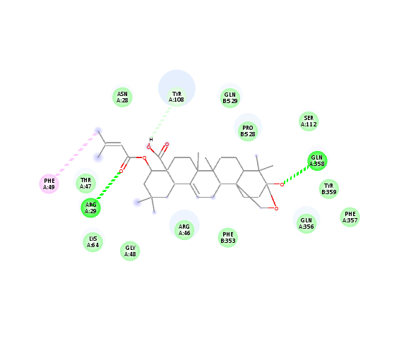
32  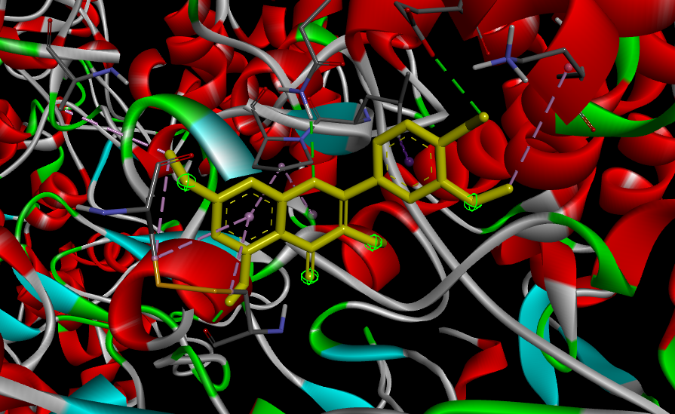 | 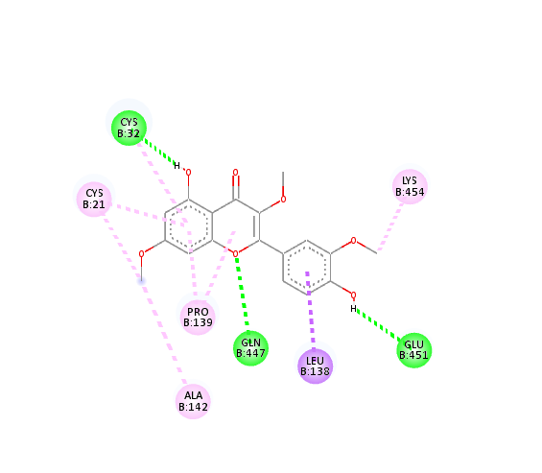
33  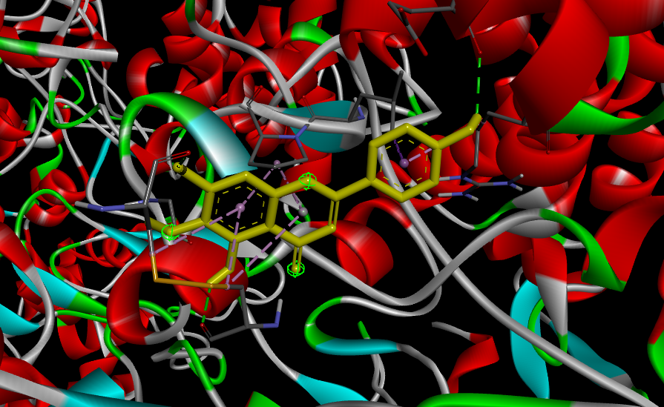 | 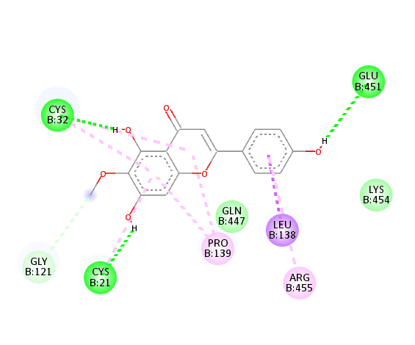
34  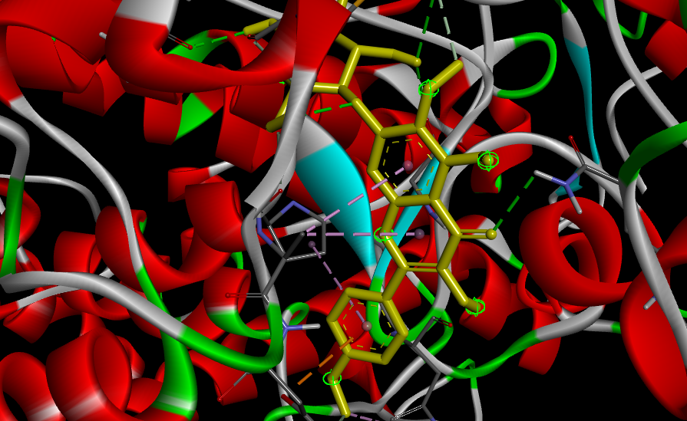 | 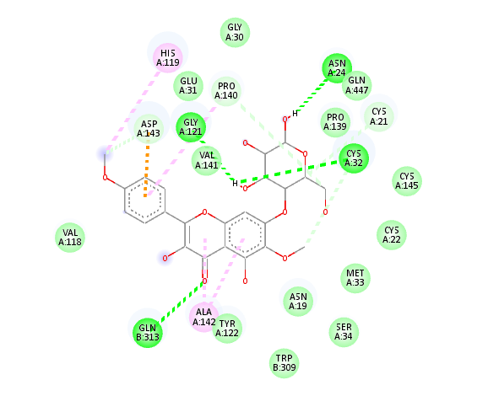

DOCKING INTRACTION OF LIGAND WITH COX-1
2  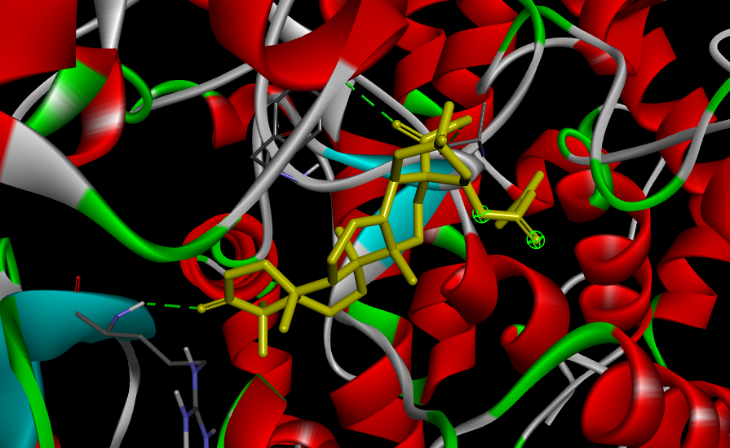 | 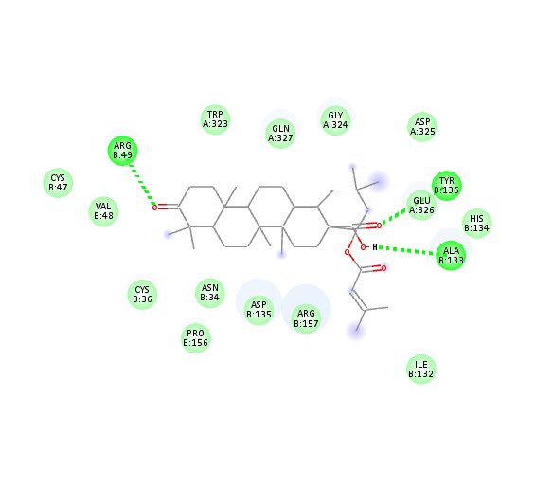
6  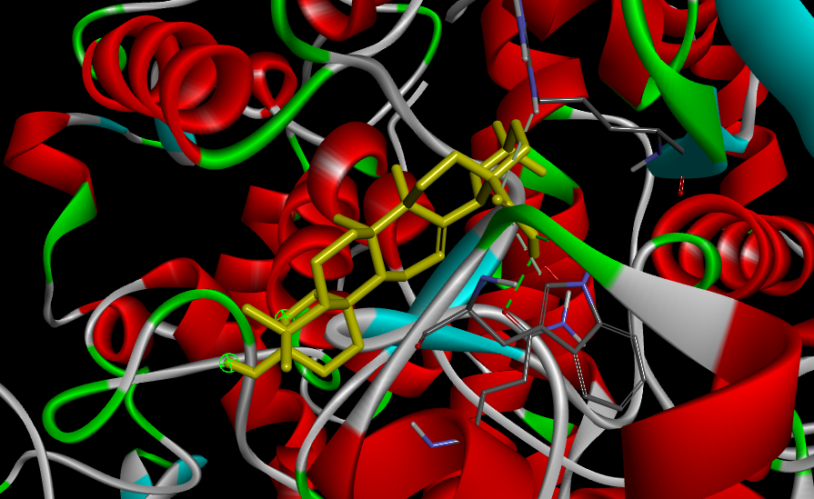 | 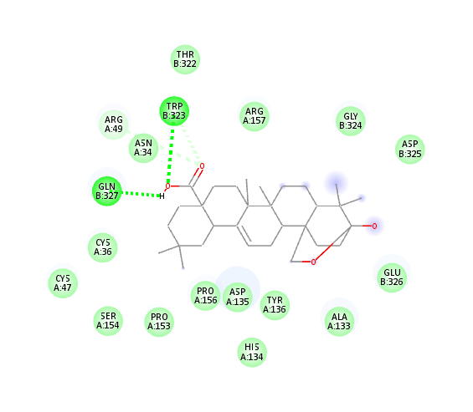
7  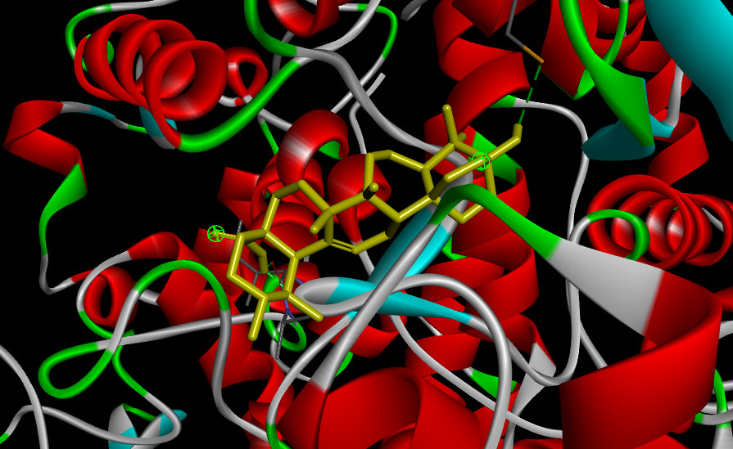 | 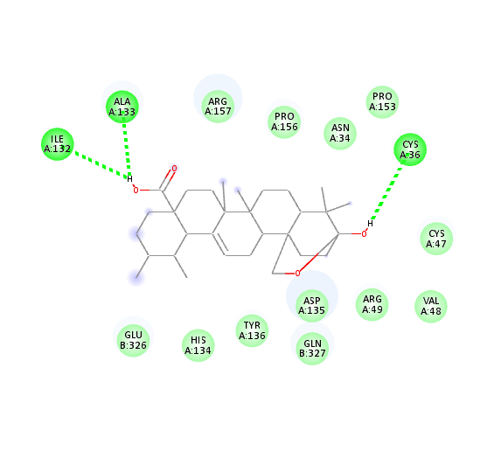
8  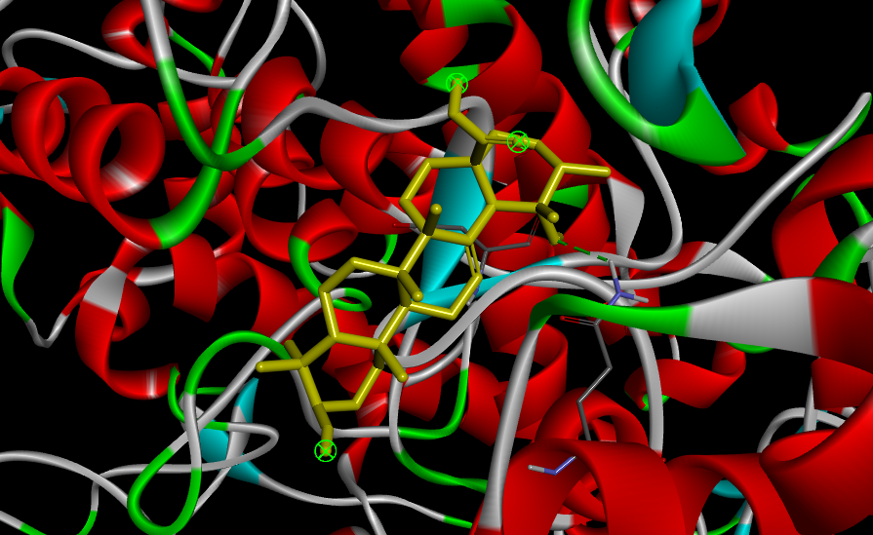 | 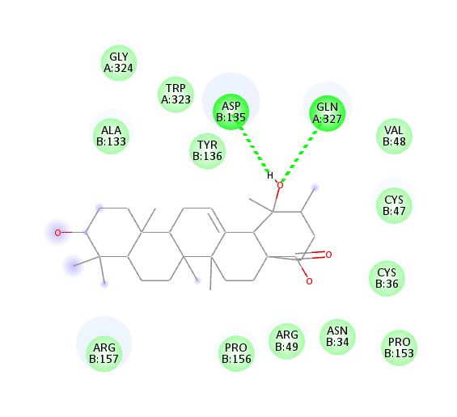
34  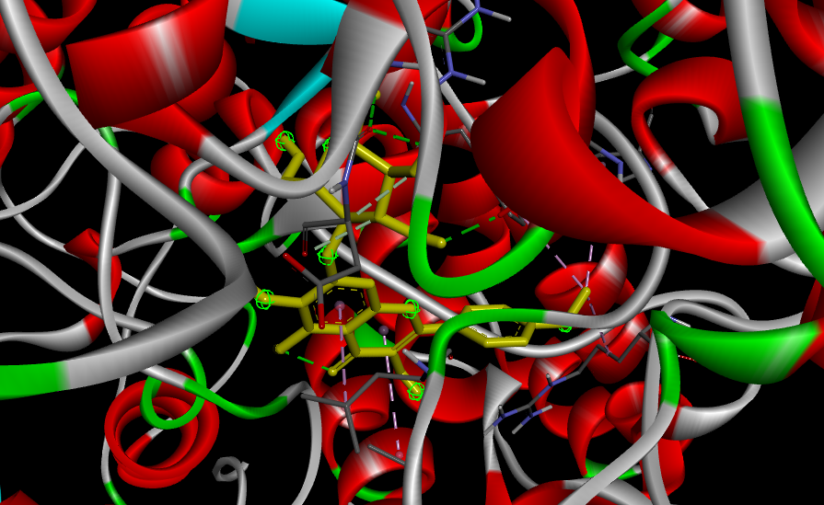 | 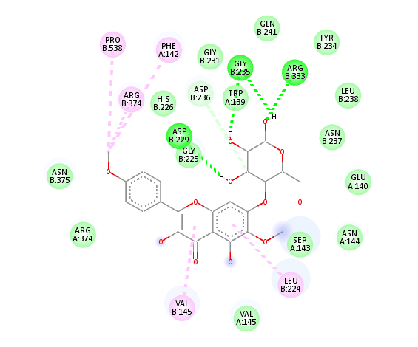
13  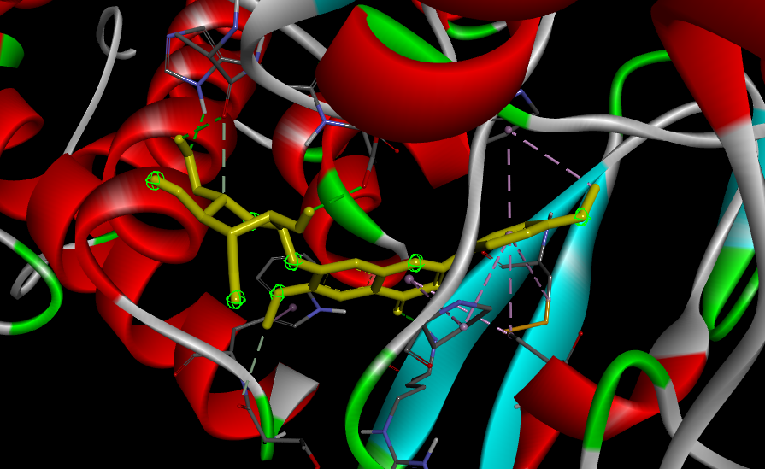 | 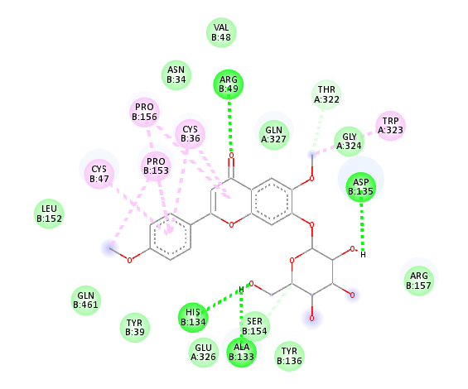
11  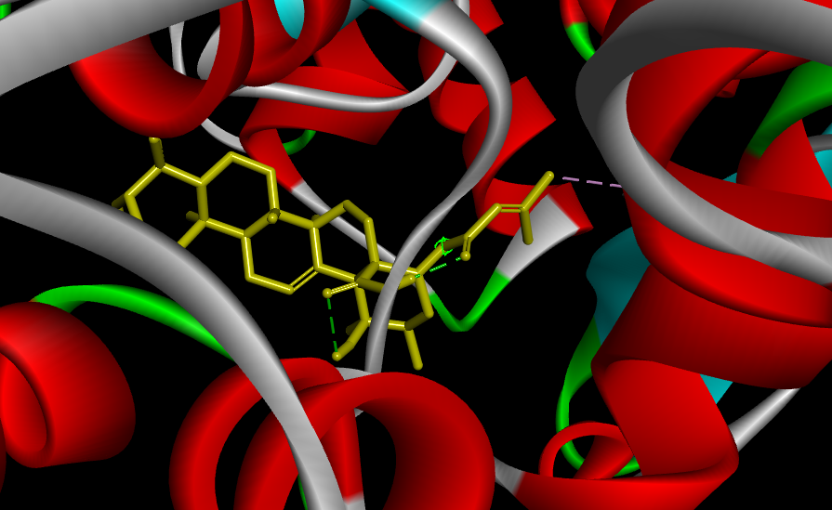 | 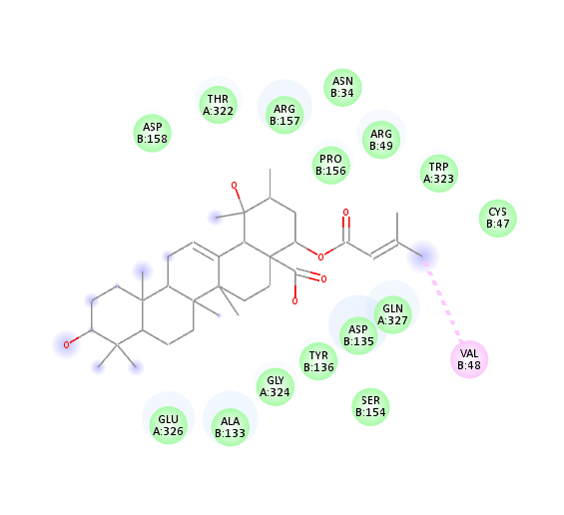
9  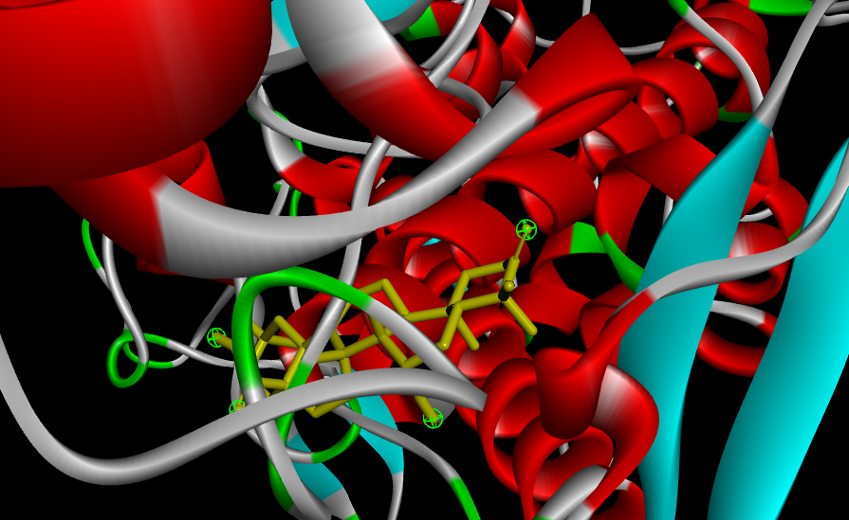 | 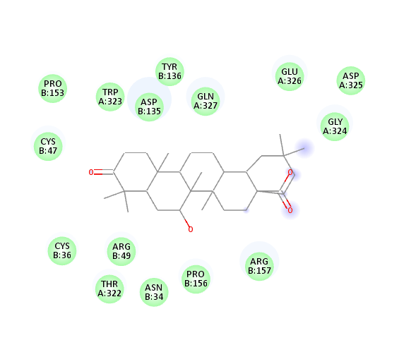

ADMET value of Selected Phytochemical Ligands and Three Standard Compounds.

Ligand | MW | nRB | nHBA | nHBD | TPSA | MLogP | LD ₅₀ | HPT | nLV
1 | 552.78 | 4 | 5 | 1 | 80.67 | 5.61 | 2.321 | No | 2
2 | 552.78 | 4 | 5 | 1 | 80.67 | 5.61 | 2.39 | No | 2
3 | 470.68 | 1 | 4 | 2 | 74.6 | 4.87 | 2.43 | No | 1
4 | 456.7 | 1 | 3 | 2 | 57.53 | 5.82 | 2.214 | Yes | 1
5 | 454.68 | 1 | 3 | 1 | 54.37 | 5.73 | 2.318 | No | 1
6 | 470.68 | 1 | 4 | 2 | 66.76 | 5.38 | 2.264 | Yes | 1
7 | 470.68 | 1 | 4 | 2 | 66.76 | 5.38 | 2.26 | Yes | 1
8 | 472.7 | 1 | 4 | 3 | 77.76 | 4.97 | 2.279 | Yes | 1
9 | 470.68 | 1 | 4 | 2 | 74.6 | 4.87 | 2.903 | No | 1
10 | 570.8 | 4 | 6 | 3 | 104.06 | 4.88 | 2.428 | Yes | 2
11 | 456.7 | 1 | 3 | 2 | 57.53 | 5.82 | 2.339 | Yes | 1
12 | 460.43 | 6 | 10 | 4 | 148.05 | -1.18 | 2.21 | No | 0
13 | 488.48 | 8 | 10 | 3 | 137.05 | -0.76 | 2.566 | No | 0
14 | 568.78 | 4 | 6 | 2 | 93.06 | 5.29 | 2.324 | Yes | 2
15 | 626.56 | 10 | 16 | 9 | 254.52 | -2.77 | 2.582 | No | 3
16 | 486.68 | 1 | 5 | 3 | 86.99 | 4.55 | 2.319 | No | 1
17 | 528.72 | 3 | 6 | 2 | 93.06 | 4.83 | 2.32 | Yes | 2
18 | 582.81 | 5 | 6 | 2 | 100.9 | 4.97 | 2.511 | No | 2
19 | 568.78 | 4 | 6 | 2 | 93.06 | 5.29 | 2.324 | Yes | 2
20 | 554.76 | 4 | 6 | 2 | 100.9 | 4.61 | 2.423 | No | 2
21 | 512.68 | 6 | 6 | 2 | 93.06 | 4.06 | 2.434 | Yes | 1
22 | 528.68 | 7 | 7 | 3 | 113.29 | 3.26 | 2.696 | Yes | 1
23 | 214.17 | 0 | 4 | 1 | 67.51 | -0.1 | 2.719 | No | 0
24 | 214.17 | 0 | 4 | 1 | 67.51 | -0.1 | 2.176 | No | 0
25 | 244.2 | 1 | 5 | 1 | 76.74 | -0.39 | 2.134 | No | 0
26 | 244.2 | 1 | 5 | 1 | 76.74 | -0.39 | 1.931 | No | 0
27 | 244.2 | 1 | 5 | 1 | 76.74 | -0.39 | 2.134 | No | 0
28 | 244.2 | 1 | 5 | 1 | 76.74 | -0.39 | 1.931 | No | 0
29 | 344.32 | 4 | 7 | 2 | 98.36 | 0.17 | 2.083 | No | 0
30 | 344.32 | 4 | 7 | 2 | 98.36 | 0.17 | 1.923 | No | 0
31 | 300.26 | 2 | 6 | 3 | 100.13 | 0.22 | 2.423 | No | 0
32 | 492.43 | 6 | 12 | 6 | 188.51 | -2.16 | 2.692 | No | 2
Aspirin | 180.16 | 3 | 4 | 1 | 63.60 | 1.51 | 2.377 | No | 0
Celecoxib | 381.37 | 4 | 7 | 1 | 86.36 | 2.65 | 2.027 | No | 0

Where, MW= Molecular Weight, nRB= Number of Rotatory Bond, nHBA= Number of Hydrogen Bond Acceptor, nHBD= Number of Hydrogen Bond Donar, TPSA= Total Polar Surface Area, MLogP= Predicted Octanol/Water Partition Coefficient, LD₅₀= Oral Rat Acute Toxicity, HPT= Hepatotoxicity, nLV= Number of Lipinski Violation.

