Supplementary
Table S1 The estimated pharmacokinetic parameters of the DHA concentration from each patient
PID | time at max Conc ($t_{m}$) (hours) | Max concentration($c_{m}$)(ng/ml) | Elimination rate ($k$) (/hour) | Site
M001 | 0.76 | 2233.65 | 1.05 | Wang Pha
M003 | 3.58 | 214.10 | 0.89 | Wang Pha
M005 | 0.75 | 1467.06 | 1.01 | Wang Pha
M006 | 1.40 | 1196.41 | 1.07 | Wang Pha
M007 | 0.74 | 857.15 | 0.78 | Wang Pha
M011 | 2.51 | 1133.77 | 1.47 | Wang Pha
M012 | 1.05 | 468.96 | 0.46 | Wang Pha
M013 | 0.45 | 532.87 | 0.65 | Wang Pha
M014 | 0.48 | 1360.17 | 1.20 | Wang Pha
M021 | 1.09 | 654.98 | 1.23 | Wang Pha
M023 | 1.16 | 960.78 | 0.88 | Wang Pha
M024 | 1.16 | 1326.49 | 1.37 | Wang Pha
M026 | 1.15 | 1086.55 | 1.04 | Wang Pha
M030 | 1.04 | 551.68 | 0.92 | Wang Pha
M032 | 1.10 | 1423.83 | 0.82 | Wang Pha
M035 | 0.55 | 1350.98 | 1.29 | Wang Pha
M036 | 0.89 | 278.56 | 0.33 | Wang Pha
M037 | 1.04 | 933.01 | 1.00 | Wang Pha
M039 | 2.03 | 461.77 | 0.97 | Wang Pha
P002 | 0.88 | 743.88 | 1.13 | Pailin
P003 | 0.49 | 1119.99 | 0.70 | Pailin
P006 | 4.26 | 379.47 | 1.16 | Pailin
P008 | 0.95 | 675.77 | 0.56 | Pailin
P009 | 1.93 | 1574.32 | 0.74 | Pailin
P011 | 1.10 | 752.57 | 0.88 | Pailin
P013 | 0.61 | 891.70 | 1.54 | Pailin
P014 | 1.06 | 986.04 | 0.60 | Pailin
P018 | 1.22 | 645.94 | 1.12 | Pailin
P020 | 1.27 | 1105.08 | 0.89 | Pailin
P021 | 2.17 | 901.20 | 1.27 | Pailin
P022 | 2.48 | 731.25 | 0.70 | Pailin
P023 | 0.52 | 962.26 | 1.14 | Pailin
P025 | 0.96 | 1146.51 | 0.97 | Pailin
P030 | 3.26 | 662.98 | 1.91 | Pailin
P031 | 3.17 | 398.19 | 0.88 | Pailin
P033 | 1.26 | 139.97 | 0.31 | Pailin
P035 | 1.08 | 1019.50 | 1.33 | Pailin
P037 | 3.01 | 255.69 | 0.61 | Pailin
P039 | 0.41 | 2983.38 | 0.88 | Pailin

Table S2 Mean (SD) of the pharmacokinetic parameters of the DHA concentrations
Site | $$t_{m}$$ | $$c_{m}$$ | $$k$$
Wang Pha | 1.21(0.76) | 973.30(505.75) | 0.97(0.29)
Pailin | 1.61(1.10) | 903.78(595.28) | 0.97(0.37)

Table S3 Median (25th ,75th percentiles) of the simulated parasite clearance times as shown in Figure 6
Site | Every 24 hours | Every 12 hours
Wang Pha | 30.0 (20.75, 50.75) | 23.0 (16.25, 44.25)
Pailin | 73.5 (53.5, 93.5) | 70.5 (51.5, 89.5)

Figure S1 The results from fitting the model to the parasite clearance data from patients who received artesunate monotherapy in Wang Pha, Thailand. In each plot, the blue dots represent the observed data and the grey line represents the median of the model outputs. The light-grey shaded area represents the 95% credible intervals (CIs).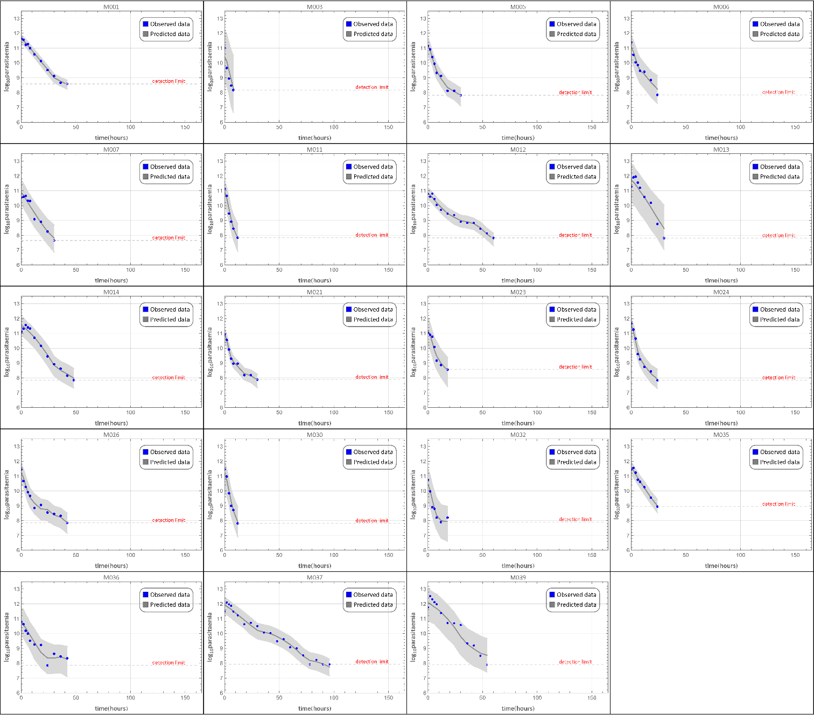
Figure S2 The results from fitting the model to the parasite clearance data from patients who received artesunate monotherapy in Pailin, Cambodia. In each plot, the blue dots represent the observed data and the grey line represents the median of the model outputs. The light-grey shaded area represents the 95% credible intervals (CIs).
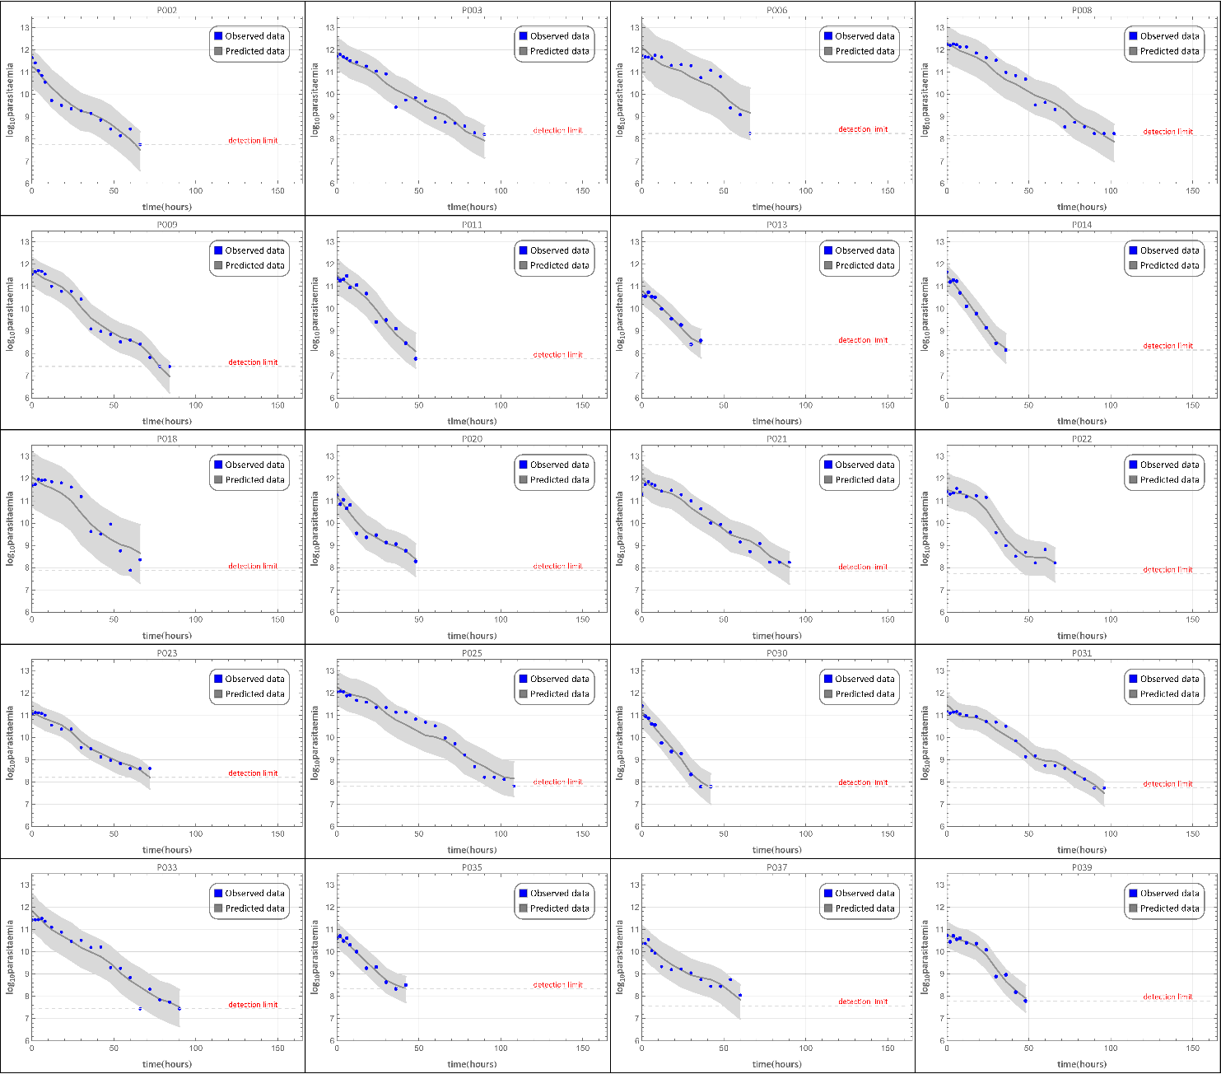
Figure S3 The results from the dose-splitting simulation in Wang Pha, Thailand. The black dots represent the observed data, the purple lines represent the median of the model outputs for taking the drug every 24 hours and the green lines represent the model outputs for taking the drug every 12 hours.
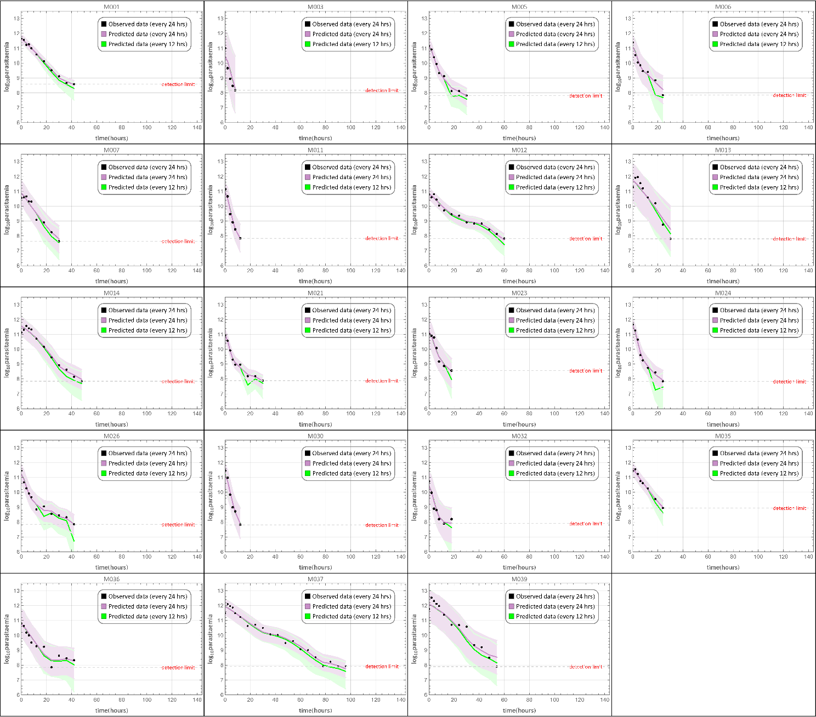
Figure S4 The results from the dose-splitting simulation in Pailin, Cambodia. The black dots represent the observed data, the purple lines represent the median of the model outputs for taking the drug every 24 hours and the green lines represent the model outputs for taking the drug every 12 hours.
