Additional file 1
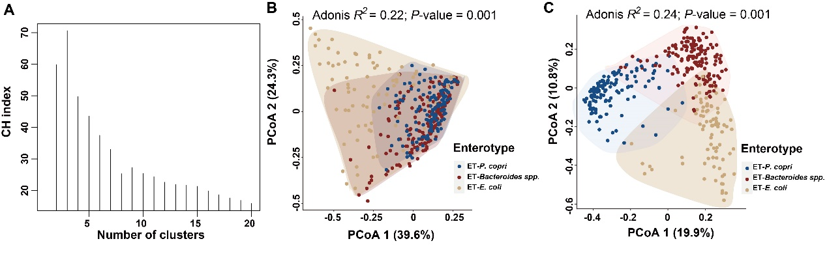
Supplementary Figure S1: Support for three enterotypes in older persons. The Calinski–Harabasz (CH) index was calculated for each set of clusters generated by PAM clustering. The CH index was maximized when gut microbial communities were assigned to three enterotypes. Principal coordinate analysis (PCoA) based on Bray–Curtis dissimilarity metrics showed clustering of samples at the order level (B) and at the species level (C).
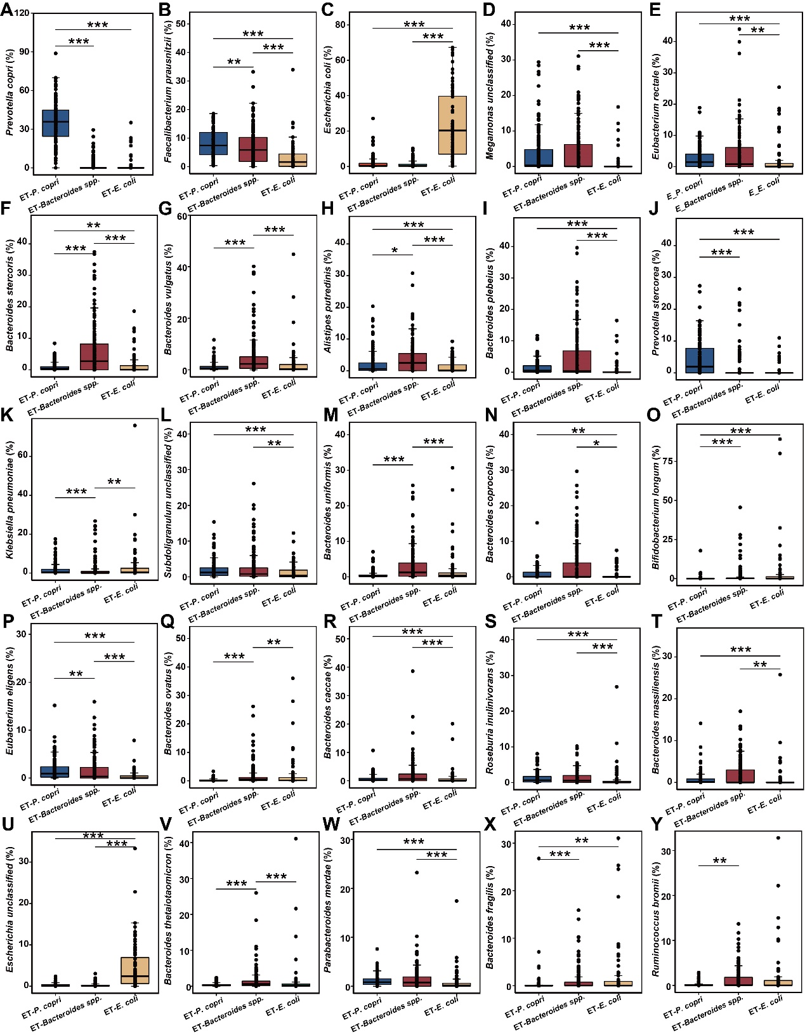
Supplementary Figure S2: Significant difference in the relative abundances of the top 25 most dominant species among the three enterotypes. The average relative abundance of these species was over 1% in at least one enterotype. The means, ranges and first and third quartiles are shown. Wilcoxon rank-sum test: P<0.05; **P<0.01; ***P<0.001.
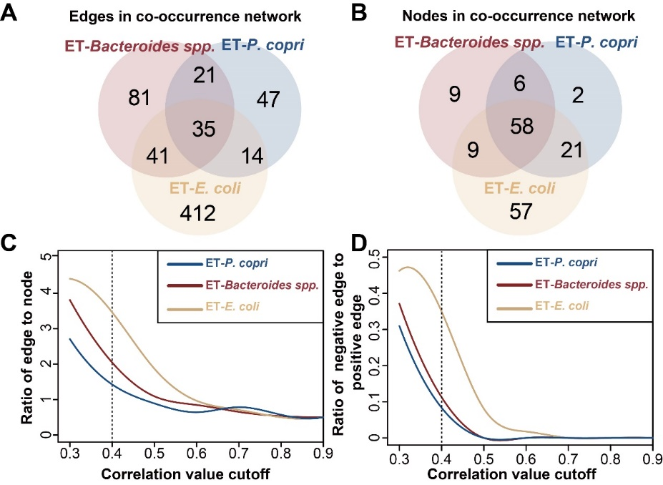
Supplementary Figure S3: Edges and nodes in each co-occurrence network.
A and B: Venn diagrams showing the number of unique and shared edges and nodes. C and D: Number of nodes retained and ratio of edges to nodes in each co-occurrence network under different correlation value cutoffs from 0.3 to 0.9.

Supplementary Table S2: Results of the Kolmogorov–Smirnov test comparing bootstrapped node attributes of co‐occurrence networks of the three enterotypes. For each network, node attributes were computed by a bootstrapping approach with 10,000 iterations.
Comparison | Degree | Betweenness | Closeness | Transitivity
ET-P. copri vs. ET-Bacteroides spp. | 0.1171*** | 0.1183*** | 0.1018*** | 0.3746***
ET-E. coli vs. ET-Bacteroides spp. | 0.0721*** | 0.1015*** | 0.0994*** | 0.0823***
ET-P. copri vs. ET-E. coli | 0.1177*** | 0.1404*** | 0.1606*** | 0.3786***
The Kolmogorov–Smirnov test compares the overall shape of the cumulative distribution of two variables, where the null hypothesis is that the variables have the same distribution patterns. The values in each box represent D, which is the maximum difference in the absolute cumulative distribution function. ***P < 0.001.
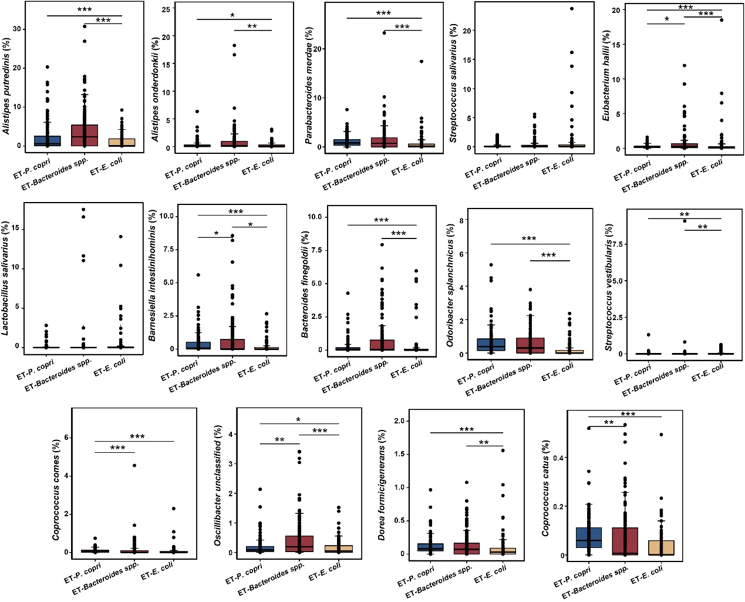
Supplementary Figure S4: Significant differences in the relative abundances of the selected biotic driver species among enterotypes. The species identified by NetShift with NESH score values > 2 were the main drivers facilitating several changes between co-occurrence networks. The means, ranges and first and third quartiles are shown. Wilcoxon rank-sum test: P < 0.05; **P < 0.01; ***P < 0.001.
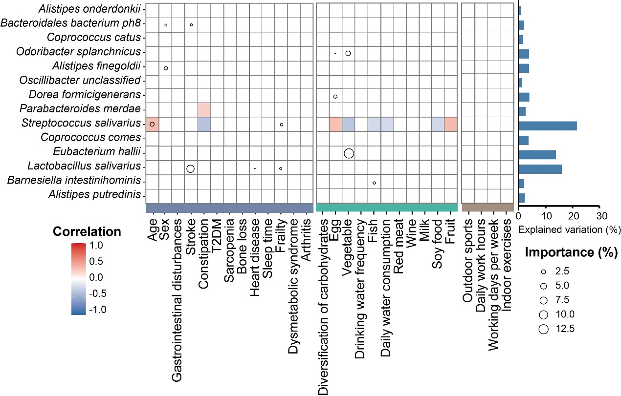
Supplementary Figure S5: Association between clinical and demographic variables and the relative abundances of the biotic driver species. The color bar shows correlation values, where red indicates a positive association, blue indicates a negative association, and only significant correlations are shown. Circle sizes represent the value of importance (%).

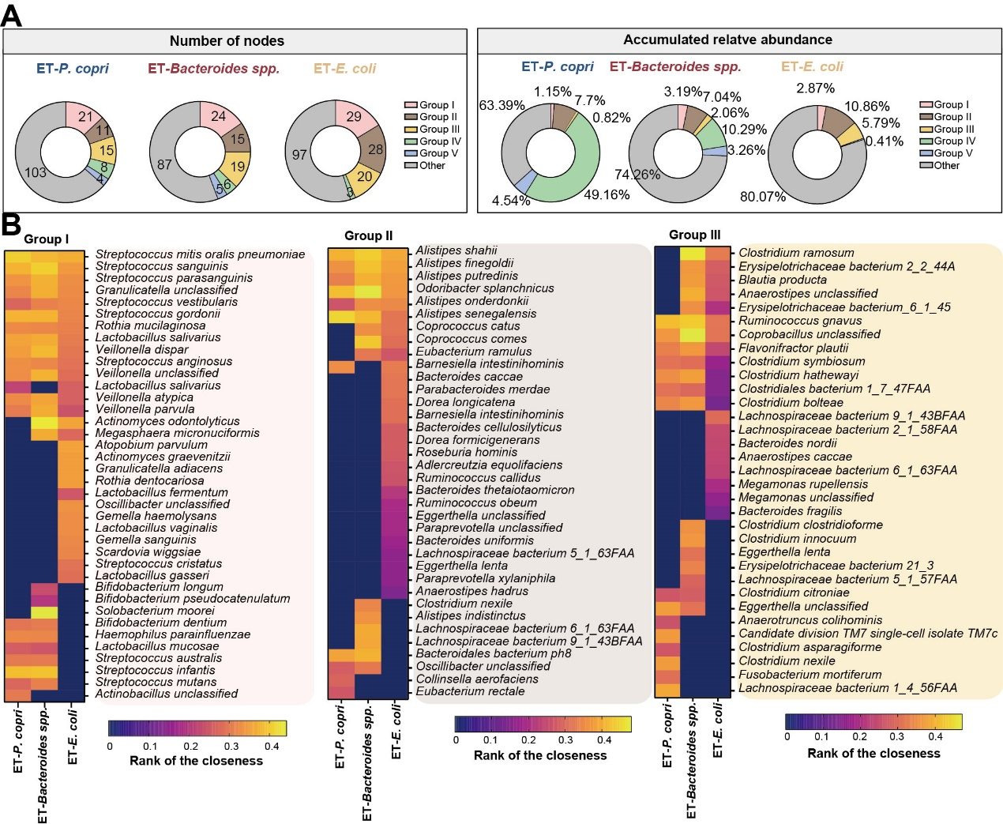
Supplementary Figure S6: Discrepancies in the centralities (rank of the closeness) of co-occurring taxa in the main groups. A: Donut charts show the number of nodes and their cumulative relative abundances in each group of the three co-occurrence networks. B: Centralities (rank of closeness) and unique nodes in the main groups in each enterotype.
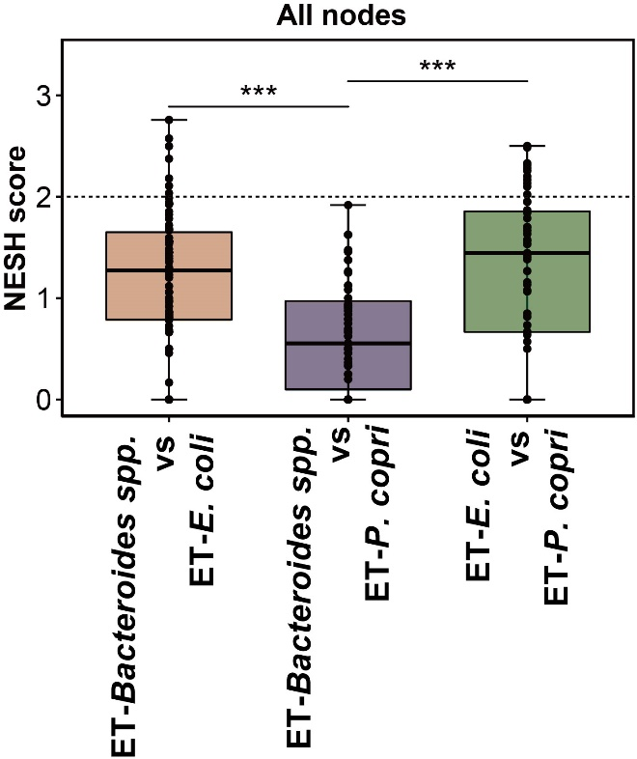
Supplementary Figure S7: Composition of NESH score values of nodes.
The means, ranges and first and third quartiles are shown. Wilcoxon rank-sum test: P<0.05; **P<0.01; ***P<0.001.
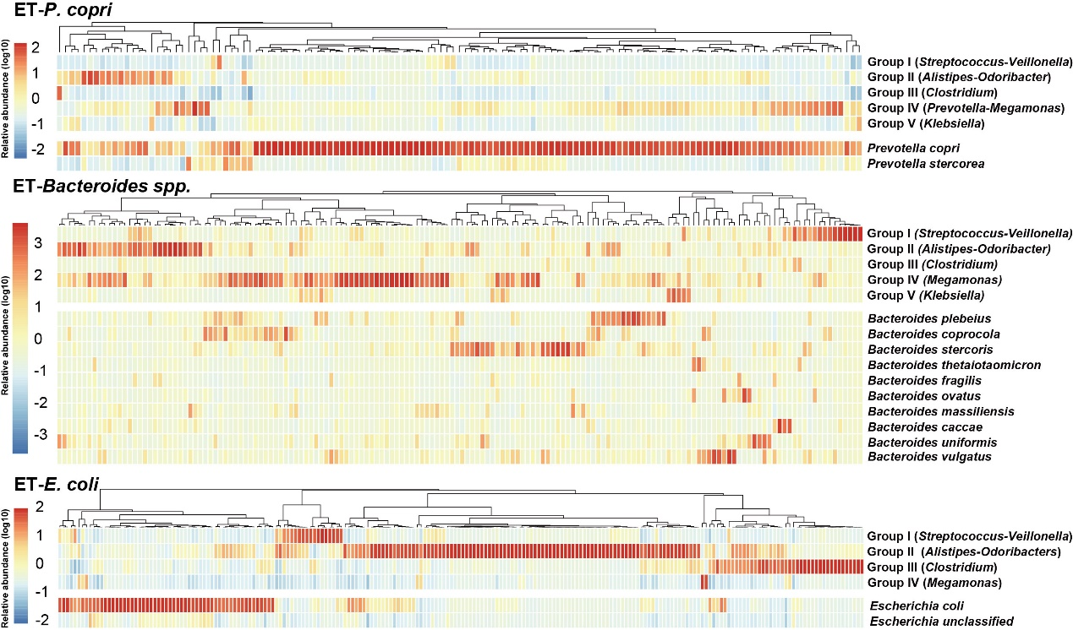
Supplementary Figure S8: Heatmap showing the prevalence of the main groups of co-occurring species and predominant species in each enterotype. The color bar shows the accumulated relative abundance of a group or the relative abundance of the predominant species, with darker colors indicating higher relative abundances.

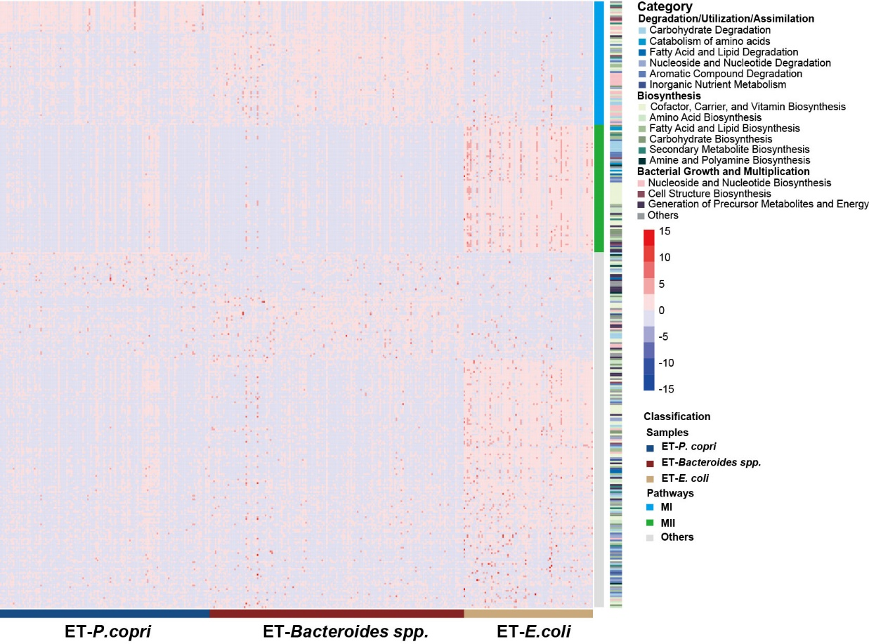
Supplementary Figure S9: Analysis of stool samples using shotgun metagenomics.
The heatmap shows a clustering of functional pathways significantly differentially enriched in each enterotype classified by metabolic categories or functional modules calculated using the SPIEC-EASI (glasso) method.

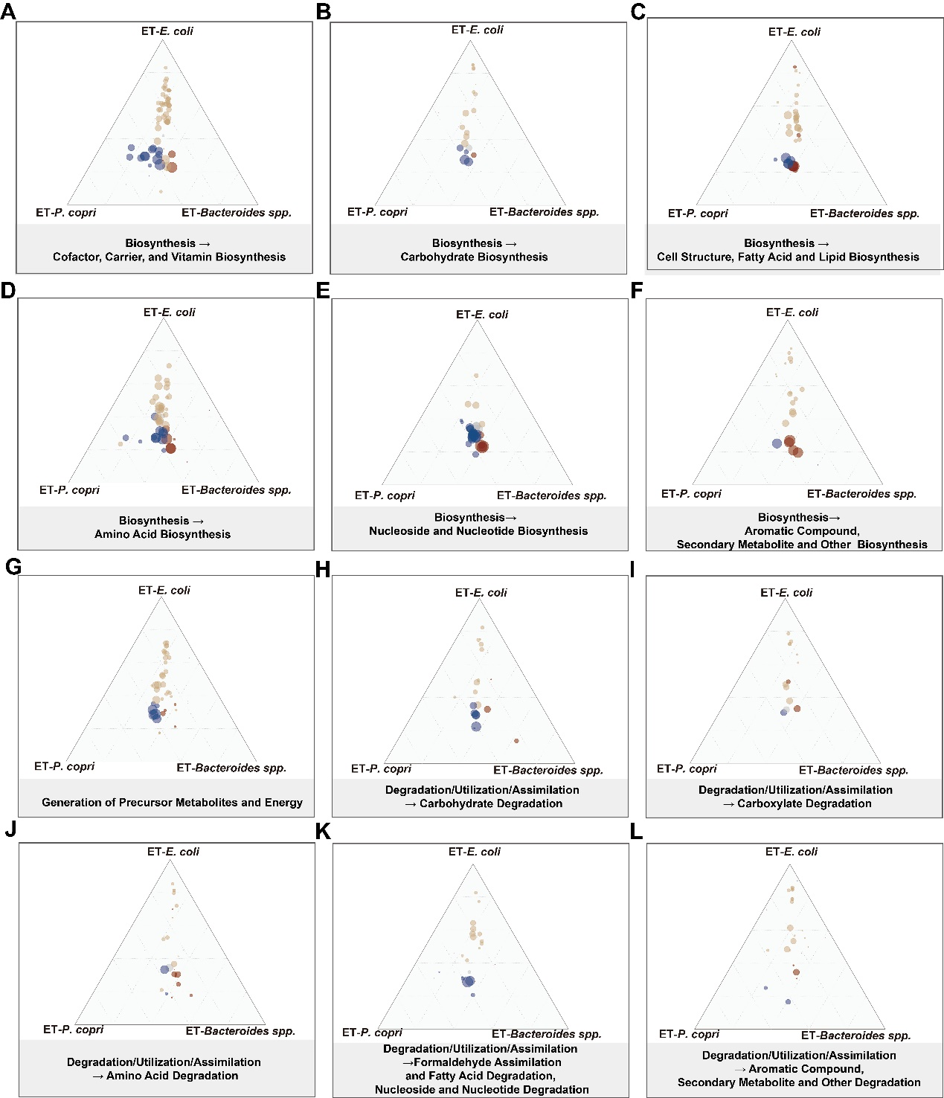
Supplementary Figure S10: Comparison of metabolic capacity between enterotypes.
Dot sizes represent the mean relative abundances of pathways. Bacterial functions that were significantly enriched (FDR-corrected *p < 0.05) in the comparison among enterotypes are indicated in color (red, ET-Bacteroides spp.; gold, ET-E. coli; blue, ET-P. copri); pathways without significant differences in relative abundance are indicated in gray. Pathways from the same metabolic category are presented in each diagram. The closer the point is to the apex of the triangle, the higher the abundance of this pathway in the corresponding enterotype.

