Table S1. Patients’ characteristics for RNA sequencing
Parameters | Cachexia (n = 3)
Ages (years) | 61.5±7.4
Sex (n) | Male (3)
BMI (kg/m²) | 21.9±2.1
Proportion of weight loss in recent 6 months (%) | 9.5±1.6
Lymphocyte count (10^9/L) | 1.4±0.1
Albumin (g/L) | 35.6±3.9
IL-6 (pg/ml ) | 9.8±1.3
TNF-α (pg/ml) | 11.2±1.8
TNM stage III+IV(n) | 3
VAT area (cm²) | 75.5±15.2
SAT area (cm²) | 69.2±12.4
BMI, body mass index; IL-6, interleukin-6; TNF-α, tumor necrosis factor-α; SAT: subcutaneous adipose tissue; VAT: visceral adipose tissue

Table S2. Primer Sequences used for qRT-PCR.
Name |  | Mouse
ATGL | Forward | CAACGCCACTCACATCTACG
 | Reverse | AGCAGGCAGGGTCTTCAGT
HSL | Forward | CCTCAAAGTCAAACCCTCCA
 | Reverse | GTGCGTAAATCCATGCTGT
UCP1 | Forward | CACCTTCCCGCTGGACACT
 | Reverse | CCCTAGGACACCTTTATACCTAATGG
PRDM16 | Forward | ACTGAAGGAGGCCGACTTTG
 | Reverse | CGGAATGTGGGGTCCTCATC
CPT1 | Forward | TCGGTGAGCCTGGCCT
 | Reverse | TTGAGTGGTGACCGAGTCTG
AdipoQ | Forward | CCAATGTACCCATTCGCTTTAC
 | Reverse | GAAGTAGTAGAGTCCCGGAATG
FABP4 | Forward | CATCCGGTCAGAGAGTACTTTT
 | Reverse | TAGGGTTATGATGCTCTTCACC
CEBPα | Forward | AAGCCAAACAACGCAACGTG
 | Reverse | ACCAAGGAGCTCTCAGGCAG
GAPDH | Forward | TTGCCCTCAACGACCACTTT
 | Reverse | TGGTCCAGGGGTCTTACTCC
IRX1 | Forward | AGTATGAACTGAAGGACAACCC
 | Reverse: | ACCATAGGGATAATAAGCAGGC
β-ACTIN | Forward: | AGGTGTGCACCTTTTATTGGTCTCAA
 | Reverse: | TCCCTCTGGTTTGGAAGTATGT

Figure S1.
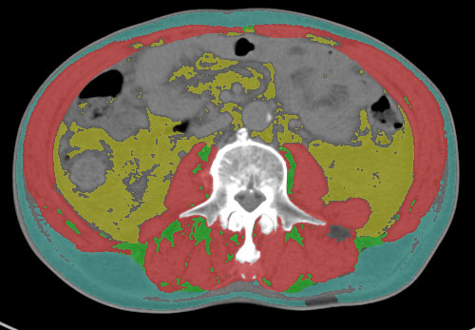

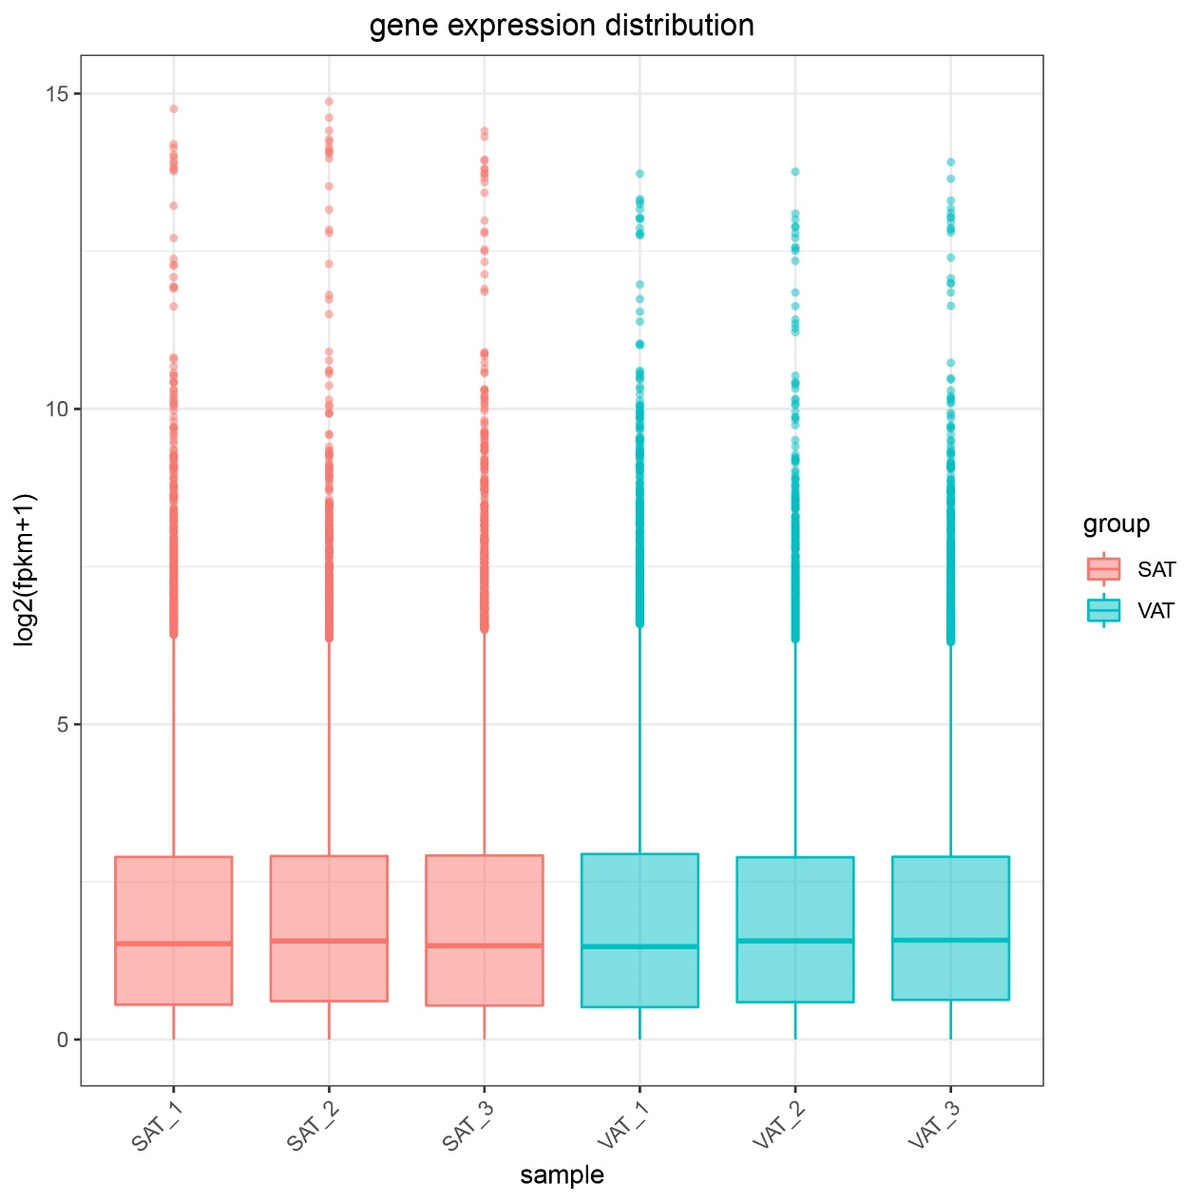
Figure S2.

