APPENDIX A

Table 1.1 - Search strategy Medline
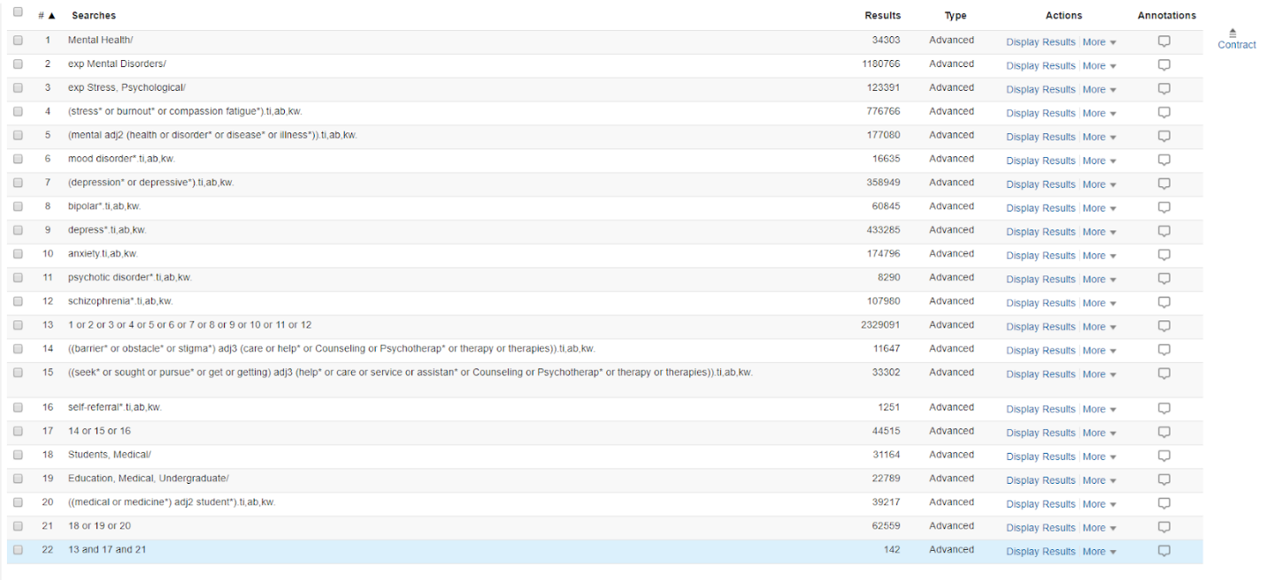

Table 1.2 - Search Strategy Embase
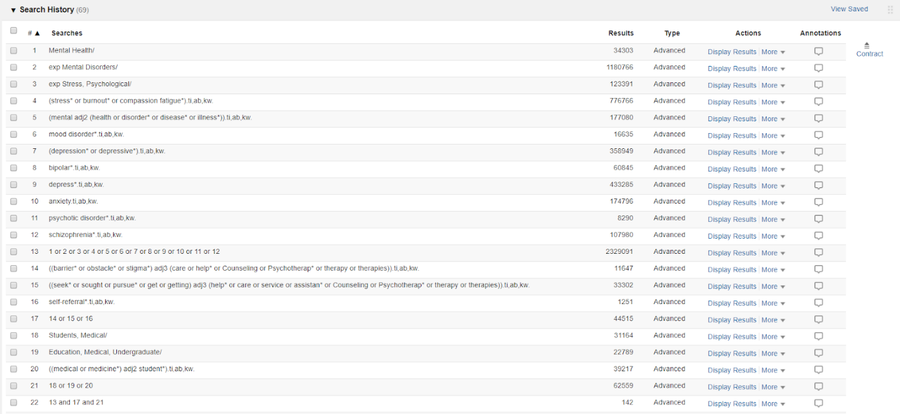
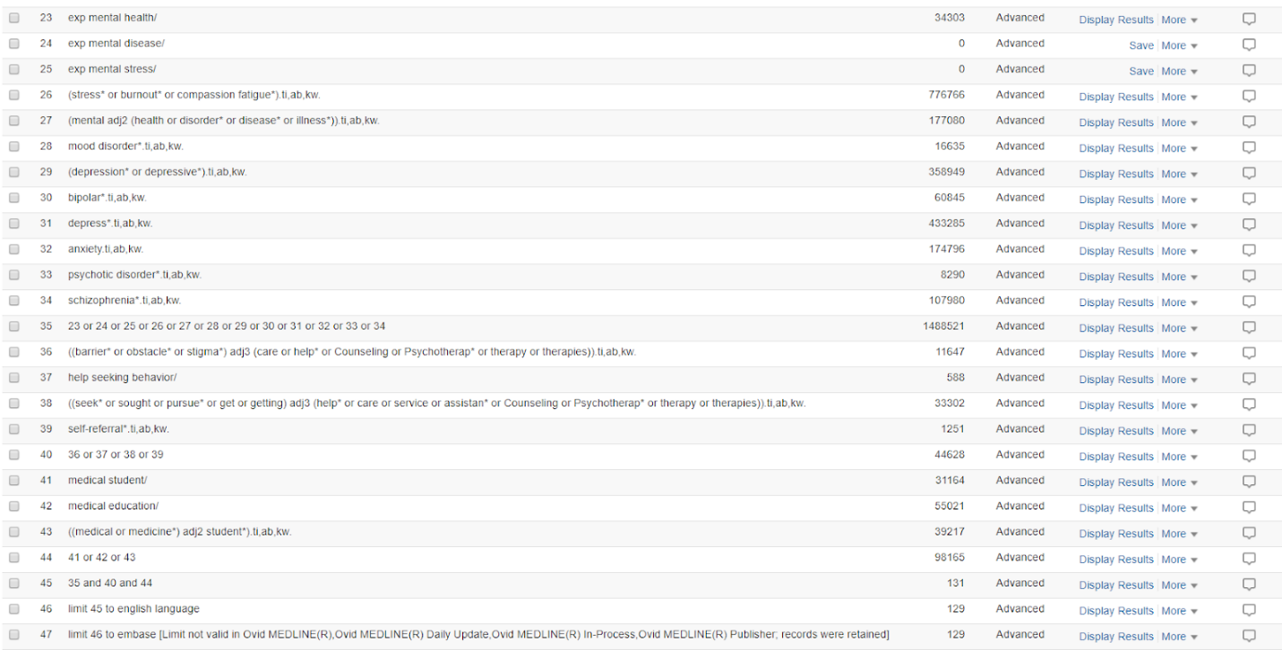
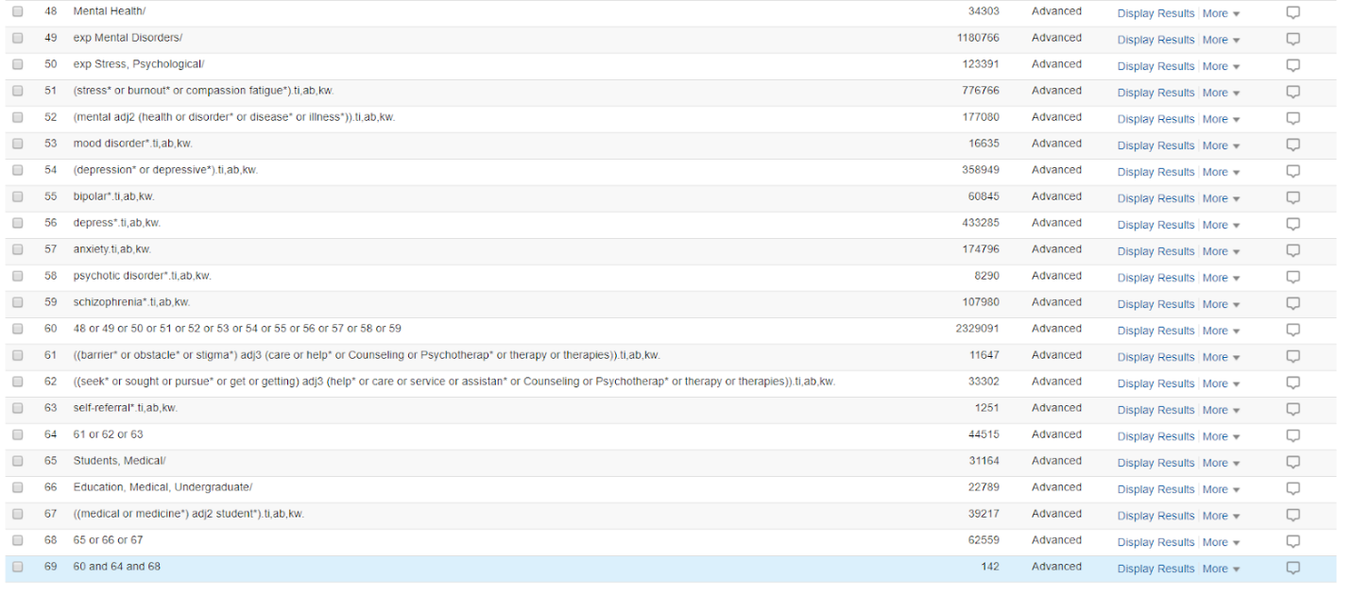

Table 1.3 - Search Strategy PsychInfo
# | Searches | Results
1 | exp mental health/ | 66222
2 | exp mental disorders/ | 855958
3 | exp stress/ | 115002
4 | (stress* or burnout* or compassion fatigue*).tw. | 272840
5 | (mental adj2 (health or disorder* or disease* or illness*)).tw. | 267851
6 | mood disorder*.tw. | 17278
7 | (depression* or depressive* or bipolar* or depress* or anxiety or psychotic disorder* or schizophrenia*).tw. | 534816
8 | 1 or 2 or 3 or 4 or 5 or 6 or 7 | 1356613
9 | ((barrier* or obstacle* or stigma*) adj3 (care or help* or Counseling or Psychotherap* or therapy or therapies)).tw. | 6776
10 | ((seek* or sought or pursue* or get or getting) adj3 (help* or care or service or assistan* or Counseling or Psychotherap* or therapy or therapies)).tw. | 26954
11 | exp help seeking behavior/ | 13578
12 | self-referral*.tw. | 441
13 | 9 or 10 or 11 or 12 | 39476
14 | medical students/ | 13366
15 | medical education/ | 17877
16 | ((medical or medicine*) adj2 student*).tw. | 15783
17 | 14 or 15 or 16 | 28656
18 | 8 and 13 and 17 | 166
19 | limit 18 to english language | 154
20 | exp mental health/ | 66222
21 | exp mental disorders/ | 855958
22 | exp stress/ | 115002
23 | (stress* or burnout* or compassion fatigue*).tw. | 272840
24 | (mental adj2 (health or disorder* or disease* or illness*)).tw. | 267851
25 | mood disorder*.tw. | 17278
26 | (depression* or depressive* or bipolar* or depress* or anxiety or psychotic disorder* or schizophrenia*).tw. | 534816
27 | 20 or 21 or 22 or 23 or 24 or 25 or 26 | 1356613
28 | ((barrier* or obstacle* or stigma*) adj3 (care or help* or Counseling or Psychotherap* or therapy or therapies)).tw. | 6776
29 | ((seek* or sought or pursue* or get or getting) adj3 (help* or care or service or assistan* or Counseling or Psychotherap* or therapy or therapies)).tw. | 26954
30 | exp help seeking behavior/ | 13578
31 | self-referral*.tw. | 441
32 | 28 or 29 or 30 or 31 | 39476
33 | medical students/ | 13366
34 | medical education/ | 17877
35 | ((medical or medicine*) adj2 student*).tw. | 15783
36 | 33 or 34 or 35 | 28656
37 | 27 and 32 and 36 | 166
38 | limit 37 to english language | 154
39 | exp mental health/ | 66222
40 | exp mental disorders/ | 855958
41 | exp stress/ | 115002
42 | (stress* or burnout* or compassion fatigue*).tw. | 272840
43 | (mental adj2 (health or disorder* or disease* or illness*)).tw. | 267851
44 | mood disorder*.tw. | 17278
45 | (depression* or depressive* or bipolar* or depress* or anxiety or psychotic disorder* or schizophrenia*).tw. | 534816
46 | 39 or 40 or 41 or 42 or 43 or 44 or 45 | 1356613
47 | ((barrier* or obstacle* or stigma*) adj3 (care or help* or Counseling or Psychotherap* or therapy or therapies)).tw. | 6776
48 | ((seek* or sought or pursue* or get or getting) adj3 (help* or care or service or assistan* or Counseling or Psychotherap* or therapy or therapies)).tw. | 26954
49 | exp help seeking behavior/ | 13578
50 | self-referral*.tw. | 441
51 | 47 or 48 or 49 or 50 | 39476
52 | medical students/ | 13366
53 | medical education/ | 17877
54 | ((medical or medicine*) adj2 student*).tw. | 15783
55 | 52 or 53 or 54 | 28656
56 | 46 and 51 and 55 | 166
57 | limit 56 to english language | 154

