Supplementary data

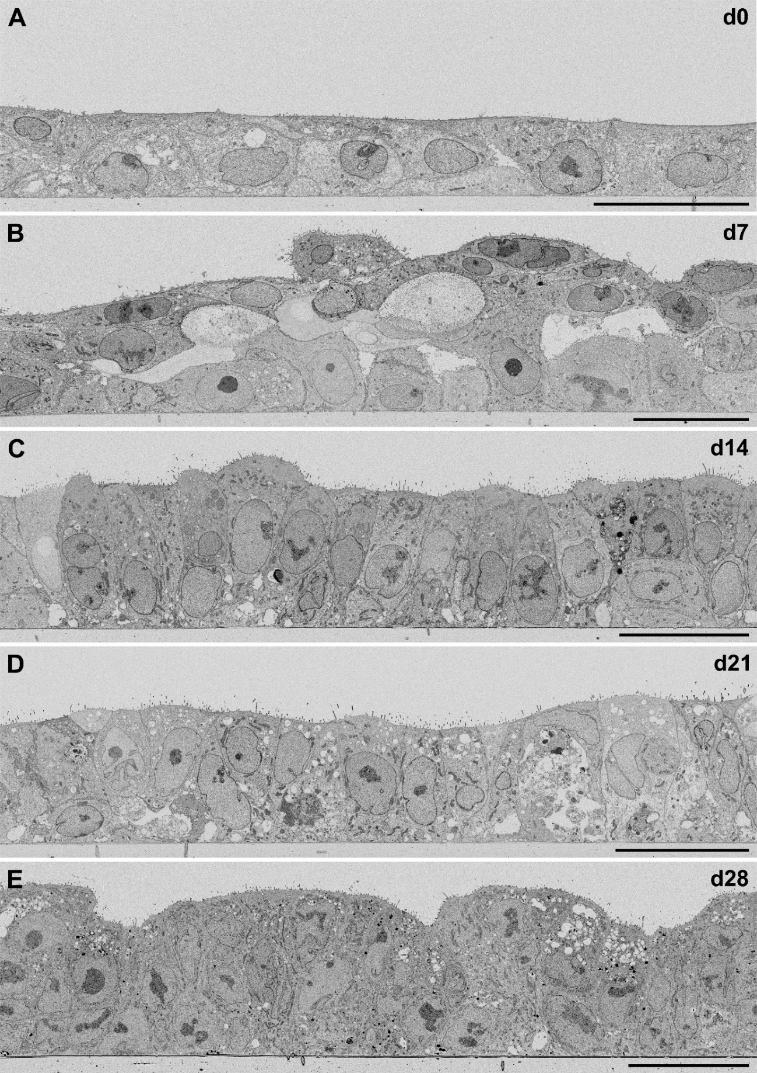
Supplementary Figure 1: EM of cross-sections through non-infected hAELVi-cells at different time points (day 0 to day 28) of cultivation at the ALI. Cells change their shape from cuboidal to columnar and develop into a polarized epithelium, which appears stratified or pseudo-stratified. Images were taken from the block-face by using SEM and detection of backscattered electrons (inverted grayscale). Scale bars = 25 µm.
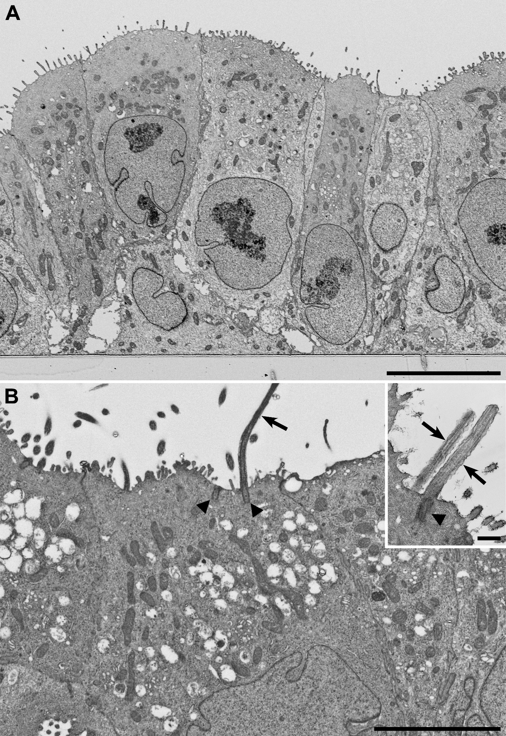
Supplementary Figure 2: EM of the hAELVi-cell epithelium. A Cross-section through the hAELVI-cell epithelium on day 14 at ALI. The epithelium appears pseudostratified in certain regions, with cells that have contact with the substrate but do not reach to the apical surface, like basal cells. B At later time points, single epithelial cells show cilia (arrows) with prominent basal bodies (arrowheads) at their surface. Images were taken from the block-face by using SEM and detection of backscattered electrons (inverted grayscale) or (inset) from thin sections by TEM. Scale bar in A = 10 µm, B = 5 µm, inset = 0.5 µm.
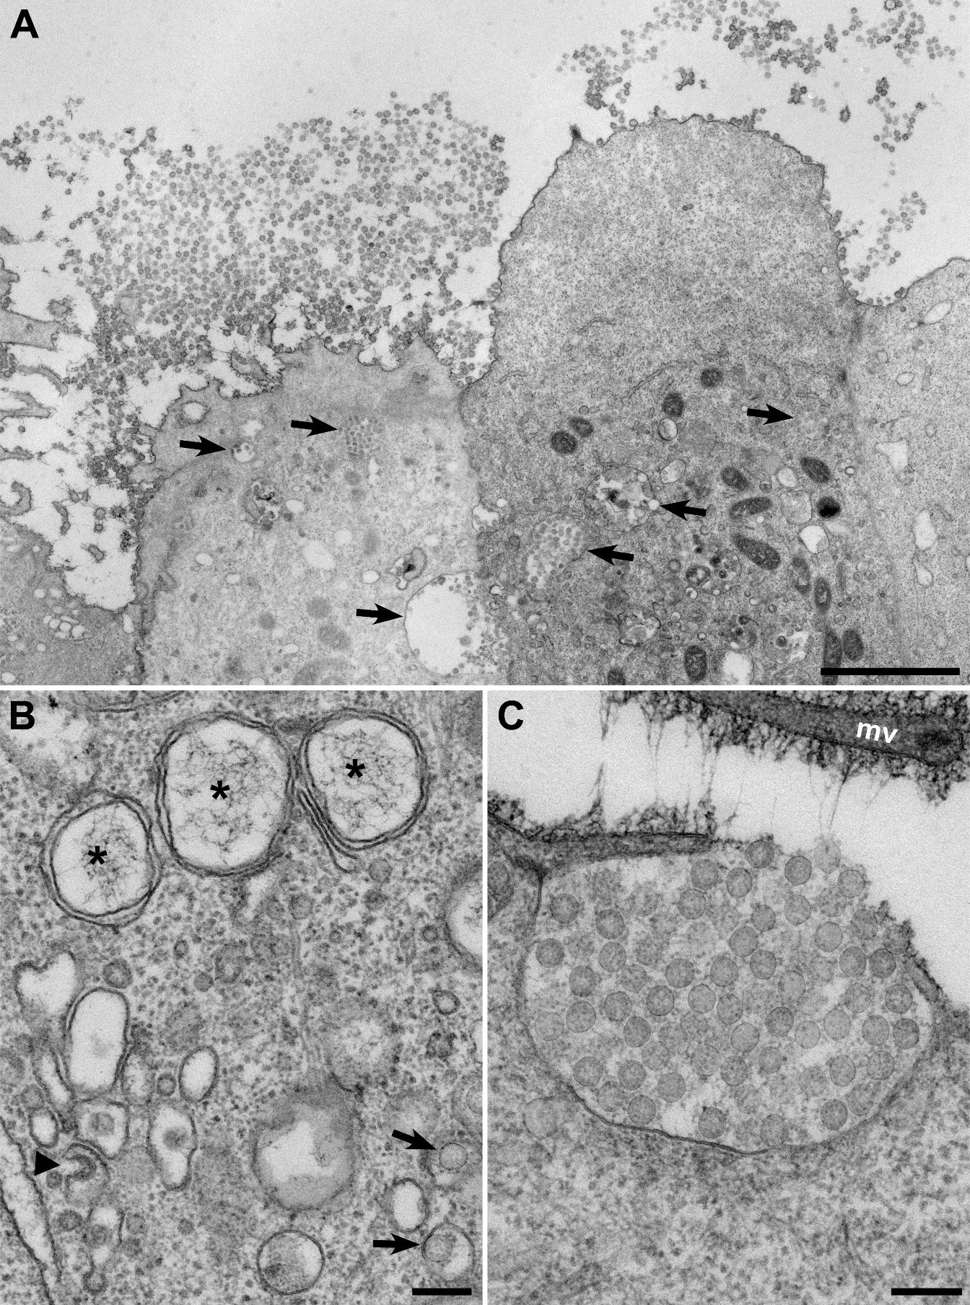
Supplementary Figure 3: EM of hAELVI-cell epithelium infected with SARS-CoV-2 on day 21 at ALI. A Apical region of two infected epithelial cells which show large clusters of virus particles at their surface. Larger virus particle assemblies are also visible in membrane-bound compartments within the cells (arrows). B Double-membrane vesicles with filamentous content (*) or budding structures (arrowhead) indicate replication and assembly of virus particles. Single virus particles (arrows) are visible in vesicles. C Virus particles are released from a large vesicle which has fused with the plasma membrane. The surface of the plasma membrane, including microvilli (mv), is coated with filamentous material produced by the cells. Images were taken from thin sections by TEM. Scale bar A = 2 µm, B, C = 200 nm.
Supplementary Figure 4: Induction of innate immune factors following virus infection in polarized hAELVi cells. Cells were infected with SARS-CoV-2, SARS-CoV, MERS-CoV and IAV at MOI of 1 followed by collection of the basolateral fluid at 48h p.i. for ELISA detection of type I and III IFN or the indicated cyto- and chemokines. Concentrations are shown as mean ± SEM (n=3 in technical duplicates). Limit of detection is marked by the dotted line.

