SUPPLEMENTARY ONLINE MATERIAL
Supplementary Table 1 Age groups of Iraqi refugees Al Hol Camp March 2017-March 2018
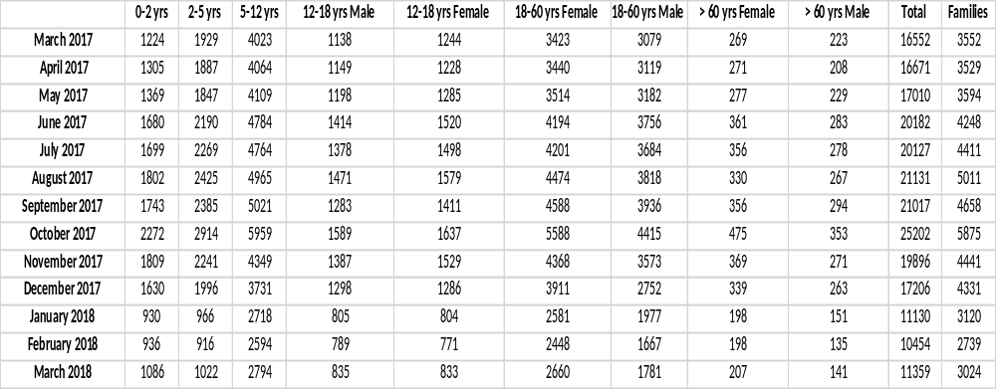
Supplementary Figure 1 Total Iraqi camp population Al Hol March 2017- March 2018

Supplementary Figure 2 Age groups Iraqi refugees Al Hol Camp March 2017- March 2018.

Supplementary Figure 3 Number of Iraqi families in Al Hol camp March 2017- March 2018.

Supplementary Table 2: Daily Staffing Levels at Phase 1 & 4 Clinics in the Al Hol refugee camp
Profession | Phase 1  08.30-15.30 | Phase 1  15.30-08.30 | Phase 4  08.30-15.30 | Phase 4  15.30-08.30
Clinic Manager | 1 | 0 | 1 | Closed
Doctors | 1 pediatric  1 Medical  1 Gynecologist (Sat, Sun, Friday) | 1 ER | 1 pediatric  1 Medical  1 Gynecologist | Closed
Nurses | 1 pediatric nurse  1 Medical nurse  1 Midwife | 1 midwife | 1 pediatric nurse  1 Medical nurse  1 Midwife | Closed
Pharmacist | 1 | 0 | 1 | Closed
Paramedics | 4 |  | 2 | Closed
Laboratory Technician | 1 | 0 | 0 | Closed
Cleaners | 2 | 0 |  | Closed
M & E | 1 | 0 |  | Closed
Health Promotion Coordinator | 1 | 0 |  | Closed
Ambulance Drivers | 2 | 1 | 0 | Closed
Registration | 2 | 1 | 1 | Closed

Supplementary Figure 4: Type of consultations provided (phase 1)
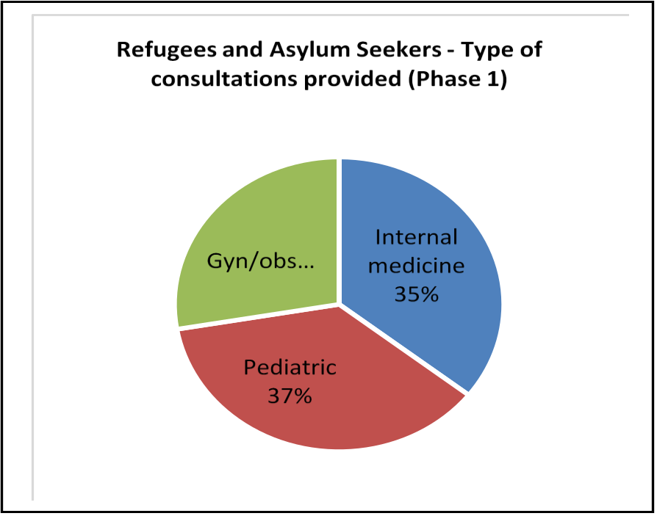

Supplementary Figure 5: RTI consultations March 2017- March 2018

Supplementary Figure 6: Watery diarrhoea cases, indicating the vulnerable group of children < 5 years old.

Supplementary Figure 7: Urinary tract infection cases over 13 months

Supplementary Figure 8: Proportion of UTIs in male and female population.

Supplementary Figure 9: Vaginal discharge cases March 2017- March 2018.

Supplementary Figure 10: Skin diseases: total number of cases per month, and indicating cases in patients < 5 years old.

Supplementary Figure 11: Leishmaniosis cases detected in the camp March 2017- May 2017.

Supplementary Figure 12: Hypertension cases in male and females March 2017-March 2018.

Supplementary Figure 13: Non-communicable diseases consultations March 2017- March 2018.

Supplementary Figure 44: Cases of Anaemia in male and female camp residents March 2017- March 2018.

