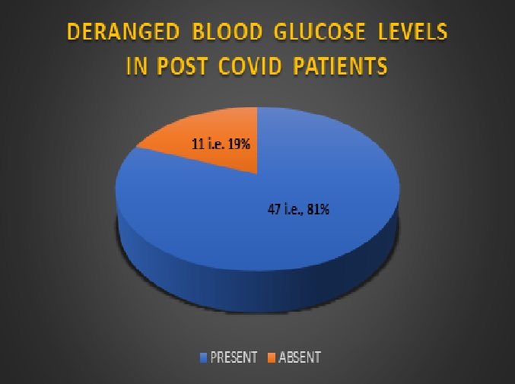
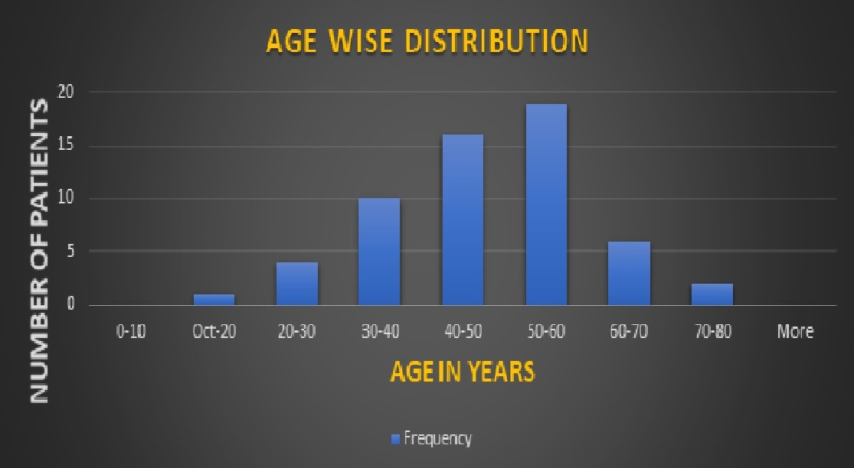
SEX | Number of Patients
MALE | 47
FEMALE | 11
Table no. 9 Genderwise distribution of the study population

Chart no. 1 : Genderwise distribution of the study population

KNOWN DIABETES | Number of Patients
DIABETIC | 37
NON-DIABETIC | 21
Table no. 10 Diabetic status of the study population

Chart 2 Diabetic status of the study population

EXTRA OCULAR MUSCLES | BOTH | RIGHT | LEFT | UNINVOLVED
SUPERIOR RECTUS | 2 | 10 | 9 | 37
MEDIAL RECTUS | 4 | 13 | 21 | 20
INFERIOR RECTUS | 3 | 10 | 10 | 35
LATERAL RECTUS | 1 | 4 | 8 | 45
SUPERIOR OBLIQUE | 0 | 7 | 13 | 38
INFERIOR OBLIQUE | 0 | 5 | 7 | 46
Table no. 11(Extraocular muscle involvement)

Chart no. 3 (Extraocular muscle involvement)

Table no. 12 (Extraconal fat involvement)
REGION OF EXTRACONAL FAT INVOLVED | BOTH | RIGHT | LEFT | UNINVOLVED
EXTRACONAL SUPERIOR | 2 | 10 | 11 | 35
EXTRACONAL MEDIAL | 5 | 13 | 18 | 22
EXTRACONAL INFERIOR | 5 | 12 | 13 | 28
EXTRACONAL LATERAL | 1 | 5 | 8 | 44

PERINEURAL SPREAD | NUMBER OF PATIENTS
Absent | 47
Left Maxillary Nerve | 2
Left Mandibular nerve | 8
Right Mandibular nerve | 1
Table no. 13 (Perineural spread)

