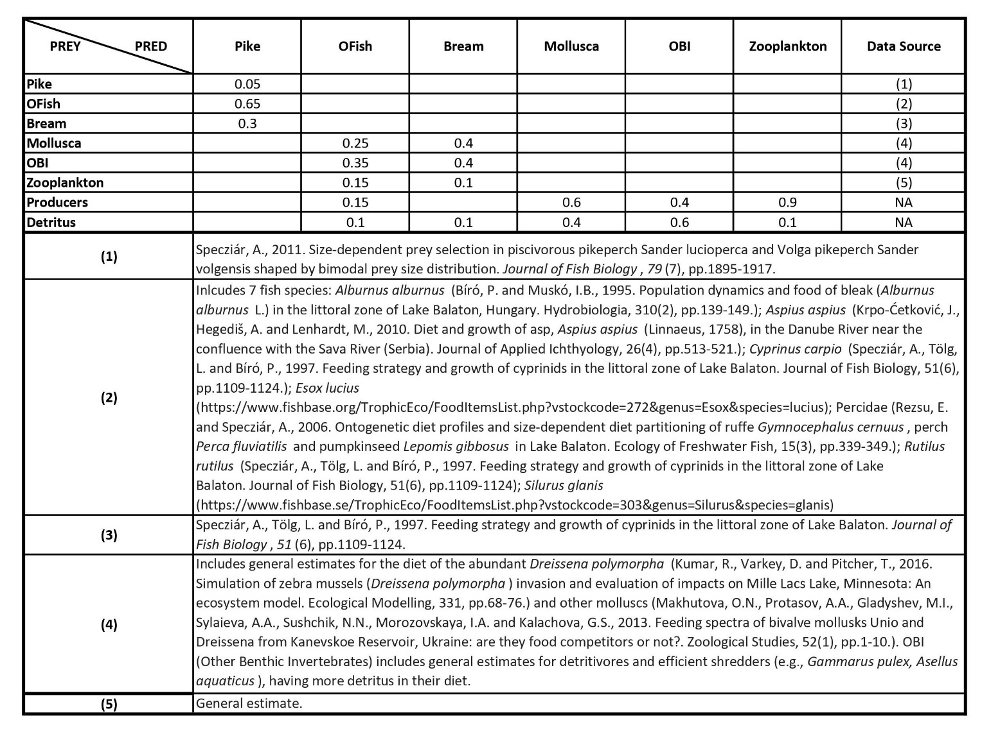
Appendix A. Diet matrix values and data sources used in the Ecopath model.

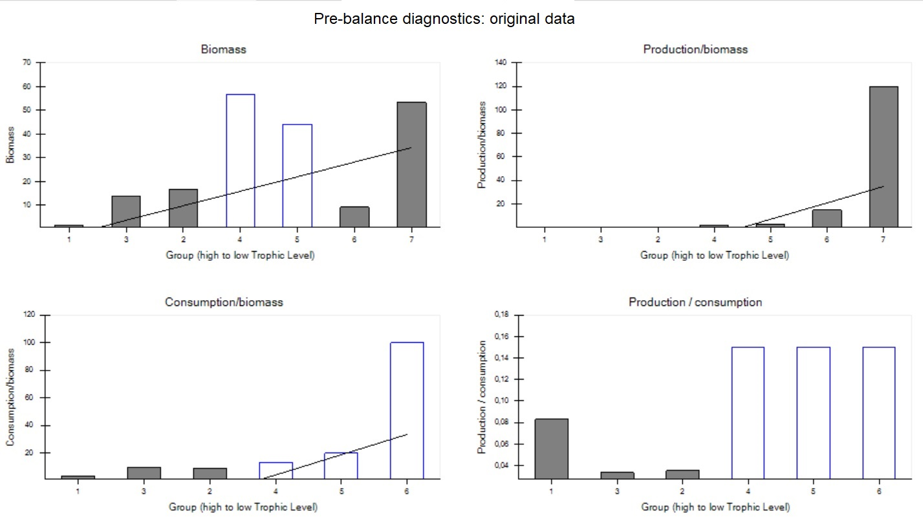

Appendix B-1. PREBAL diagnostics obtained from Ecopath (Link 2010). Groups are: 1=Pike, 2=OFish, 3=Bream, 4=Mollusca, 5=OBI, 6=Zooplantkon, 7=Producers. Blue bars indicate values estimated by the model (e.g., biomass data was not feasible to estimate from survey data). Biomass for Mollusca is estimated by Ecopath to be high and Zooplankton biomass (based on survey data) is low. Biomass data were obtained from the best available data from years 2000-2020 for Lake Balaton, Hungary (modified from Bíró, 2002).

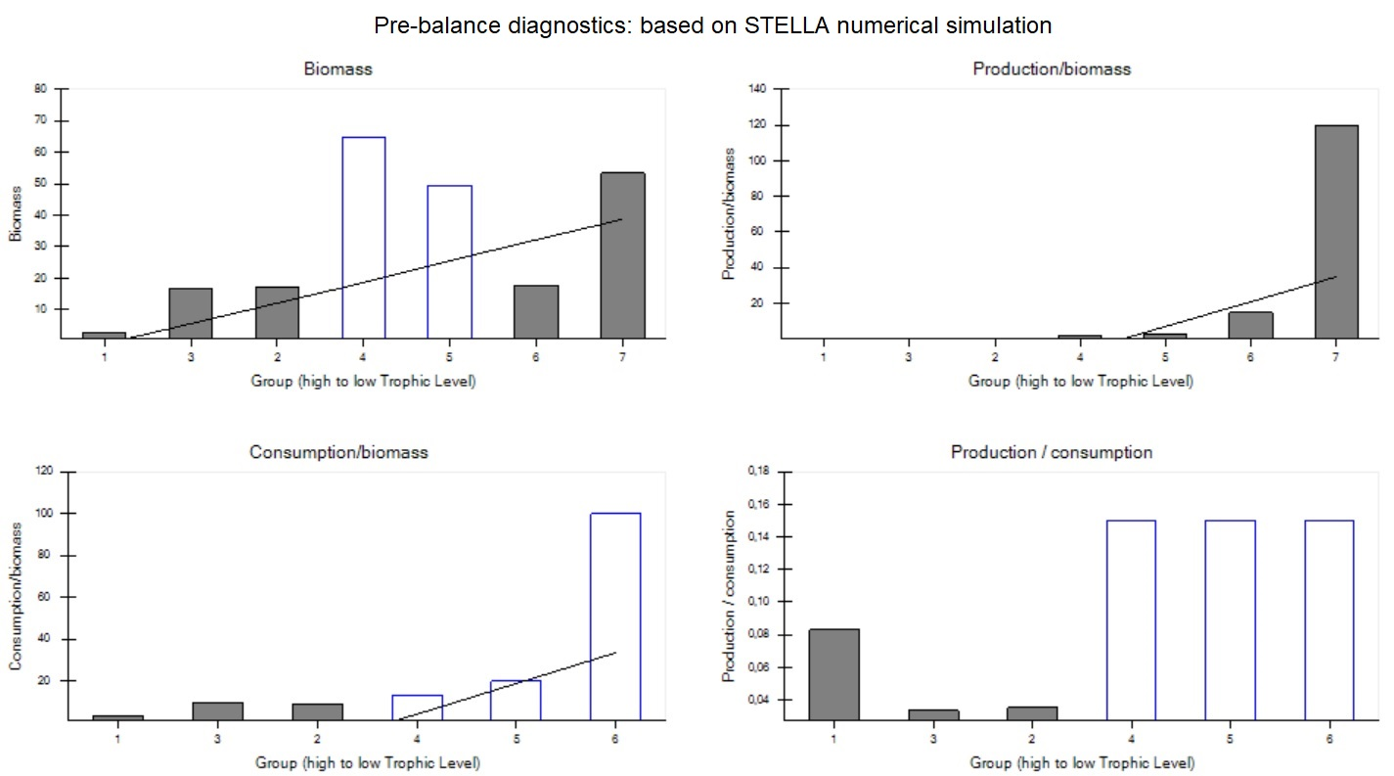

Appendix B-2. PREBAL diagnostics obtained from Ecopath based on the biomass numerical simulation output from STELLA (all other settings remained the same). The diagnostics are comparable to the original Ecopath model.

 |  | Impacted group
 |  | 1 | 2 | 3 | 4 | 5 | 6 | 7 | 8 | 9
Impacting group | 1 | -0.617 | -0.306 | -0.257 | 0.14 | 0.146 | 0.148 | -0.14 | -0.132 | -0.151
Impacting group | 2 | 0.207 | -0.258 | -0.275 | -0.023 | -0.117 | -0.228 | 0.135 | 0.0867 | 0.132
Impacting group | 3 | 0.0617 | -0.155 | -0.222 | -0.25 | -0.165 | -0.0587 | 0.135 | 0.168 | 0.352
Impacting group | 4 | 0.0361 | 0.0364 | 0.165 | -0.212 | -0.209 | -0.174 | -0.0856 | -0.121 | 0.101
Impacting group | 5 | 0.0449 | 0.0908 | 0.101 | -0.232 | -0.289 | -0.142 | -0.0181 | -0.31 | 0.0871
Impacting group | 6 | -0.0032 | -0.00075 | -0.0202 | -0.158 | -0.0926 | -0.263 | -0.305 | 0.031 | -0.0109
Impacting group | 7 | 0.0677 | 0.169 | 0.0798 | 0.234 | 0.0582 | 0.468 | -0.313 | -0.156 | 0.105
Impacting group | 8 | 0.0679 | 0.128 | 0.175 | 0.133 | 0.305 | -0.11 | -0.0486 | 0 | 0.14
Impacting group | 9 | -0.0183 | 0.0116 | -0.0024 | -0.001 | -0.0023 | -0.0039 | 0.00255 | 0.00186 | -0.0011

Appendix C. Mixed Trophic Impact (MTI) table obtained from Ecopath in numeric format (the equivalent of Figure 3). 1-8 are coded the same as in the MTI plot (Figure 3), and 9= Fishing.

BREAM(t) = BREAM(t - dt) + (OBI__to_Bream + Zooplankton__to_Bream + Moll_to__Bream + Detritus__to_Bream - Bream_to_Pike - bream_yield - bream__mortality) * dt
INIT BREAM = 14
OBI__to_Bream = OBI*0.4
Zooplankton__to_Bream = ZOO*0.1
Moll_to__Bream = MOLL*0.4
Detritus__to_Bream = 2
Bream_to_Pike = (BREAM/PIKE)*predation_rate
bream_yield = 0.03
bream__mortality = (BREAM*bream_natural__mortality_rate)*PIKE
DETRITUS(t) = DETRITUS(t - dt) + (Prod_to_Detritus - Detritus__to_Bream - Detritus__to_OFish - Detr_to_Moll - Detr_to_OBI - Detritus_to_Zoo) * dt
INIT DETRITUS = 10
Prod_to_Detritus = PRODUCERS*0.1
Detritus__to_Bream = 2
Detritus__to_OFish = DETRITUS*0.1
Detr_to_Moll = DETRITUS*0.06
Detr_to_OBI = DETRITUS*0.09
Detritus_to_Zoo = DETRITUS*0.015
MOLL(t) = MOLL(t - dt) + (Prod_to_Moll + Detr_to_Moll - Moll_to__Bream - Moll_to_OFish - Loss_at_Moll) * dt
INIT MOLL = 56
Prod_to_Moll = PRODUCERS*0.3
Detr_to_Moll = DETRITUS*0.06
Moll_to__Bream = MOLL*0.4
Moll_to_OFish = MOLL*0.2
Loss_at_Moll = MOLL*0.40
OBI(t) = OBI(t - dt) + (Prod_to_OBI + Detr_to_OBI - OBI__to_Bream - OBI_to_OFish - Loss_at_OBI) * dt
INIT OBI = 44
Prod_to_OBI = PRODUCERS*0.2
Detr_to_OBI = DETRITUS*0.09
OBI__to_Bream = OBI*0.4
OBI_to_OFish = OBI*0.35
Loss_at_OBI = OBI*0.25
OFISH(t) = OFISH(t - dt) + (Prod_to_OFish + Moll_to_OFish + OBI_to_OFish + Detritus__to_OFish + Zooplankton_to_OFish - OFish_to_Pike - OFish__mortality - OFish_yield) * dt
INIT OFISH = 16.6
Prod_to_OFish = PRODUCERS*0.07
Moll_to_OFish = MOLL*0.2
OBI_to_OFish = OBI*0.35
Detritus__to_OFish = DETRITUS*0.1
Zooplankton_to_OFish = ZOO*0.15
OFish_to_Pike = (OFISH/PIKE)*0.32
OFish__mortality = OFISH*PIKE*OFish_natural__mortality_rate
OFish_yield = 0.018
PIKE(t) = PIKE(t - dt) + (Bream_to_Pike + OFish_to_Pike - pike_yield - pike_mortality) * dt
INIT PIKE = 1.63
Bream_to_Pike = (BREAM/PIKE)*predation_rate
OFish_to_Pike = (OFISH/PIKE)*0.32
pike_yield = 0.011+(PIKE*cannibalism)
pike_mortality = 2.4+(PIKE*pike_natural__mortality_rate)
PRODUCERS(t) = PRODUCERS(t - dt) + (photosynthesis - Prod_to_Moll - Prod_to_OBI - Prod_to_Zooplankton - Prod_to_OFish - Prod_to_Detritus) * dt
INIT PRODUCERS = 53.3
photosynthesis = production_input
Prod_to_Moll = PRODUCERS*0.3
Prod_to_OBI = PRODUCERS*0.2
Prod_to_Zooplankton = PRODUCERS*0.33
Prod_to_OFish = PRODUCERS*0.07
Prod_to_Detritus = PRODUCERS*0.1
ZOO(t) = ZOO(t - dt) + (Prod_to_Zooplankton + Detritus_to_Zoo - Zooplankton__to_Bream - Zooplankton_to_OFish - Loss_at__Zooplankton) * dt
INIT ZOO = 9.2
Prod_to_Zooplankton = PRODUCERS*0.33
Detritus_to_Zoo = DETRITUS*0.015
Zooplankton__to_Bream = ZOO*0.1
Zooplankton_to_OFish = ZOO*0.15
Loss_at__Zooplankton = ZOO*0.75
bream_natural__mortality_rate = 0.32
cannibalism = PIKE*0.001
OFish_natural__mortality_rate = 0.285
pike_natural__mortality_rate = 0.25
predation_rate = 0.15
production_input = 53.3

Appendix D. STELLA model equation layer. INIT [group name] indicates the initial biomass (t/km²/yr), which are the same as in the Ecopath model (e.g., INIT ZOO = 9.2 t/km²/yr). Constant values are set for production input, natural mortality rates, and fishing yield. Others are expressed as rate of change: e.g., “Bream_to_Pike = (BREAM/PIKE)*predation_rate” means that the amount of biomass transferring from Bream to Pike is a function of the Bream to Pike ratio, multiplied by the predation rate. “PIKE(t) = PIKE(t - dt) + (Bream_to_Pike + OFish_to_Pike - pike_yield - pike_mortality) * dt” is the difference equation describing the dynamics of the pike stock, where inflow = (Bream_to_Pike + OFish_to_Pike); outflow = (pike_yield - pike_mortality), at each time step (dt). These equations are represented in the STELLA symbology layer (Figure 2.).

 | Pike | OFish | Bream | Mollusca | OBI | Zooplankton | Producers | Detritus | Fishing
Pike | + | - | ?- | ?+ | ?+ | ?+ | ?- | 0 | 0
OFish | 0 | + | - | ?- | ?- | 0 | ?- | ?+ | ?+
Bream | 0 | ?- | + | 0 | 0 | 0 | + | ?- | ?+
Mollusca | 0 | 0 | 0 | + | ?- | ?- | 0 | ?- | 0
OBI | 0 | 0 | 0 | ?- | + | ?- | 0 | ?- | ?-
Zooplankton | 0 | 0 | 0 | ?- | ?- | + | 0 | ?- | 0
Producers | 0 | ?+ | - | 0 | 0 | 0 | + | - | 0
Detritus | 0 | ?+ | + | 0 | 0 | 0 | ?- | + | +
Fishing | - | 0 | 0 | 0 | 0 | 0 | 0 | 0 | +
Appendix E. Table of predictions by Loop Analysis including all six categories (see Table 3 for version with only directions). The frequency of positive (“ + ”) effects in the inverted matrices defines the sign of predictions: “-” = 0-24%, “?-” = 25-39%, “0*” = 40-59%, “?+” = 60-74%, “+” = 75-100%, finally “0” means no change (where 100% of the values were 0).
 |  | Impacted group
 |  | 1 | 2 | 3 | 4 | 5 | 6 | 7 | 8 | 9
Impacting group | 1 | - | - | - | + | + | + | - | - | -
Impacting group | 2 | + | - | - | 0 | - | - | + | 0 | +
Impacting group | 3 | 0 | - | - | - | - | 0 | + | + | +
Impacting group | 4 | 0 | 0 | + | - | - | - | 0 | - | +
Impacting group | 5 | 0 | 0 | + | - | - | - | 0 | - | 0
Impacting group | 6 | 0 | 0 | 0 | - | 0 | - | - | 0 | 0
Impacting group | 7 | 0 | + | 0 | + | 0 | + | - | - | +
Impacting group | 8 | 0 | + | + | + | + | - | 0 | 0 | +
Impacting group | 9 | 0 | 0 | 0 | 0 | 0 | 0 | 0 | 0 | 0

Appendix F. Signs of predictions in the MTI table. We transcribed the values of the MTI table (Appendix C) in the [-0.1,0.1] interval to “0”, then the values under (above) this interval to “-” (“+”) sign.
Overall (%): |  | 63.9
Groups | Rows (%) | Groups | Columns (%)
OFish | 37.5 | Mollusca | 50
Producers | 50 | Detritus | 50
Detritus | 50 | Fishing | 50
Bream | 62.5 | Bream | 62.5
Zooplankton | 62.5 | OBI | 62.5
Pike | 75 | Zooplankton | 62.5
Mollusca | 75 | Producers | 62.5
OBI | 75 | Pike | 75
Fishing | 87.5 | OFish | 100

Appendix G. Percent (%) of sign-agreement between Loop Analysis and MTI tables. Loop Analysis cannot predict reliably the results of MTI in case of 50 % or lower percent of sign-agreement.

